Subject: Invitation to the 3GPP SA1 ad-hoc meetings
October 15-17, 2001
Loipersdorf, Austria

Dear Colleagues,

Siemens Austria is pleased to invite you to the SA1 ad-hoc Meetings, which will take place October 15-17, 2001 in Loipersdorf, Austria.

The meeting will be held at:

Loipersdorf Inter-Continental Resort,
A-8282 Loipersdorf 219, Austria

How to get there:
Loipersdorf is a well known spa in the south of Austria, in a nice, hilly landscape.
It is situated approximately 60 kilometers from Graz, 160 kilometers from Vienna.
The nearest airport is Graz- Thalerhof. From there it is best to take a taxi or rent a car.

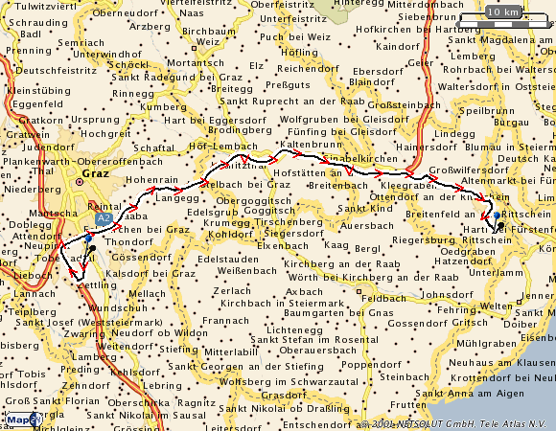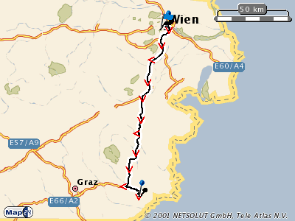

Hotel Reservations
Please make your reservation till Sept 30th (!) and use the attached hotel reservation form.
We are looking forward to seeing you in Loipersdorf

Sincerely,

Jörg Swetina
Siemens AG, Austria.
Tel.: +43 5 1707 21422
Fax: +43 5 1707 51924
Mobile: +43 676 4912429
Email: mailto:joerg.swetina@siemens.at

Loipersdorf Inter-Continental Resort
z. H. Frau Sandra Sifkovits

A-8282 Loipersdorf 219

Tel: +43 3382 / 20000 7009
Fax: +43 3382 / 20000 83
e-mail: sandra.sifkovits@basshotels.com
internet site: http://loipersdorf.interconti.com/

RESERVATION

Group Name: ”3GPP-S1-adhocs”

NAME ……………………………………… FIRST NAME…………………….…………….

Address ………………………………………………………………………………………..

City/Zip ……………………………………………… Country ……………………………….

Telephone …………………………………… Fax …………………………………………...

e-mail …………………………………………………………………………………………….

Date of Arrival …………………………… Time of Arrival ……………………………

Date of Departure …………………………

Smoker [ ] Nonsmoker [ ]

Room rates: € 125,02 / ATS 1.720,31 per person

Method of Payment: AMEX [ ] Visa [ ] Mastercard [ ]
other: ………………………………………………………………………

Card Number: ………………………………………………………………………

Card Holder: ………………………………………Exp. Date …………………

Additional remarks: ………………………………………………………………………

Fax Number for confirmation: …………………………………………………………
The Reservation cut-off date is : September 30th 2001 !

