The present document has been developed within the 3rd Generation Partnership Project (3GPP TM) and may be further elaborated for the purposes of 3GPP.
The present document has not been subject to any approval process by the 3GPP Organizational Partners and shall not be implemented.
This Report is provided for future development work within 3GPP only. The Organizational Partners accept no liability for any use of this Specification.
Specifications and Reports for implementation of the 3GPP TM system should be obtained via the 3GPP Organizational Partners' Publications Offices.

3GPP TR 22.874 V0.2.0 (2020-11)
Technical Report
3rd Generation Partnership Project;
Technical Specification Group Services and System Aspects;
Study on traffic characteristics and performance requirements for AI/ML model transfer in 5GS
(Release 18)



Keywords
AMMT, AI, ML
3GPP
Postal address

3GPP support office address
650 Route des Lucioles - Sophia Antipolis
Valbonne - FRANCE
Tel.: +33 4 92 94 42 00 Fax: +33 4 93 65 47 16
Internet
http://www.3gpp.org
Copyright Notification
No part may be reproduced except as authorized by written permission.
The copyright and the foregoing restriction extend to reproduction in all media.

© 2017, 3GPP Organizational Partners (ARIB, ATIS, CCSA, ETSI, TSDSI, TTA, TTC).
All rights reserved.

UMTS™ is a Trade Mark of ETSI registered for the benefit of its members
3GPP™ is a Trade Mark of ETSI registered for the benefit of its Members and of the 3GPP Organizational Partners
LTE™ is a Trade Mark of ETSI registered for the benefit of its Members and of the 3GPP Organizational Partners
GSM® and the GSM logo are registered and owned by the GSM Association
Contents
Foreword 6
Introduction 6
1 Scope 7
2 References 7
3 Definitions, symbols and abbreviations 9
3.1 Definitions 9
3.2 Symbols 10
3.3 Abbreviations 10
4 Overview 10
5 Split AI/ML operation between AI/ML endpoints 10
5.1 Split AI/ML image recognition 10
5.1.1 Description 10
5.1.2 Pre-conditions 12
5.1.3 Service Flows 12
5.1.4 Post-conditions 13
5.1.5 Existing features partly or fully covering the use case functionality 13
5.1.6 Potential New Requirements needed to support the use case 13
5.1.6.1 Potential KPI Requirements 13
5.2 Enhanced media recognition: Deep Learning Based Vision Applications 14
5.2.1 Description 14
5.2.2 Pre-conditions 15
5.2.3 Service Flows 15
5.2.4 Post-conditions 15
5.2.5 Existing features partly or fully covering the use case functionality 15
5.2.6 Potential New Requirements needed to support the use case 15
5.2.6.1 Potential KPI Requirements 15
5.3 Media quality enhancement: Video streaming upgrade 16
5.3.1 Description 16
5.3.2 Pre-conditions 17
5.3.3 Service Flows 17
5.3.4 Post-conditions 17
5.3.5 Existing features partly or fully covering the use case functionality 17
5.3.6 Potential New Requirements needed to support the use case 18
5.3.6.1 Potential KPI Requirements 18
5.4 Split control for robotics 18
5.4.1 Description 18
5.4.2 Pre-conditions 20
5.4.3 Service Flows 20
5.4.4 Post-conditions 20
5.4.5 Existing features partly or fully covering the use case functionality 20
5.4.6 Potential New Requirements needed to support the use case 20
5.4.6.1 Potential KPI Requirements 20
5.5 Session-specific model transfer split computation operations 21
5.5.1 Description 21
5.5.2 Pre-conditions 21
5.5.3 Service Flows 22
5.5.4 Post-conditions 22
5.5.5 Existing features partly or fully covering the use case functionality 22
5.5.6 Potential New Requirements needed to support the use case 23
6 AI/ML model/data distribution and sharing over 5G system 23
6.1 AI/ML model distribution for image recognition 23
6.1.1 Description 23
6.1.2 Pre-conditions 25
6.1.3 Service Flows 25
6.1.4 Post-conditions 25
6.1.5 Existing features partly or fully covering the use case functionality 25
6.1.6 Potential New Requirements needed to support the use case 25
6.1.6.1 Potential KPI Requirements 25
6.2 Real time media editing with on-board AI inference 26
6.2.1 Description 26
6.2.2 Pre-conditions 27
6.2.3 Service Flows 28
6.2.4 Post-conditions 28
6.2.5 Existing features partly or fully covering the use case functionality 29
6.2.6 Potential New Requirements needed to support the use case 29
6.2.6.1 Introduction 29
6.2.6.2 Potential KPI Requirements 31
6.3 AI/ML model distribution for speech recognition 32
6.3.1 Description 32
6.3.2 Pre-conditions 32
6.3.3 Service Flows 32
6.3.4 Post-conditions 33
6.3.5 Existing features partly or fully covering the use case functionality 33
6.3.6 Potential New Requirements needed to support the use case 33
6.3.6.1 Potential KPI Requirements 33
6.4 AI model management as a Service 33
6.4.1 Description 33
6.4.2 Pre-conditions 34
6.4.3 Service Flows 34
6.4.4 Post-conditions 34
6.4.5 Existing features partly or fully covering the use case functionality 34
6.4.6 Potential New Requirements needed to support the use case 35
7 Distributed/Federated Learning over 5G system 35
7.1 Federated Learning for image recognition 35
7.1.1 Description 35
7.1.2 Pre-conditions 36
7.1.3 Service Flows 37
7.1.4 Post-conditions 37
7.1.5 Existing features partly or fully covering the use case functionality 37
7.1.6 Potential New Requirements needed to support the use case 37
7.1.6.1 Potential KPI Requirements 38
7.2 Compressed Federated Learning for image/video processing 38
7.2.1 Description 38
7.2.2 Pre-conditions 40
7.2.3 Service Flows 40
7.2.4 Post-conditions 40
7.2.5 Gap analysis 40
7.2.6 Potential New Requirements needed to support the use case 41
7.3 Data Transfer Disturbance in Multi-agent multi-device ML Operations 42
7.3.1 Description 42
7.3.2 Pre-conditions 44
7.3.3 Service Flows 45
7.3.4 Post-conditions 45
7.3.5 Existing features partly or fully covering the use case functionality 46
7.3.6 Potential New Requirements needed to support the use case 46
7.4 Group Performance “Flocking” Use Case 49
7.4.1 Description 49
7.4.2 Pre-conditions 49
7.4.3 Service Flows 49
7.4.4 Post-conditions 50
7.4.5 Existing features partly or fully covering the use case functionality 50
7.4.6 Potential New Requirements needed to support the use case 50
8 Consolidated potential requirements 51
9 Conclusion and recommendations 51
Annex A: Introduction to AI/ML models 52
A.1: AI and ML 52
A.2 Deep neural network 52
A.3 Training and inference 53
A.4 Widely-used DNN models and algorithms 54
Annex B: General principle of split AI/ML operation between AI/ML endpoints 56
Annex C: General principle of AI/ML model/data distribution and sharing over 5G system 59
Annex D: General principle of Distributed/Federated Learning over 5G system 60
Annex E: Change history 63

Foreword
This Technical Report has been produced by the 3rd Generation Partnership Project (3GPP).
The contents of the present document are subject to continuing work within the TSG and may change following formal TSG approval. Should the TSG modify the contents of the present document, it will be re-released by the TSG with an identifying change of release date and an increase in version number as follows:
Version x.y.z
where:
x the first digit:
1 presented to TSG for information;
2 presented to TSG for approval;
3 or greater indicates TSG approved document under change control.
y the second digit is incremented for all changes of substance, i.e. technical enhancements, corrections, updates, etc.
z the third digit is incremented when editorial only changes have been incorporated in the document.

Introduction

1 Scope
This report captures the study of the use cases and the potential performance requirements for 5G system support of Artificial Intelligence (AI)/Machine Learning (ML) model distribution and transfer (download, upload, updates, etc.), and identifies traffic characteristics of AI/ML model distribution, transfer and training for various applications, e.g. video/speech recognition, robot control, automotive, other verticals.
The aspects addressed include:
- AI/ML operation splitting between AI/ML endpoints;
- AI/ML model/data distribution and sharing over 5G system;
- Distributed/Federated Learning over 5G system.
Study of the AI/ML models themselves are not in the scope of the TR.

2 References
The following documents contain provisions which, through reference in this text, constitute provisions of the present document.
- References are either specific (identified by date of publication, edition number, version number, etc.) or non-specific.
- For a specific reference, subsequent revisions do not apply.
- For a non-specific reference, the latest version applies. In the case of a reference to a 3GPP document (including a GSM document), a non-specific reference implicitly refers to the latest version of that document in the same Release as the present document.
[1] 3GPP TR 21.905: "Vocabulary for 3GPP Specifications".
[2] 3GPP TR 22.891, Feasibility Study on New Services and Markets Technology Enablers
[3] 3GPP TR 22.863, Feasibility study on new services and markets technology enablers for enhanced mobile broadband
[4] 3GPP TS 22.261, Service requirements for the 5G system
[5] 3GPP TS 22.104, Service requirements for cyber-physical control applications in vertical domains
[6] 3GPP TR 37.910, Study on self evaluation towards IMT-2020 submission (Release 16)
[7] A. Krizhevsky, I. Sutskever, and G. E. Hinton, “ImageNet classification with deep convolutional neural networks”, in Proc. NIPS, 2012, pp. 1097–1105.
[8] K. Simonyan and A. Zisserman, “Very deep convolutional networks for large-scale image recognition,” 2014, arXiv:1409.1556. [Online]. Available: https://arxiv.org/abs/1409.1556
[9] C. Szegedy, et al., “Going deeper with convolutions”, in Proc. CVPR, 2015, pp. 1-9.
[10] Zhi Zhou, Xu Chen, En Li, Liekang Zeng, Ke Luo, Junshan Zhang, “Edge intelligence: Paving the last mile of artificial intelligence with edge computing”, Proceeding of the IEEE, 2019, Volume 107, Issue 8.
[11] Jiasi Chen, Xukan Ran, “Deep learning with edge computing: A review”, Proceeding of the IEEE, 2019, Volume 107, Issue 8.
[12] I. Stoica et al., “A Berkeley view of systems challenges for AI”, 2017, arXiv:1712.05855. [Online]. Available: https://arxiv.org/abs/1712.05855
[13] Y. Kang et al., “Neurosurgeon: Collaborative intelligence between the cloud and mobile edge”, ACM SIGPLAN Notices, vol. 52, no. 4, pp. 615–629, 2017.
[14] E. Li, Z. Zhou, and X. Chen, “Edge intelligence: On-demand deep learning model co-inference with device-edge synergy”, in Proc. Workshop Mobile Edge Commun. (MECOMM), 2018, pp. 31–36.
[15] 3GPP TR 38.913, Study on Scenarios and Requirements for Next Generation Access Technologies (Release 15)
[16] B. Kehoe, S. Patil, P. Abbeel, and K. Goldberg, “A survey of research on cloud robotics and automation,” IEEE Transactions on automation science and engineering, vol. 12, no. 2, pp. 398–409, 2015.
[17] Huaijiang Zhu, Manali Sharma, Kai Pfeiffer, Marco Mezzavilla, Jia Shen, Sundeep Rangan, and Ludovic Righetti, “Enabling Remote Whole-body Control with 5G Edge Computing”, to appear, in Proc. 2020 IEEE/RSJ International Conference on Intelligent Robots and Systems. Available at: https://arxiv.org/pdf/2008.08243.pdf
[18] K. He, X. Zhang, S. Ren, and J. Sun, “Deep residual learning for image recognition,” in Proc. IEEE CVPR, Jun. 2016, pp. 770-778.
[19] A. G. Howard et al., “MobileNets: Efficient convolutional neural networks for mobile vision applications,” 2017, arXiv:1704.04861. [Online]. Available: https://arxiv.org/abs/1704.04861
[20] B. Taylor, V. S.Marco, W. Wolff, Y. Elkhatib, and Z. Wang, “Adaptive deep learning model selection on embedded systems,” in Proc. ACM LCTES, 2018, pp. 31–43.
[21] G. Shu, W. Liu, X. Zheng, and J. Li, “IF-CNN: Image-aware inference framework for CNN with the collaboration of mobile devices and cloud”, IEEE Access, vol. 6, pp. 621–633, 2018.
[22] D. Stamoulis et al., “Designing adaptive neural networks for energy-constrained image classification”, in Proc. ACM ICCAD, 2018, Art. no. 23.
[23] Sergey Ioffe and Christian Szegedy. “Batch normalization: Accelerating deep network training by reducing internal covariate shift”, In ICML., 2015.
[24] C.-J. Wu et al., “Machine learning at facebook: Understanding inference at the edge,” in Proc. IEEE Int. Symp. High Perform. Comput. Archit. (HPCA), Feb. 2019, pp. 331–344.
[25] Vivienne Sze, Yu-Hsin Chen, Tien-Ju Yang, Joel S. Emer, “Efficient processing of deep neural networks: A tutorial and survey”, Proceeding of the IEEE, 2017, Volume 105, Issue 12.
[26] Y. LeCun, Y. Bengio, and G. Hinton, “Deep learning,” Nature, vol. 521, no. 7553, pp. 436-444, May 2015.
[27] “An All-Neural On-Device Speech Recognizer”, March 12, 2019, Posted by Johan Schalkwyk, https://ai.googleblog.com/2019/03/an-all-neural-on-device-speech.html
[28] Yanzhang He, etc., “Streaming End-to-end Speech Recognition for Mobile Devices”, 2019 IEEE International Conference on Acoustics, Speech and Signal Processing (ICASSP 2019)
[29] 3GPP TS 22.243: "Speech recognition framework for automated voice services; Stage 1".
[30] H. B. McMahan, E. Moore, D. Ramage, S. Hampson, and B. A. Y. Arcas, “Communication-efficient learning of deep networks from decentralized data”, Proc. of the International Confe rence on Artificial Intelligence and Statistics, Apr. 20 17. [Online]. Available: https://arxiv.org/abs/1602.05629
[31] “Federated Learning”, https://justmachinelearning.com/2019/03/10/federated-learning/
[32] T. Nishio and R. Yonetani, “Client selection for federated learning with heterogeneous resources in mobile edge”, 2018, arXiv:1804.08333. [Online]. Available: https://arxiv.org/abs/1804.08333
[33] E. Park et al., “Big/little deep neural network for ultra low power inference”, in Proc. 10th Int. Conf. Hardw./Softw. Codesign Syst. Synth., 2015, pp. 124–132.
[34] Nguyen H. Tran ; Wei Bao ; Albert Zomaya ; Minh N. H. Nguyen ; Choong Seon Hong, “Federated Learning over Wireless Networks: Optimization Model Design and Analysis”, In proc. IEEE INFOCOM 2019 - IEEE Conference on Computer Communications
[35] Song Han, Xingyu Liu, Huizi Mao, Jing Pu, Ardavan Pedram, Mark A Horowitz, and William J Dally. “EIE: efficient inference engine on compressed deep neural network”, In 43rd International Symposium on Computer Architecture, IEEE Press, 243–254.
[36] V. Sze, “Efficient Computing for Deep Learning, AI and Robotics,” Dept EECS, MIT, Available online at https://lexfridman.com/files/slides/2020_01_15_vivienne_sze_efficient_computing.pdf
[37] V. Sze, Y. Chen, “Efficient Processing of Deep Neural Networks: A Tutorial and Survey” Proc. of IEEE, 2017, Available online at: https://www.semanticscholar.org/paper/Efficient-Processing-of-Deep-Neural-Networks%3A-A-and-Sze-Chen/3f116042f50a499ab794bcc1255915bee507413c
[38] Stanford University, CS231n – Lecture 5-7: CNN, Training NNs, Available at YouTube.com
[39] S. Han, J. Pool, J. Tran, and W, J. Dally, "Learning both weights and connections for efficient neural networks", NIPS, May 2015
[40] P. A. Merolla, et al., “A million spikingneuron integrated circuit with a scalable communication network and interface”,Science, vol. 345, no. 6197, pp. 668–673, Aug. 2014.
[41] R. Collobert, J. Weston, L. Bottou, M. Karlen, K. Kavukcuoglu, and P. Kuksa, “Natural language processing (almost) from scratch,” J. Mach. Learn. Res., vol. 12 pp. 2493–2537, Aug. 2011.
[42] T. N. Sainath, A.-R. Mohamed, B. Kingsbury, and B. Ramabhadran, “Deep convolutional neural networks for LVCSR”, in Proc. ICASSP, 2013, pp. 8614–8618.
[43] L. P. Kaelbling, M. L. Littman, and A. W. Moore, “Reinforcement learning: A survey”, J. Artif. Intell. Res., vol. 4, no. 1, pp. 237–285, Jan. 1996.
[44] 3 AI Trends for Enterprise Computing. [Online]. Available: https://www.gartner.com/smarterwithgartner/3-ai-trends-for-enterprise-computing/
[45] Shiming Ge ; Zhao Luo ; Shengwei Zhao ; Xin Jin ; Xiao-Yu Zhang, “Compressing deep neural networks for efficient visual inference”, In proc. 2017 IEEE International Conference on Multimedia and Expo (ICME)
[46] 3GPP TS 22.186, Enhancement of 3GPP support for V2X scenarios; Stage 1 (Release 16) v16.2.0
[47] “Develop Smaller Speech Recognition Models with NVIDIA’s NeMo Framework”, https://developer.nvidia.com/blog/develop-smaller-speech-recognition-models-with-nvidias-nemo-framework/

3 Definitions, symbols and abbreviations

3.1 Definitions
For the purposes of the present document, the terms and definitions given in 3GPP TR 21.905 [1] and the following apply. A term defined in the present document takes precedence over the definition of the same term, if any, in 3GPP TR 21.905 [1].
example: text used to clarify abstract rules by applying them literally.

3.2 Symbols
For the purposes of the present document, the following symbols apply:
<symbol> <Explanation>

3.3 Abbreviations
For the purposes of the present document, the abbreviations given in 3GPP TR 21.905 [1] and the following apply. An abbreviation defined in the present document takes precedence over the definition of the same abbreviation, if any, in 3GPP TR 21.905 [1].
<ACRONYM> <Explanation>

4 Overview

5 Split AI/ML operation between AI/ML endpoints

5.1 Split AI/ML image recognition

5.1.1 Description
The AI/ML-based mobile applications are increasingly computation-intensive, memory-consuming and power-consuming. Meanwhile end devices usually have stringent energy consumption, compute and memory limitations for running a complete offline AI/ML inference onboard. Many AI/ML applications, e.g. image recognition, currently intent to offload the inference processing from mobile devices to internet datacenters (IDC). For example, photos shot by a smartphone are often processed in a cloud AI/ML server before shown to the user who shot them. However, the cloud-based AI/ML inference tasks needs to take into account the computation pressure at IDCs, required data rate/latency and privacy protection requirement.
Image and video are the biggest data on today’s Internet. Videos account for over 70% of daily Internet traffic [4]. Convolutional Neural Network (CNN) models have be widely used for image/video recognition tasks on mobile devices, e.g. image classification, image segmentation, object localization and detection, face authentication, action recognition, enhanced photography, VR/AR, video games. Meanwhile, CNN model inference requires an intensive computation and storage resource. For example, AlexNet [7], VGG-16 [8] and GoogleNet [9] require 724M, 15.5G and 1.43G MACs (multiply-add computation) respectively for a typical image classification task.
Many references [10-14] have shown that AI/ML inference for image processing with device-network synergy can alleviate the pressure of computation, memory footprint, storage, power and required data rate on devices, reduce end-to-end latency and energy consumption, and improve the end-to-end accuracy, efficiency and privacy when compared to the local execution approach on either side. The scheme of split AI/ML image recognition can be depicted in Figure 5.1.1-1. The CNN is split into two parts according to the current image recognition task and environment. The intention is to offload the computation-intensive, energy-intensive parts to network server, whereas leave the privacy-sensitive and delay- sensitive parts at the end device. The device executes the inference up to a specific CNN layer and sends the intermediate data to the network server. The network server runs through the remaining CNN layers. While the model is developed or invocated, the split AI/ML operation is based on the legacy model.
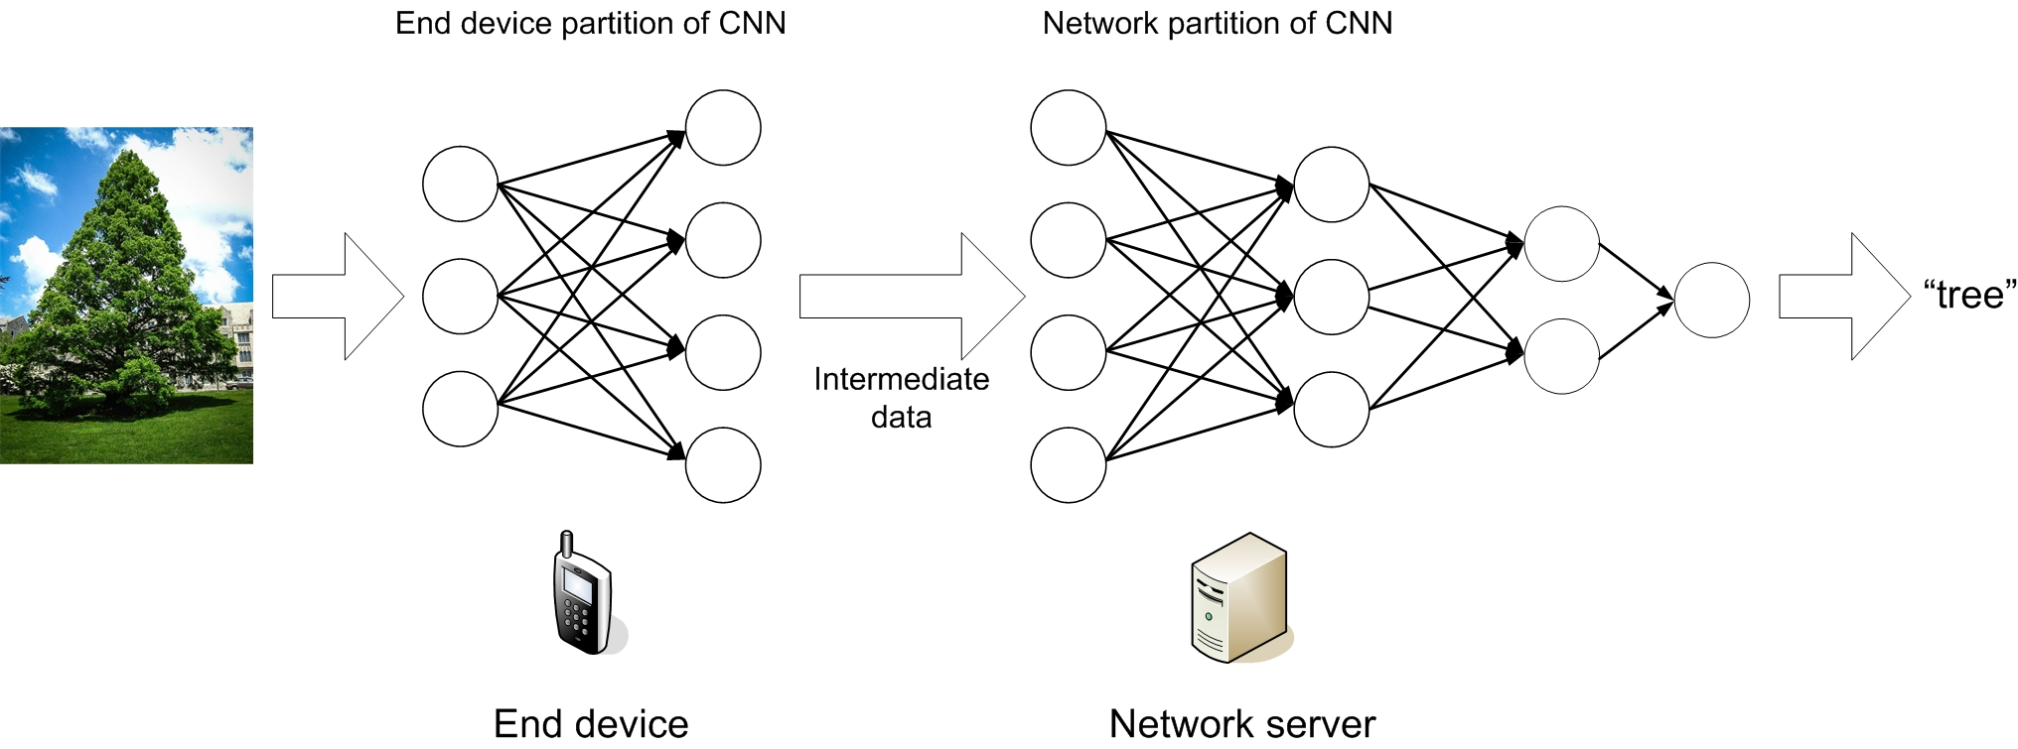
Figure 5.1.1-1. Example of split AI/ML image recognition
The split AI/ML image recognition algorithms can be analyzed based on the computation and data characteristics of the layers in the CNN. As shown in Figure 5.1.1-2 [13], the intermediate data size transferred from one CNN layer to the next depends on the location of the split point. Hence, the required UL data rate is related to the model split point and the frame rate for the image recognition, as also observed by [13-14]. For example, assuming images from a video stream with 30 frames per second (FPS) need to be classified, the required UL data rate for different split points ranges from 4.8 to 65 Mbps (listed in Table 5.1.1-1). The result is based on the 227×227 input images. In case of images with a higher resolution, higher data rates would be required.
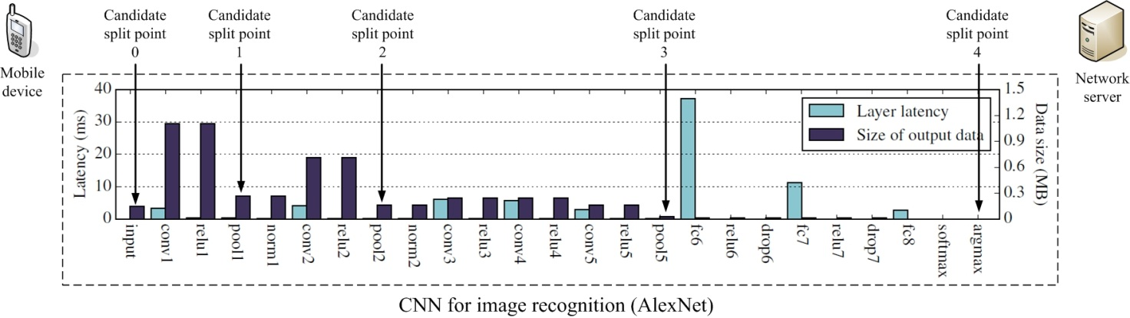
Figure 5.1.1-2. Layer-level computation/communication resource evaluation for an AlexNet model (based on the figure adopted from [13])
Table 5.1.1-1: Required UL data rate for different split points of AlexNet model for video recognition @30FPS
Split point | Approximate output data size (MByte) | Required UL data rate (Mbps)
Candidate split point 0  (Clould-based inference) | 0.15 | 36
Candidate split point 1  (after pool1 layer) | 0.27 | 65
Candidate split point 2  (after pool2 layer) | 0.17 | 41
Candidate split point 3  (after pool5 layer) | 0.02 | 4.8
Candidate split point 4  (Device-based inference) | N/A | N/A

VGG-16 is another widely-used CNN model for image recognition. Still assuming images from a video stream with 30 FPS need to be classified, the required UL data rate for different split points ranges from 24 to 720 Mbps (listed in Table 5.1.1-2).
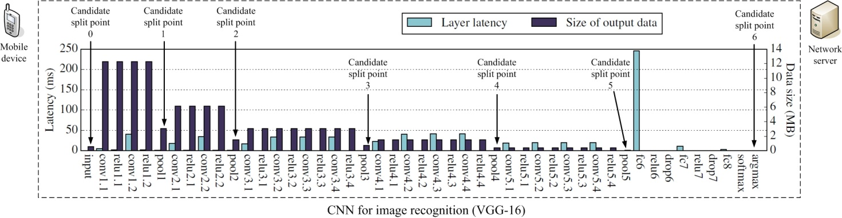
Figure 5.1.1-3. Layer-level computation/communication resource evaluation for a VGG-16 model (based on the figure adopted from [13])
Table 5.1.1-2: Required UL data rate for different split points of VGG-16 model @30FPS
Split point | Approximate output data size (MByte) | Required UL data rate (Mbps)
Candidate split point 0  (Cloud-based inference) | 0.6 | 145
Candidate split point 1  (after pool1 layer) | 3 | 720
Candidate split point 2  (after pool2 layer) | 1.5 | 360
Candidate split point 3  (after pool3 layer) | 0.8 | 192
Candidate split point 4  (after pool4 layer) | 0.5 | 120
Candidate split point 5  (after pool5 layer) | 0.1 | 24
Candidate split point 6  (Device-based inference) | N/A | N/A

5.1.2 Pre-conditions
The involved AI/ML endpoints (e.g. UE, AI/ML cloud/edge server) run applications providing the capability of AI/ML model inference for image recognition, and support the split AI/ML image recognition operation.
The 5G system has the ability to provide 5G network related information to the AI/ML server.

5.1.3 Service Flows
- The AI/ML based image recognition application is requested by the user to start recognizing the image/video shot by the UE.
- Under the determined split mode and split point, the AI/ML based image recognition application in an involved AI/ML endpoint excutes the allocated part of AI/ML model, and sends the intermediate data to the next endpoint in the AI/ML pipeline.
- After all the involved AI/ML endpoints finish the co-inference, the image recognition results are fed to the user using the results.
- The AI/ML based image recognition applications in the endpoints perform the split image recognition until the image recognition task is terminated.
Redo Step 3) and 4) for split mode/point re-selection/switching if needed to adapt to the changing conditions.

5.1.4 Post-conditions
The objects in the input images or videos are recognized and the recognition accuracy and latency need to be guaranteed.
The image recognition task can be completed under the available computation and energy resource of the UE. And the consumed the computation, communication and energy resources over the AI/ML endpoints are optimized.

5.1.5 Existing features partly or fully covering the use case functionality
It should be noticed that the data rates required by this use case are user experienced data rates, not peak data rates (legacy 5G NR supports 10Gbps UL peak data rate). According to the self evaluation results in [6], 5G NR can provide up to 73.15Mbps UL user experienced data rate. The experienced data rate is defined as the achievable data rate in 95% network coverage. The data rate performance of legacy 5G NR system cannot meet the high-end requirement of this use case.

5.1.6 Potential New Requirements needed to support the use case
The “image recognition latency” can be defined as the latency from the image is captured to the recognition results of the image are output to the user application, which was not specially addressed in [4][15]. Following the principle of analyzing the latency and data rate requirements of split image recognition introduced in Section 5.1.1, the image recognition latency is related to the user application the recognition is used for.
Computer vision and image recognition have been widely used for many important mobile applications such as object recognition, photo enhancements, intelligent video surveillance, mobile AR, remote-controlled automotive, industrial control and robotics. The image recognition is usually a step of the processing pipeline of the application. And the recognition latency is a part of the end-to-end latency, as depicted in Figure 5.1.6-1.
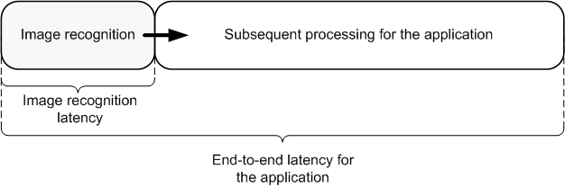
Figure 5.1.6-1. Image recognition latency is a part of end-to-end latency
For example, if the image recognition results are just used for the object recognition e.g. unknown object recognition for smartphone user or criminal searching in database for intelligent security, it is acceptable that the image recognition is finished in seconds. If the image recognition result is used as an input to another time-sensitive application, e.g. AR display/gaming, remote-controlled automotive, industrial control and robotics, a much more stringent latency will be required. Based on the end-to-end latency requirements of the applications, the image recognition latency requirement can be derived, as listed in Table 5.1.6-1.

5.1.6.1 Potential KPI Requirements
The potential KPI requirements needed to support the use case include:
[P.R.5.1-001] The 5G system shall support the functionality to enable intermediate data uploading for split image recognition with latency as given in Table 5.1.6.1-1.
[P.R.5.1-002] The 5G system shall support the functionality to enable intermediate data uploading for split image recognition with UL data rate as given in Table 5.1.6.1-1.
[P.R.5.1-003] The 5G system shall support the functionality to enable intermediate data uploading for split image recognition with communication service availability not lower than 99.999 %.
Table 5.1.6.1-1: Image recognition latency and UL data rate for intermediate data uploading
User application | Latency requirements |  |  | Required UL data rate
User application | Required end-to-end latency | Image recognition latency | Intermediate data uploading latency | AlexNet  (Fig. 5.1.1-1, Note 4) | VGG-16  (Fig. 5.1.1-2, Note 4)
One-shot object recognition at smartphone | Several seconds | ~1s | ~100ms | 1.6~21.6Mbps | 8~240Mbps
Person identification in security surveillance system | Several seconds | ~1s | ~100ms | 1.6~21.6Mbps | 8~240Mbps
Photo enhancements at smartphone | Several seconds | ~1s] | ~100ms | 1.6~21.6Mbps | 8~240Mbps
Video recognition | Several seconds | 33ms@30FPS | ~10ms] | 16~216Mbps | 80Mbps~2.4Gbps
AR display/gaming | 7~15ms (Note 1) | <5ms | 2ms | 80Mbps~1.08Gbps | 0.4~12Gbps (Note 5)
Remote driving | 10ms (Note 2) | <5ms | 2ms | 80Mbps~1.08Gbps | 0.4~12Gbps (Note 5)
Remote-controlled robotics | 10~100ms (Note 3) | <5ms | 2ms | 80Mbps~1.08Gbps | 0.4~12Gbps (Note 5)
NOTE 1: According to [4][5], the VR motion-to-photon latency is in the range of 5-15ms.
NOTE 2: According to [46] the one-way latency required for remote driving is 5ms. The round-trip latency is assumed to be 10ms.
NOTE 3: According to [5] the end-to-end latency required for video-operated remote-controlled robotics is 10~100ms.
NOTE 4: As listed in Table 5.1.1-1 and Table 5.1.1-2, the intermediate data size for the split points of AlexNet and VGG-16 is 0.02 ~ 0.27MByte and 0.1 ~ 3MByte respectively.
NOTE 5: Some required UL data rates for some split points of VGG-16 for some specific user applications may not be feasible for 5G network. The unfeasible values will be checked and removed in the Consolidated potential requirements.

5.2 Enhanced media recognition: Deep Learning Based Vision Applications

5.2.1 Description
A tourist is wandering around a city and discovering the attractions and sights of the city. The user sees a beautiful object and she decides to shoot a video of the object. The application uses deep learning algorithms to process the video and identify of the object of interest and provide historical information about it to the user. Furthermore, the application uses deep learning to reconstruct a 3D model of the object of interest by using the captured 2D video.
As an example, we investigate Feature Pyramid Network (FPN)-based object detection approaches. These networks are usually composed of a backbone FPN and a head that performs task-specific inference. The FPN processes the input images at different scales to allow for the detection of small-scale and large-scale features. The head may for instance segment the objects, infer a bounding box for the objects, or classify the objects.
The FPN backbone constitutes the most complex portion of the network and lends itself to be offloaded to the edge/cloud. The backbone is a common part to a wide range of networks that can perform different tasks. The produced feature maps can then be sent back to the UE for task-specific inference.
A breakdown of the network architecture is shown in the following figure:
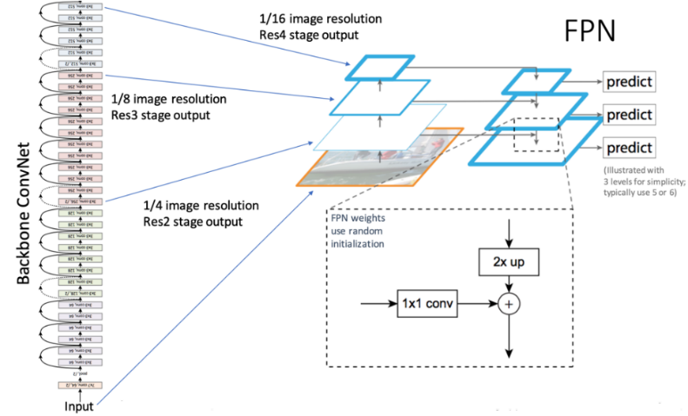
Figure 5.2.1-1. Example Multi-Task Network
As shown in the figure, a classical CNN architecture is used as the core. The FPN is used to extract features at different scales of the image, making it scale-invariant. The prediction tasks constitute the head of the network. By plugging in different network heads, different AI tasks can be performed. This makes the network a Multi-Task Network (MTN). For example, a Region Proposal Network can be appended to detect and frame objects in the input sequence by outputting bounding boxes. Other Task-specific Heads can be appended to detect humans and poses, classify objects, track objects, etc.

5.2.2 Pre-conditions
The user wants to receive instantaneous information and reconstruction to enhance their experience. The user’s device is battery operated.

5.2.3 Service Flows
- User opens their camera app and starts shooting a video
- Application pre-processes the video to prepare it for inference
- The application streams the extracted features and/or the video to the edge/cloud for processing.
- The network performs the split-inference (e.g. only running the backbone) and streams the results back to the client
- The application runs task-specific inference to solve the specific task of interest (e.g. object detection, tracking, …)
- The application uses the inferred labels and classes to enhance the user’s view

5.2.4 Post-conditions
The user gets enhanced information extracted from the video about the object of interest that the user was shooting a video of.

5.2.5 Existing features partly or fully covering the use case functionality
[FFS]

5.2.6 Potential New Requirements needed to support the use case
[FFS]

5.2.6.1 Potential KPI Requirements
The potential KPI requirements to support the use case are:
[P.R.5.2-001] The 5G system shall support the uplink streaming of video for enhanced recognition at the network with total round-trip latency (i.e. including the uplink streaming delay, the inference and processing latency, and the downlink delay) not higher than [200ms-1s] with a delay breakdown as given in Table 5.2.6.1-1.
Table 5.2.6.1-1: Recognition: latency breakdown and bitrate requirements
Recognition Task | Latency Requirement  (Note 4) | Downlink Bandwidth |  | Uplink Bandwidth
Recognition Task | Latency Requirement  (Note 4) | Faster R-CNN  (Note 1) | YOLOv3  (Note 2) | Faster R-CNN | YOLOv3
Uplink Streaming | 100-200ms |  |  | 100-1000 kbps | 200-1500 kbps
Generic FPN Inference | 100-500ms | FPN:  4-10fps  Sum(Pi)~1MB/frame  32-100Mbps uncompressed  (Note 3)  Compression factor 10~100 | Multiple scale (similar to FPN):  1.5 MB feature map/frame  40-150 Mbps uncompressed  Compression factor 10~100
Object Classification | 20-50ms | Performed on UE | Performed on UE
Bounding Box Detection | 20-50ms | Performed on UE | Performed on UE
Object Tracking | 50-150ms | Performed on UE | Performed on UE
Enhanced Information Retrieval |  | Few kBytes per request |  | Few kBytes per request
Overlay Rendering | 10ms | Performed on UE |  | Performed on UE
Note 1: Faster R-CNN uses an input image size of 3x224x224. The video is downscaled on the UE to that target resolution and then compressed (e.g. using HEVC) and streamed to the edge for further processing.
Note 2: YOLOv3 uses an input image size of 3x416x416. The captured video is downscaled on the UE to the target resolution and compressed prior to streaming to the edge.
Note 3: Faster R-CNN uses an FPN with ResNet 101 as backbone; thus resulting in feature maps {P2=(256x56x56), P3=(256x28x2), P4=(256x14x14), P5=(256x7x7)}.
Note 4: the latency estimates assume an overall latency of around 1s from a user pointing at an object until overlay information is displayed to the user.

[P.R.5.2-002] The 5G system shall support the update of the task-specific network part (the network head that performs task-specific operations such as object detection) on demand or on application start.

5.3 Media quality enhancement: Video streaming upgrade

5.3.1 Description
A user is playing a VR game on the cloud using their VR headset. The game is being rendered on the cloud and streamed down to the UE. The user wants to enjoy an immersive gaming experience which requires very high quality video, e.g. 8K per eye at 120 frames per second. The cloud game server can only produce 4K video data due to hardware, load, and networking restrictions. AI is used to upscale the 4K content into 16K content for a better user experience for the user.
The following figure shows an example of such a network:
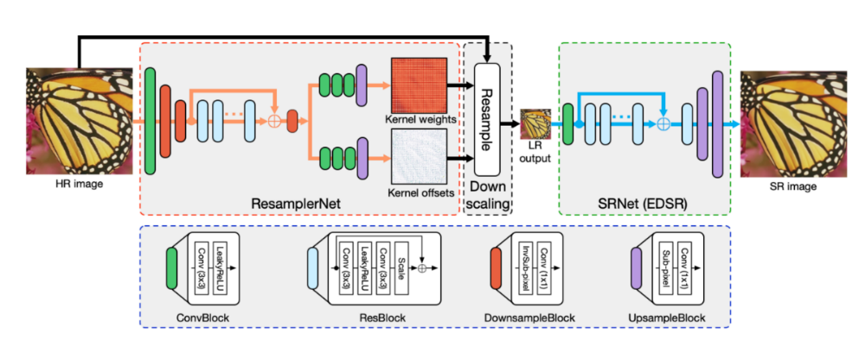
Figure 5.3.1-1. Example DNN-based Down/Up-scaler
The Low Resolution video is streamed to the UE, which will process the video to infer the high resolution version. The down-sampling and up-sampling parts of the network are matched to produce best results. Any updates to the down-sampling part of network would require updates on the UE-side to the up-sampling part of the network. In addition to the LR version of the video, model weights and topology updates may need to be sent to the UE.
The pre-trained models are optimized to the type of content (e.g. sport, cartoons, movie,…) and to the scale factor. As the user switches to a different piece of content, the device will check if the corresponding pre-trained model weights are already downloaded in the cache. If not available, the UE will download the pre-trained model weights for the selected piece of content and based on the desired up-scaling factor. The new content is shown to the user in less than 3 seconds from the user selecting it.

5.3.2 Pre-conditions
The remote gaming server generates streams metadata together with the stream that is extracted by running AI autoencoder on the originally captured content.

5.3.3 Service Flows
- Users starts a cloud VR gaming session on their HMD
- The game is launched on the cloud server and the game can start
- The cloud server renders and captures the content and downscales it to 4K video
- The cloud server also runs a DNN to produce a metadata stream that will be used for upscaling
- The UE uses a reverse DNN network to upscale the received 4K stream into 16K. The input to the DNN is the 4K video and the metadata stream.
- The UE renders the high quality 16K view on the HMD.

5.3.4 Post-conditions
The user enjoys a high-quality VR experience.

5.3.5 Existing features partly or fully covering the use case functionality
[FFS]

5.3.6 Potential New Requirements needed to support the use case
[FFS]

5.3.6.1 Potential KPI Requirements
The potential KPI requirements to support the use case are:
[P.R.5.3-001] The 5G system shall support the delivery of pre-trained model weights and weight updates with a latency no more than 3 seconds.
Note 1: the model download time takes into account acceptable channel switch time, which generally should not exceed 2-3 seconds.
The following table provides an estimate of the model weight sizes:
Table 5.3.6.1-1: Model Weight Sizes and Data rates
Model Name (Note 2) | Model Weight Size | Data Rate (Note 3)
CAR 4x | Downsampling: ~40MB  Upsampling: ~170MB | Upsampling model download:  450Mbps (downloaded over a period of 3 seconds)
SR-GAN 4x | Downsampling: N/A (bicubic)  Upsampling: ~6MB | Upsampling model download:  12Mbps (downloaded over a period 3 seconds)
SRResNet 4x | Downsampling: N/A (bicubic)  Upsampling: ~6MB | Upsampling model download:  12Mbps (downloaded over a period of 3 seconds)
NOTE 2: the size of the weights of the pre-trained models dependes on the nature of the content and the scaling factor of the video.
NOTE 3: model weight download is triggered by change of content by the user and thus results in bursty traffic by nature with relatively long off periods.
NOTE 4: all model weight sizes are from pre-trained PyTorch models.

5.4 Split control for robotics

5.4.1 Description
Mobile robots have been playing an increasingly important role in some scenarios, e.g. warehouse, disaster rescue and smart factories [5], thanks to their high mobility. The mobile robots need to work in an ever-changing environment, hence need to perform fast and reliable sensing, planning and controlling. If the corresponding computation is performed on board in the robot, it will require intensive computations which lead to increased requirements of computation capabilities and power consumption. However, a light-weight form factor is always a requirement to the mobile robots working in the real-world environment, which prevents the robots to be equiped with a large number of CPU/GPU units and large-capacity batteries. As the example provided in [17], ANYmal, one of the most advanced commercially available quadruped robot, carries 3kg of batteries of about 650Wh energy, while the high-end GPU Nvidia Titan X consumes more than 250W of power, significantly impacting battery life if such computational power was embedded on the robot.
Offloading computations from robots to the cloud has been studied in many references [16]. Meanwhile relying on either data or code from a network to support the robot’s operation, the designers of autonomous mobile robots have to consider the scenarios where the robots must include capacity of local processing for low-latency responses during periods when network access quality is varying worse.
The resulting system is different from the fully remote-controlled robot system described in [5], in which the planning and controlling are carried out by cloud computing, and the robots only reports the sensing data (incl. video), and receives the control commands. Since the complete cloud computing can hardly meet the latency requirement of the ms-level feedback control loop of some types of mobile robots, e.g. legged robots, the split control of mobile robots is an agreeable solution in this case.
[17] introduces a robot whole-body balance control split over 5G network. The AI inference for the controlling can be split between the robot and the cloud server: As shown in Figure 5.4.1-1, the part which is complex but less susceptible to delays is offloaded to the remote computation in the cloud or edge control server. The low-complexity part which contains the error feedback terms and is latency-critical can be efficiently done by the local computation in the robot. If the robot fails to receive the optimal control from “remote control part” from the cloud/edge control server due to communication delays or packet loss, it can approximate the “remote control part” using pre-computed feedback matrices received previously. And in certain duration, the approximation will still enable the robot to perform feedback control for the tasks approximately and ensure that the robot can still operate.
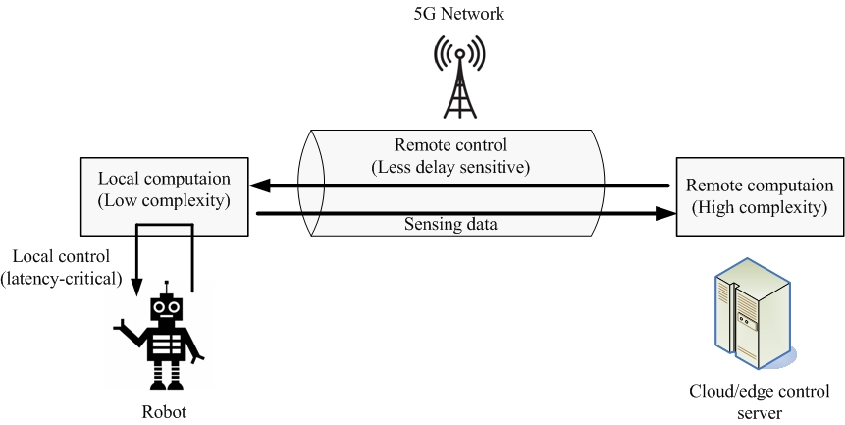
Figure 5.4.1-1. Split control of leggered robot over 5G network
The results in [17] show that, in case the robot is completely controlled by a cloud server, the robot cannot finish the walking task if the round-trip latency is larger than 3ms (from sending sensing data to receiving control commands, including processing at cloud/edge). Due to delayed control commands, the robot would fall down (as shown in Figure 5.4.1-2 (a)). However, if the split control is employed, a worse-case 25ms round-trip latency can be sustained, and the robot can still perform the walking task (as shown in Figure 5.4.1-2 (b)).
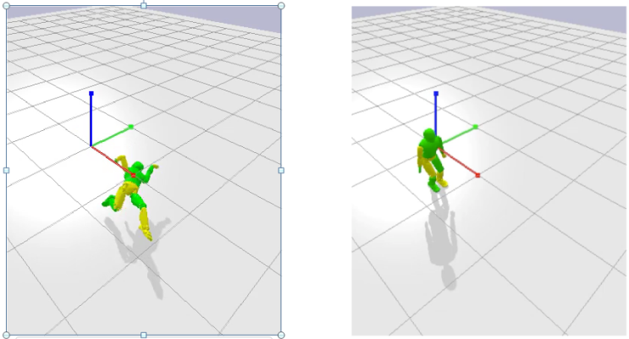
- 5G remote control without local control (b) 5G remote control with local control at robot
Figure 5.4.1-2. Simulated performance of robot whole-body balance control over 5G network with 25ms round-trip latency

5.4.2 Pre-conditions
The involved AI/ML endpoints (e.g. UE (robot), AI/ML cloud/edge server) run applications providing the capability of AI/ML model inference for robot control task, and support the split robot control operation.
The 5G system has the ability to provide 5G network related information to the AI/ML server.

5.4.3 Service Flows
- The UE (robot) is connected with the cloud/edge control server via 5G network.
- The split of the control operations on robot side and cloud/edge control server side for the robot control task is determined by the robot or the network.
- Under the determined split mode and split point, the robot performs the local control computation based on the collected sensing data, and sends the sensing data to the cloud/edge control server. The cloud/edge control server performs the remote control computation, and feeds the outputs back to the robot.
- The robot controls its motion jointly based on the outputs of local and remote control computations.
- Start with Step 3) with more control operations, until the robot control task is terminated.

5.4.4 Post-conditions
The robot receives the control from local and remote with required accuracy and latency, so to finish the moving tasks, e.g. balance task and walking task.
The robot control task can be completed under the available computation and energy resource of the robot. And the consumed the computation, communication and energy resources over the AI/ML endpoints are optimized.

5.4.5 Existing features partly or fully covering the use case functionality
It should be noticed that the data rates required by this use case are user experienced data rates, not peak data rates (legacy 5G NR supports 20Gbps DL peak data rate). In [4], 100Mbps DL experienced data rate is required in 95% coverage. According to the self evaluation results in [6], 5G NR can provide up to 144.34 DL user experienced data rate in 95% coverage. The experienced data rate is defined as the achievable data rate in 95% network coverage. The data rate performance of legacy 5G NR system cannot meet the requirement of this use case.

5.4.6 Potential New Requirements needed to support the use case
If everything is done on the edge part, the robot needs to send 592B sensing data per control cycle (every millisecond) and receive 200B per control cycle from the “remote controller”, which leads to a UL data rate of 4.7Mbps and a DL data rate of 1.6Mbps. However maximum communication latency is limited to 3ms. If the splitting strategy is followed, downloading the “remote control part” from the cloud/edge control server requires downloading a 40kB data burst per control cycle (every millisecond) as more information is needed to ensure the local controller can take over in case of unexpected latencies, which leads to a DL data rate of 320Mbps. In that case, a worst-case latency of 25ms can be tolerated between each control cycle.
This implies a trade-off between DL data rate and latency: Compared with the full control at edge, the split control mode requires a higher DL data rate, but relaxes the stringent latency requirement. Different from the traditional URLLC services requiring continuous coverage of 5G network which can only be provided with FR1 spectrum, for a 5G operator with FR2 spectrum, the split control for robotics can be offloaded to the 5G mmWave network with non-continuous coverage.

5.4.6.1 Potential KPI Requirements
The potential KPI requirements needed to support the use case include:
[P.R.5.4-001] The 5G system shall support the functionality to enable “Remote control part” downloading for split control for robotics with latency as given in Table 5.4.6.1-1 (corresponding size of “Remote control part” is also listed in the table).
[P.R.5.4-002] The 5G system shall support the functionality to enable “Remote control part” downloading for split control for robotics with DL data rate as given in Table 5.4.6.1-1 (corresponding size of “Remote control part” is also listed in the table).
[P.R.5.4-003] The 5G system shall support the functionality to enable “Remote control part” downloading for split control for robotics with communication service availability not lower than 99.999 %.
Table 5.4.6.1-1: Data rate and latency requirements for robotic control
Control mode | UL data rate for sensing data uploading | Size of “Remote control part” | DL data rate for “Remote control part” downloading | Required latency for “Remote control part” downloading
Full control at edge | 4.7Mbps | 200Bytes | 1.6Mbps | 3ms
Split control | 4.7Mbps | 40kBytes | 320Mbps | 25ms

5.5 Session-specific model transfer split computation operations

5.5.1 Description
A UE, to achieve results for the user, employs split computation. Computation intensive tasks (machine learning, complex computation using input data and the model, etc.) can be fully or partially offloaded. This use case considers a particular use – rendering augmented reality in a headset with modest computational resources. The decision how to split the computation task between the UE and other computation resources depends in part on the conditions of the communication network.
NOTE: The decision of how to split computation is itself out of scope of 3GPP and not discussed here.

5.5.2 Pre-conditions
Abigail has Augmented Reality glasses, a UE with limited computational power. She leaves a bus and stands at the bus stop, where, behind a large advertisement display, a gNB is installed. Abigail’s glasses get access through the access point. She seeks to augment her view of the city with directions and annotations (opening hours, local history, description of businesses, etc.) Augmenting the visual scene of the city in real time is a computationally intensive task, accomplished by a model developed through ML. the model has two candidate split points, each candidate split point has a different workload and communication requirement shown as below. A strategy for splitting computation has been installed in UE and network server so that the split point can be adjusted based on change of communication performance and/or UE’s capabilities.
Table 5.5.2-1: Workload and communication requirement for split points
 | Approximate output UL data rate (mbps) | Computation load in UE
Candidate split point 1 | 120 | Low
Candidate split point 2 | 24 | High

The glasses have limited computational capacity, and this capacity varies over time. A means for identifying the current status (capabilities) of the UE is available to the network. Initially it is determined that the UE has the capability to support either candidate split point 1 or 2.
The network communication resources are enormous, it is determined by the augmented reality service to apply candicate split point 1 so that computation is executed mainly in the network, receiving large quantities of data provided by her glasses and this helps reduce computation in UE. The large quantity of data is transmitted via the QoS flow with guaranteed data rate (GBR) 200 Mbps.

5.5.3 Service Flows
Case-a (split pont adjusted based on communication performance):
Abigail walks away from the bus stop and the vicinity of the hot spot.
As Abigail stood a few meters from the gNB hotspot, The insufficient communication resources leads to the serving gNB becoming unable to keep the QoS flow with GBR 200 Mbps any more Thus the policy decision point (which could be anywhere – we leave out what takes the decision and how) determines to downgrade will be executed at the time point-a the GBR from 200 Mbps to 30 Mbps and immediately notifies UE and Application server of this downgrade. The strategy for splitting computation for the AR application now must be adjusted, i.e. change to candidate split point 2, for which more computation needs to be done locally but the required bit rate for UL transmission is reduced to 24 mbps.
The strategy and constraints for the partition of work is out of scope of this use case. (These could include e.g. partial results could be sent to the UE, which could perform sub-optimally with reduced resources, can model information be sent in a lossy / compressed form that is still useful, etc.) In any case, one of the crucial inputs to the decision of how to split the work is the current set of communication resources available.
The network provides current network resource information concerning the UE to network communication performance such as new QoS paramteres (GBR=20mbps), the condition information (time point-a) for update of a new QoS, as well as end to end performance between the UE and the computation resources (e.g. in the Service Hosting Environment). This information is made available (exposed) to the split computation ‘policy decision point’ (which could be anywhere – in the UE, the edge, the cloud, etc., this is not relevant to the use case.)
Case-b (split point adjusted based on UE’s capability):
Originally candidate split point-2 is selected when UE’s capability can support a high work load.
Abigail’s UE’s capabilities are monitored. When the communication resources are sufficient to support Candidate split point 1, if the UE’s capabilities degraded sufficiently (e.g. due to depleted battery, lack of storage, reduced computation capacity) then this would be a reason to select Candidate split point 1.
Then the split computation decision point then adjusts the split computation strategy:
For case-a:to avoid service interruption, the split computation decision point selects the new split point-2 before the time point-a arrives. How this is communicated or ‘enforced’ is out of scope of this use case and it is not suggested that this would be standardized.
For case-b: to guarantee the user experience, the split computation decision point selects the split point-1 as the UE’s capability is insufficient to support a high work load anymore.

5.5.4 Post-conditions
Abigail has no awareness of the change of model split point and continues to enjoy acceptable performance as she ventures into the city, even if perhaps it is not as good as when she stood at the bus stop. Note that this use case doesn’t conclude as long as Abigail continues to use the service – as the UE to network communication performance can change at any time.

5.5.5 Existing features partly or fully covering the use case functionality
22.261 v17.1.0 6.6.2
Based on operator policy, the 5G system shall support an efficient mechanism for selection of a content caching application (e.g. minimize utilization of radio, backhaul resources and/or application resource) for delivery of the cached content to the UE.
NOTE 1: The selection of content caching relies upon knowledge of communication resources (e.g. radio, backhaul, application) for delivery of content to the UE. Thus this requirement satisfies the requirements partly.
22.261 v17.1.0 6.7.2
The 5G system shall be able to provide the required QoS (e.g. reliability, end-to-end latency, and bandwidth) for a service and support prioritization of resources when necessary for that service.
The 5G system shall be able to support E2E (e.g. UE to UE) QoS for a service.
NOTE 2: E2E QoS needs to consider QoS in the access networks, backhaul, core network, and network to network interconnect.
The 5G system shall be able to support QoS for applications in a Service Hosting Environment.
22.261 v17.1.0 6.8
Based on operator policy, the 5G system shall support a real-time, dynamic, secure and efficient means for authorized entities (e.g. users, context aware network functionality) to modify the QoS and policy framework. Such modifications may have a variable duration.
Based on operator policy, the 5G system shall maintain a session when prioritization of that session changes in real time, provided that the new priority is above the threshold for maintaining the session.
22.261 v17.1.0 6.10.2
Based on operator policy, the 5G network shall provide suitable APIs to allow a trusted third-party application to request appropriate QoE from the network.
Based on operator policy, the 5G network shall expose a suitable API to an authorized third-party to provide the information regarding the availability status of a geographic location that is associated with that third-party.
Based on operator policy, the 5G network shall expose a suitable API to allow an authorized third-party to monitor the resource utilisation of the network service (radio access point and the transport network (front, backhaul)) that are associated with the third-party.

5.5.6 Potential New Requirements needed to support the use case
[P.R.5.5-001] Based on operator policy, the 5G network shall provide the means to allow an authorized third-party to monitor the resource utilisation of the network service (radio access point and the transport network (front, backhaul)) that are associated with the third-party. The resource utilization includes the realtime decision for change of QoS made by 5G network.
[P.R.5.5-002] Based on operator policy, the 5G system shall be able to modify the QoS parameters with a delay to give the 3rd party application sufficient time to accordingly adjust the AI model split point.
[P.R.5.5-003] Based on operator policy, the 5G system shall be able to expose the condition information such as time point for updating a new QoS to an authorized 3rd party so that the 3rd party can make an adjustment of candidate split point before the update occurs.
NOTE: how the 3rd party adjust the candidate split point based on the condition is out of 3GPP scope.
Editor’s Note: It is FFS whether and how (units and measurement frequency) granularity of spatial information and resource utilization listed in the above requirements can be expressed in KPIs.

6 AI/ML model/data distribution and sharing over 5G system

6.1 AI/ML model distribution for image recognition

6.1.1 Description
Image recognition is an area where a rich set of pre-trained AI/ML models are available. The optimum model depends on the feature of the input image/video, environment and the precision requirement. The model used for vision processing at device needs to be adaptively updated for different vision objects, backgrounds, lighting conditions, purposes (e.g. image recovery vs. classification), and even target compression rates. Although a static model can also work as default in some cases, adapting the model to different working conditions will provide improved recognition accuracy and better user experience.
An example was given in [20] for the motivation of selecting the optimum model for different image recognition tasks and environments. As shown in Figure 6.1.1-1, 4 typical CNN models were evaluated and compared for different image recognition tasks, i.e. MobileNet_v1_025 [19], ResNet_v1_50 (ResNet [18] with 50 layers), Inception_v2 [23], and ResNet_v2_152 (ResNet with 152 layers). This example shows that the best model depends on the type of input image and the task requirement. For a mobile device which needs to recognize diverse types of images and meet various requirements for different applications, the model needs to be adaptively switched.
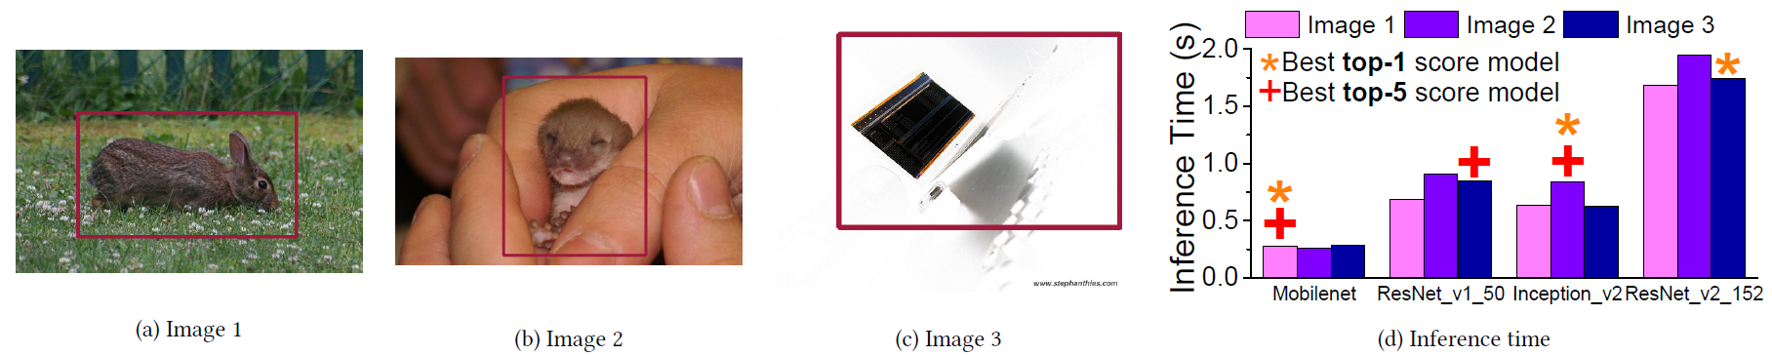
Figure 6.1.1-1. Example of selecting the optimum model for different image recognition tasks/environments (figure adopted from [20])
In case the selected model has not pre-loaded in the device, the device needs to download it from the network before the image recognition task can start. A model can be reused if it is kept in storage after the previous use. But due to the limited storage resource, the device cannot retain all models for potential use in storage. The data rate for downloading the needed models depends on the size of the model and the required downloading latency.
Along with the increasing performance requirements to AI/ML operations, the size of the models also keeps increasing, although model compression techniques are under improvements. The typical sizes of typical DNN models for image recognition are listed in Table 6.1.1-1. A DNN parameter can be expressed in 32 bits for a higher inference accuracy. The model size and downloading overhead can be compressed if the size of a parameter is reduced to 8 bits, by potentially sacrificing the image recognition accuracy.
The required model downloading latency depends on how fast the model needs to be ready at the device. It is impacted by the extent to which the oncoming application can be predicted. In the use case, we assume the device cannot predict and download the needed model in advance. In this case, the downloading of the AI/ML model needs to be finished in seconds or even in milliseconds. Different from a streamed video which can be played when a small portion is buffered, a DNN model can only be used until the whole model is completely downloaded.
For example, if the downloading latency is 1s, the required DL data rate ranges from 134.4 Mbps to 1.92Gbps in case of 32-bit parameters, as shown in Table 6.1.1-1. In case of 8-bit parameters, the required DL data rate can be limited to 33.6Mbps~1.1Gbps.
Table 6.1.1-1: Sizes of typical image-recognition models and required DL data rates for downloading in 1s
DNN model for image recognition | Number of parameters (Million) | 32 bits per parameter |  | 8 bits per parameter
DNN model for image recognition | Number of parameters (Million) | Size of the model (MByte) | Required DL data rate (Mbps) | Size of the model (MByte) | Required DL data rate (Mbps)
AlexNet [7] | 60 | 240 | 1920 | 60 | 480
VGG16 [8] | 138 | 552 | 4416 | 138 | 1104
ResNet-152 [18] | 60 | 240 | 1920 | 60 | 480
ResNet-50 [18] | 25 | 100 | 800 | 25 | 200
GoogleNet [9] | 6.8 | 27.2 | 217.6 | 6.8 | 54.4
Inception-V3 [23] | 23 | 92 | 736 | 23 | 184
1.0 MobileNet-224 [19] | 4.2 | 16.8 | 134.4 | 4.2 | 33.6

6.1.2 Pre-conditions
The UE runs an application providing the capability of AI/ML model inference for image recognition.
An AI/ML server manages the AI/ML model pool, and is capable to download the requested model to the application providing AI/ML based image recognition.
The 5G system has the ability to provide 5G network related information to the AI/ML server.

6.1.3 Service Flows
- The AI/ML based image recognition application is requested by the user to start recognizing the image/video shot by the UE.
- The AI/ML model is downloaded from the model server to the AI/ML based image recognition application via 5G network.
- The AI/ML based image recognition application employs the AI/ML model for inference until the image recognition task is finished.
- Redo Step 2) to 3) for AI/ML model re-selection and re-downloading if needed to adapt to the changing conditions.

6.1.4 Post-conditions
The objects in the input images or videos are recognized by the AI/ML based image recognition application and the inference accuracy and latency need to be guaranteed.
The image recognition task can be completed under the available computation and energy resource of the UE.

6.1.5 Existing features partly or fully covering the use case functionality
It should be noticed that the data rates required by this use case are user experienced data rates, not peak data rates (legacy 5G NR supports 20Gbps DL peak data rate). According to the self evaluation results in [6], 5G NR can provide up to 144.34 DL user experienced data rate. The experienced data rate is defined as the achievable data rate in 95% network coverage. The data rate performance of legacy 5G NR system cannot meet the requirement of this use case.

6.1.6 Potential New Requirements needed to support the use case
Considering the time taken by the device to finish the image recognition task, a small portion of the recognition latency budget can be used to download the model. For one-shot object recognition at smartphone and photo enhancements at smartphone, a pre-installed sub-optimal model can be temporarily employed while downloading the optimal model. The optimal model in need should be downloaded on level of 1s, and then replaces the pre-installed model. If 8-bit parameters are used for describing the DNN, the required DL data rate ranges from 33.6Mbps to 1.1Gbps. For video recognition, the target can be updating the model in one frame duration (so to adopt the updated model for the next frame. But for an application with an always-on camera, the device can predict the needed model and start the downloading in-advance. Downloading the model within 1s is acceptable. Similarly, for other applications with an always-on camera, i.e. person identification in security surveillance system, AR display/gaming, remote driving, remote-controlled robotics, the required DL data rate ranges from 33.6Mbps to 1.1Gbps. It should be noted that the size of the model may be further reduced if more advanced model compression techniques can be adopted.

6.1.6.1 Potential KPI Requirements
The potential KPI requirements needed to support the use case include:
[P.R.6.1-001] The 5G system shall support the functionality to enable AI/ML model downloading for image recognition with latency as given in Table 6.1.6.1-1.
[P.R.6.1-002] The 5G system shall support the functionality to enable AI/ML model downloading for image recognition with DL data rate as given in Table 6.1.6.1-1.
[P.R.6.1-003] The 5G system shall support the functionality to enable AI/ML model downloading for image recognition with communication service availability not lower than 99.999 %.
Table 6.1.6.1-1: Image recognition model downloading latency analysis for example applications (8-bit parameters for the DNN)
User application | Latency requirements |  | Model downloading data rate
User application | Image recognition latency | Model downloading latency | Model downloading data rate
One-shot object recognition at smartphone | ~1s | 1s (Note 1) | 33.6Mbps~1.1Gbps
Person identification in security surveillance system | ~1s | 1s (Note 2) | 33.6Mbps~1.1Gbps
Photo enhancements at smartphone | ~1s | 1s (Note 1) | 33.6Mbps~1.1Gbps
Video recognition | 33ms@30FPS | 1s (Note 2) | 33.6Mbps~1.1Gbps
AR display/gaming | <5ms (Note 3) | 1s (Note 2) | 33.6Mbps~1.1Gbps
Remote driving | <5ms (Note 4) | 1s (Note 2) | 33.6Mbps~1.1Gbps
Remote-controlled robotics | <5ms (Note 5) | 1s (Note 2) | 33.6Mbps~1.1Gbps
NOTE 1: A pre-installed sub-optimal model can be temporarily employed while downloading the optimal model. The optimal model should be downloaded on level of 1s.
NOTE 2: For applications with an always-on camera, the device can predict the needed model and start the downloading in-advance. Downloading the model within 1s is acceptable.
NOTE 3: According to [4][5], the VR motion-to-photon latency is in the range of 7-15ms. It can be assumed that the AR display or gaming requires a similar end-to-end latency. Considering the time taken by the AR rendering (e.g. 3D rendering of the virtual objects, rendering augmentation in overlay), the background video recognition is better to be finished within 5ms.
NOTE 4: According to [46] the one-way latency required for remote driving is 5ms. The round-trip latency is assumed to be 10ms. Considering the time taken by the vision-based driving inference at server, the latency budget for traffic object recognition can be estimated to be 5ms.
NOTE 5: According to [5] the end-to-end latency required for video-operated remote-controlled robotics is 10~100ms. Considering the time taken by the robot controlling inference at server, the robot vision recognition needs to be finished within 5ms.

6.2 Real time media editing with on-board AI inference

6.2.1 Description
Smartphone is the #1 device that people carry and use everywhere for audio and video recording. It also becomes the first device to exchange media content with friends and family, to publish on social media. High end smartphones embed more and more powerful CPU and GPU and even dedicated AI hardware accelerators. As camera and picture/video quality become a differentiator among high end smartphones, AI/ML models to enhance photo shoots locally emerge on these high-end devices. AI accelerators are expected to enable the execution of complex AI/ML models directly on end-users connected devices; not only photo enhancements but high-quality audio and video content analysis and enhancement are expected to be executed locally on smartphones. Smartphones will consequently become a device to edit media content prior to sharing over the network. With the advent of 5G, new services relying on on-demand downloads of large AI/ML models to be executed in (near) real time on end user device will emerge; depending on the service, the environment, the user’s preference, the device characteristics, etc., these DNN models will need to be adapted or updated under strict latency constraints which prevent all of them to be stored locally in advance.
Media content analysis combines tasks as object detection, segmentation, face recognition, people counting, human activity tracking. In table 6.2.1-1, examples of commonly used DNN models for object detection (with their respective sizes) are listed.
Table 6.2.1-1. Sizes of typical object detection models
Model for object detection | Number of parameters (Million) | Size of the model (MByte)  32 bits parameters | Size of the model (MByte)  8 bit parameters
MobileNet | 3.2 | 12.8 | 3.2
DarkNet | 20 | 80 | 20
SE ResNet | 26 | 104 | 26
Inception v4 | 41 | 164 | 41
YOLONet | 64 | 256 | 64
VGGNet | 134 | 536 | 134
Media content edition combines tasks as audio and video quality improvement, language translation, face anonymisation. In tables 6.2.1-2 and 6.2.1-3, examples of commonly used DNN models for image super-resolution and for video super-resolution are listed.
Table 6.2.1-2. Sizes of typical image super-resolution models
Model for image super-resolution | Number of parameters (Million) | Size of the model (MByte)  32 bits parameters | Size of the model (MByte)  8 bits parameters
RCAN | 15.44 | 61.78 | 15.44
SAN | 15.71 | 62.82 | 15.71
RDN | 22.12 | 88.48 | 22.12
EDSR | 40.73 | 162.92 | 40.73
OISR-RK3 | 41.91 | 167.64 | 41.91

Table 6.2.1-3. Sizes of typical video super-resolution models
Model for video super-resolution | Number of parameters (Million) | Size of the model (MByte)  32 bits parameters | Size of the model (MByte)  8 bits parameters
RBPN/4-PF | 12.7 | 50.8 | 12.7
RBPN/6-PF | 12.7 | 50.8 | 12.7
VSR-DUF | 6.8 | 27.2 | 6.8
DRDVSR | 0.7 | 2.8 | 0.7
Two settings are considered for the use case:
- Independent user: a person takes a video or starts a video call on its UE in a noisy environment, with difficult lighting conditions, and automatic tagging of scene and objects are embedded in the video.
- Crowd: During a large event, like a live concert, several thousand people use their UEs to film or photograph the musician band at the same time, and request additional information on the concert like band discography, lyrics, artist facial recognition, instrument/equipment brand. In this context, UEs request the downloads of DNN models to improve the capture and recording of the concert, and to provide information requested by people attending the concert. Several DNN models can be requested by each UE to e.g. execute the following tasks: image shooting and video optimization, artist face recognition, musical instrument identification, audio improvement and lyrics generation. Given the heterogeneous fleet of UEs, thousands of DNN models required by the application/service can be requested for download. These DNN models are adapted or updated to the UEs operating system type and version, hardware characteristics and environment.

6.2.2 Pre-conditions
The setting for this use case is as follows. Alice is attending a crowded live concert. She is eager to get movie clips and pictures as a great souvenir of the concert, but she is worried about difficult conditions to get this great souvenir as the conditions for light and sound are very variable, with limited light for the spectators and too much light on the scene. The audio stereo is variable and not well-balanced dependant on where she is among the audience and has a very noisy background.
Alice would like to store good quality movie clips and pictures on her private account on the internet for the future, and also post photos and videos tagged with artist name and other relevant information during the concert. As Alice is also an amateur musician, she also wants to get detailed real-time information about the structure of the song, the lyrics and the instruments.
The pre-conditions are:
- Alice is attending a crowded live concert.
- Her UE is registered to the 5G network.
- Applications of Alice’s smartphone can rely on fine-tuned machine learning models that are available via the network that covers the concert hall. These models are:
- An ML model improving photo capture for this concert hall (a model specially fine-tuned for this concert place).
- An ML model improving audio capture for this concert hall (a model specially fine-tuned for this concert place).
- An ML model specialized in the discography and the lyrics of the band.
- An ML model specialized in the artists face recognition.
- An ML model specialized in music instrument identification.
NOTE: The listed models above are examples for this use-case and is not an exhaustive list.

6.2.3 Service Flows
1) Shortly after the start of the concert, Alice, as most of the fans, launches the camera application on her mobile phone to film the scene and to get additional information about the band, the individual artists or the songs or instruments.
2) She points her device’s camera towards the scene.
3) The environment is very dark with strong light spots. To be fully functional and to render the best user experience, the camera application downloads ad-hoc ML models.
4) The proposed ML models are very performant in this environment but also very heavy in size.
5) The ML models can be used for the whole capture especially if environment remains stable. If the environment changes substantially, or better ML models become available, ML models can be progressively updated accordingly with respect of some operating rules (like a maximum number of ML update per second). In all cases, the camera application continues working seamlessly.
6) The audio and video streams are captured, improved in quality, processed to extract and display additional information, and stored in real-time on the mobile phone itself.

6.2.4 Post-conditions
Alice can see that even in the hard light conditions and with the noisy background the photos and videos are great, additional information is provided and all is correctly tagged as requested.
The post-conditions are:
- Photos and videos are stored on the mobile phone in the improved high quality, ready to be uploaded and shared on social media.
- Audio recording is high quality with ambient noise reduction, improved stereo balance.
- Additional information about band, song/lyrics, instruments, etc. are displayed on the mobile phone and stored in media recordings’ metadata.
- Alice can visualize additional information and upload the photos and videos on her social network(s) with the associated tags and information provided by the models, and also store the above on her personal media server.

6.2.5 Existing features partly or fully covering the use case functionality
The performance requirements for high data rate and traffic density scenarios are found in 3GPP TS 22.261 [4] clause 7.1. The scenario Broadband access in a crowd is relevant for the use case of very dense crowds, for example at stadiums or concerts. In addition to a very high connection density, the users can share their experience, i.e. what they see and hear. This can put a higher requirement on the uplink than the downlink.
This new use case has some requirements on the downlink not covered by the existing requirements, see Table 6.2.5-1.
Table 6.2.5-1. Excerpt from 3GPP TS 22.261 [4] Table 7.1-1
 | Scenario | Experienced data rate (DL) | Experienced data rate (UL) | Area traffic capacity  (DL) | Area traffic capacity  (UL) | Overall user density | Activity factor | UE speed | Coverage
4 | Broadband access in a crowd | 25 Mbit/s | 50 Mbit/s | [3,75] Tbit/s/km² | [7,5] Tbit/s/km² | [500 000]/km² | 30% | Pedestrians | Confined area

6.2.6 Potential New Requirements needed to support the use case

6.2.6.1 Introduction
Potential new requirements needed to support the use case result of the following parameters:
- AI/ML model size.
- latency constraint of the application or service.
- number of concurrent downloads, i.e. number of UEs requesting AI/ML model downloads within same time window.
The number of concurrent downloads further depends on the density of UE in the covered area and the covered area size.
The tables 6.2.6.1-1, 6.2.6.1-2 and 6.2.6.1-3 contain KPI for different aspects of the real-time media editing use case.
Table 6.2.6.1-1. Typical sizes of AI/ML models for the UC
AI/ML model | Number of parameters (Million) | Size of the AI/ML model (MByte) | Comments
MobileNet | 3.2 | 3.2 | 8-bit parameters
MobileNet | 3.2 | 12.8 | 32-bit parameters
RCAN | 15.44 | 15.44 | 8-bit parameters
DarkNet | 20 | 20 | 8-bit parameters
Inception v4 | 41 | 41 | 8-bit parameters
RCAN | 15.44 | 61.78 | 32-bit parameters
YOLONet | 64 | 64 | 8-bit parameters
DarkNet | 20 | 80 | 32-bit parameters
VGGNet | 134 | 134 | 8-bit parameters
Inception v4 | 41 | 164 | 32-bit parameters
YOLONet | 64 | 256 | 32-bit parameters
VGGNet | 134 | 536 | 32-bit parameters

From Table 6.2.6.1-1, AI/ML models currently available to elaborate the use case have sizes that vary from 3.2 MB to 536 MB.
As indicated in the use case in clause 6.1, it can be noted that the size of AI/ML models can be reduced prior to transmission with dedicated model compression techniques. On the contrary, AI/ML models with more neural network layers and more complex architectures arise to solve more complex tasks and to improve accuracy. This trend is expected to continue in the coming years. Typical model sizes in the range of 3 MB to 500 MB appear to be a reasonable compromise to consider for this use case.
In the following, two categories are considered for AI/ML model sizes:
- AI/ML model sizes below 64 MB, which can be associated to models optimized for fast transmission,
- AI/ML model sizes below 500 MB, which can be associated to models optimized for higher accuracy.
Latency requirements in function of application or service:
- Videocall service requires an end-to-end latency below 200 ms,
- Video recording, video streaming, and object recognition applications require a latency below 1 s.
DL bitrate requirements resulting from above AI/ML models’ sizes and latency requirements are summarized in the following table:
Table 6.2.6.1-2. UC AI/ML model download – single UE – KPIs
UC model download | AI/ML model size | Latency | User experienced DL data rate | Supported
Single Model / Single UE | [3 MB – 64 MB] | <1 s | [24 Mb/s ~ 512 Mb/s] | Yes
Single Model / Single UE | [3 MB – 64 MB] | <200 ms | [120 Mb/s ~ 2.56 Gb/s] | Yes
Single Model / Single UE | [64 MB – 500 MB] | <1 s | [512 Mb/s ~ 4 Gb/s] | Yes
Single Model / Single UE | [64 MB – 500 MB] | <200 ms | [2.56 Gb/s ~ 20 Gb/s] | No

As indicated above, the number of concurrent downloads is a third parameter to determine potential new requirements. This corresponds to the maximum number of UEs requesting a AI/ML model download in a same time window and same covered area/cell.
The case of a concert hall is an illustration of the scenario, “Broadband access in a crowd” from 3GPP TS 22.261 [4]. This scenario evoques an overall user density of 500 000 UE / km² (i.e. 0.5 UE / m²) and an activity factor of 30 %.
In the concert hall case, it is also assumed that only a part of the UEs intends to request AI/ML model downloads. Moreover, only a subpart will request AI/ML model download during the same time window in the same cell. The activity factor is finally estimated to 1 % (i.e. % of UE requesting an AI/ML model download within same time window).
Typical number of UEs in a concert hall varies from ~1000 seats to ~ 5000 seats.
Based on these figures and UE activity assumption, the number of concurrent downloads is estimated as follows.
Table 6.2.6.1-3. Estimated number of concurrent downloads
Number of UEs | Estimated area  (density of  0.5 UE / m² ) | Activity Factor | Number of concurrent downloads in the same cell
1000 | 2000 m² | 1 % | 10
5000 | 10000 m² | 1 % | 50

From Table 6.2.6.1-2 and Table 6.2.6.1-3, requirements on the covered area are estimated as follows:
Table 6.2.6.1-4. Estimated covered area DL bitrate requirements
Number of UEs | Activity Factor | Number of concurrent downloads | AI/ML model size | Latency | User experienced DL data rate | Covered area DL data rate requirement
1000 | 1 % | 10 | [3 MB – 64 MB] | <1 s | [24 Mb/s ~ 512 Mb/s] | [240 Mb/s ~ 5.12 Gb/s]
1000 | 1 % | 10 | [3 MB – 64 MB] | <200 ms | [120 Mb/s ~ 2.56 Gb/s] | [1.2 Gb/s ~ 25.6 Gb/s]
1000 | 1 % | 10 | [64 MB – 500 MB] | <1 s | [512 Mb/s ~ 4 Gb/s] | [5.12 Gb/s ~ 40 Gb/s]
5000 | 1 % | 50 | [3 MB – 64 MB] | <1 s | [24 Mb/s ~ 512 Mb/s] | [1.2 Gb/s ~ 25.6 Gb/s]
5000 | 1 % | 50 | [3 MB – 64 MB] | <200 ms | [120 Mb/s ~ 2.56 Gb/s] | [6 Gb/s ~ 128 Gb/s]
5000 | 1 % | 50 | [64 MB – 500 MB] | <1 s | [512 Mb/s ~ 4 Gb/s] | [25.6 Gb/s ~ 200 Gb/s]

Another approach to estimate the number of concurrent downloads is to estimate the number of different AI/ML models requested by UEs instead of the number of UEs requesting AI/ML models. The AI/ML models can then be broadcast/multicast to multiple UEs. The number of different AI/ML models depends on the accuracy expectations of the AI/ML models, the execution environments and the hardware characteristics of end devices. When the number of UE requesting AI/ML models is very high, the number of different AI/ML models can remain smaller. This approach is well suited for very large crowd.
The number of concurrent downloads when transmitted in broadcast/multicast to many UEs can be estimated between 1 (i.e. all UEs request the same AI/ML model) and 50 (i.e. all UEs request different AI/ML models).

6.2.6.2 Potential KPI Requirements
Independent user:
[P.R.6.2-I-001] The 5G system shall support the download of AI/ML models with a latency below 200 ms and a data rate of 2.56 Gb/s.
Editor's Note: The assumptions in this use case and related requirements for an AI/ML model download latency below 200 ms are FFS.
NOTE 1: This requirement concerns AI/ML models having a size below 64 MB.
[P.R.6.2-I-002] The 5G system shall support the download of AI/ML models with a latency below 1 s and a data rate of 4 Gb/s.
NOTE 2: This requirement concerns AI/ML models having a size below 500 MB.
Crowd:
[P.R.6.2-C-001] The 5G system shall support the parallel download of up to 50 AI/ML models with a latency below 1 s.
NOTE 3: This requirement concerns AI/ML models having a size below 64 MB.
[P.R.6.2-C-002] The 5G system should support the functionality to broadcast/multicast a same AI/ML model to many UEs with a latency below 1 s.
NOTE 4: This requirement concerns AI/ML models having a size below 64 MB.

6.3 AI/ML model distribution for speech recognition

6.3.1 Description
AI/ML-based speech processing has been widely used in applications on mobile devices (e.g. smartphone, personal assistant, language translator), including automatic speech recognition (ASR), voice translation, speech synthesis. Speech recognition for dictation, search, and voice commands has become a standard feature on smartphones and wearable devices.
Service requirements to ASR have been addressed in [29]. Traditional ASR systems are based on hidden Markov model (HMM) and Gaussian mixture model (GMM). However the HMM-GMM systems suffer a relatively high WER (Word Error Rate) with presence of environmental noise. Although some enhancements were developed including “feature enhancement” (attempts to remove the corrupting noise from the observations prior to recognition) and “model adaptation” (leaves the observations unchanged and instead updates the model parameters of the recognizer to be more representative of the observed speech), the traditional models can hardly fulfil the requirements of commercial applications. Acoustic models based on deep neural networks (DNN) have remarkable noise robustness [25-26], and have been widely used in the ASR applications in mobile devices.
Nowadays, most of ASR applications on smartphones such as Apple Siri and Amazon Alexa are operating in cloud servers. The end device uploads the speech to the cloud server, and then downloads the decoded results back to the device. However, cloud-based speech recognition potentially introduces a higher latency (not only due to the 4G/5G network latency, but also the internet latency), and the reliability network connection and privacy issue need to be considered.
An embedded speech recognition system running on a mobile device is more reliable and can have lower latency. Currently, some ASR apps would switch from cloud-based model inference to offline model inference when uplink coverage of the mobile user turns weak, e.g. when entering a basement or an elevator. However, the ASR models for cloud servers are too complex for computation and storage resources on mobile devices. The size of a ML-based ASR model running on cloud server has rapidly increased in the recent year, from ~1GByte to ~10GByte, which cannot be run on a mobile device. Due to the restriction, only the simple ASR applications, e.g. wakeword detection, can be implemented on smart phones. Realizing more complicated ASR applications, e.g. large vocabulary continuous speech recognition (LVCSR) is still a challenging area for an offline speech recognizer.
In 2019, a state-of-the-art offline LVCSR recognizer for Android mobile devices was announced. The streaming end-to-end recognizer is based on the recurrent neural network transducer (RNN-T) model [27-28]. It was stated that, by employing all kinds of improvements and optimizations, the memory footprint can be dramatically reduced and the computation can be speed up. The model can be compressed to 80MB. Meanwhile the ASR model is compressed to fit the use at mobile device, the robustness to the various types of background noises has to been sacrificed. When the noise environment changes, the model needs to be re-selected, and in case the model is not kept in the device, the model needs to be downloaded from the cloud/edge server of the AI/ML model owner via 5G network.

6.3.2 Pre-conditions
The UE runs an application providing the capability of AI/ML model inference for speech recognition.
An AI/ML server manages the AI/ML model pool, and is capable to download the requested model to the application providing AI/ML based speech recognition.
The 5G system has the ability to provide 5G network related information to the AI/ML server.

6.3.3 Service Flows
- The AI/ML based speech recognition application is requested by the user to start recognizing the speech recorded.
- The AI/ML model is downloaded from the model server to the AI/ML based speech recognition application via 5G network.
- The AI/ML based speech recognition application employs the AI/ML model for inference until the speech recognition task is finished.
- Redo Step 2) to 3) for AI/ML model re-selection and re-downloading if needed to adapt to the changing conditions.

6.3.4 Post-conditions
The content in the input speech is recognized by the AI/ML based speech recognition application and the inference accuracy and latency need to be guaranteed.
The speech recognition task can be completed under the available computation and energy resource of the UE.

6.3.5 Existing features partly or fully covering the use case functionality
It should be noticed that the data rates required by this use case are user experienced data rates, not peak data rates (legacy 5G NR supports 20Gbps DL peak data rate). According to the self evaluation results in [6], 5G NR can provide up to 144.34 DL user experienced data rate. The data rate performance of legacy 5G NR system cannot meet the requirement of this use case.

6.3.6 Potential New Requirements needed to support the use case
An ASR model can only be used until the whole model is completely downloaded. And device needs to adopt the noise-robust ASR model which adapts to the changing noise environment. In general the device’s microphone is switched on only when the speech recognition application is triggered. The device needs to identify the noise environment and download the corresponding ASR model in a low latency (level of 1s). The sizes of some typical ASR models are listed [27][47] in Table 6.3.6-1, which are used to derive the required data rate.

6.3.6.1 Potential KPI Requirements
The potential KPI requirements needed to support the use case include:
[P.R.6.3-001] The 5G system shall support the functionality to enable AI/ML model downloading for speech recognition with latency not higher than 1s.
[P.R.6.3-002] The 5G system shall support the functionality to enable AI/ML model downloading for speech recognition with DL data rate as given in Table 6.3.6.1-1.
[P.R.6.3-003] The 5G system shall support the functionality to enable AI/ML model downloading for speech recognition with communication service availability not lower than 99.999 %.
Table 6.3.6-1: Sizes of typical speech-recognition models and required DL data rates for downloading in 1s (8 bits per parameter)
DNN model for speech recognition | Number of parameters (Million) | Size of the model (MByte) | Required DL data rate (Mbps)
RNN-CTC [27] | 26.5 | 26.5 | 212
ResCNN-LAS [27] | 6.6 | 6.6 | 52.8
QuartzNet-15×5 [27] | 19 | 19 | 152
Gboard speech recognizer [27] | N.A. | 80 | 640

6.4 AI model management as a Service

6.4.1 Description
The AI/ML models can be classified and generated from different perspectives, such as services, users, time, locations, etc. So there can be a large number of AI/ML models (incl. data for structure and weight factors, gradient) used for inference and training. Due to the limitation of storage, UE cannot always preload all AI/ML models for different works. It can be a new commercial opportunity that operators provide services to help manage and distribute the AI/ML models so that UE can acquire a proper model immediately.
Since operator cloud resource has advantage to manage different AI/ML models centrally (e.g. cloud server) and locally (e.g. MEC server), such services can be exposed to 3rd party users as well. Specifically,
- The operator has its own need to maintain a AI/ML model pool for its own business like network optimization;
- The 3rd party would like to use some common AI/ML models already stored in operator’s cloud;
- Due to resource limitation of 3rd party, they would like to lease operator’s cloud resource to manage their AI models.
Therefore, as shown in Figure 6.4.1-1, MNO cloud resource is used for:
- AI model storage for both operator and 3rd party’s requirement;
- AI model distribution from Edge server in operator cloud to UE in real-time;
- Invoking 5GS’s network capability exposure, such as QoS flow, Ultra-reliability, to sends the AI/ML model to UE timely.
Figure 6.4.1-1: Operator cloud for model management
Thus, both the operator and 3rd party can benefit from this new service provided by MNO cloud resource.

6.4.2 Pre-conditions
The operator cloud (e.g. Edge server) stores a variety of AI/ML models according to operator’s or 3rd party’s requirement.
The operator cloud (e.g. Edge server) is capable to distribute a model stored in the operator cloud to devices.

6.4.3 Service Flows
1. Company A provides panorama tourist guide using Augmented Reality (AR) technology. They provide guide services in a commercial area and a tourist resort. UE needs to download Model A and B (both are 32 bits VGGnet, 536MByte) respectively;
2. To reach the SLA, company A indicates to the operator that UE requires model A in area A and model B in area B.
3. When UE moves to one place, The local Edge server trigger to establish a QoS acceleration and UE downloads the corresponding Model (A or B) stored in the local Edge server timely so that user can enjoy the continuous AR world without obvious interruption when model changes.

6.4.4 Post-conditions
UE uses the Model for panorama tourist guide.

6.4.5 Existing features partly or fully covering the use case functionality
None.

6.4.6 Potential New Requirements needed to support the use case
The 5G system shall be able to assist 3rd party to storage AI/ML models as a capability exposed to 3rd party for invoking.
The 5G system shall be able to be aware of UE entering or leaving a certain area.
Editor’s Note: It is FFS if the above requirements are covered by existing spec.
The 5G system shall be able to assist 3rd party to distribute an AI/ML model ranging from 3.2~536MB to the 3rd party application running on the device in less than 1 second with a user density of up to 5000~10000/km2 in an urban area.
Editor’s Note: The definition of “urban area” and how 5GS can determine whether device is in an urban area or not is FFS.

7 Distributed/Federated Learning over 5G system

7.1 Federated Learning for image recognition

7.1.1 Description
Nowadays, the smartphone camera has become the most popular tool to shoot image and video, which holds many valuable vision data for image recognition model training. For many image recognition tasks, the images/videos collected by mobile devices are essential for training a global model. Federated Learning (FL) is an increasingly widely-used approach for training computer vision and image recognition models.
In Federated Learning mode, the cloud server trains a global model by aggregating local models partially-trained by each end devices based on the iterative model averaging [30]. As depicted in Figure 7.1-2, within each training iteration, a device performs the training based on the model downloaded from the AI server using the local training data. Then the device reports the interim training results (e.g., gradients for the DNN) to the cloud server via 5G UL channels. The server aggregates the gradients from the devices, and updates the global model. Next, the updated global model is distributed to the devices via 5G DL channels, the devices can perform the training for the next iteration.
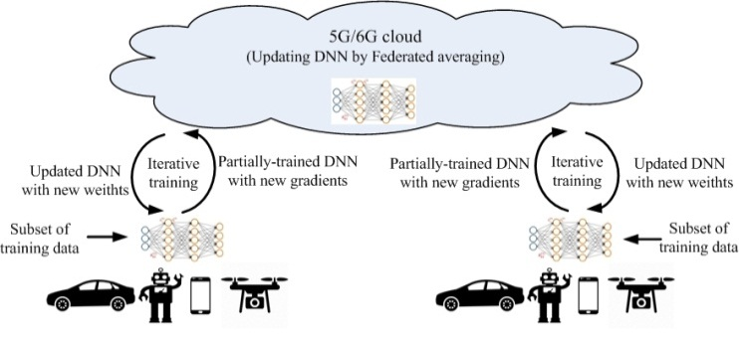
Figure 7.1.1-1. Federated Learning over 5G system
A real-time iterative Federated Learning procedure is illustrated in Figure 7.1.1-2. In the Nth training iteration, the device performs the training based on the model downloaded from the FL training server using the images/videos collected locally. Then the device reports the Nth-iteration interim training results (e.g., gradients for the DNN) to the server via 5G UL channels. Meanwhile, the global model and training configuration for the (N+1)th iteration are sent to the device. When the server aggregates the gradients from the devices for the Nth iteration, the device performs the training for the (N+1)th interation. The federated aggregation outputs are used to update the global model, which will be distributed to devices, together with the updated training configuration.
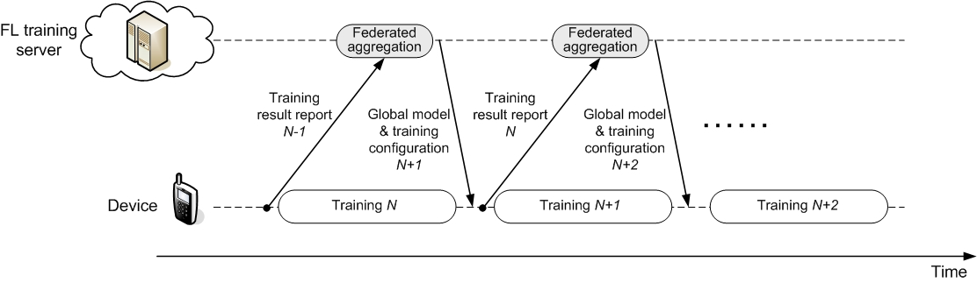
Figure 7.1.1-2. Real-time Federated Learning timeline for image recognition
In order to fully utilizing the training resource at device and minimizing the training latency, the training pipeline shown in Figure 7.1.1-2 requires the training results report for the (N-1)th interation and the global model/training configuration distribution for the (N+1)th interation are finished during the device’s training process for the Nth iteration. The analysis in Section 7.1.6 will be developed based on the processing timeline. In practice, more relaxing FL timeline can also be considered with sacrificing the training convergence speed, which can be called unreal-time FL.
The training time should be minimized since mobile devices may only stay in an environment for a short period of time. Further, considering the limited storage at device, it may not realistic to require the training device to restore a large amount of training data in the memory for a training after it moves outside the environment.
Different from the decentralized training operated in cloud datacenters, Federated Learning over wireless communications systems need to be modified to adapt to the variable wireless channel conditions, unstable training resource on mobile devices and the device heterogenity [10, 32, 34]. The Federated Learning protocol for wireless communications can be depicted in Figure 7.1.1-3 [10, 31-32].
For each iteration, the training devices can firstly be selected. The candidate training devices report their computation resource available for the training task to the FL server. The FL server makes the training device selection based on the reports from the devices and other conditions, e.g. the devices’ wireless channel conditions. After the training devices are selected, the FL server will send the training configurations to the selected training devices, together with global model for training. A training device starts training based on the received global model and training configuration. When finishing the local training, a device reports its interim training results (e.g., gradients for the DNN) to the FL server. In Figure 7.1.1-3, the training device selection is performed and the training configurations are sent to the training devices at the beginning of each iteration. If the conditions (e.g. device’s computation resource, wireless channel condition) are not changed, the training device re-selection and training re-configuration are not needed, i.e. the same group of training devices can participate the training with the same configuration for multiple iterations.
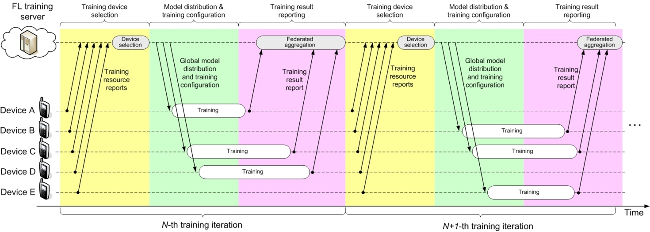
Figure 7.1.1-3. Typical Federated Learning protocal over wireless communication systems

7.1.2 Pre-conditions
The UE runs an application providing the capability of Federated Learning (FL) for the image recognition task.
The FL application on the UE is capable to report its interim training results to the FL server.
The FL server is capable to aggregate the interim training results from the federated UE, form the global model, and distribute the global model for training in the next iteration.
The 5G system has the ability to provide 5G network related information to the FL server.

7.1.3 Service Flows
- The FL server distributes the global model to be federated UEs via 5G network.
- The FL application in a federated UE performs the training based on the local training data set collected by the UE, and then reports the interim training results (e.g., gradients for the DNN) to the FL server via 5G network.
- The FL server aggregates the gradients from the UEs, and updates the global model.
- Redo Step 1) to 3) for the training for the next iteration.

7.1.4 Post-conditions
The AI/ML model for image recognition is trained and converges, and the training accuracy and latency need to be guaranteed.
The FL training task for image recognition can be completed under the available computation and energy resource of the federated UEs. And the consumed the computation, communication and energy resources over the the federated UEs and the FL server are optimized.

7.1.5 Existing features partly or fully covering the use case functionality
It should be noticed that the data rates required by this use case are user experienced data rates, not peak data rates (legacy 5G NR supports 20Gbps DL peak data rate and 10Gbps UL peak data rate). According to the self evaluation results of in [6], 5G NR can provide up to 144.34 DL user experienced data rate and 73.15Mbps UL user experienced data rate. The data rate performance of legacy 5G NR system cannot meet the requirement of this use case.

7.1.6 Potential New Requirements needed to support the use case
As introduced in Section 7.1.1, In order to minimizing the training latency for a real-time Federated Learning for image recognition, the computation resource at device for the training task should be fully utilized, i.e. the training pipeline in Figure 7.1.1-1 is desired to be maintained.
If considering to train a 7-bit CNN model VGG16_BN using 224×224×3 images as training data, Table 7.1.6-1 shows the sum of gradient uploading latency, the federated aggregation latency and the global model downloading latency should be no larger than the GPU computation time at device for one iteration. For different batch sizes, the gradient uploading and the global model downloading for each iteration needs to be finished in [52~162ms], respectively.
Different from the “single-UE latency” considered by previous requirement study [15], what is more essential for synchronous Federated Learning is the latency within which all federated devices can finish the gradient uploading. In other words, all training devices need to finish the gradient uploading within the latency in Table 7.1.6-1, even if multiple training devices are present in a cell.
The size of the 8-bit VGG16_BN model is 132MByte for either the trained gradients or the global model. Hence in order to finish the gradient uploading and the global model downloading within the duration, the required UL and DL data rate are shown in Table 7.1.6.1-1, which are [6.5Gbps to 20.3Gbps] respectively. And it should be noted that 132MByte is the size without compression. The size may be reduced if advanced model/gradient compression techniques can be adopted.
In the legacy requirements to 5G system, e.g. [4], the full coverage is always desired for all UEs. However, the AI/ML model training task may to some extent relax the requirements on continuous network coverage. When a FL server selects the training devices for a Federated Learning task, it can try to pick the UEs in a satisfactory coverage, if they can collect the training data needed. This implies that even in a non-continuous coverage of 5G mmWave, the Federated Learning task can be well carried out. This provides to 5G operators a service better exploring the use of their FR2 spectrum resource.

7.1.6.1 Potential KPI Requirements
The potential KPI requirements needed to support the use case include:
[P.R.7.1-001] The 5G system shall support the functionality to enable real-time Federated Learning for image recognition with DL data rate not lower than [6.5Gbps ~ 20.3Gbps], as given in Table 7.1.6.1-1.
[P.R.7.1-002] The 5G system shall support the functionality to enable real-time Federated Learning for image recognition with UL data rate not lower than [6.5Gbps ~ 20.3Gbps], as given in from Table 7.1.6.1-1.
Table 7.1.6.1-1: Required latency and data rate for Federated Learning
Mini-batch size  (images) | GPU computation time (ms) | Required latency |  | Required data rate
Mini-batch size  (images) | GPU computation time (ms) | for trained gradient uploading (ms) | for global model distribution (ms) | for trained gradient uploading (Gbps) | for global model distribution (Gbps)
64 | 325 | [<162ms] | [<162ms] | [6.5] | [6.5]
32 | 191 | [<95ms] | [<95ms] | [11.1] | [11.1]
16 | 131 | [<65ms] | [<65ms] | [16.2] | [16.2]
8 | 111 | [<55ms] | [<55ms] | [19.2] | [19.2]
4 | 105 | [<52ms] | [<52ms] | [20.3] | [20.3]

7.2 Compressed Federated Learning for image/video processing

7.2.1 Description
Federated learning can be used to train AI/ML models based on number of images and videos generated by cameras in mobiles devices by iteratively exchanging gradient of updating models instead of direct user images and videos. Because this method can utilize images and videos from many users, the performance of a trained AI/ML model can be significantly higher than a stand-alone case. However, the basic federated learning methods can have disadvantages by massive uplink traffics and high computational cost at a mobile device. Therefore, it is beneficial to consider a compressed federated learning (CFL) method, which allows compressed (not full) models to be transferred during a learning period.
Figure 7.2.1-1 shows the essential procedure of compressed federated learning. Compressed federated learning performs a set of the three operation stages iteratively. The three operation stages include the training UE selection, the sparse weight distribution, and the training result reporting stages, while the operations of the first iteration and the last iteration are different from operations in the other iterations.
Each iteration in CFL starts with the training UE selection stage, at which the CFL server selects a set of available users from the candidate users to associate with the same purpose AI/ML model. To the selected users, ready to participate in the learning process because of being an available state, the CFL server transmits the train configuration information. At the next stage, the CFL server sends the sparse global model, which could be an initial version of the AI/ML model in the first iteration. Otherwise, the sparse global model is an aggregated version based on user reporting information.
Then, each UE trains a received model after expanding the spatial model and reports an intermediate training result to the CFL server, where the training result is comprised only of significant value weight gradients for applying a model compression. By doing so, uplink throughout requirement can be significantly reduced in comparison with the basic federated learning method without compression. In the last iteration, I-th iteration, the CFL Server sends ‘train stop message’ to UEs so that the UEs can stop sending its update any longer, and the CFL Server performs fine-tuning by pruning unnecessary nodes. Throughout these multiple iterations from the 1st iteration through the I-th iteration as in the figure, the AI/ML model will be progressively enhanced based on user data in mobile networks at reduced uplink and downlink throughput.
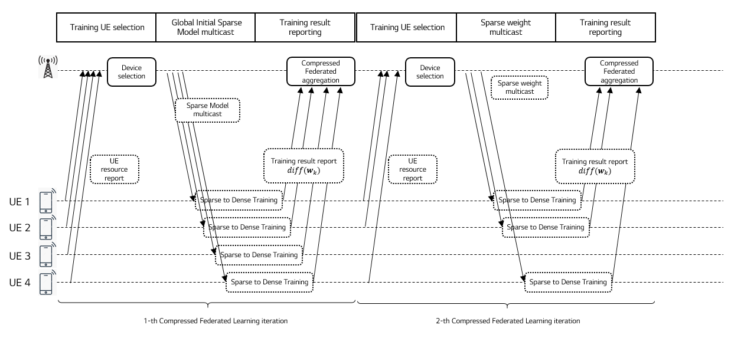
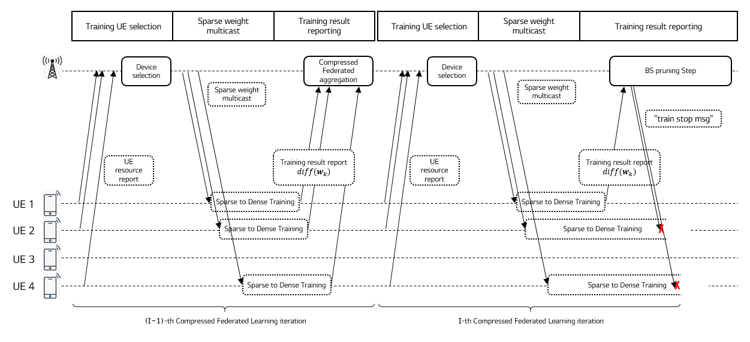
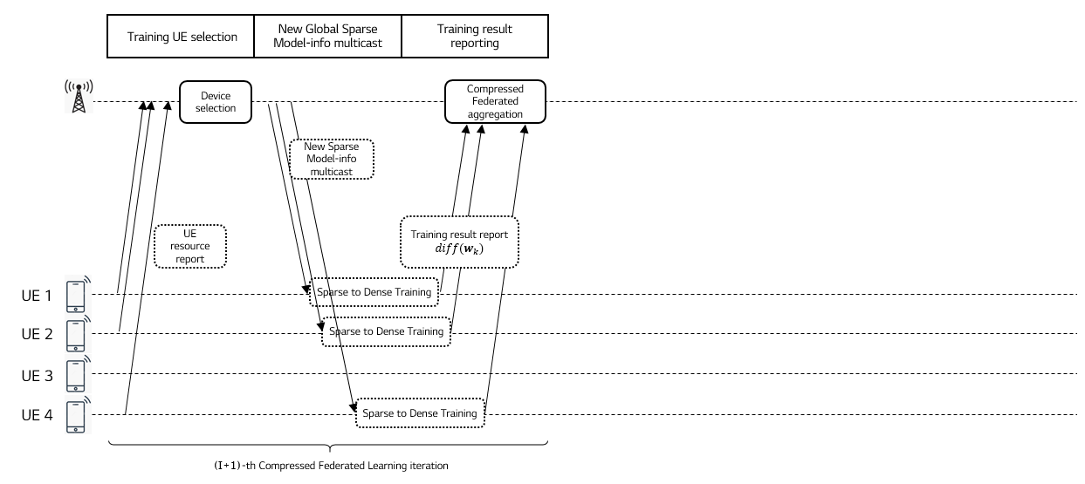
Figure 7.2.1-1. Compressed Federated Learning timeline for image recognition

7.2.2 Pre-conditions
UE can have a computational hardware and algorithm capability to train an AI/ML model such as for an image and video cognition.
UE can send intermediate training results to a CFL server.
A CFL server can select training devices and determine training configuration.
A CFL server can aggregate intermediate training results and generate a sparse global model for the next learning iteration.
A CFL server can distributed a global AI/ML mode to a set of selected users.

7.2.3 Service Flows
Step 1: The CFL server selects the training users from candidate users.
Step 2: The CFL server sends the configuration information to the selected users.
Step 3: The CFL server distributes the initial (or, aggregated) sparse global model to the selected users through a 5G networks.
Step 4: Each UE expands the sparse global model and train the expanded model using its local data. Then, each UE sends only significant value weight gradients to the CFL server.
Step 5: The CFL server aggregates the training results received from the training UEs and update a global model using the aggregated results.
Step 6: Until the AI/ML model reaches saturated performance enhancement, the process runs repeatedly from step 1.
Step 7: Otherwise, the CFL server performs fine-tuning for a global model compression for a global model. This process can applied regularly so as to improve bandwidth and computation resource efficiency before the training finalization.
Finally, the CFL server distributes the new sparse global model to all users which needs the same AI/ML model.

7.2.4 Post-conditions
For a UE prospective, CFL can reduce uplink and downlink throughput requirements for the federated learning process. Also, the computational complexity in UEs can be significantly reduced because of enabling a compressed model.

7.2.5 Gap analysis
Latency analysis for gradient uploading and the global model downloading for image recognition
AI/ML model training data for CFL is a new type of traffic. Consider CFL to train a 8-bit CNN VGG16 model with 224x224x3 images. Table 7.2.5-1 shows that the single GPU computation time should be larger than the addition of gradient uploading latency and global model downloading latency.
Table 7.2.5-1: GPU computation time for different mini-batch sizes
for Compressed Federated Learning
Mini-batch size  (images) | GPU computation time (ms) | Required latency for trained gradient uploading (ms) | Required latency for global model distribution (ms)
64 | 325 | <162ms | <162ms
32 | 191 | <95ms | <95ms
16 | 131 | <65ms | <65ms
8 | 111 | <55ms | <55ms
4 | 105 | <52ms | <52ms

Data rate analysis for gradient uploading and the global model downloading for image recognition
Table 7.2.5-2 shows the required data rate for gradient uploading and global model downloading for the above 8-bit VGG16 model when CFL is applied. We calculated the required data rate based on Table 1 in [39], in which the pruning size of the 8-bit VGG16 model can be reduced 13 times from the original size of 138 Mbyte. It is noteworthy that 13 times model compression gives almost no accuracy degradation for the 8-bit VGG16 model. If we assume that the minibatch size is 4, the uplink required rate is compressed trained parameter size * 8 / (GPU computation time / 2) = (138 / 13) Mbyte * 8 bits / (105ms / 2) = 1.56Gbps which is same to the downlink require rate. For 7 UE cases, the total uplink required data can be 1.56Gbps * 7 = 11Gbps, which is higher than the NR UL peak data rate (10Gbps). However, we remind that it could be 143Gbps for federated learning. Therefore, a model compression approach, such as CFL should be considered for the federated learning process.
Table 7.2.5-2: Required data rate for gradient uploading and global model downloading
Required data rate = compressed trained parameter size * 8 / (GPU computation time / 2)
Mini-batch size  (images) | Required UL data rate for trained gradient uploading (Gbps) | Required DL data rate for global model distribution (Gbps)
64 | 0.50 | 0.50
32 | 0.86 | 0.86
16 | 1.25 | 1.25
8 | 1.48 | 1.48
4 | 1.56 | 1.56

Latency analysis for training device selection and training configuration
The CFL Server should notice training device and configuration information in [1]ms.

7.2.6 Potential New Requirements needed to support the use case
[P.R.7.2.6-001] The 5G system shall support the UE to report its trained gradient for each iteration of Compressed Federated Learning within [52~162]ms.
[P.R.7.2.6-002] The 5G system shall support the CFL server to distribute the global model for each iteration of Compressed Federated Learning within [52~162]ms.
[P.R.7.2.6-003] The 5G system shall support UL unicast or multicast transmission with [0.5]-[1.56]Gbps data rates and the communication service availability not lower than [99.999%] for reporting the trained gradients for Compressed Federated Learning.
[P.R.7.2.6-004] The 5G system shall support DL multicast transmission with [0.5]-[1.56]Gbps data rates and the communication service availability not lower than [99.999%] for distributing the global model for Compressed Federated Learning.

7.3 Data Transfer Disturbance in Multi-agent multi-device ML Operations

7.3.1 Description
A brief story of machine learning is nothing but a computer (that has no or limited imprinted programs for a certain task) exploiting its own capability (“performance”) towards a certain task using data (“experience”). There are several criteria to classify the types of Machine Learning depending on the characteristics of the method used. This use case is intended to describe a case of multi-agent multi-device ML operations with heavy data (i.e., the data size is huge) when there is partial or total disturbance for data collection/transfer (e.g., privacy regulation or temporary technical limitation like shortage of network resources or temporary failure). As depicted in Fig. 7.3.1-1, this use case, Part I, is specifically related to a scenario that there are multiple agents and multiple collecting devices where the devices can perform ML operations, not necessarily in full but as much as they can (i.e., functional splitting is possible between a device and one or more learning agents).
NOTE: MBL (Multiple Batch Learning) is one of examples that belong to this scenario, which is known to be better performing when the data is too big for a single agent/server to handle.

Figure 7.3.1-1: Functional relation between multiple devices (M₁, M₂, …, M_{k} in the form of UE) and multiple agents (A1, A2, …, An). Data sharing between any pair of agents, if exists, is not disturbed/restricted. In “sharing scenario”, the data would generally be deep-processed data as opposed to simply pre-processed or raw data.
In the age that privacy was not affecting the flow of data from the source to the learning agent (e.g., a computer), the expected performance is the outcome of all possible computational considerations of the data collected (e.g., refer to the green solid curve of Fig. 7.3.1-2). However, if there is a certain level of disturbance in data collection, the achievable performance toward the given task would not be as good as the one with no such disturbances (refer to the gap between the green solid curve and blue dotted curve in the same figure). Some examples of such disturbances include:
- privacy regulations, such as EU’s General Data Protection Regulation (GDPR) or California Consumer Privacy Act (CCPA);
- limited capability of transport-layers, such as lack of network resources (e.g., radio resources due to temporal degradation, higher noise/interference level, highly crowed situations, partial/total break-down, and so on) preventing input data from being delivered in time:
  - case 1: a portion of input data delivered in time, if any, is still useful (i.e., entropy can get increased/ improved)
  - case 2: a portion of input data delivered in time, if any, is not useful (i.e., it’s not enough to get entropy increased/ improved)
NOTE: “input data” can be raw data, trained data, or an intermediate combination of them that is to be transferred from a UE (or a group of UEs, respectively) to one of learning agents.
It is commonly understood that the more data a learning model utilizes the better performance the learning model can achieve (assuming the data are reasonably independent from statistics perspectives or sufficiently correctly labelled (when supervised learning is concerned)), if not too large. However, if there is some disturbance in data collection/transfer, such as regional regulations or technical limitations (as described above), the expected performance would not be as good as the case without the disturbance (the vertical difference in Fig. 7.3.1-2); in addition, it is expected that the learning model would need to take more time to accumulate “experience” with the reduced feeding-rate of learning data caused by such disturbance (the horizontal difference in Fig. 7.3.1-2).
Figure. 7.3.1-2: Performance gap vs. experience of learning for a given task: (1) with disturbance of input data collection/transfer (green, solid) (2) without disturbance of input data collection/transfer (blue, dotted).
Fig. 7.3.1-3 shows an example of possible preparation action that can be taken in UE side if some predictive information can be made available when disturbance is about to happen. In the figure, the preferred deadline for input data transfer is 1 sec (t = t₀+1) with the amount of useful “input data” 3 bits in which two different kinds of scheduling are given: (a) is imperfect scheduling whereas (b) is good scheduling as an example, respectively. In reality, the transfer payload type is not limited to “input data” for learning agent(s) and it can also be applied to “learning model” transfer. The transfer direction can be “uplink” (e.g., for input data transfer) or “downlink” (e.g., for model distribution/transfer). This simplified example is intended to explain the justification why new technical requirements would be needed especially when some disturbance exists (e.g., by regulatory or technical causes).

Figure 7.3.1-3: Example of disturbance of input data transfer within a preferred deadline of 1 sec (t = t₀+1) with the amount of useful “input data” 3 bits (as an example): (a) For the 3-bit input data amount (“trapezoid” in grey), it takes 2 sec with “imperfect scheduling” (b) For the 3-bit input data amount (“rectangle” in grey), it takes 1 sec with “good scheduling” where the network resources can be assigned to others (other UEs) during (t₀+1, t₀+2).
Given the regulatory disturbance, it is intended to minimize (or to prepare to minimize) the impact on transfer caused by technology (e.g., scheduling and/or information necessary for 3GPP entity to perform “good scheduling”). The expected requirements and service flow description are as follows.

7.3.2 Pre-conditions
There are three UEs M1, M2 and M3 (computers or learning machines in the form of a UE).
There are two learning agents/servers in the cloud.
UEs M1, M2 and M3 collect data and they process the data for learning they have collected or are collecting, if available, but they don’t have to complete the processing due to limited computational capability.
Each UE (M1, M2 and M3, respectively) has a functional splitting point negotiated with their agent(s) regarding data processing for learning.
Agent A1 working with agent A2 for a task can share its outcome with agent A2 so that the outcome from agent A2 can jointly improve the outcome, if possible, which is possibly better than A1’s individual outcome and A2’s individual outcome.
UE M1 and UE M2 are located in Area 1 of some jurisdiction that doesn’t restrict collecting certain type of data.
Initial connections:
UE M1 is connected to agent A1 (via eNB, ng-eNB, or gNB) when data connection is necessary (e.g., when needed to upload some data or when needed to download some model).
- Agent A1 provides UE M1 with an alternative agent (i.e., Agent A2) for the use of disturbance, which is (one of) participating agent(s) that agent A1 shares data. [See Description clause for typical types of data]
- UE M1 is transferring learning data to agent 1.
UE M2 is connected to agent A1.
- Agent A1 provides UE M2 with an alternative agent (i.e., Agent A2) for the use of disturbance, which is (one of) participating agent(s) that agent A1 shares data.
- UE M2 is transferring learning data to agent 1.
UE M3 is connected to agent A2.
- Agent A2 provides UE M3 with an alternative agent (i.e., Agent A1) for the use of disturbance, which is (one of) participating agent(s) that agent A2 shares data.
- UE M3 is transferring learning data to agent 2.

Figure 7.3.2-1: Initial connections b/w mobile devices and agents

7.3.3 Service Flows
While transferring learning data to agent A1, UEs M1 and M2 move into Area 2 of some jurisdiction that has restrictive regulations for agent A1 to collect data from UEs within a specific area (or outside a specific area).
As a result, UEs M1 and M2 are restricted to transfer their data to agent 1.
While transferring learning data to agent A2, UE M3 moves into a different area where 5G system provides prior notification on possible traffic congestion which might disturb UE M3 from keeping transferring learning data to agent A2.
UE M3 makes a selection of an action policy: (action 1) to defer the transfer or (action 2) to request to speed up the transfer.
- If action 1 is selected, UE M3 will resume transferring when it becomes available (not the main focus of this use case);
- If action 2 is selected, UE M3 will be able to (2a) more urgent/useful segment of data (send priority one over the other) and/or (2b) request more network resources to use.
Modified connections (UEs M1 and M2):
UE M1 attempts to get connected to agent A2 based on the information that agent A1 has provided when initially connected.
- UE M1 keeps transferring the data to agent A2
- Agent A1 can share the collected data or its processed form of data, vice versa
UE M2 is connected to agent A2
- UE M1 keeps transferring the data to agent A2
- Agent A1 can share the collected data or its processed form of data, vice versa
UE M3 is allowed to use more network resources to speed up the transfer to agent A2 (case 2b).
Figure 7.3.3-1: Modified connections b/w mobile devices and agents

7.3.4 Post-conditions
NOTE: Post-conditions are described in two different aspects (communication aspect and ML operation aspect).
Table 7.3.4-1: Post-conditions in communication aspect and ML operation aspect.
Post-condition | Description in Communication aspects | Description in AI/ML operation aspects
#1 | UE M1 and UE M2 can continue to transfer data. | Agent A1 and Agent A2 could continue to improve the outcome (e.g., learning model) even when disturbance happens.
#2 | UE M3 can (1) send priority portion of data over the other and/or (2) complete the transfer or maximize the transfer completion ratio before congestion happens. | Agent A2 could minimize the impact of temporal traffic congestion as UE M3 (1) transferred priority portion of data and (2) transferred more data to Agent A2 before traffic congestion happens and disturbs.

7.3.5 Existing features partly or fully covering the use case functionality

7.3.6 Potential New Requirements needed to support the use case
In Table 7.3.6-1, the service-level implications of AI/ML operation are summarized in the third column of Table 7.3.6-1, which are used to derive high-level potential service requirements in communication layer in order to support the AI/ML operation.
Table 7.3.6-1: High level service requirements (in Communication and AI/ML operation aspects)
PR | Potential Requirements in Communication aspects | Implications in AI/ML operation aspects (Note 1)
[PR.7.3-001]  (Note 2) | Editor’s Note: Below is an intermediate formulation of PR in Communication aspects from this AI/ML operation aspect:  5G system shall be able to provide a suitable standardized interface for a learning agent to enable exposure of the AI/ML operations service to support the AI/ML application of the learning agent to provide the AI/ML application of UE with necessary information that can minimize communication disruption.  Editor’s Note: Further performance requirements are FFS | From this Use Case, what is required in AI/ML aspect is “A learning agent is able to provide a UE with information on candidate participating learning agents.”
[PR.7.3-002] | Editor’s Note: Below is an intermediate formulation of PR in Communication aspects from this AI/ML operation aspect:  5G system shall be able to provide a suitable standardized interface for a UE to enable exposure of the AI/ML operations service to support the AI/ML application of the UE to provide the AI/ML application of a learning agent with necessary information that can share the learning task splitting point.  Editor’s Note: Further performance requirements are FFS | From this Use Case, what is required in AI/ML aspect is “A UE is able to inform a learning agent of learning task splitting point.”
[PR.7.3-003]  (Note 3) | 5G system shall provide a means to supply prediction info (e.g., on traffic congestion, the related geographical area/spot) so that a UE or learning agent can minimize the impact of learning data transfer disturbance.
[PR.7.3-xxx]  (Note 4)  (Note 5) |  | From this Use Case, what is required in AI/ML aspect is “The learning agent in the cloud or the learning agent in a UE is able to be aware of task splitting related info”. From this implication, PR in the left is derived.
[PR.7.3-xxy] |  | From this Use Case, what is required in AI/ML aspect is “The learning agent in the cloud or the learning agent in a UE is able to be aware of the disturbance that has happened in the counterpart (i.e., entity/UE that was transferring learning-related data to the learning agent).”
NOTE 1: From this Use Case, the AI/ML aspects/implications are summarized based on which the PR in the left-hand column is formulated
NOTE 2: It is one of possible scenarios that the learning agent can be located within MNO’s network (e.g., for learning-based signal processing optimization for RAN entity (e.g., gNB)), which operation is outside the scope of 3GPP but is used for optimization in RAN operations.
NOTE 3: Disturbance by both jurisdiction (e.g., regional laws that prohibit personal data from being transferred) or by technical difficulty (e.g., traffic congestion for transferring heavy data for AI/ML) are considered in prediction.
NOTE 4: possible scenarios for secure sharing include federated learning and multi-agent multi-device learning.
NOTE 5: the learning agent described in this requirement is in a UE or in the cloud.

Editor’s Note: NOTEs appeared inside the table is placed with the PR, which is temporary, and will be holistically organized to the latter part of the table later.
Table 7.3.6-2 provides a summary of performance requirements for different usage scenarios. The required KPIs are dependent upon usage scenarios, especially on the task splitting points of given tasks even under the same usage scenarios. The calculation procedure can be referred to in [36-39].
For an example of image size 32 x 32 x 3 (32 wide, 32 high, 3 depth/colour channels), the weight is 3072; for images with more respectable size 200 x 200 x 3 = 120,000 weights; For a simple ConvNet for CIFAR-10 classification, the regular Neural Network architecture is INPUT→CONV→RELU→POOL→FC (Input layer, convolutional layer, pooling layer and fully-connected layer).
Example 1: 32 x 32 x 3 image and six 5 x 5 filters produce a new image of size 28 x 28 x 6! = 564,480
Example 2 (Language understanding): BERT_{base} with L = 12 (layers), H = 768 (hidden size), A = 12 (heads). The number of parameters = 110M
Example 3 (Language understanding): BERT_{large} with L = 24 (layers), H = 1024 (hidden size), A = 16 (heads). The number of parameters = 340M
Example 4: [39] for 8-bit VGG16 Pruned, it can reduce the original size (VGG-16 Ref) of 138MB by a factor of (1/13), which size will be approximately 10.3MB. Thus, 10.3MB / (GPU time / 2) ≒ 196MB/sec = 1.56Gb/sec.
Others: Compared to raw data, the latency requirement for trained data is considered more rigorous as it belongs to the category of data that is more readily usable by the related machine (e.g., by UE, or by agent).
Table 7.3.6-2: Performance requirements (KPI vectors)
 | Description in Communication aspects |  |  | Description in AI/ML operation aspects (all inclusive) |  |  | Range (NOTE 2)
 | End-to-end latency (NOTE 1) | Data rate (per UE) (NOTE 1) | Service interruption time | End-to-end latency | Data rate | Service interruption time | Range (NOTE 2)
Learning data (raw data) at Service robot at initial launch (NOTE 4) | < 100 ms | UL: < [1.5] Gbps  DL: [tbd] |  | < 10 s |  | < [100] ms | < [500] km
Learning data (trained data) at Service robot at initial launch (NOTE 4) | < 50 ms | UL: < [50] Mbps  DL: [tbd] |  | < 10 s |  | < [100] ms | < [500] km
Learning data (raw data) at Service robot in routine operation (NOTE 4) | < 100 ms | UL: 700 Mbps  DL: [tbd] |  | < 1 s |  | < [100] ms | < [200] km
Learning data (trained data) at Service robot in routine operation (NOTE 4) | < 50 ms | UL: 50 Mbps  DL: [tbd] |  | < 1 s |  | < [100] ms | < [200] km
Remote control of robots (type 1) (NOTE 3) | < [5] ms | UL: < [700] Mbps  DL: [1] Mbps |  | < [10] ms |  | < [10] ms | < [3] km (aerial, outdoor);  < [500] m (indoor)
Remote control of robots (type 2) (NOTE 3) | < [20] ms | UL: < [700] Mbps  DL: [1] Mbps |  | < [25] ms |  | < [100] ms | < [tbd] km
NOTE 1: The end-to-end latency and data rate are dependent on which learning model the UE and agent have selected to use. The required data rate varies depending on the task splitting point between UE and the learning agent. The suggested number in this table is based on the maximum possible value (e.g., non-splitting cases or on splitting stage at pooling).
NOTE 2: Range is between a Service Robot (as a UE) and the learning agent (including candidate learning agent). For routing operation, the range is typically smaller than that for initial launch of a task/job site.
NOTE 3: For robot control, only two categories are suggested. A refined use of more categories is FFS. Type 1 requires more rigorous KPIs (e.g., helicopter, humanoid robots).
NOTE 4: In these scenarios, service robots are assumed to have basic robotics mobility.

7.4 Group Performance “Flocking” Use Case

7.4.1 Description
A new ‘service enabler’ is introduced that allows a service provider to achieve effective performance for the entire group of devices. The term ‘Flock’ stands for a group that has performance requirements that consider the performance ‘as a team’ as opposed to the ‘total’ or results of the ‘best performers.’
The example of a Flock provided in this use case (an application of this service enabler) is for Synchronous Federated Learning. Please note that “Flocking” is a general service enabler. Synchronous Federated Learning is discussed here because (a) it is a concrete application of the “Flocking” service enabler, (b) the topic of this study is model and AI data set communication. To explain and motivate “Flocking” we need an example, and fortunately this application is directly within the scope of the FS_AMMT study.
Synchronous federated learning involves a set of contributing terminals, as described in clause 7 of this TR. In a federation, a hierarchy exists that provides an effective delegation of work and information. This federation functions as if it were a single (non-federated) system to the extent that the distributed components can operate within the same expectations. For synchronous federated learning some number of the federation’s components lag, these become stragglers. Information and function availability of the whole federation suffers when the performance of individual components fall significantly behind the others as the entire group should complete the iteration.
Synchronous federated learning works best by eliminating bias – allowing diverse users and devices to participate and bring to the learning task diversity of input data, as the users will have different attributes. It is important not to merely focus on the ‘best performing devices’ in the federation and drop the rest. It may increase the performance in terms of time to iterate the synchronous federated learning task to drop stragglers, but this will reduce the diversity of the data set and introduce bias.
Where group performance is defined by the weakest member (as in the slowest flying bird), we term this a “flock.” The 5GS normally considers performance objectives and QoS for individual communicating terminals. Here, the 5GS QoS objective relates to the entire set of terminals making up the federation, the “flock” of UEs.

7.4.2 Pre-conditions
A set of UEs that participated in federated learning exists. These UEs have registered with a PLMN and operate in a federation to perform federated learning tasks.
The federated learning service provider “Avian” organizes the work of these UEs so that repeated iterations of training will occur over time.
It is assumed that the UEs provide federated learning input using the same network resources (e.g. network slice) and that the policy for this network communication is distinct from the policy for other activities that the UE performs. In this way, the network can adjust the QoS policy for federated learning communication for individual UEs without any service impact except to the federated learning service.

7.4.3 Service Flows
As the performance and quality of the output of the entire set of UEs is bounded by the performance of the weakest members of the group, Avian provides the 5GS with a policy identifying the reporting interval for which different iterations should conclude. Avian also provides reports on the progress of different UEs as they proceed. The 5GS is then in a position to adjust the QoS policies of some UEs to allocate more resources for those UEs that lag, and less resources for those that are ahead of the flock. The resource allocated to UE is maintained for at least one iteration. The 5GS can inform Avian of any additional UEs with good communication performance (e.g. due to radio resources) and/or existing UEs whose connection has degraded to a level which is no longer sufficient for FL tasks. This enables Avian to determine when to add new UEs into the flock or remove existing UEs from the flock.
NOTE: While it is clear that the speed with which training occurs and reports are generated by UEs is only partially bounded by communication, it is assumed that the communication resources available to the UE is a significant contributor to the time it requires to complete a training iteration.
When a new UE joins the federation, it will register with Avian. Avian can then notify the 5GS (by means of a standard interface) of this addition. This interface is depicted logically in Figure 7.4.3-1 below.
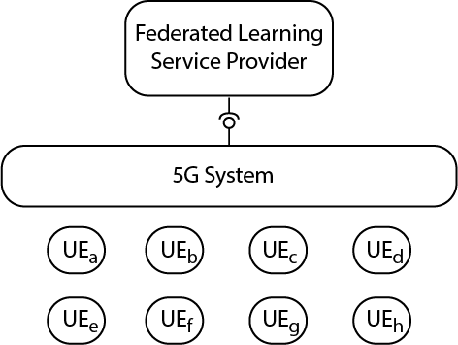
Figure 7.4.3-1: 5G Service Enabler interface, Example for Synchronous Federated Learning
Similarly, when a UE leaves the federation, the 5GS is notified. This allows the 5GS to modify the policy to balance the QoS policy to achieve the most consistent performance across the involved UEs.

7.4.4 Post-conditions
The ‘flock’ of UEs performs consistently. The slowest UEs (e.g. at producing a report after an iteration of a federated learning task) achieve an improved performance. The fastest UEs (e,g. also at producing a report after a federated learning task) do not need as much network resources (higher QoS), so the 5GS can reduce the QoS guarantees for these, and thereby saves these resources. The overall result is more efficient for the Synchronous Federated Learning service and for the network operator.
Sometimes, some UEs fall out of the ‘flock’ because their performance does not improve or falls below a certain level. These UEs with inadequate communication performance (e.g. due to radio conditions) may be removed.
Conversely, some UEs may become candidates to add to the ‘flock’ due to their excellent performance as well as other aspects (e.g. proximity to where the group task is being performed, excellent radio performance, etc.) These UEs may be added to the group.
NOTE: The removal of UEs whose performance is too poor and the addition of UEs whose performance is adequate to the “flock” has broad applicability to maintaining a well-performing group, even to ‘asynchronous federated learning.’

7.4.5 Existing features partly or fully covering the use case functionality
The existing QoS features controlled by the network with reconfigurable policy provide necessary but not sufficient functionality to support the use case.

7.4.6 Potential New Requirements needed to support the use case
[PR7.4.6-1] The 5G system shall support ‘aggregated performance’ for a group of UEs where the worst performing member defines the performance of the entire group. The 5G system should achieve performance for the entire group so as to avoid members achieving either significantly less or more performance than others in the group.
Editor’s Note: It is FFS by what criteria the 5G System determines the performance of a member of the group and determines the ‘worst performing member.’
[PR7.4.6-2] The 5G system shall be able to maintain a required QoS for each member in a group for at least one iteration. The 5G system shall be able to inform a service provider of new UEs with good performance (e.g. excellent radio resources) and/or of existing UEs whose performance (e.g. connection) has degraded to a level in which they can no longer perform sufficiently in the group. This enables the service provider to add UEs to the group or remove existing UEs from the group.

8 Consolidated potential requirements

9 Conclusion and recommendations

Annex A:
Introduction to AI/ML models

A.1: AI and ML
Artificial Intelligence (AI)/Machine Learning (ML) is being used in a range of application domains across industry sectors, realizing significant productivity gains. In particular, in mobile communications systems, mobile devices (e.g. smartphones, smart vechicles, UAVs, mobile robots) are increasingly replacing conventional algorithms (e.g. speech recognition, mechine translation, image recognition, video processing, user behavior prediction) with AI/ML models to enable applications like enhanced photography, intelligent personal assistants, VR/AR, video gaming, video analytics, personalized shopping recommendation, autonomous driving/navigation, smart home appliances, mobile robotics, mobile medicals, as well as mobile finance. As forecast by Gartner [44], more than 80% of enterprise IoT projects will include an AI component by 2022, up from only 10% today.
Artificial Intelligence (AI) is the science and engineering to build intelligent machines capable of carrying out tasks as humans do, defined by John McCarthy in 1956. The catagorization of AI approaches can be illustrated in Figure A.1-1 [25].
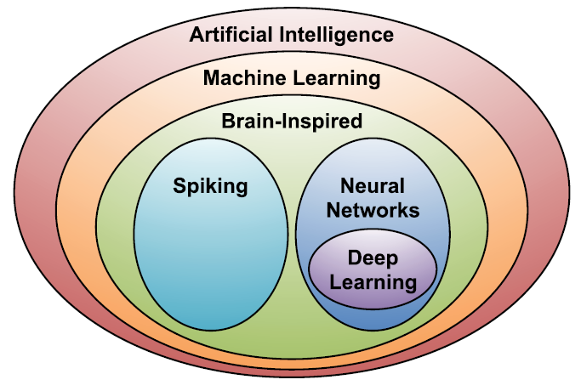
Figure A.1-1. Catagorization of AI/ML approaches (figure adopted from [25])
Within AI is a large subfield called machine learning (ML), which was defined in 1959 by Arthur Samuel as the field of study that gives computers the ability to learn without being explicitly programmed. Instead of the laborious and hit-or-miss approach of creating a distinct, custom program to solve each individual problem in a domain, a single ML algorithm simply needs to learn, via a processes called training, to handle each new problem [25]. Many ML methodologies as exemplified by decision tree, K-means clustering, and Bayesian network have been developed to train the model to make classifications and predictions, based on the data obtained from the real world [19].

A.2 Deep neural network
Within the ML field, there is an area that is often referred to as brain-inspired computation, which is a program aiming to emulate some aspects of how we understand the brain to operate. Since it is believed that the main computational elements a human brain are 86 billion neurons, the two subareas of brain-inspired computation are both inspired by the architecture of a neuron [25], as shown in Figure A.2-1 (a).
Compared to spiking computing approaches, e.g. [3], the more popular ML approaches are using “neural network” as the model. Neural networks (NN) take their inspiration from the notion that a neuron’s computation involves a weighted sum of the input values. But instead of simply outputing the weighted sum, a NN applies a nonlinear function to generate an output only if the inputs cross some threshold, as shown in Figure A.2-1(a). Figure A.2-1(b) shows a diagrammatic picture of a computational neural network. The neurons in the input layer receive some values and propagate them to the neurons in the middle layer of the network, which is also called a “hidden layer”. The weighted sums from one or more hidden layers are ultimately propagated to the output layer, which presents the final outputs of the network [25].
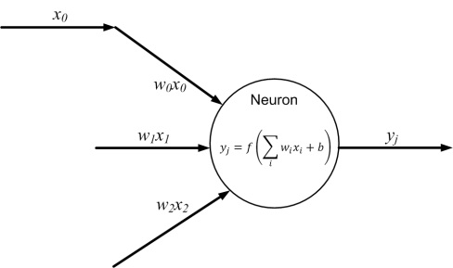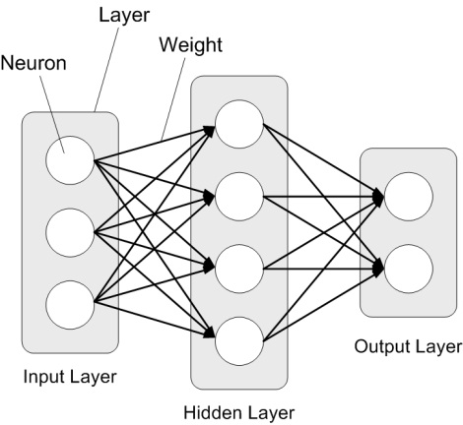
- (b)
Figure A.2-1. Architecture of neuron and neural network
Neural networks having more than three layers, i.e., more than one hidden layer are called deep neural networks (DNN). In contrast to the conventional shallow-structured NN architectures, DNNs, also referred to as deep learning, made amazing breakthroughs since 2010s in many essential application areas because they can achieve human-level accuracy or even exceed human accuracy. Deep learning techniques use supervised and/or unsupervised strategies to automatically learn hierarchical representations in deep architectures for classification [26]. With a large number of hidden layers, the superior performance of DNNs comes from its ability to extract high-level features from raw sensory data after using statistical learning over a large amount of data to obtain an effective representation of an input space [25]. In recent years, thanks to the big data obtained from the real world, the rapidly increased computaion capacity and continuously-evolved algorithms, DNNs have become the most popular ML models for many AI applications.

A.3 Training and inference
Training is a process in which a AI/ML model learns to perform its given tasks, more specifically, by optimizing the value of the weights in the DNN. A DNN is trained by inputting a training set, which are often correctly-labelled training samples. Taking image classification for instance, the training set includes correctly-classified images. When training a network, the weights are usually updated using a hill-climbing optimization process called gradient descent. The gradient indicates how the weights should change in order to reduce the loss (the gap between the correct outputs and the outputs computed by the DNN based on its current weights). The training process is repeated iteratively to continuously reduce the overall loss [25]. Until the loss is below a predefined threshold, the DNN with high precision is obtained.
There are multiple ways to train the network for different targets. The introduced above is supervised learning which uses the labeled training samples to find the correct outputs for a task. Unsupervised learning uses the unlabeled training samples to find the structure or clusters in the data. Reinforcement learning can be used to output what action the agent should take next to maximize expected rewards. Transfer learning is to adjust the previously-trained weights (e.g. weights in a global model) using a new training set, which is used for a faster or more accurate training for a personalized model [25].
After a DNN is trained, it can perform its task by computing the output of the network using the weights determined during the training process, which is referred to as inference. In the model inference process, the inputs from the real world are passed through the DNN. Then the prediction for the task is output, as shown in Figure A.3-1. For instance, the inputs can be pixels of an image, sampled amplitudes of an audio wave or the numerical representation of the state of some system or game. Correspondingly, the outputs of the network can be a probability that an image contains a particular object, the probability that an audio sequence contains a particular word or a bounding box in an image around an object or the proposed action that should be taken [25].
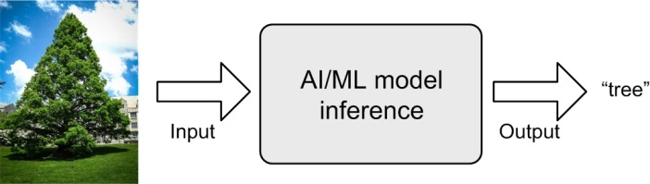
Figure A.3-1. Example of AI/ML inference
The performance of DNNs is gained at the cost of high computational complexity. Hence more efficient compute engines are often used, e.g. graphics processing units (GPU) and network processing units (NPU). Compared to the inference which only involves the feedforward process, the training often requires more computation and storage resources because it involves also the backpropagation process [10].

A.4 Widely-used DNN models and algorithms
Many DNN models have been developed over the past two decades. Each of these models has a different “network architecture” in terms of number of layers, layer types, layer shapes (i.e., filter size, number of channels and filters), and connections between layers [25]. Figure A.4-1 presents three popular structures of DNNs: multilayer perceptrons (MLPs), convolution neural networks (CNNs), and recurrent neural networks (RNNs). Multilayer perceptrons (MLP) model is the most basic DNN, which is composed of a series of fully connected layers [41]. In a fully conncected layer, all outputs are connected to all inputs, as shown in Figure A.4-1. Hence MLP requires a significant amount of storage and computation.
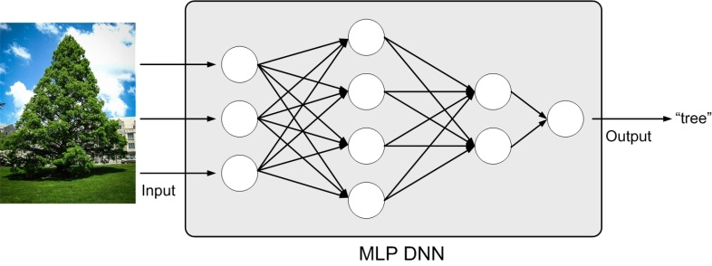
Figure A.4-1. MLP DNN model
An approach to limiting the number of weights that contribute to an output is to calculate the output only using a function of a fixed-size window of inputs. An extremely popular window-based DNN model uses a convolution operation to structure the computation, hence is named as convolution neural network (CNN) [25]. A CNN is composed of multiple convolutional layers, as shown in Figure A.4-2. Applying various convolutional filters, CNN models can capture the high-level representation of the input data, making it popular for image classification [7] and speech recognition [42] tasks. In recent years, the modern CNN models have dramatically improved the performance of image classification tasks (e.g., AlexNet [7], VGG network [8], GoogleNet [9], ResNet [18], MobileNet [19]), as shown in Figure A.4-3 [25].
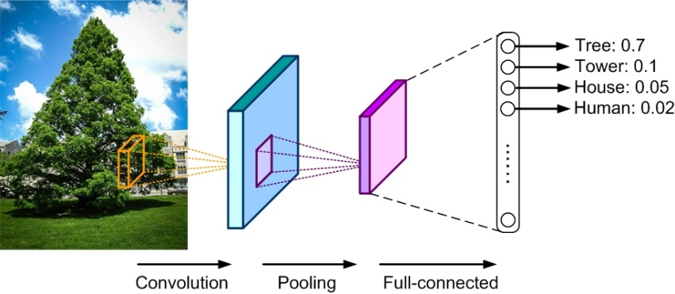
Figure A.4-2. CNN model

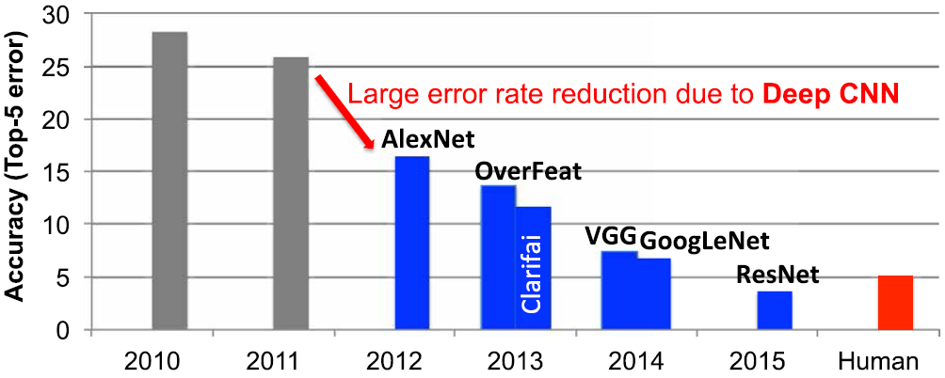
Figure A.4-3. Image classification improvements made by CNN models (Figure adopted from [25])
Recurrent neural network (RNN) models are another type of DNNs, which use sequential data feeding. The input of RNN consists of the current input and the previous samples. Each neuron in an RNN owns an internal memory that keeps the information of the computation from the previous samples. As shown in Figure A.4-4, the basic unit of RNN is called cell, and further, each cell consists of layers and a series of cells enables the sequential processing of RNN models. RNN models have been widely used in the natural language processing task on mobile devices, e.g., language modeling, machine translation, question answering, word embedding, and document classification.
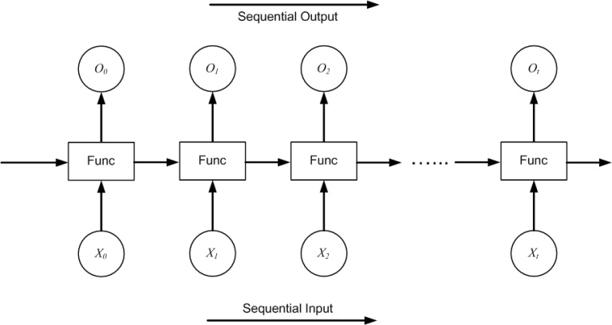
Figure A.4-4. RNN model
Deep reinforcement learning (DRL) is not another DNN model. It is composed of DNNs and reinforcement learning [43]. As illustrated in Figure A.4-5, the goal of DRL is to create an intelligent agent that can perform efficient policies to maximize the rewards of long-term tasks with controllable actions. The typical application of DRL is to solve various scheduling problems, such as decision problems in games, rate selection of video transmission, and so on.
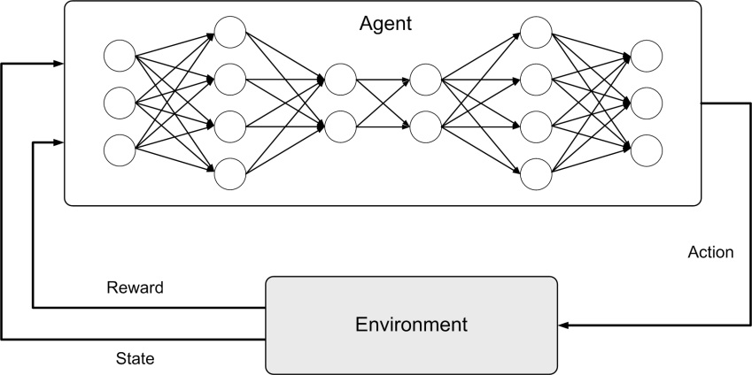
Figure A.4-5. Reinforcement learning

Annex B:
General principle of split AI/ML operation between AI/ML endpoints
In recent years, the AI/ML-based mobile applications are increasingly computation-intensive, memory-consuming and power-consuming. Meanwhile end devices usually have stringent energy consumption, compute and memory cost limitations for running a complete offline AI/ML inference onboard. Hence many AI/ML applications currently intent to offload the inference processing from mobile devices to internet datacenters (IDC). Nowadays, even photos shot by a smartphone are often processed in a cloud AI/ML server before shown to the user who shot them. However, the cloud-based AI/ML inference tasks needs to take the following factors into account:
- Computation pressure at IDCs
As the estimates in [44], by 2021, nearly 850ZB data will be generated by end devices per year, whereas the global IDC traffic can only reach 20.6ZB. That means most of the data can only be left at network edge (i.e. devices and MEC) for AI/ML processing.
- Required data rate and latency
Increasing number of AI/ML applications are requiring a high data rate meanwhile a low latency for communications between devices and the network, e.g. VR/AR, automatic driving, remote-controlled robotics. According to the estimates in [44] on device-initiated traffic, offloading all the data to cloud servers for AI/ML inference would consume excessive uplink bandwidth. This introduces challenging requirements on mobile communications system capacity, including for the 5G system.
- Privacy protection requirement
The sensing/perception data supporting the inference in the cloud server often carry privacy of the end users. Different types of privacy protection problems need to be considered in case of either processing the data at the device or reporting it to the cloud/edge server. Compared to reporting it to the server, keeping the raw data at the device can reduce the pressure of privacy protection at the network side.
Hence in many cases, the split AI/ML inference over device and network are required, to enable the AI/ML applications with conflicting requirements which are computation-intensive, energy-intensive as well as privacy-sensitive and delay- sensitive. Many references [10-14] have shown that processing AI/ML inference with device-network synergy can alleviate the pressure of computation, memory footprint, storage, power and required data rate on devices, reduce end-to-end latency and energy consumption, and improve the end-to-end accuracy and efficiency when compared to the local execution approach on either side.
The scheme of split AI/ML inference can be depicted in Figure B.1-1. The AI/ML operation/model is split into multiple parts according to the current task and environment. The intention is to offload the computation-intensive, energy-intensive parts to network endpoints, whereas leave the privacy-sensitive and delay- sensitive parts at the end device. The device executes the operation/model up to a specific part/layer and send the intermediate data to the network endpoint. The network endpoint executes the remaining parts/layers and feeds the inference results back to the device. It should be noted that, in the example in Figure B.1-1, the final inference result is output by network AI/ML endpoint 2. According to actual use case, the inference result can also be outuput by other endpoints, e.g. network AI/ML endpoint 1.
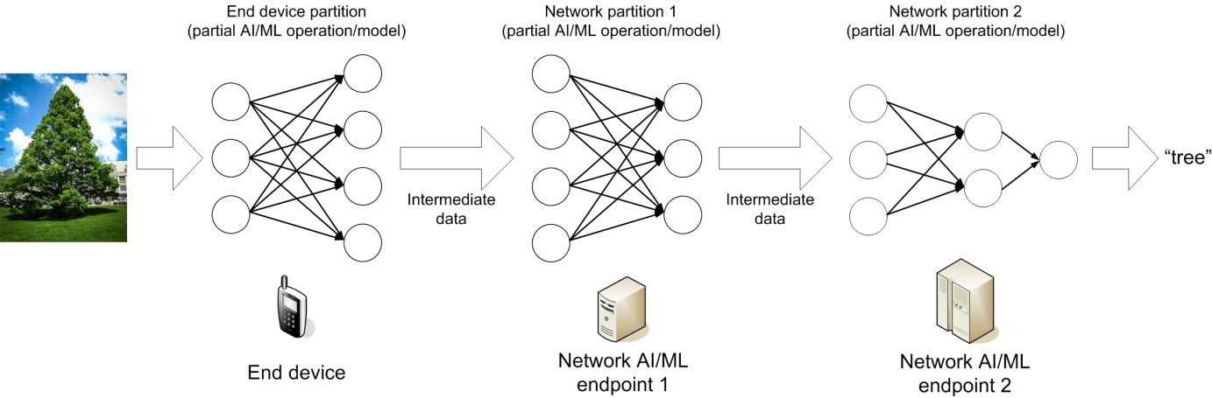
Figure B.1-1. Example of split AI/ML inference
The modes for split AI/ML operations between device and network are illustrated in Figure B.1-2. The modes are in general applicable for AI/ML training as well as inference. In this section, we focus on the inference processing. Mode a) and b) are traditional schemes operating the AI/ML inference wholy on one endpoint. Mode c) - g) attempt to split the AI/ML inference or even the model into multiple parts according to the current task and environment, to alleviate the pressure of computation, memory/storage, power and required data rate on both device and NW endpoints, as well as to obtain a better model inference performance on latency, accuracy and privacy protection.
- Mode a): Cloud/edge-based inference
In this mode (as shown in Figure B.1-2 (a)), the AI/ML model inference is only carried out in a cloud or edge server. The device only reports the sensing/perception data to the server, and does not need to support AI/ML inference operations. The server returns the inference results to the device. The advantage of this mode is limiting the device complexity. One disadvantage is that the inference performance depends on communications data rate and latency between the device and the server. Real-time uploading some perception data (e.g. high-resolution video streaming) requires a stably-high data rate and some AI/ML services (e.g. remote-controlled robotics) requires a stably-low latency, which are challenging to be guaranteed in 5G system due to different network coverages. And due to the disclosure of the privacy-sensitive data to the network, corresponding privacy protection measurements are required.
- Mode b): Device-based inference
In this mode (as shown in Figure B.1-2 (b)), the AI/ML model inference is perform locally at the modile device. The advantage is that, during the inference process, the device does not need to communicate with the cloud/edge server. Another motivation of this mode is perserving the privacy at the data source, i.e. the device, although the privacy protection problem needs also be considered at the device side. The disadvantage is potentially imposing an excessive computation/memory/storage resource to the device. And also pointed out by [10], we cannot assume the device always keep all the potentially-needed AI/ML models onboard. In some cases, the mobile device may need to obtain the AI/ML model from the edge cloud/server, which requires a corresponding downloading data rate from the 5G system, as introduced in Section 7.
- Mode c): Device-cloud/edge split inference
In this mode (as shown in Figure B.1-2 (c)), an AI/ML inference operation or model is firstly split into two parts between the device and the cloud/edge server according to the current system environmental factors such as communications data rate, device resource, and server workload. Then, the device will execute the AI/ML inference up to a specific part or the DNN model up to a specific layer, and send the intermediate data to the cloud/edge server. The server will execute the remaining part/layers and sends the inference results to the device. Compared to Mode a) and b), this mode is more flexible and more robust to the varying computation resource and communications condition. A key link for this mode is to properly select the optimum split point between device side and network side based on the conditions.
- Mode d): Edge-cloud split inference
This mode (as shown in Figure B.1-2 (d)) can be regarded as an extension of Mode a). The difference is that the DNN model is executed through edge-cloud synergy, rather than executed only on either cloud or edge server. The latency-sensitive part of an AI/ML inference operation or layers of an AI/ML model can be performed at the edge server. The computation-intensive parts/layers that the edge server cannot perform can be offloaded to cloud server. The device only reports the sensing/perception data to the server, and does not need to support AI/ML inference operations. The intermediate data are sent from the edge server to the cloud server. A proper split point needs to be selected for an efficient cooperation between edge server and cloud server.
- Mode e): Device-edge-cloud split inference
This mode (as shown in Figure B.1-2 (e)) is the combination of Mode c) and d). An AI/ML inference operation or an AI/ML model is split over the mobile device, the edge server and the cloud server. The computation-intensive parts/layers of an AI/ML operation/model can be distributed among the cloud and/or edge server. The latency-sensitive parts/layers can be performed on the device or the edge server. The privacy-sensitive data can be left at the device. The device sends the intermediate data outcome from its computation to the edge server. And the edge server sends the intermediate data outcome from its computation to the cloud server. Two split points need to be selected for an efficient cooperation between the device, the edge server and the cloud server.
- Mode f): Device-device split inference
This mode (as shown in Figure B.1-2 (f)) provides a de-centralized split inference. An AI/ML inference operation or model can be split over different mobile devices. A group of mobile devices can perform different parts of an AI/ML operation or different DNN layers for an inference task, and exchange intermediate data between each other. The computation load can be distributed over devices meanwhile each device preserves it private information locally.
- Mode g): Device-device-cloud/edge split inference
Mode g) can be further combined with Mode c) or e). As shown in Figure B.1-2 (g), ) an AI/ML inference operation or model is firstly split into the device part and network part. Then the device part can be excuted in a de-centralized manner, i.e. further split over different mobile devices. The intermediate data can be sent from one device to the cloud/edge server. Or multiple devices can send intermediate data to the cloud/edge server.

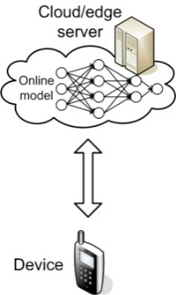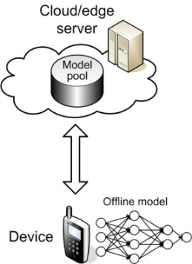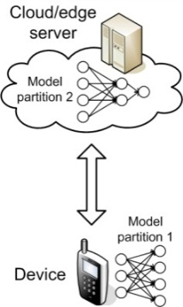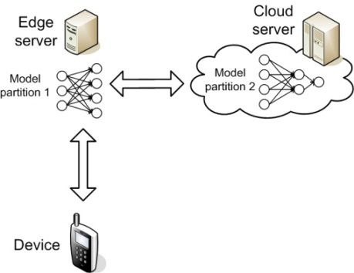
(a) (b) (c) (d)
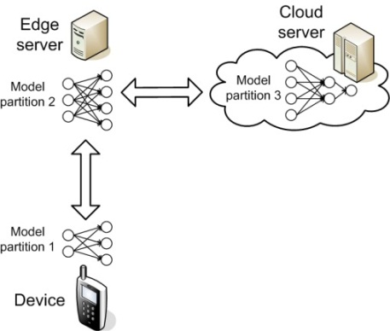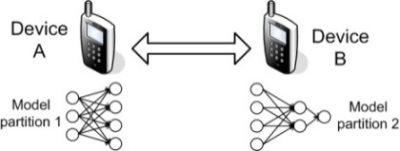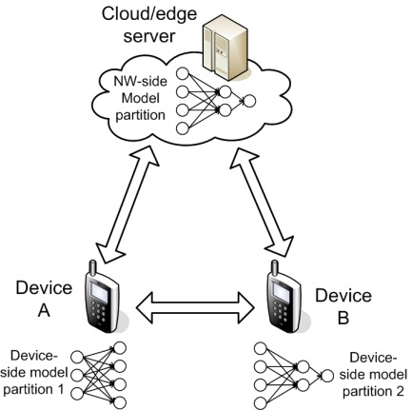
(e) (f) (g)
Figure B.1-2. Split AI/ML inference modes over endpoints

Annex C:
General principle of AI/ML model/data distribution and sharing over 5G system
For the inference tasks which requires low latency and desires the privacy-sensitive data to be preserved at the UE side, offline AI/ML inference is desired, rather than the cloud-based inference. However, an offline AI/ML model running on mobile devices must have a relatively low computation complexity and a small storage size. An approach to enabling offline DNN models on mobile devices is to compress the model to reduce its resource and computational requirements [27-28, 35, 45]. However, DNN compression will lead to loss of inference accuracy and adaptivity to various tasks and environments. A solution to this challenge is to adaptively select the model for inference from a set of trained models [10]. The model selection is motivated by the observation that the optimum model for inference depends on the input data and the precision requirement [20][45]. Multi-functional mobile terminals usually need to switch the AI/ML model in response to task and environment variations.
The condition of adaptive model selection is that the models to be selected have been available for the mobile device. However, given the fact that the DNN models are becoming increasingly diverse, and with the limited storage resource in a UE, it is unfeasible to pre-load all candidate AI/ML models on-board. Online model distribution (i.e. new model downloading) or online transfer learning (i.e. partial model updating) is needed. As illustrated in Figure C.1-1, an AI/ML model can be distributed from a NW endpoint to the devices when they need it to adapt to the changed AI/ML tasks and environments.
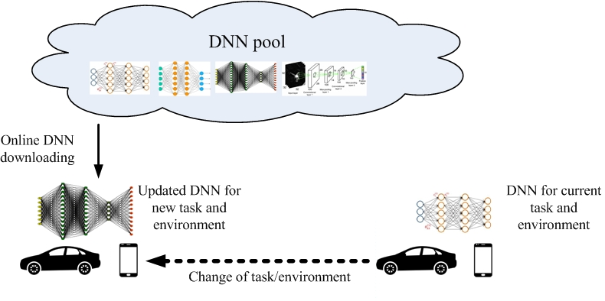
Figure C.1-1. AI/ML model downloading over 5G system
The model to be distributed can be determined in two ways: Requested by a device, or controlled by a network server. The condition of the first mechanism is that the device can make the model selection/re-selection decision based on the understanding to the oncoming AI/ML task, environment and the list of the models available at the network server. As shown in Figure C.1-2, a model selector on the device is trained to select the best DNN for different input data.
The model selector is trained to determine the optimum DNN model for a new, unseen input using a set of automatically tuned features of the DNN model input, and taking into consideration the precision constraint and the characteristics of the input.
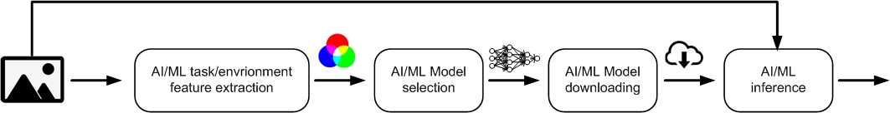
Figure C.1-2. AI/ML model selection and downloading
The data rate for downloading the needed models depends on the following factors:
- Size of the model
This depends on different AI/ML applications. Along with the increasing performance requirements to AI/ML operations, the sizes of the models also keep increasing, although model compression techniques are under improvements.
- Required downloading latency
This depends on how fast the model needs to be ready at the device. It is impacted by the extent to which the oncoming application can be predicted. Considering the unpredictability of user behaviour and typical waiting time a user can tolerate, the downloading of the AI/ML model needs to be finished in seconds or even in milliseconds. Different from a streamed video which can be played when a small portion is buffered, a DNN model can only be used until the whole model is completely downloaded.
In should be noted that the network-based and split AI/ML inference often requires a high and constant uplink data rate for continuously offloading sensing/intermediate data to the cloud/edge server. On the contrary, AI/ML model distribution mainly requires a high downlink data rate in a burst. This makes model distribution more suitable to the downlink-dominant (e.g. employing a high DL-to-UL ratio) mobile communications systems or systems with an unstable coverage. Of course the condition is that the mobile device’s computation resource can afford the on-board execution of the AI/ML model. If the computation load is beyond the device’s capability, the network-based or split inference has to be adopted.

Annex D:
General principle of Distributed/Federated Learning over 5G system
With continuously improving capability of cameras and sensors on mobile devices, valuable training data, which are essential for AI/ML model training, are increasingly generated on the devices. For many AI/ML tasks, the fragmented data collected by mobile devices are essential for training a global model. In the traditional approaches, the training data gathered by mobile devices are centralized to the cloud datacenter for a centralized training.
However, an AI/ML model training often requires a large data set and significant computational resources for multiple weight-update iterations. Nowadays, most of the AI/ML model training tasks are performed in the power cloud datacenters since the resource consumption of the training phase significantly overweights the inference phase. In many cases, training a DNN model still takes several hours to multiple days. However, cloud-based training means that the enormous amount of training data should be shipped from devices to the cloud, incurring prohibitive communication overhead as well as the data privacy pressure at the network side [10]. Similar to the split AI/ML inference introduced in Annex B, AI/ML model training tasks can also work in a cloud-device coordination manner. Distributed Learning and Federated Learning are examples in this manner.
In Distributed Learning mode, as shown in Figure D.1-1, each computing node trains its own DNN model locally with local data, which preserves private information locally. To obtain the global DNN model by sharing local training improvement, nodes in the network will communicate with each other to exchange the local model updates. In this mode, the global DNN model can be trained without the intervention of the cloud datacenter [10].
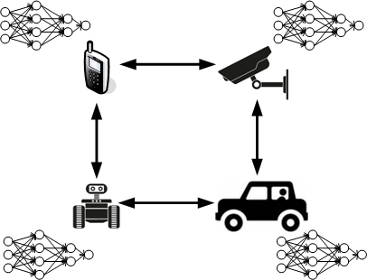
Figure D.1-1. Distributed Learning
In Federated Learning (FL) mode, the clould server trains a global model by aggregating local models partially-trained by each end devices. The most agreeable Federated Learning algorithm so far is based on the iterative model averaging [30]. As depicted in Figure D.1-2, within each training iteration, a UE performs the training based on the model downloaded from the AI server using the local training data. Then the UE reports the interim training results (e.g., gradients for the DNN) to the cloud server via 5G UL channels. The server aggregates the gradients from the UEs, and updates the global model. Next, the updated global model is distributed to the UEs via 5G DL channels. Then the UEs can perform the training for the next iteration.
Figure D.1-2. Federated Learning over 5G system
The performance requirements for Distributed/Federated Learning are listed below. The requirements to 5G communication links (e.g. data rate, latency, reliability) can be derived from the following requirements.
- Training loss:
Training loss is the gap between the correct outputs and the outputs computed by the DNN model which indicates how well the trained DNN model fits the training data. Aim of training task is to minimize the training loss. Training loss is mainly affected by the quality of the training data and the efficiency of the training methods, i.e. whether the meaning of training data can be fully and properly explored. For Federated Learning, only when the valuable local training data can be fully learned in the duration of the iteration and the local training updates can be correctly reported to the cloud server within the target duration, the training loss can be minimized.
This implies that the requirements to the devices joining in the training process on the achievable UL data rate, latency and reliability for reporting the trained updates, and the the achievable UL data rate, latency and reliability for distributing the model for training in next iteration. And to minimize the training loss with device heterogenity (in computation and communication performance), training device selection and training configuration are needed before the training is performed in an iteration [31, 48] (will be introduced later in this section). The QoS of the relevant controlling messages, e.g. for training request, training resource reporting, training device selection, training configuration, and resource allocation for the training updates reporting, also needs to be guaranteed.
- Training latency:
Training latency is one of the most fundamental performance metrics of AI/ML model training task since it directly influences when the trained model is available for use. Nowadays, cloud-based training often takes several hours to multiple days. The latency of the Distributed/Federated Learning process would take even a longer time if the computation latency or the communication latency is not minimized.
The latency of the Distributed/Federated Learning process is determined by the convergence rate (e.g. number of iterations before the training process converges to a consensus) and the latency of each iteration which consists of computation latency and communication latency. The computation latency depends on the computation/memory resource available on training devices. The computation latency depends on the DL data rate available for model distribution and UL data rate available for trained model updating. The latency of the whole training process is determined by the larger one between the computation latency and the communication latency. Hence the latencies of the computation and communication links need to be cooperatively minimized. If the communication latency cannot match to the computation latency, the communication link will become the bottleneck and prolong the whole training process.
For synchronous Federated Learning, in each iteration, the training latency is determined by the last device that reports its training update because the federated aggregation can be finished when all needed training updates are correctly gathered. That means the device heterogenity (in computation and communication performance) will also highly impact the overall training latency. Rather than requiring the UL transmission latency of a specific device, the overall latency required for all training devices to upload the training updates (device-group latency) needs to be defined. And the QoS of the controlling messages for minimizing the device-group latency, e.g. for training request, training resource reporting, training device selection, training configuration, and resource allocation for the training updates reporting, also needs to be guaranteed.
- Energy efficiency:
For Distributed/Federated Learning, both the computation and communication processes consume considerable energy. The Federated Learning architecture and protocol should also consider the power constraints on the training devices and the energy efficiency on device as well as the network side.
- Privacy:
When training the DNN model by using the data originated at a massive of end devices, the raw data or intermediate data should be transferred out of the end devices. Compared to reporting it to the cloud/edge server, preserving privacy at the end devices can reduce the pressure of privacy protection at network side. For example, Federated Learning is an agreeable approach to avoid uploading the raw data from device to network, as a cloud-based training requires.

Annex E:
Change history
Change history
Date | Meeting | TDoc | CR | Rev | Cat | Subject/Comment | New version
2020-09 | SA1#91-e | S1-203150 |  |  |  | TR Skeleton agreed | 0.0.0
2020-09 | SA1#91-e | S1-203382 |  |  |  | Agreements in SA1#91-e: S1-203137, S1-203284, S1-203074, S1-203135, S1-2031356, S1-203312, S1-203133, S1-203314, S1-203315, S1-203316, S1-203317, S1-203318, S1-203144, S1-203145, S1-203146, S1-203158 | 0.1.0
2020-11 | SA1#92-e | S1-204352 |  |  |  | Agreements in SA1#92-e: S1-204014, S1-204339, S1-204394, S1-204395, S1-204396, S1-204397, S1-204398, S1-204399, S1-204400, S1-204401, S1-204402, S1-204403, S1-204404 | 0.2.0

