As shown in following Figure 1, for the hybrid beamfomring architecture, then both analog beamforming within sub-array and digital beamforming among different sub-arrays should be considered, the detailed weighting factors for digital and analog beamforming are demonstrated as following:

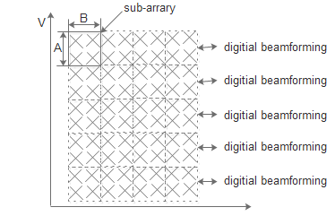

**Figure 1. hybrid beamforming architecture**

The weighting factors for digital beamforming is given by:

 (1)

Where each sub-array comprise of A antenna elements in vertical domain and B antenna elements in horizontal domain.

The weighting factors for analog beamforming is given by:

(2)

The combined weighting factors for digital beamforming and analog beamforming:





The super position vector is given by:

