**3GPP TSG-RAN WG4 Meeting # 98-bis-e R4-21xxxxx**

**Electronic Meeting, 12th – 20th April, 2021**

**Agenda item:** 9.1.1

**Source:** Moderator (Apple)

**Title:** Email discussion summary for [98-bis-e][327] FR2_enhTestMethods

**Document for:** Information

# Introduction

*The email discussion is separated into the following topics:*

* *Topic 1: high DL and low UL power*
* *Topic 2: polarization basis mismatch*
* *Topic 3: inter-band (FR2+FR2) CA*
* *Topic 4: extreme temperature conditions*
* *Topic 5: enhancements to reduce test time*
* *Topic 6: extension of permitted methods to band n262*
* *Topic 7: rapporteur input*

# Topic #1: high DL and low UL power

*Main technical topic overview. The structure can be done based on sub-agenda basis.*

## Companies’ contributions summary

|  |  |  |
| --- | --- | --- |
| **T-doc number** | **Company** | **Proposals / Observations** |
| [R4-2104522](http://www.3gpp.org/ftp/tsg_ran/WG4_Radio/TSGR4_98bis_e/Docs/R4-2104522.zip) | vivo | **Discussions on test procedure of FR2 enhanced test methods**  Observation 1: the overall applicability of these test methods is still very complicated, clear guidance on how to select the enhanced approach is needed.  Observation []: the overall applicability of these test methods is still very complicated, clear guidance to RAN5 on how to select the enhanced approach is needed.  Proposal 1: The detailed test procedure and rationale of CFFNF system should be added to the TR 38.884.  Proposal 2: Further study whether the combination of DFF and NF system would increase the MU or not. |
| [R4-2104684](http://www.3gpp.org/ftp/tsg_ran/WG4_Radio/TSGR4_98bis_e/Docs/R4-2104684.zip) | Huawei, HiSilicon | **On black box test**  Observation 1: the field or power distribution close to device surface could be used to determine antenna locations within a few millimetres.  Observation 2: the far field distances for various frequencies seem to be acceptable compared to those in Table 6 of [7].  Proposal []: further study on this approach may be worth pursuing. |
| [R4-2106695](http://www.3gpp.org/ftp/tsg_ran/WG4_Radio/TSGR4_98bis_e/Docs/R4-2106695.zip) | MVG Industries, Sony | **DNF Method**  Observation 1: For this simulated antenna arrays config, EIRP and TRP errors are very minor.  Observation 2: Path Loss and Beam pattern compensation would help to decrease the errors. |
| [R4-2107130](http://www.3gpp.org/ftp/tsg_ran/WG4_Radio/TSGR4_98bis_e/Docs/R4-2107130.zip) | Keysight Technologies | **On CFFNF and CFFDNF test methodologies for high DL power and low UL power test cases**  Observation 4: When performing measurements in the NF with CFFDNF methodology assuming the black&white-box approach, the path loss and probe antenna pattern must be compensated  Observation 5: CFFDNF simulations with 250 random offsets approximate the MUs (mean error and standard deviation) very well  Observation 6: CFFDNF simulations at 49GHz yield smaller MUs than at 28GHz.  Observation 7: A local search to determine the optimized NF beam peak direction/EIRP after pathloss and feed pattern compensation is not necessary.  Observation 8: The Matlab and CST antenna array patterns in the NF and FF are very similar.  Observation 9: The Matlab and CST MU analyses for CFFDNF with black&white-box approach yield very similar MU results.  Observation []: The CFFDNF methodology assuming the black&white-box approach with array offsets and the probe antenna pattern compensated is suitable for EIRP/EIS measurements with insignificant MU for PC3 devices with 8x2 antenna configuration when range length is greater or equal to 45cm. At smaller range lengths, small MUs (0dB) must be applied to the measurements.  Observation 10: The CFFDNF methodology assuming the black&white-box approach with array offsets and the probe antenna pattern compensated is suitable for EIRP/EIS measurements with insignificant MU for PC3 devices with 4x1 antenna configuration when range length is greater or equal to 20cm.  Observation 11: The CFFDNF methodology assuming the black&white-box approach with array offsets and the probe antenna pattern compensated is suitable with small MUs (0dB) for EIRP/EIS measurements for PC1 devices with 12x12 antenna configuration when range length is greater or equal to 45cm.  Observation []: For PC3 TRP analyses based on the CFFDNF approach,  - no additional MU is needed for range lengths exceeding 20cm if the path loss correction is applied for measurement grids with step size of at most 10o - no additional MU is needed for range lengths exceeding 43cm if the path loss correction is not applied for measurement grids with step size of at most 10o  Observation []: For PC1 TRP analyses based on the CFFDNF approach,  - no additional MU is needed for range lengths exceeding 20cm if the path loss correction is applied for measurement grids with step size of at most 5o - no additional MU is needed for range lengths exceeding 43cm if the path loss correction is not applied for measurement grids with step size exceeding 5o  Observation 12: The CFFNF methodology with the black&white-box approach yields smaller MUs than the CFFDNF methodology.  Observation 13: The CFFNF methodology assuming the black&white-box approach with array offsets and the probe antenna pattern compensated is suitable for EIRP/EIS measurements with insignificant MU for PC3 devices with 8x2 antenna configuration when range length is greater or equal to 21cm.  Observation 14: Local Searches of the CFFNF methodology using black box approach can be accelerated using coarse&fine search grids and continuous scan measurements.  Observation 12: The CFFNF methodology with the black&white-box approach yields smaller MUs than the CFFDNF methodology.  Observation 13: The CFFNF methodology assuming the black&white-box approach with array offsets and the probe antenna pattern compensated is suitable for EIRP/EIS measurements with insignificant MU for PC3 devices with 8x2 antenna configuration when range length is greater or equal to 21cm.  Observation 14: Local Searches of the CFFNF methodology using black box approach can be accelerated using coarse&fine search grids and continuous scan measurements.  Proposal 1: Incorporate the presented MU results into TR 38.884  Proposal 2: Capture in TR 38.884 that CFFNF and CFFDNF methodologies require the compensation of the path loss (w.r.t. to the active antenna array) and the compensation of the probe antenna pattern  Revision: Number of CFFNF and CFFDNF offset simulations were adjusted from 369 to 500 for 8x2 (PC3); additionally, 52 offset simulations for 12x12 (PC1) were included in the revision  Revision (v2): ‘Annex E: Additional Background on CFFNF Methodology/Asymptotic Expansion Approach’ was added to provide additional background and clarifications on the asymptotic expansion approach |
| [R4-2107187](http://www.3gpp.org/ftp/tsg_ran/WG4_Radio/TSGR4_98bis_e/Docs/R4-2107187.zip) | Rohde & Schwarz | **Analysis of NF based solutions**  Observation 1: the asymptotic expansion approach definition is not complete and has fundamental issues in the formulation.  Observation 2: E-field dependence to and imply very small antenna aperture size.  Observation 3: measurement distance close to reactive NF boundary requires NF to FF transform techniques based on magnitude and phase measurements, necessary to reliably reconstruct the Far Field data.  Observation 4: manufacturer declaration is the easiest and most consistent way to obtain the antenna offset required for offset correction.  Observation []: E-field dependence to and imply very small antenna aperture size.  Proposal 1: do not consider CFFNF with transform as enhanced methodology for FR2 testing.  Proposal 2: define 32 cm as minimum range length for CFFDNF systems to perform EIRP/EIS and TRP measurements for PC3.  Proposal 3: adopt Black&white box approach as manufacturer declaration. |

## Open issues summary

*Before e-Meeting, moderators shall summarize list of open issues, candidate options and possible WF (if applicable) based on companies’ contributions.*

### Sub-topic 1-1: CFFNF

**Issue 1-1-1: Determining the unknown antenna location in CFFNF setup**

- Alt 1-1-1-1: The detailed antenna location can be estimated by the three radii approach only  
NOTE: this approach is already captured in TR 38.884 at the high level as “Three radii approach (i.e. local search on radius r1 and very localized searches at r2 and r3) can be used”

- Alt 1-1-1-2: In addition to the three radii approach, consider a scan of the field or power distribution close to device surface to determine antenna locations within a few millimetres

**Issue 1-1-2: CFFNF test procedure and rationale**

- Proposal: The detailed test procedure and rationale of CFFNF system should be added to the TR 38.884

**Issue 1-1-3: CFFNF MU elements**

Moderator’s note: the intention of this issue is to collect inputs on all proposed MU elements (or mechanisms which contribute to an MU element) for further investigation; round 2 of the discussion can be used to converge on the agreed set of MU elements which are applicable to CFFNF.

- Alt 1-1-3-1: compensation of the path loss (w.r.t. to the active antenna array)

- Alt 1-1-3-2: compensation of the probe antenna pattern

- Alt 1-1-3-3: switching between the FF and NF signal paths

- Alt 1-1-3-4: estimation of DUT antenna location

- Alt 1-1-3-5: EIRP measurement error  
NOTE: this option added by the moderator; the assessment of this uncertainty element is covered in Issue 1-1-4

**Issue 1-1-4: Preliminary assessment of CFFNF MU**

- Alt 1-1-4-1: consider the preliminary assessment below as the starting point:

|  |  |  |  |  |  |
| --- | --- | --- | --- | --- | --- |
| **Antenna Configuration** | **Methodology** | **Number of Offsets** | **Range Length [m]** | **|Mean EIRP Error| w.r.t. FF [dB]** | **Std. Dev of EIRP at NF BP [dB]** |
| **8x2** | **CFFNF with black box approach** | **369** | 0.22 |  |  |
| 0.27 |  |  |
| 0.32 |  |  |
| **8x2** | **CFFNF with black&white-box approach** | **369** | 0.21 | 0.04 | 0.04 |
| 0.26 | 0.03 | 0.03 |
| 0.31 | 0.02 | 0.03 |

- Alt 1-1-4-2: Simple expansion techniques are too much sensitive to extrapolation error, as summarized below, and may only be feasible under high SNR conditions. Therefore, they are not suitable to solve the kind of testability issues defined in the scope of this SI

|  |  |  |  |
| --- | --- | --- | --- |
| SNR (dB) | Peak to Peak error (dB) | Mean error (dB) | Std. Deviation (dB) |
| 40 | 0.069 | -0.072 | 0.012 |
| 10 | 2.985 | 0.381 | 0.747 |
| 6 | 6.656 | 0.941 | 1.424 |

### Sub-topic 1-2: CFFDNF

**Issue 1-2-1: CFFDNF MU elements**

Moderator’s note: the intention of this issue is to collect inputs on all proposed MU elements (or mechanisms which contribute to an MU element) for further investigation; round 2 of the discussion can be used to converge on the agreed set of MU elements which are applicable to CFFNF.

- Alt 1-2-1-1: compensation of the path loss (w.r.t. to the active antenna array)

- Alt 1-2-1-2: compensation of the probe antenna pattern

- Alt 1-2-1-3: switching between the FF and NF signal paths

- Alt 1-2-1-4: EIRP measurement error  
NOTE: this option added by the moderator; the assessment of this uncertainty element is covered in Issue 1-2-2

- Alt 1-2-1-5: TRP measurement error  
NOTE: this option added by the moderator; the assessment of this uncertainty element is covered in Issue 1-2-3

**Issue 1-2-2: Preliminary assessment of CFFDNF MU (EIRP/EIS test cases)**

Moderator’s note: companies are encouraged to consider the below analyses as starting points to define the preliminary uncertainty estimate for the corresponding MU element for CFFDNF. In the end, a single value (or a set of values corresponding to certain frequencies of operation) is needed for the preliminary assessment of the MU budget.

- Alt 1-2-2-1: consider the preliminary assessment below as the starting point:

|  |  |  |  |  |  |
| --- | --- | --- | --- | --- | --- |
| **Antenna Configuration** | **Methodology** | **Number of Offsets** | **Range Length [m]** | **|Mean EIRP Error| w.r.t. FF [dB]** | **Std. Dev of EIRP at NF BP [dB]** |
| **8x2** | **CFFDNF with black&white-box approach** | **369** | 0.2 | 0.42 | 0.19 |
| 0.25 | 0.22 | 0.07 |
| 0.3 | 0.14 | 0.04 |

- Alt 1-2-2-2: consider the preliminary assessment below as the starting point:

|  |  |  |
| --- | --- | --- |
| Range Length | Mean EIRP error (dB) | EIRP Std. Deviation (dB) |
| 20cm | -0.555 | 0.538 |
| 25cm | -0.209 | 0.400 |
| 30cm | -0.049 | 0.360 |
| 35cm | 0.007 | 0.364 |
| 40cm | 0.076 | 0.418 |
| 45cm | 0.094 | 0.391 |
| 20m | 0.036 | 0.058 |

- NOTE from authors of [R4-2107187]: After a first analysis, it was confirmed that the limited performance in terms of EIRP can be explain by the 5º step grid selected for these simulations. Thus, revised results with a smaller grid together with the corresponding simulation results for 4x2 and 12x12 antenna array cases will be shared in a revised (late) contribution for this meeting.

**Issue 1-2-3: Preliminary assessment of CFFDNF MU (TRP test cases)**

Moderator’s note: companies are encouraged to consider the below analyses as starting points to define the preliminary uncertainty estimate for the corresponding MU element for CFFDNF. In the end, a single value (or a set of values corresponding to certain frequencies of operation) is needed for the preliminary assessment of the MU budget.

- Alt 1-2-3-1: consider the preliminary assessment below as the starting point:

|  |  |  |  |  |  |  |
| --- | --- | --- | --- | --- | --- | --- |
| **Antenna Configuration** | **Range Length [cm]** | **Constant Density Grid Step Size = [o]** | **With Path Loss Correction** | | **Without Path Loss Correction** | |
| **|Mean TRP Error| [dB]** | **TRP Std. Dev. [dB]** | **|Mean TRP Error| [dB]** | **TRP Std. Dev. [dB]** |
| **8x2** | **20** | 5 | 0.01 | 0.04 | 0.39 | 0.24 |
| 7.5 | 0.02 | 0.13 | 0.39 | 0.25 |
| 10 | 0.03 | 0.17 | 0.39 | 0.29 |
| **32** | 5 | 0.02 | 0.01 | 0.14 | 0.08 |
| 10 | 0.04 | 0.03 | 0.14 | 0.09 |
| **43** | 5 | 0.02 | 0.01 | 0.08 | 0.04 |
| 10 | 0.04 | 0.03 | 0.08 | 0.04 |
| **12x12** | **20** | 5 | 0.02 | 0.07 | 0.29 | 0.17 |
| 7.5 | 0.01 | 0.24 | 0.29 | 0.21 |
| 10 | 0.01 | 0.36 | 0.27 | 0.39 |
| **32** | 5 | 0.04 | 0.13 | 0.11 | 0.06 |
| 10 | 0.09 | 0.63 | 0.07 | 0.64 |
| **43** | 5 | 0.06 | 0.13 | 0.06 | 0.03 |
| 10 | 0.12 | 0.65 | 0.01 | 0.66 |

- Alt 1-2-3-2: consider the preliminary assessment below as the starting point:

|  |  |  |
| --- | --- | --- |
| Range Length | Mean TRP error (dB) | TRP Std. Deviation (dB) |
| 20cm | -0.519 | 0.357 |
| 25cm | -0.360 | 0.215 |
| 30cm | -0.274 | 0.145 |
| 35cm | -0.220 | 0.105 |
| 40cm | -0.184 | 0.080 |
| 45cm | -0.159 | 0.063 |
| 20m | -0.015 | 0.014 |

- NOTE from authors of [R4-2107187]: After a first analysis, it was confirmed that the limited performance in terms of EIRP can be explain by the 5º step grid selected for these simulations. Thus, revised results with a smaller grid together with the corresponding simulation results for 4x2 and 12x12 antenna array cases will be shared in a revised (late) contribution for this meeting.

### Sub-topic 1-3: DNF

**Issue 1-3-1: Applicability of the DNF setup**

- Proposal: The applicability of the low UL power/high DL power EIRP/EIS test cases in the known BP direction and with the black&white-box approach is feasible with compensation due to known antenna array offset

### Sub-topic 1-4: Summary of applicable enhancements

**Issue 1-4-1: Clear summary of applicable enhancements**

- Alt 1-4-1-1: Sumamrize the applicability of enhancements as proposed in R4-2107130

|  |  |  |  |  |  |  |
| --- | --- | --- | --- | --- | --- | --- |
| **►Test Case ►** | **BP Searches & Spherical Coverage** | | **TRP** | | **EIRP/EIS** | |
| ►Methodology ►  ▼Test Approach▼ | CFFDNF | CFFNF | CFFDNF | CFFNF | CFFDNF | CFFNF |
| Black Box | Yes (FF) | Yes (FF) | Yes (Note 1) | No (Note 6) | No (Note 7) | Yes (Note 4) |
| Black & White Box | Yes (FF) | Yes (FF) | Yes (Note 2) | No (Note 6) | Yes (Note 3) | Yes (Note 5) |
| Note 1: At >32cm, no offset compensation is required. If offset is determined from CFFNF approach, range length ≤32cm are applicable with offset approach  Note 2: At range length ≤32cm, offset compensation is required while at >32cm, no offset compensation is required.  Note 3: Whether a local search to determine the NF test direction and/or optimize EIRP/EIS is FFS; min. range lengths are FFS  Note 4: Three radii approach with local searches can be used; EIRP/EIS can be approximated at very close distances (~22cm PC3; ~27cm PC1); unknown offset can be estimate accurately; other approaches no precluded  Note 5: Two radii approach without local searches can be used; EIRP/EIS can be approximated at very close distances (~21cm PC3; ~26cm PC1); other approaches no precluded  Note 6: not applicable since this approach is test time prohibitive  Note 7: This can be revised whenever empirical methods to determine the offset location are shown feasible | | | | | | |

- Alt 1-4-1-2: do not consider CFFNF with transform as enhanced methodology for FR2 testing.

## Companies views’ collection for 1st round

### Open issues

|  |  |
| --- | --- |
| **Issue** | **Company comments** |
| **Issue 1-1-1: Determining the unknown antenna location in CFFNF setup** | Keysight:  Alt 1-1-1-1: support  Alt 1-1-1-2: while technically feasible, the implementation of the outlined approach would increase test system complexity and MU significantly since the proposed scan will have to be performed inside the chamber after the beam was locked to the FF BP. The applicability of this approach to non-planar devices, e.g., laptops with open screen, or devices with phantoms is likely rather limited |
|  |
|  |
|  |
|  |
| **Issue 1-1-2: CFFNF test procedure and rationale** | Keysight:  Details/rationale of the asymptotic expansion approach are provided in a revision (v2) of R4-2107130; a more extensive write-up of the test procedures can be provided in RAN4#99-e. |
|  |
|  |
|  |
|  |
| **Issue 1-1-3: CFFNF MU elements** | Keysight:  Alt 1-1-3-1: not clear this corresponds to an MU element as the compensation of path loss to centre of QZ does not have an MU element  Alt 1-1-3-2: as long as the NF pattern of the probe antenna is known, the MU should be small or insignificant  Alt 1-1-3-3: since each path is calibrated, it is not clear how this corresponds to an MU element  Alt 1-1-3-4: agreed (applies to black box and black&white box)  Alt 1-1-3-5: covered in 1-1-4 |
|  |
|  |
|  |
|  |
| **Issue 1-1-4: Preliminary assessment of CFFNF MU** | Keysight:  Alt 1-1-4-1: support; black-box CFFNF data will likely be presented in RAN4#99  Alt 1-1-4-2: not agree with the results presented in R4-2107187. Looking at Figure 2.3 2 for instance, it seems that the R&S simulations show that normalized power is decreasing as a function of distance    while in KS simulations, the normalized power is increasing as a function of distance, e.g., Figure 19 of the revision (v2) of R4-2107130    Our analyses of impact of SNR on EIRP shows the following results based on applying the asymptotic expansion approach at two sets of radii.   |  |  |  |  |  |  | | --- | --- | --- | --- | --- | --- | | **SNR (dB)** | **FF Power Reference (dBm)** | **(*r*1, *r*2, *r*3)=(7.5, 8.5, 9.5)cm** | | **(*r*1, *r*2, *r*3)=(20, 21, 22)cm** | | | |Mean Err to FF Reference| (dB) | Est Std. Dev. (dB) | |Mean Err to FF Reference| (dB) | Est Std. Dev. (dB) | | 6 | 83.28 | 0.01 | 0.08 | 0.10 | 0.22 | | 10 | 83.28 | 0.05 | 0.05 | 0.04 | 0.14 | | 15 | 83.28 | 0.08 | 0.03 | 0.01 | 0.08 | | 20 | 83.28 | 0.09 | 0.02 | 0.00 | 0.04 | | 25 | 83.28 | 0.09 | 0.01 | 0.01 | 0.02 | | 30 | 83.28 | 0.09 | 0.00 | 0.01 | 0.01 |   In these results, the 8x2 antenna array was analysed using 10k different AWGN simulations and 10 averages were taken for each EIRP analysed. In each of the 10k AWGN simulations, we first generated a signal with 1000 samples, applied AWGN with specified SNR (e.g., 6dB, 10dB,…) on the signal, then measured the power of signal + AWGN at three distances r1, r2 and r3 to perform asymptotic expansion estimation.  Clarification question regarding R4-2107187: How exactly was the noise applied? Did R&S apply noise using the approach as we did (described above), or was the noise directly applied to the three measured powers at r1, r2 and r3? We believe the approach outlined above is more closely aligned to actual OTA measurements |
|  |
|  |
|  |
|  |
| **Issue 1-2-1: CFFDNF MU elements** | Keysight:  Alt 1-2-1-1: not clear this corresponds to an MU element  Alt 1-2-1-2: as long as the NF pattern of the probe antenna is known, the MU should be small or insignificant  Alt 1-2-1-3: since each path is calibrated, it is not clear how this corresponds to an MU element  Alt 1-2-1-4: covered in 1-2-2  Alt 1-2-1-5: covered in 1-2-3 |
|  |
|  |
|  |
|  |
| **Issue 1-2-2: Preliminary assessment of CFFDNF MU (EIRP/EIS test cases)** | Keysight:  Alt 1-2-2-1: the Matlab results with the 100k offset simulations might be more appropriate to be used as a baseline. The CST simulations were performed with a grid step size of 1deg (very fine) but the Matlab results calculated the EIRPs in the exact NF BP directions.  Alt 1-2-2-2: once the grid step size is reduced, the data will likely converge with the data in Alt 1-2-2-1. Some clarification questions regarding the results in R4-2107187:   * The results presented are after probe pattern compensation, i.e., probe antenna is assumed isotropic? * Was the NF BP direction found after a local search or calculated (and then interpolated based on the 5deg grid step size)? * How was the reference defined considering the mean EIRP error is <>0 or was this due to the 5deg grid step size |
|  |
|  |
|  |
|  |
| **Issue 1-2-3: Preliminary assessment of CFFDNF MU (TRP test cases)** | Keysight:  Alt 1-2-3-1: preferred as baseline as the assessment includes with and without path loss correction  Alt 1-2-3-2: considering a 5deg grid step size was used, the TRP MU results should match those from Alt 1-2-3-2 but they seem to be much higher (even higher than the results without pass loss correction). An analysis with different grid step sizes and with/without path loss correction would be good |
|  |
|  |
|  |
|  |
| **Issue 1-3-1: Applicability of the DNF setup** | Keysight:  Alt 1-3-1: we do not agree with this proposal as the corresponding contribution R4-2106695 describes the CFFDNF methodology instead of DNF methodology in step 1a  *To summarize, the following is the test/simulation procedure:*  *1. Beam peak search is performed in FF system setup*  *a. Beam is locked in the BP direction*  *2. Locked Beam is measured in NF system setup*  We agree with this proposal once applied to CFFDNF which matches the observations made in R4-2107130 |
|  |
|  |
|  |
|  |
| **Issue 1-4-1: Clear summary of applicable enhancements** | Keysight:  Alt 1-4-1-1: support. This table captures agreements (in written form) from last meeting; additional updates will likely be necessary based on analyses presented this meeting and next  Alt 1-4-1-2: do not support. A couple of important aspects of the asymptotic expansion approach should be pointed out:   * The asymptotic expansion approach is suitable to estimate EIRP/EIS measurements at/near the beam peak using NF measurements. For arbitrary measurement directions or full FF pattern determination, a NF to FF transform is more suitable * The asymptotic expansion approach is based on EIRP/EIS measurements in the radiative NF and not the reactive NF * In theory, R&S is correct that electromagnetic field theory suggests that the fields follow a series of terms in the NF, especially the reactive NF. The asymptotic expansion approach was not meant to solve for the fields/power exactly but to approximate the rate of decay in the NF and thus estimate the FF based on a series of NF measurements for the BP direction only. Our results clearly show that the expansion approach is suitable to perform those approximations in the beam peak direction accurately even for not so small antenna apertures.   As outlined in the revision (v2) of R4-2107130, an even more accurate approximation was determined previously which yields a field/power dependence w.r.t (*kr*) that is commonly found in literature for the radiative NF |
|  |
|  |
|  |
|  |

### CRs/TPs comments collection

*N/A*

## Summary for 1st round

### Open issues

*Moderator tries to summarize discussion status for 1st round, list all the identified open issues and tentative agreements or candidate options and suggestion for 2nd round i.e. WF assignment.*

|  |  |
| --- | --- |
| **Issue** | **Status summary** |
| **Issue 1-1-1: Determining the unknown antenna location in CFFNF setup** | *Tentative agreements:*  *Candidate options:*  *Recommendations for 2nd round:* |
| **Issue 1-1-2: CFFNF test procedure and rationale** | *Tentative agreements:*  *Candidate options:*  *Recommendations for 2nd round:* |
| **Issue 1-1-3: CFFNF MU elements** | *Tentative agreements:*  *Candidate options:*  *Recommendations for 2nd round:* |
| **Issue 1-1-4: Preliminary assessment of CFFNF MU** | *Tentative agreements:*  *Candidate options:*  *Recommendations for 2nd round: Tentative agreements:*  *Candidate options:*  *Recommendations for 2nd round:* |
| **Issue 1-2-1: CFFDNF MU elements** | *Tentative agreements:*  *Candidate options:*  *Recommendations for 2nd round:* |
| **Issue 1-2-2: Preliminary assessment of CFFDNF MU (EIRP/EIS test cases)** | *Tentative agreements:*  *Candidate options:*  *Recommendations for 2nd round:* |
| **Issue 1-2-3: Preliminary assessment of CFFDNF MU (TRP test cases)** | *Tentative agreements:*  *Candidate options:*  *Recommendations for 2nd round:* |
| **Issue 1-3-1: Applicability of the DNF setup** | *Tentative agreements:*  *Candidate options:*  *Recommendations for 2nd round:* |
| **Issue 1-4-1: Clear summary of applicable enhancements** | *Tentative agreements:*  *Candidate options:*  *Recommendations for 2nd round:* |

### CRs/TPs

*N/A*

## Discussion on 2nd round (if applicable)

# Topic #2: polarization basis mismatch

*Main technical topic overview. The structure can be done based on sub-agenda basis.*

## Companies’ contributions summary

|  |  |  |
| --- | --- | --- |
| **T-doc number** | **Company** | **Proposals / Observations** |
| [R4-2104489](http://www.3gpp.org/ftp/tsg_ran/WG4_Radio/TSGR4_98bis_e/Docs/R4-2104489.zip) | Qualcomm Incorporated | **Transmit signal quality measurements by TE with dual pol Rx**  Observation 1: The proposed demodulation procedure does not inject any amplitude flatness or phase artefacts in measurements of UE from a UE that uses transparent diversity schemes.  Observation 2: The proposed demodulation procedure has strong continuity with legacy methods owing to retention of ZF equalization and LSE-based channel estimation.  Observation 3: The proposed demodulation procedure gracefully scales between 2L UL and single layer UL operation.  Observation 4: Transmit modulation quality metrics (EVM, IBE, carrier leakage) are calculated by the proposed demodulation procedure in per layer form as required by the standard.  Proposal 1: The 2L MIMO demodulation scheme in figure 2.2.1-2 is proposed as the basis for TE employing dual receive chains.  Proposal []: The 2L MIMO demodulation scheme pictured below is proposed as the basis for TE employing dual receive chains. |
| [R4-2104558](http://www.3gpp.org/ftp/tsg_ran/WG4_Radio/TSGR4_98bis_e/Docs/R4-2104558.zip) | MediaTek Inc. | **TPMI, 2-port CSI-RS, and EVM issues about polarization basis mismatch**  Observation 1: “Optimal TPMI” can reflect UE achievable EIRP performance well compared to “Fixed TPMI”. In the case study, the differences are 0.6 dB @peak and 2 dB @50-tile, respectively.  Observation 2: Same UE but different polarization basis mismatch conditions with current EVM test procedure can lead to quite different test results, even affect pass/fail results.  Observation 3: The EVM test result period is about 90 degree as expected, due to the inherent possible polarization basis mismatch is 0 to 90 degree.  Proposal 1: Define option-2 “Optimal TPMI index”.  Proposal 2: Define 2-port CSI-RS configuration as below:  Proposal 3: RAN4 shall define solution(s) for EVM issue due to polarization basis mismatch.  Proposal 4: For EVM test, different polarization angles shall be applied to avoid test results be affected due to polarization basis mismatch.  Proposal 5: The conceptual EVM test conditions and flow are proposed as Fig 3.  Proposal 6: RAN4 shall send LS to RAN5 to notify the EVM issue and the agreed solution(s). |
| [R4-2104569](http://www.3gpp.org/ftp/tsg_ran/WG4_Radio/TSGR4_98bis_e/Docs/R4-2104569.zip) | Anritsu Corporation | **Considerations on test with TPMI method**  Observation 1: There is a need to clarify the expected functionality of a test equipment (TE) when configuring a UE with SRS resources.  Observation 2: There is a need to clarify conditions when configuring SRS - actual SRS configurations to set, assumptions to judge the best grid point and the best TPMI index finally.  Observation 3: It is not clear whether the coherent UEs are always activating dual Tx paths or not.  Observation 4: Implementation of the test feature may become complicated depending on the condition of SRS configuration.  Observation 5: Relationship of measurement time is expected as follows.  Observation 6: Option 1 would be the simplest and likely to be the shortest test time method within 3 options.  Observation 7: Option 2-A would be the similar or longer test time method than option 1. It would be the most complicated method and requires more time to complete this discussion.  Observation 8: Option 2-B would be the 2nd simplest test method. But requires the longest test time in 3 options, approximately 4 times than others.  Observation 9: Our preference is option 1 and option 2-B as a second choice.  Proposal 1: Clarify an expected functionality of a test equipment when configuring SRS in a UE - actual SRS configurations to set, and assumptions to judge the best grid point and the best TPMI index. |
| [R4-2104701](http://www.3gpp.org/ftp/tsg_ran/WG4_Radio/TSGR4_98bis_e/Docs/R4-2104701.zip) | Sony, Ericsson | **Views on solutions to minimize the impact of polarization basis mismatch**  Observation 1: TPMI method is applicable for clause 6.2 of TS 38.101-2 for Rel-15 and Rel-16 coherent UEs and is applicable for clause 6.2D for Rel-16 nonCoherent UEs with uplink full power transmission.  Observation 2: There could be a difference in antenna performance between different TPMI precoding matrices, but the impact is limited.  Observation 3: the TPC power command is also the only mechanism that the network can use to control the UE output power in real life.  Observation 4: The power UP command has been adopted in the RF test to ensure the UE reaches its maximum output power.  Proposal 1: Any potential command or setting (test mode) for the EIRP test enhancement shall be avoided. The Test Equipment shall use the same signaling/commands to the UE as used in a real network deployment.  Proposal 2: No test mode should be introduced for polarization basis mismatch enhancement.  Proposal 3: There is no need to introduce additional test methods for Rel-15 nonCoherent UEs and Rel-16 nonCoherent UEs. |
| [R4-2105043](http://www.3gpp.org/ftp/tsg_ran/WG4_Radio/TSGR4_98bis_e/Docs/R4-2105043.zip) | Samsung | **Discussion on TPMI configuration in EIRP measurement**  Proposal 1: TPMI method is applicable for clause 6.2 of TS38.101-2 and other transmitter test cases and 2TX TPMI shall be configured for coherent UEs and nonCoherent UEs supporting full power transmission (mode-1, mode-full power). For nonCoherent UEs which do not support full power transmission (mode-1, mode-full power), 2-port transmission shall be not configured.  Proposal 2: When 2-port transmission is configured for EIRP measurement for test cases in clause 6.2 of TS38.101-2, fixed TPMI index=2 shall be configured. |
| [R4-2106570](http://www.3gpp.org/ftp/tsg_ran/WG4_Radio/TSGR4_98bis_e/Docs/R4-2106570.zip) | OPPO | **Solution to minimize the impact of polarization basis mismatch**  Proposal []: consider the test system having the following functions for the EIRP test cases to minimize the impact of polarization basis mismatch. |
| [R4-2107111](http://www.3gpp.org/ftp/tsg_ran/WG4_Radio/TSGR4_98bis_e/Docs/R4-2107111.zip) | Rohde & Schwarz | **Text proposal to TR38.884: FR2 UL EVM measurements**  Proposal []:  Proposal 1: RAN4 agrees on the presented approach for FR2 UL MIMO EVM measurements.  Proposal 2: The 1-layer measurement presented in this paper extends the currently defined approach, where EVM is measured separately for each measurement polarization.  Proposal 3: The attached text proposal to TR 38.884 is agreed. |

## Open issues summary

*Before e-Meeting, moderators shall summarize list of open issues, candidate options and possible WF (if applicable) based on companies’ contributions.*

### Sub-topic 2-1: EIRP measurement

**Issue 2-1-1: TPMI method**

- Alt 2-1-1-1: adopt optimal TPMI approach, as proposed in [R4-2104558]

- Alt 2-1-1-2: Clarify an expected functionality of a test equipment when configuring SRS in a UE - actual SRS configurations to set, and assumptions to judge the best grid point and the best TPMI index [R4-2104569]

- Alt 2-1-1-3: TPMI method is applicable for clause 6.2 of TS 38.101-2 for Rel-15 and Rel-16 coherent UEs and is applicable for clause 6.2D for Rel-16 nonCoherent UEs with uplink full power transmission. [R4-2104701]

- Alt 2-1-1-4 [R4-2105043]:

- TPMI method is applicable for clause 6.2 of TS38.101-2 and other transmitter test cases and 2TX TPMI shall be configured for coherent UEs and nonCoherent UEs supporting full power transmission (mode-1, mode-full power). For nonCoherent UEs which do not support full power transmission (mode-1, mode-full power), 2-port transmission shall be not configured.

- When 2-port transmission is configured for EIRP measurement for test cases in clause 6.2 of TS38.101-2, fixed TPMI index=2 shall be configured.

**Issue 2-1-2: 2-port CSI-RS**

- Proposal: define 2-port CSI-RS configuration, as proposed in [R4-2104558]:

- Repetition = ON

- Repetition number = 8

- Density = 2

**Issue 2-1-3: Other methods**

- Proposal [R4-2106570]:

1. TE transmits downlink signals with circular polarization.

2. TE measures uplink signals with two linear orthogonal polarizations.

### Sub-topic 2-2: Demodulation of UL signal with dual polarizations

*Sub-topic description*

*Open issues and candidate options before e-meeting:*

**Issue 2-2-1: EVM measurement setup (2L MIMO)**

- Alt 2-2-1-1: adopt 2L MIMO demodulation scheme in [R4-2104489] as the basis for TE employing dual receive chains

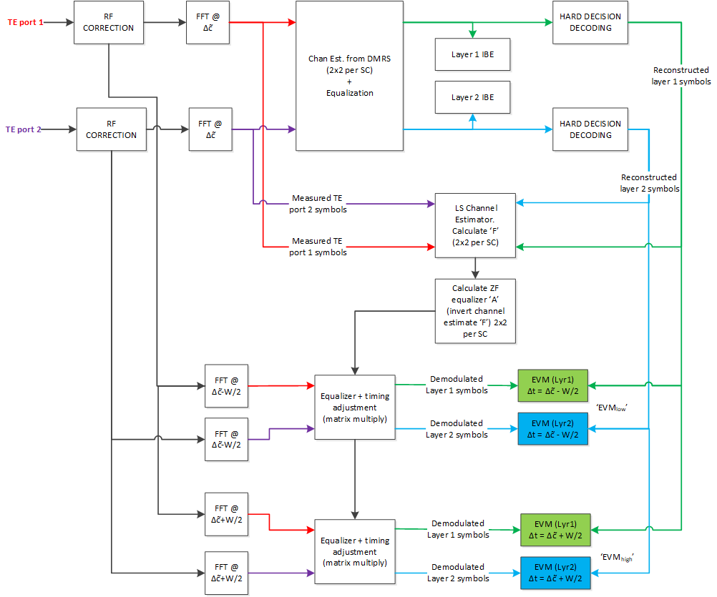

- Alt 2-2-1-2: adopt 2L MIMO demodulation scheme in [R4-2107111] as the basis for TE employing dual receive chains

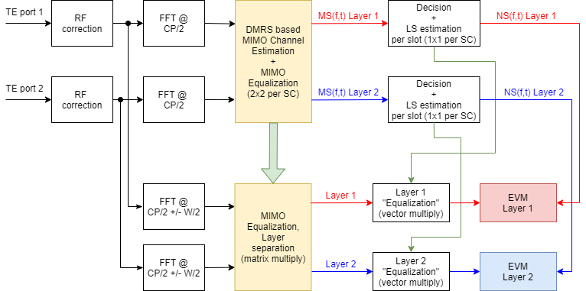

**Issue 2-2-2: EVM measurement setup (1L MIMO)**

- Alt 2-2-2-1: adopt 1L MIMO demodulation scheme in [R4-2104489] as the basis for TE employing dual receive chains

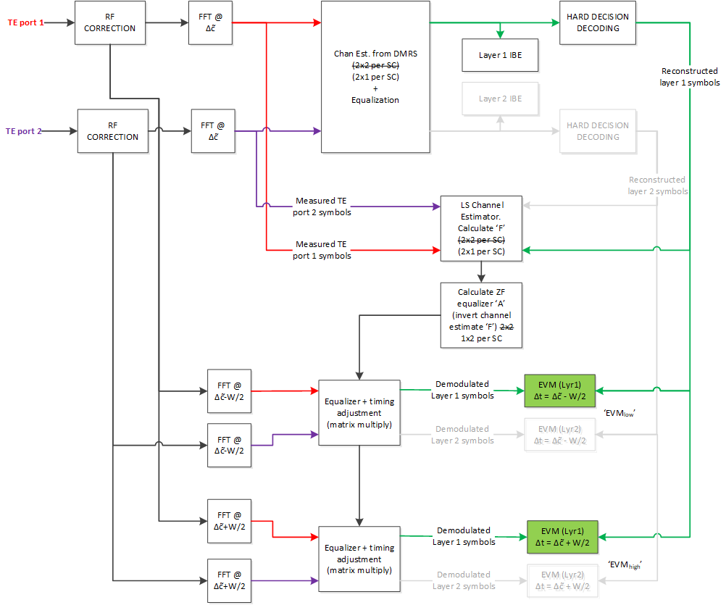

- Alt 2-2-2-2: adopt 1L MIMO demodulation scheme in [R4-2107111] as the basis for TE employing dual receive chains

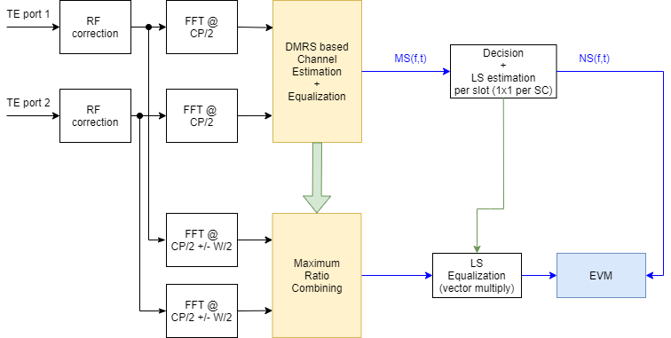

**Issue 2-2-3: EVM measurement parameters**

- Proposal:

- For EVM test, different polarization angles shall be applied to avoid test results be affected due to polarization basis mismatch

- RAN4 shall send LS to RAN5 to notify the EVM issue and the agreed solution(s)

- Proposed procedure in [R4-2104558] is below:

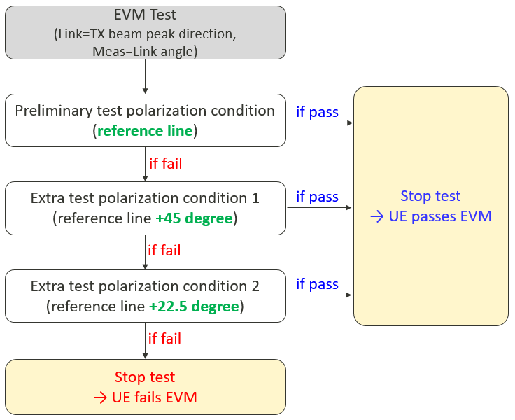

## Companies views’ collection for 1st round

### Open issues

|  |  |
| --- | --- |
| **Issue** | **Company comments** |
| **Issue 2-1-1: TPMI method** | Qualcomm: The alternatives are not mutually exclusive, so the comments are against each of the listed alternatives:   1. -1 is not complete without resolving -2. 2. Alt -3 is agreeable. 3. Alt -4: we agree with this aspect ‘For nonCoherent UEs which do not support full power transmission (mode-1, mode-full power), 2-port transmission shall be not configured’ . Our understanding however is that RAN5 expects the opposite, so it would behoove us to invite them into the conversation if we pursue this route. |
|  |
|  |
|  |
|  |
| **Issue 2-1-2: 2-port CSI-RS** | Qualcomm: More details are needed…. For example how do we ensure that CSIRS port to polarization mapping matches that of PDSCH?  Also would proponent (MediaTek) kindly provide reference for definition of density = 2? |
|  |
|  |
|  |
|  |
| **Issue 2-1-3: Other methods** | Qualcomm:   1. The reference cited by the proponent itself says ‘The use of circular polarization in wireless telecommunications is very untypical’. In our view unless gNBs are restricted to using CP for DL, it is not good practice to use CP in TE as representative of a typical deployment in LOS condition. 2. UE UL is already captured by two orthogonally polarized antennae. So would proponent (Oppo) kindly elaborate on what their proposal 2 would change. |
| Keysight: similar comments as QC. The KS contribution R4-1904192 lists Observations 5 through 14 commenting on the adverse effects of CP. |
|  |
|  |
|  |
| **Issue 2-2-1: EVM measurement setup (2L MIMO)** | Qualcomm: Prefer Alt 2-2-1-1.  Our concern with Alt -2 is that it has fundamentally different structure than the legacy method, and in our estimation, will yield a pessimistic result for the UE.  Recall that in the legacy method (and in alt -1), an LS estimator is used to estimate the channel. In alt-1, the LS estimator estimates all 4 elements of the channel estimate. The LS estimate is an average over multiple symbols which minimizes error in all 4 elements.  In the Alt-2 method, a 2 stage method is applied, where the first stage uses only DMRS for bulk of the channel inversion process, with a second LSE based ‘refinement’ stage that only operates on each layer individually. Estimation from DMRS is inherently noisy (compared to an LSE estimate derived from averaging over multiple symbols), i.e each of the 4 elements in the channel matrix has some random error associated with it. Now, the second stage only acts on individual layers (effectively the refinement stage is a diagonal matrix). We would need 4 degrees of freedom to individually adjust each of the 4 noisy DMRS-based channel estimate elements, but the diagonal matrix of the refinement stage only provides 2 degrees of freedom. Consequently, this method does not have an effective refinement method, and will have an inferior channel estimate that will lead to pessimistic results. |
|  |
|  |
|  |
|  |
| **Issue 2-2-2: EVM measurement setup (1L MIMO)** | Qualcomm: 2-2-2-1  2L and single layer treatment would have to be treated as a package. |
|  |
|  |
|  |
|  |
| **Issue 2-2-3: EVM measurement parameters** | Qualcomm: Proposal not necessary. Prefer to resolve through 2-2-1 and 2-2-2 |
| Keysight: support polarization scan if 2-2-1 and 2-2-2 are not agreed |
|  |

### CRs/TPs comments collection

Moderator’s note: Although R4-2107111 “Text proposal to TR38.884: FR2 UL EVM measurements” was submitted to the meeting as a text proposal to the TR, it is recommended to first align on the technical details of the UL EVM measurement scheme before drafting/editing the TP. TP discussion can follow in Round 2.

## Summary for 1st round

### Open issues

*Moderator tries to summarize discussion status for 1st round, list all the identified open issues and tentative agreements or candidate options and suggestion for 2nd round i.e. WF assignment.*

|  |  |
| --- | --- |
| **Issue** | **Status summary** |
| **Issue 2-1-1: TPMI method** | *Tentative agreements:*  *Candidate options:*  *Recommendations for 2nd round:* |
| **Issue 2-1-2: 2-port CSI-RS** | *Tentative agreements:*  *Candidate options:*  *Recommendations for 2nd round:* |
| **Issue 2-1-3: Other methods** | *Tentative agreements:*  *Candidate options:*  *Recommendations for 2nd round:* |
| **Issue 2-2-1: EVM measurement setup (2L MIMO)** | *Tentative agreements:*  *Candidate options:*  *Recommendations for 2nd round:* |
| **Issue 2-2-2: EVM measurement setup (1L MIMO)** | *Tentative agreements:*  *Candidate options:*  *Recommendations for 2nd round:* |

### CRs/TPs

*N/A*

## Discussion on 2nd round (if applicable)

*Moderator can provide summary of 2nd round here. Note that recommended decisions on tdocs should be provided in the section titled ”Recommendations for Tdocs”.*

# Topic #3: inter-band (FR2+FR2) CA

*Main technical topic overview. The structure can be done based on sub-agenda basis.*

## Companies’ contributions summary

|  |  |  |
| --- | --- | --- |
| **T-doc number** | **Company** | **Proposals / Observations** |
| [R4-2104958](http://www.3gpp.org/ftp/tsg_ran/WG4_Radio/TSGR4_98bis_e/Docs/R4-2104958.zip) | Anritsu Corporation | **TP to TR 38.884 on Inter-band DL CA in FR2**  Observation 1: The shortest distance between antennae is around 40 to 50 mm when we take into consideration of the mutual coupling effect and the system assembly procedures.  Observation 2: A post processing of obtained data and an adjustment of start/ stop coordinates to measure are necessary.  Observation 3: Care must be taken to avoid diffraction and/or scattering effects created by the reflector’s paraboloid edges when fixing the offset antenna with a tilt.  Observation 4: The best distance of each antenna and a reflector varies with the test system depending on the frequency coverage in FR2.  Observation 5: When we consider a design that a placement of the offset antenna is above the main antenna, there might be another factor to increase the measurement uncertainty since coordinates of the measurement grid changes.  Proposal 1: It is proposed to approve the text proposal related to the design of offset antenna test system for inter-band DL CA (FR2 + FR2) tests. |

## Open issues summary

*Since the only submitted contribution to this topic is a text proposal, it is recommended to focus on stabilizing the TP contents during the email discussion.*

### Sub-topic 3-1

*N/A*

## Companies views’ collection for 1st round

### Open issues

*N/A*

### CRs/TPs comments collection

*Major close to finalize WIs and Rel-15 maintenance, comments collections can be arranged for TPs and CRs. For Rel-16 on-going WIs, suggest to focus on open issues discussion on 1st round.*

|  |  |
| --- | --- |
| **CR/TP number** | **Comments collection** |
| R4-2104958 TP to TR 38.884 on Inter-band DL CA in FR2 | Company A |
| Company B |
|  |

## Summary for 1st round

### Open issues

*N/A*

### CRs/TPs

*Moderator tries to summarize discussion status for 1st round and provided recommendation on CRs/TPs Status update suggestion*

|  |  |
| --- | --- |
| **CR/TP number** | **CRs/TPs Status update recommendation** |
| R4-2104958 TP to TR 38.884 on Inter-band DL CA in FR2 | *Based on 1st round of comments collection, moderator can recommend the next steps such as “agreeable”, “to be revised”* |

## Discussion on 2nd round (if applicable)

*Moderator can provide summary of 2nd round here. Note that recommended decisions on tdocs should be provided in the section titled ”Recommendations for Tdocs”.*

# Topic #4: extreme temperature conditions

*Main technical topic overview. The structure can be done based on sub-agenda basis.*

## Companies’ contributions summary

|  |  |  |
| --- | --- | --- |
| **T-doc number** | **Company** | **Proposals / Observations** |
| [R4-2104521](http://www.3gpp.org/ftp/tsg_ran/WG4_Radio/TSGR4_98bis_e/Docs/R4-2104521.zip) | vivo | **TP to TR38.884 v0.2.0 on ETC system** |
| [R4-2104570](http://www.3gpp.org/ftp/tsg_ran/WG4_Radio/TSGR4_98bis_e/Docs/R4-2104570.zip) | Anritsu Corporation | **Considerations on ETC MUs and a testability**  Observation 1: Since there are no agreements on common assumptions regarding the ETC enclosure, we cannot apply in ETC the same MUs as used under normal temperature condition (NTC).  Observation 2: Since there are no agreements on common assumptions regarding the ETC enclosure, it is difficult to discuss ETC MUs and test requirements among vendors under equal conditions.  Observation 3: Assumptions of ETC test environment may already vary between vendors and it could be difficult to align them anymore.  Observation 4: We need to consider the differences between vendors when discussing MUs, test environments and requirements under ETC.  Observation 5: There is no significant difference of path loss between the NTC and ETC environment up to 49 GHz, approximately 0.1 dB at most.  Observation 6: For ETC tests with band n262, it is expected that we can use same variety of ETC measurement uncertainty contributions for lower frequency bands. Actual MU values are FFS. |
| [R4-2107128](http://www.3gpp.org/ftp/tsg_ran/WG4_Radio/TSGR4_98bis_e/Docs/R4-2107128.zip) | Keysight Technologies | **On extreme temperature condition testing**  Observation 1: The measurement uncertainty work on the MOP-EIRP and REFSENS-EIS test cases performed under ETC have been finalized  Observation 2: ETC testing including full 3D beam peak searches can proceed as planned with Release 15  Observation 3: The restrictions in 38.101-2 that UE EIRP and EIS spherical coverage, Power control, EVM, and UE beam correspondence are not testable should be revised and test cases applicable to ETC in FR1 should be considered applicable to ETC in FR2 as part of Release 15 maintenance.  Proposal 1: Consider full 3D scans the default approach for BP searches and have RAN5 consider partial scans based on vendor declarations at a later time  Proposal 2: RAN4 should assume that ETC testing is feasible from a testability perspective for all FR2 UE RF test cases  Proposal 3: Define the temperature tolerance to be ±4oC as the RAN4 recommendation and inform RAN5 via an LS. |

## Open issues summary

*Before e-Meeting, moderators shall summarize list of open issues, candidate options and possible WF (if applicable) based on companies’ contributions.*

### Sub-topic 4-1

**Issue 4-1-1: Applicability of ETC**

- Proposal [R4-2107128]:

- The restrictions in 38.101-2 that UE EIRP and EIS spherical coverage, Power control, EVM, and UE beam correspondence are not testable should be revised and test cases applicable to ETC in FR1 should be considered applicable to ETC in FR2 as part of Release 15 maintenance.

- Consider full 3D scans the default approach for BP searches and have RAN5 consider partial scans based on vendor declarations at a later time

- RAN4 should assume that ETC testing is feasible from a testability perspective for all FR2 UE RF test cases

**Issue 4-1-2: ETC MU**

- Alt 4-1-2-1 [R4-2104570]

- Need to consider the differences between vendors when discussing MUs, test environments and requirements under ETC

- Max difference of path loss between the NTC and ETC environment up to 49 GHz is ~0.1 dB

- For ETC tests with band n262, it is expected that we can use same variety of ETC measurement uncertainty contributions for lower frequency bands. Actual MU values are FFS

- Alt 4-1-2-2 [R4-2107128]

- The measurement uncertainty work on the MOP-EIRP and REFSENS-EIS test cases performed under ETC have been finalized

- Define the temperature tolerance to be ±4oC as the RAN4 recommendation and inform RAN5 via an LS.

## Companies views’ collection for 1st round

### Open issues

|  |  |
| --- | --- |
| **Issue** | **Company comments** |
| **Issue 4-1-1: Applicability of ETC** | Qualcomm: Agree |
| Keysight: support |
|  |
|  |
|  |
| **Issue 4-1-2: ETC MU** | Keysight:  Alt 4-1-2-1: do not support that differences between vendors need to be considered. Every vendor is free to make certain design decisions. The ETC enclosure should not be considered differently than for instance IFF reflector size, absorbers, chamber size, etc.  Alt 4-1-2-2: support |
|  |
|  |
|  |
|  |

### CRs/TPs comments collection

*Major close to finalize WIs and Rel-15 maintenance, comments collections can be arranged for TPs and CRs. For Rel-16 on-going WIs, suggest to focus on open issues discussion on 1st round.*

|  |  |
| --- | --- |
| **CR/TP number** | **Comments collection** |
| R4-2104521 TP to TR38.884 v0.2.0 on ETC system | Keysight:   * Figure 5.4.1-1 is misleading as it seems to indicate that the ETC enclosure contains the positioning system as well * Clause 5.4.1: last sentence/bullet is not applicable since QoQZ MU was specified in RAN5#90 * Clause 5.4.4: should take conclusion of R4-2107128 into account |
| Company B |
|  |

## Summary for 1st round

### Open issues

*Moderator tries to summarize discussion status for 1st round, list all the identified open issues and tentative agreements or candidate options and suggestion for 2nd round i.e. WF assignment.*

|  |  |
| --- | --- |
|  | **Status summary** |
| **Issue 4-1-1: Applicability of ETC** | *Tentative agreements:*  *Candidate options:*  *Recommendations for 2nd round:* |
| **Issue 4-1-2: ETC MU** | *Tentative agreements:*  *Candidate options:*  *Recommendations for 2nd round:* |

### CRs/TPs

*Moderator tries to summarize discussion status for 1st round and provided recommendation on CRs/TPs Status update suggestion*

|  |  |
| --- | --- |
| **CR/TP number** | **CRs/TPs Status update recommendation** |
| R4-2104521 TP to TR38.884 v0.2.0 on ETC system | *Based on 1st round of comments collection, moderator can recommend the next steps such as “agreeable”, “to be revised”* |

## Discussion on 2nd round (if applicable)

*Moderator can provide summary of 2nd round here. Note that recommended decisions on tdocs should be provided in the section titled ”Recommendations for Tdocs”.*

# Topic #5: enhancements to reduce test time

*Main technical topic overview. The structure can be done based on sub-agenda basis.*

## Companies’ contributions summary

|  |  |  |
| --- | --- | --- |
| **T-doc number** | **Company** | **Proposals / Observations** |
| [R4-2104518](http://www.3gpp.org/ftp/tsg_ran/WG4_Radio/TSGR4_98bis_e/Docs/R4-2104518.zip) | vivo | **(draft) LS on antenna assumption and measurement grids for FR2 PC3 UE**  LS to 3GPP RAN5  1 Overall description  The antenna assumption of UE is important to define corresponding measurement grids which has great impacts on FR2 conformance testing time. In the FR2 test method enhancement SI, RAN4 has studied some approaches to reduce the test time [1]. New measurement grids based on reasonable antenna assumption of FR2 PC3 UE is one of the basic approaches to reduce the measurement time.  RAN4 has agreed the new antenna assumption [2]:  For PC3 UE, antenna assumption of 4x2 array is agreed.  Keeping the same upper bound of measurement grid MU, the new measurement grids based on 4x2 antenna array for spherical coverage, TRP and Tx/Rx beam peak search measurement, need be defined.  The new measurement grids can be adopted for FR2 RF conformance test case as an additional option.  The selection of the new measurement grid with 4x2 array is based on optional vendor declaration.  To reduce the impacts on RAN5 test spec, the system-related assumptions are kept unchanged in RAN5, i.e., based on the previously agreed worst case 8x2 assumptions.  An example of Min Number of Grid Points for TX/RX Beam Peak Search (366 for constant-step type, 275 for constant density type) is presented in the following table, which shows ~3 times improvement.   |  |  |  |  | | --- | --- | --- | --- | | **Antenna**  **Assumption Grid Type** | **8x2** | **4x2** | **Factor of Improvement** | | **Constant-Step Size** | 1106 | 366 | 3.0 | | **Constant-Density** | 800 | 275 | 2.9 |   The new measurement grids can be used for both NTC and ETC.  Currently, RAN4 is also working on other approaches to reduce FR2 test time.  Reference:  [1] R4-2017597 WF on testability enhancements to reduce test time, vivo, Samsung  [1] R4-2103920 WF on ETC and test time reduction, vivo  2 Actions  To RAN5:  ACTION: RAN4 respectfully asks RAN5 to take the new antenna assumption and measurement grids into account in FR2 test conformance test cases. |
| [R4-2104519](http://www.3gpp.org/ftp/tsg_ran/WG4_Radio/TSGR4_98bis_e/Docs/R4-2104519.zip) | vivo | **Discussion and TP to TR38.884 on FR2 test time reduction**  Observation 1: Several DUT antenna location assumptions have been used for FR2 simulation.  Observation 2: Absolute and Relative SS RSRP in 38.133 are defined only for test purposes different than beampeak search and they cannot be used to determine the beampeak search accuracy.  Observation 3: The new accuracy of RSRP for Rx beam peak search at high power level should not be defined according to the same simulation procedure for RRM.  Observation 4: Even consider a bad UE performance which just pass the requirement of peak EIS and spherical coverage (i.e. gain drop ~12.8dB), for the beam directions fulfil spherical coverage, the SNR is larger than 17.2dB in a typical FR2 RF test system.  Proposal 1: The TRP and spherical coverage measurement grids based on 4x2 antenna array assumption should be derived.  Proposal []: 2：RAN4 should decide the antenna location of 4x2 antenna array for spherical coverage measurement grids simulation, three options can be considered:  Proposal 3: Adopt RSRP(B)&EIS-based measurement for Rx beam peak search.  Proposal 4: RAN4 should discuss a reasonable threshold value [x]dB for 2nd step EIS searching, after 1st step 3D RSRP scan.  Proposal 5: RAN4 should develop a reasonable RSRP accuracy value for Rx beam peak search.  Proposal 6: For RSRP accuracy analysis, the SNR17dB condition should be considered.  Proposal 6: For RSRP accuracy analysis, the SNR17dB condition should be considered. |
| [R4-2105001](http://www.3gpp.org/ftp/tsg_ran/WG4_Radio/TSGR4_98bis_e/Docs/R4-2105001.zip) | LG Electronics | **Discussion on test time reduction for FR2 OTA test time**  Proposal 1: Reuse test procedure of Rx beam peak search based on RSRPB for demodulation and CSI testing  Proposal 2: It should be considered to determine which single link polarization to be used for the test based on UE declaration.  Proposal 3: The UEs supporting Mode-2 and Mode-full power for ULFPTx should be tested by existing test method using two link polarization. |
| [R4-2105044](http://www.3gpp.org/ftp/tsg_ran/WG4_Radio/TSGR4_98bis_e/Docs/R4-2105044.zip) | Samsung | **Discussion on prioritized methods for test time reduction**  Observation 1: our simulation shows that the 8x2 array based measurement grids in TR38.810 corresponds to the same 0.5dB system error at 95% confidence level, though the standard deviation may be different for different test cases.  Proposal 1: adopt new measurement grid for spherical coverage based on 4x2 array as 146 points (20º step size) for constant step size grid type.  Proposal 2: For the RX beam peak search test case, both RSRP and RSRPB are doable, and it is slightly preferred to reuse previously defined SS-RSRPB.  Proposal 3: only RSRP(B)-based measurement is enough for RX beam peak search and additional EIS local scan is not necessary.  Proposal 4: for EIRP test of UL MIMO and Tx diversity, by default single Pollink can be randomly selected from either theta Pollink or phi Pollink. |
| [R4-2107110](http://www.3gpp.org/ftp/tsg_ran/WG4_Radio/TSGR4_98bis_e/Docs/R4-2107110.zip) | Rohde & Schwarz | **Text proposal to TR38.884: Fast Spherical Coverage Method** |
| [R4-2107129](http://www.3gpp.org/ftp/tsg_ran/WG4_Radio/TSGR4_98bis_e/Docs/R4-2107129.zip) | Keysight Technologies UK Ltd | Draft LS to RAN5 on Test Time Reduction  LS to RAN WG5  The enhanced testability SI (Acronym: FS_FR2_enhTestMethods; Latest approved SID: RP-210633) includes one topic/objected related to test time reduction   |  | | --- | | 5. Study testability enhancements to reduce test time  - Including RF test method enhancement with reduced test time, and possible test time saving approach for UE Demodulation test and RRM test |   One suitable approach to reduce overall test time for conformance testing was related to the antenna array assumption; other approaches are still under discussion. In RAN4, antenna array configurations ranging from 4x1 to 8x2 were considered for testability and preliminary MU assumptions. In the end, the 8x2 antenna array assumptions were selected as worst case which was also adopted in RAN5 to finalize MUs, the Maximum Test System Uncertainty (MTSU), and Test Tolerances (TTs).  Based on feedback from OEMs in RAN4, many PC3 UE implementations utilize antenna array configurations with fewer elements than 8x2, e.g., one OEM highlighted that “only 4 antenna elements are the dominant configuration in commercial PC3 UE.” Thus, measurement grid analyses were performed for the beam peak searches, a pre-requisite for all NR FR2 UE RF and many RRM test cases and a large contributor in terms of overall test time, to quantify the test time reduction impact of the relaxed 4x2 array configuration. Those results for the minimum number of grid points of the TX/RX beam peak searches are summarized below; clearly, the reduction of grid points by ~1/3 yields a significant improvement in test time.   |  |  |  |  | | --- | --- | --- | --- | | Antenna  Assumption  Grid Type | 8x2 | 4x2 | Factor of Improvement | | Constant-Step Size | 1106 | 366 | 3.0 | | Constant-Density | 800 | 275 | 2.9 |   Since RAN5 has finalized maximum test system uncertainties (MTSUs) and test tolerances (TTs) for many test cases already, it is not suggested to change the baseline antenna array assumptions at this point as this will have significant impact in RAN5 and industry since changes in MU/MTSU could have impact on certifications and test platform validations. It is furthermore proposed for RAN5 to keep all system-related assumptions, e.g., related to max antenna aperture of D=5cm for PC3, based on the 8x2 antenna array assumptions.  Given the improvement in test time, it is suggested for RAN5 to support a relaxation of the beam peak search measurement grid requirements for the beam peak searches, TRP, and spherical coverage based on an optional vendor declaration.  2. Actions  To RAN WG5  RAN4 respectfully asks RAN5 to take the above information into consideration to support test time reduction efforts and to determine the min required number of grid points for TRP, spherical coverage, beam peak search for the 4x2 antenna configuration. |
| [R4-2107296](http://www.3gpp.org/ftp/tsg_ran/WG4_Radio/TSGR4_98bis_e/Docs/R4-2107296.zip) | Huawei, HiSilicon | **Discussion on enhance test method to reduce FR2 OTA test time**  Observation 1: ：An important prerequisite for single link polarization measurement is that dual polarization receiving antennas have the same beam.  Proposal 1: Single link polarization measurement can be selected based on manufacturer declarations. |

## Open issues summary

*Before e-Meeting, moderators shall summarize list of open issues, candidate options and possible WF (if applicable) based on companies’ contributions.*

### Sub-topic 5-1: prioritized potential solutions

**Issue 5-1-1: New measurement grid (1-MG)**

- Alt 5-1-1-1: Simulation assumptions to derive MU contribution of the 4x2 measurement grid need to be further aligned based on the following options:

- Option 1: reuse the antenna array location defined in TR38.810 for Rel-15 spherical coverage measurement grid to keep the simulation parameters consistency (front and back, in the centre)

- Option 2: the antenna array location is aligned with that for Rel-15 spherical coverage requirement definition (left and right)

- Option 3: reuse the antenna array location in TR 38.884 for beam management sensitivity study (front and back, in the corner)

- Alt 5-1-1-2: to keep the same MU (0.5dB at 95% confidence level), simulation for spherical coverage measurement grid based on 8x2 array and 4x2 array are performed respectively. 8x2 array with 15º step size shows 0.247dB standard deviation and 4x2 array with 20º step size shows 0.254dB standard deviation

|  |  |  |  |
| --- | --- | --- | --- |
| **Antenna  Assumption  Grid Type** | **8x2** | **4x2** | **Factor of Improvement** |
| **Constant-Step Size** | 266  (15o step)  (σ=0.247dB) | 146  (20o step)  (σ=0.254dB) | 1.8 |

**Issue 5-1-2: RSRP(B) based RX beam peak search (2-RSRP)**

- Alt 5-1-2-1: adopt the measurement procedure proposed in [R4-2104519], including:

- RAN4 should discuss a reasonable threshold value [x]dB for 2nd step EIS searching, after 1st step 3D RSRP scan.

- For RSRP accuracy analysis, the SNR>17dB condition should be considered.

- Alt 5-1-2-2: reuse test procedure of Rx beam peak search based on RSRPB for demodulation and CSI testing

**Issue 5-1-3: 3-Single Pollink**

- Alt 5-1-3-1: for EIRP test of UL MIMO and Tx diversity, by default single Pollink can be randomly selected from either theta Pollink or phi Pollink

- Alt 5-1-3-2: consider using a single link polarization based on UE declaration

- Alt 5-1-3-3: UEs supporting Mode-2 and Mode-full power for UL MIMO should be tested by existing test method using two link polarization

## Companies views’ collection for 1st round

### Open issues

|  |  |
| --- | --- |
| **Issue** | **Company comments** |
| **Issue 5-1-1: New measurement grid (1-MG)** | Qualcomm: Option 1 in Alt 5-1-1-1 makes more sense. Per our understanding, Alt 5-1-1-2 is based on the assumptions used in TR38.810 for Rel-15 spherical coverage measurement, i.e., option 1. |
| Keysight:  Alt 5-1-1-1: support Option 1 to keep consistency with how MU was defined in RAN4 and RAN5.  Alt 5-1-1-2: as highlighted in Table M.3.1.1.3-2 of TS38.521-2, the spherical coverage MU (std. deviation) for the 8x2 array with 15deg step size is 0.12dB. The results in R4-2105044 do not reflect this MU. However, a spherical coverage analysis with the 4x2 array and constant-density grid yields the following results   |  |  |  |  | | --- | --- | --- | --- | | **Step Size [o]** | **Number of unique grid points** | **Std. Dev [dB]** | **|Mean Error| [dB]** | | 10.0 | 614 | 0.04 | 0.00 | | 12.0 | 422 | 0.04 | 0.01 | | 15.0 | 266 | 0.05 | 0.01 | | 20.0 | 146 | 0.08 | 0.03 | | 22.5 | 114 | 0.11 | 0.03 | | 30.0 | 62 | 0.13 | 0.04 | | 45.0 | 26 | 0.27 | 0.13 |   These results yield a grid of 22.5deg step size with ~0.12dB std. deviation, i.e., a similar conclusion as in R4-2105044 can be drawn. |
|  |
|  |
|  |
| **Issue 5-1-2: RSRP(B) based RX beam peak search (2-RSRP)** |  |
| Qualcomm: Option 2 sounds like a potential WF, but we would like some clarifications from Vivo to further develop the idea:   1. ‘1.) Perform a 3D RSRP measurement on both polarizations for each point on the measurement grid’: What is ‘on both polarizations’? are you mandating two separate DL measurements (how to construct the composite of the two?). if instead you mean the TE should transmit on both ports, why is this beneficial? 2. We are not sure how [x] dB would be used. Would you list the steps the TE could take if say 3 different directions had peak RSRP readings with say a dB of each other? What procedure would the TE use to identify if all the 3 directions were part of the same peak? 3. Do RSRP measurement and EIS measurement both use the same measurement grid or different ones? |
| Keysight:  There were concerns raised in the past that the RSRP(B) approach for RX BP search is not applicable since the RSRP(B) measurements are commonly performed on the rough (wide) beams while EIS is performed on the fine (narrow) beams. It is suggested to hold off on the proposed approach until it can be confirmed that RSRP(B) measurements trigger fine beams. |
|  |
|  |
| **Issue 5-1-3: 3-Single Pollink** | Qualcomm: 5-1-3-1  Alt 5-1-3-2 is not justifiable because the UE cannot pick and choose DL polarization in the field.  Alt 5-1-3-3 is a proposal to not change, which is the default condition anyway. |
|  |
|  |
|  |
|  |

### CRs/TPs comments collection

*Major close to finalize WIs and Rel-15 maintenance, comments collections can be arranged for TPs and CRs. For Rel-16 on-going WIs, suggest to focus on open issues discussion on 1st round.*

|  |  |
| --- | --- |
| **CR/TP/LS number** | **Comments collection** |
| R4-2104518 (draft) LS on antenna assumption and measurement grids for FR2 PC3 UE | Company A |
| Company B |
|  |
| R4-2107129 Draft LS to RAN5 on Test Time Reduction | Company A |
| Company B |
|  |
| R4-2104519 Discussion and TP to TR38.884 on FR2 test time reduction | Company A |
| Company B |
|  |
| R4-2107110 Text proposal to TR38.884: Fast Spherical Coverage Method | Keysight (did not realize the note below until after comments were added; thought it would be useful to provide this feedback early just in case): We agree to the early pass approach; however, we cannot agree to allow measurements beyond 90deg if the re-positioning concept is adopted, i.e., as agreed earlier, only measurements in one hemisphere up to 90deg should be considered. In Clause 8.1.2, Steps 17 and 18 should therefore change the 112.5deg to 90deg and in Clause 8.1.3, Steps 10 and 11 should change the 112.5deg to 90deg. |
|  |
|  |

Moderator’s note: the submitted text proposal R4-2107110 “Text proposal to TR38.884: Fast Spherical Coverage Method” is related to the “4-others” category of potential solutions. According to the agreed WF last meeting, work on categories 1, 2, and 3 is prioritized. It is recommended to return to this TP during the second round of discussion.

## Summary for 1st round

### Open issues

*Moderator tries to summarize discussion status for 1st round, list all the identified open issues and tentative agreements or candidate options and suggestion for 2nd round i.e. WF assignment.*

|  |  |
| --- | --- |
| **Issue** | **Status summary** |
| **Issue 5-1-1: New measurement grid (1-MG)** | *Tentative agreements:*  *Candidate options:*  *Recommendations for 2nd round:* |
| **Issue 5-1-2: RSRP(B) based RX beam peak search (2-RSRP)** | *Tentative agreements:*  *Candidate options:*  *Recommendations for 2nd round:* |
| **Issue 5-1-3: 3-Single Pollink** | *Tentative agreements:*  *Candidate options:*  *Recommendations for 2nd round:* |

### CRs/TPs

*Moderator tries to summarize discussion status for 1st round and provided recommendation on CRs/TPs Status update suggestion*

|  |  |
| --- | --- |
| **CR/TP/LS number** | **CRs/TPs Status update recommendation** |
| R4-2104518 (draft) LS on antenna assumption and measurement grids for FR2 PC3 UE | *Based on 1st round of comments collection, moderator can recommend the next steps such as “agreeable”, “to be revised”* |
| R4-2107129 Draft LS to RAN5 on Test Time Reduction | *Based on 1st round of comments collection, moderator can recommend the next steps such as “agreeable”, “to be revised”* |
| R4-2104519 Discussion and TP to TR38.884 on FR2 test time reduction | *Based on 1st round of comments collection, moderator can recommend the next steps such as “agreeable”, “to be revised”* |

## Discussion on 2nd round (if applicable)

*Moderator can provide summary of 2nd round here. Note that recommended decisions on tdocs should be provided in the section titled ”Recommendations for Tdocs”.*

# Topic #6: extension of permitted methods to band n262

*Main technical topic overview. The structure can be done based on sub-agenda basis.*

## Companies’ contributions summary

|  |  |  |
| --- | --- | --- |
| **T-doc number** | **Company** | **Proposals / Observations** |
| [R4-2104896](http://www.3gpp.org/ftp/tsg_ran/WG4_Radio/TSGR4_98bis_e/Docs/R4-2104896.zip) | Apple | **On permitted test methods for demodulation in band n262**  Observation 1: The relative increase in free space path loss from 43.5 GHz to 48.2 GHz is 0.9 dB  Observation 2: The relative increase in cable loss per meter from 43.5 GHz to 48.2 GHz is 0.33 dB  Observation 3: The values of probe antenna gain and backoff from P1dB need to be further checked with test equipment vendors to verify their applicability to band n262  Observation 4: In general, we observe a 3.5 dB degradation in maximum achievable SNR for band n262 relative to the budgeted values in TR38.810.  Proposal 1: Finalize the set of band-dependent parameters and values for the demodulation test setup SNR calculation based while taking Table 1 as the baseline.  Proposal 2: Calculate the maximum achievable SNR for the RRM test setup once the band-dependent parameters in Table 1 are resolved. |

## Open issues summary

### Sub-topic 6-1: demodulation setup

**Issue 6-1-1: Band-dependent parameters for the demodulation setup**

- Proposal: Finalize the set of band-dependent parameters and values for the demodulation test setup SNR calculation based while taking the table below as the baseline.

|  |  |  |
| --- | --- | --- |
| Parameter | Value | Comment |
| REFSENS | -82.8 dBm/50 MHz | Using REFSENS agreed for band n262 |
| Multi-band relaxation | 1.0 dB | Defined as ceil(.); change from 2.0 dB |
| FS path loss | -63.2 dB | Change from -62.3 dB (scaling from 43.5 to 48.2 GHz) |
| Cable loss | -8.7 dB | Additional 0.33 dB/m in cable loss at 48.2 GHz |
| Probe antenna gain | [12.0] dB | Needs checking |
| Backoff from P1dB | [13.0] dB | Needs checking |

## Companies views’ collection for 1st round

### Open issues

|  |  |
| --- | --- |
| **Issue** | **Company comments** |
| **Issue 6-1-1: Band-dependent parameters for the demodulation setup** | Qualcomm: In general, the SNR calculation is fine. RAN5 has updated the xls from RAN4 to account for additional changes, such as lower cable loss, and FS path loss. Are the parameters listed in the above table in line with latest parameters concluded in RAN5? |
|  |
|  |
|  |
|  |

### CRs/TPs comments collection

*N/A*

## Summary for 1st round

### Open issues

*Moderator tries to summarize discussion status for 1st round, list all the identified open issues and tentative agreements or candidate options and suggestion for 2nd round i.e. WF assignment.*

|  |  |
| --- | --- |
| **Issue** | **Status summary** |
| **Issue 6-1-1: Band-dependent parameters for the demodulation setup** | *Tentative agreements:*  *Candidate options:*  *Recommendations for 2nd round:* |

### CRs/TPs

*N/A*

## Discussion on 2nd round (if applicable)

*Moderator can provide summary of 2nd round here. Note that recommended decisions on tdocs should be provided in the section titled ”Recommendations for Tdocs”.*

# Topic #7: rapporteur input

*Main technical topic overview. The structure can be done based on sub-agenda basis.*

## Companies’ contributions summary

|  |  |  |
| --- | --- | --- |
| **T-doc number** | **Company** | **Proposals / Observations** |
| [R4-2104523](http://www.3gpp.org/ftp/tsg_ran/WG4_Radio/TSGR4_98bis_e/Docs/R4-2104523.zip) | vivo | **TP to TR38.884 v0.2.0 on MU Annex** |
| [R4-2104897](http://www.3gpp.org/ftp/tsg_ran/WG4_Radio/TSGR4_98bis_e/Docs/R4-2104897.zip) | Apple, vivo | **Rapporteur input to TR38.884** |
| [R4-2104898](http://www.3gpp.org/ftp/tsg_ran/WG4_Radio/TSGR4_98bis_e/Docs/R4-2104898.zip) | Apple, vivo | **TR38.884 work split** |

## Open issues summary

*Before e-Meeting, moderators shall summarize list of open issues, candidate options and possible WF (if applicable) based on companies’ contributions.*

### Sub-topic 7-1: TR work split

**Issue 7-1-1: TR work split**

Proposal:

|  |  |
| --- | --- |
| Clause | TP Editor Company |
| 5.1         High DL power and low UL power | Keysight and R&S (1) |
| 5.2         Polarizaton basis mismatch between the UE and DUT | Apple |
| 5.3         Inter-band (FR2+FR2) CA | Anritsu |
| 5.4         Extreme temperature conditions | vivo |
| 5.5         Extension of frequency applicability for band n262 [this is the RF part] | vivo |
| 6.1         Extension of frequency applicability for band n262 [this is the RRM part] | Apple |
| 7.1         Extension of frequency applicability for band n262 [this is the demodulation part] | Apple |
| 8            Test time reduction (including RF, RRM, and demodulation scope) | vivo and Huawei (1) |
| B.1         Measurement uncertainty budget for UE RF testing methodology | vivo |
| NOTE 1: For TR clauses where multiple companies are listed as TP editors, the expectation is that they will prepare a single text proposal prior to the start of each meeting based on consensus; any additional or alternative proposals can be submitted in each company’s own and separate discussion paper | |

- This work split is separate from WF assignments, since that is very much topic driven depending on the meeting and major issues which come up.

- Clause numbering takes the removal of the 256QAM objective into account (please see R4-2104897)

## Companies views’ collection for 1st round

### Open issues

|  |  |
| --- | --- |
| **Issue** | **Company comments** |
| **Issue 7-1-1: TR work split** |  |
|  |
|  |
|  |
|  |

### CRs/TPs comments collection

*Major close to finalize WIs and Rel-15 maintenance, comments collections can be arranged for TPs and CRs. For Rel-16 on-going WIs, suggest to focus on open issues discussion on 1st round.*

|  |  |
| --- | --- |
| **CR/TP number** | **Comments collection** |
| R4-2104523 TP to TR38.884 v0.2.0 on MU Annex | Company A |
| Company B |
|  |
| R4-2104897 Rapporteur input to TR38.884 | Company A |
| Company B |
|  |

## Summary for 1st round

### Open issues

*Moderator tries to summarize discussion status for 1st round, list all the identified open issues and tentative agreements or candidate options and suggestion for 2nd round i.e. WF assignment.*

|  |  |
| --- | --- |
| **Issue** | **Status summary** |
| **Issue 7-1-1: TR work split** | *Tentative agreements:*  *Candidate options:*  *Recommendations for 2nd round:* |

### CRs/TPs

*Moderator tries to summarize discussion status for 1st round and provided recommendation on CRs/TPs Status update suggestion*

|  |  |
| --- | --- |
| **CR/TP number** | **CRs/TPs Status update recommendation** |
| R4-2104523 TP to TR38.884 v0.2.0 on MU Annex | *Based on 1st round of comments collection, moderator can recommend the next steps such as “agreeable”, “to be revised”* |
| R4-2104897 Rapporteur input to TR38.884 | *Based on 1st round of comments collection, moderator can recommend the next steps such as “agreeable”, “to be revised”* |

## Discussion on 2nd round (if applicable)

*Moderator can provide summary of 2nd round here. Note that recommended decisions on tdocs should be provided in the section titled ”Recommendations for Tdocs”.*

# Recommendations for Tdocs

## 1st round

**New tdocs**

|  |  |  |
| --- | --- | --- |
| **Title** | **Source** | **Comments** |
| WF on … | YYY |  |
| LS on … | ZZZ | To: RAN_X; Cc: RAN_Y |
|  |  |  |

**Existing tdocs**

|  |  |  |  |  |
| --- | --- | --- | --- | --- |
| **Tdoc number** | **Title** | **Source** | **Recommendation** | **Comments** |
| R4-210xxxx | CR on … | XXX | Agreeable, Revised, Merged, Postponed, Not Pursued |  |
|  |  |  |  |  |
|  |  |  |  |  |
|  |  |  |  |  |

Notes:

1. Please include the summary of recommendations for all tdocs across all sub-topics incl. existing and new tdocs.
2. For the Recommendation column please include one of the following:
   1. CRs/TPs: Agreeable, Revised, Merged, Postponed, Not Pursued
   2. Other documents: Agreeable, Revised, Noted
3. For new LS documents, please include information on To/Cc WGs in the comments column
4. Do not include hyper-links in the documents

## 2nd round

|  |  |  |  |  |
| --- | --- | --- | --- | --- |
| **Tdoc number** | **Title** | **Source** | **Recommendation** | **Comments** |
| R4-210xxxx | CR on … | XXX | Agreeable, Revised, Merged, Postponed, Not Pursued |  |
| R4-210xxxx | WF on … | YYY | Agreeable, Revised, Noted |  |
| R4-210xxxx | LS on … | ZZZ | Agreeable, Revised, Noted |  |
|  |  |  |  |  |

Notes:

1. Please include the summary of recommendations for all tdocs across all sub-topics.
2. For the Recommendation column please include one of the following:
   1. CRs/TPs: Agreeable, Revised, Merged, Postponed, Not Pursued
   2. Other documents: Agreeable, Revised, Noted
3. Do not include hyper-links in the documents