3GPP TSG-RAN WG4 Meeting #98bis-e R4-21xxxxx Electronic Meeting, Apr. 12-20, 2021

Source: Nokia, Nokia Shanghai Bell
Title: Simulation assumptions for HAPS co-existence
Agenda item: 8.8.2.1 Coexistence scenarios and Simulation assumptions [NR_NTN_solutions-Core]
Document for: Discussion and Approval

Introduction
The NTN WI has been started in RAN4#98-e. The discussions of the general aspect of NTN, including use cases, deployment scenarios, architecture, frequency bands, are summarized in [1]. The discussions on NTN coexistence study are summarized in [2]. Agreed way forward for issues in the general aspect and coexistence study are respectively documented in [3] and [4]. With respect to HAPS, the agreements in [3][4] are listed below:
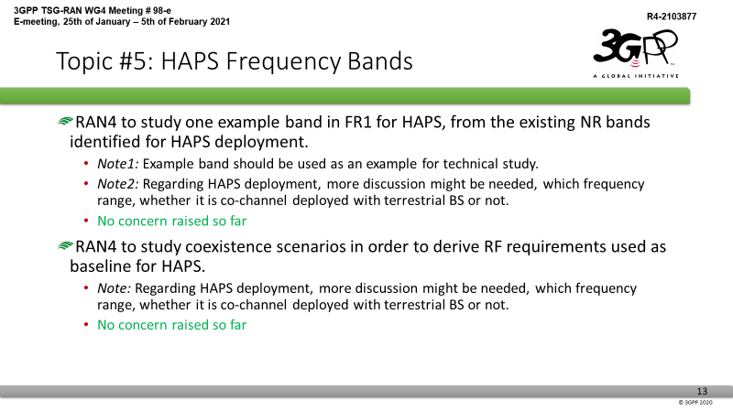

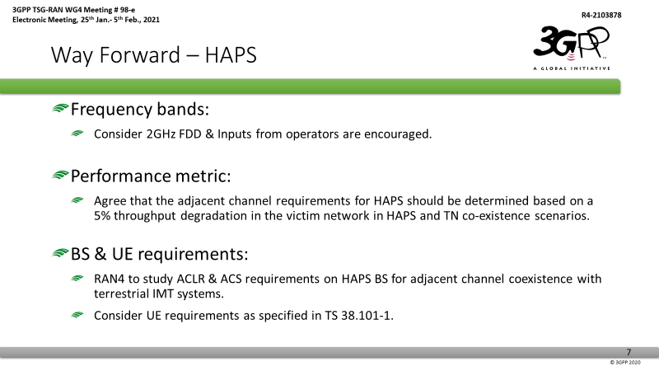
Furthermore, the chairman’s note [5] captures the agreed scenarios of initial NTN coexistence simulations as follows:
Agreements:
RAN4 agreed to take following scenarios for initial simulation alignment purpose in Q2 2021:
TN deployment: NR only with Rural, Urban Macro
NTN deployment: GEO, LEO-600, LEO-1200, HAPS
Satellite Set: Set1
The detailed set as following:
No. | Frq. | TN | TN scenario | NTN | Prioritize (Selected set for simulator alignment in Q2’ 2021)
1 | 2GHz | NR | Rural | GEO | THALES, Nokia
2 | 2GHz | NR | Rural | LEO 600km | THALES, Nokia
3 | 2GHz | NR | Rural | LEO 1200km
4 | 2GHz | NR | Urban macro | GEO | THALES, Nokia
5 | 2GHz | NR | Urban macro | LEO 600km | THALES, Nokia
6 | 2GHz | NR | Urban macro | LEO 1200km
25 | 2GHz | NR | Rural | HAPS | Nokia
26 | 2GHz | NR | Urban macro | HAPS | Nokia

No. | Frq. | NTN | NTN
1 | 2GHz | GEO | GEO
2 | 2GHz | GEO | LEO 600km
5 | 2GHz | LEO 600km | LEO 600km
9 | 2GHz | LEO 1200km | LEO 1200km
10 | 2GHz | HAPS | HAPS
Companies are encouraged to bring simulation results at least for above cases in Q2’ 2021 for simulator alignment purpose.

and noted that the simulation assumption provided in [6] “was for simulation alignment purpose; companies are encouraged to follow such simulation assumption to provide results in April RAN4 meeting.”
In this contribution, simulation assumptions for HAPS coexistence study is specified.

Discussion

Simulation scenarios
The agreed HAPS scenarios for initial coexistence simulations (see the scenario tables in section 1) are (i) rural TN + HAPS, (ii) Urban macro TN + HAPS, and (iii) HAPS + HAPS. All these scenarios use 2 GHz frequency band and FDD duplex scheme.
Considering practical deployment scenarios of HAPS, 20 km altitude for HAPS is assumed when evaluating HAPS + HAPS coexistence in rural environment, since HAPS is intended to serve the rural areas where terrestrial network connectivity is unavailable.
The interference power from the aggressor depends on the distance between the victim and the aggressor. The distance between the victim and aggressor network can be characterized by the center-to-center inter-system distance, which is the distance from the center of the victim network coverage to the center of the aggressor network coverage as shown in Figure 1. Since HAPS antenna gain may vary in the elevation domain the evaluation of coexistence shall be carried out at various center-to-center inter-system distances.
Relevant scenarios for HAPS coexistence study are summarized in Table 1. Note that when the inter-system distance is 0 Km, the HAPS is right above the center of TN network in TN+HAPS coexistence. For HAPS+HAPS coexistence, 0 Km inter-system distance means adjacent channels are operated by the same HAPS.
The simulation scenario is summarized in Figure 1 and Table 1.

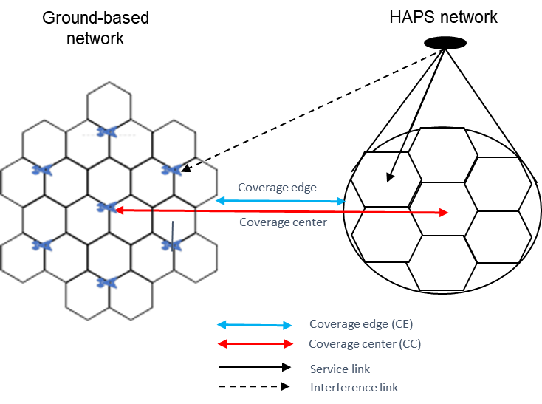  (a) | 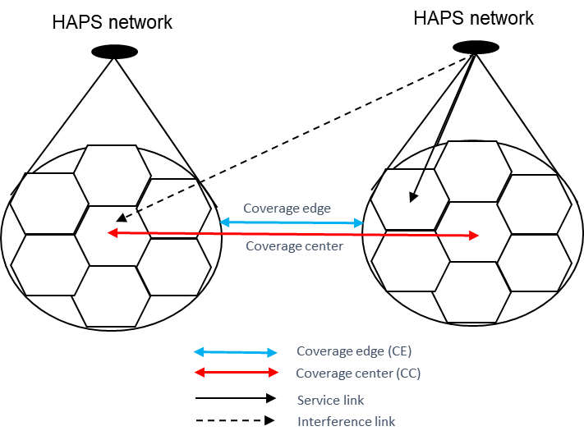  (b)
Figure 1. Coexistence scenarios of (a) HAPS and TN, (b) HAPS and HAPS.
Table 1. HAPS coexistence scenarios
HAPS altitude | 20 Km
Carrier frequency | 2 GHz
Duplex scheme | FDD
Coexistence scenarios | HAPS + TN (UMa)
 | HAPS + TN (RMa)
 | HAPS + HAPS (RMa)
Center-to-center inter-system distance (Km) | 0, 10, 20, 30, 40, 50

HAPS antenna and cell layout
A reference HAPS antenna model proposed for HIBS (HAPS as IMT base stations) study in ITU WP-5D [7] is shown in Figure 2. The antenna array is composed of seven antenna panels (six side panels and one downward facing panel). Antenna elements on each panel are co-phased to form one beam in two crossed linear polarizations to serve one cell. There are a total of seven cells in two layers, one cell in the 1st layer and six cells in the 2nd layer. Other parameters of this antenna model are listed in Table 2. The same antenna model shall be used for HAPS coexistence study.
Although it is possible for HAPS to serve indoor UEs, the large building penetration loss may cause link failure due to low SINR. In a realistic scenario, the majority of the UEs connected to HAPS are outdoor. Therefore, for simplification of the coexistence study all UEs served by HAPS are outdoor UEs.

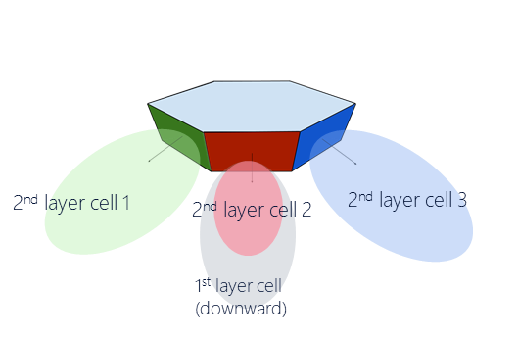 | 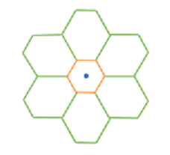
(a) | (b)
Figure 2. HAPS antenna array and cell layout
Table 2. HAPS network parameters
Number of cells | 7
Antenna array configuration (row x column) | 2 x 2 for 1st layer cell  4 x 2 for 2nd layer cell
Antenna polarization | Linear $±45°$
Element gain | 8 dBi
Element HPBW horizontal/vertical | $65°$ for both H/V
Element front-to-back ratio horizontal/vertical | 30 dB for both H/V
Element spacing horizontal/vertical | 0.5 wavelength for both H/V
Antenna panel tilt (from the horizon) | $90°$ for 1st layer cell  $23°$ for 2nd layer cell
Tx power per antenna panel | 43 dBm
Noise figure | 5 dB
Indoor UE percentage | 0%
Coverage area (7 cells combined) | A 100 Km radius circular area centered by the serving HAPS
UE distribution | Uniformly distributed in the coverage area

When HAPS altitude is 20 Km, the antenna gain of this model perceived on the ground is shown in Figure 3, where (a) is the gain of the 1st layer cell (i.e., the center cell) produced by the 90⁰ tilt angle panel (downward facing panel), and (b) is the gain of a 2nd layer cell (i.e., an outer cell) produced by an eastward facing antenna panel with 23⁰ tilt angle. For a 2nd layer cell, the antenna gain depends on not only the distance but also the azimuth $ϕ$ from the boresight. With this antenna model, SINR can be calculated for a given location on the ground taking into account the propagation loss and co-channel interference. Figure 4 shows the downlink SINR as a function of distance from the coverage center for different azimuth angles ($ϕ=0$ is the direction of 2nd layer cell boresight, $ϕ=30°$ is at the cell edge), assuming 2 GHz carrier frequency, 20 MHz channel bandwidth, free space path loss, 4 dB fade margin, and 7 dB UE noise figure. It can be observed that for outdoor UEs in a rural environment, where the propagation condition is close to free space path loss with shadow fading, HAPS coverage range can reach 100 km at 2 GHz frequency.
Based on the above a coverage range of 100 km is assumed when operating in the 2 GHz range. UEs should be dropped uniformly in a 100 Km radius circular coverage area centered by the serving HAPS.

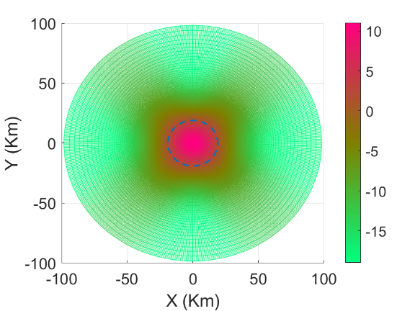  (a) | 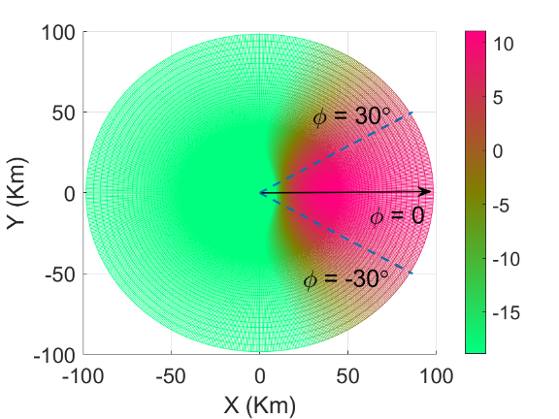  (b)
Figure 3. HAPS antenna gain (in dB) in a 100 Km radius area on the ground. (a) Antenna gain of the 1st layer cell. (b) Antenna gain of a 2nd layer cell.

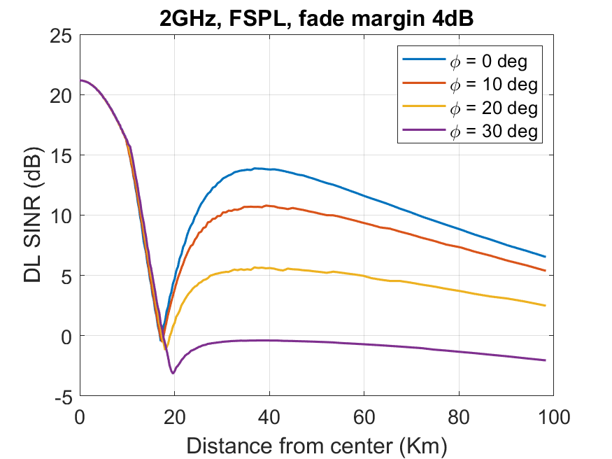
Figure 4. HAPS single system SINR as a function of distance from coverage center assuming 2 GHz carrier frequency, free space path loss and 4 dB fade margin

Terrestrial network layout
The typical network layout of 19 sites, 3 sectors per site, with co-channel interference wrap-around can be adopted for the coexistence study. System parameters such as inter-site distance, BS antenna height, antenna array and array downtilt angle, indoor UE percentage, etc. should be adjusted according to the environment. Table 3 and Table 4 summarize the assumptions for Urban macro and rural macro environments.
Table 3. Terrestrial network parameters
Terrestrial environment | Urban macro | Rural macro
Network layout | 19 sites (57 cells) wrap-around | 19 sites (57 cells) wrap-around
Inter-site distance | 1 Km | 2 Km
BS antenna height | 25 m | 35 m
BS transmit power | 46 dBm | 46 dBm
BS antenna array (M, N, P) | (8, 8, 2) | (8, 1, 2)
BS antenna Element spacing horizontal/vertical | 0.5 wavelength for both H/V | 0.5 wavelength for both H/V
BS antenna downtilt | 10⁰ | 6⁰
BS antenna element gain pattern | Table 4 | Table 4
BS noise figure | 5 dB | 5 dB
Indoor UE percentage | 70% | 50%

Table 4. Terrestrial BS antenna element gain pattern
Parameter | Values
Antenna element vertical radiation pattern (dB)
Antenna element horizontal radiation pattern (dB)
Combining method for 3D antenna element pattern (dB)
Maximum directional gain of an antenna element G_{E,max} | 8 dBi

Propagation model
Consider coexistence scenarios TN+HAPS and HAPS+HAPS. The radio link between a TN BS and an UE served by TN (TN UE) may follow either the UMa model in [8] or the RMa model in [10] depending on the terrestrial environment. The radio link between HAPS and a UE, regardless of the UE being served by TN or HAPS, follows the NTN path loss model of either “Urban” or “Rural” scenario. For the HAPS to TN UE link, an additional O-to-I penetration loss needs to be applied if the UE is indoor. This penetration loss is not needed for HAPS UE (i.e., UE served by HAPS) since all HAPS UEs are assumed to be outdoor. The O-to-I penetration loss model specified in [8] with 50%/50% probability for the low-loss/high-loss model is used when applicable. The use of channel model for different radio links in the coexistence scenarios is summarized in Table 5.
Table 5. Channel model used in HAPS coexistence study
Scenario | Radio Link | Channel model | Reference
TN+HAPS (UMa) | TN BS to TN UE | Urban Macro | TR 38.803 [8]
TN+HAPS (UMa) | HAPS to TN UE | NTN Urban + penetration loss¹ | TR 38.811 [9]
TN+HAPS (UMa) | HAPS to HAPS UE | NTN Urban | TR 38.811 [9]
TN+HAPS (RMa) | TN BS to TN UE | Rural Macro | TR 38.901 [10]
TN+HAPS (RMa) | HAPS to TN UE | NTN Rural+ penetration loss¹ | TR 38.811 [9]
TN+HAPS (RMa) | HAPS to HAPS UE | NTN Rural | TR 38.811 [9]
HAPS+HAPS (RMa) | HAPS to HAPS UE | NTN Rural | TR 38.811 [9]
Note 1: Penetration loss model is specified in TR 38.803, assuming 50% low-loss model and 50% high-loss model. It only applies to indoor UEs.

UE assumption
The same UE characteristics should be used for both TN UEs and HAPS UEs. It is reasonable to assume that UE has a single omni-directional antenna element with linear cross-polarizations. The UE assumptions is summarized in Table 6, which is in line with [6].
Table 6. UE assumption
UE antenna array (M, N, P) | (1, 1, 2)
UE antenna element gain | 0 dBi, omni-directional
UE transmit power | 23 dBm
UE noise figure | 7 dB

Channel bandwidth and scheduled bandwidth
For FDD at 2 GHz band, 20 MHz channel bandwidth and 15 KHz subcarrier spacing is assumed. For downlink simulations, UEs are scheduled in a round-robin fashion and the scheduled UE is given the full bandwidth. For uplink simulations, attention shall be paid to the power limited nature of HAPS networks. When the UE is in a NLOS condition with HAPS, the allocated bandwidth may need to be reduced to the minimum in order to overcome the additional clutter loss (17-19 dB) and maintain an acceptable SINR. For terrestrial NR network, the assumption of UL bandwidth allocation for the LTE coexistence study (i.e., 16 RBs per UE) [11] is reused.
A simple and realistic model of UL bandwidth allocation for the considered HAPS coexistence scenarios is still for further discussion. For initial simulations, we can consider parameters in Table 7.
Table 7. Proposed DL and UL transmission bandwidth
Parameters | Downlink | Uplink
Subcarrier spacing (SCS) | 15 KHz | 15 KHz
Channel bandwidth | 20 MHz | 20 MHz
Scheduled bandwidth per TN UE | 20 MHz | [16 RBs]
Number of scheduled UEs per TN cell | 1 | [6]
Scheduled bandwidth per HAPS UE | 20 MHz | [2 RBs]
Number of scheduled UEs per HAPS cell | 1 | [10]

Uplink transmission power control model
Since terrestrial NR and HAPS networks have very different coverage and topology, UL power control setting for TN and HAPS should not be the same. The same power control model may be used but the UE transmit power should depend on the allocated bandwidth. To start the initial simulations, we can use the power control model suggested in [6], with UE transmit power $P_{t}$ determined according to
where, P_{max} = 23dBm, R_{min} = TBD dB, CL_{x-ile} and γ are set as following:
- CL_{x-ile} = 88 + 10*log₁₀ (200/X) + 11 – Y,
where X is UL transmission BW (MHz) and Y is the BS noise figure
- γ = 1
UEs connected to TN and HAPS networks may have different X (transmission BW) in this model. As a starting point, the UE’s transmission BW may be 16 RBs for TN as in [11] and 2 RBs for the HAPS network.
Table 8. UL power control parameters
UL power control parameter | TN | HAPS
P_{max} (dBm) | 23 | 23
R_{min} (dB) | [-54] | [-54]
γ | 1 | 1
X, transmission bandwidth (MHz) | [2.88] | [0.36]
Y, BS noise figure (dB) | 5 | 5

Conclusion
It is proposed to use the simulation assumptions in this paper for NTN HAPS co-existence study.

References
- R4-2103948, Moderator (Thales), “Email discussion summary for [98e][310] NTN_Solutions_Part1,”
- R4-2103949, Moderator (Samsung), “Email discussion summary for [98e][311] NTN_Solutions_Part2,”
- R4-2103877, Moderator (Thales), “WF for NTN General Part,” 3GPP TSG-RAN WG4 Meeting #98-e, 21st Jan – 5th Feb, 2021.
- R4-2103878, Moderator (Samsung), “Way Forward for NTN Coexistence Study,” 3GPP TSG-RAN WG4 Meeting #98-e, 21st Jan – 5th Feb, 2021.
- DRAFT Meeting Report for TSG RAN WG4 meeting: 98-e, 3GPP TSG-RAN WG4 Meeting #98-e, 21st Jan – 5th Feb, 2021.
- R4-2103998, CATT, “Simulation assumption for NTN co-existence study,” 3GPP TSG-RAN WG4 Meeting #98-e, 21st Jan – 5th Feb, 2021.
- SoftBank, Loon LLC, Nokia, Ericsson, “Proposed deployment and system characteristics of HIBS in the working document towards a preliminary draft new Report ITU-R M.[HIBS-CHARACTERISTICS],” ITU WP-5D contribution, Sep. 28, 2020.
- 3GPP TR 38.803, “Study on new radio access technology: Radio Frequency (RF) and co-existence aspects.”
- 3GPP TR 38.811, “Study on New Radio (NR) to support non-terrestrial networks.”
- 3GPP TR 38.901, “ Study on channel model for frequencies from 0.5 to 100 GHz.”
- 3GPP TR 36.942, “Radio Frequency (RF) system scenarios.”

The transmit power has been corrected from 46 dBm to 43 dBm to be consistent with the model in [7].

