3GPP TSG-RAN WG4 Meeting # 98-bis-e R4-210xxxx

Electronic Meeting, Apr. 12-20, 2021

**Agenda Item:** 8.1.2.2

**Source:** Qualcomm Incorporated, [Huawei, HiSilicon, CAICT, vivo, OPPO]

**Title**: TP to TS38.151: revision on MIMO Average Spherical Coverage

**Document for:** Approval

# 1 Introduction

As discussed in [1], we propose the following TP to TS38.151 to revise the definition for MASC.

# 2 Text Proposal to TS 38.151

**--------------Start of text proposal -------------**

7.1.1 MIMO Average Spherical Coverage (MASC)

The MIMO Average Spherical Coverage (MASC) is the Figure of Merit of FR2 MIMO OTA requirement. FR2 MIMO OTA is measured with 36 constant-density points within the 3D sphere, the MASC is determined by the averaging of the best N sensitivity values. The averaging shall be done in linear scale for the MASC result according to the formula:

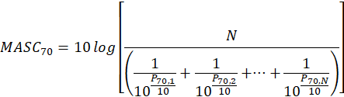

Such that {P70,1, …, P70,N} are the best N sensitivity values at 70% maximum throughput outage measured from all the 36 constant density points, as defined in Annex B.2.3. N is determined by M and the number of test points, i.e., 36, according to the formula:



M is 50 for PC3 DUT. For other power class DUT, M is FFS.

The MASC shall be measured at the mid channel as specified in TS 38.508-1 subclause 4.3.1 [7]. The MASC shall be lower than the requirements specified in Clause 7.2.

If the number of test points where the UE can meet 70% maximum throughput outage is less than TBD, then UE fails the test.

Other criteria for FR2 are FFS.

**--------------End of text proposal -------------**

# Reference

[1] R4-2105997, Email discussion summary for [98-bis-e][326] NR_MIMO_OTA, Moderator (CAICT)