3GPP TSG-RAN WG4 Meeting #112 DraftR4-2413429

**Maastricht, NETHERLANDS, 19th – 23th August, 2024**

**Agenda item:** 8.8.5

**Source:** Moderator (Samsung)

**Title:** Topic summary for [112][329] NTN_testing_NGSO_channel_model

**Document for:** Information

# Introduction

This t-doc provides summary for thread “[112][329] NTN_testing_NGSO_channel_mode” based on submitted t-docs before meeting:

|  |  |  |  |  |  |
| --- | --- | --- | --- | --- | --- |
| **#** | **Title** | **Topic title** | **WI** | **Topic areas** | **AI** |
| 329 | NTN_testing_NGSO_channel_model | [112][329] NTN_testing_NGSO_channel_model | NR_IoT_NTN_req_test_enh-Perf | NTN testing for NGSO -- Channel model | 8.8.4  R4-2411467 (proposal 2)   R4-2412866 (move to AI 8.8.4 from AI 8.4.4) |

The WI objective from latest WID RP-241281 copied below for reference:

|  |
| --- |
| **NTN testing for NGSO**   * Specify the TE-emulated channel model with varying Doppler and delay shifts for NR-NTN and IoT-NTN in the FR1-NTN bands and the corresponding LTE bands   + Match the satellite motion trajectory based on the ephemeris for NGSO (Non-Geostationary Orbit) scenarios   + Inform RAN5 to assist specifying RF frequency error tests, if needed     - Checking if the existing frequency error requirement, can be met under the TE-emulated channel model without intention of modifying the existing core requirement   + Specify UE RRM performance test of uplink timing for NGSO for NR-NTN and IoT-NTN in the FR1-NTN bands and the corresponding LTE bands based on the above channel model     - Checking if the existing RRM uplink timing requirements, can be met under the TE-emulated channel model without intention of modifying the existing core requirement * Specify UE demodulation performance requirement(s) of PDSCH for NGSO for NR-NTN and IoT-NTN in the FR1-NTN bands and the corresponding LTE bands based on the above channel model   + Minimize the number of demodulation performance requirements * Specify the applicability of the tests under the TE-emulated channel model |

Following sub- topics are recommended to be treated during on-line session:

* Issue 1-1-1: Work plan (to be treated on line)
* Issue 1-2-1 Methodology for Time varying Doppler and Delay shifts channel modelling (to be treated on line)
* Issue 1-2-2 Parameters for TE-emulated channel model (to be treated on line)

# Topic #1: NGSO testing

## Companies’ contributions summary

|  |  |  |
| --- | --- | --- |
| **T-doc number** | **Company** | **Proposals / Observations** |
| R4-2411467 | MediaTek Inc. | Proposal 2*:* Discuss the TE-emulated channel model with varying Doppler and delay shifts for NTN bands in demod session. Update RRM uplink timing test cases for NGSO when the TE-emulated channel model has been specified. |
| [R4-2411710](https://www.3gpp.org/ftp/TSG_RAN/WG4_Radio/TSGR4_112/Docs/R4-2411710.zip) | MediaTek inc. | ***Observation 1***: The value of varying Doppler and delay shifts depends on the trajectory of satellite.  ***Observation 2***: The ephemeris should match the trajectory of satellite.  ***Proposal 1***: RAN4 to discuss use which way to determine the trajectory of satellite   * Option 1: Assuming satellite moves in an orbit with some shape around the earth, e.g., a circular orbit. Then derive Doppler and delay at every instance mathematically. Ephemeris can also be derived from the trajectory * Option 2: Use GMAT to generate Ephemeris and the trajectory of satellite   ***Proposal 2***: The Doppler and delay should consider the trajectory of satellite and the position of UE assumed in RAN5. |
| [R4-2411722](https://www.3gpp.org/ftp/TSG_RAN/WG4_Radio/TSGR4_112/Docs/R4-2411722.zip) | QUALCOMM Europe Inc. - Spain | Observation 1: The complexity of the propagator models needs to be considered as the UE vendors may have to implement the chosen model in their channel emulator.  Proposal 1: RAN4 to study the feasibility of introducing a reference propagator model for RAN4 requirement definition.  Proposal 2: RAN4 to consider the following reference propagator models.   * Eckstein-Hechler propagator model as a reference model for satellite mobility projection and ephemeris data generation from TE * Keplerian propagator model as a reference model for UE performance evaluation in case performance alignment across companies is needed.   Proposal 3: Ephemeris information shall be updated based on the chosen reference propagator model for TE at least every 10.24sec. The exact frequency of ephemeris updates is subject to test configurations. The ephemeris information must be generated and provided to the UE for more than one satellite, as needed by test cases, using the same chosen reference propagator model.  Proposal 4: RAN4 to discuss whether to consider a non-zero time-varying feeder link delay as part of the new channel model.  Proposal 5: RAN4 to decouple the deterministic time and frequency shifts due to satellite mobility from the traditional fading channel.   * RAN4 to strive to use the already adopted fading models, such as NTN TDLA and NTN TDLC fading models.   Proposal 6: Defer any discussion on the UE demodulation performance requirements (for both NR-NTN and IoT-NTN) until after the discussion around the propagator model has been settled and its potential impact on the demodulation performance requirements have been determined.  Proposal 7: RAN4 should not relax the current RRM requirements (for both NR-NTN and IoT-NTN) for cases where satellite projection error has been taken into account, e.g. UL timing, mobility, etc. RAN4 can revisit some of core requirement and test cases if affected by the new channel model accommodating satellite mobility, e.g. RLM/BFD.  Proposal 8: If new PDSCH demodulation performance requirement is introduced, consider applicability of tests between different HARQ configurations and channel models. |
| [R4-2412532](https://www.3gpp.org/ftp/TSG_RAN/WG4_Radio/TSGR4_112/Docs/R4-2412532.zip) | Samsung | **Proposal 1: Focus on channel model discussion in initial stage for NGSO testing**   * Once sufficient progress made for channel model introduction, RAN4 can start the discussion on the impact to UE demodulation, RF/RRM test cases   **Proposal 2: RAN4 shall consider additional TT and/or MU for RF (frequency error) and UL timing RRM test cases if variable channel model introduced without change on the existing core requirements.**  **Proposal 3: Existing channel model from TR 38.811 5.3.4 can be considered as starting point with further simplifications and down selection on the parameters.**   * UE mobility: fixed UE without mobility * Target frequency range: 2GHz * Satellite type:   - LEO- 600 km  - LEO- 1200 km |
| [R4-2412552](https://www.3gpp.org/ftp/TSG_RAN/WG4_Radio/TSGR4_112/Docs/R4-2412552.zip) | Ericsson, Anritsu Corporation | **Observation 1: RAN4 performance test is defined based on the assumption UE has already performed the pre-compensation based on the ephemeris information signaled from the network.**  **Observation 2: RAN5 NGSO conformance test procedure sets the constant Doppler shift and delay with the range:**   * **One-way delay between UE and satellite to be between 2 ms (lowest value for LEO orbit 600 km) and 6.67 ms (highest value for LEO orbit 1200 km)** * **Doppler (frequency) shift up to 24 ppm for NGSO (LEO-600).**   **Proposal 1: Assume the varying Doppler (frequency) and delay shifts are applied before the fading simulator.**  **Proposal 2: Use the following model to derive the TE-emulated channel for NTN: $$d_{h}\left(t\right)=mod\left(v_{NGSO}⋅t, {2d}_{h,max}\right)-d_{h,max}$$ $$T\left(t\right)=\frac{d\left(t\right)}{c}=\frac{\sqrt{{d_{h}(t)}^{2}+h_{NGSO}^{2}}}{c}$$ $$F\left(t\right)=-f_{d}\frac{d_{h}\left(t\right)}{d(t)}=-f_{d}\frac{d_{h}(t)}{\sqrt{{d_{h}\left(t\right)}^{2}+h_{NGSO}^{2}}}$$**  where $T\left(t\right)$  * : Propagation delay of the signal from the satellite at time $t$, $F(t)$* : Doppler (frequency) shift of the signal from the satellite at time * : the horizontal distance between the satellite and UE at time , * : the distance between the satellite and UE at time $t$, $d_{h,max}$* : the maximum horizontal distance between the satellite and UE, i.e., $h_{NGSO}/tan⁡(E)$, $c$* : the speed of light, $f_{d}$* : Maximum Doppler shift (Hz)   **Proposal 3: RAN4 further discuss the suitable parameters for TE-emulated channel model, e.g., height of satellite, speed of satellite, considering realistic satellite motion trajectory and test time.**  **Proposal 4: RAN4 discuss how to apply the varying Doppler and delay shifts to the UE performance requirements** |
| [R4-2412783](https://www.3gpp.org/ftp/TSG_RAN/WG4_Radio/TSGR4_112/Docs/R4-2412783.zip) | Huawei,HiSilicon | 1. Only consider LEO-600 scenario for NTN testing for NGSO. 2. Consider following channel model for NTN testing for NGSO. A small period (such as 5s) of time should be selected to perform the test starting from the typical parameters (such as when α=30° corresponding to above figures).  |  | | --- | | **The instant satellite speed $v$ is given as: $$v=\sqrt{\frac{μ}{R+h}}$$**  **The initial angle $β$ of vector geocentric to UE relative to the x axis is given as:**  **The satellite position is given as:**  **The UE position is given as:**  **The Doppler is given as:**  **The delay is given as:**  **where is standard gravitational parameter, is earth average radius, is satellite altitude for LEO-600, is initial angle of vector UE to satellite relative to vector UE to clockwise side horizon, is the time, is the speed of light, is the carrier frequency.** |  1. Consider above test procedure for NGSO test. 2. Enter UE Positioning test mode, inform UE position that is randomly selected by TE from a pre-defined position set (including latitude and longitude). The UE position is static during the whole test. 3. Based on above UE position, TE calculates initial satellite position at α=30° and generates ephemeris information that is accordance with above channel model. 4. TE sends the ephemeris information to the UE via SIB19 at the starting of the test, and add Doppler and delay to the transmitting signal based on above channel model. 5. Check whether UE can meet the requirements. |
| [R4-2413333](https://www.3gpp.org/ftp/TSG_RAN/WG4_Radio/TSGR4_112/Docs/R4-2413333.zip) | THALES | **Proposal 1:** For deriving NGSO Doppler and Delay required for the SAT-UE NTN dynamic channel model, RAN4 can use the following example files:      **Proposal 2:** The intermediate values for Doppler and Delay can be easily interpolated from the points provided in these files allowing sufficient level of granularity to generate the channel dynamics with granularity below OFDM symbol level.  **Observation 1:** Doppler values are expressed in ppm and can be easily adapted for any carrier frequency/satellite frequency band.  **Proposal 3:** Depending on the elevation range and satellite orbit, RAN4 can easily identify several sets of profiles as a combination of Doppler – Delay:  1/ Channel variation **Profile 1:**   * Doppler decreasing slowly, * Delay decreasing fast.   2/ Channel variation **Profile 2:**   * Doppler decreasing fast, * Delay decreasing fast.   3/ Channel variation **Profile 3:**   * Doppler near zero range (positive and then negative), * Delay variation low (decreasing and then increasing).   4/ Channel variation **Profile 4:**   * Doppler decreasing fast, * Delay increasing fast.   5/ Channel variation **Profile 5:**   * Doppler decreasing slowly, * Delay increasing fast.   **Proposal 4:** These profiles can be extracted directly from the previous files as in the following example for **LEO@600km:**    **Proposal 5:** These profiles can be extracted directly from the previous files as in the following example for **LEO@1200km:** |
| R4-2412866 | Nokia | Proposal 1: Confirm that the core requirements for transmit timing do not need to be modified if a trajectory satellite motion is adopted in NTN test case configuration.  Proposal 2: Select between one of the following options for the satellite motion trajectory in the test case:  a. Option 1: Utilize a set of pre-defined (in specification annex) vector of NGSO satellite ephemeris information collected from real samples to be selected by TE before the test case. The UE position in this case is also deterministic such that a meaningfu UE position is selected for each vector of ephemeris information.  b. Option 2: Adopt a motion trajectory model (e.g. Eckstein-Hechler) and provide general guidelines for testing equipment to design UE position and trajectory information (e.g. ensure a range for the elevation angle).  Observation 1: it is not meaningful for the transmit timing cases that the elevation angle between the UE and the serving cell is set close to 90 degrees for NGSO scenarios, as there will be almost no variation on the UE transmit timing.  Observation 2: For mobility cases, it is not meaningful that the serving cell is configured such that the elevation angle between the satellite and the UE is close to 90 degrees (best propagation case scenario). In special, for the distance-based triggers.  Proposal 3: In the configuration for NGSO test cases, the satellite information for the serving cell shall be initiated at a position where the elevation angle measured by the UE at the chosen GNSS position used for the test is below [35] degrees and the satellite is moving away from the UE.  a. This configuration applies regardless if the UE position is obtained via AT command or via GNSS simulator.  b. The initial elevation angle might be increased if needed for guaranteeing the GNSS is within the limit of 30 degrees throughout the entire duration of the test.  Proposal 4: For the frequency error test cases, decide between the options below for the satellite trajectory reference configuration  a. Option 1: Select a region where the doppler vary the fastest (close to 0 degrees of elevation)  b. Option 2: Select a region where the absolute doppler deviation is the largest (smaller elevation angles)  Observation 3: The doppler observed in NGSO orbits is not static and follows a time-varying S-curve pattern.  Proposal 5: RAN4 shall discuss the introduction of a time-varying doppler for NGSO cases.  Proposal 6: RAN4 shall make an assumption that the UE remains static in the middle of the beam on earth.  Proposal 7: RAN4 shall take a similar approach to HST channel modelling and combine time varying doppler with a NTN TDL channel for performance requirements derivation. |

## Open issues summary

**Sub-topic 1-1 General**

Issue 1-1-1: Work plan (to be treated on line)

Issue 1-1-2: Relation-ship between TE-emulated channel model for satellite motion and fading channel model

**Sub-topic 1-2 TE emulated channel model for satellite mobility**

Issue 1-2-1 Methodology for Time varying Doppler and Delay shifts channel modelling (to be treated on line)

Issue 1-2-2 Parameters for TE-emulated channel model (to be treated on line)

Issue 1-2-3 Test set-up

**Sub-topic 1-3 RAN4 requirements**

Issue 1-3-1 RRM requirements

Issue 1-3-2 demodulation requirements

**Issue 1-3-3 Frequency error test cases**

### Sub-topic 1-1 General

**Issue 1-1-1: Work plan**

* Proposals
  + Option 1: Focus on TE-emulated channel model in initial stage for NGSO testing (Samsung, MTK, QC)
    - Samsung (R4-12532): Proposal 1: Focus on channel model discussion in initial stage for NGSO testing
      * Once sufficient progress made for channel model introduction, RAN4 can start the discussion on the impact to UE demodulation, RF/RRM test cases
    - MTK (R4-2411467): Proposal 2: Discuss the TE-emulated channel model with varying Doppler and delay shifts for NTN bands in demod session. Update RRM uplink timing test cases for NGSO when the TE-emulated channel model has been specified.
    - QC (R4-2411722) Proposal 6: Defer any discussion on the UE demodulation performance requirements (for both NR-NTN and IoT-NTN) until after the discussion around the propagator model has been settled and its potential impact on the demodulation performance requirements have been determined.
* Recommended WF
  + Focus on TE-emulated channel model in initial stage for NGSO testing
    - Once sufficient progress made for channel model introduction, RAN4 can start the discussion on the details for demodulation requirements, RF and RRM test cases

**Issue 1-1-2: Relation-ship between TE-emulated channel model for satellite motion and fading channel model**

* Proposals
  + Option 1: Assume the varying Doppler (frequency) and delay shifts are applied before the fading simulator. (Ericsson, Anritsu R4-2412552, P1)
  + Option 2: RAN4 to decouple the deterministic time and frequency shifts due to satellite mobility from the traditional fading channel. (QC R4-2411722, P5)
    - RAN4 to strive to use the already adopted fading models, such as NTN TDLA and NTN TDLC fading models.
* Recommended WF
  + Decouple TE-emulated time-varying Doppler (frequency) and delay shifts due to satellite mobility from traditional fading channel

### Sub-topic 1-2 TE emulated channel model for statellite mobility

**Issue 1-2-1 Methodology for Time varying Doppler and Delay shifts modelling (to be treated online)**

* Proposal:
  + Option 1: RAN4 to consider the following reference propagator models. (QC, P2 R4-2411722)
    - Eckstein-Hechler propagator model as a reference model for satellite mobility projection and ephemeris data generation from TE
    - Keplerian propagator model as a reference model for UE performance evaluation in case performance alignment across companies is needed.
  + Option 2: Predefined several sets of profiles as a combination of Doppler – Delay (Thales, P1, P2, P3, P4, P5 R4-2413333)

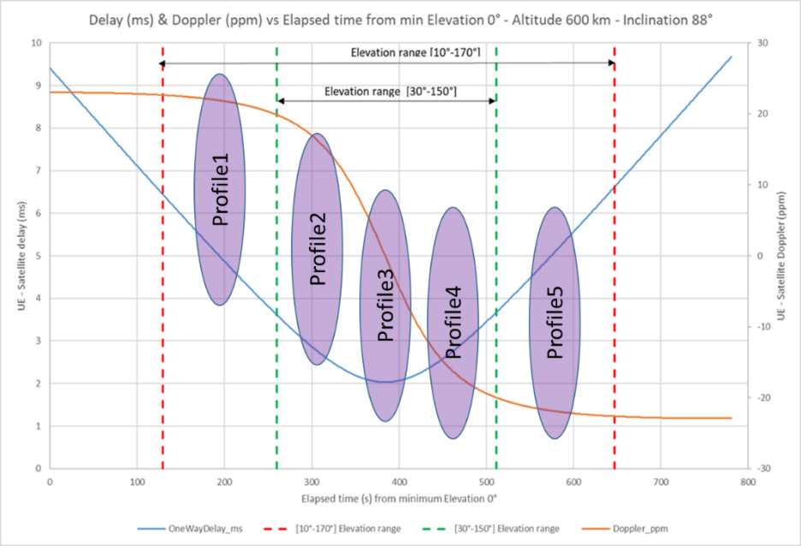

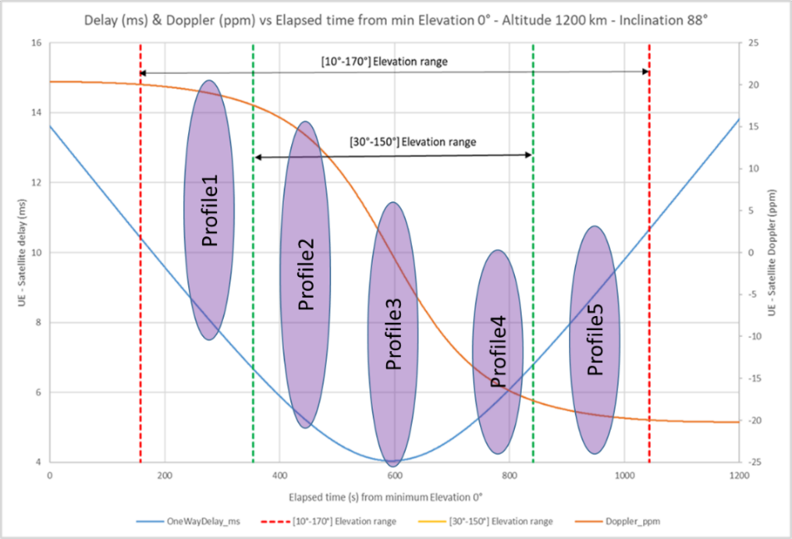

*Moderator note: From TR 38.863 18.2.0 annex E, generation following Section 5.3 of TR 38.811 with fixed parameter assumption*

* + Option 3: Existing channel model from TR 38.811 5.3.4 can be considered as starting point with further simplifications and down selection on the parameters. (Samsung, P3 R4-2412532)
  + Option 4: Use the following model to derive the TE-emulated channel for NTN (Ericsson, Anritsu R4-2412552, P2)

$$d_{h}\left(t\right)=mod\left(v_{NGSO}⋅t, {2d}_{h,max}\right)-d_{h,max}$$

$$T\left(t\right)=\frac{d\left(t\right)}{c}=\frac{\sqrt{{d_{h}(t)}^{2}+h_{NGSO}^{2}}}{c}$$

$$F\left(t\right)=-f_{d}\frac{d_{h}\left(t\right)}{d(t)}=-f_{d}\frac{d_{h}(t)}{\sqrt{{d_{h}\left(t\right)}^{2}+h_{NGSO}^{2}}}$$

where

* $T\left(t\right)$: Propagation delay of the signal from the satellite at time $t$,
* $F(t)$: Doppler (frequency) shift of the signal from the satellite at time
* : the horizontal distance between the satellite and UE at time ,
* : the distance between the satellite and UE at time $t$,
* $d_{h,max}$: the maximum horizontal distance between the satellite and UE, i.e., $h_{NGSO}/tan⁡(E)$,
* $c$: the speed of light,

* $f_{d}$: Maximum Doppler shift (Hz)
  + Option 5: Consider following channel model for NTN testing for NGSO. A small period (such as 5s) of time should be selected to perform the test starting from the typical parameters (Huawei R4-2412783, P2)

|  |
| --- |
| * The instant satellite speed $v$ is given as: $$v=\sqrt{\frac{μ}{R+h}}$$* The initial angle $β$ of vector geocentric to UE relative to the x axis is given as: * The satellite position is given as: * The UE position is given as: * The Doppler is given as: * The delay is given as:   where is standard gravitational parameter, is earth average radius, is satellite altitude for LEO-600, is initial angle of vector UE to satellite relative to vector UE to clockwise side horizon, $t$ is the time, $c=299792458m/s$ is the speed of light, $f_{c}=2×{10}^{9}Hz$ is the carrier frequency. |

* Option 6: RAN4 to discuss use which way to determine the trajectory of satellite (MTK R4-2411710, P1)
  + Option 1: Assuming satellite moves in an orbit with some shape around the earth, e.g., a circular orbit. Then derive Doppler and delay at every instance mathematically. Ephemeris can also be derived from the trajectory
  + Option 2: Use GMAT to generate Ephemeris and the trajectory of satellite
* Option 7: Select between one of the following options for the satellite motion trajectory in the test case: (Nokia R4-2412866, P2)
  + Option 1: Utilize a set of pre-defined (in specification annex) vector of NGSO satellite ephemeris information collected from real samples to be selected by TE before the test case. The UE position in this case is also deterministic such that a meaningfu UE position is selected for each vector of ephemeris information.
  + Option 2: Adopt a motion trajectory model (e.g. Eckstein-Hechler) and provide general guidelines for testing equipment to design UE position and trajectory information (e.g. ensure a range for the elevation angle).
    - RAN4 shall take a similar approach to HST channel modelling and combine time varying doppler with a NTN TDL channel for performance requirements derivation. (Nokia R4-2412866, P6, P7)
      * RAN4 shall make an assumption that the UE remains static in the middle of the beam on earth.

*Moderator note: Above proposals from companies not are mutual exclusive with each other. It’s moderator’s observation for how to model time varying Doppler and Delay shifts for satellite motion trajectory, two alternatives proposed by companies:*

* *Alternative 1: Introduce TE-emulated channel model with time varying doppler shift and delay shift to match with the satellite motion trajectory*
* *Alternative 2: Utilize a set of pre-defined ephemeris information with associated delay and Doppler shift*

*It’s moderator’s understanding all the companies are ok to follow alternative 1 to introduce a TE-emulated channel model to match with satellite motion trajectory which also aligned with WI objective. Regarding test set-up, check issue 1-2-3.*

* Recommended WF
* *Introduce TE-emulated mathematical channel model with time varying doppler shift and delay shift to match with the satellite motion trajectory*
* *Further discuss candidate option as list above:*
  + *Option 1*
  + *Option 2*
  + *Option 4*
  + *Option 5*

**Issue 1-2-2 Parameters for TE-emulated channel model**

*Moderator note: moderator tried to generate parameters and candidate values based on the review from sub-mitted contributions; and some of options not proposed by companies directly.*

* Proposals: candidate parameters for further consideration and discussion
  + Satellite altitude:
    - Option 1: LEO -600km only
    - Option 2: Both LEO-600km and LEO-1200km
  + Elevation angle range
    - Option 1: 30o  to 150o
    - Option 2: 0o to 180o
  + UE position
  + Whether to consider a non-zero time-varying feeder link delay
* Recommended WF
  + Further discuss

**Issue 1-2-3 Test set-up**

* Proposals:
  + QC R4-2411722, P3: Ephemeris information shall be updated based on the chosen reference propagator model for TE at least every 10.24sec. The exact frequency of ephemeris updates is subject to test configurations. The ephemeris information must be generated and provided to the UE for more than one satellite, as needed by test cases, using the same chosen reference propagator model.
  + Huawei R4-2412783, P3: Consider above test procedure for NGSO test.
    - Enter UE Positioning test mode, inform UE position that is randomly selected by TE from a pre-defined position set (including latitude and longitude). The UE position is static during the whole test.
    - Based on above UE position, TE calculates initial satellite position at α=30° and generates ephemeris information that is accordance with above channel model.
    - TE sends the ephemeris information to the UE via SIB19 at the starting of the test, and add Doppler and delay to the transmitting signal based on above channel model.
    - Check whether UE can meet the requirements.
* Recommended WF

*Moderator note: Detailed test procedure shall belong to RAN5 work, RAN4 can have some discussion on general test principle and how to generate channel model to match with satellite motion trajectory.*

* + During test, ephemeris information shall be updated and aligned with TE-emulated channel model which match with satellite motion trajectory
  + Further discuss details together with channel modelling

### Sub-topic 1-3 RAN4 requirements

**Issue 1-3-1 RRM requirements**

* Proposal:
  + QC R4-2411722, P7:RAN4 should not relax the current RRM requirements (for both NR-NTN and IoT-NTN) for cases where satellite projection error has been taken into account, e.g. UL timing, mobility, etc. RAN4 can revisit some of core requirement and test cases if affected by the new channel model accommodating satellite mobility, e.g. RLM/BFD.
  + Samsung R4-12532, P2: RAN4 shall consider additional TT and/or MU for RF (frequency error) and UL timing RRM test cases if variable channel model introduced without change on the existing core requirements.
  + MTK R4-2411467, P2: Discuss the TE-emulated channel model with varying Doppler and delay shifts for NTN bands in demod session. Update RRM uplink timing test cases for NGSO when the TE-emulated channel model has been specified.
  + Nokia R4-12866, P1: Confirm that the core requirements for transmit timing do not need to be modified if a trajectory satellite motion is adopted in NTN test case configuration
  + Nokia R4-12866, P3 (UL timing test cases): In the configuration for NGSO test cases, the satellite information for the serving cell shall be initiated at a position where the elevation angle measured by the UE at the chosen GNSS position used for the test is below [35] degrees and the satellite is moving away from the UE.
    - This configuration applies regardless if the UE position is obtained via AT command or via GNSS simulator.
    - The initial elevation angle might be increased if needed for guaranteeing the GNSS is within the limit of 30 degrees throughout the entire duration of the test.
* Recommended WF
  + RAN4 further discuss RRM requirements impact and how to apply TE-emulated channel model for UL timing test cases pending on channel model discussion progress.

**Issue 1-3-2 demodulation requirements**

* Proposal:
  + QC R4-2411722, P8: If new PDSCH demodulation performance requirement is introduced, consider applicability of tests between different HARQ configurations and channel models.
  + Ericsson, Anritsu R4-2412552, P4: RAN4 discuss how to apply the varying Doppler and delay shifts to the UE performance requirements
* Recommended WF
  + RAN4 further discuss how to apply the varying Doppler and delay shifts to the UE performance requirements pending on channel model discussion progress.
  + RAN4 further discuss test applicability if new PDSCH demodulation requirements introduced.

**Issue 1-3-3 Frequency error test cases**

* Proposal:
  + Nokia R4-12866, P4 For the frequency error test cases, decide between the options below for the satellite trajectory reference configuration
    - Option 1: Select a region where the doppler vary the fastest (close to 0 degrees of elevation)
    - Option 2: Select a region where the absolute doppler deviation is the largest (smaller elevation angles)
* Recommended WF
  + RAN4 further discuss how to apply the varying Doppler shifts to RAN5 frequency error test cases pending on channel model discussion progress.