3GPP TSG-RAN WG4 Meeting #112 draft R4-2413414

Maastricht, Netherlands, 19th – 23th Aug, 2024

Agenda item: 8.9.6
Source: Moderator (Eutelsat Group)
Title: Topic summary for [112][314] NR_NTN_Ku_Band_General
Document for: Information

Introduction
In RAN#104, a work item for defining NR NTN Ku band was approved [RP-241690]. Based on the WID, RAN4 will define the Ku band, conduct coexistence study, and specify the RF requirements for satellite access node and NTN VSAT types for the Ku band.
This document is provided for the moderator summary on the general aspects and work plan, coexistence study and system parameters of the Rel-19 NR NTN Ku band work item, in which the following highlighted agenda items are supposed to be covered specifically:
  - Introduction of Ku Band for NR NTN [NR_NTN_Ku_bands-Core]
    - General aspects and work plan [NR_NTN_Ku_bands-Core]
    - Coexistence study based on ITU regulations [NR_NTN_Ku_bands-Core]
    - System parameters [NR_NTN_Ku_bands-Core]
    - UE RF requirements [NR_NTN_Ku_bands-Core]
    - SAN RF core requirements [NR_NTN_Ku_bands-Core]
    - Moderator summary and conclusions [NR_duplex_evo]
Before Meeting, moderators shall summarize list of open issues, candidate options and possible WF (if applicable) based on companies’ contributions.

Topic #1: General aspects and work plan (agenda 8.9.1)

Companies’ contributions summary
All Tdocs related to the following topics (agenda 8.9.1) are listed here:
T-doc number | Company | Proposals / Observations
R4-2411506 | Intelsat | August 2024, RAN4#112 | RF (0.5TU):  - Conduct the regulation analysis for the Ku band.  - Discussion on the Ku band plan for #1a and #1b (Priority 1) according to the ITU-R/regional regulations.  - Initial discussion on the numerology support for the Ku band #1a and #1b (Priority 1), and the down selection on FR1/FR2 approaches.  - Discussion on the system parameters including SAN/UE channel bandwidth, channel arrangement.  Identify whether additional practical co-existence scenarios are needed to be considered while re-using the Ka band coexistence study assumptions as much as possible.
 |  | October 2024, RAN4#112-bis | RF (0.5TU):  - Continue discussion on the regulation analysis for the Ku band.  - Conclude the Ku band plan for #1a and #1b (Priority 1), and start discussion on the Ku band plan for #2a and #2b (Priority 2).  - Try to conclude the numerology support for the Ku band #1a and #1b (Priority 1), and the down selection on FR1/FR2 approaches.  - Discussion on the system parameters including SAN/UE channel bandwidth, channel arrangement.  - Initial discussion on the SAN/VSAT parameters and the corresponding core requirements to be specified.  Discussion on the simulation parameters for the co-existence scenarios if identified.
 |  | November 2024, RAN4#113 | RF (0.5TU):  - Continue discussion on the regulation analysis for the Ku band (if needed).  - Conclude the Ku band plan for #2a and #2b (Priority 2).  - Conclude the system parameters including SAN/UE channel bandwidth, channel arrangement for the Ku band #1a and #1b (Priority 1).  - Discussion on the Rx/Tx core requirements for satellite access node and different VSAT UE classes for the Ku band.  Initial discussion on calibration of simulations for coexistence scenarios if identified.
 |  | February 2025, RAN4#114 | RF (0.5TU):  - Discussion on the system parameters including SAN/UE channel bandwidth, channel arrangement for the Ku band #2a and #2b (Priority 2) based on the approach for priority 1.  - Further discussion on the Rx/Tx core requirements for satellite access node and different VSAT UE classes for the Ku band.  - Start drafting the CRs based on the agreements so far.  - Continue discussion on the simulation results for the coexistence scenarios if identified.  RRM (0.5TU):  - Identify the impacted RRM core requirements.
 |  | April 2025, RAN4#114-bis | RF (1TU):  - Conclude the system parameters including SAN/UE channel bandwidth, channel arrangement for the Ku band #2a and #2b (Priority 2).  - Further discussion on the Rx/Tx core requirements for satellite access node and different VSAT UE classes for the Ku band.  - Conclude the coexistence study for the Ku band.  - Further drafting the CRs.  RRM (0.5TU):  - Discuss RRM core requirements.  - Start drafting the CRs.
 |  | May 2025, RAN4#115 | RF (1TU):  - Conclude the Rx/Tx requirements for satellite access node and different VSAT UE classes as much as possible.  - Further drafting the CRs.  RRM (0.5TU):  - Further discuss RRM core requirements  - Further drafting the CRs.
 |  | August 2025, RAN4#116 | RF (1TU):  - Agree on the remaining Rx/Tx requirements for satellite access node and different VSAT UE classes.  - Agree on the Final CRs.  RRM (0.5TU):  - Conclude the RRM core requirements.  - Agree on the Final CRs.
R4-2411190 | Ericsson | In this contribution, we investigated the Regulations in Region 1 and in Region 2 (Canada) related to the NTN Ku-band. We made the following proposals and observations:  Proposal1: For Region 1, consider a Ku-band covering 10.7 – 12.75 GHz and 14.0 - 14.5 GHz as starting point.  Proposal2: Consider and further discuss if this band (S-to-E) should be split in 2 bands actually, splitting the 10.7 – 12.75 GHz frequency range in two: one covering 10.7 – 11.7 GHz where FSS only is allocated and one covering 11.7 – 12.75 GHz where both FSS and Fixed are allocated.  Observation1: Any band covering the 12.75 – 13.25 GHz (E-to-S) should be further discussed, this frequency range has been regulated for free circulation and use of earth stations on-board aircraft, and it seems the only Harmonized Standard covering this frequency range is for “news gathering transportable earth station”.  Proposal3: Do not consider the 10.7 – 10.95 GHz frequency range (S-to-E) for NTN Ku-band in Region 2 (Canada).  Proposal4: For Canada at least, consider 2 NTN Ku-bands:  - One continuous band covering 11.45 – 12.7 GHz (S-to-E) and 13.75 – 14.0 GHz (E-to-S) supporting fixed and mobile NTN UE.  - One continuous band covering 10.95 – 11.45 GHz (S-to-E) and 13.75 – 14.0 GHz (E-to-S) supporting fixed NTN UE only.
R4-2412960 | Huawei, HiSilicon | Observation 1: In total, it seems that UL frequency range 14-14.5GHz is harmonized in the world for the use of ESIM in Ku band.  Observation 2: For the DL frequency range, RAN4 need more discussion on how to coordinate different regions. For example, one DL frequency range to cover all the regions or different bands for different regions considering different regulatory requirements.  Observation 3: Once RAN4 starts to discuss the Priority 2, the conclusion in agenda 1.15 for Ku band from WRC-23 can be considered as an input from ITU.

Open issues summary

Sub-topic 1-1: Work plan
- Proposals:
- Proposal 1; [Intelsat] Work plan in R4-2411506
- Proposal 2: [Huawei, HiSilicon] Priority 2 objectives of the WID are put on hold until Priority 1 objectives are agreed. Further work on Priority 2 objectives to leverage previous agreements on Priority 1 package, wherever possible.

- Moderator Recommendation:
  - Adopt the work plan in R4-2411506
  - Agree to complete priority 1 before starting priority 2

Sub-topic 1-2: Band definitions
- Proposals:
- Proposal 1: [Ericsson] For Region 1, consider a Ku-band covering 10.7 – 12.75 GHz (E-to-S) and 14.0 - 14.5 GHz (E-to-S) as starting point.
- Proposal 2: [Ericsson] Consider splitting downlink into 10.7 – 11.7 (FSS) and 11.7 – 12.75 (FSS and Fixed)
- Proposal 3: [Ericsson] Exclude 10.7 – 10.95 GHz for Canada [Moderator, is this just a Canadian issue?]
- Proposal 4: [Ericsson] Consider two bands for Canada
  - 11.45 – 12.7 GHz and 13.75 – 14.0 GHz fixed and mobile NTN UE.
  - 10.95 – 11.45 GHz and 13.75 – 14.0 GHz fixed NTN UE.
- Proposal 5: [Vivo] Proposal 2. Consider define two Ku bands for different regions as first priority:
  - FDD band nX: UL 13.75-14.5 GHz DL 10.70-12.75 GHz
  - FDD band nY: UL 13.75-14.5 GHz DL 10.70-12.70 GHz
- Proposal 6: [CHTTL] Consider a single harmonized band with downlink 10.70 – 12.75 GHz & uplink 13.75 – 14.5 GHz for all regions excluding US in this Ku band work (i.e. combining Ku band #1a and #1b).
- Restriction on some regions can be implemented by a note in the frequency band table.
- Proposal 7: [Huawei, HiSilicon] As a starting point, define two separate Ku bands for #1a and #1b (i.e. Priority 1 bands).
- Moderator Recommendation:
  - Adopt Proposal 1 as a starting point but include 13.75 – 14.0 with a footnote on antenna sizes
  - Further discuss proposals 2 through 7

Topic #2: Coexistence study based on ITU regulations (agenda 8.9.2)

Companies’ contributions summary
All Tdocs related to the following topics (agenda 8.9.2) are listed here:
T-doc number | Company | Proposals / Observations
R4-2411120 | CATT | This contribution provides analysis on coexistence evaluation parameters for Ku-band for NR NTN, and the following proposals and observations are concluded as follows:  Proposal 1: Use 12GHz for DL coexistence evaluation and 14GHz for UL coexistence evaluation for Ku-band.  Proposal 2: Use the Satellite antenna parameter in following table for Ku-band coexistence simulation.  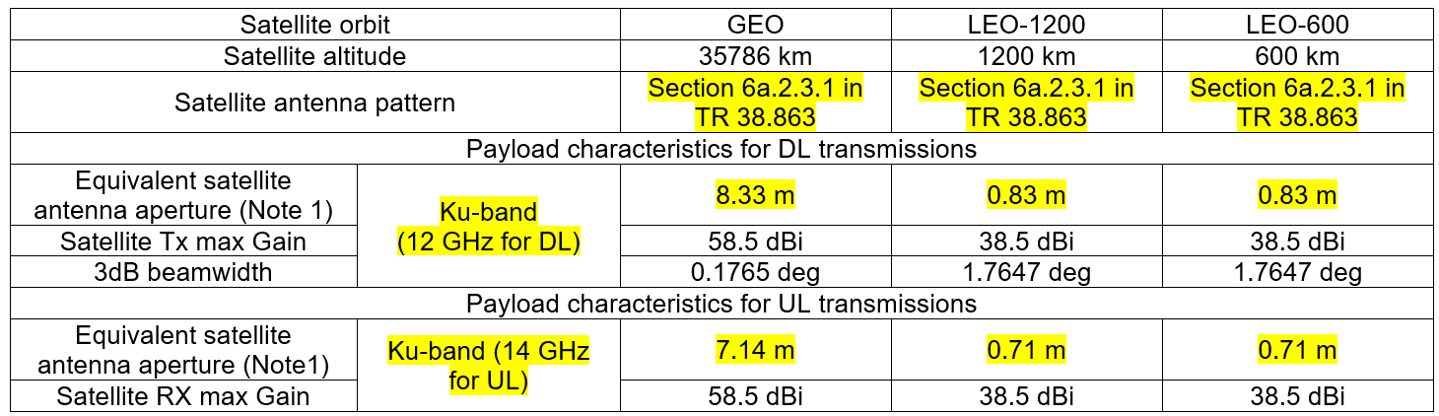
 |  | Proposal 3: Use the VSAT antenna parameter in following table for Ku-band coexistence simulation.
 |  | Characteristics | VSAT
 |  | Frequency band | Ku band(14 GHz UL and 12 GHz DL)
 |  | Antenna type and configuration | Directional  Section 6a.2.3.1 in TR 38.863 with129 cm equivalent aperture diameter
 |  | Polarisation | circular
 |  | Rx antenna gain | 39.7 dBi
 |  | Tx antenna gain | 43.2 dBi
R4-2411188 | Ericsson | Proposal1: As done for any TN/NTN band previously, and as also mentioned in the WI objectives, RAN4 shall conduct a coexistence study assuming adjacent TN/NTN networks.  Observation1: ESIM connected to NGSO SAN is a new additional scenario to consider for the coexistence study for the NTN Ku band.  Proposal2: The reference frequencies to be considered in the coexistence study should be 14 GHz for UL (Earth to Space) and 11 GHz for DL (Space to Earth).  Proposal3: Use 100 MHz channel BW for both NTN and TN network.  Proposal4 : RAN4 shall collect the following missing information on:  - SAN: EIRP density, Tx antenna max gain, Rx antenna max gain, G/T figure.  - VSAT UE: antenna type, noise figure, Tx antenna max gain, Rx antenna max gain, UE max Tx power.  Proposal5: RAN4 shall collect the following missing information on NTN propagation model to progress on the coexistence study:  - Shadow fading and clutter loss tables for the reference frequencies  - Tropospheric scintillation.  Observation2: To minimize potential issues during calibration, RAN4 should also align on the atmospheric absorption (based on the method of Annex 2 in ITU-R P.676 ).  Proposal6: Use as starting point the antenna parameters and BS/UE ACLR/ACS agreed for:  - The 10.0-10.5 GHz frequency range ([2]) for the reference frequency of 11 GHz  - The 14.8-15.35 GHz frequency range (pending on conclusion of SI FS_NR_IMT_4400_7125_14800MHz) for the reference frequency of 14 GHz.  Proposal7: For TN channel model, reuse existing version of TR 38.901.
R4-2411507 | Intelsat | In this contribution we have illustrated various scenario in which co-existence studies could be carried out in the Ku Band.  From the discussions presented in this contribution, we can conclude that:  - All mobile/terrestrial and IMT services around the Ku Band have already been assigned  - There are no vacant spectrum remaining for any possible fictitious or virtual IMT bands  - Interferers that have been illustrated can be used for co-existence analysis  - To arrive at ACLR and ACS values between the Ku Band services and non-3GPP service ITU Protection level could be used  Proposal 1: We propose to proceed with the co-existence study in the order of priority:  Priority 1 Downlink with Uplink Band B in Regions 1,2 and 3 (Figure 6)  Priority 2 Downlink with Uplink Band A in Regions 1, 3 and 2 excluding US, (Figure 7)  Proposal 2: To streamline the analysis and to avoid duplication, we propose to use the following interfering carriers, from Table 3, for the co-existence scenarios.  - Priority 1 10.50GHz and 14.50 GHz  - Priority 2 10.50 GHz  Proposal 3: We propose to use the interference scenarios, see following Table 4, for the co-existence study  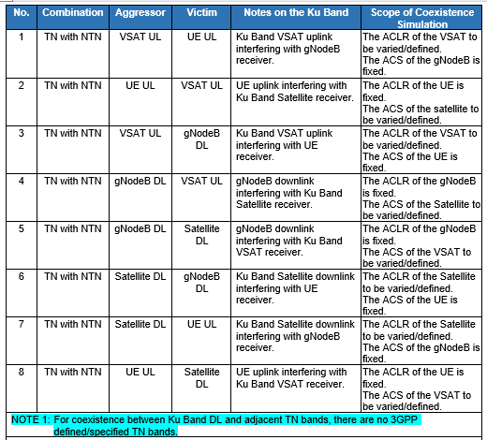  Proposal 4 We propose to use the following Satellite parameters, see Table 1, for the co-existence study  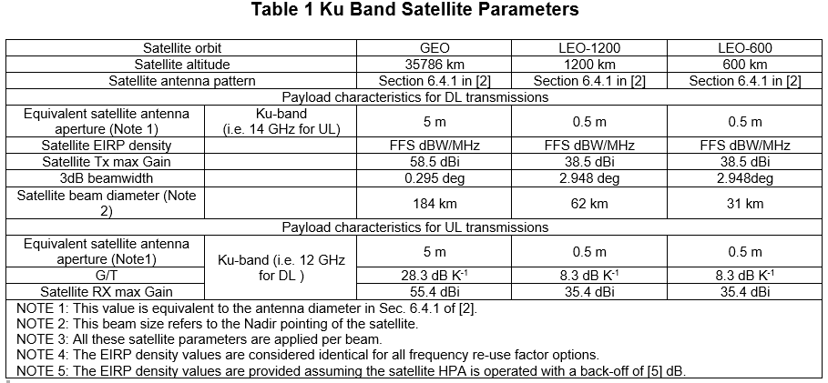  Proposal 5 We propose to use the following VSAT parameters , see Table 2, for the co-existence analysis  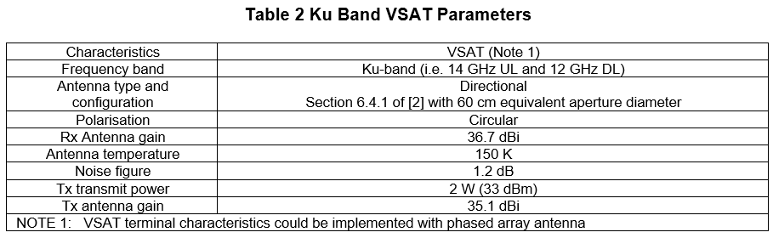
R4-2411658 | Nokia | Proposal 1: Agree to reuse simulation scenarios, assumptions and methodology from TR 38.863.
R4-2411858 | ZTE Corporation, Sanechips | Proposal: It is proposed to use the simulation assumptions in this paper for Ku band NTN coexistence study.
R4-2412560 | Samsung | Proposal 1: Given the difference between Ku-band and Ka-band, the isolation setting between TN and NTN should be revisited for co-ex studies. The co-ex without isolation distance, i.e. geographical overlapping case should not be skipped for Ku-band study from the beginning.  Proposal 2: The WID proposed channel bandwidth and SCS combinations should be taken into account for the Ku-band studies as the difference to previous studies. Among those, the worst case should be evaluated for co-ex purpose.  Proposal 3: It is proposed to discuss and confirm whether Set-1 and Set-2 satellite Tx and Rx parameters are still applicable to this Ku-band studies.  Proposal 4: The existing regulation, as mentioned by the WID, should be considered and taken into account when making assumptions on NTN VSAT antenna size, gain, max power, etc.  Proposal 5: A different uplink control SNR target other than 15dB can be considered for Ku-band depending on the inputs from satellite companies.
R4-2412962 | Huawei, HiSilicon | Proposal 1: the scenarios for aggressor and victim specified in Table 6a.1-2 of TR 38.863 can be reused for Ku band adjacent channel coexistence study.  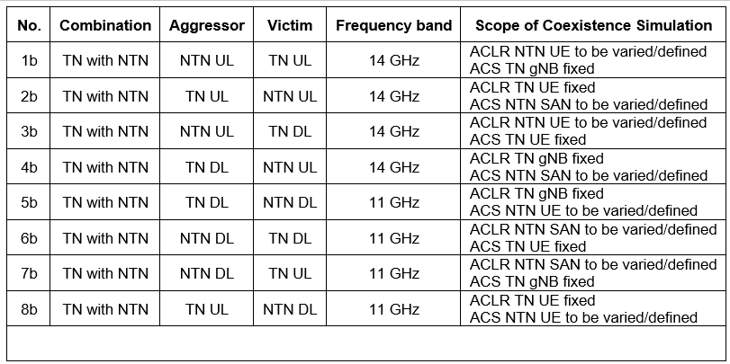  Proposal 2: RAN4 should discuss and analyze the RF parameters for satellite and VSAT in Ku band, e.g. EIRP, antenna gain, TRP and antenna types.  Proposal 3: for the TN RF parameters, it’s better to align the outcomes of SI on IMT parameters for 4400 to 4800 MHz, 7125 to 8400 MHz and 14800 to 15350 MHz as much as possible.
R4-2412993 | Eutelsat Group | Figure 1 shows the frequency ranges of the Ku band downlink and uplinks, as well as the adjacent space science service below 10.7 GHz and the proposed future IMT band above 14.8 GHz.  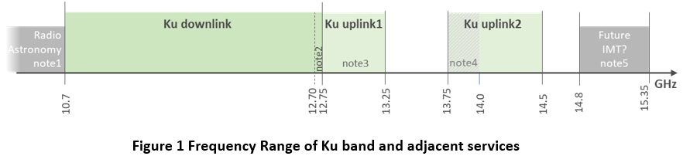
R4-2413217 | SKY Perfect JSAT Corporation | Proposal 1: RAN4 to discuss whether the results of the coexistence study are affected by the choice between linear and circular polarization and whether it is also necessary to conduct a separate study on shared use considerations for the linear polarization model.

Open issues summary
Before f2f meeting, moderators shall summarize list of open issues, candidate options and possible WF (if applicable) based on companies’ contributions.

Sub-topic 2-1: Coexistence scope
- Proposals:
- Proposal 1: [Ericsson] As done for any TN/NTN band previously, and as also mentioned in the WI objectives, RAN4 shall conduct a coexistence study assuming adjacent TN/NTN networks.
- Moderator Recommendation:
- Clarify the scope of co-existence studies as regards adjacent services and TN networks, referring to pre-existing studies, ECC decisions, WRC-23 etc.

Sub-topic 2-2: Coexistence scenarios
- Proposals:
- Proposal 1: [Intelsat] We propose to use the interference scenarios, see following Table 4 in R4-2411507, for the co-existence study
- Proposal 2: [Huawei, HiSilicon] The scenarios for aggressor and victim specified in Table 6a.1-2 of TR 38.863 can be reused for Ku band adjacent channel coexistence study in R4-2412962
- Moderator Recommendation:
- Proposals are similar. Relevant choices dependent on subtopic 2-1.

Sub-topic 2-3: Coexistence assumptions
- Proposals:
- Proposal 1: [Nokia] Agree to reuse simulation scenarios, assumptions and methodology from TR 38.863.
- Proposal 1: [ZTE] It is proposed to use the simulation assumptions in this paper for Ku band NTN coexistence study in R4-2411858
- Proposal 3: [Samsung] Given the difference between Ku-band and Ka-band, the isolation setting between TN and NTN should be revisited for co-ex studies. The co-ex without isolation distance, i.e. geographical overlapping case should not be skipped for Ku-band study from the beginning.
- Aproposal 4: [Samsiung] different uplink control SNR target other than 15dB can be considered for Ku-band depending on the inputs from satellite companies.
- Proposal 5: [SKY Perfect JSAT Corporation] RAN4 to discuss whether the results of the coexistence study are affected by the choice between linear and circular polarization and whether it is also necessary to conduct a separate study on shared use considerations for the linear polarization model.
- Moderator Recommendation:
- Further discussion required

Sub-topic 2-4: Coexistence frequencies
- Proposals:
- Proposal 1: [CATT] Use 12GHz for DL coexistence evaluation and 14GHz for UL coexistence evaluation for Ku-band.
- Proposal 2: [Intelsat] To streamline the analysis and to avoid duplication, we propose to use the following interfering carriers, from Table 3, for the co-existence scenarios.
  - Priority 1 10.50GHz and 14.50 GHz
  - Priority 2 10.50 GHz

- Moderator Recommendation:
- Choice of co-existence frequencies dependent on agreed scope and specific cases. A generic mid-band choice may not be optimal.

Sub-topic 2-5: Coexistence SAN parameters
- Proposals:
- Proposal 1: [CATT] Table from R4-2411120
- Proposal 2 [Intelsat] We propose to use the following Satellite parameters, see Table 1, for the co-existence study in R4-2411507)
- Moderator Recommendation:
- Further discussion required

Sub-topic 2-6: Coexistence UE parameters
- Proposals:
- Proposal 1: [CATT] Table from R4-2411120
- Proposal 2 [Intelsat] We propose to use the following VSAT parameters , see Table 2, for the co-existence analysis in R4-2411507)
- Moderator Recommendation:
- Further discussion required

Sub-topic 2-7: Coexistence channel bandwidth
- Proposals:
- Proposal 1: {Ericsson] Use 100 MHz channel BW for both NTN and TN network.
- Moderator Recommendation:
- Optimal decision depends on the specific scenario and UL vs DL

Sub-topic 2-8: Coexistence channel model
- Proposals: Proposal 1: {Ericsson]For TN channel model, reuse existing version of TR 38.901..
- Moderator Recommendation:
- The specifics of NTN channels such as ground scatter and very large distances need to be checked in 38.901

Topic #3: System parameters (agenda 8.9.3)

Companies’ contributions summary
All Tdocs related to the following topics (agenda 8.9.3) are listed here:
T-doc number | Company | Proposals / Observations
R4-2411121 | CATT | Proposal 1: Extend FR2-NTN downwards for Ku-band as following table 2-1:  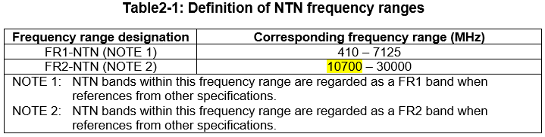  Proposal 2: Define n509, n508, n507, and n506 operating bands in FR2-NTN for Ku-band as following table 2-2.  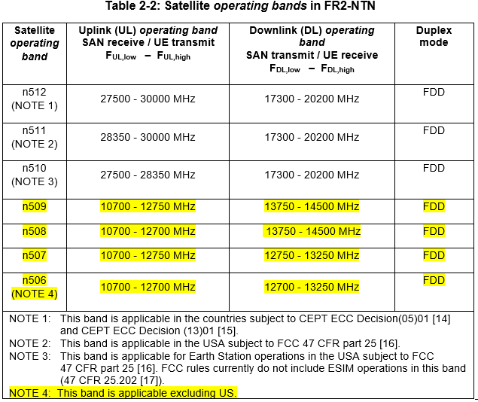
R4-2411189 | Ericsson | In this contribution, we analyzed the impacts of considering the NTN Ku-band(s) as part of FR1-NTN or FR2-NTN. We made the following proposals and observations:  Observation1: To better support 125 MHz UL aggregated, 25 MHz channel BW should also be supported in the Ku-band(s), if FR1-NTN is the frequency range supposed to host this Ku-band(s).  Observation2: The targeted 125 MHz BW could be supported by aggregated 100 and 25 MHz channel BW. The targeted 250 MHz BW could be supported by aggregated 2 times 100 and 1 time 50 MHz channel BW.  Observation3: If the Ku-band(s) is part of the FR1-NTN frequency range, RF and demodulation requirements shall be specified at least for 35, 50, 70 and 100 MHz channel BW to address the WI objective.  Observation4: RF and demodulation requirements are specified for NTN UE types 1-5 when operating in bands belonging to FR2-NTN.  Observation5: 60kHz SCS is not supported in RRM specifications.  Observation6: If the Ku-band(s) should be considered as a FR1-NTN band(s), FR1-NTN upper limit should be extended from 7125 MHz up to 14.5 GHz.  Observation7: The targeted 125 MHz aggregated channel BW might be challenging if Ku-band(s) is considered as a FR2-NTN band.  Observation8: The targeted 250 MHz BW could be supported by aggregated 200 and 50 MHz channel BW.  Observation9: If the Ku-band(s) should be considered as a FR2-NTN band(s), FR2-NTN lower limit should be extended from 17300 MHz down to 10700 MHz.
R4-2411481 | Eutelsat Group | Proposal 1: At least the following technical factors should be considered before deciding whether FR1 and/or FR2 numerology could be applicable for Ku band:  - The possibility using a feasible SCS to meet the channel bandwidth requirements of NTN  - Phase noise  - UL timing synchronization  - Beam hopping granularity  Proposal 2: A thorough analysis of these factors should be conducted before considering other factors such as commercial considerations.  Proposal 3: Companies are encouraged to provide evidence with respect to FR1 and/or FR2 applicability for NTN Ku-band
R4-2411508 | Intelsat | In this contribution we have illustrated several channel bandwidths and other fundamental band parameters under FR1-NTN and FR2-NTN Numerologies for the Ku Band.  The NTN Band numbering shown in the tables are yet to be agreed by RAN4.  We propose to capture the band calculations illustrated in this contribution for the Ku Band.
R4-2411509 | Intelsat | - The conclusions that we can draw from the presented analysis are as follows:  - 1- The FR1-NTN numerology can potentially accommodate the Ku Band legacy, advanced and future satellite transponder bandwidths with lower spectrum wastage.  - 2- The FR1-NTN Numerology allows for greater flexibility in deploying 5G/NR Services in the Ku Band provided we can address the outstanding issues in Appendix A  - 3- The FR2-NTN Numerology, can potentially has higher spectrum wastage compared to FR1-NTN.
R4-2411777 | MediaTek inc. | In this paper, we provide our views on the system parameters for Ku band. We have the following observations and proposals.  Observation 1: Larger channel BW would lead to higher sensitivity levels in the receiver and lower power spectrum density in the transmitter. These may need even more antennas to mitigate, putting extra cost and implementation constraint to UEs.  Proposal 1: RAN4 to carefully discuss the need of larger channel BWs. If needed, large BWs can be considered as optional.  Observation 2: Beside large bandwidth, the shorter CP length at FR2 make it very challenging for implementation due to very tight UE Tx transmit timing accuracy requirements.  Proposal 2: RAN4 to prioritize FR1 over FR2 in Ku band system parameter discussions.
R4-2411859 | ZTE Corporation, Sanechips | In this contribution, we shared some views on system parameters for NTN Ku band and the proposal is made as follows:  Observation 1: The frequency range of Ku band is closer to FR1. However, channel bandwidths specified in current NTN specification only support 5, 10, 15, 20 MHz, and 30 MHz channel bandwidth only be introduced without defining related RF requirements.
R4-2411950 | Nokia | Observation 1: The Ku Band is not within any of the existing frequency ranges.  Proposal 1: It is proposed to further discuss whether we define a new frequency range covering Ku band(s) or extend the existing frequency range (either FR1-NTN or FR2-NTN) to cover Ku bands.  Proposal 2: Any new or extended frequency range covering Ku band(s) can only be reflected in TS 38.101-5 and TS 38.108.  Proposal 3: We wait for the agreement on frequency range issue before agreeing to band numbers.  Proposal 4: It is for further discussion whether we nail down SCS options for Ku bands.  Proposal 5: SCS based channel raster is introduced to Ku bands.  Proposal 6: Flexible Tx-Rx frequency separation can be used for Ku band NTN FDD operation.  Proposal 7: The existing sync raster design is reused for Ku bands.
R4-2412079 | vivo | This contribution gives our initial views on system parameters for Ku band NTN. The following proposals are made:  Proposal 1. Discuss whether to define FR3-NTN for Ku band.  Proposal 2. Consider define two Ku bands for different regions as first priority:  FDD band nX: UL 13.75-14.5 GHz DL 10.70-12.75 GHz  FDD band nY: UL 13.75-14.5 GHz DL 10.70-12.70 GHz  Observation 1: It can be observed that existing Ku band satellite systems use FR1-NTN like channel bandwidth.  Proposal 3: To adopt channel bandwidth as FR1-NTN.  Ku band #1a and #1b as FR1-NTN supporting 20 MHz, 35 MHz, 50 MHz, 70 MHz and 100 MHz channel bandwidths with 30 kHz subcarrier spacing  Proposal 4：The channel raster and sync raster can be decided after the definition of channel bandwidth for the Ku band.
R4-2412265 | CHTTL | Based on the discussion above, four observations are summarized below.  Observation 1: A single harmonized band with downlink 10.70 – 12.75 GHz & uplink 13.75 – 14.5 GHz for all regions excluding US could avoid market fragmentation in the future.  Observation 2: At least the 60kHz SCS should be suitable for NTN Ku band in terms of the phase noise, Doppler effect comparing with the NTN Ka band.  Observation 3: The flexibility on the channel usage could be a factor to consider when down selecting between FR1/FR2 approaches, if the assumption is no brand new channel BW for FR2 or new FR with new set of parameters can be introduced for the NR NTN Ku band.  Observation 4: Considering some current Ku band transponders using 36, 54, 72 MHz bandwidth, the FR1 numerologies is much suitable in terms of the flexibility of the channel usage.  And two proposals are summarized below.  Proposal 1: Consider a single harmonized band with downlink 10.70 – 12.75 GHz & uplink 13.75 – 14.5 GHz for all regions excluding US in this Ku band work (i.e. combining Ku band #1a and #1b).  - Restriction on some regions can be implemented by a note in the frequency band table.  Proposal 2: RAN4 to confirm the feasibility on supporting NTN Ku band within FR1 numerologies if the assumption is no new channel BW can be introduced for FR2.
R4-2413247 | Huawei, HiSilicon | Based on the discussion above, the following proposals were formulated:  Proposal 1: Regardless of the decision on FR1-NTN, or FR2-NTN extension for Ku range introduction, FR extension shall be done in a continuous fashion based on Variant b, i.e. 410 – 14500 MHz in case of FR1-NTN, or 10700 – 30000 MHz in case of FR2-NTN extension.  Proposal 2: Priority 2 objectives of the WID are put on hold until Priority 1 objectives are agreed. Further work on Priority 2 objectives to leverage previous agreements on Priority 1 package, wherever possible.  Proposal 3: As a starting point, define two separate Ku bands for #1a and #1b (i.e. Priority 1 bands).  Proposal 4: RAN4 to focus on the reuse of the existing NR channel bandwidths for Ku band, and postpone discussion on 125 MHz (UL) and 250 MHz (DL) new channel bandwidths for Ku band at least until February 2025 meeting.  Proposal 5: Companies to provide further feedback on the selection of Solution 1 vs. Solution 2, based on a set of pre-defined metrics (to be decided during the meeting), e.g. standardisation effort, competitive Ku VSAT, device cost, Ka/Ku components integration, etc.
R4-2413458 | SKY Perfect JSAT Corporation | Observation 1: By using the FR1 channel definitions, it is possible to utilize channels with a bandwidth slightly smaller than the legacy satellite channel bandwidth.  Observation 2: Utilizing FR1 channels with a bandwidth smaller than the satellite channel bandwidth is possible without impacting RAN4 requirements.  Observation 3: By using the definition of FR1 channels, it is possible to use an NR channel bandwidth that matches the legacy satellite channel spacing.  Observation 4: By allocating only the PRBs that can be used through scheduling, the legacy satellite bandwidth can be utilized efficiently with no impact on existing RAN4 requirements.  Observation 5: When comparing FR1 and FR2 in a general sense, it is fair to say that FR1 has a more mature industry status considering the standardization work was completed earlier and it has been more widely implemented and deployed.  Issue 1: By using FR1 channels with a bandwidth smaller than the legacy satellite channel bandwidth, satellite bandwidth is underutilized.  Issue 2: Using BWPs that exactly match the available legacy satellite bandwidth requires a study by RAN4 because BWPs of sizes different from the already defined NR channel bandwidths are not currently tested within the RAN4 defined requirements.  Issue 3: Using NR channel bandwidths that have already been tested within RAN4 defined requirements does not allow for efficient utilization of legacy satellite bandwidth.  Issue 4: When using both polarizations, the NR channel boundaries are placed within the usable satellite bandwidth, which makes it inefficient to fully utilize the satellite bandwidth.  Issue 5: When the legacy satellite channel spacing is smaller than the smallest FR2 channel bandwidth of 50 MHz, and the FR2 channel that is closest to the satellite channel spacing is used to allocate NR channels without overlap, the NR channel boundaries are placed within the usable satellite bandwidth, which makes it inefficient to fully utilize the legacy satellite bandwidth.  Issue 6: Applying an FR2 channel with the closest channel bandwidth to the satellite channel spacing with overlapping allocation of the NR channels will not satisfy the RAN4 requirements.  Proposal 1: RAN4 to provide input on whether there are any issues or requirement impacts for scheduling fewer PRBs as a method for avoiding legacy satellite guard bands.  Proposal 2: To ensure legacy GEO satellite operators can meet their deployment requirements with minimal impact to RAN4, RAN4 to prioritize the channel definitions of FR1 over these of FR2.

# Open issues summary
Before f2f meeting, moderators shall summarize list of open issues, candidate options and possible WF (if applicable) based on companies’ contributions.

Sub-topic 3-1: Frequency range definition
- Proposals:
- Proposal 1: [CATT] Extend FR2-NTN downwards for Ku-band as following table 2-1:
- Proposal 2: [Nokia] It is proposed to further discuss whether we define a new frequency range covering Ku band(s) or extend the existing frequency range (either FR1-NTN or FR2-NTN) to cover Ku bands.
- Proposal 3. [Vivo] Discuss whether to define FR3-NTN for Ku band.
- Proposal 4: [Huawei, HiSilicon] Regardless of the decision on FR1-NTN, or FR2-NTN extension for Ku range introduction, FR extension shall be done in a continuous fashion based on Variant b, i.e. 410 – 14500 MHz in case of FR1-NTN, or 10700 – 30000 MHz in case of FR2-NTN extension.
- Moderator Recommendation:
- Following the scope of the WID, definition of a new frequency range e.g. FR3, is not in scope. This may have unintended consequences, so proposal 4 above, to define a contiguous extension of either FR1-NTN upwards or FR2-NTN downwards is preferred.

Sub-topic 3-2: Numerology – decision criteria
- Proposals:
- Proposal 1: [Eutelsat] Proposal 1: At least the following technical factors should be considered before deciding whether FR1 and/or FR2 numerology could be applicable for Ku band:
  - UL timing synchronization
  - Phase noise
  - Efficient channel utilization
  - Band hopping granularity

- Moderator Recommendation:
- To focus the FR1/FR2 decision, technical factors should be thoroughly analyzed before other factors.

Sub-topic 3-3: Numerology – timing aspects
- Proposals:
- Proposal 1: [Eutelsat] A thorough analysis of timing aspects should be conducted before considering other factors such as commercial considerations.
- Moderator Recommendation:
- The impact of SCS on timing is critical to reliable performance therefore decisions on FR1 and FR2 feasibility should not be made without a thorough analysis of the issues.

Sub-topic 3-4: Numerology – phase noise
- Proposals:
- Proposal 1: [Eutelsat] Proposal 1: A thorough analysis of phase noise should be conducted before considering other factors such as commercial considerations.
- Proposal 2: [CHTTL] At least the 60kHz SCS should be suitable for NTN Ku band in terms of the phase noise, Doppler effect comparing with the NTN Ka band.
- Moderator Recommendation:
- The impact of SCS on susceptibility to phase noise is critical to reliable performance therefore decisions on FR1 and FR2 feasibility should not be made without a thorough analysis of the issues.

Sub-topic 3-5: Numerology – efficient channel utilization
- Proposals:
- Proposal 1: [Eutelsat] Proposal 1: A thorough analysis of efficient channel utilization should be conducted before considering other factors such as commercial considerations.
- Proposal 2: [SKY Perfect JSAT] RAN4 to provide input on whether there are any issues or requirement impacts for scheduling fewer PRBs as a method for avoiding legacy satellite guard bands.
- Proposal 3: [CHTTL] Considering some current Ku band transponders using 36, 54, 72 MHz bandwidth, the FR1 numerologies is much suitable in terms of the flexibility of the channel usage.
  - RAN4 to confirm the feasibility on supporting NTN Ku band within FR1 numerologies if the assumption is no new channel BW can be introduced for FR2.

- Moderator Recommendation:
- The ability to efficiently support the required aggregate bandwidths for different SCS choices needs to be fully studied. New native channel bandwidths that require RAN1 support are out of scope and it is assumed that intra-band contiguous CA will be used to meet the required aggregate channel bandwidths.

Sub-topic 3-6: Numerology – beam hopping granularity
- Proposals:
- Proposal 1: [Eutelsat] Proposal 1: A thorough analysis of beam hopping granularity should be conducted before considering other factors such as commercial considerations.
- Moderator Recommendation:
Beam hopping granularity is a performance factor that influences channel capacity and power consumption. It is a function of SCS which determines the minimum dwell time and periodicity of serving different hex tiles. An analysis of the impact of different SCS on performance, although not critical, can influence the decision on FR1 vs FR2 numerology.

