**3GPP TSG-RAN WG4 Meeting #112 R4-2412803  
Maastricht, Netherlands, 19th – 23rd August, 2024**

**Title:** Topic summary for [111][101] Upto_R17_UERF_maintenance_Part1

**Source:** Moderator (OPPO)

**Agenda item:** 4.1

**Document for:** Information

# Introduction

This is the summary for Rel-15/16 maintenance under agenda 4.2 and 4.8.

**List of topics below:**

* Discussion papers and corresponding CRs (14)
* CRs for 38.101-1 (31)
* CRs for 38.101-2 (1)
* CRs for 38.101-3 (5)
* CRs for 38.101-5 (1)
* CRs for 36.101 (2)
* CRs for other spec (3)

# Discussion papers and corresponding CRs (14)

## Contributions summary

|  |  |  |
| --- | --- | --- |
| **T-doc number** | **Company** | **Proposals / Observations** |
| R4-2412614 | Qualcomm France | About n28/n83 30MHz channel confinement  **Proposal 1**: Modify Note 7 as follows: |
| R4-2412615 (R16) | Qualcomm France | CR on n28 30MHz channel confinement |
| R4-2412616 (R17)  CAT-A:  R4-2412617 | Qualcomm France | CR on n28 and n83 30MHz channel confinement |
| R4-2411717 | Murata | Discussion on Measurement Bandwidth for FR2 UE Tx  Observation 1: The measurement bandwidth of PC5 and PC6 is apparently narrower by one SCS than that of other Power Classes (PC1~PC4 and 7)  Proposal 1: To revise the measurement bandwidth of PC5 and PC6 on the minimum output power requirement as follows. |
| R4-2411718 (R17)  CAT-A:  R4-2411719 | Murata | CR to TS 38.101-2: Correction on Measurement BW for FR2 PC5, 6 |
| R4-2412784 | Huawei, HiSilicon | Discussion on introduction of new FR2 PC  Observation 1: It’s essential to introduce the new power class into 3GPP by the end of 2024, given that local industry standard targets for the completion by the end of 2024 to facilitate the FR2 industry development.  Proposal 1: Some PC7 requirements can be applied for this new FR2 power class.  Proposal 2: New RF requirements shall cover 200MHz and 400MHz channel bandwidth for single carrier operation. Note that targeted bands are n257, n258 and n261.  Proposal 3: Specify new RF requirements for CA and UL-MIMO for this new FR2 power class.  Proposal 4: Introduce the new power class based on the proposals 1, 2 and 3 with specification of the requirements as shown in Table 1. |
| R4-2413064 (CAT-B R18) | Huawei, HiSilicon | CR on introduction of new FR2 power class 8 |
| R4-2412868 | Nokia | (NR_NTN_Solutions) On the definition of geosynchronous satellites  Observation 1: GSO is defined as geosynchronous satellite in other specifications, including other RAN4 specifications and the specification of UE capabilities (TS 38.306).  Observation 2: The “Geostationary” definition is inconsistent with the doppler values used inside TS 38.101-5, for the test cases, in Annex 4  Observation 3: The NTN work item uses GSO as Geosynchronous.  Observation 4: It is more likely that NTN deployments in the market are deployed in Geosyncrhonous orbits than in Geoestationary orbits.  **Proposal 1:** In order to keep the harmony between the work done in the different RAN groups we propose to adopt one of the following options:  a. Update the definition of GSO satellites in 38.101-5 to Geosyncrhonous satellites  b. Adopt a different acronym for Geosyncrhonous satellites in RAN4 |
| R4-2412943 | Huawei, HiSilicon | (NR_NTN_solutions-Core) Discussion on clarification for Terminology GSO  Observation 1: in the satellite industry, most of satellite operators and vendors think that GSO represented Geo Synchronous Orbit.  Observation 2: all of regulatory bodies, including ECC, FCC and ITU, think that GSO represents geostationary-satellite orbit.  Observation 3: If RAN4 has a different understanding of GSO definition with other regulatory bodies, we have to face the risks that there is a different understanding of the regulatory requirements in the future. It may cause some issues about regulation compliance.  **Proposal 1:** In order to solve this issue, RAN4 can discuss whether to clearly indicate the applicability with Geo Synchronous Orbit or geostationary-satellite orbit in the spec instead of using the abbreviation of “GSO”/”NGSO” in RAN4’s spec. |
| R4-2412985 | Ericsson | (NR_NTN_solutions-Core) DMRS bundling feature support from Rel-17  Observation 1 DMRS bundling requirement applies from Rel-17 in TS 38.101-5.  Observation 2 DMRS bundling reporting capability defined in FG 30-4 in Rel-17 is reused for NTN GSO scenario according to RAN1.  **Proposal-1:** Update the Rel-17 TS 38.101-5 to reflect the RAN1 decision [2] according to the proposal above. |
| R4-2412986 (R17) | Ericsson | (NR_NTN_solutions-Core) CR to 38.101-5 DMRS bundling requirement update for NTN GSO |
| R4-2411306 (R17) | Apple, Huawei, HiSilicon | (NR_NTN_solutions-Core) CR to 38.101-5 to clarify applicability of phase continuity requirements in R17 |
| R4-2412102 | vivo | (NB_IOT-Core) Discussion on SEM and MPR requirements correction for NB-Iot  Moderator note: it is reserved but not uploaded before meeting. |
| R4-2413319 | Qualcomm | (NR_RF_FR1_enh-Core) DL interruptions for 2Tx vs 1Tx switching  Proposal: Consider “no DL interruption” mandate for earlier releases to be dependent on the switching case |

## Open issues summary

### Sub-topic 1-1 n28/n83 30MHz channel confinement

**Issue 1-1-1: About n28/n83 30MHz channel confinement**

**Proposal 1:** Modify “transmission bandwidth configuration” to “carrier frequency” in Note 7 as below: (R4-2412614, QC)

From:

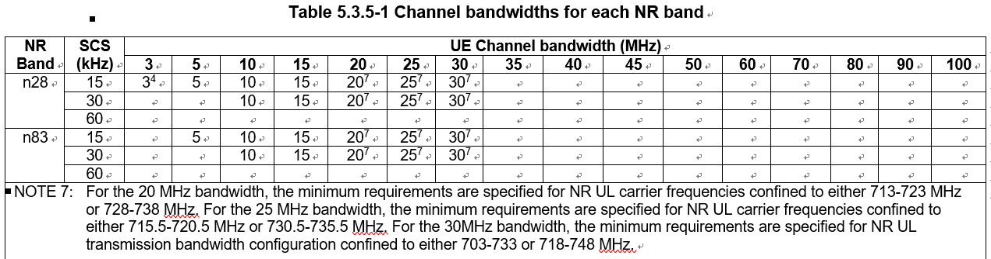

Modified to:

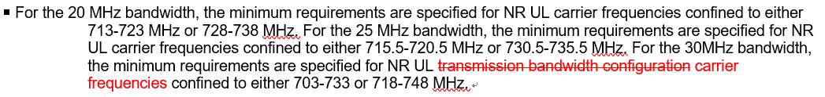

Recommended WF:

**Issue 1-1-2: Corresponding CRs**

|  |  |  |  |
| --- | --- | --- | --- |
| **T-doc** | **Company** | **Title/Comments** | **Recommend** |
| R4-2412615 (R16) | Qualcomm France | CR on n28 30MHz channel confinement |  |
| R4-2412616 (R17)  CAT-A:  R4-2412617 | Qualcomm France | CR on n28 and n83 30MHz channel confinement |  |

### Sub-topic 1-2 MBW for FR2 Min ouptut power

**Issue 1-2-1: MBW of Min output power for FR2 UE PC5/6**

**Proposal 1:** To revise the measurement bandwidth of PC5 and PC6 on the minimum output power requirement as follows.

From:

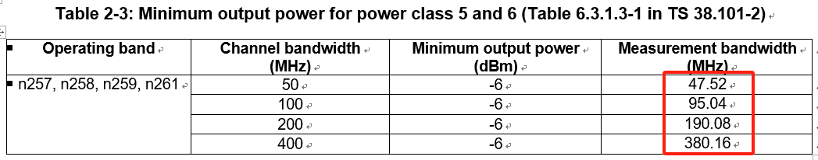

To:

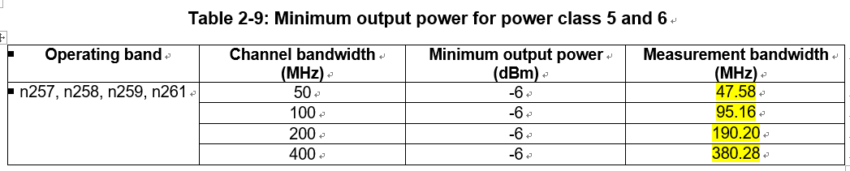

*Moderator note: it is pointed out the MBW of PC5 and PC6 is narrower by one SCS than that of other Power Classes (PC1~PC4 and 7).*

Recommended WF:

**Issue 1-2-2: Corresponding CRs**

|  |  |  |  |
| --- | --- | --- | --- |
| **T-doc** | **Company** | **Title/Comments** | **Recommend** |
| R4-2411718 (R17)  CAT-A:  R4-2411719 | Murata | CR to TS 38.101-2: Correction on Measurement BW for FR2 PC5, 6 |  |

### Sub-topic 1-3 FR2 PC8

**Issue 1-3-1: About n28/n83 30MHz channel confinement**

**Proposal 1:** Some PC7 requirements can be applied for this new FR2 power class. (R4-2412784, HW)

**Proposal 2:** New RF requirements shall cover 200MHz and 400MHz channel bandwidth for single carrier operation. Note that targeted bands are n257, n258 and n261.

**Proposal 3:** Specify new RF requirements for CA and UL-MIMO for this new FR2 power class.

**Proposal 4:** Introduce the new power class based on the proposals 1, 2 and 3 with specification of the requirements as shown in Table 1.

Recommended WF:

**Issue 1-3-2: Corresponding CRs**

|  |  |  |  |
| --- | --- | --- | --- |
| **T-doc** | **Company** | **Title/Comments** | **Recommend** |
| R4-2413064 (CAT-B R18) | Huawei, HiSilicon | CR on introduction of new FR2 power class 8 |  |

### Sub-topic 1-4 On the definition of geosynchronous satellites

**Issue 1-4-1: On the definition of geosynchronous satellites**

**Option 1:** In order to keep the harmony between the work done in the different RAN groups we propose to adopt one of the following options: (R4-2412868 Nokia)

a. Update the definition of GSO satellites in 38.101-5 to Geosyncrhonous satellites

b. Adopt a different acronym for Geosyncrhonous satellites in RAN4

**Option 2:** In order to solve this issue, RAN4 can discuss whether to clearly indicate the applicability with Geo Synchronous Orbit or geostationary-satellite orbit in the spec instead of using the abbreviation of “GSO”/”NGSO” in RAN4’s spec. (R4-2412943 HW)

Recommended WF:

### Sub-topic 1-5 On DMRS bundling feature for NTN

**Issue 1-5-1: DMRS bundling feature for NTN**

**Proposal-1:** Update the Rel-17 TS 38.101-5 to reflect the RAN1 decision [2] according to the proposal.

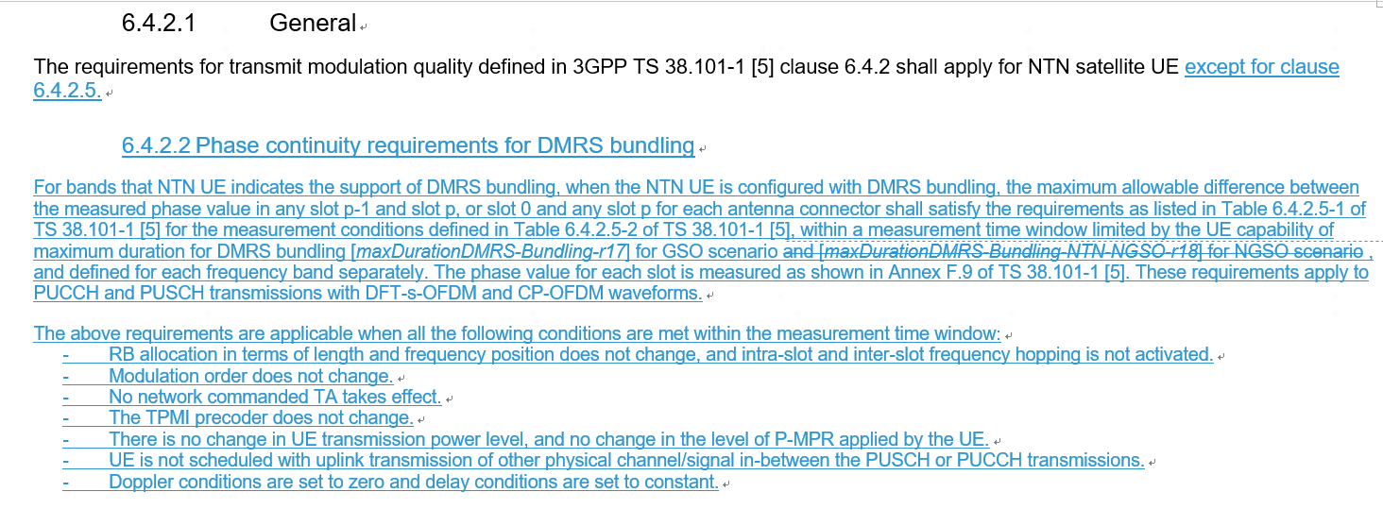

Recommended WF:

**Issue 1-5-2: Corresponding CRs**

|  |  |  |  |
| --- | --- | --- | --- |
| **T-doc** | **Company** | **Title/Comments** | **Recommend** |
| R4-2412986 (R17) | Ericsson | (NR_NTN_solutions-Core) CR to 38.101-5 DMRS bundling requirement update for NTN GSO |  |
| R4-2411306 (R17) | Apple, Huawei, HiSilicon | (NR_NTN_solutions-Core) CR to 38.101-5 to clarify applicability of phase continuity requirements in R17 |  |

### Sub-topic 1-6 DL interruptions for 2Tx vs 1Tx switching

**Issue 1-6-1: “no DL interruption” mandate for earlier releases**

**Proposal:**  Consider “no DL interruption” mandate for earlier releases to be dependent on the switching case. (R4-2413319 QC)

Recommended WF:

# CRs for 38.101-1 (31)

## CRs

|  |  |  |  |
| --- | --- | --- | --- |
| **T-doc** | **Company** | **Title** | **Recommend** |
| R4-2411036 (R17)  CAT-A:  R4-2411046 | Skyworks Solutions Inc. | CR to R17 38.101-1 to add 25MHz CBW to NS_18 emissions requirement |  |
| R4-2411162 (R17)  CAT-A:  R4-2411163 | Apple | (NR_PC2_CA_R17_2BDL_2BUL-Core) CR for 38.101-1 to add general text descriptions on higher power class(es) applicability for higher order band combinations |  |
| R4-2411240 (R17) | Huawei, HiSilicon | (NR_newRAT-Core) Clarification on modifiedMPR-Behaviour |  |
| R4-2411241 (R18) | Huawei, HiSilicon | (NR_newRAT-Core) More on clarification on modifiedMPR-Behaviour |  |
| R4-2411532 (R17)  CAT-A:  R4-2411533 | Rohde & Schwarz | (NR_CADC_R17_2BDL_xBUL) Removal of CA combinations containing n48(A-C) |  |
| R4-2411588 (R15)  CAT-A:  R4-2411589  R4-2411590  R4-2411591 | Sony, Ericsson | CR for TS 38.101-1 Rel-15 correction on the terminology of emission bandwidth for NS_04 |  |
| R4-2411668 (R17)  CAT-A:  R4-2411669 | Ericsson | (NR_redcap-Core) Correction of the channel raster for RedCap UEs by added entries |  |
| R4-2411829 (R17)  CAT-A:  R4-2411830 | ZTE Corporation, Sanechips | (NR_6GHz_unlic_EU-Core) CR for TS 38.101-1 on UE transmitter power for the Pcmax tolerance for NR unlicensed operation (R17) |  |
| R4-2411831 (R17) | ZTE Corporation, Sanechips | (NR_CADC_R17_3BDL_2BUL-Core) CR for TS 38.101-1 on UE configured power relaxation for special component bands (R17) |  |
| R4-2411864 (R18) | ZTE Corporation, Sanechips | (NR_RF_FR1_enh-Core) CR for TS 38.101-1: Corrections on intra-band UL contiguous CA with UL MIMO for PC3 |  |
| R4-2411890 (R17)  CAT-A:  R4-2411891 | ZTE Corporation, Sanechips | CR on 38.101-1 Remove the superscript NOTE 1 for intra-band contiguous CA |  |
| R4-2411925 (R16)  CAT-A:  R4-2411926  R4-2411927 | ZTE Corporation, Sanechips | (NR_n28_BW-Core) Apply ?MPR to the total MOP reduction |  |
| R4-2412040 (R16)  CAT-A:  R4-2412043  R4-2412044 | LG Electronics | CR on typo for A-MPR of NR unlicensed band |  |
| R4-2412446 (R15)  CAT-A:  R4-2412447  R4-2412448  R4-2412449 | Spreadtrum Communications | (NR_newRAT-core) CR for TS 38.101-1 R15 correction on AMPR for NS_10 |  |
| R4-2412469 (R17)  CAT-A:  R4-2412470 | Anritsu Limited | (TEI17) CR to correct the note 1 indication from NS_05 to NS_05U - TS38.101-1 |  |
| R4-2412471 (R16)  CAT-A:  R4-2412472  R4-2412473 | Anritsu Limited | (5G_V2X_NRSL-Core) CR to correct the name of the feature "V2X con-current operation" to "V2X concurrent operation" - TS38.101-1 |  |
| R4-2412474 (R17)  CAT-A:  R4-2412475 | Anritsu Limited | (TEI17) CR to modify MBW definition - TS38.101-1 |  |
| R4-2412476 (R16)  CAT-A:  R4-2412477  R4-2412478 | Anritsu Limited | (TEI16) CR to correct (typo) of the definitions of the symbols Nrb_agg - TS38.101-1 |  |
| R4-2412479 (R15) | Anritsu Limited | (NR_newRAT-Core) CR to correct the definition of the symbol Nrb_agg and two symbols on same line - TS38.101-1 |  |
| R4-2412564 (R16)  CAT-A:  R4-2412566  R4-2412567 | LG Electronics | Correction for value B for non-contiguous uplink carrier aggregation |  |
| R4-2412946 (R17)  CAT-A:  R4-2412947 | Huawei, HiSilicon | (NR_SUL_combos_R17-Core) CR for TS 38.101-1 to clarify the applicability for NUL carriers (R17) |  |
| R4-2413135 (R16)  CAT-A:  R4-2413136  R4-2413137 | Qualcomm Inc. | (NR_n41_BW-Core) CR to TS 38.101-1: NS_47 correction |  |
| R4-2413152 (R15) | Apple | (TEI) On missing BCS set definition for asymmetric FDD |  |
| R4-2413153 (R15)  CAT-A:  R4-2413154  R4-2413155  R4-2413156 | Apple | (TEI) On missing BCS set definition for asymmetric TDD |  |
| R4-2413055 (R15)  CAT-A:  R4-2413057  R4-2413058  R4-2413059 | Skyworks Solutions Inc. | Cat F CR to TS 38.101-1 Rel-15 Power Class 4 clean-up |  |
| R4-2413211 | Keysight Technologies UK Ltd | Rel-15 SUL configuration correction for REFSENS alignment with subsequent releases |  |
| R4-2413241 (R16)  CAT-A:  R4-2413242 | Huawei, HiSilicon | (NR_n14-Core, TEI16) Correction of notes for UE output power |  |
| R4-2413243 (R18) | Huawei, HiSilicon | (NR_n14-Core, TEI16) Correction of notes for UE output power |  |
| R4-2413334 (R15) | Ericsson India Private Limited | (TEI15) CR to 38.101-1 Rel-15: Corrections of NR operating bands clause in FR1 |  |
| R4-2413351 (R16) | Ericsson | (TEI16) CR to 38.101-1 Rel-16: Corrections of NR operating bands clause in FR1 |  |
| R4-2413354 (R17) | Ericsson India Private Limited | (TEI17) CR to 38.101-1 Rel-17: Corrections of NR operating bands clause in FR1 |  |

# CRs for 38.101-2 (1)

## CRs

|  |  |  |  |
| --- | --- | --- | --- |
| **T-doc** | **Company** | **Title/Comments** | **Recommendation** |
| R4-2412944 (R17)  CAT-A:  R4-2412945 | Huawei, HiSilicon | (NR_redcap-Core) CR for TS 38.101-2 to modify the applicable maximum BW for PC7 RedCap UE (R17) |  |

# CRs for 38.101-3 (5)

## CRs

|  |  |  |  |
| --- | --- | --- | --- |
| **T-doc** | **Company** | **Title/Comments** | **Recommend** |
| R4-2411160 (R17)  CAT-A:  R4-2411161 | Apple | (DC_R17_2BLTE_1BNR_3DL2UL-Core, DC_R17_xBLTE_2BNR_yDL2UL) CR to introduce missing MSD requirements |  |
| R4-2411164 (R17)  CAT-A:  R4-2411165 | Apple | (ENDC_UE_PC2_R17_NR_TDD-Core) CR for 38.101-3 to add general text descriptions on higher power class(es) applicability for higher order band combinations |  |
| R4-2412293 (R17) | Huawei, HiSilicon | (DC_R17_1BLTE_1BNR_2DL2UL-Core) CR to TS 38.101-3 Rel17 Removal of Unnecessary NE-DC Requirements |  |
| R4-2412329 (R16) | Huawei, HiSilicon | (DC_R16_1BLTE_1BNR_2DL2UL) CR to TS 38.101-3 Rel16 Removal of Unnecessary NE-DC Requirements |  |
| R4-2413166 (R17)  CAT-A:  R4-2413194 | Huawei, HiSilicon | (ENDC_UE_PC2_R17_NR_TDD-Core) CR 38.101-3 Clean up of power class indication for DC configurations |  |

# CRs for 38.101-5 (1)

## CRs

|  |  |  |  |
| --- | --- | --- | --- |
| **T-doc** | **Company** | **Title/Comments** | **Recommend** |
| R4-2413129 (R17)  CAT-A:  R4-2413130 | Qualcomm | (NR_NTN_solutions-Core) CR to TS 38.101-5: variable duplex distance |  |

# CRs for 36.101 (2)

## CRs

|  |  |  |  |
| --- | --- | --- | --- |
| **T-doc** | **Company** | **Title/Comments** | **Recommend** |
| R4-2412103 (R18) | vivo | (NB_IOT-Core)Correct the MPR requirements for NB-Iot |  |
| R4-2413132 (R16)  CAT-A:  R4-2413133  R4-2413134 | Qualcomm | (LTE_CA_R16_intra-Core) CR to TS 36.101: B41 emissions |  |

# CRs for other spec (3)

## CRs

|  |  |  |  |
| --- | --- | --- | --- |
| **T-doc** | **Company** | **Title/Comments** | **Recommend** |
| R4-2413102 | Union Inter. Chemins de Fer, Huawei, HiSilicon | CR to TR 38.852: Clarification on PC1 Rx requirements for FRMCS operation in band n101 (TR 38.852) |  |
| R4-2413239 | Huawei, HiSilicon, UIC | (NR_RAIL_EU_900MHz-Core, LTE_NR_HPUE_FWVM_R18-Core) Clarification on PC1 Rx requirements for FRMCS operation in band n100 (TR 38.853) |  |
| R4-2413323 | Huawei Technologies Sweden AB | (LTE410_Europe_PPDR-Core) Removal of FFS (TR36.762) |  |