**3GPP TSG-RAN WG4 Meeting #112 R4-2412803  
Maastricht, Netherlands, 19th – 23rd August, 2024**

**Title:** Topic summary for [111][101] Upto_R17_UERF_maintenance_Part1

**Source:** Moderator (OPPO)

**Agenda item:** 4.1

**Document for:** Information

# Introduction

This is the summary for Rel-15/16 maintenance under agenda 4.2 and 4.8.

**List of topics below:**

* Discussion papers and corresponding CRs (12)
* CRs for 38.101-1 (31)
* CRs for 38.101-2 (1)
* CRs for 38.101-3 (5)
* CRs for 36.101 (3)
* CRs for other spec (3)

# Discussion papers and corresponding CRs (12)

## Contributions summary

|  |  |  |
| --- | --- | --- |
| **T-doc number** | **Company** | **Proposals / Observations** |
| R4-2412614 | Qualcomm France | About n28/n83 30MHz channel confinement  **Proposal 1**: Modify Note 7 as follows: |
| R4-2412615 (R16) | Qualcomm France | CR on n28 30MHz channel confinement |
| R4-2412616 (R17)  CAT-A:  R4-2412617 | Qualcomm France | CR on n28 and n83 30MHz channel confinement |
| R4-2411717 | Murata | Discussion on Measurement Bandwidth for FR2 UE Tx  Observation 1: The measurement bandwidth of PC5 and PC6 is apparently narrower by one SCS than that of other Power Classes (PC1~PC4 and 7)  Proposal 1: To revise the measurement bandwidth of PC5 and PC6 on the minimum output power requirement as follows. |
| R4-2411718 (R17)  CAT-A:  R4-2411719 | Murata | CR to TS 38.101-2: Correction on Measurement BW for FR2 PC5, 6 |
| R4-2412868 | Nokia | (NR_NTN_Solutions) On the definition of geosynchronous satellites  Observation 1: GSO is defined as geosynchronous satellite in other specifications, including other RAN4 specifications and the specification of UE capabilities (TS 38.306).  Observation 2: The “Geostationary” definition is inconsistent with the doppler values used inside TS 38.101-5, for the test cases, in Annex 4  Observation 3: The NTN work item uses GSO as Geosynchronous.  Observation 4: It is more likely that NTN deployments in the market are deployed in Geosyncrhonous orbits than in Geoestationary orbits.  **Proposal 1:** In order to keep the harmony between the work done in the different RAN groups we propose to adopt one of the following options:  a. Update the definition of GSO satellites in 38.101-5 to Geosyncrhonous satellites  b. Adopt a different acronym for Geosyncrhonous satellites in RAN4 |
| R4-2412943 | Huawei, HiSilicon | (NR_NTN_solutions-Core) Discussion on clarification for Terminology GSO  Observation 1: in the satellite industry, most of satellite operators and vendors think that GSO represented Geo Synchronous Orbit.  Observation 2: all of regulatory bodies, including ECC, FCC and ITU, think that GSO represents geostationary-satellite orbit.  Observation 3: If RAN4 has a different understanding of GSO definition with other regulatory bodies, we have to face the risks that there is a different understanding of the regulatory requirements in the future. It may cause some issues about regulation compliance.  **Proposal 1:** In order to solve this issue, RAN4 can discuss whether to clearly indicate the applicability with Geo Synchronous Orbit or geostationary-satellite orbit in the spec instead of using the abbreviation of “GSO”/”NGSO” in RAN4’s spec. |
| R4-2412985 | Ericsson | (NR_NTN_solutions-Core) DMRS bundling feature support from Rel-17  Observation 1 DMRS bundling requirement applies from Rel-17 in TS 38.101-5.  Observation 2 DMRS bundling reporting capability defined in FG 30-4 in Rel-17 is reused for NTN GSO scenario according to RAN1.  **Proposal-1:** Update the Rel-17 TS 38.101-5 to reflect the RAN1 decision [2] according to the proposal above. |
| R4-2412986 (R17) | Ericsson | (NR_NTN_solutions-Core) CR to 38.101-5 DMRS bundling requirement update for NTN GSO |
| R4-2411306 (R17) | Apple, Huawei, HiSilicon | (NR_NTN_solutions-Core) CR to 38.101-5 to clarify applicability of phase continuity requirements in R17 |
| R4-2412102 | vivo | (NB_IOT-Core) Discussion on SEM and MPR requirements correction for NB-Iot  Moderator note: it is reserved but not uploaded before meeting. |
| R4-2413319 | Qualcomm | (NR_RF_FR1_enh-Core) DL interruptions for 2Tx vs 1Tx switching  Proposal: Consider “no DL interruption” mandate for earlier releases to be dependent on the switching case |

## Open issues summary

### Sub-topic 1-1 n28/n83 30MHz channel confinement

**Issue 1-1-1: About n28/n83 30MHz channel confinement**

**Proposal 1:** Modify “transmission bandwidth configuration” to “carrier frequency” in Note 7 as below: (R4-2412614, QC)

From:

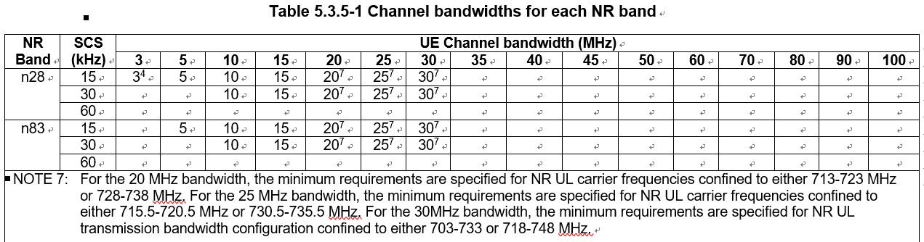

Modified to:

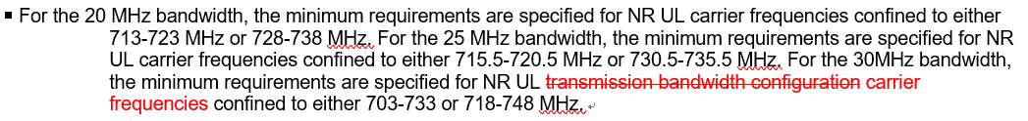

Recommended WF:

**Issue 1-1-2: Corresponding CRs**

|  |  |  |  |
| --- | --- | --- | --- |
| **T-doc** | **Company** | **Title/Comments** | **Recommend** |
| R4-2412615 (R16) | Qualcomm France | CR on n28 30MHz channel confinement |  |
| R4-2412616 (R17)  CAT-A:  R4-2412617 | Qualcomm France | CR on n28 and n83 30MHz channel confinement |  |

### Sub-topic 1-2 MBW for FR2 Min ouptut power

**Issue 1-2-1: MBW of Min output power for FR2 UE PC5/6**

**Proposal 1:** To revise the measurement bandwidth of PC5 and PC6 on the minimum output power requirement as follows.

From:

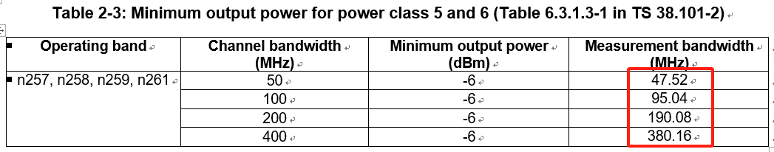

To:

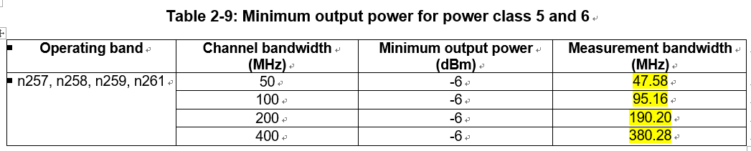

*Moderator note: it is pointed out the MBW of PC5 and PC6 is narrower by one SCS than that of other Power Classes (PC1~PC4 and 7).*

Recommended WF:

**Issue 1-2-2: Corresponding CRs**

|  |  |  |  |
| --- | --- | --- | --- |
| **T-doc** | **Company** | **Title/Comments** | **Recommend** |
| R4-2411718 (R17)  CAT-A:  R4-2411719 | Murata | CR to TS 38.101-2: Correction on Measurement BW for FR2 PC5, 6 |  |

### Sub-topic 1-3 On the definition of geosynchronous satellites

**Issue 1-3-1: On the definition of geosynchronous satellites**

**Option 1:** In order to keep the harmony between the work done in the different RAN groups we propose to adopt one of the following options: (R4-2412868 Nokia)

a. Update the definition of GSO satellites in 38.101-5 to Geosyncrhonous satellites

b. Adopt a different acronym for Geosyncrhonous satellites in RAN4

**Option 2:** In order to solve this issue, RAN4 can discuss whether to clearly indicate the applicability with Geo Synchronous Orbit or geostationary-satellite orbit in the spec instead of using the abbreviation of “GSO”/”NGSO” in RAN4’s spec. (R4-2412943 HW)

Recommended WF:

### Sub-topic 1-4 On DMRS bundling feature for NTN

**Issue 1-4-1: DMRS bundling feature for NTN**

**Proposal-1:** Update the Rel-17 TS 38.101-5 to reflect the RAN1 decision [2] according to the proposal.

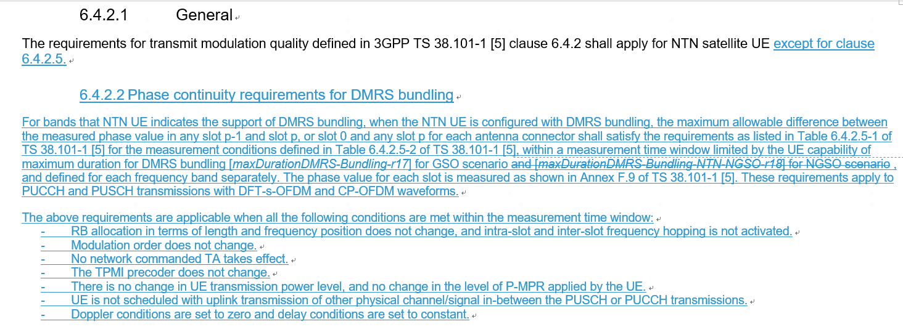

Recommended WF:

**Issue 1-4-2: Corresponding CRs**

|  |  |  |  |
| --- | --- | --- | --- |
| **T-doc** | **Company** | **Title/Comments** | **Recommend** |
| R4-2412986 (R17) | Ericsson | (NR_NTN_solutions-Core) CR to 38.101-5 DMRS bundling requirement update for NTN GSO |  |
| R4-2411306 (R17) | Apple, Huawei, HiSilicon | (NR_NTN_solutions-Core) CR to 38.101-5 to clarify applicability of phase continuity requirements in R17 |  |

### Sub-topic 1-5 DL interruptions for 2Tx vs 1Tx switching

**Issue 1-5-1: “no DL interruption” mandate for earlier releases**

**Proposal:**  Consider “no DL interruption” mandate for earlier releases to be dependent on the switching case. (R4-2413319 QC)

Recommended WF:

# CRs for 38.101-1 (31)

## CRs

|  |  |  |  |
| --- | --- | --- | --- |
| **T-doc** | **Company** | **Title** | **Recommend** |
| R4-2411036 (R17)  CAT-A:  R4-2411046 | Skyworks Solutions Inc. | CR to R17 38.101-1 to add 25MHz CBW to NS_18 emissions requirement |  |
| R4-2411162 (R17)  CAT-A:  R4-2411163 | Apple | (NR_PC2_CA_R17_2BDL_2BUL-Core) CR for 38.101-1 to add general text descriptions on higher power class(es) applicability for higher order band combinations |  |
| R4-2411240 (R17) | Huawei, HiSilicon | (NR_newRAT-Core) Clarification on modifiedMPR-Behaviour |  |
| R4-2411241 (R18) | Huawei, HiSilicon | (NR_newRAT-Core) More on clarification on modifiedMPR-Behaviour |  |
| R4-2411532 (R17)  CAT-A:  R4-2411533 | Rohde & Schwarz | (NR_CADC_R17_2BDL_xBUL) Removal of CA combinations containing n48(A-C) |  |
| R4-2411588 (R15)  CAT-A:  R4-2411589  R4-2411590  R4-2411591 | Sony, Ericsson | CR for TS 38.101-1 Rel-15 correction on the terminology of emission bandwidth for NS_04 |  |
| R4-2411668 (R17)  CAT-A:  R4-2411669 | Ericsson | (NR_redcap-Core) Correction of the channel raster for RedCap UEs by added entries |  |
| R4-2411829 (R17)  CAT-A:  R4-2411830 | ZTE Corporation, Sanechips | (NR_6GHz_unlic_EU-Core) CR for TS 38.101-1 on UE transmitter power for the Pcmax tolerance for NR unlicensed operation (R17) |  |
| R4-2411831 (R17) | ZTE Corporation, Sanechips | (NR_CADC_R17_3BDL_2BUL-Core) CR for TS 38.101-1 on UE configured power relaxation for special component bands (R17) |  |
| R4-2411864 (R18) | ZTE Corporation, Sanechips | (NR_RF_FR1_enh-Core) CR for TS 38.101-1: Corrections on intra-band UL contiguous CA with UL MIMO for PC3 |  |
| R4-2411890 (R17)  CAT-A:  R4-2411891 | ZTE Corporation, Sanechips | CR on 38.101-1 Remove the superscript NOTE 1 for intra-band contiguous CA |  |
| R4-2411925 (R16)  CAT-A:  R4-2411926  R4-2411927 | ZTE Corporation, Sanechips | (NR_n28_BW-Core) Apply ?MPR to the total MOP reduction |  |
| R4-2412040 (R16)  CAT-A:  R4-2412043  R4-2412044 | LG Electronics | CR on typo for A-MPR of NR unlicensed band |  |
| R4-2412446 (R15)  CAT-A:  R4-2412447  R4-2412448  R4-2412449 | Spreadtrum Communications | (NR_newRAT-core) CR for TS 38.101-1 R15 correction on AMPR for NS_10 |  |
| R4-2412469 (R17)  CAT-A:  R4-2412470 | Anritsu Limited | (TEI17) CR to correct the note 1 indication from NS_05 to NS_05U - TS38.101-1 |  |
| R4-2412471 (R16)  CAT-A:  R4-2412472  R4-2412473 | Anritsu Limited | (5G_V2X_NRSL-Core) CR to correct the name of the feature "V2X con-current operation" to "V2X concurrent operation" - TS38.101-1 |  |
| R4-2412474 (R17)  CAT-A:  R4-2412475 | Anritsu Limited | (TEI17) CR to modify MBW definition - TS38.101-1 |  |
| R4-2412476 (R16)  CAT-A:  R4-2412477  R4-2412478 | Anritsu Limited | (TEI16) CR to correct (typo) of the definitions of the symbols Nrb_agg - TS38.101-1 |  |
| R4-2412479 (R15) | Anritsu Limited | (NR_newRAT-Core) CR to correct the definition of the symbol Nrb_agg and two symbols on same line - TS38.101-1 |  |
| R4-2412564 (R16)  CAT-A:  R4-2412566  R4-2412567 | LG Electronics | Correction for value B for non-contiguous uplink carrier aggregation |  |
| R4-2412946 (R17)  CAT-A:  R4-2412947 | Huawei, HiSilicon | (NR_SUL_combos_R17-Core) CR for TS 38.101-1 to clarify the applicability for NUL carriers (R17) |  |
| R4-2413135 (R16)  CAT-A:  R4-2413136  R4-2413137 | Qualcomm Inc. | (NR_n41_BW-Core) CR to TS 38.101-1: NS_47 correction |  |
| R4-2413152 (R15) | Apple | (TEI) On missing BCS set definition for asymmetric FDD |  |
| R4-2413153 (R15)  CAT-A:  R4-2413154  R4-2413155  R4-2413156 | Apple | (TEI) On missing BCS set definition for asymmetric TDD |  |
| R4-2413055 (R15)  CAT-A:  R4-2413057  R4-2413058  R4-2413059 | Skyworks Solutions Inc. | Cat F CR to TS 38.101-1 Rel-15 Power Class 4 clean-up |  |
| R4-2413211 | Keysight Technologies UK Ltd | Rel-15 SUL configuration correction for REFSENS alignment with subsequent releases |  |
| R4-2413241 (R16)  CAT-A:  R4-2413242 | Huawei, HiSilicon | (NR_n14-Core, TEI16) Correction of notes for UE output power |  |
| R4-2413243 (R18) | Huawei, HiSilicon | (NR_n14-Core, TEI16) Correction of notes for UE output power |  |
| R4-2413334 (R15) | Ericsson India Private Limited | (TEI15) CR to 38.101-1 Rel-15: Corrections of NR operating bands clause in FR1 |  |
| R4-2413351 (R16) | Ericsson | (TEI16) CR to 38.101-1 Rel-16: Corrections of NR operating bands clause in FR1 |  |
| R4-2413354 (R17) | Ericsson India Private Limited | (TEI17) CR to 38.101-1 Rel-17: Corrections of NR operating bands clause in FR1 |  |

# CRs for 38.101-2 (1)

## CRs

|  |  |  |  |
| --- | --- | --- | --- |
| **T-doc** | **Company** | **Title/Comments** | **Recommendation** |
| R4-2412944 (R17)  CAT-A:  R4-2412945 | Huawei, HiSilicon | (NR_redcap-Core) CR for TS 38.101-2 to modify the applicable maximum BW for PC7 RedCap UE (R17) |  |

# CRs for 38.101-3 (5)

## CRs

|  |  |  |  |
| --- | --- | --- | --- |
| **T-doc** | **Company** | **Title/Comments** | **Recommend** |
| R4-2411160 (R17)  CAT-A:  R4-2411161 | Apple | (DC_R17_2BLTE_1BNR_3DL2UL-Core, DC_R17_xBLTE_2BNR_yDL2UL) CR to introduce missing MSD requirements |  |
| R4-2411164 (R17)  CAT-A:  R4-2411165 | Apple | (ENDC_UE_PC2_R17_NR_TDD-Core) CR for 38.101-3 to add general text descriptions on higher power class(es) applicability for higher order band combinations |  |
| R4-2412293 (R17) | Huawei, HiSilicon | (DC_R17_1BLTE_1BNR_2DL2UL-Core) CR to TS 38.101-3 Rel17 Removal of Unnecessary NE-DC Requirements |  |
| R4-2412329 (R16) | Huawei, HiSilicon | (DC_R16_1BLTE_1BNR_2DL2UL) CR to TS 38.101-3 Rel16 Removal of Unnecessary NE-DC Requirements |  |
| R4-2413166 (R17)  CAT-A:  R4-2413194 | Huawei, HiSilicon | (ENDC_UE_PC2_R17_NR_TDD-Core) CR 38.101-3 Clean up of power class indication for DC configurations |  |

# CRs for 36.101 (3)

## CRs

|  |  |  |  |
| --- | --- | --- | --- |
| **T-doc** | **Company** | **Title/Comments** | **Recommend** |
| R4-2412103 (R18) | vivo | (NB_IOT-Core) Correct the MPR requirements for NB-Iot |  |
| R4-2411992 (R17)  CAT-A:  R4-2411993 | Nokia | LTE Band 88 REFSENS UL allocation is missing R17 |  |
| R4-2413132 (R16)  CAT-A:  R4-2413133  R4-2413134 | Qualcomm | (LTE_CA_R16_intra-Core) CR to TS 36.101: B41 emissions |  |

# CRs for other spec (3)

## CRs

|  |  |  |  |
| --- | --- | --- | --- |
| **T-doc** | **Company** | **Title/Comments** | **Recommend** |
| R4-2413102 | Union Inter. Chemins de Fer, Huawei, HiSilicon | CR to TR 38.852: Clarification on PC1 Rx requirements for FRMCS operation in band n101 (TR 38.852) |  |
| R4-2413239 | Huawei, HiSilicon, UIC | (NR_RAIL_EU_900MHz-Core, LTE_NR_HPUE_FWVM_R18-Core) Clarification on PC1 Rx requirements for FRMCS operation in band n100 (TR 38.853) |  |
| R4-2413323 | Huawei Technologies Sweden AB | (LTE410_Europe_PPDR-Core) Removal of FFS (TR36.762) |  |