3GPP TSG-RAN WG2 Meeting #121bis-e R2-2304222
Online, 17th– 26th April, 2023

Agenda item: 6.10.2
Source: Huawei, HiSilicon
Title: Summary on [AT121bis-e][504][V2X/SL] R17 CP Corrections (Huawei)
Document for: Discussion and Decision

1. Introduction
This document summarizes the offline discussion as:
- [AT121bis-e][504][V2X/SL] R17 CP Corrections (Huawei)
Scope: Discuss corrections for 38.331/304, including 2683 (except change-3), 2686
Identify CRs that can be agreed in principle with or without revision
Intended outcome:
- Discussion summary in R2-2304222.
- For CRs can be agreed in principle after revision, Tdoc number will be allocated after conclusion from discussion.
Deadline: Aim at email approval before 4/25 CB session
Contact list:

Company | Name | e-mail
Huawei, HiSilicon | Tao Cai | tao.cai@huawei.com
Xiaomi | Xing Yang | Yangxing1@xiaomi.com
Nokia | Jakob buthler | Jakob.buthler@nokia.com
Ericsson | Min Wang | Min.w.wang@ericsson.com
Apple | Zhibin Wu | Zhibin_wu@apple.com
Intel | Ansab Ali | ansab.ali@intel.com
LG | Giwon Park | giwon.park@lge.com
CATT | Jie Shi | shijie@catt.cn
ZTE | Weiqiang Du | du.weiqiang2@zte.com.cn
Sharp | Chongming Zhang | Chongming.zhang@cn.sharp-world.com
Qualcomm | Qing Li | qinli@qti.qualcomm.com
Lenovo | Jing HAN | hanjing8@lenovo.com
MediaTek | Ming-Yuan Cheng | ming-yuan.cheng@mediatek.com

2. Changes in R2-2302683 (except change-3)
Changes in R2-2302683 (except change-3) comprise new changes proposed and (old) changes based on last meeting Xiaomi contribution R2-2300837.
Regarding the (old) changes based on R2-2300837 which is 7th change in R2-2302683:
Q1: Would your company agree on the 7th change in R2-2302683? (Note: in 7th change, for FD of sl-ResourcePoolID, there is a redundant "sidelink" now: shall be "the sidelink configured grant type 1")?
Company | Agree/Disagree | Further comments
Xiaomi | Agree | The redundant ‘sidelink’ should be removed
Nokia | No strong view
vivo | Agree
Ericsson | No strong view | The proposed changes are rather editorial, seem unnecessary. But, we are also fine if there is majority view.
Apple | NO strong view | Just editorial. Can be in rapp CR
Intel | Agree
LG | Agree
CATT | No strong view | Slightly agree to this change to make the description better. But, respect to majority view.
ZTE | No strong view
Sharp | No strong view | We can go with majority view.
Qualcomm | Prefer no change | It’s redundant -- not causing any misunderstanding. If we follow this reasoning then we’ll have more CRs for this kind of rewording which causes wasteful time for delegates to discuss and for product companies to update all the product specification documents.
Lenovo | Agree
MediaTek | Prefer no change
Huawei, HiSilicon | Agree
[Summary] Out of 14 participating companies, Agree/can follow majority: 6/4 , No strong view:2 , No change: 2. There was understanding last meeting that changes in Rel-17 mirror CR R2-2300837 will be included in a Rapporteur CR which is intended to handle minor/editorial changes. Rapporteur proposes to include above changes in the Rapp CR except the redundant "sidelink".
Proposal 1: 7th change in R2-2302683 is agreed.

Other changes (1st, 2nd, 4th, 5th, 6th, 8th) in R2-2302683 are minor changes:
Q2: Would your company agree/disagree on the 1st, 2nd, 4th, 5th, 6th, 8th changes in R2-2302683?
Company | Agree/Disagree | Further comments
Xiaomi | Disagree with change 6 | In 331, SL is defined in abbreviation for sidelink. However, ‘S’ is not defined in 331. Original SL-SSB is clearer.
Nokia | Disagree with change 6 | Agree with Xiaomi
vivo | Agree with all changes
Ericsson | Disagree with change 5 and 6. | 5th change is not needed, the existing text is already clear. Since the timer is for SL reception, and of course the BWP is SL BWP. There is no confusion with the existing text.  6th change, change to S-SSB is not needed. The existing term SL-SSB is fine.
Intel | Agree
LG | Agree with all changes
CATT | Agree
ZTE | Disagree with change 6 | Same view with xiaomi and Ericsson for change 6. SL-SSB is more appropriate for sidelink.
Sharp | Agree
Qualcomm | Prefer no change, but follow the majority | Many of editorial changes not causing any misunderstanding may cause wasteful time for delegates to discuss and for product companies to update all the product specification documents.
Lenovo | Agree | For 6th change, fine to align with PHY spec
MediaTek | Prefer no change
Huawei, HiSilicon | Agree
[Summary] All changes can be agreed except change 5 and change 6. Regarding change 5, one company says that it is already clear the bwp is sidelink bwp. As this is misc Rapp CR, Rapporteur thinks no harm to agree on change 5, it is equivalent either way. Regarding change 6, indeed there are no definitions for either S-SSB or SL-SSB and SL-SSB seems clearer to read though S-SSB is used in PHY spec. Actually there are two parameters directFrameNumber and slotIndex are described in their FD with term "S-SSB", in IE MasterInformationBlockSidelink (clause 6.6.2). As preferably we are not to use both SL-SSB and S-SSB in 331, changing the term one way or another is needed. Considering agree to change 6 by 7 companies (plus one follow majority) and no change 6 by 5 companies, Rapporteur proposes to agree also change 6.
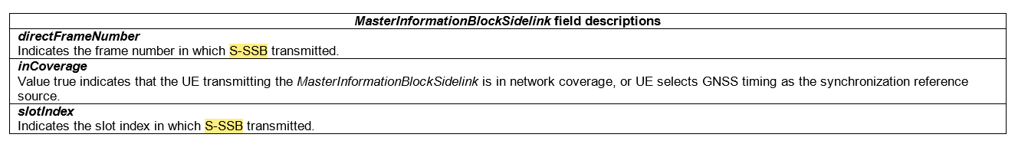
Proposal 2: 1st, 2nd, 4th, 5th, 6th, 8th changes in R2-2302683 are agreed.

3. Changes in R2-2302686
Two changes proposed on TS 38.304 based on the definition of “UE out-of-coverage” and on the condition of when UE can obtain SL DRX configuration and IUC information configuration from SL-PreconfigurationNR as:
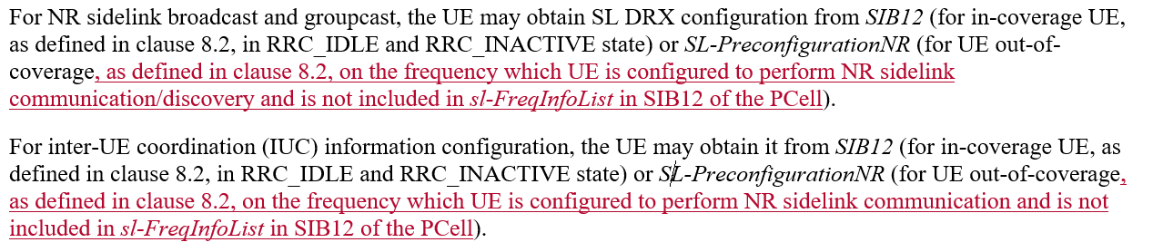
Rapporteur thinks those two changes are in line with the existing description for UE in-coverage.
Q3: Would your company agree/disagree on the above changes in R2-2302686?
Company | Agree/Disagree | Further comments
Xiaomi | Disagree | The text can be improved. UE can obtain SIB12 from SIB12 from non-PCell, e.g. inter-frequency neighbour cell. Also, the UE shall check whether there is cellular coverage on the frequency indicated by sl-PreconfigFreqInfoList in preconfiguration  Furthermore, current change seems only consider non-remote UE. The change may not be correct for remote UE. Because remote UE may also be OOC, but use configuration in SIB12.  Following change is suggested to consider remote UE,  For NR sidelink broadcast and groupcast, the UE may obtain SL DRX configuration from SIB12 (for U2N remote UE and in-coverage UE, as defined in clause 8.2, in RRC_IDLE and RRC_INACTIVE state) or SL-PreconfigurationNR (for non U2N remote UE out-of-coverage, as defined in clause 8.2, on the frequency which UE is configured to perform NR sidelink communication/discovery and is not included in sl-FreqInfoList in SIB12 or sl-PreconfigFreqInfoList in preconfiguration).  For inter-UE coordination (IUC) information configuration, the UE may obtain it from SIB12 (for U2N remote UE and in-coverage UE, as defined in clause 8.2, in RRC_IDLE and RRC_INACTIVE state) or SL-PreconfigurationNR (for non U2N remote UE out-of-coverage, as defined in clause 8.2, on the frequency which UE is configured to perform NR sidelink communication and is not included in sl-FreqInfoList in SIB12 sl-PreconfigFreqInfoList in preconfiguration).
Nokia | No strong view
vivo | Disagree with comments | It’s observed that in current TS 38.304 how the UE is defined as out-of-coverage on the frequency for sidelink operation (including sidelink relay operations) is captured in clause 8.2. See highlighted yellow as below.  8.2 Cell selection and reselection for Sidelink  The requirements defined in this clause for sidelink operation (including sidelink relay operations) apply for Ues in RRC_IDLE, RRC_INACTIVE and in RRC_CONNECTED.  If the UE detects at least one cell on the frequency which UE is configured to perform NR sidelink communication on fulfilling the S criterion in accordance with clause 8.2.1, it shall consider itself to be in-coverage for NR sidelink communication on that frequency. If the UE cannot detect any cell on that frequency meeting the S criterion, it shall consider itself to be out-of-coverage for NR sidelink communication on that frequency.  Therefore, our views to the changes in R2-2302686 are as below:  - Ok to add the reference i.e. “as defined in clause 8.2” but prefer to remove the remaining text i.e. “on the frequency which UE is configured to perform NR sidelink communication/discovery and is not included in sl-FreqInfoList in SIB12 of the Pcell”.  - suggest to merge the removed text for OOC definition i.e. “on the frequency which UE is configured to perform NR sidelink communication/discovery and is not included in sl-FreqInfoList in SIB12 of the Pcell” into the existing clause 8.2.
Ericsson | disagree | The changes seem unnecessary, we are also ok to follow the majority view to accept minimum change.  It is sufficient to just add “as defined in clause 8.2”. the rest changes are omitted.
Apple | Same view as Vivo
Intel | See comment | We share vivo’s suggestion that it is enough to just refer to the corresponding section and the additional text is not needed
LG | Same view as vivo | prefer vivo’s suggestion
CATT | Same view as vivo. | Prefer vivo’s view.
ZTE | Same view as vivo.
Sharp | disagree | We share the view with Ericsson that it is sufficient to just add “as defined in clause 8.2”. The rest changes are omitted.
Qualcomm | Disagree | Same view as Vivo
Lenovo | See comments | just add “as defined in clause 8.2” is sufficient
MediaTek | Disagree
[Summary] The CR in current form is not agreeable while only one company disagree at all. Other companies agree to change from only adding reference of clause 8.2 to adding OOC definition. Rapporteur wants to remind the condition of when UE can obtain SL DRX configuration and IUC information configuration from SL-PreconfigurationNR needs to specify correctly as well. Considering there is no much time to do a thorough revision, Rapporteur proposes the proponent company can work with interested companies on a revision of this CR for next meeting.
Proposal 3: CR in R2-2302686 is postponed to next meeting.

4. Conclusion
Proposal 1: 7th change in R2-2302683 is agreed.
Proposal 2: 1st, 2nd, 4th, 5th, 6th, 8th changes in R2-2302683 are agreed.
Proposal 3: CR in R2-2302686 is postponed to next meeting.

5. Reference
- R2-2302683 Miscellaneous corrections on 38.331 for SL enhancements Huawei, HiSilicon CR Rel-17 38.331 17.4.0 3960 - F NR_SL_enh-Core
- R2-2302686 Corrections on TS 38.304 for SL enhancements Huawei, HiSilicon CR Rel-17 38.304 17.4.0 0329 - F NR_SL_enh-Core

