3GPP TSG-RAN WG2 Meeting #121bis-e R2-2304222
Online, 17th– 26th April, 2023

Agenda item: 6.10.2
Source: Huawei, HiSilicon
Title: Summary on [AT121bis-e][504][V2X/SL] R17 CP Corrections (Huawei)
Document for: Discussion and Decision

1. Introduction
This document summarizes the offline discussion as:
- [AT121bis-e][504][V2X/SL] R17 CP Corrections (Huawei)
Scope: Discuss corrections for 38.331/304, including 2683 (except change-3), 2686
Identify CRs that can be agreed in principle with or without revision
Intended outcome:
- Discussion summary in R2-2304222.
- For CRs can be agreed in principle after revision, Tdoc number will be allocated after conclusion from discussion.
Deadline: Aim at email approval before 4/25 CB session
Contact list:

Company | Name | e-mail
Huawei, HiSilicon | Tao Cai | tao.cai@huawei.com
Xiaomi | Xing Yang | Yangxing1@xiaomi.com

2. Changes in R2-2302683 (except change-3)
Changes in R2-2302683 (except change-3) comprise new changes proposed and (old) changes based on last meeting Xiaomi contribution R2-2300837.
Regarding the (old) changes based on R2-2300837 which is 7th change in R2-2302683:
Q1: Would your company agree on the 7th change in R2-2302683? (Note: in 7th change, for FD of sl-ResourcePoolID, there is a redundant "sidelink" now: shall be "the sidelink configured grant type 1")?
Company | Agree/Disagree | Further comments
Xiaomi | Agree | The redundant ‘sidelink’ should be removed
Other changes (1st, 2nd, 4th, 5th, 6th, 8th) in R2-2302683 are minor changes:
Q2: Would your company agree/disagree on the 1st, 2nd, 4th, 5th, 6th, 8th changes in R2-2302683?
Company | Agree/Disagree | Further comments
Xiaomi | Disagree with change 6 | In 331, SL is defined in abbreviation for sidelink. However, ‘S’ is not defined in 331. Original SL-SSB is clearer.

3. Changes in R2-2302686
Two changes proposed on TS 38.300 based on the definition of "UE out-of-coverage" and on the condition of when UE can obtain SL DRX configuration and IUC information configuration from SL-PreconfigurationNR as:
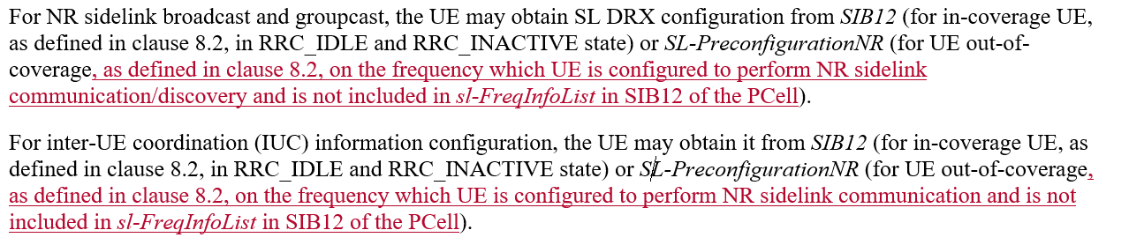
Rapporteur thinks those two changes are in line with the existing description for UE in-coverage.
Q3: Would your company agree/disagree on the above changes in R2-2302686?
Company | Agree/Disagree | Further comments
Xiaomi | Disagree | The text can be improved. UE can obtain SIB12 from SIB12 from non-PCell, e.g. inter-frequency neighbour cell. Also, the UE shall check whether there is cellular coverage on the frequency indicated by sl-PreconfigFreqInfoList in preconfiguration  Furthermore, current change seems only consider non-remote UE. The change may not be correct for remote UE. Because remote UE may also be OOC, but use configuration in SIB12.  Following change is suggested to consider remote UE,  For NR sidelink broadcast and groupcast, the UE may obtain SL DRX configuration from SIB12 (for U2N remote UE and in-coverage UE, as defined in clause 8.2, in RRC_IDLE and RRC_INACTIVE state) or SL-PreconfigurationNR (for non U2N remote UE out-of-coverage, as defined in clause 8.2, on the frequency which UE is configured to perform NR sidelink communication/discovery and is not included in sl-FreqInfoList in SIB12 or sl-PreconfigFreqInfoList in preconfiguration).  For inter-UE coordination (IUC) information configuration, the UE may obtain it from SIB12 (for U2N remote UE and in-coverage UE, as defined in clause 8.2, in RRC_IDLE and RRC_INACTIVE state) or SL-PreconfigurationNR (for non U2N remote UE out-of-coverage, as defined in clause 8.2, on the frequency which UE is configured to perform NR sidelink communication and is not included in sl-FreqInfoList in SIB12 sl-PreconfigFreqInfoList in preconfiguration).

4. Conclusion
Proposal(s).

5. Reference
- R2-2302683 Miscellaneous corrections on 38.331 for SL enhancements Huawei, HiSilicon CR Rel-17 38.331 17.4.0 3960 - F NR_SL_enh-Core
- R2-2302686 Corrections on TS 38.304 for SL enhancements Huawei, HiSilicon CR Rel-17 38.304 17.4.0 0329 - F NR_SL_enh-Core

