3GPP TSG-RAN WG2 Meeting #121bis-e R2-2304222
Online, 17th– 26th April, 2023

Agenda item: 6.10.2
Source: Huawei, HiSilicon
Title: Summary on [AT121bis-e][504][V2X/SL] R17 CP Corrections (Huawei)
Document for: Discussion and Decision

1. Introduction
This document summarizes the offline discussion as:
- [AT121bis-e][504][V2X/SL] R17 CP Corrections (Huawei)
Scope: Discuss corrections for 38.331/304, including 2683 (except change-3), 2686
Identify CRs that can be agreed in principle with or without revision
Intended outcome:
- Discussion summary in R2-2304222.
- For CRs can be agreed in principle after revision, Tdoc number will be allocated after conclusion from discussion.
Deadline: Aim at email approval before 4/25 CB session
Contact list:

Company | Name | e-mail
Huawei, HiSilicon | Tao Cai | tao.cai@huawei.com

2. Changes in R2-2302683 (except change-3)
Changes in R2-2302683 (except change-3) comprise new changes proposed and (old) changes based on last meeting Xiaomi contribution R2-2300837.
Regarding the (old) changes based on R2-2300837 which is 7th change in R2-2302683:
Q1: Would your company agree on the 7th change in R2-2302683? (Note: in 7th change, for FD of sl-ResourcePoolID, there is a redundant "sidelink" now: shall be "the sidelink configured grant type 1")?
Company | Agree/Disagree | Further comments
Other changes (1st, 2nd, 4th, 5th, 6th, 8th) in R2-2302683 are minor changes:
Q2: Would your company agree/disagree on the 1st, 2nd, 4th, 5th, 6th, 8th changes in R2-2302683?
Company | Agree/Disagree | Further comments

3. Changes in R2-2302686
Two changes proposed on TS 38.300 based on the definition of "UE out-of-coverage" and on the condition of when UE can obtain SL DRX configuration and IUC information configuration from SL-PreconfigurationNR as:
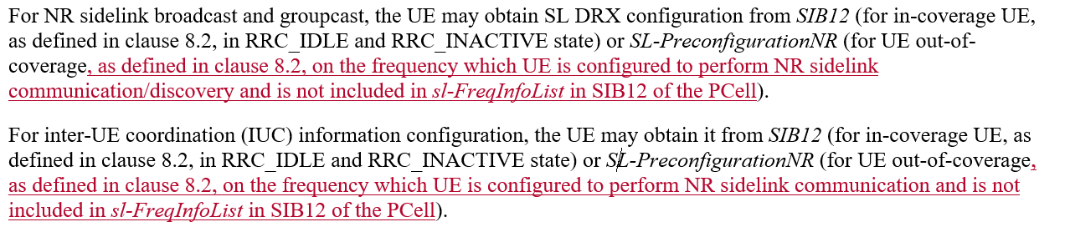
Rapporteur thinks those two changes are in line with the existing description for UE in-coverage.
Q3: Would your company agree/disagree on the above changes in R2-2302686?
Company | Agree/Disagree | Further comments

4. Conclusion
Proposal(s).

5. Reference
- R2-2302683 Miscellaneous corrections on 38.331 for SL enhancements Huawei, HiSilicon CR Rel-17 38.331 17.4.0 3960 - F NR_SL_enh-Core
- R2-2302686 Corrections on TS 38.304 for SL enhancements Huawei, HiSilicon CR Rel-17 38.304 17.4.0 0329 - F NR_SL_enh-Core

