3GPP TSG-RAN WG2 Meeting #121bis-e R2-2304216
Online, 17th– 26th April, 2023

Agenda item: 5.2
Source: Huawei, HiSilicon
Title: Summary on [AT121bis-e][501][V2X/SL] R16 RRC corrections (Huawei)
Document for: Discussion and Decision

Introduction
This document summarizes the offline discussion [AT121bis-e][501][V2X/SL] R16 RRC corrections (Huawei) as:
- [AT121bis-e][501][V2X/SL] R16 RRC corrections (Huawei)
Scope: Discuss corrections for
1) sl-MaxTransPower, including 3157, 3158, 3906, 2799, 3909, 3912, 3913, and
2) carrier frequency for SL-RSRP measurement, including 4144, 4145.
3) measurement event triggering: 4078
Merge corrections that can be agreed in principle.
Intended outcome:
- Discussion summary in R2-2304216.
- If needed, 38.331 CR in R2-2304217 for R16 and R2-2304218 for R17
Deadline: Aim at email approval before at 4/25 CB session

Contact list:
Company | Name | e-mail
Huawei, HiSilicon | Tao Cai | tao.cai@huawei.com
Ericsson | Min Wang | Min.w.wang@ericsson.com
Apple | Zhibin Wu | Zhibin_wu@apple.com
Samsung | Hyunjeong Kang | hyunjeong.kang@samsung.com
Nokia | Jakob Buthler | Jakob.buthler@nokia.com
Xiaomi | Xing Yang | Yangxing1@xiaomi.com
vivo | Jing LIANG | liangjing@vivo.com
NEC | Boyuan Zhang | zhang_boyuan@nec.cn
Intel | Ansab Ali | ansab.ali@intel.com
Sharp | Chongming Zhang | Chongming.zhang@cn.sharp-world.com
LG | Giwon Park | giwon.park@lge.com
Lenovo | Jing HAN | hanjing8@lenovo.com
ZTE | Weiqiang Du | du.weiqiang2@zte.com.cn
Qualcomm | Dan Vassilovski | dvassilo@qti.qualcmm.com
CATT | Hao Xu | xuhao@catt.cn

Change related to sl-MaxTransPower
R2-2302799 proposes changes on the FD of sl-MaxTransPower according to RAN1 LS [11], as below:
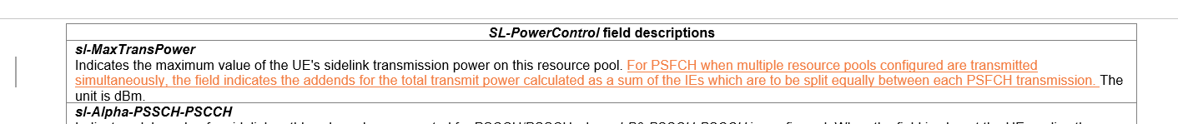
R2-2303906/R2-2303909 propose similar changes related to this FD as:
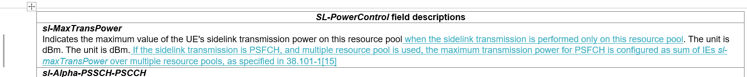
Also R2-2303912/R2-2303913 propose similar changes as:
It can be discussed whether such changes are needed in Rel-16, as well as in Rel-17 (mirror changes). Also the description may be further revised if the change is needed, e.g. sum of the Ies (where “sum of the field values” can be more suitable).
Q1: Would your company agree to change the FD of sl-MaxTransPower based on RAN1 LS, and, if RAN2 agrees to change this FD, which version should be used as baseline?
Option 1: based on R2-2302799
Option 2: based on R2-2303906/R2-2303909
Option 3: based on R2-2303912/R2-2303913
Option 4: Other(s), please elaborate.
Company | Agree/Disagree to change | Option as baseline for the change | Further comments
Ericsson | agree | Option 3 can be adopted as the baseline
Apple | Agree | Option 2
Samsung | Agree | Option 2
Nokia | Agree | Fine with eather | As we anyway are going for a detailed description, we would prefer to explicitly state that the power should be split evenly across all PSFCH resources, otherwise the power for each PSFCH may be assumed as what is indicated in the IE, which is not according to RAN1/RAN4 agreement.  As an alternative, we can be less specific, and simply just refer to TS 38.101-1 i.e. “When this field is used the transmission power of each PSFCH should be calculated as in 38.101-1”  Above would also minimise maintenance, as we follow RAN1 agreements.
Xiaomi | Agree | Option 3
vivo | Agree | Option 3 | For Nokia’s comment, we understand the ‘split evenly’ is not necessary in the field description. The current text is just aligned with 38.101-1 and should be ok.
NEC | Agree | Option 2/3
Intel | Agree | Option 2 | Wording correction to say “…if multiple resource pools are used..”
Sharp | Agree | Option 2
LG | Agree | Option 2
Lenovo | Agree | Can follow majority
ZTE | Agree | Option 2
Qualcomm | Neutral | Go with majority | Between Options 1, 2, 3 we find 3 the clearest. However, our view is while the proposed change can improve clarity, we do not find a FASMO issue with the current spec to justify a change to a frozen release.
CATT | Agree

Changes related to dl-Alpha-PSFCH/ dl-P0-PSFCH
R2-2303157/R2-2303158 propose changes related to FD of dl-Alpha-PSFCH/ dl-P0-PSFCH (from network perspective), according to the latest RAN1 specs as below:
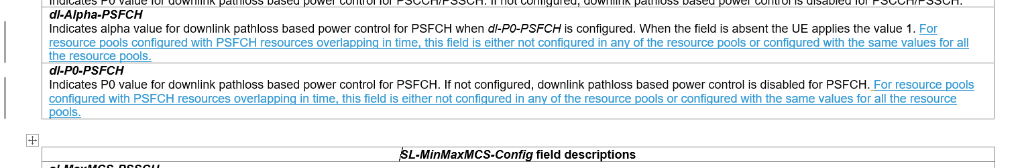
R2-2303906/3909 propose similar changes on the FD of dl-Alpha-PSFCH/ dl-P0-PSFCH (albeit from the UE perspective) as below:
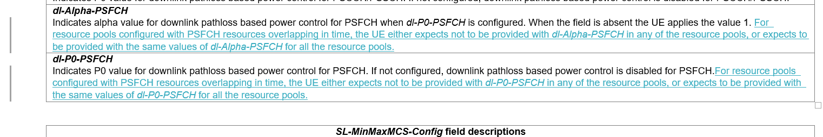
Rapporteur thinks the proposed changes (in one form or another) are needed, as they provide further restrictions on the configuration of dl-Alpha-PSFCH/ dl-P0-PSFCH.
If the changes are agreed, the “Impact analysis” part might need to be added/revised accordingly to demonstrate why the changes are mandatory for Rel-16 RRC spec.

Q2: Would your company agree to change the FD of dl-Alpha-PSFCH/ dl-P0-PSFCH based on RAN1 spec, and, if RAN2 agrees to change these FDs, which version should be used as baseline?
Option 1: based on R2-2303157/R2-2303158
Option 2: based on R2-2303906/3909
Option 3: Other(s), please elaborate.
Company | Agree/Disagree to change | Option as baseline for the change | Further comments
Ericsson | agree | Option 1 can be adopted as the baseline
Apple | Agree | Option 1
Samsung | Agree | Option 1
Nokia | Agree | Either
Xiaomi | Agree | Option 1
vivo | Agree | Option 1
NEC | Agree | Option 1
Intel | Agree | Option 1
Sharp | Agree | Option 1
LG | Agree | Option 1
Lenovo | Agree | Option 1
ZTE | Agree | Can follow majority
Qualcomm | Neutral | Go with majority | Same view as Q1
CATT | Agree | Option 1

Changes related to Measurement Event Triggering Criteria
R2-2304078 proposes correction for Measurement Event Triggering Criteria as:
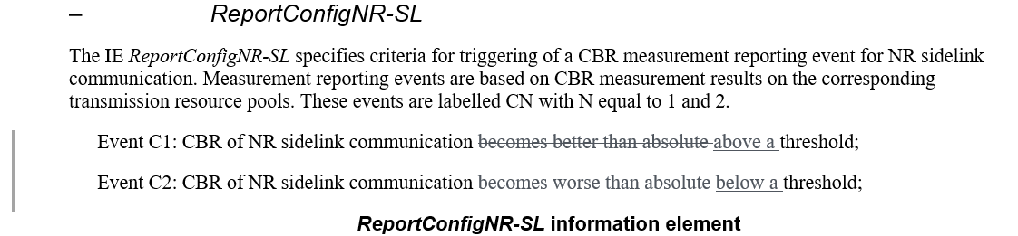
CR for the same issue for Rel-17 was approved in last meeting. Rapporteur thinks this change may be also needed for Rel-16. Though there is common understanding that we don’t usually do (standalone) editorial corrections for R16 RRC, one can say “better than absolute threshold” can be somehow misleading technically (as CBR is worse if "above").
Q3: Would your company agree to the above change proposed on Measurement Event Triggering Criteria?
Company | Agree/Disagree | Further comments
Ericsson | No strong view | We are also ok if there is majority view.
Apple |  | Just cosmetic changes. No strong view.
Samsung | Agree
Nokia | Can agree | Seems more in line with remaining of specification
Xiaomi | Agree
vivo | Agree
NEC | No strong view
Intel | No strong view | Seems just a matter of preference
Sharp | Agree | Proponent
LG | No strong view
Lenovo | No strong view | Nothing is broken
ZTE | No strong view
Qualcomm | No strong view
CATT | Agree

Changes related to carrier frequency for SL-RSRP measurement
R2-2304144/ R2-2304145 propose below change due to one FFS issue in RAN5 spec related to carrier frequency for SL-RSRP measurement, as well as the missing FD of frequencyInfoSL :
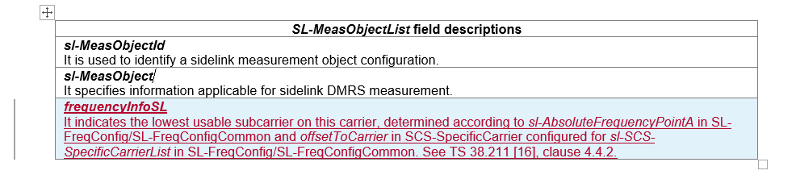
Rapporteur recommends that companies can check with their RAN5 colleagues on this issue and can discuss the needed changes.
Q4: Would your company agree this is an issue that shall be solved, according to the FFS Note in RAN5 spec? If RAN2 agrees this is an issue that shall be solved, would your company agree to the change on the (new) FD of field frequencyInfoSL?
Company | Agree/Disagree this is an issue that shall be solved | Agree/Disagree to the change on the (new) FD of frequencyInfoSL | Further comments
Ericsson | No strong view | No strong view
Samsung | Agree | Disagree | It is not clear the motivation of this FD on carrier frequency. In our understanding offsetToCarrier for sidelink is not specified in clause 4.4.2 in TS 38.211. We wonder whether carrier frequency can be SL-AbsoluteFrequencyPointA or sl-AbsoluteFrequencySSB.
Nokia | Agree | Disagree | Agree with rapporteur that we can check with RAN5 colleagues first
Xiaomi | Not sure |  | The motivation is not from RAN2. RAN5 input, i.e. RAN5 LS, is needed.
vivo | See comments | Disagree | Although it is true that the field description for frequencyInfoSL is missed in TS 38.331, the field description can be as simple as ‘use to indicate the SL carrier frequency in the measurement object configuration’. The detailed description as in the CR about how to determine the frequency should be discussed in other WGs.
NEC | Not sure |  | RAN5 LS is needed if this is really an issue
Intel |  |  | Similar comment as Xiaomi that if a change is needed, we need some input from RAN5
LG | Not sure |  | Same view as Xiaomi and NEC. RAN5 LS is needed if this is really an issue
Lenovo | No strong view
ZTE | Not sure |  | Further check this issue with other WGs.
Qualcomm | No strong view |  | We tend to share the view expressed that an LS from RAN5 should motivate this change.

Conclusion
Proposal(s)

Reference
- R2-2302799 Correction to sl-MaxTransPower Nokia, Nokia Shanghai Bell CR Rel-17 38.331 17.4.0 3965 - F NR_SL_enh-Core
- R2-2303157 Correction on PSFCH configured power for NR sidelink CATT CR Rel-16 38.331 16.12.0 3993 - F 5G_V2X_NRSL-Core
- R2-2303158 Correction on PSFCH configured power for NR sidelink CATT CR Rel-17 38.331 17.4.0 3994 - A 5G_V2X_NRSL-Core
- R2-2303906 Correction on field description for transmission power ZTE Corporation, Sanechips CR Rel-16 38.331 16.12.0 4031 - F 5G_V2X_NRSL-Core Late
- R2-2303909 Correction on field description for transmission power ZTE Corporation, Sanechips CR Rel-17 38.331 17.4.0 4034 - F NR_SL_enh-Core
- R2-2303912 Clarification on sl-MaxTransPower vivo CR Rel-16 38.331 16.12.0 4047 - F 5G_V2X_NRSL-Core
- R2-2303913 Clarification on sl-MaxTransPower vivo CR Rel-17 38.331 17.4.0 4046 - A 5G_V2X_NRSL-Core
- R2-2304078 Correction for Measurement Event Triggering Criteria Sharp CR Rel-16 38.331 16.12.0 4049 - F 5G_V2X_NRSL-Core
- R2-2304144 TS 38.331 correction on carrier frequency for SL-RSRP measurement Huawei, HiSilicon CR Rel-16 38.331 16.12.0 4018 1 F 5G_V2X_NRSL-Core R2-2303632
- R2-2304145 TS 38.331 correction on carrier frequency for SL-RSRP measurement Huawei, HiSilicon CR Rel-17 38.331 17.4.0 4019 1 A 5G_V2X_NRSL-Core R2-2303633
- R2-2302415 Reply LS to RAN4 on PSFCH configured power with multiple resource pools (R1-2302231; contac: LGE) RAN1 LS in Rel-16 5G_V2X_NRSL-Core To:RAN4 Cc:RAN2

