3GPP TSG-RAN WG2 Meeting #121bis-e R2-2304216
Online, 17th– 26th April, 2023

Agenda item: 5.2
Source: Huawei, HiSilicon
Title: Summary on [AT121bis-e][501][V2X/SL] R16 RRC corrections (Huawei)
Document for: Discussion and Decision

Introduction
This document summarizes the offline discussion [AT121bis-e][501][V2X/SL] R16 RRC corrections (Huawei) as:
- [AT121bis-e][501][V2X/SL] R16 RRC corrections (Huawei)
Scope: Discuss corrections for
1) sl-MaxTransPower, including 3157, 3158, 3906, 2799, 3909, 3912, 3913, and
2) carrier frequency for SL-RSRP measurement, including 4144, 4145.
3) measurement event triggering: 4078
Merge corrections that can be agreed in principle.
Intended outcome:
- Discussion summary in R2-2304216.
- If needed, 38.331 CR in R2-2304217 for R16 and R2-2304218 for R17
Deadline: Aim at email approval before at 4/25 CB session

Contact list:
Company | Name | e-mail
Huawei, HiSilicon | Tao Cai | tao.cai@huawei.com

Change related to sl-MaxTransPower
R2-2302799 proposes changes on the FD of sl-MaxTransPower according to RAN1 LS [11], as below:
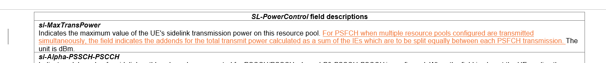
R2-2303157/R2-2303158 propose similar changes related to this FD as:
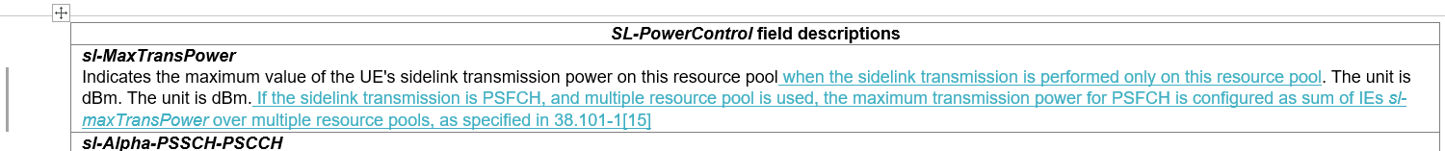
Also R2-2303912/R2-2303913 propose similar changes as:
It can be discussed whether such changes are needed in Rel-16, as well as in Rel-17 (mirror changes). Also the description may be further revised if the change is needed, e.g. sum of the IEs (where "sum of the field values" can be more suitable).
Q1: Would your company agree to change the FD of sl-MaxTransPower based on RAN1 LS, and, if RAN2 agrees to change this FD, which version should be used as baseline?
Option 1: based on R2-2302799
Option 2: based on R2-2303157/R2-2303158
Option 3: based on R2-2303912/R2-2303913
Option 4: Other(s), please elaborate.
Company | Agree/Disagree to change | Option as baseline for the change | Further comments

Changes related to dl-Alpha-PSFCH/ dl-P0-PSFCH
R2-2303157/R2-2303158 propose changes related to FD of dl-Alpha-PSFCH/ dl-P0-PSFCH (from network perspective), according to the latest RAN1 specs as below:
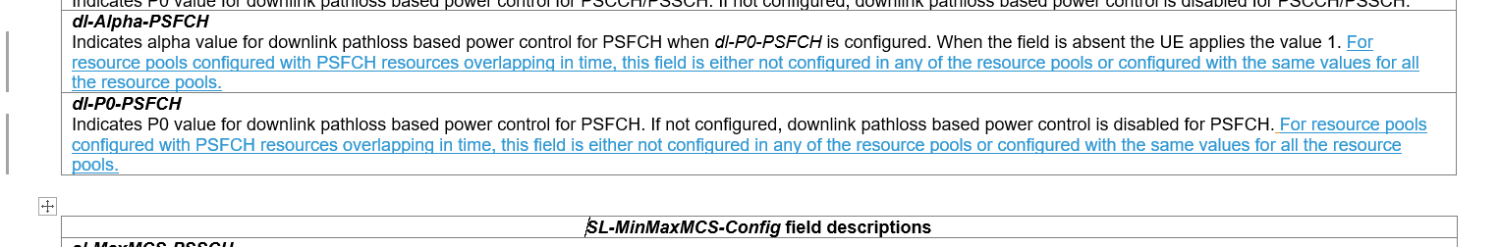
R2-2303906/3909 propose similar changes on the FD of dl-Alpha-PSFCH/ dl-P0-PSFCH (albeit from the UE perspective) as below:
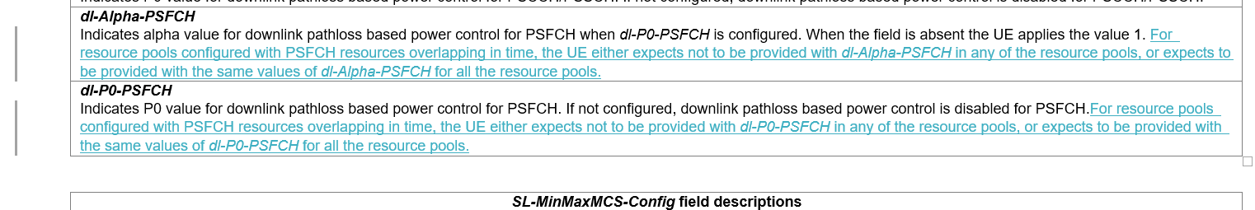
Rapporteur thinks the proposed changes (in one form or another) are needed, as they provide further restrictions on the configuration of dl-Alpha-PSFCH/ dl-P0-PSFCH.
If the changes are agreed, the "Impact analysis" part might need to be added/revised accordingly to demonstrate why the changes are mandatory for Rel-16 RRC spec.

Q2: Would your company agree to change the FD of dl-Alpha-PSFCH/ dl-P0-PSFCH based on RAN1 spec, and, if RAN2 agrees to change these FDs, which version should be used as baseline?
Option 1: based on R2-2303157/R2-2303158
Option 2: based on R2-2303906/3909
Option 3: Other(s), please elaborate.
Company | Agree/Disagree to change | Option as baseline for the change | Further comments

Changes related to Measurement Event Triggering Criteria
R2-2304078 proposes correction for Measurement Event Triggering Criteria as:
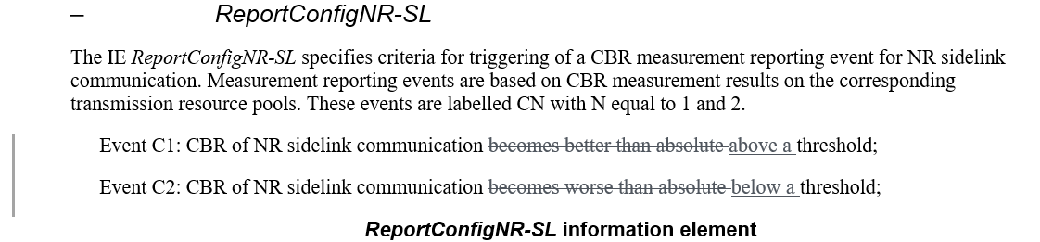
CR for the same issue for Rel-17 was approved in last meeting. Rapporteur thinks this change may be also needed for Rel-16. Though there is common understanding that we don’t usually do (standalone) editorial corrections for R16 RRC, one can say “better than absolute threshold” can be somehow misleading technically (as CBR is worse if "above").
Q3: Would your company agree to the above change proposed on Measurement Event Triggering Criteria?
Company | Agree/Disagree | Further comments

Changes related to carrier frequency for SL-RSRP measurement
R2-2304144/ R2-2304145 propose below change due to one FFS issue in RAN5 spec related to carrier frequency for SL-RSRP measurement, as well as the missing FD of frequencyInfoSL :
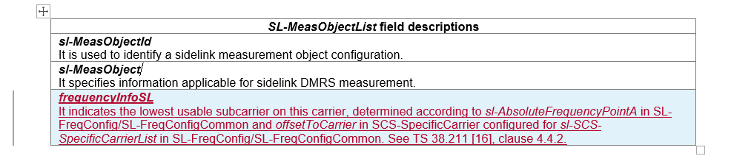
Rapporteur recommends that companies can check with their RAN5 colleagues on this issue and can discuss the needed changes.
Q4: Would your company agree this is an issue that shall be solved, according to the FFS Note in RAN5 spec? If RAN2 agrees this is an issue that shall be solved, would your company agree to the change on the (new) FD of field frequencyInfoSL?
Company | Agree/Disagree this is an issue that shall be solved | Agree/Disagree to the change on the (new) FD of frequencyInfoSL | Further comments

Conclusion
Proposal(s)

Reference
- R2-2302799 Correction to sl-MaxTransPower Nokia, Nokia Shanghai Bell CR Rel-17 38.331 17.4.0 3965 - F NR_SL_enh-Core
- R2-2303157 Correction on PSFCH configured power for NR sidelink CATT CR Rel-16 38.331 16.12.0 3993 - F 5G_V2X_NRSL-Core
- R2-2303158 Correction on PSFCH configured power for NR sidelink CATT CR Rel-17 38.331 17.4.0 3994 - A 5G_V2X_NRSL-Core
- R2-2303906 Correction on field description for transmission power ZTE Corporation, Sanechips CR Rel-16 38.331 16.12.0 4031 - F 5G_V2X_NRSL-Core Late
- R2-2303909 Correction on field description for transmission power ZTE Corporation, Sanechips CR Rel-17 38.331 17.4.0 4034 - F NR_SL_enh-Core
- R2-2303912 Clarification on sl-MaxTransPower vivo CR Rel-16 38.331 16.12.0 4047 - F 5G_V2X_NRSL-Core
- R2-2303913 Clarification on sl-MaxTransPower vivo CR Rel-17 38.331 17.4.0 4046 - A 5G_V2X_NRSL-Core
- R2-2304078 Correction for Measurement Event Triggering Criteria Sharp CR Rel-16 38.331 16.12.0 4049 - F 5G_V2X_NRSL-Core
- R2-2304144 TS 38.331 correction on carrier frequency for SL-RSRP measurement Huawei, HiSilicon CR Rel-16 38.331 16.12.0 4018 1 F 5G_V2X_NRSL-Core R2-2303632
- R2-2304145 TS 38.331 correction on carrier frequency for SL-RSRP measurement Huawei, HiSilicon CR Rel-17 38.331 17.4.0 4019 1 A 5G_V2X_NRSL-Core R2-2303633
- R2-2302415 Reply LS to RAN4 on PSFCH configured power with multiple resource pools (R1-2302231; contac: LGE) RAN1 LS in Rel-16 5G_V2X_NRSL-Core To:RAN4 Cc:RAN2

