3GPP TSG-RAN WG2 Meeting #121bis-e R2-230xxxx
Online Meeting, 17-26 April 2023

Agenda item: 7.2.2
Source: CATT
Title: Report of [AT121bis-e][428][POS] Sidelink positioning stage 2 (CATT)
WID/SID: NR_pos_enh - Release 18
Document for: Discussion and Agreement

1 Introduction
This document is to kick off the following email discussion:
- [AT121bis-e][428][POS] Sidelink positioning stage 2 (CATT)
Scope:
- Discuss the proposals for an architecture figure at stage 2 level and attempt to converge.
- Discuss the proposals for SLPP signalling procedures between UEs and attempt to reach agreement on a basic set of procedures.
Intended outcome: Report to CB session
Deadline: Monday 2023-04-24 2359 UTC
In this email discussion Sidelink positioning stage 2 are discussed based on following contributions to decide if these proposals and TPs in the contributions can be agreed.
- R2-2302503 Discussion on sidelink positioning CATT discussion Rel-18 NR_pos_enh2
- R2-2302740 Further considerations on sidelink positioning Intel Corporation discussion Rel-18 NR_pos_enh2
- R2-2304033 Discussion on SL positioning Xiaomi discussion Rel-18
- R2-2303591 Sidelink Positioning Protocol (SLPP) Signaling and Procedures Qualcomm Incorporated
- R2-2302655 Discussion of signalling procedures Nokia Germany discussion Rel-18
- R2-2302958 Discussion on sidelink positioning vivo discussion Rel-18 FS_NR_pos_enh2

2 Architecture figure at stage 2 level
This section will discuss the stage-2 sidelink positioning architecture. Taking the figures proposed in contribution R2-2302503, R2-2302740, R2-2303591 and R2-2304033 into consideration.
Contributions | Proposed architecture
R2-2302503 CATT | Figure 1 UE Sidelink Positioning Overall Architecture applicable to NG-RAN  Proposal 1: Capture Sidelink Positioning Architecture in Figure 1 in TS 38.305.
R2-2302740 Intel | NOTE: Anchor UE/node is only supported in NR  Figure 1 Overall architecture to support SL positioning  Proposal 10: In order to support sidelink based positioning for in coverage and out of coverage case, RAN2 to confirm the SL positioning architecture (including the concept of an anchor node/UE) shown in figure 1.  Proposal 11: To support sidelink based positioning, RAN2 to confirm the corresponding functionality of the anchor node, i.e. (interact with the target UE over PC5 to deliver assistance data, perform SL-PRS transmission/measurement and location estimation).  Proposal 12: RAN2 confirms that either the target UE or the anchor UE may handle the functionality of the SL positioning server UE
R2-2303131  LG | 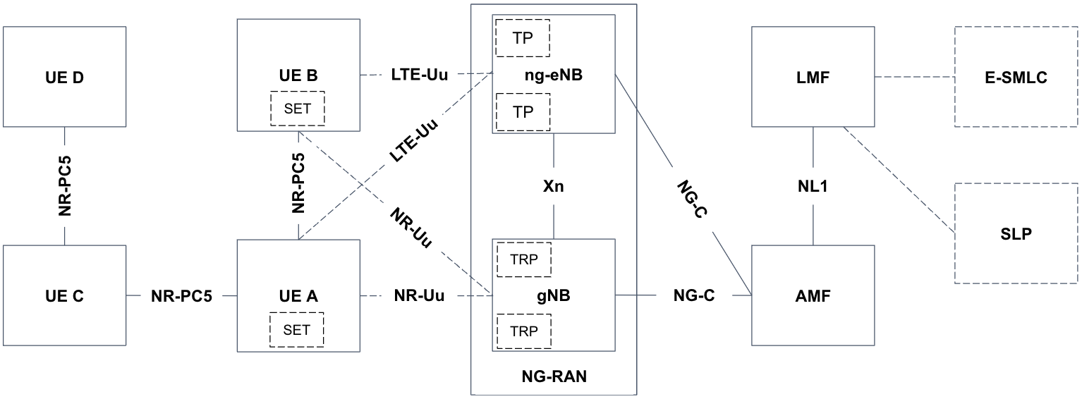  Note: UE A, UE B, UE C and UE D can be Target UE, Anchor UE and SL Positioning Server UE.  Figure 1: UE Positioning Overall Architecture applicable to NG-RAN  Proposal 7. RAN2 to capture figure 1 for architecture diagram to support sidelink positioning in TS 38.305.
R2-2303591 Qualcomm | Figure 2: UE Positioning Overall Architecture applicable to NG-RAN  Proposal 1: The UE Positioning Architecture applicable to NG-RAN should be applicable to all coverage scenarios (e.g., no separate architecture for in-coverage or out-of-coverage scenarios is needed).  Proposal 2: Extend the UE Positioning Architecture applicable to NG-RAN as shown in Figure 2.
R2-2304033 xiaomi | Fig 1 architecture for supporting SL positioning  Proposal 8 RAN2 to agree the architecture.
Rapporteur’s comment:
RAN2 has agreed to follow SA2 on the architecture in SI stage. Based on that, only the UE roles are not captured in the diagram of the positioning architecture. The difference among companies’ contribution is on how to represent the interface relationship of terminals. For faster convergence, the architecture based on the figure proposed by CATT may be as the baseline for further discussion.
Question 1: Do you agree to take the architecture proposed in CATT’s contribution as baseline? If yes, Please provide comments to polish the architecture. If no, please provide your suggestion.
Company | Yes/No | Comments
Qualcomm | Yes with comment | In general we are fine with CATT’s proposed architecture. We do wonder if UE B is intended to be an NR-only UE.
OPPO | Yes
LG | Yes but | We also proposed an architecture diagram n R2-2303131 in this meeting, as below;  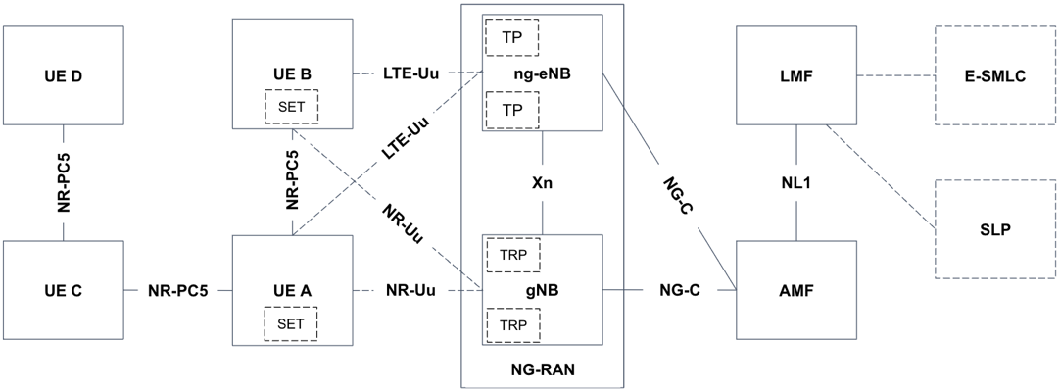  Same question, UE B is only NR-only UE?
CATT | Yes | feedback on LG and Qualcomm’s question:  More cases should be captured in the architecture. For Uu interface, both NR-only UE and LTE+NR UE are involved in the architecture.
Fraunhofer | Yes
Lenovo | Yes, with comments | CATT’s proposed architecture is basically fine for us, but there seems missing PC5 link between UEBUEC, UEBUED, and UEAUED. In addition, we have concern on why UE-B has no SET functionality.
Intel | Yes | We are fine with CATT’s proposed architecture. Regarding UE-B, we agree with CATT that it makes sense to cover both LTE+NR and NR only cases
Apple | Yes, with comments and corrections | We disagree to cover LTE, it is not in the WI scope.
vivo | Yes, with comments | The architecture seems to exclude the case that UE B (e.g., acts as anchor UE) connects the NW via ng-eNB.  Whether UE B has SET (SUPL Enabled Terminal) functionality depends on whether SUPL supports SL positioning.
Ericsson | No | We would prefer Xiaomi to be baseline; it shows with only 3 UEs which is better than having 4 UEs and also for now it does not consider ng-eNB into consideration which is good for a baseline.
ZTE | No | We agree with LG’s figure that UE B and UE A should be same in Uu interface, i.e., UE B also has the line of LTE and NR
Nokia | No | Xiaomi is preferred for same reasons as expressed by Ericsson and Apple
Samsung | Yes, with comments | UE B can also support SET functionality.

Summary:
10 companies agreed to take the architecture proposed in CATT’s contribution as baseline. Ericsson and Nokia preferred the architecture proposed by Xiaomi as baseline for only 3 UEs are involved. ZTE preferred the architecture proposed by LG as baseline for UE B is also LTE+NR UE. Qualcomm, LG and vivo suggested confirming that UE-B is NR-only UE. Lenovo want to add PC5 connection between all pairs of UEs. Apple considered LTE should be excluded. Lenovo, vivo and Samsung pointed out SET functionality is absent in the architecture. The moderator clarifies that UE B is NR-only UE, UE-D is OOC UE without SL connection with the IC UE, UE-C is the OOC UE with SL connection with the IC UE. The proposed architecture changed to:
Proposal 1-1: RAN2 to agree the UE Sidelink Positioning Architecture is based on the Figure 5.1-1: UE Positioning Overall Architecture applicable to NG-RAN in TS 38.305,
- UE A connects with NG-RAN via both LTE-Uu and NR-Uu following the legacy Architecture,
Figure 5.1-1: UE Positioning Overall Architecture applicable to NG-RAN
Proposal 1-2: RAN2 to agree there are two UEs which connect with NG-RAN for in coverage scenario:
- one UE (UE B) only connects with NG-RAN via NR which can be FFS.
- one UE (UE A) as in Proposal 1-1.
- there is NR-PC5 connection between the two UEs
Figure 1-2 Two UEs which connect with NG-RAN
Proposal 1-3: RAN2 to agree there are two UEs (UE C and UE D in the figure) which don't connect with NG-RAN and there is NR-PC5 connection between the two UEs for out of coverage scenario.
Figure 1-3 Two UEs which don’t connect with NG-RAN
Proposal 1-4: [10/13] RAN2 to agree Sidelink Positioning Architecture in Figure 1-4 as baseline in TS 38.305 for further discussion.
Figure 1-4 UE Sidelink Positioning Overall Architecture applicable to NG-RAN

3 SLPP signalling procedures between UEs for out of coverage
The proposals for SLPP signalling procedures between UEs and attempt to reach agreement on a basic set of procedures will be discussed in this section.
In RAN2#121 meeting, RAN2 agreed the basic signaling procedure for PC5-only positioning.
Agreement:
With respect to the overall signaling procedure for PC5-only positioning (including at least IC and OOC; FFS if there are differences for PC), it is proposed to agree that the sidelink positioning procedure comprises the following series of steps as a baseline, between the LMF/positioning server UE/NG-RAN/candidate Anchor UE(s) and Target UE(s):
1. Triggering event
2. Sidelink positioning capability exchange
3. Sidelink positioning assistance data transfer
4. SL Positioning Request Location Information
5. Measurement of SL-PRS
6. Location calculation
7. SL Positioning Provide Location Information
Some steps may have dependencies on SA2 and can be revisited in this light. The order is subject to further discussion. FFS if discovery and selection of anchor UEs and/or server UE are part of the positioning layer in RAN2 scope.
LS to SA2 to ask for confirmation and guidance on the SA2 aspects.
The above series of steps have been captured in the proposals from companies. Clause 3.1- 3.2 will further discuss the details of steps.

Involved UE roles in general sidelink positioning procedure
The following contributions discuss SLPP signalling procedures for out of coverage scenario or LMF-independent SLPP procedures:
Contributions | Proposed procedures
CATT  R2-2302503 | Figure 2.3-1: SLPP signaling procedures for OOC scenario
Nokia  R2-2302655 | 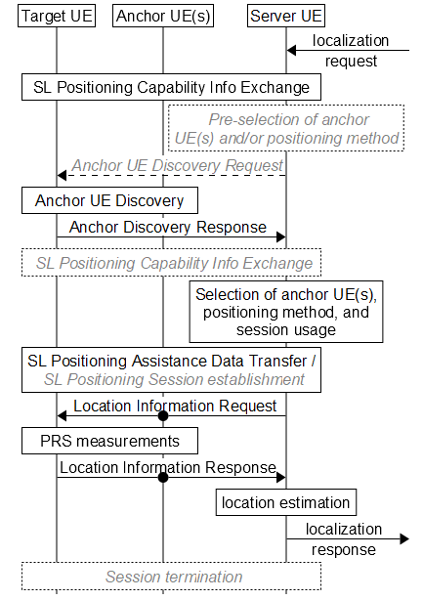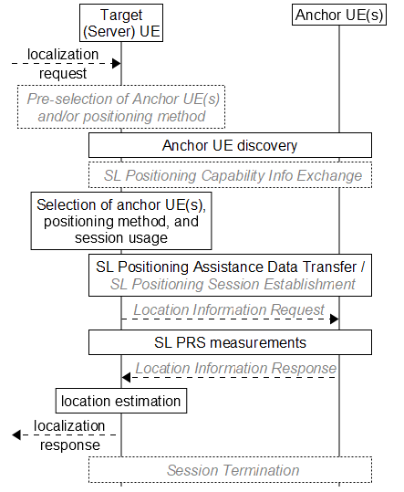  (a) Target UE and server UE are two different nodes. (b) Target UE acts as the server UE  Fig. 2 –Server UE-assisted SL positioning.  [black font / solid lines indicate = mandatory steps, grey font / dashed lines = optional steps]
Intel  R2-2302740 | Figure 3 UE sidelink positioning for out of coverage scenario
vivo  R2-2302958 | Figure 2.2.2-1: LMF-independent sidelink positioning signaling procedures

CATT, Intel and vivo put all involved UE roles in the general procedure, even when anchor UE or target UE acts as server UE. However Nokia distinguish the two cases. Server UE always acts as an entity in general procedure when server UE is target UE/ anchor UE/ the 3rd UE, shown in figure 1.
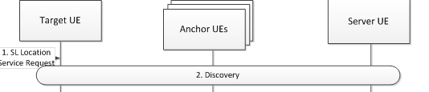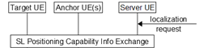
Figure1 Server UE as an entity

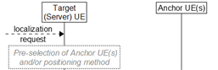
Figure2 Target UE/anchor UE act as server UE
Question 2: Do you agree that server UE acts as an entity separately shown in figure 1 in the general sidelink positioning procedures between UEs for out of coverage scenario?
Company | Yes/No | Comments
Qualcomm | See comment | We find this question somewhat unclear. Our view is there is no need to distinguish UE role in the description of SLPP signaling procedures (as in the call flow suggested as a baseline in [AT121bis-e][424], Question 4).
OPPO | Yes | The entities shown in the signalling procedure are just logical entities. Including each logical entity independently in the signalling procedure is clearer to present every necessary step to be involved in the SLPP. We know that if two UE roles are actually co-located in the same UE, then no inter-UE signalling is needed between them.
LG | See comment | We also proposed a high-level overall procedure in R2-2303131 in this meeting, as below;  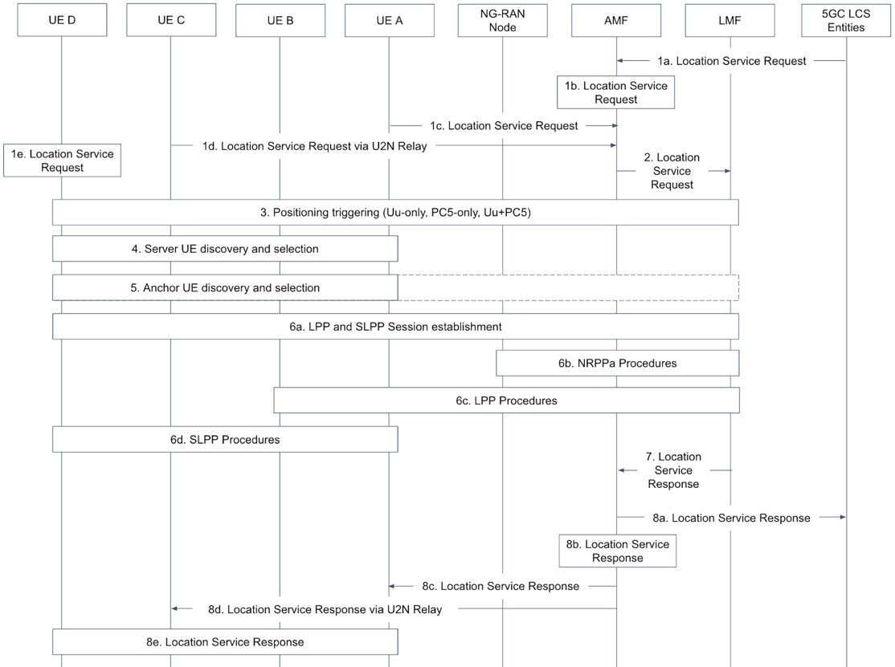  We think it would be better for stage-2 understanding to be matched between an architecture diagram and a high-level overall procedure, i.e. UE A/B/C/D in procedure can be used in procedure as architecture. Also, which can be extended from Figure 5.2-1 in current stage-2 document (TS 38.305).  [CATT]: According to the scope defined by Chair, “- Discuss the proposals for SLPP signalling procedures between UEs”, the procedures which include LMF and AMF are not discussed here.
CATT | Yes | Agree with OPPO.
Fraunhofer | Yes | How a server UE is selected by the target UE is not clear. There may be one or more UE that may advertise server capability. We need to capture that the target UE selects one server UE.  In CATT’s contribution, we see that the server UE is responsible for selecting anchor UEs. If our understanding is correct, then we share this viewpoint.  We presume Step 4 also means includes initial measurements.
Lenovo | No | We prefer Figure2 and share the comments that the “SL positioning server UE” as a functionality which is part of a target UE or an anchor UE.  Since the need for a SL Positioning server UE caters to only certain limited scenarios in SL Positioning based on coverage situations and UE capabilities based on SA2’s solutions, and such UEs may be discoverable and further selected for result calculation purposes only.  It is assumed that a target UE and anchor UEs have sufficient capabilities to perform SL Positioning including, configuration, measurements and result calculation across all coverage scenarios, and the results calculation is usually up to UE implementation. The functions for the server UE may be resolved if the SL Positioning Server UE may be integrated as part of the Anchor UE or Target-UE or if the server UE is simply a set of UE capabilities.  In addition, the scope of introducing additional discovery and selection procedures for a separate server UE entity may increase the complexity of the SL positioning framework. We also wonder in which scenarios will a server UE always be available, so we would tend to prefer more flexibility in the SL positioning procedures.
Intel | No | We think adding server UE as a separate entity implies introduction of a new node in the positioning architecture. Moreover, most companies seem to be aligned on the anchor/target UE (implicitly) handling the functionality of the server UE, so we do not see the need to introduce yet another node and associated signaling
Apple | No | Agree with Intel
vivo | Yes | Similar view with OPPO. Introducing a separate positioning server UE in the procedure may help with the understanding of specification impact.  In TS 23586, it is observed that the positioning server UE is not always co-located with target/anchor UE.  A SL Positioning Server UE can be discovered and selected for result calculation, method determination, assistant data distribution and SL Reference UE selection in case of out-of-coverage or for UE-only Operation if the serving network does not support Ranging/SL Positioning. If the LMF capable for Ranging/SL Positioning is reachable by Target UE and/or Reference UE, the LMF can still decide that Target UE or Reference UE executes the result calculation. A SL Positioning Server UE can be co-located with a Target UE or Reference UE.  Besides, even if the positioning server UE co-locates with an anchor UE, only one of the anchor UEs acts as server UE and its procedure is different from other anchor UEs, e.g., only one UE is expected to acquire the capabilities of related UEs and decide the location method.
Ericsson | No | We should have Intel’s version as baseline
ZTE | No | The baseline procedure should not explicitly draw server UE since server UE has many functions, it is not sure whether the UE satisfies all functions should be a server UE or if the UE satisfies one, it is a server UE. The proposed figures are all assuming the server UE supports all the function.  For example, if target UE is able to perform location estimation but not be able to perform anchor UE selection, a location server UE also needs to perform location estimation instead of target UE? It is obviously unnecessary
Nokia | Yes | We also see individual UE roles as logical functions determined by UE capability. So in general, we are fine with representing individual logical entities in SLPP call flows separately for the sake of clarity. The point of Figure 2 (examplary in our Tdoc) is that SLPP signalling may be non-negligibly simplified (eg by eliminating the need to send certain SLPP messages) in case one UE implements more than one of such logical functions (eg, anchor UE + server UE, or target UE + server UE). In other words, the SLPP design should permit such signalling simplifications, for example based on stateless implementation.
Samsung | Yes | Share the view with vivo. There is no need to have the restriction that only target UE or anchor UE can take the server UE role considering that the server UE can be replaced with the LMF in IC scenario.  In addition, we believe that the scenario where a direct PC5 unicast link can be established between a server UE and each UE (target or anchor UE) can be the baseline.  The SLPP message forwarding between UEs within SLPP session (via U2U relay) should be discusses later (maybe not in this release).

Summary:
Six companies (OPPO, CATT, Fraunhofer, vivo, Nokia and Samsung) agreed that server UE acts as an entity separately in the general sidelink positioning procedures between UEs for out of coverage scenario. Qualcomm suggested not distinguish UE roles in the description of SLPP signaling procedures. LG suggested using UE A/B/C/D in sidelink positioning procedure. vivo pointed out that even if one of anchor UE acts as server UE, it should acquire the capabilities of other anchor UEs. Five companies (Lenovo, Intel, Apple, ZTE and Ericsson) considered no need to introduce server UE as a separate entity.
Proposal 2-1: RAN2 to agree to include anchor UE and Target UE in the general sidelink positioning procedures, when server UE is either Target UE or anchor UE.
Proposal 2-2: RAN2 to further discuss if Server UE acts as an entity separately in the general sidelink positioning procedures.
Proposal 2-3: RAN2 to further discuss whether UE roles are distinguished or not in the SLPP signaling procedures, e.g. UE A/B/C/D instead of UE roles.

Involved UEs in capability and assistant data exchange procedures
CATT and Intel proposed target UE needs to exchange sidelink positioning capability and assistant data with anchor UEs. Nokia proposed the sidelink positioning capability and assistant data exchange only between target UE / anchor UEs and server UE, not between target UE and anchor UE.
Question 3: What is your view on sidelink positioning capability and assistant data exchange procedures for out of coverage scenario?
Option 1: The sidelink positioning capability and assistant data exchange happen between target UE/anchor UEs and server UE, but don’t happen between target UE and anchor UEs when there is server UE;
Option 2: The sidelink positioning capability and assistant data exchange can happen between target UE and anchor UEs whatever there is server UE or not;
Option 3: Others.
Company | Options | Comments
Qualcomm | Option 3 | RAN2 has agreed that Capability and Assistance data can be exchanged between UEs via unicast, groupcast or broadcast. As such, it seems unnecessary to levy a restriction on distribution of Capability and Assistance data. Rather, Capability and Assistance data can be exchanged between UEs participating in a sidelink positioning and ranging transaction.
OPPO | Option 3 | If unicast is employed, we prefer to follow the Uu based positioning implementation, for example, the anchor UE could firstly send the assistance data to the server UE, then the server UE can forward the assistance data to the target UE.  If broadcast is employed, then nothing could prevent from direct signalling exchange between the anchor UE and the target UE.
LG | Option 1 but | According to agreement in RAN2#121, server UE takes a role of location server.  RAN2 confirm that for cases without LMF involvement, besides method determination, assistant data distribution and anchor UE selection (agreed in RAN2), the SL positioning server UE may perform SL-PRS configuration coordination and location calculation.  But, we think RAN2 should firstly decide whether server UE is either target UE or anchor UE, or not.
CATT | Option 2 | In some case, there may be no unicast SL connection between anchor UE and server UE. SLPP capabilities and SLPP assistant data (e.g. SL-PRS configuration) can be exchanged between target UE and anchor UEs directly.  For groupcast/broadcast, any SLPP signalling exchange should be happened between the anchor UE and the target UE.
Fraunhofer | (soft) Option 1 | The sidelink positioning capability and assistant data exchange happen between target UE/anchor UEs and server UE is supported, if the target UE and anchor UE do not exchange information directly.
Lenovo | Option 3 | From our side it is necessary to exchange sidelink positioning capability and assistance data between target UE and anchor UE since the PRS transmission/reception and corresponding measurements are performed between target and anchor UEs.  But we also share the view that the sidelink positioning capability and assistance data exchange are not limited to the case only between target UE and anchor UEs. Since it may be transmitted by either unicast or groupcast/broadcast, the capability/assistance data exchange can also be performed between target/anchor UE and server UE during the SLPP session.
Intel | Option 2 with comment | We think that this anyway depends on the role of the server UE covered in the previous question. If server UE role is served by the anchor UE, then capability and assistance data exchange shall involve the target UE and the anchor UE anyway. In any case, if we assume that either the target or the anchor UE may serve the role of the server UE, we need to support Option 2
Apple | Option 3 | We are not sure this discussion is useful at this stage
vivo | Option 3 | Based on the following definition in 23.586. The server UE needs to acquire the capability of anchor/target UE to decide the positioning method and it will coordinate and distribute the assistance data.  SL Positioning Server UE: A UE offering method determination, assistant data distribution and/or location calculation functionalities and/or location calculation functionalities for Sidelink Positioning and Ranging based service. It interacts with other UEs over PC5 as necessary in order to determine Ranging/SL Position method, distribute assistant data and calculate the location of the Target UE. Target UE or SL Reference UE can act as SL Positioning Server UE if any of the functionalities is supported.  However, the capability and assistance data exchange between target UE and anchor UE is not precluded, e.g., via broadcast and groupcast.
Ericsson | Option 2 | Server UE is just a UE role; which can be also any UE; so there is no point to have a dedicated sequence flow to cover each individual UE.
ZTE | Option 2 | There should have no restrictions of UE roles on capability transfer and AD transfer
Nokia | Option 3 | Just to clarify, our proposed signalling does NOT restrict capability / AD exchange between specific UE roles. In general, every UE can exchange information with other UEs.  Practically, however, we believe it is the server UE that shall (by definition) configure SL positioning sessions, by either  - selecting anchor UEs based on positioning session constrains such as method supported by server UE or required QoS, or  - configuring positioning session (eg, choice of method) based on anchor UE availability and type.  To this end, we believe the target UE shall assist with selective discovery and pre-filtered reporting as in other SL discovery / reporting procedures.
Samsung | Option 3 | Share the view with Qualcomm, vivo.  Capability and Assistance data can be exchanged between UEs participating in a sidelink positioning. There is no need to have a restriction on the capability and assistance data exchange.

Summary
Ericsson considered no need to have a dedicated sequence flow to cover each individual UE. Apple considered this discussion is not useful at this stage.
In the comments, there are different views upon three cases:
Case 1: Capability and Assistance data are exchanged between UEs via unicast. Server UE act as a separate entity;
Case 2: Capability and Assistance data are exchanged between UEs via unicast. Server UE is target UE or anchor UE;
Case 3: Capability and Assistance data are exchanged between UEs via groupcast or broadcast.
For case 1, OPPO, LG, vivo and Fraunhofer considered that server UE takes a role of location server. The sidelink positioning capability and assistant data exchange happen between target UE/anchor UEs and server UE. CATT, Lenovo, ZTE and Intel considered that sidelink positioning capability and assistant data exchange between target UE and anchor UEs should be supported.
For case 2 and case 3, most companies supported that sidelink positioning capability and assistant data exchange between target UE and anchor UEs.
Proposal 3-1: It is supported that the sidelink positioning capability and assistant data can be exchanged between target UE and anchor UEs via groupcast or broadcast.
Proposal 3-2: It is supported that the sidelink positioning capability and assistant data can be exchanged between target UE and anchor UEs via unicast if server UE is target UE or anchor UE.
Proposal 3-3: RAN2 to further discuss whether the sidelink positioning capability and assistant data can be exchanged between target UE and anchor UEs via unicast if server UE is a separate entity.

The following series of steps based on previous agreement are proposed by companies, between the server UE/ candidate Anchor UE(s) and Target UE(s):
1. Discovery procedure
2. SL connection establishment
3. Anchor UEs selection
4. Positioning methods selection
We will further discuss these steps to figure out if these steps may be included in the general sidelink positioning procedures.

Discovery procedure aspect
All above companies considered that discovery procedure between target UE and anchor UEs should be performed. CATT considered discovery procedure should also be performed between target UE / anchor UEs and server UE.
Question 4: Do you agree discovery procedure should be included in the sidelink positioning procedure for out of coverage scenario?
Company | Yes/No | Comments
Qualcomm | Yes
OPPO | Yes | The target UE should perform discovery procedure to find the UEs supporting SLPP in the proximity, since the positioning measurement should be done between target UE and anchor UEs.
LG | Yes | It is an essential step for sidelink communication/positioning for SL-PRS transmission/measurement even in session-less operation.
CATT | Yes
Fraunhofer | Yes
Lenovo | Yes | It used to find candidate UEs and get in touch with other UEs, although as we mentioned earlier the discovering an additional server UE increases the complexity of the overall SL positioning procedures.
Intel | Yes
Apple | Yes
vivo | Yes
Ericsson | Yes, but | Unclear the relevance of OOC. We should also discuss for in-coverage.
ZTE | Yes | The UE triggered discovery procedure is essential in OOC scenario
Nokia | Yes
Samsung | Yes

Question 5: What is your view on which discovery procedure is needed for out of coverage scenario?
Option 1: Discovery procedure between target UE and anchor UEs;
Option 2: Discovery procedure between target UE and server UE;
Option 3: Discovery procedure between server UE and anchor UEs.
Option 4: Not distinction in which UEs participate in the Discovery procedure.
Company | Option 1/2/3 | Comments
Qualcomm | Option 4 | Since a UE is permitted to undertake any role, we see no need to draw a distinction in which UEs participate in the Discovery procedure. Rather, Discovery should enable SLPP-capable UEs to learn of the presence of other SLPP-capable UEs.
OPPO | Option 4 | Agree with Qualcomm
LG | See comments | If server UE is neither target UE nor anchor UE, discovery procedure could be very complicated. SL-PRS is transmitted/received between target UE and anchor UEs, so discovery is needed between two UE types. If the location server role (including anchor UE selection) is performed in server UE, discovery is needed between server UE and target/anchor UEs. Moreover, two discovery results should be exchanged in order to find overlapped anchor UEs. Therefore, server UE should be at least either target UE or anchor UE, but we still believe target UE can take a role of server UE if we do not see some benefit for anchor UE taking a role of server UE, except positioning calculation. In this sense, discovery is needed between target UE and anchor UEs.
CATT | Option 4 | Agree with Qualcomm
Fraunhofer | Option 4 | Our understanding is that the UEs may discover each other, but the target UE either takes the server role itself or requests other UE to take server role after discovery.
Lenovo | Option 4 | We think all options are needed, depends on specific scenarios.  When a location service is initiated in a target UE, the target UE may perform discovery to select candidate anchor UEs/server UEs; When the location service is initiated from other entities, server UE may need to perform discovery to select target UE and/or candidate anchor UE. Since a UE may take any UE role, the discovery can be performed between any UEs during the SLPP session to get in touch each other.
Intel | At least option 1 (see comment) | We share the view with other companies that it really depends on the scenario and it may not be straightforward to restrict certain UEs. For instance, we assume option 1 is needed at the very least. The other options depend on the role of the server UE and whether it is captured as a separate entity in the SLPP procedures/architectures
Apple | Option 4 | That’s the whole point of the discovery procedure, isn’t it?
vivo | At least options 1 and 2 | In TS 23586,  A SL Positioning Server UE can be discovered and selected for result calculation, method determination, assistant data distribution and SL Reference UE selection in case of out-of-coverage or for UE-only Operation if the serving network does not support Ranging/SL Positioning.  A Target UE may discover and select one or more Located UEs (and other Reference UEs) to be used in the Ranging/SL positioning procedures as specified in clauses 5.3 through 5.5.  Based on the above description:  For option 1, the target UE should discover a server UE when it cannot act as a server UE.  For option 2, the target UE can also perform discovery and provide the info of discovered anchor UEs to server UE, to help with anchor UE selection.  Option 3 is not needed. To be specific, the anchor UE discovered by server UE maybe not be suitable for one specific SL positioning, e.g., the target UE may not be able to detect the SL-PRS of the anchor UE.
Ericsson | Option 4 | Agree with Qualcomm
ZTE | Option 4 | Discovery is the first step when there is no priori knowledge. Discovery happens firstly, then other steps may happen regarding UE roles.
Nokia | Option 4 | As noted above already, discovery itself should not be restricted. The subsequent reporting should however pre-filtered / selective to reduce overhead. For example, capability report is not sent to the target / server UE all nearby candidate anchor UEs but only select few promising candidates.  For example, for absolute positioning purpose, the server UE may provide the target UE with a list of RSUs with known location for targeted discovery. Or the target UE may provide the list of discovered anchor UEs that are not co-located or NLOS. Full capability reports (be it to target UE directly or via server UE) may be done only after the pre-selection stage, to reduce full-mesh reporting overhead.  For relative positioning however, nearby UEs can simply exchange capability info – an option not precluded by our proposed call flows.
Samsung | Option 4 | Agree with Qualcomm.

Summary:
All companies agreed to include discovery procedure in the sidelink positioning procedure for out of coverage scenario. [10/13] Most companies agreed not distinction in which UEs participate in the discovery procedure. Intel suggested to capture discovery procedure between target UE and anchor UEs at least. And other options will be captured basing on the server UE is a separate entity in the SLPP procedures. vivo proposed to exclude option3.
Proposal 4-1: [13/13] Discovery procedure is included in the sidelink positioning procedure for out of coverage scenario.
Proposal 4-2: [10/13] There is not distinction of UE roles in the discovery procedure for out of coverage scenario since UE roles are included in discovery message.

Nokia and vivo mentioned that server UE sends Anchor UE (discovery)Request message to target UE before the discovery procedure between target UE and anchor UEs. And after the discovery procedure, target UE sends Anchor UE (discovery) Provide message to server UE.
Question 6: Do you agree to include Anchor UE (discovery) Request and Anchor UE (discovery) Provide steps in the sidelink positioning procedures for out of coverage scenario?
Company | Yes/No | Comments
Qualcomm | No | Per our answer to Question 5 since a UE is permitted to undertake any role, we see no need to draw a distinction in which UEs participate in the Discovery procedure. Rather, Discovery should enable SLPP-capable UEs to learn of the presence of other SLPP-capable UEs. Furthermore, our view is that design of Discovery should be up to SA2.
OPPO |  | We agree that target UE should perform the anchor UE discovery procedure. However, the target UE should firstly do the discovery procedure to pre-filter the UEs in proximity and then can perform the SL capability exchange between the target UE, anchor UE and the server UE.  Also, the SL capability exchange may be only feasible after the unicast link between a pair of UEs is established.
LG | No | See Q5 comments
CATT | No strong view
Fraunhofer | Yes | Server UE needs input (initial measurements) from target UE to be able to select suitable anchors.
Lenovo |  | We tend to agree the discovery procedure is needed but the detailed steps related to discovery procedure are in SA2’ scope. Fine to follow majority views on this.
Intel | See comment | This depends on the outcome of Q2. In our view, since we think that server UE may directly be captured as part of the target/server UE, we can avoid specification of additional signaling related to request and response for discovery of anchor UE.  In any case, since this pertains to discovery procedure, we think final decision on this should be upto SA2
Apple |  | Hard to discuss this before answering the previous questions
vivo | Yes | See Q5, it is aligned with SA TS and can provide a full picture of the SL positioning procedure.
Ericsson | No | Agree with Qualcomm
ZTE | No | Agree with Qualcomm
Nokia | See comments | The message Anchor UE (discovery) Request is meant to be optional and can be used to either explicitly trigger the discovery process and / or deliver some pre-filtration criteria if desirable (eg, “report only NLOS anchor UEs” or “located UEs only”).  The Anchor UE (discovery) Provide message is meant to be the actual report of discovered anchor UE (irrespective of whether full or pre-filtered report). This message may not be needed only if no discovery takes place at all (eg when re-using the anchor UEs from a previous session).  As per QC reply, targeted anchor UE discovery is permitted by SA2 as concluded in [423]. Also, any UE may take any role but it will be the UE hosting the server UE role that in our view should configure SL positioning sessions. To this end, low-overhead interaction with the target UE (if separate UE) is critical.
Samsung | See comments | According to TS 23.586, Sever UE can determine POS method and select Anchor UEs to use. Thus, when Server UE is not Target UE, the server UE can request Target UE to proceed discovery procedure and to reply the discovery result to the server UE. However, we also think the final decision on this should be made in SA2.

Summary:
[7/13] Most companies proposed that the additional signaling related to request and response for discovery should be up to SA2.
Proposal 4-3: [7/13] The additional signaling related to request and response for discovery should be up to SA2. Send an LS on this agreement to SA2 for confirmation.

SL connection establishment aspect
CATT and Intel proposed to include unicast SL connection establishment procedure before sidelink positioning capability exchange.
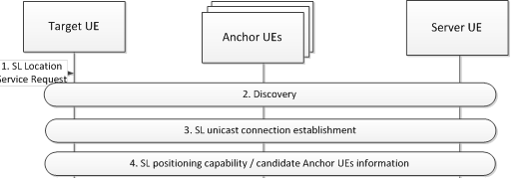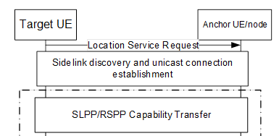
Question 7: Do you agree to include unicast SL connection establishment procedure before sidelink positioning capability exchange for out of coverage scenario?
Company | Yes/No | Comments
Qualcomm | No | In addition to unicast, RAN2 has agreed that Groupcast and Broadcast can be used for Capability and Assistance data exchange between UEs. Imposing a requirement for unicast call establishment seems unnecessary and significantly constraining sidelink positioning operation, resulting in additional over-the-air resources consumed and incurring the latency of unicast call establishment.
OPPO | Yes for unicast
LG | No | Unicast is not always required for sidelink positioning e.g. session-less operation and groupcast/broadcast.
CATT | Yes for unicast | For session-based sidelink positioning, unicast SL connection should be established for each pair of UEs to exchange the SLPP messages.
Fraunhofer | No strong view | Capability can be exchanged also via groupcast or broadcast. For some case, unicast may be beneficial (if the UE wants to exchange information with server UE only and not broadcast).
Lenovo | See comments | For unicast transmission of capability info transfer, the SL unicast connection establishment is needed. In case of groupcast/broadcast is supported, then SL unicast connection establishment seems not necessary before the step.
Intel | Yes | we think it is quite natural to perform unicast connection establishment, especially to support the QoS requirements for different positioning procedures (which may not be possible if there is no PC5 unicast). Note that RAN2 has mostly focused on the session-based scenario, for which unicast would be ideally suited anyway
Apple | No | It may not always be neededA
vivo | Yes, with comments | There will be measurement/location result exchange between target and server UE. As we did not agree on the groupcast/broadcast of location information, we suppose the unicast setup is always needed.  However, if the target UE acts as a server UE, the unicast setup is not mandatory. To address this case, the unicast establishment can be dash line.
Ericsson | Yes, for unicast, however pls see comments | There is no need to show specific UE SL Server role.  We prefer below
ZTE | Yes for unicast | Will 38.305 have separate figures for BC, GC and UC, and have different figures for IC, PC and OOC? If this is the case, then agree to add unicast link establishment in UC figure
Nokia | No | Same view as QC and LG. Also, as commented above, our baseline should not be exhaustive communication of every UE with every UE, it should be centered on selective information gathering for the decision-making node (server UE or LMF). Only in this way we prevent major overhead such as multiple unicast session and full capability exchange before even understanding how are the few relevant anchor UEs.
Samsung | Yes for unicast

Summary:
8 companies (OPPO, CATT, Fraunhofer, Lenovo, Intel, Ericsson, ZTE and Samsung) considered unicast SL connection should be established before transmission of capability info transfer via unicast. Most companies pointed out that unicast SL connection is not required for groupcast/broadcast sidelink positioning. vivo pointed out measurement/location result exchange between target and server UE has not be agreed via groupcast/broadcast. vivo supposed the unicast setup is always needed. Since when the target UE acts as a server UE, the unicast setup is not mandatory. It proposed the unicast establishment is captured with dash line. ZTE wondered whether capture separate figures for BC, GC and UC, and have different figures for IC, PC and OOC in TR 38.305. It will be discussed in section 3.6.
Proposal 5: [8/13] Include unicast SL connection establishment procedure before sidelink positioning capability exchange via unicast in the sidelink positioning procedures for out of coverage scenario.

Anchor UEs selection
All companies suggest that server UE performs anchor UEs selection. But they have different views on when the selection happens.
- Nokia and vivo suggested server UE performs anchor UE selection after sidelink positioning capability exchange between server UE and anchor UEs.
- CATT suggested server UE performs anchor UE selection before sidelink positioning capability exchange between target UE and anchor UEs.
This issue is related to anchor UEs selection criteria. For the solution of Nokia and vivo, server UE performs anchor UEs selection may depend on the information which is obtained from discovery and capability of anchor UEs. For the solution of CATT, anchor UEs selection depends on the information which is obtained from discovery of anchor UEs.
Question 8: Do you agree to include anchor UE selection in the general procedures? If yes, which option of information is preferred for the anchor UE selection?
Option 1: the information obtained from both discovery and capability of anchor UEs;
Option 2: the information obtained from discovery of anchor UEs;
Option 3: Others.
Company | Yes/No | Options | Comments
Qualcomm | Yes | 3 | Option 3: “the information obtained from SLPP capability exchange.”  Our view is UE anchor selection can be based on SLPP Capability exchange, subsequent to Discovery procedures, with Discovery providing information on UE SLPP support.
OPPO | Yes | Option 3 | We think UE selection should be done after both procedures. Suppose there are lots of UEs around the target UE. The first job for the target UE is to identify the UEs supporting the SLPP and could serve as the adapt UE roles such as anchor UEs or location server UE using the discovery msg. Then more detailed information such as AS-level capability could be exchanged in-between the UEs survive after the discovery procedure.
LG | Yes | Option 3 | Agree with Qualcomm and OPPO.
CATT | Yes | Option 2 | SLPP capability exchange procedure is after unicast SL connection establishment. Target UE/server UE needs to establish unicast SL connection with all candidate anchor UEs to obtain capabilities. And release the unicast SL connection with the candidate anchor UEs which are not selected. Both latency and signalling overhead are increased.
Fraunhofer | Yes | Option 3 | Anchor UE selection may depend on capabilities plus measurements (initial) provided to server by target UE.
Lenovo | Yes | Option 3 | This issue is related with our previous offline discussion on discovery signalling, it also depends on specific AS layer parameters agreed to be indicated in the SL Positioning discovery signalling. According to current SA2’ solution, UE role and support of SLPP is transmitted in discovery signalling, we prefer this can be used to filter candidate anchor UEs, the final anchor UE selection should be performed after the discovery procedure, which can take the UE capability information into account, e.g., the supported SL Positioning methods. In addition to the UE capability information, some other AS layer information/conditions such as based on SL measurements, LOS/NLOS, etc may also contribute to anchor UE selection.  Therefore, we prefer option3: the information obtained from both discovery and AS-layer information/conditions.
Intel | Yes | Option 1 (see comment) | In our view, anchor UE selection can be modelled as one of the two options:  - The LMF/server UE based approach, where LMF/server UE may obtain information about candidate anchor UEs (either from target UE itself or from (pre-)configuration) to make the selection.  - The LMF/server UE assisted approach, whereby LMF/server UE may provide selection criteria (e.g. based on AS layer info) to the target UE and target UE makes the final selection.  For the first case, information from discovery procedure and the positioning capability of the anchor UEs (including supported positioning methods, location calculation capability) is needed to make the selection. For the second scenario, the target UE needs both the pieces of information to make the selection according to the configured criteria.  As a sidenote, it seems companies choosing option 3 are actually supporting Option 1 plus some AS layer info/parameters? It would be good to confirm if this is indeed the case…
Apple |  | Option 1
vivo | Yes | Option 1 | Similar understanding with intel, what’s the difference between option 1 and option 3 suggested by QC and OPPO?  For the concern raised by CATT, the capability exchange can be performed without uncast setup as we already agreed that the capability can be broadcasted/groupcasted.
Ericsson | Too early to decide |  | We need to see how big a discovery msg can be and what all can be included.
ZTE | Yes | Option 3 | Agree with QC that anchor UE selection should be based on discovery(NAS layer filtering) and after SLPP capability exchange(AS layer filtering). Note that SLPP capability exchange can use BC or GC, it does not need to establish UC link then release unnecessary UC link.
Nokia | Yes | Option 3 | Both. In general, already the discovery procedure should deliver parameters (be it capaibility or (N)AS info) needed for efficient pre-filtration of candidate anchors. A full capability / measurement report should be done only for a few pre-selected / confirmed candidate anchors to improve overall efficiency and latency.
Samsung | Yes | Option 3 | Share the view with OPPO and ZTE. Some candidate anchor UE can be selected during the discovery procedure and the final decision can be made by Server UE based on capability exchange via SLPP.

Summary:
It is clarified that in this email discussion, anchor UE selection criteria were not discussed. [11/13] Most companies agreed to include anchor UE selection in the general procedures. [11/13] Most companies preferred that anchor UE selection based on the information obtained from both discovery and capability of anchor UEs. Ericsson considered we should confirm what can be included in the discovery message.
Proposal 6-1: [11/13] Include anchor UE selection in the general in the sidelink positioning procedures for out of coverage scenario.
Proposal 6-2: [11/13] Anchor UE selection is after both discovery and capability procedures of anchor UEs.

Positioning methods selection
CATT and Nokia considered server UE performs positioning method selection along with anchor UE selection.
Question 9: Do you agree to include positioning methods selection in the general procedures? If yes, does the server UE perform positioning method selection for out of coverage scenario?
Company |  | Include positioning method selection(Yes/No) |  | Server UE perform selection (Yes/No) |  | Comments
Qualcomm |  | Yes with comments |  | No |  | We agree that positioning method selection can be part of sidelink positioning procedures. However, we do not see a need to restrict selection of positioning method to a server UE. Since any UE participating in sidelink positioning can undertake any role, a UE initiating a sidelink positioning session could specify the positioning method, with another UE performing server function.
OPPO | No |  | Yes |  | We think we could follow the Uu-based positioning procedure, wehre the positioning method is selected implicitly after the sidelink positioning capability has been exchanged and is reflected in the LPP ProvideAssistanceData (which positioning method specific assistance data is provided to the UE).
LG |  | No |  | Yes |  | Method selection is one of location server roles (i.e. LMF or server UE) and up to implementation due to it is algorithm aspect. No need to be included in general procedure.
CATT |  | Yes |  | Yes |  | Server UE is terminal equipment, the behaviour of UE should be clear in the specification.
Fraunhofer |  | Yes |  | Yes |  | The target UE can request a server UE supporting the requested positioning method, or a target UE can select a server UE based on the positioning method it supports (unless a server UE has to support all SL positioning methods specified).
Lenovo |  | No |  | No |  | In current NR Uu positioning, the positioning method is determined by LMF by implementation and no explicit procedure is indicated. We think it can be a UE implementation behaviour and will be indicated by corresponding SL Positioning assistance data transmission.  Additionally, on which entity determines the positioning method, we prefer not to limit it to only server UE, other UEs which initiated the location service e.g., target UE can also determine the positioning method. In addition, the selection of the positioning method is determined based on the availability of suitable anchors. For the out-of-coverage scenario, if the server UE is unavailable (as a separate UE entity), we would like to avoid a situation where the SL procedures fail due to the dependency on a server UE for positioning method selection.
Intel |  | No |  | Yes |  | We do not see the need to have a separate dedicated procedure for positioning method selection. The selection of the anchor UE determines which positioning methods may be used, but which particular positioning method is used does not need to be part of the anchor UE selection itself.  Regarding role of the server UE, we have already agreed that server UE does the method determination in case of no LMF involvement:  Agreement:  RAN2 confirm that for cases without LMF involvement, besides method determination, assistant data distribution and anchor UE selection (agreed in RAN2), the SL positioning server UE may perform SL-PRS configuration coordination and location calculation.
Apple |  | No |  | Yes
vivo |  | Yes, with comments |  | Yes |  | Fine to have an action step of method determination in the stage 2 procedure. But the step is up to implementation and no spec impact is expected.  Agree with Intel that we already agree that method determination is performed at server UE.
Ericsson |  | No; agree with OPPO |  | No; agree with QC |  | Also agree with Lenovo
ZTE |  | No |  | No |  | We already agreed server UE to perform method selection, but it is not sure: if the target UE supports method selection capability but does not support other server UE function, whether the target UE can act as server UE and perform method selection? (same question as Q2). So we think a UE with dedicate capability can perform the procedure, rather than restricting server UE to do so
Nokia |  | No |  | Yes |  | Generally agree with LG  By definition, it should be the server UE (or LMF) making the (final) choice of positioning method.  However, this choice can be either  - Reactive – method selected wrt to AS constraints such as anchor type and availability, as well as positioning QoS constraints, or  - Proactive - drive selection of anchors wrt to session requirements / constraints, eg OTDOA vs AoA capability  This should be kept in mind when designing SLPP signalling as commented above.
Samsung |  | No |  | Yes |  | Sever UE can control overall positioning procedure in OOC scenario as like LMF’s role in legacy positioning procedure. Thus, we think both anchor UE and POS method can be selected by Server UE.  Meanwhile, the POS method selection is up to implementation and there is no need to capture this in general procedure.

Most of companies propose the general positioning procedure for sidelink positioning, while vivo specifies two different sidelink positioning signaling procedures for different positioning methods.
Question 10: Do you agree to capture the general positioning procedure applied to all sidelink positioning?
Company | Yes/No | Comments
Qualcomm |  | We find this question somewhat unclear. Our expectation is the SLPP specification will capture required positioning procedures.
OPPO | Yes | It is not clear what is the essential difference between LMF-involved and server UE-involved SLPP procedure, and therefore we think one general positioning procedure is enough.
LG | Yes
CATT | Yes
Lenovo | Yes | The SL positioning procedure should be inclusive for all SL positioning methods.
Intel |  | We are fine with the intention to apply this for all SL positioning methods, but this may also depend on RAN1 design on how different positioning methods may work for sidelink
Apple |  | Not sure we understand the question
vivo |  | Fine to follow the majority to have a general procedure for different positioning methods.  But we should at least have two separate procedures of LMF-dependent and Location server UE-based SL positioning.
Ericsson | In principle yes; but pls see comment | Yes; good to have one generic procedure/description/sequence flow; but we may need for case when SL is performed when LMF is available and when LMF is unavailable.  When LMF is unavailable for OOC scenario; we should have generic flow with one UE to another UE; where one UE can be target UE and another UE can have any other role.  UE2  UE1  Sidelink Messages
ZTE | Yes
Nokia | Yes
Samsung |  | Share the view with vivo and Ericsson. We also see the need of having two separate procedures for the case with LMF and for the case with Server UE (w/o LMF). For instance, in IC, LMF can be aware of candidate anchor UEs before the discovery procedure via pre-configuration, which seems a bit different from the case without LMF in OOC.

Summary:
4 companies (Qualcomm, CATT, vivo and Fraunhofer) agreed to include positioning methods selection in the general procedures. 9 companies (OPPO, LG, Lenovo, Intel, Apple, Ericsson, ZTE, Nokia and Samsung) considered positioning method is determined by location server by implementation. It is not needed to have a separate dedicated procedure for positioning method selection. Qualcomm, Lenovo and Ericsson preferred not to limit positioning method selection is performed only by server UE. 9 companies (OPPO, CATT, LG, Fraunhofer, Intel, Apple, vivo, Nokia and Samsung) agreed that the server UE performs positioning method selection for out of coverage scenario.
Proposal 7-1: [9/13] Positioning methods selection is not captured in the general sidelink positioning procedures.
Proposal 7-2: [9/13] Server UE performs positioning method selection for out of coverage scenario.
[9/13]Most companies agreed to capture the general positioning procedure applied to all sidelink positioning methods for out of coverage scenario. OPPO, vivo, Ericsson and Samsung preferred to discuss whether separate procedures are used for the LMF-involved and server UE-involved SLPP procedure. Considered the issue provided by ZTE in section 3.4, RAN2 can further discuss the following issues:
- Issue 1: Whether separate procedures are used for the LMF-involved and server UE-involved SLPP procedure.
- Issue 2: Whether separate procedures are used for unicast, groupcast, broadcast SLPP procedure.
Proposal 7-3: [9/13] RAN2 to agree the general positioning procedure which applies to all sidelink positioning methods for out of coverage scenario.
Proposal 7-4: RAN2 can further discuss the following issues:
- Issue 1: Whether separate procedures are used for the LMF-involved and server UE-involved SLPP procedure.
- Issue 2: Whether separate procedures are used for unicast, groupcast, broadcast SLPP procedure.

4 Conclusion
Companies discussed the proposals and TPs in the email discussion, here are the proposals:
Potentially to be agreed for online discussion
Architecture figure at stage 2 level:
Proposal 1-1: RAN2 to agree the UE Sidelink Positioning Architecture is based on the Figure 5.1-1: UE Positioning Overall Architecture applicable to NG-RAN in TS 38.305,
- UE A connects with NG-RAN via both LTE-Uu and NR-Uu following the legacy Architecture,
Proposal 1-2: RAN2 to agree there are two UEs which connect with NG-RAN for in coverage scenario:
- one UE (UE B) only connects with NG-RAN via NR which can be FFS.
- one UE (UE A) as in Proposal 1-1.
- there is NR-PC5 connection between the two UEs
Figure 1-2 Two UEs which connect with NG-RAN
Proposal 1-3: RAN2 to agree there are two UEs (UE C and UE D in the figure) which don't connect with NG-RAN and there is NR-PC5 connection between the two UEs for out of coverage scenario.
Figure 1-3 Two UEs which don’t connect with NG-RAN
Proposal 1-4: [10/13] RAN2 to agree Sidelink Positioning Architecture in Figure 1-4 as baseline in TS 38.305 for further discussion.
Figure 1-4 UE Sidelink Positioning Overall Architecture applicable to NG-RAN

SLPP signalling procedures
Involved UE roles aspect:
Proposal 2-1: RAN2 to agree to include anchor UE and Target UE in the general sidelink positioning procedures, when server UE is either Target UE or anchor UE.
Proposal 2-2: RAN2 to further discuss if Server UE acts as an entity separately in the general sidelink positioning procedures.
Proposal 2-3: RAN2 to further discuss whether UE roles are distinguished or not in the SLPP signaling procedures, e.g. UE A/B/C/D instead of UE roles.
Involved UEs in capability and assistant data exchange procedures:
Proposal 3-1: It is supported that the sidelink positioning capability and assistant data can be exchanged between target UE and anchor UEs via groupcast or broadcast.
Proposal 3-2: It is supported that the sidelink positioning capability and assistant data can be exchanged between target UE and anchor UEs via unicast if server UE is target UE or anchor UE.
Proposal 3-3: RAN2 to further discuss whether the sidelink positioning capability and assistant data can be exchanged between target UE and anchor UEs via unicast if server UE is a separate entity.
Discovery procedure aspect:
Proposal 4-1: [13/13] Discovery procedure is included in the sidelink positioning procedure for out of coverage scenario.
Proposal 4-2: [10/13] There is no distinction of UE roles in the discovery procedure for out of coverage scenario since UE roles are included in discovery message.
Proposal 4-3: [7/13] The additional signaling related to request and response for discovery should be up to SA2. Send an LS on this agreement to SA2 for confirmation.
Anchor UEs selection aspect:
Proposal 6-1: [11/13] Include anchor UE selection in the general in the sidelink positioning procedures for out of coverage scenario.
Proposal 6-2: [12/13] Anchor UE selection is after both discovery and capability procedures of anchor UEs.
SL connection establishment aspect:
Proposal 5: [8/13] Include unicast SL connection establishment procedure before sidelink positioning capability exchange via unicast in the sidelink positioning procedures for out of coverage scenario.
Positioning methods selection aspect:
Proposal 7-1: [9/13] Positioning methods selection is not captured in the general sidelink positioning procedures.
Proposal 7-2: [9/13] Server UE performs positioning method selection for out of coverage scenario.
Proposal 7-3: [9/13] RAN2 to agree the general positioning procedure which applies to all sidelink positioning methods for out of coverage scenario.
Proposal 7-4: RAN2 can further discuss the following issues:
- Issue 1: Whether separate procedures are used for the LMF-involved and server UE-involved SLPP procedure.
- Issue 2: Whether separate procedures are used for unicast, groupcast, broadcast SLPP procedure.

5 Reference
[1] R2-2302503 Discussion on sidelink positioning CATT
[2] R2-2302655 Discussion of signalling procedures Nokia Germany
[3] R2-2302740 Further considerations on sidelink positioning Intel Corporation
[4] R2-2302958 Discussion on sidelink positioning vivo
[5] R2-2303591 Sidelink Positioning Protocol (SLPP) Signaling and Procedures Qualcomm Incorporated
[6] R2-2304033 Discussion on SL positioning Xiaomi

