3GPP TSG-RAN WG2 Meeting #121bis-e R2-23xxxxx
Online Meeting, 17-26 April 2023

Agenda item: 7.2.2
Source: CATT
Title: [AT121bis-e][428][POS] Sidelink positioning stage 2 (CATT)
WID/SID: NR_pos_enh - Release 18
Document for: Discussion and Agreement

1 Introduction
This document is to kick off the following email discussion:
- [AT121bis-e][428][POS] Sidelink positioning stage 2 (CATT)
Scope:
- Discuss the proposals for an architecture figure at stage 2 level and attempt to converge.
- Discuss the proposals for SLPP signalling procedures between UEs and attempt to reach agreement on a basic set of procedures.
Intended outcome: Report to CB session
Deadline: Monday 2023-04-24 2359 UTC
In this email discussion Sidelink positioning stage 2 are discussed based on following contributions to decide if these proposals and TPs in the contributions can be agreed.
- R2-2302503 Discussion on sidelink positioning CATT discussion Rel-18 NR_pos_enh2
- R2-2302740 Further considerations on sidelink positioning Intel Corporation discussion Rel-18 NR_pos_enh2
- R2-2304033 Discussion on SL positioning Xiaomi discussion Rel-18
- R2-2303591 Sidelink Positioning Protocol (SLPP) Signaling and Procedures Qualcomm Incorporated
- R2-2302655 Discussion of signalling procedures Nokia Germany discussion Rel-18
- R2-2302958 Discussion on sidelink positioning vivo discussion Rel-18 FS_NR_pos_enh2

2 Architecture figure at stage 2 level
This section will discuss the stage-2 sidelink positioning architecture. Taking the figures proposed in contribution R2-2302503, R2-2302740, R2-2303591 and R2-2304033 into consideration.
Contributions | Proposed architecture
R2-2302503 CATT | Figure 1 UE Sidelink Positioning Overall Architecture applicable to NG-RAN  Proposal 1: Capture Sidelink Positioning Architecture in Figure 1 in TS 38.305.
R2-2302740 Intel | NOTE: Anchor UE/node is only supported in NR  Figure 1 Overall architecture to support SL positioning  Proposal 10: In order to support sidelink based positioning for in coverage and out of coverage case, RAN2 to confirm the SL positioning architecture (including the concept of an anchor node/UE) shown in figure 1.  Proposal 11: To support sidelink based positioning, RAN2 to confirm the corresponding functionality of the anchor node, i.e. (interact with the target UE over PC5 to deliver assistance data, perform SL-PRS transmission/measurement and location estimation).  Proposal 12: RAN2 confirms that either the target UE or the anchor UE may handle the functionality of the SL positioning server UE
R2-2303591 Qualcomm | Figure 2: UE Positioning Overall Architecture applicable to NG-RAN  Proposal 1: The UE Positioning Architecture applicable to NG-RAN should be applicable to all coverage scenarios (e.g., no separate architecture for in-coverage or out-of-coverage scenarios is needed).  Proposal 2: Extend the UE Positioning Architecture applicable to NG-RAN as shown in Figure 2.
R2-2304033 xiaomi | Fig 1 architecture for supporting SL positioning  Proposal 8 RAN2 to agree the architecture.
Rapporteur’s comment:
RAN2 has agreed to follow SA2 on the architecture in SI stage. Based on that, only the UE roles are not captured in the diagram of the positioning architecture. The difference among companies’ contribution is on how to represent the interface relationship of terminals. For faster convergence, the architecture based on the figure proposed by CATT may be as the baseline for further discussion.
Question 1: Do you agree to take the architecture proposed in CATT’s contribution as baseline? If yes, Please provide comments to polish the architecture. If no, please provide your suggestion.
Company | Yes/No | Comments
Qualcomm | Yes with comment | In general we are fine with CATT’s proposed architecture. We do wonder if UE B is intended to be an NR-only UE.
OPPO | Yes

Summary:

3 SLPP signalling procedures between UEs for out of coverage
The proposals for SLPP signalling procedures between UEs and attempt to reach agreement on a basic set of procedures will be discussed in this section.
In RAN2#121 meeting, RAN2 agreed the basic signaling procedure for PC5-only positioning.
Agreement:
With respect to the overall signaling procedure for PC5-only positioning (including at least IC and OOC; FFS if there are differences for PC), it is proposed to agree that the sidelink positioning procedure comprises the following series of steps as a baseline, between the LMF/positioning server UE/NG-RAN/candidate Anchor UE(s) and Target UE(s):
1. Triggering event
2. Sidelink positioning capability exchange
3. Sidelink positioning assistance data transfer
4. SL Positioning Request Location Information
5. Measurement of SL-PRS
6. Location calculation
7. SL Positioning Provide Location Information
Some steps may have dependencies on SA2 and can be revisited in this light. The order is subject to further discussion. FFS if discovery and selection of anchor UEs and/or server UE are part of the positioning layer in RAN2 scope.
LS to SA2 to ask for confirmation and guidance on the SA2 aspects.
The above series of steps have been captured in the proposals from companies. Clause 3.1- 3.2 will further discuss the details of steps.

Involved UE roles in general sidelink positioning procedure
The following contributions discuss SLPP signalling procedures for out of coverage scenario or LMF-independent SLPP procedures:
Contributions | Proposed procedures
CATT  R2-2302503 | Figure 2.3-1: SLPP signaling procedures for OOC scenario
Nokia  R2-2302655 | 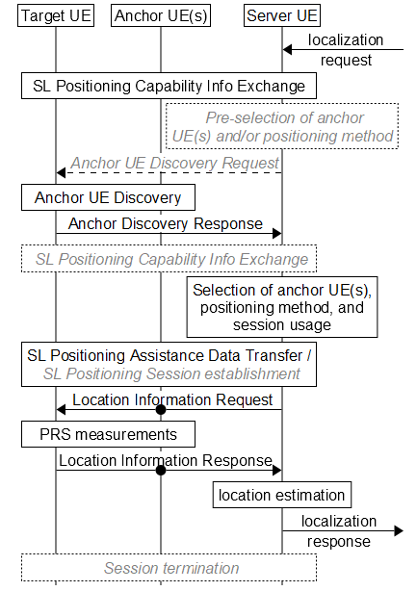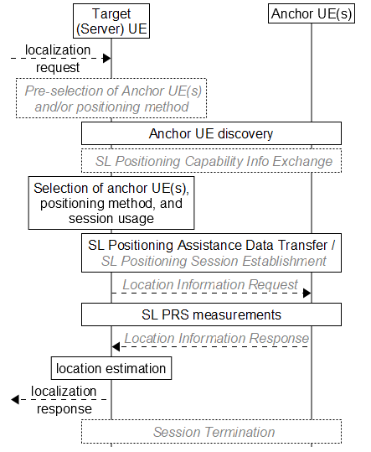  (a) Target UE and server UE are two different nodes. (b) Target UE acts as the server UE  Fig. 2 –Server UE-assisted SL positioning.  [black font / solid lines indicate = mandatory steps, grey font / dashed lines = optional steps]
Intel  R2-2302740 | Figure 3 UE sidelink positioning for out of coverage scenario
vivo  R2-2302958 | Figure 2.2.2-1: LMF-independent sidelink positioning signaling procedures

CATT, Intel and vivo put all involved UE roles in the general procedure, even when anchor UE or target UE acts as server UE. However Nokia distinguish the two cases. Server UE always acts as an entity in general procedure when server UE is target UE/ anchor UE/ the 3rd UE, shown in figure 1.
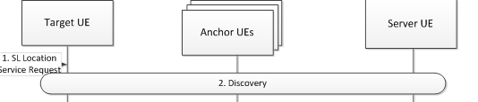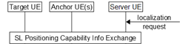
Figure1 Server UE as an entity

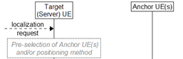
Figure2 Target UE/anchor UE act as server UE
Question 2: Do you agree that server UE acts as an entity separately shown in figure 1 in the general sidelink positioning procedures between UEs for out of coverage scenario?
Company | Yes/No | Comments
Qualcomm | See comment | We find this question somewhat unclear. Our view is there is no need to distinguish UE role in the description of SLPP signaling procedures (as in the call flow suggested as a baseline in [AT121bis-e][424], Question 4).
OPPO | Yes | The entities shown in the signalling procedure are just logical entities. Including each logical entity independently in the signalling procedure is clearer to present every necessary step to be involved in the SLPP. We know that if two UE roles are actually co-located in the same UE, then no inter-UE signalling is needed between them.

Summary:

Involved UEs in capability and assistant data exchange procedures
CATT and Intel proposed target UE needs to exchange sidelink positioning capability and assistant data with anchor UEs. Nokia and vivo proposed the sidelink positioning capability and assistant data exchange only between target UE / anchor UEs and server UE, not between target UE and anchor UE.
Question 3: What is your view on sidelink positioning capability and assistant data exchange procedures for out of coverage scenario?
Option 1: The sidelink positioning capability and assistant data exchange happen between target UE/anchor UEs and server UE, but don’t happen between target UE and anchor UEs when there is server UE;
Option 2: The sidelink positioning capability and assistant data exchange can happen between target UE and anchor UEs whatever there is server UE or not;
Option 3: Others.
Company | Options | Comments
Qualcomm | Option 3 | RAN2 has agreed that Capability and Assistance data can be exchanged between UEs via unicast, groupcast or broadcast. As such, it seems unnecessary to levy a restriction on distribution of Capability and Assistance data. Rather, Capability and Assistance data can be exchanged between UEs participating in a sidelink positioning and ranging transaction.
OPPO | Option 3 | If unicast is employed, we prefer to follow the Uu based positioning implementation, for example, the anchor UE could firstly send the assistance data to the server UE, then the server UE can forward the assistance data to the target UE.  If broadcast is employed, then nothing could prevent from direct signalling exchange between the anchor UE and the target UE.

Summary

The following series of steps based on previous agreement are proposed by companies, between the server UE/ candidate Anchor UE(s) and Target UE(s):
1. Discovery procedure
2. SL connection establishment
3. Anchor UEs selection
4. Positioning methods selection
We will further discuss these steps to figure out if these steps may be included in the general sidelink positioning procedures.

Discovery procedure aspect
All above companies considered that discovery procedure between target UE and anchor UEs should be performed. CATT considered discovery procedure should also be performed between target UE / anchor UEs and server UE.
Question 4: Do you agree discovery procedure should be included in the sidelink positioning procedure for out of coverage scenario?
Company | Yes/No | Comments
Qualcomm | Yes
OPPO | Yes | The target UE should perform discovery procedure to find the UEs supporting SLPP in the proximity, since the positioning measurement should be done between target UE and anchor UEs.

Question 5: What is your view on which discovery procedure is needed for out of coverage scenario?
Option 1: Discovery procedure between target UE and anchor UEs;
Option 2: Discovery procedure between target UE and server UE;
Option 3: Discovery procedure between server UE and anchor UEs.
Company | Option 1/2/3 | Comments
Qualcomm | Option 4 | Since a UE is permitted to undertake any role, we see no need to draw a distinction in which UEs participate in the Discovery procedure. Rather, Discovery should enable SLPP-capable UEs to learn of the presence of other SLPP-capable UEs.
OPPO | Option 4 | Agree with Qualcomm

Summary:

Nokia and vivo mentioned that server UE sends Anchor UE (discovery)Request message to target UE before the discovery procedure between target UE and anchor UEs. And after the discovery procedure, target UE sends Anchor UE (discovery) Provide message to server UE.
Question 6: Do you agree to include Anchor UE (discovery) Request and Anchor UE (discovery) Provide steps in the sidelink positioning procedures for out of coverage scenario?
Company | Yes/No | Comments
Qualcomm | No | Per our answer to Question 5 since a UE is permitted to undertake any role, we see no need to draw a distinction in which UEs participate in the Discovery procedure. Rather, Discovery should enable SLPP-capable UEs to learn of the presence of other SLPP-capable UEs. Furthermore, our view is that design of Discovery should be up to SA2.
OPPO |  | We agree that target UE should perform the anchor UE discovery procedure. However, the target UE should firstly do the discovery procedure to pre-filter the UEs in proximity and then can perform the SL capability exchange between the target UE, anchor UE and the server UE.  Also, the SL capability exchange may be only feasible after the unicast link between a pair of UEs is established.

Summary:

SL connection establishment aspect
CATT and Intel proposed to include unicast SL connection establishment procedure before sidelink positioning capability exchange.
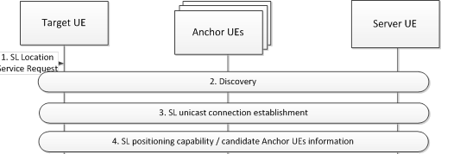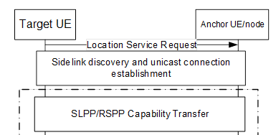
Question 7: Do you agree to include unicast SL connection establishment procedure before sidelink positioning capability exchange for out of coverage scenario?
Company | Yes/No | Comments
Qualcomm | No | In addition to unicast, RAN2 has agreed that Groupcast and Broadcast can be used for Capability and Assistance data exchange between UEs. Imposing a requirement for unicast call establishment seems unnecessary and significantly constraining sidelink positioning operation, resulting in additional over-the-air resources consumed and incurring the latency of unicast call establishment.
OPPO | Yes for unicast

Summary:

Anchor UEs selection
All companies suggest that server UE performs anchor UEs selection. But they have different views on when the selection happens.
- Nokia and vivo suggested server UE performs anchor UE selection after sidelink positioning capability exchange between server UE and anchor UEs.
- CATT suggested server UE performs anchor UE selection before sidelink positioning capability exchange between target UE and anchor UEs.
This issue is related to anchor UEs selection criteria. For the solution of Nokia and vivo, server UE performs anchor UEs selection may depend on the information which is obtained from discovery and capability of anchor UEs. For the solution of CATT, anchor UEs selection depends on the information which is obtained from discovery of anchor UEs.
Question 8: Do you agree to include anchor UE selection in the general procedures? If yes, which option of information is preferred for the anchor UE selection?
Option 1: the information obtained from both discovery and capability of anchor UEs;
Option 2: the information obtained from discovery of anchor UEs;
Option 3: Others.
Company | Yes/No | Options | Comments
Qualcomm | Yes | 3 | Option 3: “the information obtained from SLPP capability exchange.”  Our view is UE anchor selection can be based on SLPP Capability exchange, subsequent to Discovery procedures, with Discovery providing information on UE SLPP support.
OPPO | Yes | Option 3 | We think UE selection should be done after both procedures. Suppose there are lots of UEs around the target UE. The first job for the target UE is to identify the UEs supporting the SLPP and could serve as the adapt UE roles such as anchor UEs or location server UE using the discovery msg. Then more detailed information such as AS-level capability could be exchanged in-between the UEs survive after the discovery procedure.

Summary:

Positioning methods selection
CATT and Nokia considered server UE performs positioning method selection along with anchor UE selection.
Question 9: Do you agree to include positioning methods selection in the general procedures? If yes, does the server UE perform positioning method selection for out of coverage scenario?
Company |  | Include positioning method selection(Yes/No) |  | Server UE perform selection (Yes/No) |  | Comments
Qualcomm |  | Yes with comments |  | No |  | We agree that positioning method selection can be part of sidelink positioning procedures. However, we do not see a need to restrict selection of positioning method to a server UE. Since any UE participating in sidelink positioning can undertake any role, a UE initiating a sidelink positioning session could specify the positioning method, with another UE performing server function.
OPPO | No |  | Yes |  | We think we could follow the Uu-based positioning procedure, wehre the positioning method is selected implicitly after the sidelink positioning capability has been exchanged and is reflected in the LPP ProvideAssistanceData (which positioning method specific assistance data is provided to the UE).

Most of companies propose the general positioning procedure for sidelink positioning, while vivo specifies two different sidelink positioning signaling procedures for different positioning methods.
Question 10: Do you agree to capture the general positioning procedure applied to all sidelink positioning?
Company | Yes/No | Comments
Qualcomm |  | We find this question somewhat unclear. Our expectation is the SLPP specification will capture required positioning procedures.
OPPO | Yes | It is not clear what is the essential difference between LMF-involved and server UE-involved SLPP procedure, and therefore we think one general positioning procedure is enough.

Summary:

4 Conclusion
Companies discussed the proposals and TPs in the email discussion, here are the proposals:
TBD

5 Reference
[1] R2-2302503 Discussion on sidelink positioning CATT
[2] R2-2302655 Discussion of signalling procedures Nokia Germany
[3] R2-2302740 Further considerations on sidelink positioning Intel Corporation
[4] R2-2302958 Discussion on sidelink positioning vivo
[5] R2-2303591 Sidelink Positioning Protocol (SLPP) Signaling and Procedures Qualcomm Incorporated
[6] R2-2304033 Discussion on SL positioning Xiaomi

