3GPP TSG-RAN2 Meeting #121bis-e R2-2204394
eMeeting, 17~26 April 2023

Agenda Item: 7.5.4.1
Source: Qualcomm
Title: Summary of [AT121bis-e][212][XR] BSR solutions (Qualcomm)
Document for: Discussion and Decision

Introduction
This report provides a summary of the following at-meeting email discussion:
- [AT121bis-e][212][XR] BSR solutions (Qualcomm)
Scope: Attempt to find out which among the BSR table solutions have most support and preclude those with least support (if possible). Should discuss pros and cons of each solution and determine which are acceptable to companies (and why). Can also discuss other general details (e.g. how the BSR tables are used).
Intended outcome: Discussion report in R2-2304394.
Deadline: Deadline 2
During the online discussion on Monday, three solutions for BSR table enhancements were discussed:
- [1] proposes that a basic set of BSR tables can be pre-defined to support common use cases. But it also allows network to RRC configure additional BSR tables on demand, e.g. based on UE’s traffic characteristics.
- [2] proposes that UE generates a new BSR table by applying a scaling factor to a pre-defined reference BSR table. The scaling factor is RRC configured by network.
- [3] proposes that UE can send up to two BSR MAC CEs in single PUSCH transmission for a pending BSR. The first BSR MAC CE indicates a coarse value of UE’s buffer size, and the second BSR MAC CE refines the value reported by the first BSR. The two BSRs may or may not use different BSR tables.
Although these three solutions share the same goal of reducing quantization errors of BSR, they do differ in various ways and have their own advantage and disadvantages. In the following, we first discuss their pros and cons, on aspects such as whether they are efficient in reducing quantization error (e.g. weighing their achievable levels of quantization error vs overhead they introduce), their impacts on network’s flexibility in scheduling and complexity of UE implementation, etc. In the second half of this discussion, we then discuss other general but related issues for new BSR tables.

Contact information
Company | Name (Email)
Qualcomm | Linhai He (linhaihe@qti.qualcomm.com)
Nokia | Chunli Wu (Chunli.wu@nokia-sbell.com)
ZTE | eswar.vutukuri@zte.com.cn
LGE | Hanseul Hong (hanseul.hong@lge.com)
NEC | Yuhua chen(Yuhua.chen@emea.nec.com)
CMCC | Kangyi Liu (liukangyi@chinamobile.com)
Ericsson | Richard Tano (richard.tano@ericsson.com)
Quectel | Lily.huang@quectel.com
Sony | Vivek.sharma@sony.com

Discussion
One key difference between [3] and [1][2] is their overall approach in reducing quantization error. [3] uses more bits (up to two BSRs) to encode buffer size. Whereas [1][2] always sends only one BSR but UE may use a new BSR table with smaller quantization error.
Q1. Which of the following two options do you prefer for reducing quantization error in BSR?
- Option 1a. UE always sends only one BSR. UE may use either the legacy BSR table or a new BSR table with smaller quantization error. UE chooses which BSR table to use based on its buffer size, e.g. use a new BSR table if its buffer size is within the range of the new BSR table or use the legacy BSR table instead.
- Option 1b. UE may send up to two BSR MAC CEs in one PUSCH transmission. These two BSRs are coupled, i.e. the first BSR indicates a coarse value of UE’s buffer size, and the second BSR refines the value reported by the first BSR. Without loss of generality, let us assume in this discussion that either of these two BSRs can be based on either the legacy or a new BSR table.
- Option 1c. UE sends only one BSR MAC CE in one PUSCH transmission, but the UE may report the overall buffer sizes for one LCG with two buffer size values in the BSR MAC CE: the first buffer size value indicates a coarse value of the LCG’s buffer size, and the second BSR refines the first buffer size. Without loss of generality, let us assume in this discussion that either of these two buffer size values can be based on either the legacy or a new BSR table.

In addition, the rapporteur suggests companies to discuss the pros and cons of these two options in the comments, e.g. whether it is more efficient than the other in reducing quantization error, its impact on network’s flexibility in scheduling and complexity of network’s UE implementation, etc.
Company | Your preference  (Option 1a/b) | Comments  (e.g. Pros and cons of these two options)
Qualcomm | Option 1a | Regarding Option 1b:  - If only legacy BSR tables are used, the maximum quantization error of the first BSR is ~10%, then the use of 2nd BSR can reduce it down to 1%. According to SA4’s TR, at 4K and 90 fps, the range of burst size is 28~208 KB. 1% of that corresponds to 280B ~2KB, which is at most one full PDCP PDU. So we are not sure if such a fine resolution in reporting is necessary or not, especially considering the extra overhead it introduces.  - If new BSR tables are introduced, then a single BSR can offer a sufficiently good performance. Using the example above again, if the new BSR table uses linear distribution of 256 code points, then the resulting quantization error is 109B~810B, which is smaller than that of using two BSRs.  Based on the above analysis, we can see that a single BSR with a properly designed new BSR table in Option 1a can offer sufficiently good performance or beats the performance of Option 1b that uses legacy tables. Moreover, Option 1a has less UL overhead and is easier for network to decode received BSRs. Therefore, in our view, it is a better option to consider.
Nokia | See comments | Maybe better to have separate discussions about whether to allow fallback to legacy table and whether to allow two BS for an LCG as they are different issues.  Fallback to legacy table is at least needed if the new table does not cover full range (depends on the answer to Q3).  Two BS for an LCG could be used to reduce quantization error on top regardless of which table is used since the quantization error always remains.
ZTE | 1b/1c | In our view, this provides a simple mechanism to ensure an upper bound on the quantization error regardless of the new table design.  Firstly a “properly designed” new BSR table considering just the most likely application data packet sizes may not be sufficient to minimize quantization errors because the buffered data also depends on past scheduled data and newly arriving data. This will unfortunately require optimisation across the entire BSR range. As such covering all ranges of data sizes (especially now that we go towards even higher data sizes) with a very fine granularity would be impractical.  The main point is that eventually there will be gaps in these tables and it can happen that UE’s buffered data falls in these gaps, there by leading to quantization errors. This quantization error can be reduced by increasing the number of tables, but there will still be worst case values which will result in high degree of over reporting.  So, we think the solution proposed here to reduce the quantization error, especially when the quantization error exceeds some threshold (chosen by the network), is a simple way of achieving the goal.  It should be noted that the second index need not be always present. But, if the error is high, by including very few bits, we can reduce it to almost zero. With this approach, we also think we don’t need to define a large number of additional tables. And we can also have a simple table design which just covers a few additional high data code points.
LGE | Option 1a | For option 1a, it is simpler if the new table is defined. If the new table is defined, the existing BSR operation could be reused, which simplifies the spec and UE operation.  For option 1b, if two BSR indices are used, the design of new table may not be needed, which simplifies the discussion of design new BSR table(s). However, it is not desirable with following reasons:  - Generating two BSR MAC CEs for each LCG causes additional UE complexity to generate BSR table(s) and transmit the corresponding BSR MAC CE(s)  - Two BSR MAC CEs cause the additional overhead, since it needs multiple MAC subheaders.  - It also changes the procedure text of BSR operation, since in the current text specifies that only one BSR MAC CE is transmitted for multiple BSR triggering events  - it is ambiguous whether the transmission of BSR is allowed or not when UL grant(s) can accommodate one BSR MAC CE for transmission but is not sufficient to accommodate two BSR MAC CEs.  For option 1c, it looks better than option 2b since it does not need to tramsmit multiple MAC subheaders. However, given that new BSR table is defined with finer granularity, one Option 1a is simple and sufficient.
NEC | Either | Either option can equally work well, we can follow majority. Pros and cons are analysed as following:  Option1a:  - only one BS field per LCG  - assuming to keep the 8bits BS field, generally, the overhead may be slightly increased comparing legacy BSR report due to potential BS table indication field and new eLCID(s)  - likely introduce New BSR MAC CE with BS table indication  - Must discuss how to pre-define or configure new BS table(s)  Option1b/1c (assume a BS threshold will be configured and used to trigger second BSR):  - When buffer size is lower than the threshold, all legacy MAC CE format/procedure/LCID can be reused without any change  - When buffer size is higher than the threshold. the first BS can be same as legacy, the second BS is reported with same or different format. potentially, this means nearly doubled overhead.  - Potentially, no need to introduce new BS table(s), if the second BSR also use the legacy table . (i.e., no need to discussion Q2-Q7)  - Potentially achieve smaller quantization error but with more bits in total
CMCC | Option 1a | We think that with new BSR table, one BSR is sufficient for reducing quantization error. Therefore, there is no need to introduce a secondary BSR.  For Option 1b, we think using two BSR MAC CE will increase overhead since BSR can be very common. Considering Long BSR, it can be even worse.
Ericsson | 1a | Reporting one BSR table value is sufficient (for each LCG/delay group in LCG).  We see no reason to send multiple BSRs to provide the same information, e.g. buffer size, if this can be done by transmitting one BSR.
Quectel | 1a | Option 1a is simple. Although option 1b and 1c may lead less wireless overhead, the triggering condition and the configuration is too complex.
Sony | 1b/1c | We think both options of either one MAC CE or two MAC CEs could be supported. This may carry the value from legacy BSR table and a delta compared to this value.

Summary
(to be added later)

There have been different proposals on how new BSR tables may be introduced. For example, they may be pre-defined in specifications, generated on demand based on parameters configured by RRC, or a combination of these two approaches.

Q2. Which of the following option(s) do you prefer for introducing the new BSR table(s)?
- Option 2a. They are pre-defined in the spec;
- Option 2b. They are generated on demand based on a pre-defined formula whose parameters are RRC configured by network;
- Option 2c. Option 2a + 2b, i.e. a basic set of BSR tables can be pre-defined in the spec to cover common use cases, but network can configure additional BSR tables using one of the methods in Option 2b.
- Option 2d. They are generated based on a reference BSR table and a scaling factor RRC configured by network.
You may choose more than one option from the above in your reply. If possible, please also include your analysis on the pros and cons of these four options in your comment.

Company | Your preference  (Option 2a/b/c/d) | Comments  (e.g. Pros and cons of these options)
Qualcomm | Option 2a or 2c | From UE’s perspective, Option 2a is the simplest for UE to implement and yet serves the purpose well. Since new BSR table(s) only need to cover the size range of common XR encoding rates and frame rate, which are known, BSR tables can be predefined accordingly.  We understand that Option 2b can provide more flexibility for network. And if done right, it may be able to achieve lower quantization errors too. However, given the fact that the target range for new tables are known, we are not sure how much gain (e.g. in term of capacity improvement) Option 2b can offer and whether that would justify the extra implementation effort by UE. And the worst concern for UE implementation is that it is uncertain how much computing cycles it needs to budget for dynamic BSR table generation, because we don’t know how often network may ask UE to generate a new BSR table.  Therefore, Option 2c can be a good compromise for UE and network, because pre-defined BSR tables can help handle most of the scenarios and UE only needs to generate a new BSR table occasionally.  Option 2d can be an alternative to 2c if all the parameters of the reference table (e.g. min, max, distribution of its code points) can scale in the same way when encoding/frame rate changes. But that assumptions needs to be fully vetted before it can be considered.
Nokia | Option 2b or 2d | More flexible to cover all typical data rate and frame rate than 2a, without too much UE complexity.  No simplification for UE implementation with 2c compared to 2b since the UE would anyway need to implement both.
ZTE | Option 2a | We prefer a single additional table with focus on larger data packet sizes.
LGE | Option 2a  Acceptable for 2b  No for 2c and 2d | Option 2a is preferred since it minimizes the UE complexity using the new BSR table. If the UL XR traffic range can be covered using the several BSR tables, defining one or more fixed tables seems sufficient.  Option 2b is acceptable if it is the data volume range of UL XR traffic is diversified. In addition, no new BSR table would be needed in the future releases in order to support other types of traffic. The additional UE complexity depends on the details of the additional BSR table(s) (e.g., distribution of code points as in Q5).  Option 2c and Option 2d is not preferable since there is no additional benefits compared to option 2b. If the new BSR table(s) need to handle various range of data volume, option 2b seems sufficient.
NEC | Option 2b | Option2a has futureproof issue, and less flexible  Option2c basically specify two solutions for one issue, which is not the normal way we work in 3gpp  Option2d, with scaling factor, it means UE need to generate new table same as option2b. moreover, UE implementation may need to deal with non-integer values due to the scaling
CMCC | Option 2b | We think Option 2b can provide the least quantization error. UE or NW may trigger a BSR table update when it finding the quantization error between BSR table and actual buffer are too large.  For Option 2a, we think it has least impact on UE. However, XR can have multiple and/or unstable data rates, it’s difficult to the find all pre-defined BSR tables that suits for all or most XR applications.  For Option 2d, it’s easy for implementation as well, but it has the same problem as Option 2a, i.e., a suitable reference BSR table for XR service may not exist.
Ericsson | 2b | Configured/generated tables are really the only solution that is needed. This option gives the largest gain (shown to be close to the ideal case in simulations) and is a clean and easy to understand solution which is matching legacy operation of BSR reporting. It will have a low cost since the generation is only done when changes are needed (rare occasion if a few tables are generated from the start and selected from). Thus the benefit of introducing new pre-defined tables is hard to justify. Pre-defined tables will never be able to cover all the ranges that is needed and at same time keep the granularity high enough to get good gains. The range is shown (in simulations) to be dependent both on the traffic sizes and on the transmission sizes. Both are factors that will change with time and can't be known beforehand when defining the tables.  Legacy tables will always be an option for all solutions (those are of course pre-defined).  For option 2c we have done some comparison simulations on this option (of dividing/scaling every step size) and it seems to not be as good as the configurable table solution:  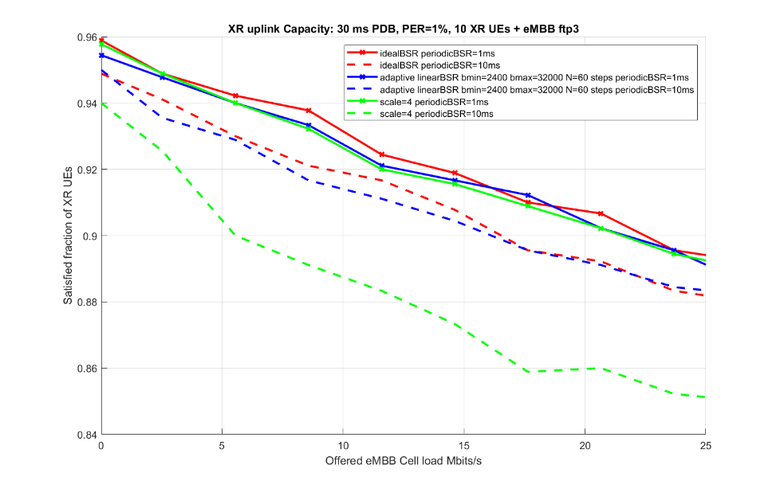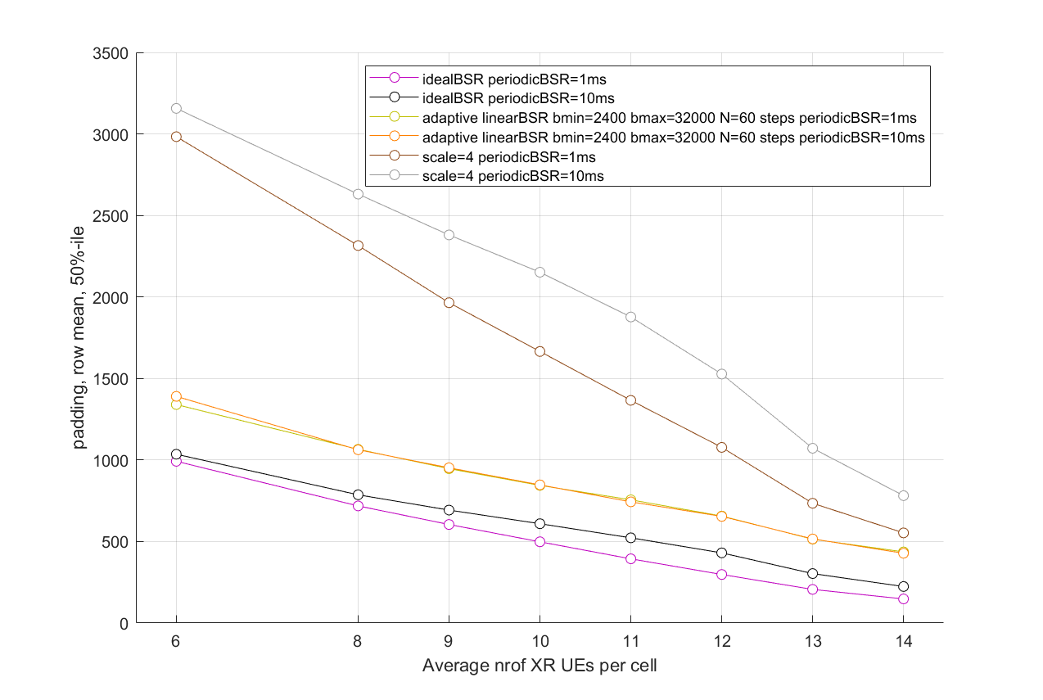  As can be seen with higher indexes the granularity is still low with the scaling solution, so it doesn’t actually solve the problem with low granularity for large sizes. And with increasing bitrates/transmission sizes the problem will only become larger.
Quectel | 2a/2b or 2c | Considering the difference character of XR sessions, it is benefit to predefine some tables, and let some space for gNB configuration.
Sony | 2a/2d | We think 2a is straightforward

Summary
(to be added later)

To either pre-define or RRC configure a new BSR table based on a formula, one needs to decide on three factors: the range of buffer sizes in a table, number of code points, and the distributions of code points within the range. Some of these factors may need to be considered together. For example, the choice in number of code points may affect the choice on the range of a table, and vice versa. Or the choice in the distribution of code points may depend on the choice in the range or number of code points, and vice versa. We discuss these issues in the following.

For the range, the rapporteur thinks that there can be at least two possible options: either reuse the same range of the legacy BSR table or define a narrower range, e.g. based on the sizes of data bursts produced based on common XR encoding rates and frame rates. In the first option, quantization error can be reduced through techniques such as use of more code points or more efficient distribution of code points.

Q3. What range of buffer sizes should new BSR table(s) have?
- Option 3a. Reuse the same range of the legacy BSR table;
- Option 3b. A narrower range, e.g. based on the sizes of data bursts produced based on commonly used XR encoding rates and frame rates
- Option 3c. It depends on other options. No need to impose anything for now.
Company | Your preference  (Option 3a/b/c) | Comments
Qualcomm | Option 3b | We think there are two possible dimensions in reducing quantization errors: reduce the range of a table vs increase number of code points. Between these two choices, we think increasing number of code points is less desirable, because it will increase UL overhead and make the design of new BSR MAC CE more complicated. On the other hand, reducing the range of a table has much less overall impact on the current BSR framework.
Nokia | Option 3b | Finer granularity with narrower range. No need to cover full range as legacy table can be used for smaller buffered data, otherwise if with 3a it would have worse granularity for some code points than legacy table if to have finer granularity for others?
ZTE | Option 3b | As shown in our contribution, the problem is higher towards higher BSR indices (when there is more buffered data). This is because the code points are sparser in this region. So, targeting these regions seems to make sense. On top, if we have some fail-safe mechanism to ensure that the quantization error never exceeds a given value (like including second index if it exceeds), then the design can simply focus on the higher end of the buffer sizes (and typical frame sizes for XR traffic etc). If we have no such fail-safe mechanism, some more detailed analysis may be needed to see how to optimise over entire range.
LGE | 3c | It depends on the result of Q2.  If Option 2a is agreed, it should be determined based on the characteristic of XR traffic.  If Option 2b is agreed, it depends on the network configuration.
NEC | Option 3b | Optin3a (cover 0 to infinite) does not work well:  - With the same bits, quantification error is reduced in a certain buffer size range, while increase in other buffer size range  Or much more bits is required for BS report
CMCC | Option 3b | We think that this issue depends on the characteristics of XR traffic. Since XR traffic consists mainly of periodic Data bursts with finite size, a BSR table whose range covers Data burst seems fine
Ericsson | 3b/3c | The range of the tables depend on how the NW configures them and thus what is suitable for the traffic. This is not something we can decide on here.  It is likely that the configured tables will be narrower than legacy tables, to make possible for higher precision on some specific range, but it all depends on the bits/code points used.
Quectel | 3b
Sony | 3b

Summary
(to be added later)

For the number of code points, the rapporteur thinks that there can be at least two possible options (for both RRC configured and predefined tables): all new BSR tables have the same number of code points or different new BSR tables may have different number of code points. The first option would simplify the design and implementation of the enhanced BSR MAC CE, whereas the second option maximizes the flexibility in defining/configuring new BSR tables.

Q4. Which of the following is your preferred option for the number of code points in a new BSR table?
- Option 4a. All new BSR tables have the same number of code points;
- Option 4b. Different new BSR tables can have different number of code points (e.g. depending on their ranges);
- Option 4c. Other (Please provide details in your comment)
Company | Your preference  (Option 4a/b/c) | Comments
Qualcomm | Option 4a | This choice is a tradeoff between performance and complexity. Theoretically, Option 4b probably has a better performance in reducing quantization errors than Option 4a, because tables with large ranges can benefit from having more code points. However, if network can configure different LCGs to use different BSR tables, then having different BS field lengths for different LCGs can make the format of the new BSR MAC CE much more complicated not desirable for UE implementation.
Nokia | Option 4a | 8-bit table(s) are enough.
ZTE | 4a | We think just one additional table would be sufficient.
LGE | 4a | We prefer to define same size of BS field in order to simplify the new BSR MAC CE design, given that each LCG may use different BSR table(s) (related to Q6). Furthermore, the number of code points of BS field should be same as legacy BSR table (i.e., 8 bits for long BSR format), given that some LCGs may use the legacy BSR table.
NEC | Option4a | 8bits BS table.  it is likely that a long or long truncated BSR MAC CE includes some BS fields encoded based on a legacy 8bits BS table, and some other BS field encoded based on a new BS table, it would be easier to define the MAC CE format if we keep all the BS fields with same length.
CMCC | Option 4a | We think that using the same bit length has less complexity for implementation.  Besides, we think 8 bit is enough for XR, so Option 4b is less preferred.
Ericsson | Option 4b | There are mainly two aspects coming into this, how many bits and how many indexes that are used. Both of these can vary, e.g. we can have the same amount of bits as today or even less. Then what indexes are used is up to NW when deciding to configure the table, it may even decide to not use all indexes.  More bits/code points give higher precision and/or larger range, which may lower the number of tables needed. But fewer code points reduce overhead and can allow for reporting other information. This depends on what BSR formats that is selected to be used (e.g. new formats with other length than legacy may be introduced).
Quectel | 4a and 4b | For the predefined table, the code point is fixed. But for the RRC configured BSR table, the number of code point and the exact value depends on the configuration.
Sony | 4a

Summary
(to be added later)

For the distribution of code points, three options have been proposed in contributions: exponential (as in legacy, the ratio between a step size and its associated buffer size is a constant across all code points), linear (step size for each code point is a constant), and truncated Gaussian [2]. A sensible choice in the distribution of code point may depend on factors such as range and number of code points of a BSR table, as well as traffic characteristics (e.g. size distribution of data burst).

Q5. Which of the following is your preferred option for the distribution of code points for new BSR table(s)?
- Option 5a. Exponential distribution, i.e. The same as in legacy;
- Option 5b. Linear distribution, i.e. equal interval between any two consecutive code points;
- Option 5c. Truncated Gaussian distribution;
- Option 5d. Other (Please provide details in your comments).
You may choose more than one option from the above. In that case, please provide the criteria for each selected option in your comment.
Company | Your preference  (Option 5a/b/c/d) | Comments
Qualcomm | Option 5a and 5b | In our understanding, exponential distribution is better suited for a large range (e.g. across several orders of magnitude), whereas linear distribution is better suited for a small range. Hence different new BSR tables may benefit from using different distributions.  Our understanding on truncated Gaussian distribution is that it is just a model used in RAN1’s evaluation study. It needs to be vetted whether it matches well with actual XR traffic generated by different codec algorithms and how forward compatible it can be.
Nokia | Option 5b or 5c | Depends on the option adopted for question 2.  5b with linear distribution is simpler for 2b with formula-based calculation.  5c could match with the traffic distribution better for 2d with scaling on top of the reference table without the need to define the Gaussian formula.
ZTE | 5a | Some exponential distribution optimising for higher data sizes would be suitable.
LGE | Depends on Q2;  (5a/5b for Option 2a,  5b for Option 2b) | If the new BSR table is generated by UE using formula (i.e., Option 2b in Q2), it should follow the linear distribution, in order to minimize the additional UE complexity.  If the new BSR table is specified (i.e., Option 2a in Q2), we are okay with option 5a and 5b. However, if the new table can be used other than XR services (related to Q8), the option 5c is not needed, since the benefits of option 5c would be limited to video traffics.
NEC | Option 5b | Option5b is simple and enough. NW can configure the (min, max ) properly to guarantee the quantization error is low
CMCC | Option 5c | For Option 5c, there are serval studies and simulations show that the size of video frame follows truncated Gaussian distribution. In AR/MR, video frames consist most of uplink data.  And for other information in uplink (e.g., pose, controller, audio) are not really sensitive to quantization error, therefore the need for BSR enhancement is mainly driven by video frames.  So Truncated Gaussian distribution should be introduced.  Option 5b is also acceptable for us, it can be utilized for pose and control information, they are relatively fixed in size.
Ericsson | 5b/5d | Linear distribution seems to be the simplest choice (and is found in simulations to be working well) for generation and configuration. However, if there is shown that there is a benefit to have other distributions (and the complexity to generate those is not a concern) then such distribution may also be considered.
Quectel | 5b | Since the new table only prefer a limited scope, 5b is enough.
Sony | 5b

Summary
(to be added later)

There are a number of contributions on the granularity for using new BSR table(s). Most of them have proposed that network can configure on a per LCG basis which BSR table(s) UE should use, e.g. LCG #1 may use the legacy BSR table but LCG #2 may use one of the new BSR tables, and so on. On the other hand, it is also possible that in some solutions, it may be simpler for all LCGs in a BSR MAC CE to use the same BSR table.

Q6. Which of the following is your preferred granularity for using new BSR table(s)?
- Option 6a. Network can configure which BSR table(s) (either legacy or new) an LCG should use;
- Option 6b. All LCGs in a BSR MAC CE use the same BSR table;
- Option 6c. Other (Please provide details in your comment)
Company | Your preference  (Option 6a/b/c) | Comments
Qualcomm | Option 6a | Different LCGs can have different data rates and different burst sizes. It hence makes sense to configure BSR table on a per LCG basis.
Nokia | Option 6a | Per LCG makes sense as not all the LCGs are for XR and different LCHs/LCGs might have different data rate.
ZTE | Option 6c | We prefer that any new BSR mechanism would be per LCG (same as legacy). Perhaps this could be agreed as an independent agreement regardless of other enhancements.  But considering that the buffer size cannot be predicted accurately, which BSR table(s) is used should be selected based on the Buffer size to be reported.  And the table used is identified by the LC-ID.
LGE | Option 6a with comment | Regarding the granularity of BSR table, it should be configured per LCG since each LCG has different range of data volume.  However, we think network can also configure to use “both legacy and new BSR tables” for an LCG. Then, depending on the size of the buffered data, UE can decide the appropriate BSR table.
NEC | See comment | This question is a bit confusing.  Two possible aspects needs discussion:  - whether new BS table is configured per LCG or per UE(same for all LCG )  - whether UE has to switch to use new BS table for all LCG once configured  For aspect 1: 6b. we are not sure if there will be two LCG requires new and different BS tables (i.e., support two XR service at the same time). so per UE may be enough, but per LCG (6a) is acceptable  For aspect 2: 6c, UE choose  Option6a cannot work, since the buffer size may fall out of the new BS table’ coverage, legacy BS table has to be used.  Option6b cannot work, since some LCG will never need new BSR table  Option 6c: UE use new BS table if the buffer size fall in the size range (min,max) of new BS table, otherwise ,use legacy BS table.
CMCC | Option 6a | When different QoS flows are mapped into different LCGs, BSR table configured per LCG can provide the least quantization errors compared to Option 6b.
Ericsson | 6a/6c | NW configures which table(s) that are applicable for each LCG. When reporting the BS, the UE should select the table and index which results in lowest inaccuracy (i.e. lowest difference between the max and min value of the index). If the configured tables do not contain an index covering the current buffer size, then UE should use legacy tables and BSR.  This also means that the same table cannot be used for all LCGs as they may have different buffer sizes and thus fit different table ranges. An example of what happen if you don’t use the suitable table for the buffer range is shown below, where an LCG is configured to only use a new configured table. It is clearly worse than using the adaptive approach, i.e. selecting the legacy table when outside of the new table range.  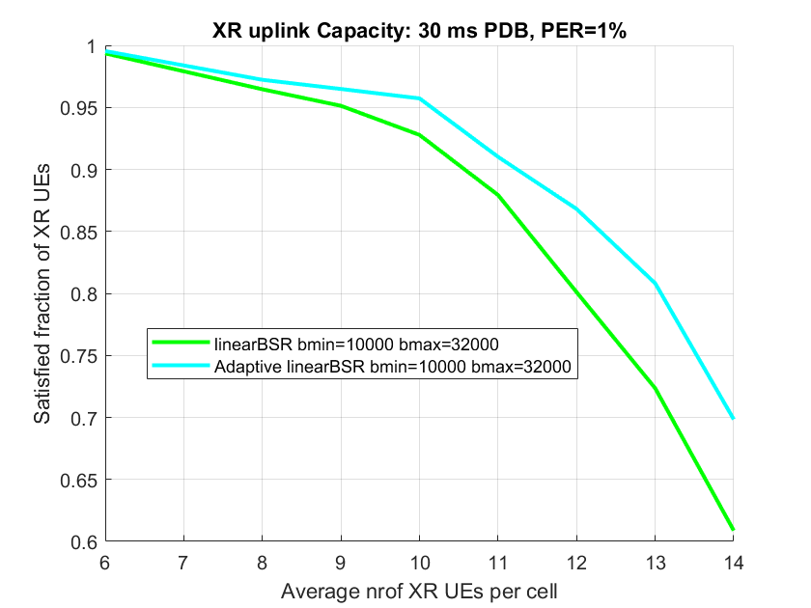
Quectel | 6a | The gNB shall configure it based on the XR session feature.
Sony | 6a

Summary
(to be added later)

In legacy, short BSR and long BSR use different BSR tables, because they use different number of code points. If we are going to introduce new BSR tables, then we need to discuss whether/how new BSR tables should be designed for them.
Q7. Which of the following is your preferred option for introducing new BSR table(s) for short/long BSR?
- Option 7a. Only long BSR need to have new BSR table(s);
- Option 7b. Only short BSR needs to have new BSR table(s);
- Option 7c. Both short BSR and long BSR can have their own new BSR table(s), which are defined/configured separately;
- Option 7d. The same set of new BSR table(s) are used by both short BSR and long BSR.
- Option 7e. Introduce new BSR formats to accommodate new BSR table(s).

Company | Your preference  (Option 7a/b/c/d) | Comments
Qualcomm | Option 7a | First, we think it is useful to keep the 2B short BSR MAC CE. For small bursts, the current short BSR table is sufficient, because its distribution of code points has fine resolution at the low end.  To cover the case where a single LCG has a large burst, we think RAN2 should agree that UE is allowed to use long BSR in that case. Then new BSR table(s) designed for long BSR can be used for to provide better resolution for large bursts, if needed.
Nokia | Option 7a | Long BSR provides finer granularity since it provides a lot more code points compared to short BSR, leading to minimizing the quantization error.
ZTE | 7a
LGE | Option 7a with comment | We think that the new BSR table for long BSR should be defined first.  Not sure about the new table for short BSR. We discuss later.
NEC | Option 7d or 7a with Comment | We can increase BS field bits for short BSR, as same as for long BSR. Then same set of BS table(s) can be used by both short BSR, long BSR, short/long truncated BSR.  7a is also fine with us, but it would mean short/short truncated BSR will not use new BS table and keep the quantization error as today
CMCC | Option 7d | We think Short and Long BSR should have the same performance on quantization errors, therefore there is no need to just configure new BSR table for short or long BSR.  Besides, Long BSR for reporting single LCG is less preferred since it has to transfer an 8-bit LCG map instead of 3-bit LCG ID.
Ericsson | 7e | There is no need to limit this. New tables can be used for any BSR format. New BSR formats can be introduced with different lengths.
Quectel | 7e
Sony | 7a

Summary
(to be added later)

Last but not least, there was discussion near the end of the online session on whether new BSR table(s) is available only to XR UEs or to any UEs. Let us continue that discussion here to collect more views.
Q8. Do you think new BSR table(s) is available only to UEs supporting XR services or to any UEs?
- Option 8a. Only UEs supporting XR services;
- Option 8b. Any UEs
Company | Your preference  (Option 8a/b) | Comments
Qualcomm | Option 8b | We do not see any strong reasons why a new BSR table cannot be used by UEs not supporting XR services. Moreover, use of new BSR tables is fully under network control, i.e. if network does not want a UE to use a new BSR table, it can simply not enable or configure that BSR table for the UE.
Nokia | Option 8a for now | We can start with 8a when designing the parameters/values for the new table(s).  It can be discussed later if need to apply to other UEs.
ZTE | 8b | As normal, we assume the UE will indicate support for these and if supported, the network can configure the UE to use these whenever it is appropriate. Whether an XR service is running at this point or not may be irrelevant (what matters is the configuration that the UE receives).
LGE | Option 8b | It is up to the network configuration.
NEC | Discuss later | We can discuss this later stage when we discuss capability. This would be a question not only for BSR enhancement but also for other enhancements
CMCC | Option 8b | For traditional service like live streaming and electronic games, new BSR table is more suitable compared to legacy BSR table, therefore new BSR table should be available to all UEs
Ericsson | 8b | The feature may mostly be useful for XR services, but it is not necessarily limited to XR and can be used for other services if such benefit is seen. It is depending on UE capabilities and network decision to configure new tables.
Quectel | 8b
Sony | 8b | Based on UE capability

Summary
(to be added later)

Conclusions
(To be added later)

References
- R2-2302515, BSR enhancements for XR, Qualcomm Incorporated.
- R2-2303862, BSR enhancements for XR, Nokia, Nokia Shanghai Bell.
- R2-2302851, BSR enhancements for XR, ZTE Corporation, Sanechips.

