3GPP TSG-RAN WG2 Meeting#121bis-e R2-230xxxx

2023 E-meeting, April 17-26, 2023

CR-Form-v12.2
CHANGE REQUEST
 | 38.321 | CR | 1588 | rev | 1 | Current version: | 17.4.0
For HELP on using this form: comprehensive instructions can be found at
http://www.3gpp.org/Change-Requests.

Proposed change affects: | UICC apps |  | ME | x | Radio Access Network | x | Core Network

Title: | Clarification on UL operation upon validity timer expiry
Source to WG: | Apple
Source to TSG: | R2
Work item code: | NR_NTN_solutions-Core |  |  |  |  |  | Date: |  |  | 2023-03-14
Category: | F |  |  |  |  |  | Release: |  |  | Rel-17
 | Use one of the following categories:  F (correction)  A (mirror corresponding to a change in an earlier release)  B (addition of feature),  C (functional modification of feature)  D (editorial modification)  Detailed explanations of the above categories can  be found in 3GPP TR 21.900. |  |  |  |  |  |  |  | Use one of the following releases:  Rel-8 (Release 8)  Rel-9 (Release 9)  Rel-10 (Release 10)  Rel-11 (Release 11)  …  Rel-16 (Release 16)  Rel-17 (Release 17)  Rel-18 (Release 18)  Rel-19 (Release 19)
Reason for change: |  | Upon validity timer T430 expiry, RRC will inform MAC not to perform any uplink transmission on serving cell.  Description in RRC spec:  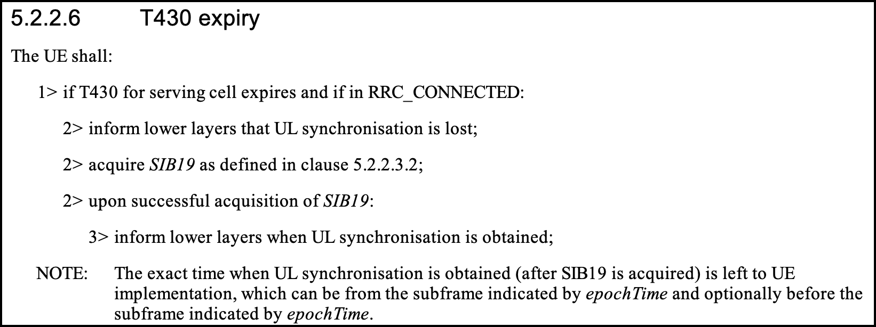  Description in MAC spec:  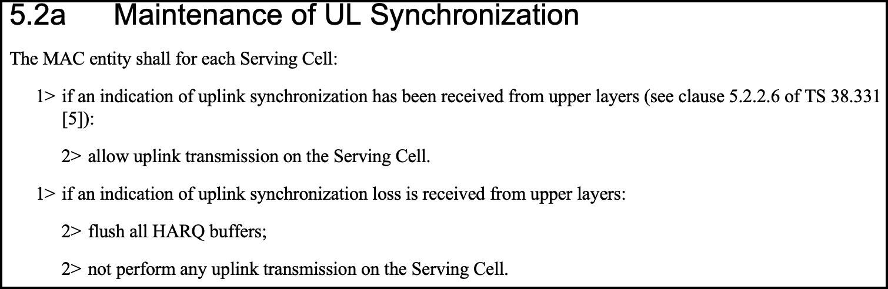  If UE just does not perform the UL transmission, but still keeps the UL operation, e.g. RACH, SR, UL HARQ, the UL operation is meaningless, and is not good for UE power.  In addition, keeping the UL operation may impact the RRC configuration and the UE RRC connection.  - If SR counter reaches the max number, PUCCH and SRS resource will be released;  - If RACH preambe transmission number reaches the max number, RACH failue will be trigger and UE will initaite the RRC connection reestablishment.  Therefore, it should be clarified that UE MAC suspends all UL operations (e.g. stop RACH, SR and BSR, UL HARQ operation, etc.) after receiving the indication of an uplink synchronization loss and resumes the operation when receiving an indication of uplink synchronization.
Summary of change: |  | - Add NOTE to clarify UE MAC suspends all UL operations (e.g. stop RACH, SR and BSR, UL HARQ operation, etc.) after receiving the indication of an uplink synchronization loss and resumes the operation when receiving an indication of uplink synchronization.  - Add the reference section and spec of the UL sync loss indiatin from upper layer.  Impact analysis  Impacted 5G architecture options:  NR-SA  Impacted functionality:  NTN  Inter-operability:  - If the network is implemented according to the CR and the UE is not, UE may release the PUCCH/SRS resource or intiate RRC reestablishment.  - If the UE is implemented according to the CR and the network is not, there is no inter-operability issue.
Consequences if not approved: |  | After validity timer expires, UE may release the PUCCH/SRS resource or intiate RRC reestablishment.
Clauses affected: |  | 5.2a
 |  | Y | N
Other specs |  |  | x | Other core specifications |  |  |  | TS/TR ... CR ...
affected: |  |  | x | Test specifications |  |  |  | TS/TR ... CR ...
(show related CRs) |  |  | x | O&M Specifications |  |  |  | TS/TR ... CR ...
Other comments:
This CR's revision history:

5.2a Maintenance of UL Synchronization
The MAC entity shall for each Serving Cell:
1> if an indication of uplink synchronization has been received from upper layers (see clause 5.2.2.6 of TS 38.331 [5]):
2> allow uplink transmission on the Serving Cell.
1> if an indication of uplink synchronization loss is received from upper layers (see clause 5.2.2.6 of TS 38.331 [5]):
2> flush all HARQ buffers;
2> not perform any uplink transmission on the Serving Cell.
NOTE: The MAC entity suspends all UL operations (e.g. stop RACH, SR and BSR, UL HARQ operation, etc.) after receiving the indication of an uplink synchronization loss and resumes the operation when receiving an indication of uplink synchronization.

