3GPP TSG-RAN WG2 Meeting#121bis-e R2-23xxxxx
Electronic Meeting, 17 – 26 April, 2023

Agenda Item: 6.6.2
Source: Apple
Title: Report of [AT121bis-e][102][NR NTN] UP corrections (Apple)
Document for: Discussion and Decision

Introduction
This document captures the outcome of the following email discussion:
- [AT121bis-e][102][NR NTN] UP corrections (Apple)
Initial scope: Discuss corrections in 6.6.2
Initial intended outcome: Summary of the offline discussion with list of agreeable corrections/CRs
Deadline for companies' feedback: Friday 2023-04-21 08:00 UTC
Deadline for rapporteur's summary (in R2-2304242): Friday 2023-04-21 10:00 UTC

NOTE: Proposals marked "for agreement" in the final report (R2-2304242) not challenged until Monday 2023-04-24 10:00 UTC will be declared as agreed via email by the session chair (for the rest the discussion might continue online).

Contact Points
Rapporteur encourages the participating delegates to provide their contact information in this table.
Company | Name | Email Address
MediaTek | Abhishek Roy | Abhishek.Roy@mediatek.com
Qualcomm | Bharat Shrestha | bshrestha@qti.qualcomm.com
Nokia | Ping Yuan | Ping.1.yuan@nokia-sbell.com
Huawei, HiSilicon | Xubin | xubin10@huawei.com
CATT | Xiangdong Zhang | zhangxiangdong@catt.cn
Google | Ming-Hung Tao | mhtao@google.com
LG | San | geumsan.jo@lge.com
Intel | Tangxun | xun.tang@intel.com
Lenovo | Xu Min | xumin13@lenovo.com
OPPO | Hatitao Li | lihaitao@oppo.com
ZTE | Zhihong Qiu | qiu.zhihong@zte.com.cn
NEC | Yuhua chen | Yuhua.chen@emea.nec.com
Thales | Flavien Ronteix | flavien.ronteix-jacquet@thalesaleniaspace.com
Xiaomi | Xiaowei jiang | jiangxiaowei@xiaomi.com
Apple | Fangli XU | fangli_xu@apple.com
Samsung | Shiyang Leng | shiyang.leng@samsung.com
Sharp | Hidekazu Tsuboi | Tsuboi.hidekazu@sharp.co.jp

Discussion

Validity timer expiry
R2-2303413 Clarification on UL operation upon validity timer expiry Apple CR Rel-17 38.321 17.4.0 1588 - F NR_NTN_solutions-Core
Summary of change:
- Add NOTE to clarify UE may suspend all UL operation (e.g. RACH, SR, UL HARQ operation) if receiving the uplink synchornization loss indication.
- Add the reference section and spec of the UL sync loss indiatin from upper layer.
R2-2303960 UE behaviour related to SR and RACH after validity timer expires Huawei, HiSilicon discussion Rel-17 NR_NTN_solutions-Core Late
Proposals:
Proposal 1: RAN2 to clarify whether the PUCCH resource is still valid after the validity timer (T430) expires and if valid, what is the intended UE behaviour when there is a pending SR.
Proposal 2: RAN2 to clarify the UE behaviour related to RACH after the validity timer (T430) expires.
R2-2303979 Corrections on MAC procedure upon validity timer expiry for NR NTN Nokia, Nokia Shanghai Bell CR Rel-17 38.321 17.4.0 1606 - F NR_NTN_solutions-Core
Summary of change:
When the MAC entity is not allowed to perform any uplink transmission on the Serving Cell in non-terrestrial network due to T430 expiry:
- Update section 5.1.3 Random Access Preamble transmission procedure, to suspend premable transmission.
- Update section 5.1.3a MSGA transmission procedure, to suspend MSGA transmission.
- Update section 5.4.1 UL Grant reception, to suspend the recevied UL grant process.
- Update section 5.4.4 Scheduling Request, to suspend the SR transmission.
R2-2304001 Discussion on the UE behaviour when the validity timer expires LG Electronics Inc. discussion NR_NTN_solutions-Core
Proposals:
Proposal 1. RAN2 confirm all uplink resources for a serving cell are considered as invalid if the MAC entity receives an indication for the uplink synchronization loss for the serving cell.
Proposal 2. For proposal 1, the specification is not changed.

Following is the spec description on the UE operation upon the validity timer T430 expiry.
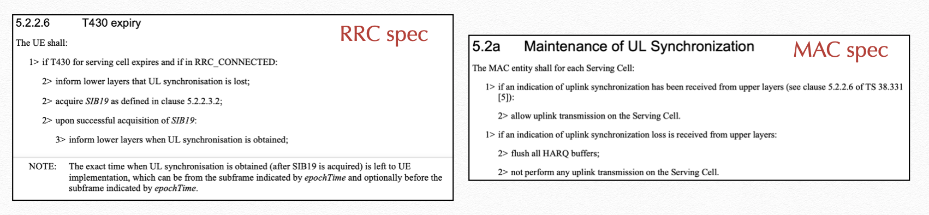

According to current spec, it’s just saying UE doesnot perform any uplink transmission on the serving cell upon the validity timer expiry, but UE operation on the following two issues is not clear, so some clarification is needed.
- Issue 1: whether the uplink resource (e.g. PUCCH and SRS) is still valid or not;
- Issue 2: whether UE needs to suspend all the uplink operations.
On Issue 1, two contributions bring the proposals about the validity of uplink resources upon the validity timer expiry:
- R2-2303960 indicates that SR over PUCCH is not performed so that the validity of PUCCH resource needs to be clarified.
- R2-2304001 proposes to clarify the uplink resources are not released but considered as invalid.
In moderator’s understanding, the key issue is to first clarify whether uplink resources (e.g. PUCCH, SRS) should be released by RRC upon the validity timer expiry, similar as the operation upon TATimer expiry.

Question 1: Which option of the UE operation on the uplink resources (PUCCH, SRS) do you prefer?
- Option 1: the uplink resources are NOT released by RRC
  - The configuration can be reused when UE acquires SIB19 later.
- Option 2: the uplink resources are released by RRC.
  - Network is required to reconfigure the resources after UE acquires SIB19 later.
Company | Preferred option? | Comments
MediaTek | Option 1 | We think the UL resources are still valid and can be reused when UE acquires SIB19 later.
Qualcomm | Option 1 | We simply disagree with the view that there is any confusion on whether the UL resources should be released.  Let’s just check the UE behavior upon expiry of such timer, both TAT and for UL synchronization timer, don’t we see the difference here?  We didn’t capture release of resource for UL synchronization, and it was by design. We heavily discussed whether to flush the HARQ buffer or not. We wanted to keep the HARQ buffer as it is but finally agreement was to flush HARQ buffer, that’s it.  This whole design is that UE just suspends UL, reads SIB19, gets UL synchronization and resumes the UL transmission, continue using UL resources.  If clarification is needed for UL operation, we can add. We should NOT just randomly propose new UE behavior as late correction.
Nokia | Option 1 | Similar view as Qualcomm. The topic was discussed in several meetings, and we proposed the validity timer expiry should be handled with the similar rule as TAT timer expiry but it was not agreed. It is too late to go Option2 in this late stage.
Huawei, HiSilicon | Option 1 | Agree with QC.  Releasing the UL resource is an overkill for this. Clarification should be sufficient for this.
CATT | Option 1 | The UL resources can be resued after the UE has reacquired the SIB19.
Google | Option 1 | The UL resources should be kept otherwise it makes no sense for UE to reacquire SIB19.
LG | Option 1
Intel | Option 1
Lenovo | Option 1 | If UE can re-acquire SIB19 then the UL resources can be resued.
OPPO | Option 1 | The UL resources should be considered as valid.
vivo | Option 1 | To reduce the overhead of reconfiguration of UL resources, UE considers any uplink resource to be invalid during the period of UL synchronization loss and reuses the configurations when UE acquires SIB19 is more reasonable.
ZTE | Option 1
NEC | Option1 | There is no clear reason to release the resource for us. And different from TAT expires case, this may be a regular scenario instead of a corner case, release and reconfiguration is not signalling efficient.
Thales | Option 1 see comment. | The principle is: after the expiration of the T430 timer, the UE is out-pf-sync and should release all UL resources and stop all UL operations.  However, at the reception of a SIB19, the UE re-synchronize and we agree to resume UL operations and configurations for overhead optimization purpose.  Also, there are a question concerning HARQ buffers as explained by Qualcomm.  In timeAlignmentTimer expiry case, HARQ buffers are flushed. We wanted to keep the HARQ buffers to avoid spurious retransmissions from higher layers but we wonder if we should align with the timeAlignmentTimer mechanism already in specifications.
Xiaomi | Option 1 | This was discussed before, the agreement is not to release the resources.
Apple | Option 1
Samsung | Option 1 | Agree with QC. This was discussed in R17. UE just reacquires SIB19, restart T430 and can continue to use the UL resources.
Sharp | Option 1 | UL resources are not released in the current spec, so it is reasonable they should be kept and reused.

On Issue 2, following contributions brings the proposals related to MAC operation upon the validity timer expiry,
- Both R2-2303413 and R2-2303979 propose to suspend all the uplink operation in MAC, including RACH, SR, UL HARQ operation, etc, but the provided TPs are different.
- R2-2303960 would like to clarify UE operation related to RACH.
In moderator’s understanding, the key issue is to first clarify the UE MAC operation and then to check company’s preference on the necessity of the spec change and the preferred TP.

Question 2: Do you agree that UE MAC should suspend all the UL operation (e.g. RACH, SR, UL HARQ) upon the validity timer expiry?
Company | Yes or No | Comments
MediaTek | Yes
Qualcomm | Yes | We are ok to clarify that UE does not perform UL operations until UL synchronization is restored.
Nokia | Yes | Since any UL transmission is not allowed to be performed during the period of UL synchronization loss, the UE should suspend the SR transmission and RACH preamble transmission in RACH procedure to avoid useless RACH or SR transmission attempts which may cause the false RACH/SR failure declaration, even the PUCCH resource is valid. Similarly, it may cause extra delay for UL data transmission to cancel the pending BSR when it is included in the TB while the corresponding PUSCH cannot be transmitted. Therefore, the TB processing upon UL grant reception should be suspended as well.
Huawei, HiSilicon | See comments | We are wondering if this implies option1 in Q2b?  If it is, we are not sure explicitly specifying “suspend” operation is a good way. Because usually if we do this, we will also need to specify the “resume” operation afterwards (when and how, which may be different for different cases).  [Rapp] It does not imply the option 1 in Q2b. Q2 is to check company’s understanding on the UE behavior. If companies think the spec change is needed to clarify it, we can discuss the preferred TP amongst 3 options in Q2b.
CATT | Yes
Google | Yes
LG | Yes
Intel | Yes
Lenovo | Yes
OPPO | Yes but | It is already clear and covered by the spec text “not perform any uplink transmission on the Serving Cell”.
vivo | Yes | BSR should also be included in the UL operation since data may arrive and the BSR may be triggered during the period of uplink synchronization loss. So the proposal should be modified that “UE MAC should suspend all the UL operation (e.g. RACH, SR, UL HARQ, BSR) upon the validity timer expiry”.
ZTE | Yes
NEC | Yes | It is clear that all uplink transmission should be suspended due to lack of synchronization
Thales | Yes | There are no doubt that without UL synchronisation, we suspend all MAC UL operations.
Xiaomi | Yes
Apple | Yes
Samsung | Yes with comment | We think the current spec saying not performing any UL tx is sufficient. UE can suspend any other UL operation up to implementation, e.g. for power saving. But no need to specify procedural text other than the current spec.
Sharp | Yes

Question 2a: If your answer to Question 2 is YES, do you think the MAC spec change for the clarification is needed?
Company | Yes or No | Comments
MediaTek | Yes
Qualcomm | Yes
Nokia | Yes | The MAC specification should be clarified to avoid confusion.
Huawei, HiSilicon | Yes
CATT | Not strong view. | But maybe not so necessary. We already have some description in 5.2.a of MAC spec:  ...  1> if an indication of uplink synchronization loss is received from upper layers:  2> flush all HARQ buffers;  2> not perform any uplink transmission on the Serving Cell.
Google | Yes
LG | NO but | We think it is generally assumed that the all uplink resources are considered as invalid if the uplink transmission is suspended. Thus, spec change is not needed.  However, if majority want to modify the spec, it is ok to have a simple change.
Intel | Yes
Lenovo | Yes
OPPO | No | It is already clear and covered by the spec text “not perform any uplink transmission on the Serving Cell”. “any uplink transmssion” has covered the cases of RACH, SR, UL HARQ, etc.
vivo | Yes
ZTE | Yes,but | We think only clarification in a note indicating the UL transmission includes RACH, SR and PUSCH and it is sufficient.
NEC | No strong view | It is not difficult to understand that “any uplink transmission” including PRACH, SR and so on in the context of invalid SIB19.  But we are fine to clarify if majority want to
Thales | Yes but | We can clarify for the special case of UL out-of-sync caused by T430 but the MAC specification seems to be already clear concerning UL synchronization loss with “not perform any uplink transmission on the serving cell”.
Xiaomi | No | Agree with OPPO
Apple | Yes
Samsung | No with comment | Agree with OPPO.  If majority want to clarify, we think only a note is sufficient.
Sharp | Yes

Question 2b: If your answer to Question 2a is YES, which TP do you prefer?
- Option 1: TP in R2-2303413 (i.e. add a note to clarify the UE operation)

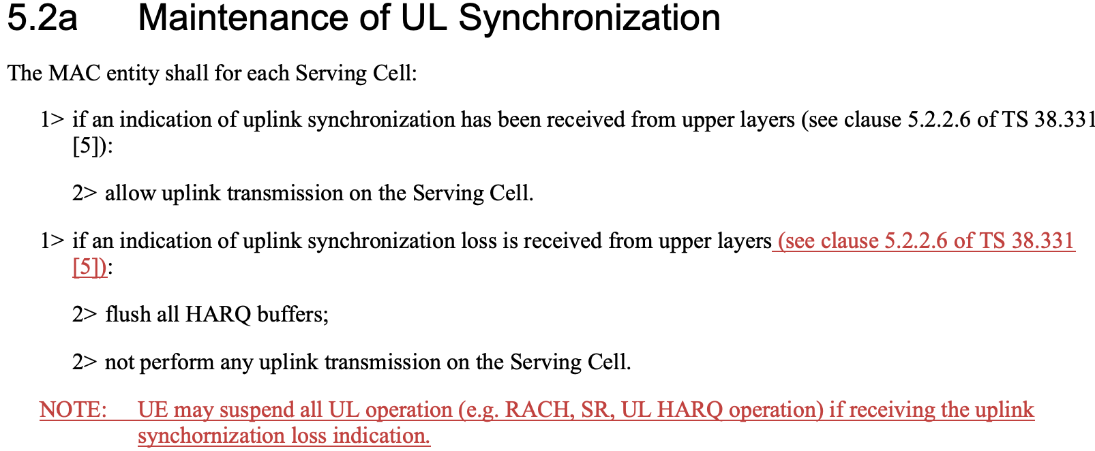

- Option 2: TP in R2-2304001 (i.e. i.e. add a note to clarify the UL resources are invalid)
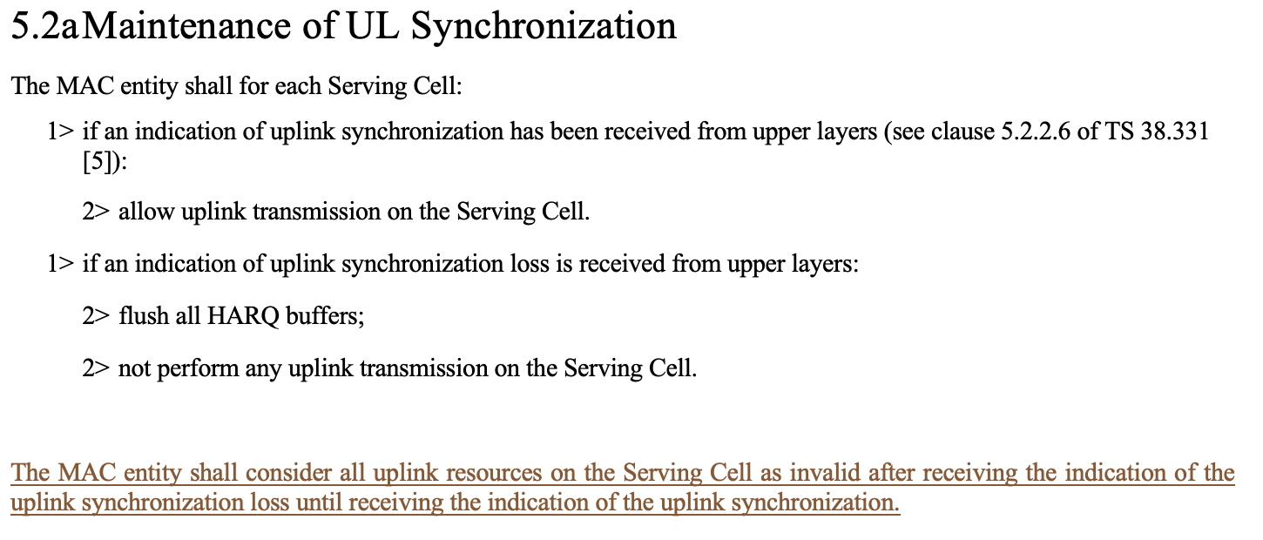

- Option 3: TP in R2-2303979 (i.e. clarify it in each procedural part)

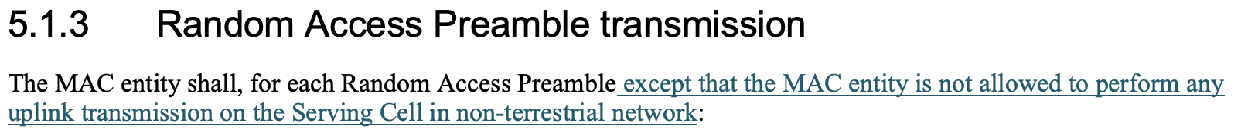
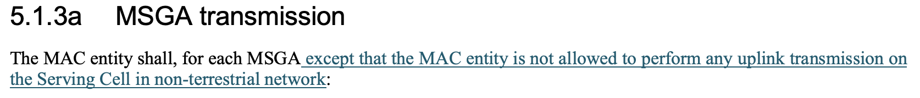

5.4.1 UL Grant reception
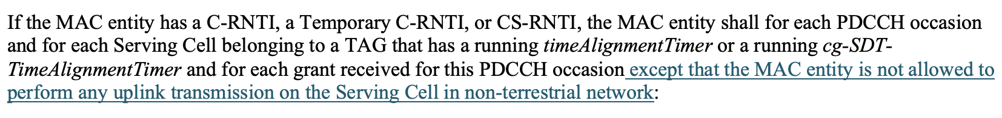

5.4.4 Scheduling Request

Company | Preferred Option | Comments
MediaTek | Option 1
Qualcomm | Option 1 see comments | Option 3 is also Ok but the text does not read very clear. Probably it should be like  Except when the UL synchronization is lost in NTN, the MAC entity shall, for each random access preamble:  But it seems option 1 requires less specification change, but still wording needs to be further checked as this can be procedural text.  We should also clarify then if there is new UL data arrival, should UE trigger BSR when UL synchronization is lost?
Nokia | Option 3 or new Option 4 | We are open to discuss how to capture the MAC behavior but we prefer to capture it in procedural text instead of NOTE. As defined in the “Specification drafting rules” TR 21.801, NOTE is for informative elements hence it is up to UE to implement it or not. While the procedure text (Normative elements) is a requirement to UE implementation. We think suspending UE MAC procedures is clearly a UE requirement hence procedure text is preferred.  For Option1, the Note does not work with "may" as it should be normative UE behavior.  For Option2, it has side effect to consider the UL resource as invalid.  For Option3, we are also fine with QC’s rewording.  After some offline discussion with companies, we think the below Option4 seems have minimum impact to MAC specification which is also OK to us.
  5.2a Maintenance of UL Synchronization
  The MAC entity shall for each Serving Cell:
  1> if an indication of uplink synchronization has been received from upper layers (see clause 5.2.2.6 of TS 38.331 [5]):
  2> allow uplink transmission on the Serving Cell.
  2> allow deliver of grants to the HARQ entity.
  2> resume suspended scheduling request procedure and Random Access procedure, if any.
  1> if an indication of uplink synchronization loss is received from upper layers:
  2> flush all HARQ buffers;
  2> not perform any uplink transmission on the Serving Cell.
  2> not deliver any grant to the HARQ entity.
  2> suspend any ongoing scheduling request procedure.
  2> suspend any ongoing Random Access procedure.
Huawei, HiSilicon | Option 2 | Seems the simplest option. Because if the UL resource is invalid, the UE will not perform UL transmission according to the specs and the procedure part can be left unchanged.  For option 1, we need to further specify when/how the UL operations are resumed, which may be different for different cases. As mentioned by other companies, procedure changes may also be needed for this.
Google | Option 1
LG | Option 2 is preferred but Option 1 is acceptable with small change | If we need to change the specification, we perfer Option 2.  In addition, option 1 is also acceptable with small change.  NOTE: UE may suspend all UL operation (e.g. RACH, SR, UL HARQ operation) after receiving the indication of the uplink synchronization loss until receiving the indication of the uplink synchronization.
Intel | Option 2
Lenovo | Option 2 or 1
vivo | See comments | Firstly, see our reply to Q2, We should also clarify that BSR is not triggered when UL synchronization is lost. And we think such UE behavior is better to be captured in normal text rather than a note, e.g., add the description that MAC shall suspend any UL operation (e.g., RACH, SR, UL HARQ, BSR) if an indication of uplink synchronization loss is received from upper layers in section 5.2a.  Secondly, except clarify the issue in Q1 and Q2, the following two issues should be discussed from our perspective.  - Issue 1: If BSR/SR/RACH is triggered before UL synchronization is lost, whether UE will transmit BSR/SR/RACH when UL synchronization is obtained?  Taking BSR as an example, if BSR is triggered but not transmitted before UL synchronization is lost, it is largely possible that the UL data which arrived during the period of UL synchronization loss will be discarded when the UL synchronization is obtained again. However, the triggered BSR cannot be canceled based on the current procedure, UE will transmit a BSR MAC CE with no data for any LCG, which will cause unnecessary resource waste. Thus, when UL synchronization is obtained as indicated by the upper layers, the MAC entity shall cancel the triggered BSR if there is no pending data available for transmission.  - Issue 2: Whether UE will resume judging the BSR/SR/RACH conditions after UL synchronization is obtained?  During the period of UL synchronization loss, since UE MAC should suspend all the UL operations (e.g. RACH, SR, UL HARQ, BSR), UE does not judge the trigger condition of BSR/SR/RACH regardless of whether new data arrives. In our understanding, when the UL synchronization is obtained, UE should resume evaluating the trigger condition of BSR/SR/RACH if new data arrives during the period of UL synchronization loss.
ZTE | Yes,but | We think only clarification in a note indicating the UL transmission includes RACH, SR,PUSCH and etc. And it is sufficient.
NEC |  | ZTE’ suggestion is a good one.  In option1, “may” is not the right wording.
Thales | Option 1 but | “may” is not the correct wording, the UE “should” suspend all UL operation
Apple | Option 1 | We are open to discuss how to capture the MAC behavior, but we slightly prefer Option 1 with LG’s change, which is the simple one.
Samsung | Option 1 with rewording | We agree with oppo that it is already clear and covered by the spec text “not perform any uplink transmission on the Serving Cell”. “any uplink transmission” has covered the cases of RACH, SR, UL HARQ, etc. So no need to repeat in procedural text.  We don’t think specify new UE behavior is needed. If majority want a clarification, we can add a note that UE can/may suspend all UL operation, which allows UE implementation to certain extend.  Suggest a note with rewording:  NOTE: UE shallmay suspend all UL operation (e.g. RACH, SR, UL HARQ, BSR operation, etc.) after receiving anthe indication of the uplink synchronization loss and resume the operation when receiving anthe indication of the uplink synchronization.
Sharp | Option 2 or 1 | Option 2 is clear description. We also accept option 1

Question 2c: If your answer to Question 2 is NO, please describe your understanding on the UE MAC operation in the table.
Company | UE MAC operation upon validity timer expiry
CATT | Not sure the difference between “not perform any uplink transmission” in the current specification and the description “suspend all UL operation” in the TP. For example, SR or BSR can be triggered, but will be pended (because of “not perform any uplink transmission”), to wait the UL synchronization.
LG | We think it is generally assumed that the all uplink resources are considered as invalid if the uplink transmission is suspended. Thus, spec change is not needed.  However, if majority want to modify the spec, it is ok to have a simple change.
OPPO | It is already clear and covered by the spec text “not perform any uplink transmission on the Serving Cell”. “any uplink transmssion” has covered the cases of RACH, SR, UL HARQ, etc.
Xiaomi | Agree with OPPO
Samsung | Agree with CATT and OPPO

Other

R2-2303820 - Clarification on HARQ feedback of the first SPS PDSCH after the activation
R2-2303820 Corrections to NR NTN for 38.321 CATT, Turkcell, Huawei, HiSilicon, Quectel, CAICT CR Rel-17 38.321 17.4.0 1597 - F NR_NTN_solutions-Core Late
Reason for change:
Current MAC spec description is not aligned with RRC description on harq-FeedbackEnablingforSPSactive, and UE may feed back ACK/NACK unnecessary for a dynamic HARQ process by mistake.
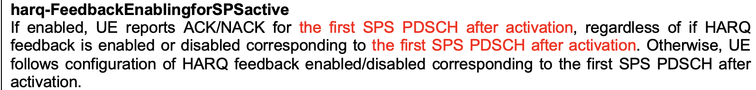
Summar of change:
In 5.3.2.2, adding a description that the first transmission after activation of the configured downlink assignment is the first transmission on the configured downlink assignment after activation of the configured downlink assignment.
MAC TP: (5.3.2.2 HARQ process)
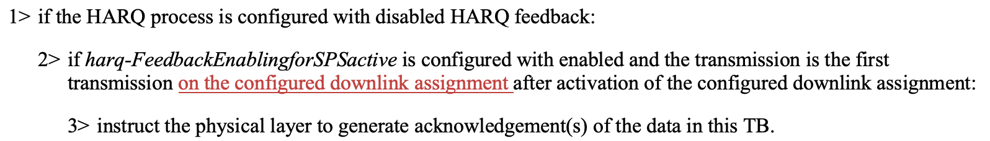

Question 3: Do you agree with the CR (R2-2303820)?
Company | Yes or No | Comments
MediaTek | Yes
Qualcomm | Yes
Nokia | Yes
Huawei, HiSilicon | Yes
CATT | Yes
Google | Yes
LG | No strong view
Intel | Yes
Lenovo | Yes
OPPO | Yes
vivo | See comments | The NW will not configure dynamic scheduling if no feedback is received for the activation of the configured downlink assignment if harq-FeedbackEnablingforSPSactive is configured with enable. But if the majority of companies think the clarification is necessary, we can follow with majorities.
ZTE | Yes
NEC | Yes
Thales | Yes | There is an agreement in RAN1 : “UE reports ACK/NACK for the first SPS PDSCH after activation, regardless of whether HARQ feedback is enabled or disabled corresponding to the first SPS PDSCH after activation”
Xiaomi | Yes
Apple | Yes
Samsung | Yes
Sharp | Yes

R2-2303833 - Correction for R17 NR NTN description of HARQ mode
R2-2303833 Correction for R17 NR NTN description of HARQ mode Ericsson CR Rel-17 38.321 17.4.0 1598 - F NR_NTN_solutions Late
Reason for change:
Currently the HARQ mode A and HARQ mode B are not described in RRC, stage 2 nor in MAC.
We think it would be benefical to have a description somewhere
Summar of change:
HARQ mode is added among the definitions in 3.1.
MAC TP: (3.1 Defitions)

Question 4: Do you agree with the CR (R2-2303833)?
Company | Yes or No | Comments
MediaTek | Yes
Qualcomm | No | After many rounds of reviews of running MAC CR, nobody raised there was any need to have such.  Simply because it is already clear when drx-RetransmissionTimerUL is started.
Nokia | No | If we want to clarify HARQ mode A/B, it should include all the impacts caused by different HARQ mode (e.g. LCP, DRX).
Huawei, HiSilicon | Yes | It is beneficial if a new concept used can be defined to avoid confusion. And usually we don’t use procedure text to define something.
CATT | Yes | Agree with Huawei,for a new concept clarification.
Google | No strong view
LG | Yes
Intel | Yes
Lenovo | Yes
OPPO | No | This has been captured in the DRX procedure.
vivo | No | It is clear how to handle drx-RetransmissionTimerUL in section 5.7 in 38.321.
ZTE | No | Do we introduce definition that is not used any where in the specs?
NEC | Neutral | There seem no strong need but just nice to have
Thales | No strong view | We define a new concept that could be useful but the implications on existing mechanisms related to HARQ should be listed to take into account HARQ mode.
Xiaomi | See comment | We agree to introduce a description of HARQ mode A and B, but we think it should be conceptual for people to understand, instead of using the detailed behavior, which doesn’t help much.  Some example of conceptual description may be:  HARQ Mode A: The gNB retransmission scheduling is based on the PUSCH decoding result.  HARQ Mode B: The gNB retransmission scheduling is not based on the PUSCH decoding result.
Apple | No strong view
Samsung | No | This definition seems problematic, HARQ mode is also applicable to HARQ process ID 0 in RA, but no DRX for RA.
Sharp | No strong view | We think section 5.7 description in MAC spec is enough, but we are fine to add if majority want to.

R2-2304000 - Restriction on the usage of the same HARQ
R2-2304000 Discussion on the restriction on the usage of the same HARQ mode to the configured grant LG Electronics Inc. discussion NR_NTN_solutions-Core
Proposals:
Observation 1. In the current specification, it seems that the configuration of the HARQ process IDs having the different HARQ modes to one configured grant is allowed.
Observation 2. In order to generate the MAC PDU containing the MAC SDUs associated with the same service, the HARQ process IDs associated with the same HARQ mode should be configured to a configured grant.
Observation 3. The configuration of two configured grant timers causes the backward compatibility issue.
Proposal. It should be restricted that the HARQ process IDs having the same HARQ mode should be configured to a configured grant.
RRC TP:

Question 5: Do you agree with the proposal?
Proposal. It should be restricted that the HARQ process IDs having the same HARQ mode should be configured to a configured grant.

Company | Yes or No | Comments
MediaTek | No | We don’t think this is needed. UE implementation can take care of this.
Qualcomm | Yes | We are ok to capture as our current understanding is network will do it.  See agreement of RAN2#116bis and following note in TS 38.300 v17.0.0.  NOTE: It is up to network implementation to ensure proper configuration of HARQ feedback (i.e. enabled or disabled) for HARQ processes used by an SPS configuration and of HARQ mode for HARQ processes used by a CG configuration.
Nokia | No | RAN2 discussed the issue with below agreement. It was concluded no specification impact.
  RAN2 understanding:
  1. RAN2 understanding is that: in general, all HARQ processes used by an SPS configuration are configured with the same HARQ feedback enabled/disabled state. No specification impact.
  2. RAN2 understanding is that: in general, all HARQ processes used by a CG configuration are configured with the same HARQ state (e.g. A or B). No specification impact
Huawei, HiSilicon | Yes | This should be the common understanding and better be clarified.
CATT | No | Agree with Nokia.
Google | Yes | The NW needs to ensure the same HARQ mode is configured to all HARQ process IDs associated to the same configured grant.
LG | Yes | Proponent. It cannot be resolved by UE implmentation.
Intel | Yes
Lenovo | Yes | OK to clarify this.
OPPO | Yes | Agree with Qualcomm. It would be good to clarify that network should configure the same HARQ mode in this case.
vivo | No | During the discussion on this issue, RAN2 agreed that there is no specification impact, the agreements are shown as follows:  RAN2 understanding:  - RAN2 understanding is that: in general, all HARQ processes used by an SPS configuration are configured with the same HARQ feedback enabled/disabled state. No specification impact.  - RAN2 understanding is that: in general, all HARQ processes used by a CG configuration are configured with the same HARQ state (e.g. A or B). No specification impact
ZTE | No | Same view as Nokia.
NEC | Yes | The proposal is right, but same as other companies’ understanding, It was agreed to leave to NW to ensure this
Xiaomi | Yes | It would be good to capture it in the spec to make it more clear to people to understand.
Apple | Yes | Agree with the proposal, but as Nokia indicated, we have already had the agreement before.
Samsung | Yes | Agree with the proposal but this was already agreed with no spec impact as Nokia mentioned.
Sharp | Yes | It’s good to add some description to clarify RAN2 understanding.

Question 5a: Do you agree with the TP in R2-2304000?
Company | Yes or No | Comments
MediaTek | No | We don’t think this is needed. UE implementation can take care of this.
Qualcomm | Yes | Better to have same HARQ behavior in every CG occasion for the same LCH traffic using same CG configuration.
Nokia | No
Huawei, HiSilicon | Yes
CATT | No
Google | No | As this is a network configuration/implementation issue, a NOTE in the specification is always better, and the Note cited by QC has taken care of the issue.
LG | Yes | Proponent.
Intel | Yes
Lenovo | Yes
OPPO | Yes
vivo | No
ZTE | No
NEC | No
Xiaomi | Yes
Apple | No
Samsung | No
Sharp | Yes

Conclusion
Based on the above discussion, we propose that:

