3GPP TSG-RAN WG2 Meeting#121bis-e R2-23xxxxx
Electronic Meeting, 17 – 26 April, 2023

Agenda Item: 6.6.2
Source: Apple
Title: Report of [AT121bis-e][102][NR NTN] UP corrections (Apple)
Document for: Discussion and Decision

Introduction
This document captures the outcome of the following email discussion:
- [AT121bis-e][102][NR NTN] UP corrections (Apple)
Initial scope: Discuss corrections in 6.6.2
Initial intended outcome: Summary of the offline discussion with list of agreeable corrections/CRs
Deadline for companies' feedback: Friday 2023-04-21 08:00 UTC
Deadline for rapporteur's summary (in R2-2304242): Friday 2023-04-21 10:00 UTC

NOTE: Proposals marked "for agreement" in the final report (R2-2304242) not challenged until Monday 2023-04-24 10:00 UTC will be declared as agreed via email by the session chair (for the rest the discussion might continue online).

Contact Points
Rapporteur encourages the participating delegates to provide their contact information in this table.
Company | Name | Email Address
MediaTek | Abhishek Roy | Abhishek.Roy@mediatek.com
Qualcomm | Bharat Shrestha | bshrestha@qti.qualcomm.com

Discussion

Validity timer expiry
R2-2303413 Clarification on UL operation upon validity timer expiry Apple CR Rel-17 38.321 17.4.0 1588 - F NR_NTN_solutions-Core
Summary of change:
- Add NOTE to clarify UE may suspend all UL operation (e.g. RACH, SR, UL HARQ operation) if receiving the uplink synchornization loss indication.
- Add the reference section and spec of the UL sync loss indiatin from upper layer.
R2-2303960 UE behaviour related to SR and RACH after validity timer expires Huawei, HiSilicon discussion Rel-17 NR_NTN_solutions-Core Late
Proposals:
Proposal 1: RAN2 to clarify whether the PUCCH resource is still valid after the validity timer (T430) expires and if valid, what is the intended UE behaviour when there is a pending SR.
Proposal 2: RAN2 to clarify the UE behaviour related to RACH after the validity timer (T430) expires.
R2-2303979 Corrections on MAC procedure upon validity timer expiry for NR NTN Nokia, Nokia Shanghai Bell CR Rel-17 38.321 17.4.0 1606 - F NR_NTN_solutions-Core
Summary of change:
When the MAC entity is not allowed to perform any uplink transmission on the Serving Cell in non-terrestrial network due to T430 expiry:
- Update section 5.1.3 Random Access Preamble transmission procedure, to suspend premable transmission.
- Update section 5.1.3a MSGA transmission procedure, to suspend MSGA transmission.
- Update section 5.4.1 UL Grant reception, to suspend the recevied UL grant process.
- Update section 5.4.4 Scheduling Request, to suspend the SR transmission.
R2-2304001 Discussion on the UE behaviour when the validity timer expires LG Electronics Inc. discussion NR_NTN_solutions-Core
Proposals:
Proposal 1. RAN2 confirm all uplink resources for a serving cell are considered as invalid if the MAC entity receives an indication for the uplink synchronization loss for the serving cell.
Proposal 2. For proposal 1, the specification is not changed.

Following is the spec description on the UE operation upon the validity timer T430 expiry.
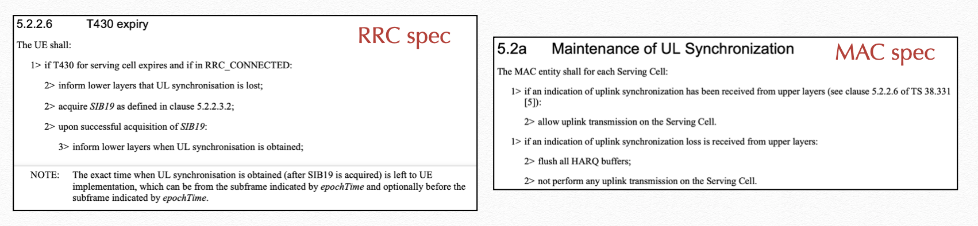

According to current spec, it’s just saying UE doesnot perform any uplink transmission on the serving cell upon the validity timer expiry, but UE operation on the following two issues is not clear, so some clarification is needed.
- Issue 1: whether the uplink resource (e.g. PUCCH and SRS) is still valid or not;
- Issue 2: whether UE needs to suspend all the uplink operations.
On Issue 1, two contributions bring the proposals about the validity of uplink resources upon the validity timer expiry:
- R2-2303960 indicates that SR over PUCCH is not performed so that the validity of PUCCH resource needs to be clarified.
- R2-2304001 proposes to clarify the uplink resources are not released but considered as invalid.
In moderator’s understanding, the key issue is to first clarify whether uplink resources (e.g. PUCCH, SRS) should be released by RRC upon the validity timer expiry, similar as the operation upon TATimer expiry.

Question 1: Which option of the UE operation on the uplink resources (PUCCH, SRS) do you prefer?
- Option 1: the uplink resources are NOT released by RRC
  - The configuration can be reused when UE acquires SIB19 later.
- Option 2: the uplink resources are released by RRC.
  - Network is required to reconfigure the resources after UE acquires SIB19 later.
Company | Preferred option? | Comments
MediaTek | Option 1 | We think the UL resources are still valid and can be reused when UE acquires SIB19 later.
Qualcomm | Option 1 | We simply disagree with the view that there is any confusion on whether the UL resources should be released.  Let’s just check the UE behavior upon expiry of such timer, both TAT and for UL synchronization timer, don’t we see the difference here?  We didn’t capture release of resource for UL synchronization, and it was by design. We heavily discussed whether to flush the HARQ buffer or not. We wanted to keep the HARQ buffer as it is but finally agreement was to flush HARQ buffer, that’s it.  This whole design is that UE just suspends UL, reads SIB19, gets UL synchronization and resumes the UL transmission, continue using UL resources.  If clarification is needed for UL operation, we can add. We should NOT just randomly propose new UE behavior as late correction.

On Issue 2, following contributions brings the proposals related to MAC operation upon the validity timer expiry,
- Both R2-2303413 and R2-2303979 propose to suspend all the uplink operation in MAC, including RACH, SR, UL HARQ operation, etc, but the provided TPs are different.
- R2-2303960 would like to clarify UE operation related to RACH.
In moderator’s understanding, the key issue is to first clarify the UE MAC operation and then to check company’s preference on the necessity of the spec change and the preferred TP.

Question 2: Do you agree that UE MAC should suspend all the UL operation (e.g. RACH, SR, UL HARQ) upon the validity timer expiry?
Company | Yes or No | Comments
MediaTek | Yes
Qualcomm | Yes | We are ok to clarify that UE does not perform UL operations until UL synchronization is restored.

Question 2a: If your answer to Question 2 is YES, do you think the MAC spec change for the clarification is needed?
Company | Yes or No | Comments
MediaTek | Yes
Qualcomm | Yes

Question 2b: If your answer to Question 2a is YES, which TP do you prefer?
- Option 1: TP in R2-2303413 (i.e. add a note to clarify the UE operation)

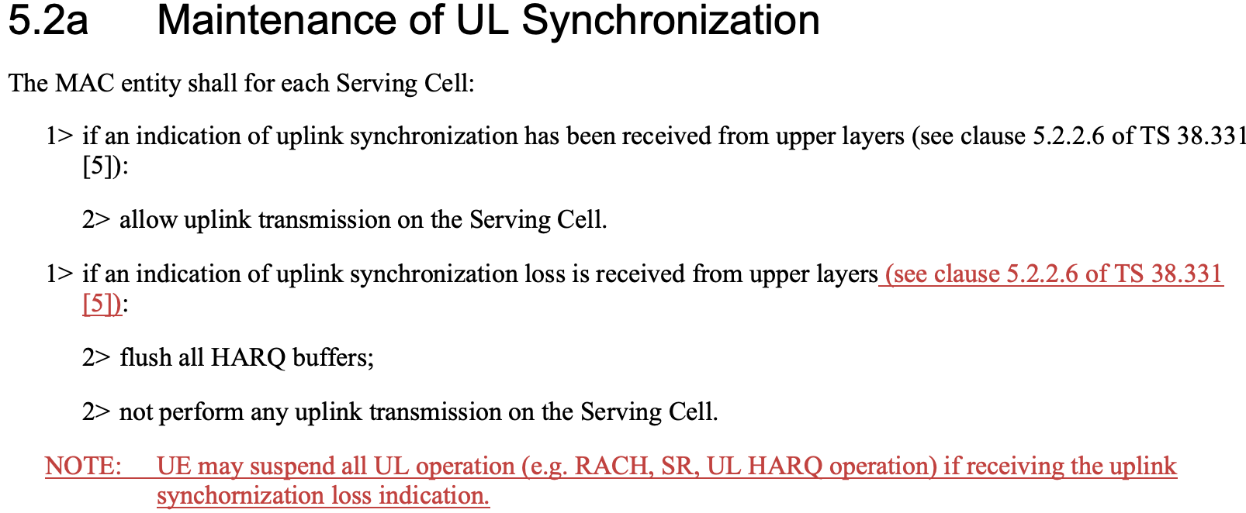

- Option 2: TP in R2-2304001 (i.e. i.e. add a note to clarify the UL resources are invalid)
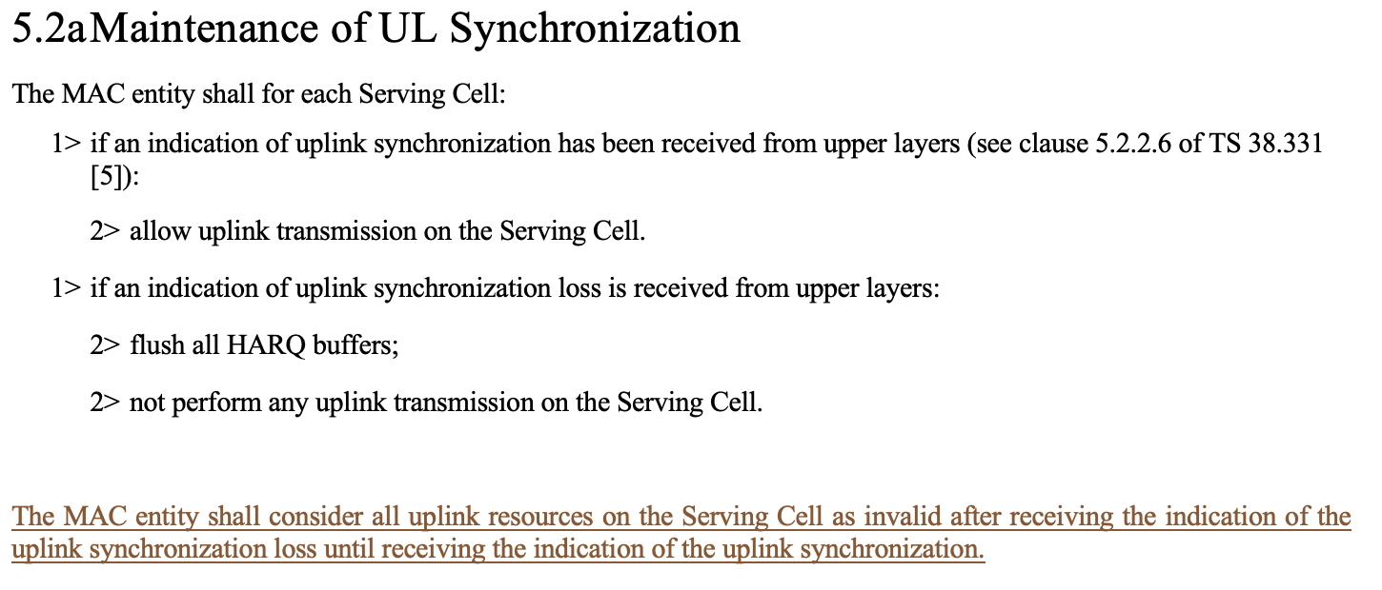

- Option 3: TP in R2-2303979 (i.e. clarify it in each procedural part)

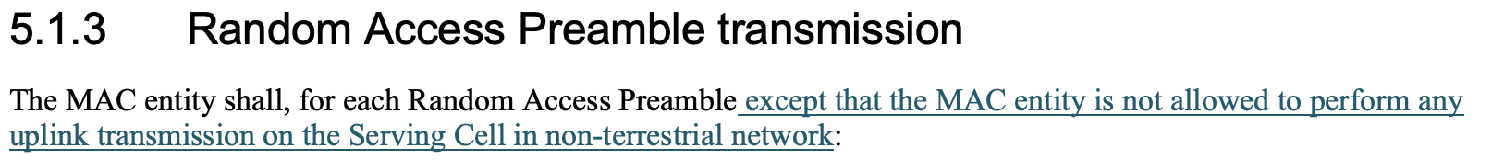
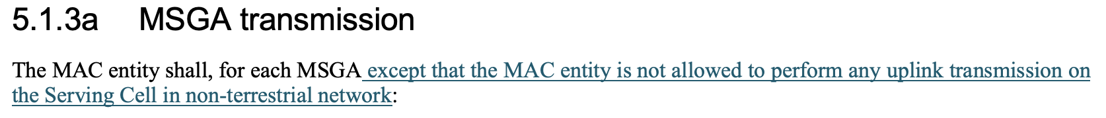

5.4.1 UL Grant reception
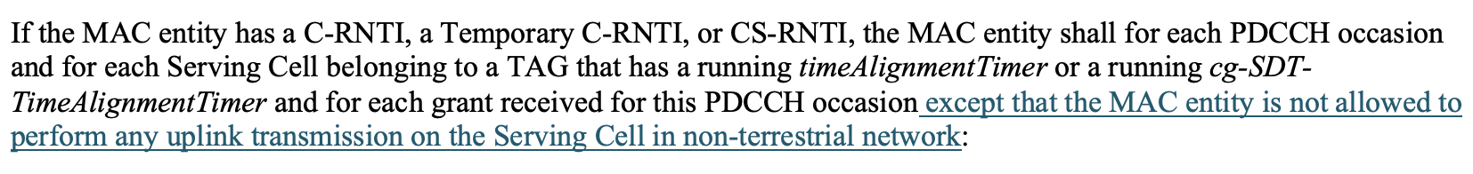

5.4.4 Scheduling Request

Company | Preferred Option | Comments
MediaTek | Option 1
Qualcomm | Option 1 see comments | Option 3 is also Ok but the text does not read very clear. Probably it should be like  Except when the UL synchronization is lost in NTN, the MAC entity shall, for each random access preamble:  But it seems option 1 requires less specification change, but still wording needs to be further checked as this can be procedural text.  We should also clarify then if there is new UL data arrival, should UE trigger BSR when UL synchronization is lost?

Question 2c: If your answer to Question 2 is NO, please describe your understanding on the UE MAC operation in the table.
Company | UE MAC operation upon validity timer expiry

Other

R2-2303820 - Clarification on HARQ feedback of the first SPS PDSCH after the activation
R2-2303820 Corrections to NR NTN for 38.321 CATT, Turkcell, Huawei, HiSilicon, Quectel, CAICT CR Rel-17 38.321 17.4.0 1597 - F NR_NTN_solutions-Core Late
Reason for change:
Current MAC spec description is not aligned with RRC description on harq-FeedbackEnablingforSPSactive, and UE may feed back ACK/NACK unnecessary for a dynamic HARQ process by mistake.
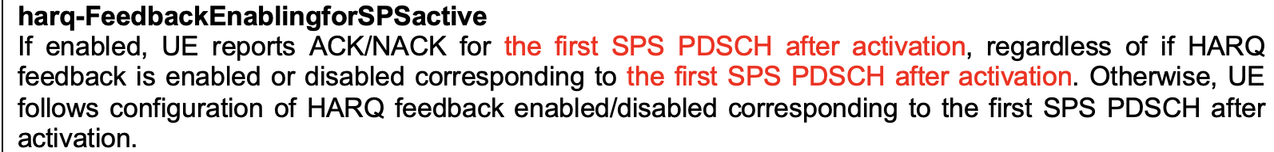
Summar of change:
In 5.3.2.2, adding a description that the first transmission after activation of the configured downlink assignment is the first transmission on the configured downlink assignment after activation of the configured downlink assignment.
MAC TP: (5.3.2.2 HARQ process)
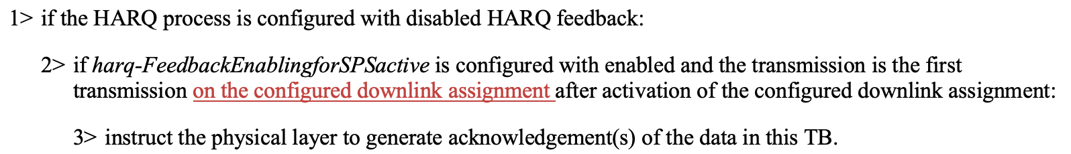

Question 3: Do you agree with the CR (R2-2303820)?
Company | Yes or No | Comments
MediaTek | Yes
Qualcomm | Yes

R2-2303833 - Correction for R17 NR NTN description of HARQ mode
R2-2303833 Correction for R17 NR NTN description of HARQ mode Ericsson CR Rel-17 38.321 17.4.0 1598 - F NR_NTN_solutions Late
Reason for change:
Currently the HARQ mode A and HARQ mode B are not described in RRC, stage 2 nor in MAC.
We think it would be benefical to have a description somewhere
Summar of change:
HARQ mode is added among the definitions in 3.1.
MAC TP: (3.1 Defitions)

Question 4: Do you agree with the CR (R2-2303833)?
Company | Yes or No | Comments
MediaTek | Yes
Qualcomm | No | After many rounds of reviews of running MAC CR, nobody raised there was any need to have such.  Simply because it is already clear when drx-RetransmissionTimerUL is started.

R2-2304000 - Restriction on the usage of the same HARQ
R2-2304000 Discussion on the restriction on the usage of the same HARQ mode to the configured grant LG Electronics Inc. discussion NR_NTN_solutions-Core
Proposals:
Observation 1. In the current specification, it seems that the configuration of the HARQ process IDs having the different HARQ modes to one configured grant is allowed.
Observation 2. In order to generate the MAC PDU containing the MAC SDUs associated with the same service, the HARQ process IDs associated with the same HARQ mode should be configured to a configured grant.
Observation 3. The configuration of two configured grant timers causes the backward compatibility issue.
Proposal. It should be restricted that the HARQ process IDs having the same HARQ mode should be configured to a configured grant.
RRC TP:

Question 5: Do you agree with the proposal?
Proposal. It should be restricted that the HARQ process IDs having the same HARQ mode should be configured to a configured grant.

Company | Yes or No | Comments
MediaTek | No | We don’t think this is needed. UE implementation can take care of this.
Qualcomm | Yes | We are ok to capture as our current understanding is network will do it.  See agreement of RAN2#116bis and following note in TS 38.300 v17.0.0.  NOTE: It is up to network implementation to ensure proper configuration of HARQ feedback (i.e. enabled or disabled) for HARQ processes used by an SPS configuration and of HARQ mode for HARQ processes used by a CG configuration.

Question 5a: Do you agree with the TP in R2-2304000?
Company | Yes or No | Comments
MediaTek | No | We don’t think this is needed. UE implementation can take care of this.
Qualcomm | Yes | Better to have same HARQ behavior in every CG occasion for the same LCH traffic using same CG configuration.

Conclusion
Based on the above discussion, we propose that:

