3GPP TSG-RAN WG2 Meeting #117 electronic R2-2203858
Electronic Meeting, Feb 21 –Mar 03, 2022

Agenda item: 7.3
Source: CMCC
Title: Report of phase 2 discussion for [AT117-e][306][NBIOT R16] Random access on multi-Carrier in NB-IoT (CMCC)
Document for: Discussion and Decision

Introduction
 [AT117-e][306][NBIOT R16] Random access on multiCarrier in NB-IoT (CMCC)
Scope: Discuss issues in R2-2202633 and CRs in R2-2202634 and R2-2202635. Discussion of whether correction is needed, and work on the CRs.
Intended outcome: Report in R2-2203573, and revised CRs (if needed – Tdocs can be allocated if necessary).
Phase 2 Deadline: Monday 28th February 1200 UTC.
Status: started

Contact list
Company and Name | Email

Discussion
Deployment scenario:
In contribution [1], Figure 1 shows a typical deployment scenario in NB-IoT real network. Single-carrier cells are deployed to meet coverage requirements for most scenarios, and multi-carriers cells are deployed for concurrent service scenarios to meet capacity expansion requirements. The anchor carriers are deployed with inter frequency to reduce interference among cells, and it’s generally that the non-anchor carriers in one cell are deployed on the same frequency as the anchor carrier in the neighbour cell.
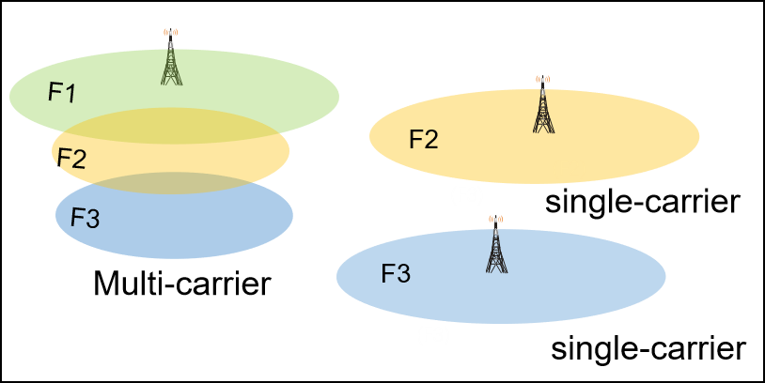
Figure 1 The deployment in the NB-IoT network
Issue description:
For the downlink, the downlink narrowband reference-signal EPRE (Energy Per Resource Element) of the non-anchor carriers is generally lower relative to the downlink narrowband reference-signal EPRE of the anchor carrier to reduce the interference between the non-anchor carrier and the neighbour cells cells using the same frequency. Due to lower EPRE of non-anchor carrier than EPRE of anchor carrier, shrunken coverage of non-anchor carrier may result to MSG2 failure if npdcch-NumRepetitions-RA-r14 is configured same for anchor carrier and non-anchor carrier.
For the uplink, the background noise is relatively strong in NB-IoT network, and the non-anchor carriers suffer more uplink interference due to the same frequency neighbor cell with uplink service terminals. This may degrade uplink performance, such as MSG 1 failure on the non-anchor carrier.
In the 116-e, RAN2 have confirmed the scenario is valid and the issue exists^{[2]} as follows:
- RAN2 confirm the following scenario is valid, for standalone deployment: EPRE of non-anchor carrier smaller than EPRE of anchor cell. Non-anchor carrier is deployed on the same frequency with anchor carrier of neighbouring cell.
- RAN2 confirm the following issue exists:
    - DL issue: Due to lower EPRE of non-anchor than EPRE of anchor cell, shrunken coverage of non-anchor carrier may results to MSG2 failure.
    - UL issue: Non-anchor carrier suffered more UL interference than anchor carrier for the same cell, due to intra-frequency interference from anchor carrier of neighbouring cell. This may degrade uplink performance, e.g., MSG 1 failure on non-anchor carrier.
- postponed
In the 117-e, RAN2 have discussed the solutions for the uplink interference on non-anchor carrier, and the solution proposed in [1] that introduce a new RSRP threshold list for each non-anchor carrier for random access to determine the UE’s CE level on non-anchor carrier needs to modify TS36.331, TS 36.321 and TS 36.306.
Q1: Do you agree with the draft 36.331CR?
Company | Yes/No for 36.331 CR | Comments

Q2: Do you agree with the draft 36.321CR?
Company | Yes/No for 36.321 CR | Comments

In the draft CR, an optional capability nonAnchorThresh-NPRACH-r16 is introduced. Companies are invited to share views whether it should be optional capability with or without capability signalling.
Q3: Whether the capability defined as optional capability with or without signaling? Do you agree with the draft 36.306CR?
Company | With or without signalling | Yes/No for 36.306 CR | Comments

Conclusions
TBD

Reference
- R2-2202633 Discussion on the issue for Random Access on multicarrier for NB-IoT CMCC discussion
- R2-2201970 Report of 3GPP TSG RAN WG2 meeting #116-e, Online ETSI MCC
[3] R2-2202634 Solution for random access issue on multiCarrier in NB-IoT CMCC draftCR Rel-16 36.331 16.7.0 F NB_IOTenh3-Core
[4] R2-2202635 Solution for random access issue on multiCarrier in NB-IoT CMCC draftCR Rel-16 36.321 16.6.0 F NB_IOTenh3-Core

