3GPP TSG-RAN WG2 Meeting #116-e R2-211xxxx
Electronic, 1st – 12th Nov, 2021

Agenda item: 8.7.1
Source: OPPO
Title: Summary of [621]
Document for: Discussion and decision

Introduction
This is for the discussion of the following:
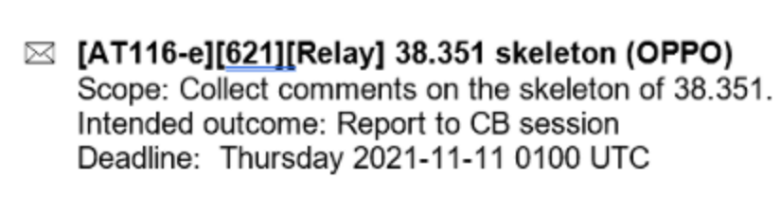
Company | Name | E-mail
Huawei, HiSilicon | Yulong Shi | shiyulong5@huawei.com
CATT | Hao Xu | xuhao@catt.cn
Ericsson | Wang Min | min.w.wang@ericsson.com

Phase-1 Discussion
Based on the submitted Skeleton,
R2-2109400 Running CR for TS 38.351 OPPO draft TS Rel-17 38.351 0.0.0 NR_SL_relay-Core

There is one issue being discussed online, i.e., the naming of TS.
Rapp understand the online output includes the following points:
- “Relay” needs to be included in the name
- “L(ayer)” does not needs to be included in the abbreviation
- Some companies claims that “Sidelink” is somehow mis-leading since the adaptation layer includes Uu hop as well
Rapp would like to suggest to do have a Q in this thread on the following two options which address all the concern(s) above
- Option-1: Relay Adaptation Protocol (RAP)
- Option-2: UE Relay adaption protocol (URAP)
Q0: Which name you prefer?
- Option-1: Relay Adaptation Protocol (RAP)
- Option-2: UE Relay adaption protocol (URAP)
- Option-3: Sidelink Relay Adaptation Protocol (SRAP)
- Others
Company | Option | Comment
Huawei, HiSilicon | Option-3 | If the common part among options is RAP, we can discuss the difference by using “UE” or “Sidelink” in front.  This spec will cover both U2N and U2U in the future. So, “UE relay” cause the confusion that this is only for UE to UE relay.  There seems no chance in near release (e.g. R18) to support relay based on other interface other than PC5/sidelink.  “Sidelink relay” is just perfect for U2N also even with Uu interface. Please note our SI/WI is called “NR Sidelink relay”, rather than “NR UE relay” or “NR relay”. There seem no reason to argue on the WI code.
CATT | Option-3 | Considering there will be different view for the scope of Relay (e.g. IAB is one kind of relay), we prefer Option-3.
OPPO | Option-1 or option-2 | We do not see it would be misleading that “This spec will cover both U2N and U2U in the future. So, “UE relay” cause the confusion that this is only for UE to UE relay.”, since it aims at UE-based relay, but not only for UE-2-UE relay..  We tend to see option-2 is a compromise way-out.
Ericsson | Option 3 | Option 3 is better, as Huawei commented, this name is generic to cover both U2N and U2U relay.

Q1: Besides naming issue in Q0, please share your additional comment on the skeleton in the following table.
Company | Comment
Huawei, HiSilicon | - Whether the data transmission should be split into DL and UL:  Considering we may support U2U relay in future release, where there is no UL and DL concept. No sure “5.2 DL Data transfer” and “5.3 UL Data transfer” have enough future compatibility.  Is the intention in the future to add “5.4 U2U data transfer”?  Another manner is to split as below without explicit UL and DL:  Transmitting operation of U2N Relay UE (incl UL and DL);  Receiving operation of U2N Relay UE(incl UL and DL);  Transmitting operation of U2N Remote UE(incl UL and DL);  Receiving operation of U2N Remote UE(incl UL and DL);  No strong view from our side, we can trust the judge of spec editor, as long as future addition of U2U relay is considered.  - Add “[SALP] structure” in 4.2, as also defined in PDCP. Or maybe the “4.2.1 General” is for the same purpose?
CATT | - Chapter 5.4 is missing. (Typo?)  - We wonder the intention of the last part “Agreement” . Will it be retained in the final version?
Ericsson | Better to have a chapter on channel mapping, same as in the BAP protocol.

Conclusion

Reference
- R2-2109400 Running CR for TS 38.351 OPPO draft TS Rel-17 38.351 0.0.0 NR_SL_relay-Core

