**3GPP TSG-RAN WG2 #112-e *Draft_R2-201xxxx***

**E-meeting, November 2020**

Agenda Item: 6.4.4

Source: OPPO

Title: Summary of [AT112-e][711][V2X] V2X UE capability (OPPO)

Document for: Discussion, Decision

# Introduction

This is for the discussion below

* [AT112-e][711][V2X] V2X UE capability (OPPO)

Discuss and update capability CRs (including R2-2008786, R2-2008787, R2-2008788, R2-2008789, R2-2008938, further RAN1 inputs, and merging the result of [AT112-e][710]). 38.331 CR in R2-2010943, 38.306 CR in R2-2010944, 36.331 CR in R2-2010945, 36.306 CR in R2-2010946, and discussion summary in R2-2010947 if needed. CR will be endorsed (for NR CRs) and agreed (for LTE CRs) by email. Deadline is 11:00am 11/13/2020 (UTC).

# Phase-1 Discussion

One issue is identified in R2-2008938, i.e., in TS 36.331 V16.2.0, the capability for mixed LTE-PC5 and NR-PC5 BC lists was not correctly defined, i.e., the dimension of band within a BC is missing.

To correct this error in TS 36.331, it suggests a BC change

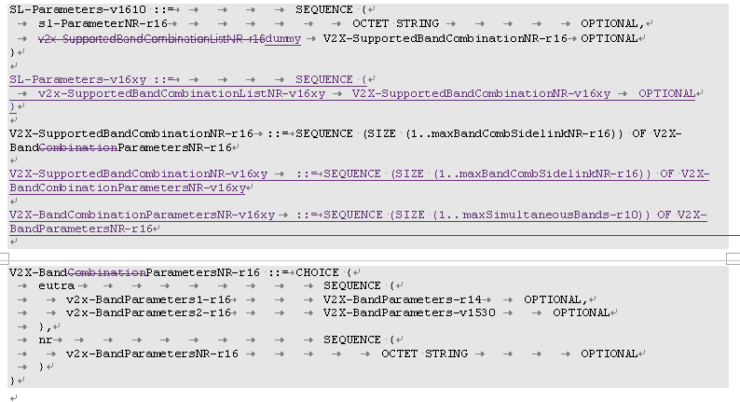

**Q1: Do you agree the change above to correct this error?**

* **Yes;**
* **No;**

|  |  |  |
| --- | --- | --- |
| Company | Yes/No | Comments |
|  |  |  |
|  |  |  |
|  |  |  |
|  |  |  |

1. xxx.

# Phase-2 Discussion

[To cover the issues from RAN1 input]

# Conclusion

We have the following proposals:

Proposal 1 xxx.

# Reference

1. R2-2008785 Summary of [POST111-e][708][V2X] Update of capability CRs (OPPO) OPPO report Rel-16 5G_V2X_NRSL-Core
2. R2-2008786 Draft 38.331 CR for V2X UE capability OPPO draftCR Rel-16 38.331 16.2.0 B 5G_V2X_NRSL-Core
3. R2-2008787 Draft 38.306 CR for V2X UE capability OPPO draftCR Rel-16 38.306 16.2.0 B 5G_V2X_NRSL-Core
4. R2-2008788 Draft 36.331 CR for V2X UE capability OPPO CR Rel-16 36.331 16.2.1 4449 - B 5G_V2X_NRSL-Core
5. R2-2008789 Draft 36.306 CR for V2X UE capability OPPO CR Rel-16 36.306 16.2.0 1786 - B 5G_V2X_NRSL-Core
6. R2-2008938 Correction on LTE V2X UE capability OPPO, Huawei, HiSilicon, Samsung discussion Rel-16 5G_V2X_NRSL-Core