**3GPP TSG-RAN WG2 Meeting #112-e *R2-20xxxxx***

**Electronic, 2nd – 13th Nov, 2020**

Agenda Item: 5.5

Source: Huawei, HiSilicon

Title: LPP transport without signaling access between LMF and ng-eNB

**Document for: Discussion**

# Introduction

During RAN2-112e, we have the following discussion on the stage2 description on the OTDOA Positioning support

R2-2010274 Correction on OTDOA Positioning support in R15 Huawei, HiSilicon CR Rel-16 38.305 16.2.0 0047 - F NR_newRAT-Core

* [AT112-e][613][POS] LPP transport without signalling access between LMF and ng-eNB (Huawei)

Scope: Clarify views on the CR in R2-2010274 and determine if it can be agreed.

Intended outcome: Agreed CR

Deadline: Tuesday 2020-11-10 1200 UTC

In this email discussion, we discuss the potential issue with this description and propose a way-forward for this.

# Discussion

In the current stage2 spec 38.305, in the chapter of OTDOA Positioning Support:

|  |
| --- |
| 5.3 NG-RAN Positioning Operations 5.3.1 General NG-RAN Positioning Operations  Separately from location service support for particular UEs, an LMF may interact with elements in the NG-RAN in order to obtain measurement information to help assist one or more position methods for all UEs.  5.3.2 OTDOA Positioning Support  An LMF can interact with any ng-eNB reachable from any of the AMFs with signalling access to the LMF in order to obtain location related information to support the OTDOA for E-UTRA positioning method, including PRS-based TBS for E-UTRA. The information can include timing information for the TP in relation to either absolute GNSS time or timing of other TPs and information about the supported cells and TPs including PRS schedule.  Signalling access between the LMF and ng-eNB may be via any AMF with signalling access to both the LMF and ng‑eNB. In the case of an ng-eNB with no signalling access to an AMF, signalling access between the LMF and ng‑eNB may be via any AMF with signalling access to both the LMF and a gNB with signalling access to the ng-eNB. |

The definition of ng-eNB has been given in the stage2 spec 38.300

|  |
| --- |
| **ng-eNB**: node providing E-UTRA user plane and control plane protocol terminations towards the UE, and connected via the NG interface to the 5GC. |

For connection of ng-eNB to 5GC, there can be 3 cases and their signalling connections (CP signallings) are summarized in the following:

* Case1: ng-eNB connected to the 5GC directly (Option5 as eLTE)
  + In this case, there is signalling access between ng-eNB and AMF
* Case2: ng-eNB serves as the MN in the MR-DC architecture (Option7 as NG-EN-DC)
  + In this case, there is signalling access between ng-eNB and AMF
* Case3: ng-eNB serves as the SN in the MR-DC architecture (Option4 as NE-DC)
  + In this case, there is no signalling access between ng-eNB and AMF

Hence, for the stage2 spec that says “when there is no signalling access between ng-eNB and AMF” we only need to consider about option4.

Then, NE-DC, the CP protocol stack can be found under 37.340.

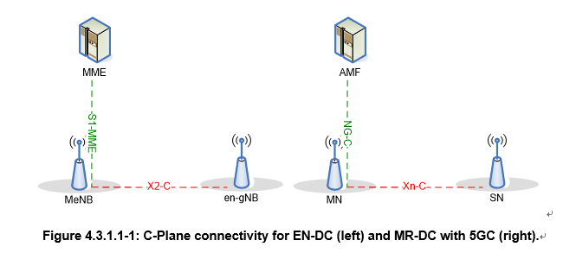

From the above figure, we can see that there is no direct CP connection between ng-eNB (SN) and AMF for architecture Option4 when ng-eNB has not signalling access to AMF. While the text says that there is no signlling between the ng-eNB and AMF, the LPP signaling for the support of OTDOA can only be via XN-AP. While in the current XnAP, there is no transport of LPP.

Based on the above analysis, we propose the following question

***Q1, Do company think that the sentence “In the case of an ng-eNB with no signalling access to an AMF, signalling access between the LMF and ng eNB may be via any AMF with signalling access to both the LMF and a gNB with signalling access to the ng-eNB.” should be removed?***

|  |  |  |
| --- | --- | --- |
| **Company** | **Yes/No** | **Comments** |
| Nokia | Yes | After checking 38.423, we confirm there is currently no support for NRPPa and LPP transport over Xn. LPP PDU is currently transported using NAS transport procedures between AMF and NG-RAN. So, we are fine to delete the quoted sentence. Also, if that sentence is deleted, then the whole paragraph in which that sentence appears can also be deleted. |
| Intel | Yes | We thought the whole section is to describe the NRPPa transmission instead of LPP. And therefore this paragraph should be also applied for NRPPa.  However, the paragraph is related to architecture that are not positioning specific and therefore it is not essential in 305 and would be good to be removed. |
| CATT | Yes | We think it can be removed by now. But once XnAP could support LPP transport in future, we can consider clarify it in stage 2. |

# Conclusions

TBD

# References

1. TS 38.305, Stage 2 functional specification of User Equipment (UE) positioning in NG-RAN , 3GPP