3GPP TSG-RAN WG2 Meeting #112 Electronic R2-200xxxx

**Elbonia, 02 – 13 November 2020**

**Agenda item: 6.7.4**

**Source: Nokia, Nokia Shanghai Bell**

**Title: [AT112-e][215][NR][MOB] Additional clarification to DAPS capabilities (Nokia)**

**Document for: Discussion and agreement**

1. Introduction

This is a summary of below offline discussion:

* [AT112-e][215][NR][MOB] Additional clarification to DAPS capabilities (Nokia)

Scope:

* + - Discuss additional clarifications for DAPS capabilities as per minutes and capture them in CRs

Intended outcome:

* + - Endorsable CRs for [R2-2010751](https://www.3gpp.org/ftp/TSG_RAN/WG2_RL2/TSGR2_112-e/Docs/R2-2010751.zip) (38.306) and [R2-2010752](https://www.3gpp.org/ftp/TSG_RAN/WG2_RL2/TSGR2_112-e/Docs/R2-2010752.zip) (38.331) based on agreements and above clarifications (if needed)

Deadline for providing comments and for rapporteur inputs:

* + - Initial deadline (for companies' feedback): 2nd week Thu, UTC 1000
    - Deadline for CR finalization: 2nd week Thu, UTC 1700
* [R2-2008827](https://www.3gpp.org/ftp/TSG_RAN/WG2_RL2/TSGR2_112-e/Docs/R2-2008827.zip) NR DAPS capability corrections Nokia, Nokia Shanghai Bell discussion NR_Mob_enh-Core
* ***Supplementary proposals for further discussion:***
* *Proposal 1a: Clarify that gNB can configure intra-frequency DAPS on each of the bands of a band combination with non-contiguous CA (assuming the intra-frequency DAPS capability is signalled)*
* *Proposal 3a: UE shall signal featureSetCombinationDAPS comprising of at least one FS where intra-frequency DAPS capability is signalled.*
* *Proposal 3b: Clarify that gNB shall not use featureSetCombinationDAPS for non-DAPS purpose.*
* *[Clarification to Proposal 4] Clarify that source and target gNB ensure that the per CC property signalled in featureSetCombinationDAPS is followed.*
* *Proposal 5a: Clarify if gNB is able to configure DAPS in the following scenario: The given band combination comprises of only two non-CA bands where intra-frequency DAPS capability is signalled for only one of the non-CA band(s).*
* *Proposal 5b: Clarify that UE shall not report intra-frequency DAPS capability when intra-freq DAPS UE capability is indicated in a band combination comprising of a non-CA single band entry.*
* *[Clarification to Proposal 6] Clarify that source and target gNB are free to choose the component carrier only based on the capability of the component carriers signalled in the given band combination.*
* *[Clarification to Proposal 7] Clarify that source and target gNB ensure that the per CC property signalled in featureSetCombinationDAPS is followed.*
* *Proposal 11: In Rel-16 no further enhancements are required to signal inter-frequency capabilities per component carrier combination within a given band combination.*

2. Discussion on Supplementary proposals

## 2.1 Intra-frequency DAPS capabilities

For the intra-frequency DAPS case the following apply:

* Target selects same frequency as source cell (same CC bandwidth)
* Target selects same frequency as source cell (diff CC bandwidth)

For each case the additional combinations are due to:

* Base capability is intraFreqDAPS-r16
  + For DL: intraFreqAsyncDAPS-r16, intraFreqDiffSCS-DAPS-r16
  + For UL: intraFreqDynamicPowersharingDAPS-r16, intraFreqMultiUL-TransmissionDAPS-r16, intraFreqSemiStaticPowerSharingDAPS-Mode1-r16, intraFreqSemiStaticPowerSharingDAPS-Mode2-r16, intraFreqTwoTAGs-DAPS-r16

For all the scenarios above recommendation is to have per band capability to capture the above requirements. Intra-frequency capability by definition would be “same band” case.

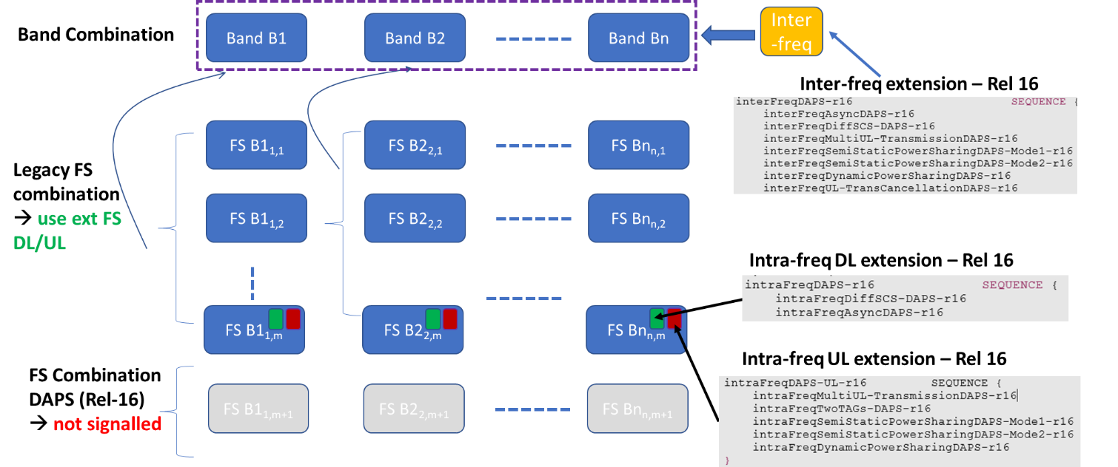

**Figure 3.1-1: Alternative way of signalling DAPS capabilities without signalling featureSetCombinationDAPS**

Firstly, when comparing Figure 3-1 with 2-1, the main difference is that in Figure 3-1 the ***featureSetCombinationDAPS*** IE is not signalled. As the ASN.1 structure for FeatureSetDL/FeatureSetUL extends the intra-frequency DAPS capabilities the question immediately comes is if the UE is allowed to signal these capabilities in the legacy FeatureSetDL/FeatureSetUL and not signal ***featureSetCombinationDAPS*** IE at all. In that case, would intra-frequency DAPS be possible to be configured to the UE? Based on the RAN2 agreement it is agreed:

**RAN2 Agreement:** *“define a new featureSetCombinationDAPS to indicate DAPS UE capability, if this field is absent, current featureSetCombination can still be used for DAPS”*

**Question 1:** If the DAPS capabilities are included in both the legacy *featureSetCombination* and UE also *featureSetCombinationDAPS* is included, which interpretation is correct?

* **Option 1:** gNB can ignore *featureSetCombinationDAPS* and just configure intra-frequency DAPS based on legacy featureSetCombination (where the DAPS is indicated).
* **Option 2:** Since UE reports *featureSetCombinationDAPS*, then it means gNB must use it in DAPS HO.
* **Option 3:** gNB can configure DAPS based on either one i.e. legacy *featureSetCombination* OR *featureSetCombinationDAPS*
* **Option 4: wrong UE implementation;**

**Question 1: Clarify how gNB should behave if** **the intra-frequency DAPS capability is included to both the legacy featureSetCombination and also *featureSetCombinationDAPS*. Which interpretation is correct?**

|  |  |
| --- | --- |
| Company | Which interpretation is correct? |
| Intel | Option 4.  Based on following agreements, the UE shall not indicate intra Freq DAPS UE capability in legacy featureSetCombination. It is must be wrong UE implementation if the scenario mentioned in question 1 happens. And the network shall follow below agreements, i.e. ignore featureSetCombination.   8: UE only uses featureSetCombinationDAPS to indicate DAPS UE capability.   9: a FS with intra-freq DAPS UE capability can only be referred to by featureSetCombinationDAPS. |
| Ericsson | Agree with Intel. |
| Huawei, HiSilicon | Agree with Intel.  And our former agreement is just “**RAN2 Agreement:** *“define a new featureSetCombinationDAPS to indicate DAPS UE capability*”, the part “*if this field is absent, current featureSetCombination can still be used for DAPS*” was not agreed. |
| ZTE | Agree with Intel. |

**Question 2: Do companies agree or disagree that UE shall signal *featureSetCombinationDAPS* comprising of at least one FS where intra-frequency DAPS capability is signalled?**

|  |  |
| --- | --- |
| Company | Agree/Disagree |
| Intel | Disagree.  Should not that have been covered by agreement 3 as below? i.e. the UE may only support interFreq DAPS, and then the FS in ***featureSetCombinationDAPS*** may not contain DAPS related capability.   3: when referred to by featureSetCombinationDAPS, a FS with intra-freq DAPS UE capability applies to both intra-freq and inter-freq DAPS, and a FS without intra-freq DAPS UE capability is only applied to inter-freq DAPS. |
| Ericsson | Agree with Intel. |
| Huawei, HiSilicon | Agree with Intel. Intra and inter freq DAPS UE capabilities are independent, and it’s possible that only inter freq DAPS is supported in UE. |
| ZTE | Agree with Intel. |

**Question 3: Do companies agree that gNB shall not use *featureSetCombinationDAPS* for non-DAPS purpose?**

|  |  |
| --- | --- |
| Company | Agree/Disagree |
| Intel | Agree. The intention of featureSetCombinationDAPS is to enable the scenario that the UE only supports DAPS, but not support CA/DC.  Therefore the network shall not use it for other purpose. |
| Ericsson | Agree with Intel. |
| Huawei, HiSilicon | Agree, it is in line with “8: UE only uses featureSetCombinationDAPS to indicate DAPS UE capability”. |
| ZTE | Agree with Intel. |

Secondly, it was agreed for DAPS handover:

**RAN2 Agreement: “***supportedBandwidthDL and supportedBandwidthUL only indicate the supported DL and UL bandwidth of source cell or target cell if featuresetcombinationDAPS is included in a band combination, i.e. a fallback per CC bandwidth is not validated.”*

We understand based on the above agreement that the source and target need to use the exact CC property signalled by the UE in the *featureSetCombinationDAPS* just to align to the UE capabilities correctly*.*

**Question 4: Do companies agree that source and target gNB ensure that the per CC property signalled in *featureSetCombinationDAPS* is followed?**

|  |  |
| --- | --- |
| Company | Agree/Disagree |
| Intel | Agree. This is general principle, i.e. the network shall respect the UE capability. |
| Ericsson | We don’t see why the NW cannot configure a BW smaller than indicated by the max supported BW (in supportedBandwidthDL/supportedBandwidthUL).  We think this means that we "Disagree" to this question. |
| Huawei, HiSilicon | The following is NOT RAN2 agreement, and just a proposal not agreed in last meeting.  **“***supportedBandwidthDL and supportedBandwidthUL only indicate the supported DL and UL bandwidth of source cell or target cell if featuresetcombinationDAPS is included in a band combination, i.e. a fallback per CC bandwidth is not validated.”*  Our agreement is as below:  **7: regarding “support FSperCC bandwidth fallback”, for inter-freq DAPS, reuse CA methofology; for intra-freq DAPS, reuse single CC fallback mechanism.**  So NW can configure a BW smaller than indicated by the max supported BW. |
| ZTE | Agree with Ericsson and Huawei that the NW can configure a BW smaller than indicated by the max supported BW. |

Thirdly, on the number of component carrier capability that require to be signalled by the UE to ensure consistent DAPS configuration the following were agreed.

**RAN2 Agreement:** *“When intra-freq/inter-freq DAPS UE capability is indicated in a band combination comprising of a single band entry, the number of CCs in this band shall be at least two”.*

**Question 5: Do companies agree that UE shall not report intra-frequency DAPS capability when intra-freq DAPS UE capability is indicated in a band combination comprising of a non-CA single band entry?**

|  |  |
| --- | --- |
| Company | Agree/Disagree |
| Intel | Disagree.  The intention of featureSetCombinationDAPS is to enable the scenario that the UE only supports DAPS, but not support CA/DC.  Therefore, there is scenario that, the band cannot support 2CCs for CA, but support 2CCs for DAPS. This should be allowed. |
| Ericsson | Is the question intended to say:  **Question 5: Do companies agree that UE shall not report intra-frequency DAPS capability ~~when intra-freq DAPS UE capability is indicated~~ in a band combination comprising of a non-CA single band entry?**  We disagree to this. Certainly the UE can do intra-freq DAPS in this scenario (if indicated that it is supported). |
| Huawei, HiSilicon | Disagree. Same comments as Intel. |
| ZTE | Disagree. Same comments as Intel. |

**RAN2 Agreement:** “*for intra-freq DAPS, in a band with two or more than two CCs, the CCs in the band with UL can all be source or target cell”*

To understand the implication of the number of CC’s on the DAPS scenarios, a Figure 3-2 is shown below.

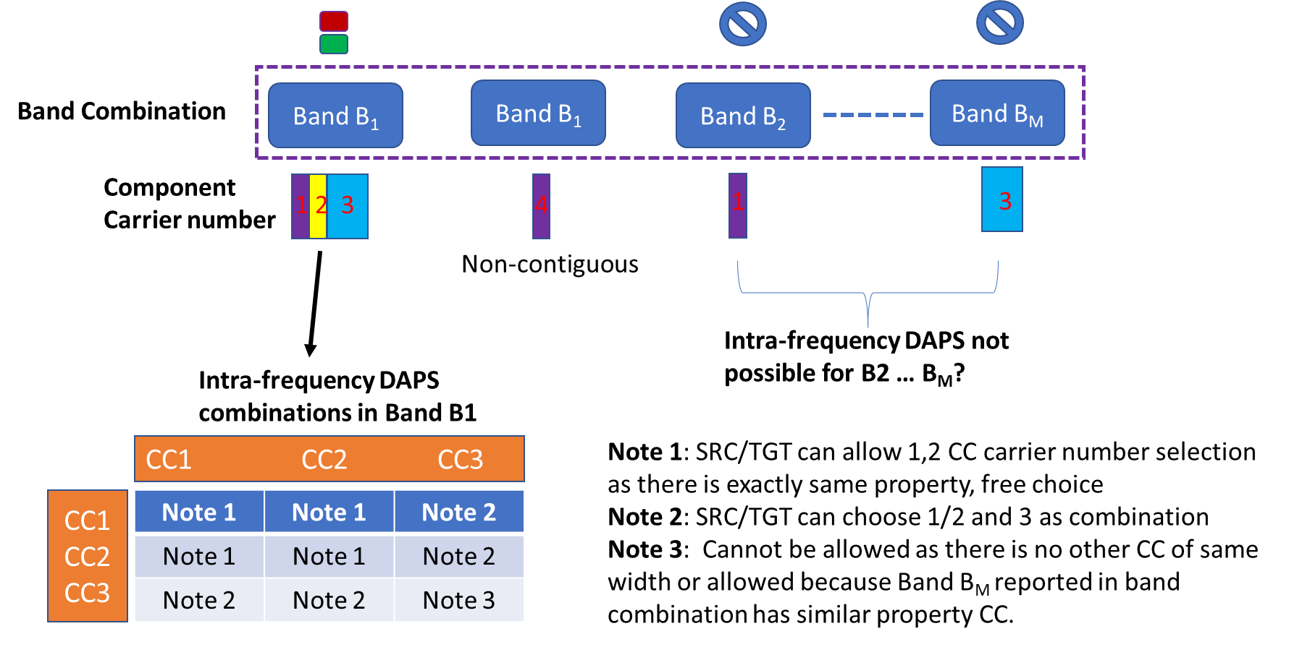

**Figure 3.1-2: Component carrier combinations for intra-frequency DAPS signalling**

Take an example of the band combination shown in Figure 3.1-2. It comprises of a band combination with Band 1, 2 up to BandM. In Band 1 there are three CC’s (1/2 with same property and 3 which is wider). Similarly, Band B1 has a non-contiguous CC number 4 followed by Band B2 and BandM with component carrier 1 and 3 respectively. A few questions remain in-spite of the agreements listed above which lead to the following proposals:

**Question 6: Do companies agree that gNB is able to configure intra-frequency DAPS in the following scenario: The given band combination comprises of only two non-CA bands where intra-frequency DAPS capability is signalled for only one of the non-CA band(s)?**

|  |  |
| --- | --- |
| Company | Agree/Disagree |
| Intel | The question is not clear. Do you want to say, is it allowed for the UE to indicate the support of DAPS based on featuresetCombinationDAPS (with 2CC) for non CA band? Then Yes.  Our understanding is, the support of DAPS is related to whether the UE indicates featuresetCombinationDAPS. It is unrelated to CA bandcombination. |
| Ericsson | If the UE indicates intra-freq DAPS for Band A but not for Band B, then the UE can do intra-freq DAPS within Band A, but **not** within Band B. We assume this to be common understanding. Unclear if the question is about this though. |
| Huawei, HiSilicon | Same comments as Intel. |
| ZTE | Same comments as Intel. |

**Question 7: Do companies agree that gNB can configure intra-frequency DAPS if there is are at least 2 CC’s across a given band combination comprising two or more unique bands?**

|  |  |
| --- | --- |
| Company | Agree/Disagree |
| Intel | See above.. |
| Ericsson | Yes, the network can configure DAPS in the above scenario, but there is no requirement that there must be "two or more unique bands" in the BC. It is perfectly fine to indicate intra-freq DAPS support with a single-band BC.  Why is it interesting to discuss multi-band BCs for **intra**-freq DAPS? |
| Huawei, HiSilicon | gNB can configure intra-freq DAPS when UE supports it in one band, not related to other bands in one BC. |
| ZTE | Some comments as Intel and Huawei. |

**Question 8: Do companies agree that gNB can configure intra-frequency DAPS on each of the bands of a band combination with non-contiguous CA (assuming the capability is signalled)?**

|  |  |
| --- | --- |
| Company | Agree/Disagree |
| Intel | See above. |
| Ericsson | See above. The UE supports intra-freq DAPS on a band if the UE includes intra-freq DAPS capabilities for the band. |
| Huawei, HiSilicon | See response to Q7 |
| ZTE | Some comments as Intel and Huawei. |

**Question 9: Do companies agree that the source and target gNB are free to choose the component carrier only based on the capability of the component carriers signalled in the given band combination?**

|  |  |
| --- | --- |
| Company | Agree/Disagree |
| Intel | Disagree, the source and target shall not configure the UE exceed the UE capability. Therefore source is free to choose. But there is limitation in target, i.e. the target can only select the rest of capability based on what source has selected. |
| Ericsson | What would the opposite mean? |
| Huawei, HiSilicon | We think based on UE capability is the normal way to determine target config. |
| ZTE | Some comments as Intel. |

## 2.2 Inter-frequency DAPS capabilities

The following Figure 3-4 describes inter-frequency DAPS scenarios:

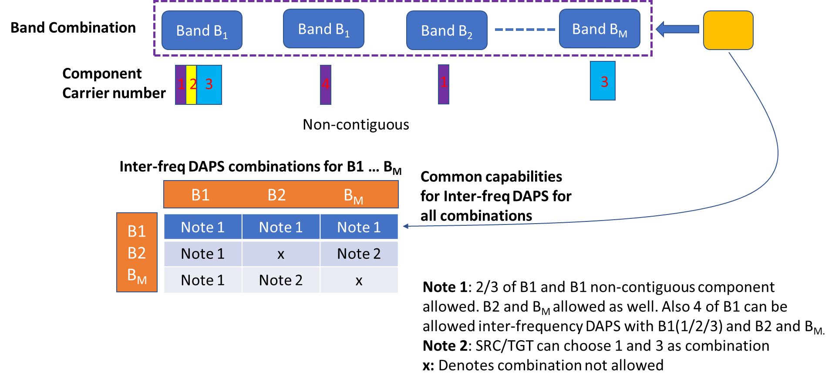

Figure 3.2-1: Scenarios for inter-frequency DAPS signalling

From Figure 3.2-1 it is clear that there are lots of possible combinations of CC’s selected between source and target for a given band combination. The inter-frequency capabilities seem to be common across each pair represented in the above table. This may increase potential test combinations but then we can restrict this to be the case for Rel-16 and not enhance further.

Question 10: Do companies agree that in Rel-16 no further enhancements are required to signal inter-frequency capabilities per component carrier combination within a given band combination?

|  |  |
| --- | --- |
| Company | Agree/Disagree |
| Intel | Agree no further enhancements are needed. |
| Ericsson | If the UE indicates inter-freq DAPS capability for a BC, the UE can do inter-freq DAPS between any carriers of the BC. |
| Huawei, HiSilicon | We don’t see requirement to enhance. |
| ZTE | Agree. |

Question 11: Do companies agree that gNB cannot configure inter-frequency DAPS for a non-CA single band entry in given band combination?

|  |  |
| --- | --- |
| Company | Agree/Disagree |
| Intel | Disagree. The network should configure the DAPS based on featureSetCombinationDAPS. We should decouple CA and DAPS, that is the reason we introduce featureSetCombinationDAPS, and the UE can only indicate DAPS capability based on featureSetCombinationDAPS instead of CA featureSetCombination. |
| Ericsson | "non-CA single band entry" means that the UE indicates support for only a single CC on a single band. Right?  If so: per definition one cannot do inter-freq HO since there is just a single CC to consider.  But maybe we have misunderstood the question. |
| Huawei, HiSilicon | If it is the single CC BC, of course it cannot support inter-freq DAPS. |
| ZTE | The inter-freq DAPS can not be configured within a non-CA single band entry. But it can be configured across multiple non-CA single band entries if the BC includes multiple such bands. |

# 3. Conclusion

# 4. Contact Information

|  |  |
| --- | --- |
| Company | Email |
| Intel | Yi.guo@intel.com |
| Ericsson | Mattias.a.bergstrom@ericsson.com |
| Huawei, HiSilicon | tangxun@huawei.com |
| ZTE | zhang.mengjie@zte.com.cn |
|  |  |
|  |  |

# 5. Annex

In a nutshell, the overall principle of DAPS capability for intra-frequency and inter-frequency DAPS scenarios may be summarized by the following Figure 5-1.

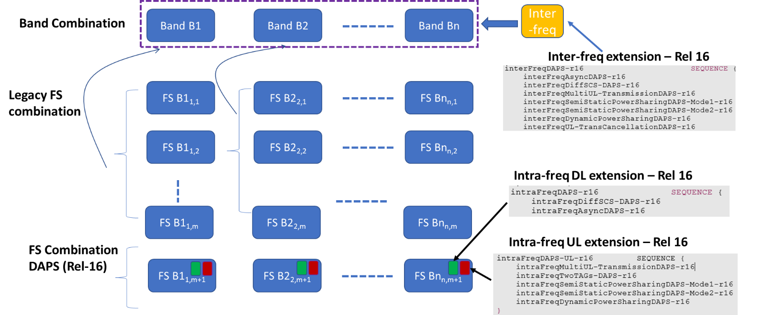

**Figure 5-1: Illustrating the DAPS capability signalling framework agreed in R2#111e**

As per the latest CRs, the intra-frequency and inter-frequency DAPS capabilities are illustrated by Figure 2-1. As can be seen:

* **Intra-frequency DAPS** capability is per band (granularity at Feature Set level) corresponding to a Rel-16 extension in each of DL/UL direction
* **Inter-frequency DAPS** capability is per band combination