3GPP TSG-RAN WG2 Meeting #112E R2-2010768

Electronic, 2 – 13 November 2020
Agenda item: 8.10.3.3
Source: CATT
Title: Report of [Post112-e] [106] [NTN] SMTC and Gaps (CATT)
Document for: Discussion & Decision

Introduction
The UE measurement issue caused by propagation delay difference between satellites is still controversial based on the NTN online discussion in the first week of RAN2#112-e meeting. To understand the issue better, the following offline discussion is reserved to discuss further:
- [AT112-e][106][NTN] SMTC and gaps (CATT)
Scope: Discuss p6 and p7 in R2-2008834 and proposals in R2-2009456
Intended outcome: summary of the offline discussion with e.g.:
    - List of proposals for agreement (if any)
    - List of proposals that require online discussions
Initial deadline (for companies' feedback): Monday 2020-11-09 17:00 UTC
Initial deadline (for rapporteur's summary in R2-2010768): Tuesday 2020-11-10 01:00 UTC
Proposals marked "for agreement" in R2-2010768 not challenged until Tuesday 2020-11-10 12:00 UTC will be declared as agreed by the session chair. For the rest the discussion will continue online.

We’d like to organize the offline discussion into two phases as follows:
Phase1: Companies are invited to give comments on the reserved questions before the deadline and the deadline for phase1 is Monday 2020-11-09 17:00 UTC. After the deadline of phase1, the rapporteur will give the summary very soon and trigger Phase2 discussion with proposals.
Phase2: Companies are encourage to comments on the proposals in the summary before Tuesday 2020-11-10 12:00 UTC.

Note1: All the proposals listed in the summary will be categorized into two types:
Type1: proposal for agreement, e.g. reach consensus by the majority.
Type2: proposal needs further discussion.
Note2: Proposals marked "for agreement" in R2-2010768 not challenged until Tuesday 2020-11-10 12:00 UTC will be declared as agreed by the session chair. For the rest the discussion will continue online.

Discussion

2.1 Background on the issue caused by propagation delay difference between satellites
The situation on propagation delay difference in NTN system is quite different than that in TN system. To simplify the analysis, the issue is illustrated in Figure 2.1:
Figure 2.1 Two different wireless links for transparent payloads scenario (C2) in NTN system
In Figure 2.1, G represents the location of NTN gateway and the location of satellites is marked by S1 and S2, while U represents the location of UE. Assume UE is in the coverage overlapping area between satellite S1 and satellite S2, the current serving satellite is S1. Due to the moving of satellite, UE should do measurement of the neighbour cell to control its mobility, e.g. cell reselection or HO. L_{US1G} represents the length of wireless link 1 which consists of service link L_{US1} and feeder link L_{S1G}, while L_{US2G} represents the length of wireless link 2 which consists of service link L_{US2} and feeder link L_{S2G}.
The length difference between L_{US1G} and L_{US2G} may be quite large, e.g. about 0~serval hundreds of kilometres for LEO and 0~serval thousands of kilometres for GEO.
For UEs in connected mode, even if the SMTC configurations of the neighbour cells generated by satellite S2 are configured to UE, UE may still miss the SSB/CSI-RS measurement window as the measurement gap configuration doesn’t consider the time difference between t_{US1G} and t_{US2G} based on current spec in TN system. To simplify the analysis, we give the timing relationship from gateway side and UE side simultaneously to directly reflect the issue:
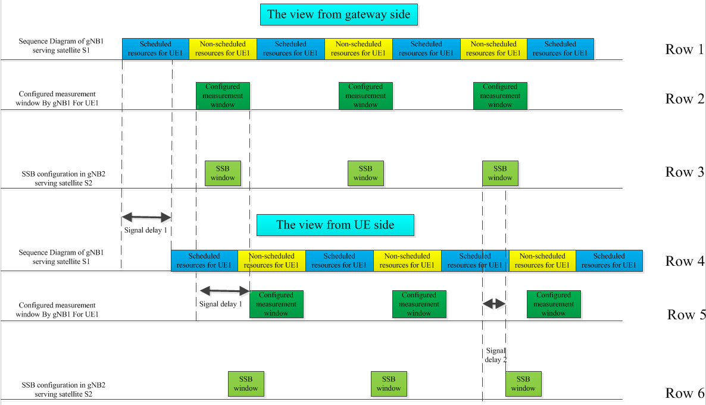
Figure 2.2 Timing from gNB1 side and UE side
In Figure 2.2, signal delay 1 is t_{US1G} and signal delay 2 is t_{US2G}. From the view of gNB1, UE can measure the whole SSB window of gNB2 within the measurement window configured by gNB1. But from the view of UE, due to the time difference between delay 1 and delay 2, the SSB window of gNB2 can’t be wholly covered by the measurement window configured by gNB1, which means the UE may miss the reference signal of gNB2 even if using the whole measurement window configured by gNB1.
More addition, the propagation delay difference between satellites is changing along with the moving of satellites.

2.2 Questions for comments
Based on the analysis in sub-clause 2.1, we believe that people now may have a primary impression for this measurement issue. Before we go to discuss any potential solution, we’d like to invite companies to clarify some question first. As DC scenario is not in the scope of NTN R17WID, all the following questions only focus on SA scenario.
In TN system, both SMTC and gap configuration is based on the timing of PCell. For SMTC configuration, it indicates UE when they can find the SSB burst of a specific MO/frequency; while for measurement gap configuration, once received, the connected mode UE as well as the network will have a consistent understanding of the UE scheduling timing on when to suspend/start the data transmission/reception.
Q1) Do you think both SMTC and gap configuration in NTN system should be generated based on the timing of PCell, just like the way we do in TN system?
Company | Yes/No | Comments (if any)

In TN system, the typical cell radius is several hundred of meters, the time difference between serving and neighbour cell is usually less than 1us, compared to the length of SMTC (at least 1ms), the impact caused by propagation delay difference between serving and neighbour cell is quite small, the risk for UE to miss the SSB burst of neighbour cell is quite small.
But for NTN system, the situation is totally different. As mentioned before, the propagation delay difference between serving and neighbour satellites may be quite large, e.g. about 0~serval millisecond for LEO, which is comparable with the length of SMTC window, sometimes even larger. Due to suffer from different delay between SMTC window configured via serving satellite and SSB burst of neighbour satellite, a big timing gap will be perceived from UE side.
Q2) Do you agree that a non-negligible timing gap will be perceived from UE side due to the different propagation delay between SMTC window configured via serving satellite and the corresponding SSB burst window generated by neighbour satellite if no enhancement is done for SMTC configuration in NTN system and this timing gap may cause UE missing to detect SSB burst signal generated by neighbour satellite within the corresponding SMTC window configured via serving satellite?
Company | Yes/No | Comments (if any)

In normal case of TN system, the SSB burst signal generated by neighbour cell is always detectable within the corresponding SMTC window configured via serving cell. There is no need for the UE to measure SSB burst signal outside the corresponding configured SMTC window. But for NTN system, based on the analysis in Q2, the SSB burst signal generated by neighbour cell may be outside the corresponding SMTC window configured via serving satellite. If the UE has the capability to acquire the propagation delay difference between serving and neighbour satellites, UE still can know when to detect the real SSB burst signal generated by neighbour cell even if the SSB burst signal is outside the corresponding configured SMTC window. If RAN2 don’t want any enhancement for SMTC configuration for NTN, the UE should be allowed to search SSB burst signal generated by neighbour cell even outside the corresponding configured SMTC window.
If the answer in Q2 is ‘Yes’, please answer Q3; otherwise, ignore Q3.
Q3) Do you agree the following understanding from RAN2 perspective?
In NTN system, if the NTN capable UEs are allowed to search the SSB burst signal generated by neighbour satellite even outside the corresponding configured SMTC window, there is no need to enhance the SMTC configuration; otherwise, enhancement for SMTC configuration is still needed due to the propagation delay difference between serving and neighbour satellites.
Company | Yes/No | Comments (if any)

Q4) Do you agree to enhance the SMTC configuration for NTN system?
Company | Yes/No | Comments (if any)

If SMTC configuration enhancement is proved to be needed in NTN system, the following options can be considered [1][2]:
Option1: Extend the measurement window to cover all the possible SSB period in NTN, in which case the configuration of SMTC is not needed.
Option2: Reuse current signaling for SMTC configuration. It is up to UE to derive the real timing on UE side (e.g. take the transmission delay into account)
Option3: Extend the SMTC configuration based on the max propagation delay difference between serving and neighbour satellite to avoid UE missing the SSB burst of neighbour satellites.
Option4: NW provides SMTC configuration for each neighbour cell with different offset value, while taking different transmission delay into account.
Option5: NW provides a list of cells that need +/- offset to the SMTC configured by smtc1.
All the above options can be categorised into two types:
Type1: Network based solution, i.e. all except Option3;
Type2: UE based solution, i.e. Option3;
The propagation delay difference between serving and neighbour satellites is per UE subjected to UE location. For Network based solution, some solutions need network to know UE location.
Q5) Can RAN2 assume that the network will always have UE accurate location info for SMTC window configuration enhancement in NTN system?
Company | Yes/No | Comments (if any)

If the answer in Q4 is ‘Yes’, please answer Q6; otherwise, ignore Q6.
Q6) which option above is more desirable from RAN2 perspective and which option above is totally unacceptable from your side for SMTC window configuration enhancement?
Company | Preferred | Not acceptable | Comments

In TN system, measurement gap is used to measure intra/inter frequency when UE can’t do unicast data receiving and intra/inter frequency measurement at the same time. During the configured measurement gap, the network will not exchange data with UE, so UE can safely do intra/inter frequency measurement without missing data. So to avoid any un-synchronized behaviour between UE and the network, UE along with the network should have a consistent understanding of the measurement gap.
Q7) Do you agree that UE along with the network in NTN system should also have a consistent understanding of the measurement gap to avoid any un-synchronized behaviour between UE and the network, just like the way we have in TN?
Company | Yes/No | Comments (if any)

Q8) Do you agree to enhance the measurement gap configuration for NTN system?
Company | Yes/No | Comments (if any)

If measurement gap configuration enhancement is proved to be needed in NTN system, the following options can be considered [1][2]:
Option1:: Extend the length of the measurement gap to ensure that the length is larger than or equal to the SSB periodicity.
Option2:: Reuse the current signaling for measurement gap configuration (i.e. configure measurement gap per frequency), and the timing of measurement gap configured refer to the timing on satellites or on NTN GW. With the configured measurement gap, it is up to UE/NW to derive the measurement gap on UE side based on its location and the ephemeris of candidate satellites. Since the real timing of SMTC window on UE side for cells in other satellites will change from time to time based on the movement of satellites, the NW need to derive the real timing of measurement gap on UE side based the location of UE and the ephemeris of candidate satellites. Note: In this alternative, the measurement gap is maintained per satellite.
Option3:: Configure multiple measurement gaps per frequency and the timing of measurement gap configured refer to the timing of PCell on UE side.
Option4:: Extend the length of the measurement gap based on the max propagation delay difference between serving and neighbor satellite to avoid UE missing the SSB burst of neighbor satellites.
All the above options can be categorised into two types:
Type1: Network based solution, i.e. all except Option2;
Type2: UE based solution, i.e. Option2;
The propagation delay difference between serving and neighbour satellites is per UE subjected to UE location. For Network based solution, some solutions need network to know UE location.
Q9) Can RAN2 assume that the network will always have UE accurate location info for measurement gap configuration enhancement in NTN system?
Company | Yes/No | Comments (if any)

If the answer in Q8 is ‘Yes’, please answer Q10; otherwise, ignore Q10.
Q10) which option above is more desirable from RAN2 perspetive and which option above is totally unacceptable from your side for measurement gap configuration enhancement?
Company | Preferred | Not acceptable | Comments

Measurement feature is also tightly related to RAN4 requirement, if RAN2 agree to enhance measurement gap configuration enhancement and/or SMTC window configuration enhancement. RAN4 may be involved.
Q11) If RAN2 agree to enhance measurement gap configuration enhancement and/or SMTC window configuration enhancement, is there any need for RAN2 to ask RAN4 on RRM requirements in NTN considering SMTC and measurement miss-alignment issue due to large differential propagation delay?
Company | Yes/No | Comments (if any)

3Conclusion:

3.1List of agreeable proposals

3.2 List of proposals to be discussed

4 Reference
[1] R2-2008834 Open Issues for Measurements in NTN CATT discussion Rel-17 NR_NTN_solutions-Core
[2] R2-2009456 SMTC and measurement gap configuration Qualcomm Inc discussion Rel-17 NR_NTN_solutions-Core

