3GPP TSG RAN WG2 #110-e draft R2-20xxxxx
Electronic meeting, 1 – 12 Jun 2020
Source: Huawei, HiSilicon
Title: [draft] Summary for Offline [008][NR15] Mobility
Agenda Item: 5.4.1.1
Document for: Discussion and decision

Introduction
This document contains a list of TDocs covered in the following offline discussion:
- [AT110e][008][NR15] Mobility (Huawei)
Scope: Treat R2-2004768, R2-2004769, R2-2005270, R2-2005271, R2-2005703, R2-2005704, R2-2005636, R2-2005637 (proponents are responsible to explain and drive)
Part 1: Decision whether to make corrections or not, identify agreeable corrections. Deadline: June 4, 0700 UTC.
Part 2: For agreeable parts, continuation to agree CRs. Deadline: June 10, 0700 UTC

Companies are invited to share their views on each TDoc submitted.

Discussion

R2-2004768, R2-2004769
Regarding which issues that need resolution, it is suggested to use the reason for change as the input:

The current field description of ran-Area is incorrect since it is indicated that RAN area code(s) can be used alone it is indicated that the network uses only TA code(s) or RAN area code(s) to configure a UE.
According to 38.300 description and ASN.1 structure, the RAN area code(s) shall be configured together with TA code(s).
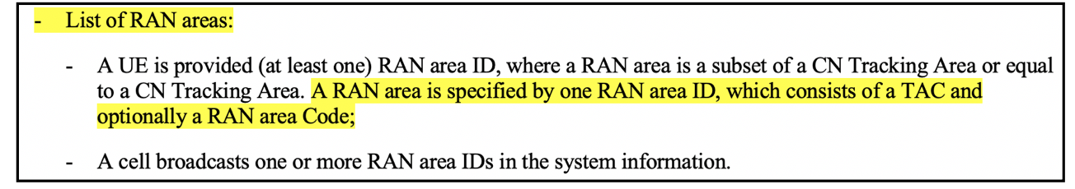

In R2-2004768, R2-2004769, it is proposed to correct the field description of ran-Area as below.
ran-Area
Indicates whether TA code(s) or RAN area code(s) are used for the RAN notification area. The network uses only TA code(s) or both TA code(s) and RAN area code(s) to configure a UE. The total number of TACs across all PLMNs does not exceed 16.

Q1.1: Do you agree with the reason for change?
Company | YES/NO | Comments

Q1.2: If your answer is Yes for Q1.1, do you agree with the changes?
Company | YES/NO | Comments

R2-2005270, R2-2005271
Q2: Do you agree with the changes?
Company | YES/NO | Comments

R2-2005703, R2-2005704
Problem statement:
Issue 1:
1> if the UE is configured with E-UTRA nr-SecondaryCellGroupConfig (UE in (NG)EN-DC):
2> if the RRCReconfiguration message was received via E-UTRA SRB1 as specified in TS 36.331 [10]:
3> submit the RRCReconfigurationComplete via E-UTRA embedded in E-UTRA RRC message RRCConnectionReconfigurationComplete as specified in TS 36.331 [10];
When performing HO from EN-DC to NR:
1) The UE is in EN-DC, so the yellow part applies;
2) UE receives MobilityFromEUTRACommand (which contains an RRCReconfiguration) via LTE SRB1, so the green part applies.
As a result, the blue part will be executed, that’s where the problem lies:
UE should send the RRCReconfigurationComplete directly to target NR node, instead of embedding it in an LTE message.
Issue 2:
1> else (RRCReconfiguration was received via SRB1):
2> submit the RRCReconfigurationComplete message via SRB1 to lower layers for transmission using the new configuration;
Since it is in 38.331, the SRB1 here refers to NR SRB1, therefore inter-RAT HO to NR is excluded, which is wrong.
Q3: Do you agree with the issues?
Company | YES/NO | Comments

Solutions to Issue 1:
Option A: Explain that UE should send the RRCReconfigurationComplete directly to the target NR node. (That’s the change provided in 2005703/2005704);
Option B: Prevent the UE from entering “1> if the UE is configured with E-UTRA nr-SecondaryCellGroupConfig (UE in (NG)EN-DC)” :
1> if the RRCReconfiguration message was not received within the E-UTRA MobilityFromEUTRACommand message, as specified in TS 36.331 [10]; and
1> if the UE is configured with E-UTRA nr-SecondaryCellGroupConfig (UE in (NG)EN-DC):

Q4: For Issue 1, which solution do you prefer?
Company | Option A/B | Comments

Solution to Issue 2:
1> else (RRCReconfiguration was received via SRB1 or within the MobilityFromEUTRACommand message):
Q5: For Issue 2, do you agree with the solution?
Company | YES/NO | Comments

R2-2005636, R2-2005637
Q6: Do you agree with the changes?
Company | YES/NO | Comments

Conclusion
To be added.

