3GPP TSG-RAN2 Meeting #109-e R2-20XXXXX

24 February – 6 March 2020
Agenda item: 6.7.3.2
Source: Samsung
Title: Report of [Offline-036][IIOT] Data Data and Data SR prioritization
Document for: Discussion & Decision

Introduction
This contributions reports results of the following offline discussion:
- [AT109e][036][IIOT] Data Data and Data SR prioritization (Samsung)
Scope: Treat summary on Data Data and Data SR prioritization.
Intended outcome: Resolve issues, Describe Open Issues accurately.
Deadline: Mar 3 1200 CET (conclusions on “easy agreements” by Feb 27 1200 CET)
During online web conference on Monday, RAN2 agreed to follows the Proposals 5 of a summary report [35], to narrow down the scope of this email discussion:
Candidates for immediate postpone, are contentious such that it is unlikely to converge at e-Meeting:
Proposal 5. Discuss the following issue by the email discussion after RAN2#109e:
5-1. Priority of MAC CE is considered for priority determination of uplink grant.
5-2. Priority of BSR can be changed dynamically, e.g. priority of BSR is determined by priority of data reported in the BSR.
5-3. Priorities of PHR, C-RNTI, Configured Grant Confirmation MAC CE can be changed dynamically.
5-4. The latency mapping restriction, maxPUSCH-Duration, is applicable to regular/periodic BSR.
5-5. Prioritization of uplink grants with same HARQ process ID should be defined.
5-6. SR triggered by high-priority LCH is not cancelled if MAC prioritizes PUSCH transmission for low-priority LCHs and BSR.
5-7. RAN2 will finalize the name lch-basedPrioritization after consideration of MAC CE priority (5-1) is concluded.
5-8. Priority of SR triggered by SCell BSR MAC CE or UL LBT failure MAC CE is higher than the PUSCH including data.
5-9. For uplink grant received in RAR or addressed to temporary C-RNTI, the prioritization should be based on the priority of the grants.
5-10. If the deprioritized MAC PDU contains a MAC CE, this MAC CE should be included in the prioritized MAC PDU.
This offline discussion is focusing on the remaining open issues: 1) confirmation of potential easy agreements and 2) check of companies’ view on relatively less controversial issue. For information, issue numbering is the same as the summary paper [35].

Discussion

2.1 Potential Easy Proposals

2.1.1 Issue #1: Confirmation of lch-basedPrioritization
Editor’s Note: The texts in this version of the running CR assume that lch-basedPrioritization, prioritization of resource conflict based on priority as a new feature of IIOT WI, is configurable for backward compatibility and separation from exisitng texts for UEs not supporting this feature. This feature requires a confirmation of RAN2. Thus, whether and how to configure it is FFS. This terminology may be changed after the discussion on MAC CE priority.
MAC running CR assumes lch-basedPrioritization and the Editor’s note above indicates that RAN2’s confirmation is required. This configuration parameter indicates the UE behaviour. For instance, if lch-basedPrioritization is configured, UE performs the Rel-16 prioritization, which is based on logical channel priority, i.e. intra-UE prioritization defined by IIOT WI. Otherwise, UE behaviour follows Rel-15 MAC specification. Two companies proposed to confirm it:
- Confirm: CATT [1], Samsung [27]
It was proposed by the initial version of the running CR (R2-1915338) and no objection has been shown so far. So we could agree easily.
Proposal 1. RAN2 confirms to introduce lch-basedPrioritization (configuration parameter of intra-UE prioritization based on LCH priority) in MAC running CR.
Q1) Do companies agree Proposal 1?
Company | Yes/No | Comments (if any)

2.1.2 Issue #2: Autonomous retransmission for uplink grant deprioritized by SR
In RAN2#108, RAN2 agreed autonomous retransmission for a deprioritized CG. LG [19] comments that current MAC running CR does not capture the autonomous retransmission of CG deprioritized by SR”. They would like to confirm it.
- In the same way as the handling of the MAC PDU from the de-prioritized configured uplink grant by dynamic grant or another configured uplink grant, the UE should be allowed to perform autonomous transmission for the MAC PDU in the de-prioritized configured uplink grant by the prioritized SR transmission: LG [19], CATT [1]
Proposal 2. RAN2 confirms that UE can perform autonomous transmission of the de-prioritized configured uplink grant by the prioritized SR transmission.
Q2) Do companies agree Proposal 2?
Company | Yes/No | Comments (if any)

2.2.3 Issue #3: An uplink grant addressed to CS-RNTI with NDI=1 (Retransmission) is a dynamic grant or configured grant?
It is not clearly defined that an uplink grant addressed to CS-RNTI is either configured grant and dynamic grant. The prioritization rule of configured grant is slightly different from that of dynamic grant, e.g. when both overlapping grants have the equal priority. Thus, RAN2 needs to define which prioritization rule will be used. In that sense, MAC running CR captures the following Editor’s Note:
Editor’s Note: It is FFS whether an uplink grant addressed to CS-RNTI with NDI=1 (i.e. retransmission of a configured grant) is a configured grant or not. In this version of running CR, it is assumed that an uplink grant addressed to CS-RNTI with NDI=1 is considered as a dynamic grant.
Based on contributions, all companies think it is a DG. The rapporteur think RAN2 can agree it via the offline discussion.
- Dynamic grant: CATT [1], Ericsson [11], Qualcomm [18], LG [20], ZTE [21], MediaTek [32], Huawei [33]
Proposal 3. An uplink grant addressed to CS-RNTI with NDI=1 (retransmission of CG) is a dynamic grant in prioritization.
Q3) Do companies agree Proposal 3?
Company | Yes/No | Comments (if any)

2.2 Open Issues Requiring Further Discussion or More Companies’ View

2.2.1 Issue #4: An uplink grant addressed to CS-RNTI with NDI=0 ((re-)Activation) is a dynamic grant or configured grant?
Editor’s Note: It is FFS whether an uplink grant addressed to CS-RNTI with NDI=0 (i.e. (re-)activation of type 2 CG) is a configured grant or not. In this version of running CR, it is not clearly captured.
For the first (re-)activated uplink grant for a Type 2 configured grant configuration (i.e. first type 2 CG), companies have a different understanding.
- Configured grant: CATT [1], Ericsson [11], LG [20], ZTE [21], Huawei [33]
- Dynamic grant: MediaTek [32]
- Do NOT specify. gNB will avoid the collision: Qualcomm [18]
Although the impact of each option could be different, each option does not have a critical blocking point. Thus, the rapporteur thinks it can be decided by majority view after an offline discussion.
Q4) Companies are invited to provide the preferred option:
- Option 1. UL grant addressed to CS-RNTI with NDI=0 is a CG.
- Option 2. UL grant addressed to CS-RNTI with NDI=0 is a DG.
- Option 3. We do not need to specify. gNB can avoid UL grant addressed to CS-RNTI with NDI=0 overlaps with other grant or SR transmission.
Company | Option | Comments (if any)

2.2.2 Issue #9: Sequential MAC PDU generation for the same PHY priority
In case of sequential MAC PDU generation for resource conflict between grants with the same PHY priority, it is possible that the second PDU has higher priority. The issue here is whether the second PDU is always transmitted and the first PDU can be pre-empted in PHY. PHY priority rule defined by RAN1 (running 38.214) does not allow the pre-emption for the first PDU whereas MAC priority rule does not consider it, i.e. the second PDU is always prioritized.
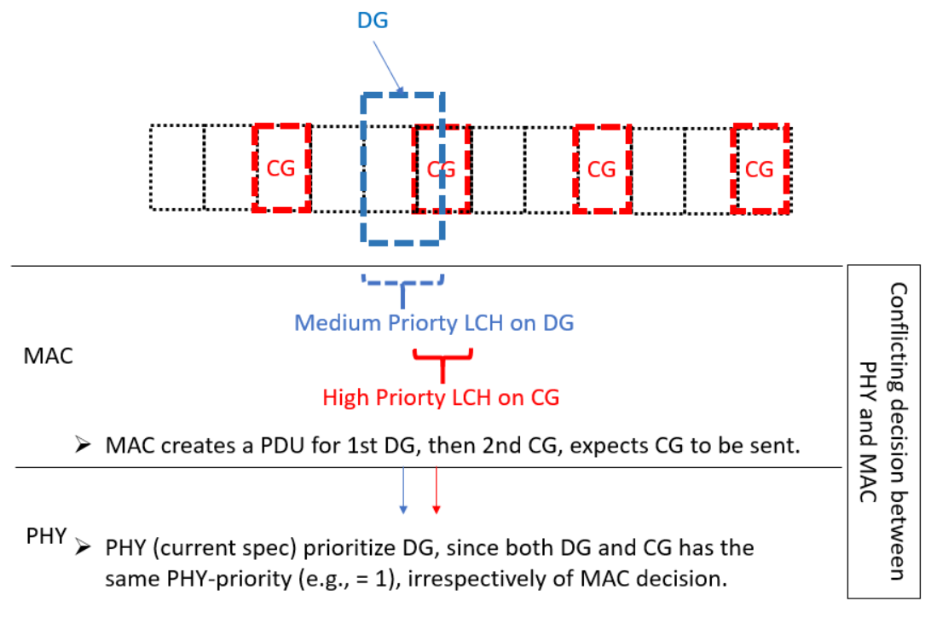
Figure 1. MAC & PHY conflicting prioritization decision with the same PHY-Priority of both CG and DG [9]
Referring to Figure 1 from Ericsson contribution [9], assuming both DG and CG have the equal physical layer priority, e.g. high-high or low-low. In this case, if CG becomes a prioritized uplink grant from MAC perspective after MAC already sent the MAC PDU for DG, PHY layer may need to pre-empt the ongoing transmission for DG. But the problem is that current PHY specification does not allow the pre-emption because both grants have the equal PHY priority.
Companies think RAN2 should discuss this issue how to resolve it .Views expressed by companies are as follows:
- For overlapping grants, when MAC generates two MAC PDUs, the second PDU has a higher priority from MAC point of view (LCH-based-priority), and thus shall be transmitted by PHY. MAC priority rule is the same regardless of PHY prioritization. But RAN1 spec change may be needed: Ericsson [9] , Nokia [12]
- Same as above with the additional restriction that an already assembled and delivered MAC PDU should not be de-prioritized in MAC by higher priority PDU or SR if the de-prioritized and prioritized UL transmissions both serve “low priority” traffic (base on RRC-configured priority threshold). MAC running CR does not assume nor specify this case. So, there may be some RAN2 impact.: CATT [3]
This issue requires more companies’ view. However, the decision may give an impact to RAN1 or MAC specification. So the rapporteur proposes to try to agree either way in this e-meeting.
CATT proposal is focusing on one case that both collided grants’ PHY priority is same as “low priority” whereas Ericsson and Nokia’s proposal covers general equal PHY priority case, i.e. high-high. The rapporteur would like to collect companies’ view one by one. Note that depending on collected companies view, RAN2 may need to send an LS to RAN1. Whether to send an LS could be discussed after the conclusion on Q4-1 and Q4-2 below.
Q5-1) Assuming 1) MAC generates two MAC PDUs i.e. the later generated PDU has higher priority from MAC perspective and 2) both MAC PDUs’ PHY priority is “low”, companies are invited to provide the preferred option and reason of your support:
- Option 1. The second PDU shall be transmitted by PHY.
- Option 2. Already assembled and delivered MAC PDU should not be de-prioritized. (Equivalently, the second PDU shall not be transmitted by PHY.)
- Option 3. Other
Company | Option | Comments (if any)
Q5-2) Assuming 1) MAC generates two MAC PDUs i.e. the later generated PDU has higher priority from MAC perspective and 2) both MAC PDUs’ PHY priority is “high”, companies are invited to provide the preferred option and reason of your support:
- Option 1. The second PDU shall be transmitted by PHY.
- Option 2. Already assembled and delivered MAC PDU should not be de-prioritized. (Equivalently, the second PDU shall not be transmitted by PHY.)
- Option 3. Other
Company | Option | Comments (if any)

2.2.3 Issue #10: SR Counter Update and Timer Start Condition
The current MAC specification and running CR assumes SR counter is incremented as soon as MAC instructs PHY to signal the SR. Many companies proposed to adjust the time point of SR counter update and SR prohibit timer starts to actual SR transmission. A potential problem is that the SR counter is incremented and prohibit timer is started even if a triggered SR is not actually transmitted. The proposals seems to align with NR-U for LBT case.
- Increase SR_COUNTER and start sr-ProhibitTimer only if the SR is transmitted: InterDigital [17], MediaTek [32], CATT, Qualcomm [34]
One example of text proposal [17] could be as follows:
2> when the MAC entity has an SR transmission occasion on the valid PUCCH resource for SR configured; and
2> if sr-ProhibitTimer is not running at the time of the SR transmission occasion; and
2> if the PUCCH resource for the SR transmission occasion does not overlap with a measurement gap; and
2> if the PUCCH resource for the SR transmission occasion does not overlap with a UL-SCH resource:
3> if SR_COUNTER < sr-TransMax:
4> increment SR_COUNTER by 1;
4> instruct the physical layer to signal the SR on one valid PUCCH resource for SR;
4> if the SR is not dropped at lower layers:
5> increment SR_COUNTER by 1;
54> start the sr-ProhibitTimer.
3> else:
All submitted contributions’ intentions [17][32][34] are the same. The detail stage-3 text can be discuss later. Anyway, the rapporteur thinks it may be not be so controversial. Thus, RAN2 may try to conclude this issue after an offline discussion to collect companies’ view.
Q6) Do companies agree the following proposal?
Proposal. Increase SR_COUNTER and start sr-ProhibitTimer only if the SR is transmitted.
Company | Yes/No | Comments (if any)

2.2.4 Issue #11: Priority of UL grant with configuredGrantTimer not running
Editor’s Note: Priority determination considering MAC CE and configuredGrantTimer is FFS.
Companies have a common understanding that this UL grant should not be considered in the prioritization, i.e. it should not be chosen as a prioritized uplink grant and excluded in the prioritization process:
- The configured grant with configuredGrantTimer running is not considered in the prioritization procedure: CATT [1], Ericsson [11], ZTE [21], Nokia [13], Huawei [33]
- No need to clarify the impact of configuredGrantTimer: Qualcomm [18]
- Grant priority should be based on configuredGrantTimer status: Asia Pacific Telecom [8]
- The configured grant with configuredGrantTimer running has the lowest priority value: Samsung [25].
Since companies have slightly different views only on how to capture in the spec, offline discussion is proposed.
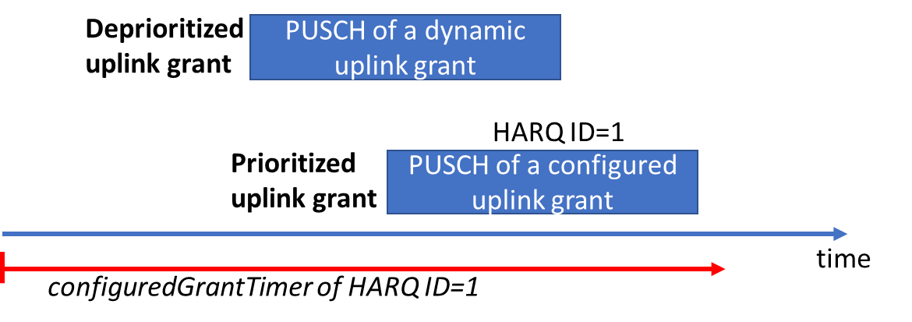
Figure 2. Problem of configuredGrantTimer [8]
This issue would like to cover the two assumptions [8]:
- A CG with configuredGrantTimer running cannot be a prioritized uplink grant.
- A CG with configuredGrantTimer running cannot deprioritize overlapping UL-SCH resources or SR transmission.
Q7-1) Do companies agree the assumptions A) and B) above?
Company | Yes/No | Comments (if any)
If companies agree the assumptions, we need to discuss how to capture in the spec.
Q7-2) Companies are invited to provide the preferred option:
- Option 1. Specify in the spec: The configured grant with configuredGrantTimer running is not considered in the prioritization.
- Option 2. Grant priority is determined by configuredGrantTimer status.
- Option 3. The CG whose configured grant timer has lowest priority value.
- Option 4. Other
Company | Option | Comments (if any)

2.2.5 Issue #12: Prioritization of SR and at least two uplink grant
Editor’s Note: It is FFS how UE handles the case that at least two uplink grants with different MAC PDUs overlap with an SR transmission.
In CA or case of more than 2 grants collided, deprioritization by other deprioritized resource may occur, which leads potential resource waste. This issue was triggered by vivo [4] during the email discussion on MAC running CR. The issue is that simultaneous PUCCH and PUSCH transmissions are not supported and one deprioritized resource (either SR or UL-SCH resource) could deprioritized other resource which can be used for transmission actually. In Figure 3 below, none of PUCCH and PUSCH is used for transmission because the PUCCH with medium priority is deprioritized by PUSCH of SCell and the PUSCH of PCell is deprioritized by the deprioritized PUCCH.
Figure 3. High priority PUSCH blocked both PUCCH and PUSCH on another cell [4]
Multiple companies think this issue should be discussed and propose how to resolve in the spec. Note that proposals may not be mutually exclusive and some of them are slightly different.
- The prioritization on Data-Data confliction (CG vs CG or DG vs CG) is applied on the same serving cell and the prioritization on SR-Data confliction (PUCCH and PUSCH) is applied on multiple serving cells: vivo [4]
- Only prioritized SR transmission is considered when the MAC entity determines the prioritized uplink grant: Samsung [24]
- UL resource (e.g. SR/grant) that has been de-prioritized, compared to a previous grant, is also de-prioritized compared to any other later grant. SR is triggered if SR priority is higher than any uplink grants overlapping with its PUCCH resource: Ericsson [11]
- Treat it as an error case or no change i.e. current running CR already covers the UE behaviour: SR vs PUSCH prioritization by comparing SR’s priority against each of the uplink grant’s priority: Qualcomm [18]
- Capture in the SR procedure the “deprioritized” status of uplink grant(s) deprioritized by an SR, i.e. If an SR is prioritized, the overlapping uplink grants (if any) becomes a de-prioritized uplink grant: CATT [1]
Q8-1) Do companies agree that this issue should be resolved?
Company | Yes/No | Comments (if any)
Q8-2) Companies are invited to provide the preferred option:
- Option 1. The prioritization on Data-Data confliction (CG vs CG or DG vs CG) is applied on the same serving cell and the prioritization on SR-Data confliction (PUCCH and PUSCH) is applied on multiple serving cells.
- Option 2. Only prioritized SR transmission is considered when the MAC entity determines the prioritized uplink grant.
- Option 3. UL resource (e.g. SR/grant) that has been de-prioritized, compared to a previous grant, is also de-prioritized compared to any other later grant.
- Option 4. No change. Treat as an error case.
- Option 5. Capture in the SR procedure the “deprioritized” status of uplink grant(s) deprioritized by an SR.
- Option 6. Other
Company | Option | Comments (if any)

2.2.6 Issue #17: Condition of priority value determination
For text update of MAC running CR, Samsung proposed to provide the condition of priority value determination.
- Provide condition when we use 1) is multiplexed and when we use 2) can be multiplexed in MAC PDU, taking into account LCH restrictions and data availability: Samsung [25]
The motivation of the paper is that condition of each condition is not clearly captured in the MAC running CR. One example of text proposal [25] could be (detail may be updated according to the further discussion):
For the MAC entity configured with priorityBasedPrioritization, the MAC entity shall:
1> if the uplink grant is a configured uplink grant and the configuredGrantTimer for the corresponding HARQ process is running; or
1> if the uplink grant is addressed to CS-RNTI and NDI is not toggled and the HARQ buffer of the identified process is empty; or
1> if the uplink grant is part of a bunle and not for the initial transmission and the HARQ buffer of the identified process is empty:
2> the priority value of the uplink grant is determined by the lowest priority value.
1> else if a MAC PDU has been obtained but not transmitted for the HARQ process; or
1> if the uplink grant is addressed to C-RNTI and CS-RNTI and NDI is not toggled and the HARQ buffer of the identified process is not empty; or
1> if the uplink grant is part of a bundle and not for the initial transmission and the HARQ buffer of the identified process is not empty:
2> the priority value of the uplink grant is determined by the highest priority of the logical channels that are multiplexed in the MAC in the HARQ buffer.
1> else:
2> the priority value of of the uplink grant is determined by the highest priority of logical channels with available data which can be multiplexed in the MAC PDU, considering the mapping restriction in clause 5.4.3.1.2.
RAN2 can conclude whether to add this detail by collecting companies’ view.
Q9) Do companies agree that providing the detail condition is useful?
Company | Yes/No | Comments (if any)

Conclusion
To be updated

References
[1] R2-2000115, Remaining issues for intra-UE multiplexing and prioritization, CATT
[2] R2-2000116, MAC CE priorities and LCP mapping restrictions, CATT
[3] R2-2000486, Avoiding unnecessary preemption among eMBB traffic, CATT
[4] R2-2000496, Intra-UE Prioritization with CA, vivo
[5] R2-2000497, Remaining issues for SR and PUSCH collision, vivo
[6] R2-2000701, Grant collision with the same HARQ process, OPPO
[7] R2-2000702, Discussion on SR cancelling on intra-UE prioritization involving SR, OPPO
[8] R2-2000722, Consideration of configured grant timer for Intra-UE prioritization, Asia Pacific Telecom co. Ltd
[9] R2-2000795, On PHY and MAC interaction to support intra-UE prioritization, Ericsson
[10] R2-2000796, Draft LS on PHY and MAC interaction to support intra-UE prioritization, Ericsson
[11] R2-2000797, Remaining details of intra-UE prioritization, Ericsson
[12] R2-2000814, Intra-UE Prioritization for conflicts with existing MAC PDU, Nokia, Nokia Shanghai Bell
[13] R2-2000815, Intra-UE Prioritization Considering MAC CEs and Configured Grant Timer, Nokia, Nokia Shanghai Bell
[14] R2-2001010, HARQ process collision between CG and DG, Huawei, HiSilicon
[15] R2-2001011, Prioritization issues for MAC CEs and PUSCH Huawei, HiSilicon
[16] R2-2001029, L1-priority applies for CG, Lenovo, Motorola Mobility
[17] R2-2001101, Handling of dropped SRs, InterDigital
[18] R2-2001289, Open issues in Intra-UE prioritization, Qualcomm Incorporated
[19] R2-2001431, The handling of de-prioritized CG due to SR transmission, LG Electronics Polska
[20] R2-2001434, CS-RNTI ambiguity in IIoT, LG Electronics Polska
[21] R2-2001457, Remainiing issues on intra-UE multiplexing, ZTE
[22] R2-2001458, Consideration on HARQ Conflict Between Configured Grant and Dynamic Grant, ZTE Corporation, Sanechips
[23] R2-2001459, Consideration on the multiplexing between BSR MAC CE and URLLC data, ZTE Corporation, Sanechips
[24] R2-2001492, UL-SCH Resource De-prioritization by Deprioritized SR, Samsung
[25] R2-2001494, Condition of Priority Value Determination, Samsung
[26] R2-2001495, Transmission of Deprioritized Data by Retransmission Grant, Samsung
[27] R2-2001496, lch-basedPrioritization and MAC CE Priority, Samsung
[28] R2-2001497, Prioritization of SR Transmission, Samsung
[29] R2-2001557, Priority determination considering MAC CE, LG Electronics Inc.
[30] R2-2001597, Additional prioritization for configured uplink grant, ASUSTeK
[31] R2-2001598, Handling UL grant prioritization with non-overlapping PUSCH duration, ASUSTeK
[32] R2-2000845, On UL intra-UE prioritisation, MediaTek Inc.
[33] R2-2001033, Remaining issues on Configured Grant, Huawei, HiSilicon
[34] R2-2000120, MAC upgrade for SR dropping in PHY, CATT, Qualcomm Inc.
[35] R2-2002083, Summary of Data-Data Prioritization and SR-Data Prioritization, Samsung

