3GPP TSG RAN WG1#116 R1-240xxxx
Athens, Greece, February 26th – March 1st, 2024
Agenda item: 8.11
Source: Moderator (Samsung)
Title: Summary of discussion on multiplexing HARQ-ACK in a PUSCH
Document for: Discussion and Decision

Introduction
This contribution aims to collect and summarize company views on the Rel-18 TEI issue of multiplexing HARQ-ACK in a PUSCH as discussed in [1] and [2].
Please consider entering the contact information below for better coordination for this discussion.
Company | Contact(s) | Email address(es)
Samsung (Moderator) | Sa Zhang | sa.zhang@samsung.com

Background
In RAN1#115 meeting, the following agreement was made.
Agreement
Update the previous agreement made RAN1#113 as following,
Agreement
If UCI multiplexing of different priorities is not enabled, the restriction on scheduling PDSCH after UL grant is removed for the case of PUSCH with repetitions except the first repetition
- UE generates Type-1 HARQ-ACK codebook according to the existing specification with the modification of setting the actual ‘ACK/NACK’ value corresponding to PDSCH(s) scheduled after the UL grant.
- UE generates Type-2/3 HARQ-ACK codebook according to the existing specification.
  - For Type-2 CB, UL DAI is used for generating HARQ CB.
- This feature is subject to separate UE capabilities for type-1, type-2, and type-3 codebooks.
- RRC parameter(s) to configure the function of scheduling PDSCH after a UL DCI format and multiplexing associated HARQ on a PUSCH repetition except the first repetition are introduced in Rel-18.
- Note: the number of PUSCH repetitions can be scheduled/configured by gNB.
- Note: same principle of current specification which UL DAI in UL grant is applied to each PUSCH repetition is reused.
- The timeline specified in TS 38.213 Clause 9.2.3 and 9.2.5 are satisfied, i.e. $T_{proc,1}^{mux}$between the last PDSCH and PUCCH, $T_{proc,2}^{mux}$ between the last PDCCH among UL grant /DL grant(s) and the earliest PUCCH or PUSCH.
- Additional UE capabilities are introduced to support the following functions (UE will be configured by gNB to use the following features via RRC)
  - HARQ-ACK codebook size change on a PUCCH slot
  - PUCCH time domain resource change on a PUCCH slot
  - The above feature cannot be simultaneously enabled with PUCCH carrier switching.

In [1] and [2] Samsung and Ericsson discuss the remaining issues on scheduling a PDSCH after UL grant.

Discussion

Issue#1: Conditions for keeping the legacy restriction.
In [1], Ericsson discusses the conditions for keeping the legacy restriction, copied below.

Issue#1
Reason for change:
According to the agreement, the restriction on scheduling PDSCH after UL grant holds if UCI multiplexing of different priorities is enabled and the UCI is multiplexed in a PUSCH without repetition or in a first repetition of a PUSCH. In this case, it is irrelevant whether the UE is provided or not with any of enable-Type1-HARQ-ACK-mux-forDLassignmentafterULgrant, or enable-Type2-HARQ-ACK-mux-forDLassignmentafterULgrant, or enable-Type3-HARQ-ACK-mux-forDLassignmentafterULgrant.
Regardless of presence or absence of these parameters, the restriction on scheduling PDSCH after UL grant for the first PUSCH or the PUSCH without repetition still remains. Therefore, additional condition on configuration of these parameters is unnecessary and may cause unnecessary implementation.
Summary of change:
In description of the restriction on scheduling PDSCH after UL grant holds if UCI multiplexing of different priorities is enabled and the UCI is multiplexed in a PUSCH without repetition or in a first repetition of a PUSCH, remove the following condition in [1]:
- is provided enable-Type1-HARQ-ACK-mux-forDLassignmentafterULgrant, or enable-Type2-HARQ-ACK-mux-forDLassignmentafterULgrant, or enable-Type3-HARQ-ACK-mux-forDLassignmentafterULgrant, and
Consequences if not approved:
Unnessary condiitons risking unnessary implemention

Ericsson proposes the following TP highlighted in yellow to resolve the above issue,
If a UE
- is not provided any of enable-Type1-HARQ-ACK-mux-forDLassignmentafterULgrant, or enable-Type2-HARQ-ACK-mux-forDLassignmentafterULgrant, or enable-Type3-HARQ-ACK-mux-forDLassignmentafterULgrant, or
- is provided uci-MuxWithDiffPrio, or
- transmits a PUSCH without repetitions or transmits a first repetition of a PUSCH transmission
the UE does not expect to detect a first DCI format scheduling a PDSCH reception and indicating a resource for a PUCCH transmission with corresponding HARQ-ACK information that would be included in a HARQ-ACK codebook in a slot if the UE
- previously detects a second DCI format scheduling the PUSCH transmission in the slot, and
- multiplexes the HARQ-ACK codebook in the PUSCH transmission in the slot.

From moderator’s understanding, the correction seems not essential and the original text is correct, i.e., if a UE is not provided any of enable-Type1-HARQ-ACK-mux-forDLassignmentafterULgrant, or enable-Type2-HARQ-ACK-mux-forDLassignmentafterULgrant, or enable-Type3-HARQ-ACK-mux-forDLassignmentafterULgrant, the legacy restriction applies.
Q1: Do you agree with the change highlighted in yellow proposed by Ericsson for this issue?
Company | View

Issue#2 No HARQ-ACK bit before UL grant
In [1], Ericsson discusses the case where there is no HARQ-ACK bit before the UL grant when a UE supports any of FG 55-4a, 55-4b and 55-4c, copied below.

Issue#2
Reason for change:
According to the agreement, when the restriction on scheduling PDSCH after UL grant is removed, a UCI including a HARQ-ACK of a PDSCH(s) scheduled by a DCI format(s) after UL grant can be multiplexed in a PUSCH repetition except the first repetition PUSCH. The agreement imposes additional conditions on a same HARQ-ACK codebook size and same time allocation of PUCCH resource in a slot for the case when the UCI additionally includes HARQ-ACK corresponding to PDSCH(s) scheduled by DCI format(s) before the UL grant (See Case 1 in Figure 1 below that is supported by CR). However, the agreement for removing scheduling restriction after UL grant, does not exclude the case when the UCI only includes HARQ-ACK corresponding to PDSCH(s) scheduled by DCI(s) after the UL grant. The current endorsed CR excludes the case when the UCI only includes HARQ-ACK corresponding to PDSCH(s) scheduled by DCI(s) after the UL grant (See Case 2 in Figure 1 below that is not supported by CR).
The consequence is the following conditions on scheduling for the gNB to utilize the scheduling relaxation by the TEI:
- The gNB has to schedule PDSCH before UL grant with a corresponding PUCCH overlapping with a PUSCH repetition except first repetition; AND
- The PDSCH scheduled after UL grant can only have corresponding PUCCH overlapping with that PUSCH repetition, and not other PUSCH repetitions except.
Clearly, these conditions not only impose additional scheduling restrictions and consequently diminish the usefulness of the feature, but also in contrary with the agreement and the intended functionalities.

Summary of change:
Clarify that when the scheduling restriction is removed, the conditions on the same codebook size and same time allocation of PUCCH resource carrying the HARQ-ACK codebook is only applicable when the HARQ-ACK codebook to be multiplexed in a PUSCH (except the first repetition) includes HARQ-ACK information corresponding to PDSCHs scheduled by a DCI before the uplink grant. Update the description to allow scheduling PDSCHs with a DCI after UL grant when the corresponding HARQ-ACK codebook to be multiplexed in a PUSCH (except the first repetition) does not include a HARQ-ACK corresponding to a PDSCH scheduled by a DCI before the UL grant.
Consequences if not approved:
Incomplete implementation of the agreement and excluding the most practical and useful cases for scheudling PDSCHs after UL grant.

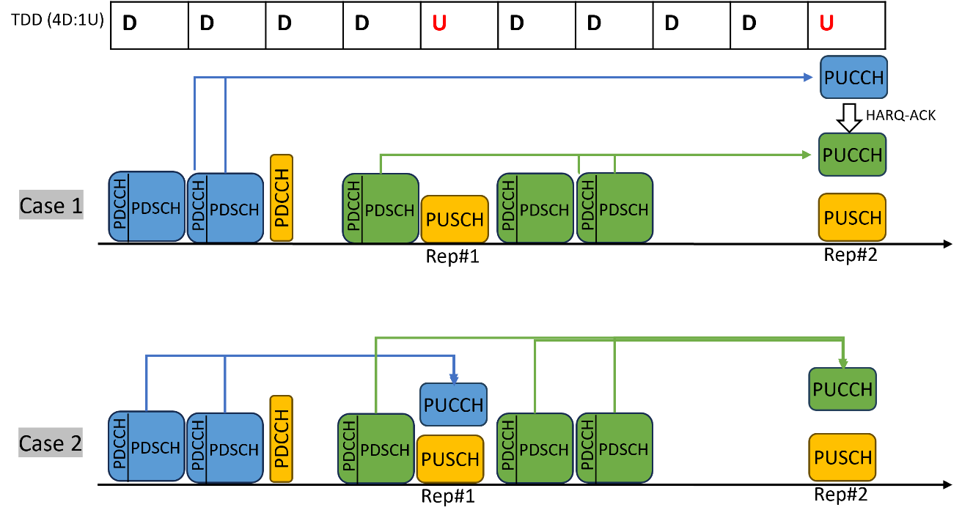
Figure 1: The agreement in TEI supports both Case 1 and Case 2 above. However, the endorsed CR supports only Case 1 and excludes Case 2. The additional restriction on codebook size and PUCCH resource is applicable only to Case 1.

Please note that resolving Issue#2 is critical from our perspective, and it also requires updating the corresponding UE capabilities, FG 55-4a/b/c in [2] accordingly. Please find the related capability discussions in our companion contribution [3].
- Resolving Issue#2 is critical from our perspective, and it also requires updating the corresponding UE capabilities, FG 55-4a/b/c accordingly.

Ericsson proposes the following TP highlighted in cyan to resolve the above issue,
If a UE
- is provided enable-Type1-HARQ-ACK-mux-forDLassignmentafterULgrant, or enable-Type2-HARQ-ACK-mux-forDLassignmentafterULgrant, or enable-Type3-HARQ-ACK-mux-forDLassignmentafterULgrant, and
- is not provided uci-MuxWithDiffPrio, and
- transmits a repetition of a PUSCH transmission other than a first repetition,
the UE includes, in a HARQ-ACK codebook, HARQ-ACK information associated with a PDSCH reception scheduled by a first DCI format indicating a resource for a PUCCH transmission in a slot, when
- the UE detects a second DCI format, in a PDCCH monitoring occasion that starts before the PDCCH monitoring occasion for the first DCI format, scheduling a PUSCH transmission in the slot, and
- the UE multiplexes the HARQ-ACK codebook in the PUSCH transmission in the slot, and
- the timeline conditions in clause 9.2.3 for PUCCH resource determination and the timeline conditions of Tproc,1mux and Tproc,2mux for multiplexing the HARQ-ACK information in the PUSCH, as described in clause 9.2.5, are satisfied, and
- if the HARQ-ACK codebook includes a HARQ-ACK information associated with a PDSCH reception scheduled by a DCI format in a PDCCH monitoring occasion that starts before the PDCCH monitoring occasion for the second DCI format
- if the UE is not provided enable-different-PUCCHresource, the UE excepts the time domain allocation of the PUCCH resource to carry the HARQ-ACK codebook in the slot is the same as the time domain allocation of the PUCCH resource to carry the HARQ-ACK codebook excluding the HARQ-ACK information associated to the PDSCH reception scheduled by the first DCI format.
- if the UE is not provided enable-different-CBsize, the UE excepts the HARQ-ACK codebook size is the same as the HARQ-ACK codebook size excluding the HARQ-ACK information associated to the PDSCH reception scheduled by the first DCI format.
- the UE does not determine a different PUCCH resource in time domain for the PUCCH transmission with the HARQ-ACK information in the slot if the UE is not provided enable-different-PUCCHresource, and
- the UE does not determine a different size for the HARQ-ACK codebook after including the HARQ-ACK information if the UE is not provided enable-different-CBsize.

In [2], Samsung discusses the same issue, copied below.
Consider another example in Figure 2. A UE receives a DL grant after the UL grant scheduling PUSCH repetitions. Before detecting the DL grant, there is no PUCCH with HARQ-ACK overlapping with the PUSCH repetition #2 and the DL grant indicates a PUCCH resource overlapping with the PUSCH repetition #2. If a UE does not indicate the capability of supporting PUCCH resource change in time domain in a PUCCH slot, whether such scheduling is allowed needs to be clarified. Considering that there is no essential difference from the case of PUCCH resource change in time domain, the scheduling should not be allowed if the UE does not indicate the capability of supporting PUCCH resource change in time domain. Similarly, such scheduling should not be allowed if the UE does not indicate the capability of supporting HARQ-ACK codebook size change.
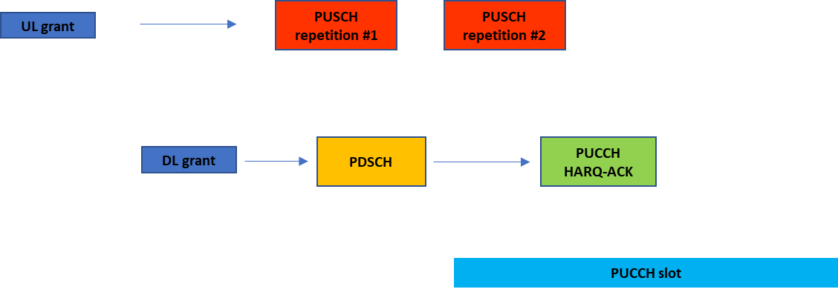
Figure 2
Observation 2: If a UE reports support for any of FG 55-4a, 55-4b and 55-4c and does not indicate the capability of supporting PUCCH time domain resource change in a PUCCH slot (FG 55-4d) or the capability of supporting HARQ-ACK codebook size change (FG 55-4e), the following case should be avoided by gNB.
- A UE detects a DL DCI format after the UL DCI format scheduling PUSCH repetitions, and the DL DCI format indicates a PUCCH resource overlapping with a PUSCH repetition scheduled by the UL DCI format, and there is no PUCCH resource for HARQ-ACK reporting that overlaps with the PUSCH repetition before detection of the DL DCI format.

The following TP is proposed by Samsung.

9 UE procedure for reporting control information

*** Unchanged parts are omitted ***
If a UE
- is provided enable-Type1-HARQ-ACK-mux-forDLassignmentafterULgrant, or enable-Type2-HARQ-ACK-mux-forDLassignmentafterULgrant, or enable-Type3-HARQ-ACK-mux-forDLassignmentafterULgrant, and
- is not provided uci-MuxWithDiffPrio, and
- transmits a repetition of a PUSCH transmission other than a first repetition,
the UE includes, in a HARQ-ACK codebook, HARQ-ACK information associated with a PDSCH reception scheduled by a first DCI format indicating a resource for a PUCCH transmission in a slot, when
- the UE detects a second DCI format, in a PDCCH monitoring occasion that starts before the PDCCH monitoring occasion for the first DCI format, scheduling a PUSCH transmission in the slot, and
- the UE multiplexes the HARQ-ACK codebook in the PUSCH transmission in the slot, and
- the timeline conditions in clause 9.2.3 for PUCCH resource determination and the timeline conditions of Tproc,1mux and Tproc,2mux for multiplexing the HARQ-ACK information in the PUSCH, as described in clause 9.2.5, are satisfied, and
- the UE does not determine a different PUCCH resource in time domain for the PUCCH transmission with the HARQ-ACK information in the slot if the UE is not provided enable-different-PUCCHresource, and for the PUCCH transmission with the HARQ-ACK information in the slot
- if based on the indication by the second DCI format the UE determines a first resource, the UE does not expect to be indicated by the first DCI format a second resource that is different than the first resource in time domain,
- else, the UE does not expect the first DCI format to schedule a PDSCH reception with TBs having enabled HARQ-ACK that is reported in the slot, and
- the UE does not expect to determine a different size for the HARQ-ACK codebook after including the HARQ-ACK information if the UE is not provided enable-different-CBsize.
If a UE multiplexes aperiodic CSI in a PUSCH and the UE would multiplex UCI that includes HARQ-ACK information in a PUCCH that overlaps with the PUSCH and the timing conditions for overlapping PUCCHs and PUSCHs in clause 9.2.5 are fulfilled, the UE multiplexes only the HARQ-ACK information in the PUSCH and does not transmit the PUCCH.
*** Unchanged parts are omitted ***

There are two different views on this issue, companies are encouraged to share their views

Q2: If a UE reports support for any of FG 55-4a, 55-4b and 55-4c and does not indicate the capability of supporting PUCCH time domain resource change in a PUCCH slot (FG 55-4d) or the capability of supporting HARQ-ACK codebook size change (FG 55-4e), what is your view on whether the legacy restriction should be removed?
Company | View

Q3: If your answer to Q2 is YES, do you agree with the change highlighted in cyan proposed by Ericsson?
Company | View

To resolve the new timeline issue, Samsung proposes that the PDCCH carrying DL grant should satisfy the UCI multiplexing timeline regardless of the later determined PUCCH overlaps with the PUSCH or not.
Q4: If your answer to Q2 is NO, do you agree with the TP proposed by Samsung?
Company | View

Q5: Any other comments for this issue?
Company | View

Issue#3 Timeline issue
In [1] Samsung discusses a timeline issue when the restriction is removed, copied below.
In RAN1#115, the HARQ-ACK overriding timeline is added in the agreement from RAN1#113 as shown above (in addition to the UCI multiplexing timeline). However, it is still possible that the current timeline requirements cannot ensure the required UE processing time. For example, if a UE indicates the capability of supporting PUCCH resource change in time domain in a PUCCH slot, it is possible that the final PUCCH after receiving the last DL grant does not overlap with the PUSCH repetition. An example is given in Figure 1. The UE first determines a PUCCH#1 with HARQ-ACK overlapping with a PUSCH repetition, i.e., PUSCH repetition#2 in a slot, and the UE would multiplex the HARQ-ACK in the PUSCH repetition if the UE does not receive any DL grant after the UL grant (as in legacy operation). However, if a Rel-18 UE receives a DL grant, after the UL grant, indicating HARQ-ACK report in the same slot, the UE should perform HARQ-ACK overriding and re-determine a PUCCH resource. If the later determined PUCCH#2 does not overlap with the PUSCH repetition, the UE should not multiplex HARQ-ACK in the PUSCH repetition. Therefore, it should be ensured that the UE has enough processing time to cancel the multiplexing of HARQ-ACK in the PUSCH repetition, i.e., the time gap between T0 (end of PDCCH with the DL grant) and T1 (start of PUSCH repetition#2) should be no less than a threshold. The current specifications define the timeline requirements only for the case where PUCCH#2 overlaps with the PUSCH repetition. The timeline for the above case should also be defined, for example, the multiplexing timeline defined in 9.2.5 can apply assuming PUCCH#2 overlaps with the PUSCH repetition #2.
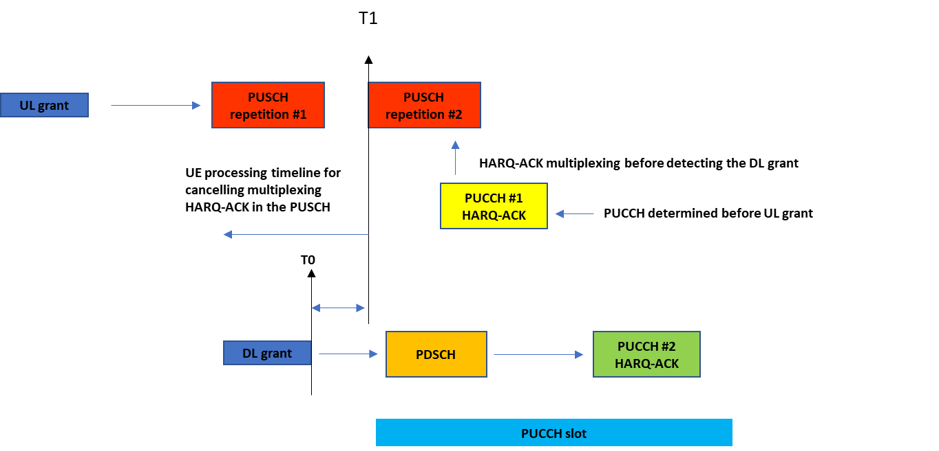
Figure 1
Observation 1: If a DL grant, after an UL grant, indicates a PUCCH transmission that does not overlap with the PUSCH repetition scheduled by the UL grant, and if the PDCCH reception with the DL grant does not end earlier than a predefined time from the beginning of the PUSCH repetition, a UE does not have enough processing time to cancel the multiplexing of HARQ-ACK in the PUSCH repetition.
Proposal 1: Update the previous agreement made RAN1#115 as following,
Agreement
If UCI multiplexing of different priorities is not enabled, the restriction on scheduling PDSCH after UL grant is removed for the case of PUSCH with repetitions except the first repetition
- UE generates Type-1 HARQ-ACK codebook according to the existing specification with the modification of setting the actual ‘ACK/NACK’ value corresponding to PDSCH(s) scheduled after the UL grant.
- UE generates Type-2/3 HARQ-ACK codebook according to the existing specification.
  - For Type-2 CB, UL DAI is used for generating HARQ CB.
- This feature is subject to separate UE capabilities for type-1, type-2, and type-3 codebooks.
- RRC parameter(s) to configure the function of scheduling PDSCH after a UL DCI format and multiplexing associated HARQ on a PUSCH repetition except the first repetition are introduced in Rel-18.
- Note: the number of PUSCH repetitions can be scheduled/configured by gNB.
- Note: same principle of current specification which UL DAI in UL grant is applied to each PUSCH repetition is reused.
- The timeline specified in TS 38.213 Clause 9.2.3 and 9.2.5 are satisfied, i.e. $T_{proc,1}^{mux}$between the last PDSCH and PUCCH, $T_{proc,2}^{mux}$ between the last PDCCH among UL grant /DL grant(s) and the earliest PUCCH or PUSCH assuming the PUCCH resource indicated by a DL DCI format received after UL grant overlaps with the PUSCH repetition.
- Additional UE capabilities are introduced to support the following functions (UE will be configured by gNB to use the following features via RRC)
  - HARQ-ACK codebook size change on a PUCCH slot
  - PUCCH time domain resource change on a PUCCH slot
- The above feature cannot be simultaneously enabled with PUCCH carrier switching.

Considering a similar issue is under the discussion in 7.1, the discussion of this issue is suggested to be postponed.

Conclusion
TBD

Reference
[1] R1-2400675 On TEI for HARQ-ACK MUX on PUSCH Ericsson
[2] R1-2400710 Remaining issues on multiplexing HARQ-ACK in a PUSCH with repetitions Samsung

