3GPP TSG RAN WG1 #109-e R1-2205357
e-Meeting, May 9th – 20th, 2022

Source: Moderator (Intel Corporation)
Title: Summary#4 of AI: 9.9.1 NR PDCCH reception in symbols with LTE CRS REs
Agenda item: 9.9.1
Document for: Discussion and Decision

Introduction
In RAN#94-e meeting a work item on enhanced MIMO support was agreed for Rel-18 [1]. The objectives of the WID include enhancements to NR PDCCH reception as shown below:

The following objectives shall be included for improvement of NR spectrum efficiency for LTE-NR co-existence (RAN1):
• Study and if needed specify NR PDCCH reception in symbols with LTE CRS REs. [RAN1]

This document contains summary of the companies’ and moderator’s proposals.

Review and observations
The following are observations from the FL based on tdoc review. This is not meant for agreement.

Multiple companies point out that the following existing methods enabling NR PDCCH capacity for DSS:
- UE supporting FG 3-2, FG 3-5, or the newly introduced Rel-16 UE capability to support monitoring PDCCH within the first 4 symbols.
- Rel-17 SCell PDCCH scheduling P(S)Cell PDSCH/PUSCH

Multiple companies point out the following consideration for UE implementation:
- Increase in UE complexity for channel estimation due to irregular DM-RS patterns for certain types of puncturing. The DMRS mapping/pattern may depend on the LTE-CRS pattern/configuration or PDCCH monitoring occasion.

Performance related:
- Multiple companies point out that enabling NR PDCCH reception in symbols with LTE CRS REs bring additional symbols for NR PDCCH allocation which contributes to NR PDCCH system capacity gain (e.g. 2 NR PDCCH symbols overlapped with 1 CRS symbol with puncturing improves the PDCCH capacity compared with 1 NR PDCCH symbol)
  - For individual link performance a UE using a higher AL with puncturing (AL=2X) compared to the case with no puncturing and lower AL (AL=X) show gains. Higher AL compensates for loss due to puncturing.
  - At least one company points out that the extent of gain over the existing capability of monitoring PDCCH in the first 4 symbols without puncturing may not be significant
- Multiple companies point out that the benefits of a potential Rel-18 solution depend on various factors including the ratio of UEs supporting legacy FGs, co-existence of LTE PDCCH/PCFICH/PHICH, number of LTE CRS ports and CRS BW relative to NR system BW.

Enhancements for NR-PDCCH for DSS

Possible specifications impact

Some companies have mentioned new or modified DMRS patterns for NR-PDCCH but given the TUs for this WID, such option is not included in this round. Pls. comment if you feel otherwise. The intention of Proposal #1 is to list few (reasonably complete) proposals in this meeting and check support. If you have alternative wording to suggest pls. also feel free to mention in comments.

Proposal #1:
- Consider the following Tx procedures: In the REs comprising an OFDM symbol that is overlapped between a NR-PDCCH candidate and LTE-CRS:
  - Option-1: No NR-PDCCH-DMRS is transmitted, NR-PDCCH is transmitted on REs not colliding with LTE-CRS, NR-PDCCH is punctured on REs colliding with LTE-CRS, NR-PDCCH must span at least 2 consecutive symbols with at least 1 symbol not overlapping with LTE-CRS
  - Option-2: NR-PDCCH or NR-PDCCH-DMRS is transmitted on REs not colliding with LTE-CRS, NR-PDCCH and NR-PDCCH-DMRS is punctured on REs colliding with LTE-CRS
  - Option-3: NR-PDCCH or NR-PDCCH-DMRS is transmitted on REs colliding as well as not colliding with LTE-CRS (superposition)
- Consider the following applicability conditions (in addition to UE feature):
  - Case-1: Applicable to NR-PDCCH candidate spanning 2 [or 3] consecutive symbols where the first 1 [or 2] symbol is overlapping with LTE CRS
  - Case-2: Applicable to NR-PDCCH reception within the first 3 [or 4] consecutive symbols in a slot
  - Case-3: Not applicable to Type-0/0A/1/2 CSS SS-sets reception
  - Case-4: No additional applicability restrictions
- Consider the following NR-PDCCH reception with LTE CRS REs: A UE is expected to monitor a PDCCH candidate where at least one RE of the candidate is overlapping with LTE-CRS according to one of the following options (other options not precluded):
  - Option-1: Tx procedure option-1 + Applicability cases-1, 2, 3
  - Option-2: Tx procedure option-2 + Applicability case-4
  - Option-3: Tx procedure option-2 and 3 + Applicability cases-1, 2

Company | Comment
OPPO | First, we are not sure which one of the following is the intention of proposal 1.  - RAN1 further discusses Options listed in the last bullet, targeting the WID term of “Study and if needed specify”.  - The agreement of the proposal means RAN1 agrees to specify something for NR-PDCCH reception with LTE CRS REs, with possible solutions from Options {1,2,3}.  Could FL please clarify the intention?  Secondly, the Options {1,2,3} are not defined per UE behavior for reception, but based on gNB behavior for transmission. This makes the proposal unclear to us. For example, does “Option-3: Tx procedure option-2, 3” mean the UE would monitor PDCCH (including using DMRS) in the same legacy way, which at least works for Tx option-3 (superposition) but maybe questionable for Tx Option-2 (puncturing)?
Qualcomm | Considering the limited time until the completion, we suggest the following:  - In this meeting, RAN1 picks up a possible solution that is understood as feasible from various angles (UE implementation, performance)  - In the next meeting, RAN1 will make a decision whether to support it or not.  - For this, LLS and SLS assumptions are to be agreed in this meeting.  Regarding the above “a possible solution”, we are OK to move forward if it is Option-1 of the Tx procedure in the FL proposal.  Option-2 and Option-3 would require UE to smartly handle irregular DMRS pattern(s) or superimposed DMRS. Different handling would be necessary for different CRS pattern configurations (v-shift, # of antenna ports, bandwidth, carrier frequency). This will be further serious problem if we consider overlapped/non-overlapped multiple LTE CRS patterns that overlaps with the PDCCH, where each CRS pattern has its own parameters. There are certain operational points where basic receiver (the receiver processing PDCCH as if it is a legacy PDCCH without overlapping CRS) works, as reported by some contributions. However, it would not be possible to say that basic receiver is sufficient and advanced receiver is not necessary. Once we decide to go with Option-2 or Option-3, we have to accommodate various receiver types for various scenarios in the end.  From both UE and NW points of view, any possible solution is anyway a new type of PDCCH. Even with the basic receiver, the UE behavior and implementation have to be not the legacy one. With that said, we propose to consider Option-1 only.  Some other aspects, e.g., whether to support Type-0/0A/1/2 CSS sets, can be concluded after the major decisions are made.
Moderator | To OPPO: the intention is the first bullet. yes – I have same understanding that for Tx procedure option 3 UE monitors in legacy way and Tx procedure option-2 is one way of puncturing
vivo | TX procedure: option1, option2  - According to our simulation, option3 suffers serious loss if UE use the RE colliding CRS for estimation or PDCCH decoding, thus it is not supported.  - With modifications to UE side, i.e., nulling the CRS REs during the channel estimation or PDCCH decoding, option2 achieves significant PDCCH capacity gain but it may lead to irregular DMRS patterns as commented by Qualcomm, in which case it is not possible to use AL=1 to achieve 1% BLER requirement for PDCCH decoding. Option1 has no irregular DMRS issue, and provides better performance than option2. Thus, we think option1/2 should be considered for further down-selection.  applicability conditions:  - In our understanding, the target scenario of the WID is case2. We are also open to case 3 to avoid impacts to common PDCCH performance of idle UE.  - Besides, we think it should be clarified if the case with two CRS patterns should be considered in this AI. If not, an additional condition as below should be introduced.  - Case-5: Applicable to NR-PDCCH candidate when there is only one LTE CRS pattern list
Nokia, NSB | We are in principle OK with all the suggested branches, but as suggested by Oppo, perhaps it would be better to formulate the Rx processing  - PDCCH and PDCCH DMRS REs overlapping with CRS are ignored (puncturing)  - PDCCH and PDCCH DMRS REs overlapping with CRS are processed as if there was no overlap  - Tx could still puncture the PDCCH/PDCCH DMRS overlapping with the CRS, or it could superposition the two.  - If the UE is able to puncture in the Rx, then it of course should be told if these REs are not transmitted.  @Qualcomm, Vivo: Superpositioning doesn’t require any changes to the UE PDCCH processing, and it actually seems to work better than puncturing with higher aggregation levels, while with low Als it would not work (would need to opt for puncturing or just not use low ALs if the UE doesn’t support puncturing). We can do superpositioning today with idle mode UEs (just as we can do puncturing, where UE still assumes the REs to be present), but because of PDCCH candidate dropping we can’t configure a connected mode UE with CRS RM pattern overlapping with PDCCHs.  Sure, the UE could do better if it wanted to, it could try to mitigate the CRS interference if it knows for sure that both CRS and PDCCH are superpositioned, or it could puncture the overlapping REs in the receiver. These could be different UE implementation alternatives. The UE would also be free to do channel estimation only based on the non-overlapping symbol or use DMRS from both overlapping and non-overlapping symbols.  On scenarios, our understanding is that case 1 is the target.  On ruling out CSS, this would be counterproductive, as it is today very bad that the UE drops PDCCH candidates overlapping with LTE CRS when it has been told that CRS is there. So if we want PDCCH we can’t configure CRS RM patter, but if want PDSCH with RM, we can’t have PDCCH. This is a pointless and counter-productive configuration restriction in Rel-15 preventing the network to find a compromise operational point without ANY impact to the UE implementation.
MediaTek | Thanks to Moderator’s further clarification. However, it is still not clear to us what is the next step after we choose some of the combination of options+cases. Is it for further study and the simulation should consider the chosen combination or is it to ignore the study and specify the feature directly? Based on the WID, I guess Moderato’s intention is to further study the selected combinations? If so, we suggest to add the wording “For the purpose of study” in each of the main bullets or simply add the wording in the beginning of proposal:  Proposal #1: For the purpose of study,  Regarding the options, we think at least option-3 might not be within the scope of WID where puncturing is specified:  - Study and if needed specify NR PDCCH reception in symbols with LTE CRS REs. [RAN1]  - Investigate enabling LTE CRS to puncture NR PDCCH, including the impact to NR PDCCH DMRS if there is the performance gain from the additional PDCCH resources.  Regarding the cases, we think case-3 should be separated as a conclusion and not as an study candidate. It’s not clear to us how gNB should handle cell-specific CSS coexistence between legacy UEs and Rel-18 DSS UEs. As for case-1 and case-2, we support to study case-2 only. As pointed out by other companies, the necessity of considering puncturing in case-1 is not clear when UE can monitor other symbols in addition to the first 3 or 4 symbols. Also, due to the limited TU, it is preferred to focus on the basic feature first in order to converge the discussion faster. Therefore, we support to study  - Option-4: Tx procedure option-1 and 2 + Applicability case-2  and separate case-3 into a proposed conclusion:  Conclusion: NR PDCCH reception in symbols with LTE CRS Res is not applicable to Type-0/0A/1/2 CSS SS-sets.
Apple | For Tx procedure Option-1, we are not sure this option can work properly, i.e., PDCCH occupies two symbols but only one symbol has the DMRS. The third symbol in the slot would be used by PDCCH for legacy UEs, only second symbol in the slot is available for Rel-18 DSS UE, but there is no DMRS in this symbol.  Similarly for applicability conditions, Case-1/2/4 is the scenario that no legacy UEs are in the network; otherwise only one symbol, i.e., the second symbol in the slot, is available for Rel-18 NR-PDCCH.
NTT DOCOMO | Our understanding is that the objective of this AI includes Tx procedure option 1 and 2. Considering the UE processing complexity and limited time, only option 1 may be sufficient.  Regarding applicability conditions, as other companies have said, we see little need to support PDCCH reception in symbols that overlap with CRS other than the first 3 or 4 symbols.
Ericsson1 | In terms of analyzing benefit, we suggest using below case as baseline for study. Many companies have evaluated at least this case and it should help simplify the discussions. Companies can also bring up other cases but it is good to have at least one case that everyone studies.  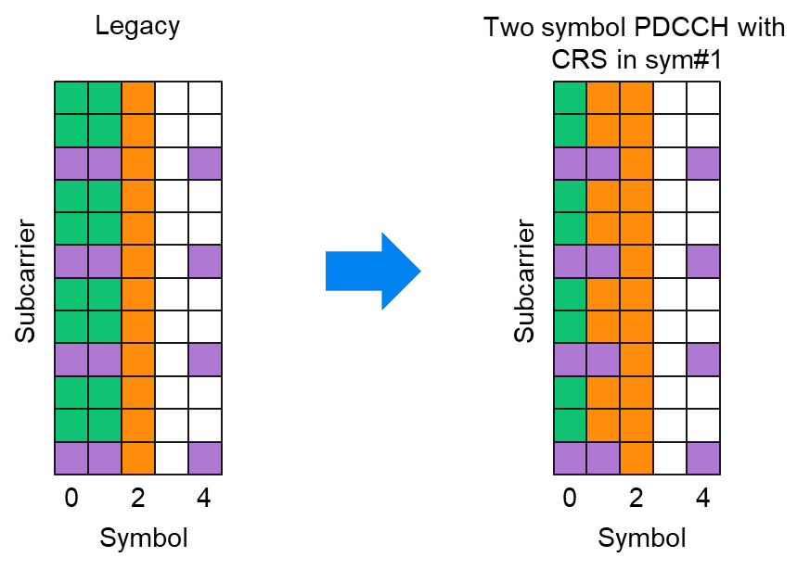  Some companies mentioned FG 22-12 but we do not see it being relevant for current discussion as it does not help reclaim sym#1 for NR PDCCH when LTE PDCCH is not used there.  Which additional symbols to support (i.e., sym#0, #4 etc.) can be later point of discussion.  We prefer Nokia proposed formulation for Rx processing. The two cases i.e., “PDCCH and PDCCH DMRS REs overlapping with CRS are ignored (puncturing)” and “PDCCH and PDCCH DMRS REs overlapping with CRS are processed as if there was no overlap” (aka basic receiver in our contribution) can used as baseline to analyze the benefit.  According to our analysis, if a two-symbol CORESET (sym#1+sym#2) is used, then it is beneficial to use PDCCH-DMRS in both sym#2 and sym#1 (in spite of some REs being punctured) for channel estimation compared to only using REs in sym#2. This can also be considered.  Then on QC proposed option (i.e., -- in the REs comprising an OFDM symbol that is overlapped between a NR-PDCCH candidate and LTE-CRS -- no NR-PDCCH-DMRS is transmitted, NR-PDCCH is transmitted on all REs not colliding with LTE-CRS, NR-PDCCH is punctured on REs colliding with LTE-CRS, NR-PDCCH must span at least 2 consecutive symbols with at least 1 symbol not overlapping with LTE-CRS), we are open to consider if there is support. However, considering the additional spec impact (effectively a new (no) PDCCH-DMRS pattern introduced in specs for sym#1), we do not think it is justified to consider it as the only option. This especially when other (arguably simpler) approaches are shown to be viable.
Huawei/Hisi | 1, For the 1st proposal, we share the same view with Qualcomm that only Option-1 is a practical way for UE channel estimation. UE cannot perform basic legacy channel estimation based on Option 2 irregular DMRS pattern. To address Ericsson’s concern, we do not see a new DMRS pattern is necessary in spec (as seen in Understanding 1 in below). For Option 3, wouldn’t the superposition NR DMRS interfere the LTE CRS for channel estimation/measurement? Such degradation of the legacy RAT is not desired.  In addition, the meaning of ‘No NR-PDCCH-DMRS is transmitted, NR-PDCCH is transmitted on REs not colliding with LTE-CRS’ in Option-1 needs clarified:  Understanding 1: No NR-PDCCH-DMRS transmitted only on the overlapped REs with CRS. In other words, DMRS is still transmitted on other non-overlapped REs on the overlapped symbol (red spot in the left figure). UE will not use them for estimation though.  Understanding 2: No NR-PDCCH-DMRS transmitted on any RE of the overlapped symbol. In other words, these REs can be 1) blank, or 2) used for carrying PDCCH payload (striped purple in right figure).  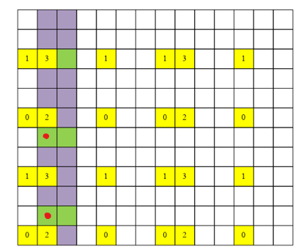 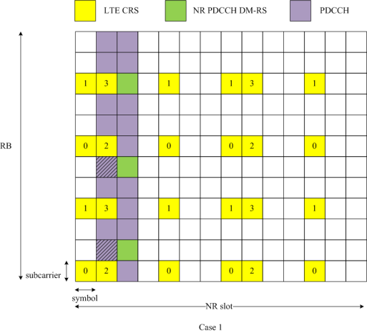  2, If the intention of Proposal#1 is to set the simulation assumptions and for the purpose of performance comparison/analysis, then we suggest the baselines (legacy PDCCH on clean symbols) are needed. E.g.:  - Baseline 1: 1 OS (3rd OS)  - R18 Alt.1 (Case-1, or Case-2 with 3 OS monitoring): 2OS (2nd OS + 3rd OS), i.e. 1OS overlap + 1OS clean  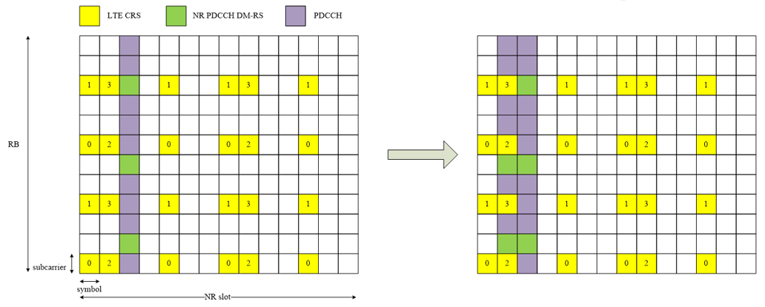  - Baseline 2: 1 OS (3rd OS+4th OS)  - R18 Alt.2 (Case-2 with 4 OS monitoring): 3OS (2nd OS + 3rd OS + 4th OS), i.e. 1OS overlap + 2OS clean  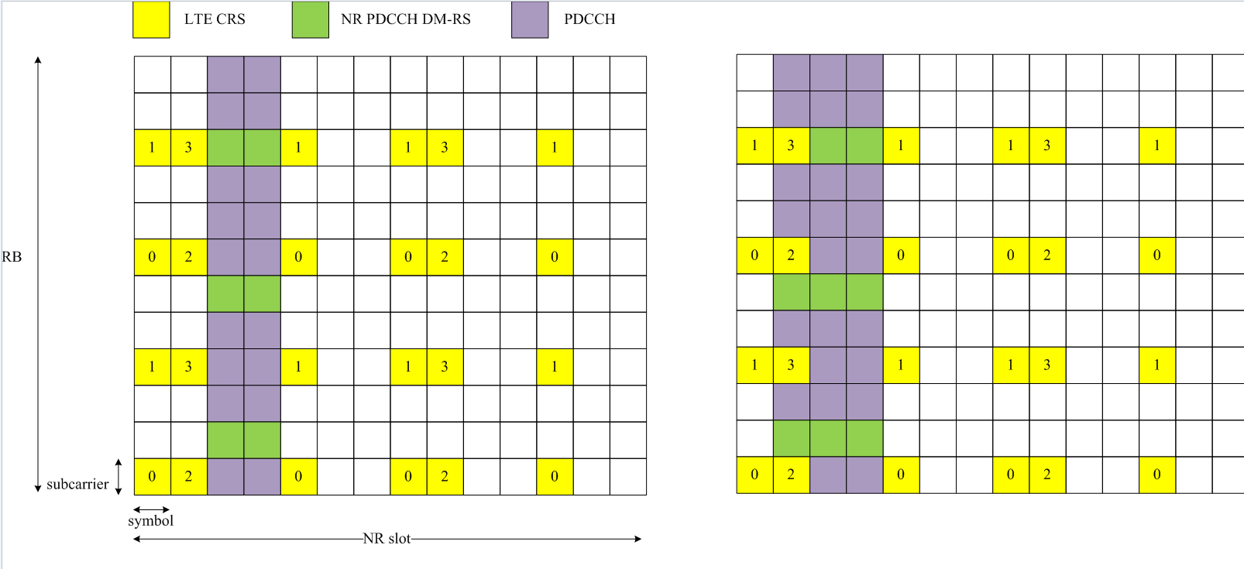  We are OK with Case-3, Case-4 in applicability cases. For the combination (3rd bullet), as we only prefer Option-1, then only the 1st combination (Option-1) is valid.
ZTE | Regarding Tx procedure, Option 2 is preferred considering the better performance provided. Option 3 is not in the scope of the WID.  For the applicable cases, Case 1 should be the target. But it’s not clear to us whether the current Case 1 could include a case that NR-PDCCH candidate spanning 3 consecutive symbols where the first 1 symbol is overlapping with LTE CRS. In addition, for Case 2, the first symbol in a slot should be excluded for Case 2, due to the impact from LTE PDCCH/CRS/PHICH/PCFICH. We are open to Case 3.
Xiaomi | For option-1 of Tx procedure, if majority goes to no NR PDCCH DMRS is transmitted on the OFDM symbols with LTE CRS, we are fine to accept it.  For option-3 of Tx-procedure, if it goes to Tx superpositions NR PDCCH and NR PDCCH DMRS on REs colliding with LTE-CRS, we think that is out of the scope. The WID aims to investigate enabling LTE CRS to puncture NR PDCCH, at least transmitting NR-PDCCH with LTE CRS is not specified in the WID. Besides, enabling transmitting NR-PDCCH or NR PDCCH DMRS on the REs colliding with LTE-CRS will result in severe interference to LTE-CRS. If it goes to Tx puncturing NR PDCCH and NR PDCCH DMRS, while the Rx chooses to “ignore” the punctured REs, it will result in worse decoding performance as vivo clarifies. Based on above observations, we do not support Tx super positioning NR PDCCH and DMRS REs on colliding REs in Option-3.  As for the applicability cases, we have similar views as Qualcomm. The cases can be concluded after the major decisions are made.  @Vivo: For case-5, do you mean if configuring two LTE CRS pattern lists, enabling NR PDCCH reception in symbols with LTE CRS REs is not supported? In some cases, e.g., one 4-port CRS with one 2-port CRS, or one 4-port CRS with one 1-port CRS, the NR PDCCH can still be received on symbol#1 with LTE CRS. This issue can be discussed after there is clear conclusion of supporting PDCCH reception in symbols with LTE CRE REs.
Spreadtrum | We think the target scenario of this feature is not very clear, hoping get some clarification. For example, the maximum number of CRS ports and CRS patterns should be clarified at the initial stage.  Same view as MTK, Option 3 in TX procedures is not in the scope of WID. We are open to Option 1 and Option 2. In our understanding, Option 1 in TX procedures and 2) in understanding 2 proposed by HW have same meaning, which should be clarified.  Regarding the Case 1 in “applicability conditions”, does it imply the feature is for NR PDCCH overlapping with LTE CRS within the first 3 symbols only? If PDCCH can span to any symbol contains LTE CRS in a slot, there will be many scenarios and symbol overlapping with the LTE CRS may not be the first 1 [or 2] symbol. It is unclear whether Case 1 includes the case where PDCCH occupies the first 3 symbols in a slot and the first 2 symbol is overlapping with LTE CRS. Thus, Case 1 is not clear to us.  We think the overlap occurs at symbol 1 can be studied as high priority. It means NR PDCCH can occupy the first 3 or 4 symbols which are overlapped with LTE CRS. Thus, we are OK to Case 2 and support Option-4 proposed by MTK. In addition, we agree with Huawei and the simulation assumptions include Baseline 1, Baseline 2, R18 Alt.1 and R18 Alt.2, which is also consistent with Option-4 proposed by MTK.  Regarding the Case 3, for the CSS such as Type 0/0A/1/2, it is typically cell specific and they might be shared by a group of UEs such as UE is before RRC connection setup. Thus, it is not feasible to do LTE CRS puncture PDCCH associated with Type 0/0A/1/2 CSS. We think NR PDCCH in Type 0/0A/1/2 CSS punctured by LTE CRS on overlapping symbols is not studied in this item, so Case 3 is fine to us.
LG | We are open to list possible TX procedures, applicable conditions, and their combinations for NR-PDCCH reception. But, we have some comments on the applicable conditions i.e., Case-1/2/3/4.  Regarding Case-2, as commented by ZTE, there can be two ways: NR-PDCCH can start at symbol index 0 or 1. Therefore, for aligned understanding, the Case-2 can be updated as the following.  - Case-2: Applicable to NR-PDCCH reception within the first 3 [or 4] consecutive symbols starting from symbol index 0 or 1 in a slot  Regarding Case-3, it doesn’t seem to be same level with other Case-1/2 since it is related to applicable SS set while Case-1/2 is about composition of NR-PDCCH. Thus, as commented by MTK, the Case-3 can be considered as a conclusion on any NR PDCCH reception (with LTE CRS REs).
Samsung | Agree with previous comments from Qualcomm and Huawei and support Option 1.  We also understand that Option 1 does not require definition of new DM-RS patterns and does not require any change to the Rel-17 UE implementation, unlike Option 2. Option 3 will certainly have an impact on LTE performance, will be difficult to evaluate for both LTE and NR, and need not be considered.  For the evaluation cases, the main issue is when the NR PDCCH has available only the third symbol and most benefit would be from also having available the second symbol. We do not think considering the first symbol makes sense as that would mean there is no LTE PDCCH/PCFICH/PHICH.  So, only the first combination needs to be considered and only for Case-1 with the text in the [ ] removed. Case-3 can be a conclusion.  - Option-1: Tx procedure option-1 + Applicability cases-1  - Case-1: Applicable to NR-PDCCH candidate spanning 2 [or 3] consecutive symbols where the first 1 [or 2] symbol is overlapping with LTE CRS

Update-1

Dear all, thanks for the comments, it seems that Tx procedure option-1 has the least concerns and if possible good to do some down-selection in this meeting. For agreement it may be good to focus on the first bullet first, then the second, then the third.
@vivo: added case-5
@Nokia, NSB: formulating from Rx point of view merges Tx procedure options-1 and option-2 (both of them are puncturing) but does not resolve the key problem of irregular DMRS channel estimation – this will make the discussion longer
@MTK: added Option-4, we can try conclusion online
@Ericsson: see response to Nokia above
@ Huawei/Hisi: It is understanding 2 (it should be clear from the main bullet but added some clarification still). Baseline discussion can be long and if possible let us come back to such issue in Proposals-2, 3.
@Spreadtrum: Case-1 is not limited to the first 2 [or 3] symbols only in a slot but LTE-CRS overlap is limited to the first 1 [or 2] symbols of a PDCCH candidate. yes, it includes the case where PDCCH occupies the fist 3 symbols in a slot and CRS is in first 2.
@LG: your suggestions are narrower than the current formulation – we can try online
@Samsung: your suggestions are narrower than the current formulation – we can try online

Proposal #1:
- Consider the following Tx procedures: In the REs comprising an OFDM symbol that is overlapped between a NR-PDCCH candidate and LTE-CRS:
  - Option-1: No NR-PDCCH-DMRS is transmitted in any such RE, NR-PDCCH is transmitted on REs not colliding with LTE-CRS, NR-PDCCH is punctured on REs colliding with LTE-CRS, NR-PDCCH must span at least 2 consecutive symbols with at least 1 symbol not overlapping with LTE-CRS
  - Option-2: NR-PDCCH or NR-PDCCH-DMRS is transmitted on REs not colliding with LTE-CRS, NR-PDCCH and NR-PDCCH-DMRS is punctured on REs colliding with LTE-CRS.
  - Option-3: NR-PDCCH or NR-PDCCH-DMRS is transmitted on REs colliding as well as not colliding with LTE-CRS (superposition).
- Consider the following applicability conditions (in addition to UE feature, other cases not precluded):
  - Case-1: Applicable to NR-PDCCH candidate spanning 2 [or 3] consecutive symbols where the first 1 [or 2] symbol is overlapping with LTE CRS
  - Case-2: Applicable to NR-PDCCH reception within the first 3 [or 4] consecutive symbols in a slot
  - Case-3: Not applicable to Type-0/0A/1/2 CSS SS-sets reception
  - Case-4: No additional applicability restrictions
  - Case-5: Applicable to NR-PDCCH candidate overlapped with only one LTE CRS pattern
- Consider the following NR-PDCCH reception with LTE CRS REs: A UE is expected to monitor a PDCCH candidate where at least one RE of the candidate is overlapping with LTE-CRS according to one of the following options (other options not precluded):
  - Option-1: Tx procedure option-1 + Applicability cases-1, 2, 3
  - Option-2: Tx procedure option-2 + Applicability case-4
  - Option-3: Tx procedure option-2 and 3 + Applicability cases-1, 2
  - Option-4: Tx procedure option-1 and/or 2 + Applicability case-2

Company | Comment
Ericsson2 | Thank you for the updated Proposal and below comments  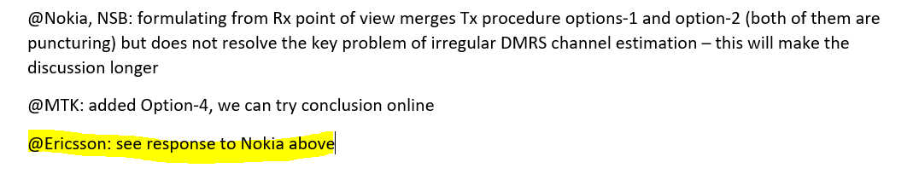  To further clarify our previous comment, current proposal focuses on Tx procedures (which are useful to explain set up for study) but does not clearly capture what PDCCH and PDCCH-DMRS assumption should be used by the UE for decoding the PDCCH candidates (in short – UE Rx point of view or UE Rx assumption, this determines spec impact).  The UE Rx assumption need not necessarily match the Tx procedure and this aspect is missing from the current Proposal.  Below updates to the third main bullet of the proposal are required to complete the framework proposed by Moderator (proposed updates in blue).  Updates to 3rd bullet of Moderator Proposal:  - Consider the following NR-PDCCH reception with LTE CRS REs: A UE is expected to monitor a PDCCH candidate where at least one RE of the candidate is overlapping with LTE-CRS according to one of the following options (other options not precluded):  - Option-1: Tx procedure option-1 + Applicability cases-1, 2, 3  - Option 1-1: UE assumption for decoding PDCCH candidates: according to Tx procedure option 1  - Option-2: Tx procedure option-2 + Applicability case-4  - Option 2-1: UE assumption for decoding PDCCH candidates: Legacy PDCCH and PDCCH-DMRS transmission is assumed in all symbols regardless of CRS overlap/not.  - Option 2-2: UE assumption for decoding PDCCH candidates: according to Tx procedure option 2.  - Option 2-3: UE assumption for decoding PDCCH candidates: NR PDCCH-DMRS REs in symbol overlapping with CRS are not used in channel estimation. NR PDCCH is punctured according to Tx procedure option 2. Legacy PDCCH and PDCCH-DMRS is assumed in symbol not overlapping with CRS (if present).  - Option 2-4: UE assumption for decoding PDCCH candidates: NR PDCCH DMRS REs in symbol overlapping with CRS are not used in channel estimation. Legacy PDCCH transmission assumed in symbol overlapping with CRS. Legacy PDCCH and PDCCH-DMRS is assumed in symbol not overlapping with CRS (if present).  - Option-3: Tx procedure option-2 and 3 + Applicability cases-1, 2  - Option 3-1: UE assumption for decoding PDCCH candidates: Legacy PDCCH and PDCCH-DMRS transmission is assumed in all symbols regardless of CRS overlap/not.  - Option 3-2: UE assumption for decoding PDCCH candidates: according to Tx procedure option 2 and 3.  - Option 3-3: UE assumption for decoding PDCCH candidates: NR PDCCH DMRS REs in symbol overlapping with CRS are not used in channel estimation. NR PDCCH is punctured according to Tx procedure option 2 and 3. Legacy PDCCH and PDCCH-DMRS is assumed in symbol not overlapping with CRS (if present).  - Option 3-4: UE assumption for decoding PDCCH candidates: NR PDCCH DMRS REs in symbol overlapping with CRS are not used in channel estimation. Legacy PDCCH transmission assumed in symbol overlapping with CRS. Legacy PDCCH and PDCCH-DMRS is assumed in symbol not overlapping with CRS (if present).  - Option-4: Tx procedure option-1 and/or 2 + Applicability case-2  To further clarify spec impact/new DMRS pattern for Option 1, our understanding is that Option 1 is according to below figure in R1-2205049. (i.e., Understanding #2 in comment from Huawei/Hisi with the striped-purple REs in the figure in their comments used for PDCCH). We think updates to sub clause 7.4.1.3.2 in 38.211 are required to enable this.  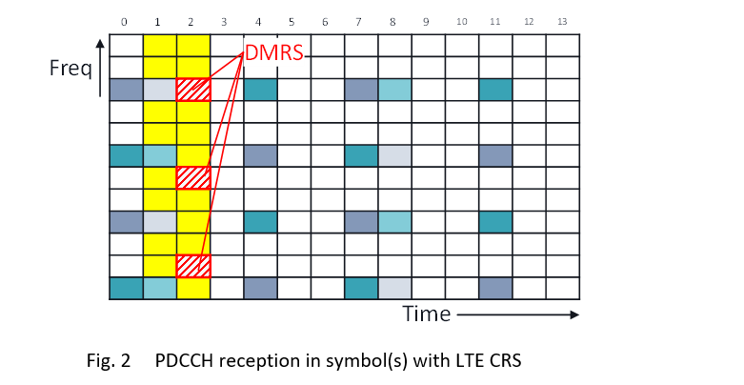
Huawei/Hisi2 | @Moderator Thanks for clarification and updates. Please see some further comments.  1, For the two understandings, we believe both should be captured as sub-options of Option 1. Understanding#2 has benefits of more PDCCH resources (assuming the striped purple is used for carrying PDCCH payload), but has additional capability requirement to UE since the UE has to support additional PDCCH rate matching patterns (one pattern including DMRS in case of no overlapping and the other does not include DMRS in case of overlapping). Thus the changes are made (Option 1-1 for Understanding#1, and Option 1-2 for Understanding#2)  Understanding#1 Understanding#2  2, For Understanding#2, the PDCCH candidate should rather be REG bundle? Consider the case PDCCH candidate may include: Case 1: 2 CCEs: CCE1 on the 2 clean symbols and CCE2 on partially overlapped symbols, or Case 2: 1 CCE, which is CCE1. Then if ‘PDCCH candidate’ is used, it would cause two hypothesis for UE channel estimation/PDCCH reception: for Case 1, legacy DMRS/PDCCH pattern using 2 symbols for CCE1; for Case 2, R18 DMRS/PDCCH pattern using only the 1 clean symbol for CCE1. The changes are made accordingly.  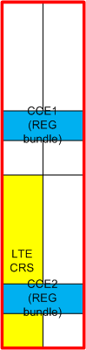  3, We still believe Option 1 should be the baseline/mandatory, instead of with the same priority of Option 2/3 up to company report. Otherwise different companies still simulated their preferred Options, and evaluations results are still non-aligned at the next meeting.  Suggested changes:  Consider the following Tx procedures: In the REs comprising an OFDM symbol that is overlapped between a NR-PDCCH candidate REG bundle and LTE-CRS  - Option-1-1: No NR-PDCCH-DMRS is transmitted for only the REs overlapping with LTE-CRS of the OFDM symbol, NR-PDCCH is punctured on REs colliding with LTE-CRS, NR-PDCCH must span at least 2 consecutive symbols with at least 1 symbol not overlapping with LTE-CRS  - Option-1-2: No NR-PDCCH-DMRS is transmitted in any such RE of the OFDM symbol, NR-PDCCH is transmitted on REs not colliding with LTE-CRS including the original DMRS, NR-PDCCH is punctured on REs colliding with LTE-CRS, NR-PDCCH must span at least 2 consecutive symbols with at least 1 symbol not overlapping with LTE-CRS

Update-2

Agreement
To evaluate the following options:
  - Option-1-1: No NR-PDCCH-DMRS is transmitted for only the REs overlapping with LTE-CRS of the OFDM symbol, NR-PDCCH is punctured on REs colliding with LTE-CRS, NR-PDCCH must span at least 2 consecutive symbols with at least 1 symbol not overlapping with LTE-CRS

  - Option-1-2: No NR-PDCCH-DMRS is transmitted in any such RE of the OFDM symbol, NR-PDCCH is transmitted on REs not colliding with LTE-CRS including the original DMRS, NR-PDCCH is punctured on REs colliding with LTE-CRS, NR-PDCCH must span at least 2 consecutive symbols with at least 1 symbol not overlapping with LTE-CRS

  - Option-2: NR-PDCCH or NR-PDCCH-DMRS is transmitted on REs not colliding with LTE-CRS, NR-PDCCH and NR-PDCCH-DMRS may or may not be punctured on REs colliding with LTE-CRS
    - No puncture is baseline (UE side)

The agreement above provides the framework for us to proceed. In terms of UE behavior my understanding is the following. This may also help us to understand the specification impact for each option.
- Option-1-1: UE assumes NR-PDCCH and NR-PDCCH-DMRS transmission according to this option for PDCCH decoding based on a CRS pattern
- Option-1-2: UE assumes NR-PDCCH and NR-PDCCH-DMRS transmission according to this option for PDCCH decoding based on a CRS pattern
- Option-2:
  - Baseline UE reception: UE assumes NR-PDCCH rate-matching and NR-PDCCH-DMRS transmission according to legacy for PDCCH decoding and is not based on any CRS pattern

If you require any further clarifications/discussions on the agreement please comment below:

Company | Comment
Nokia, NSB | In an attempt to rephrase the options to explain how I understand them. I am not asking to rephrase the agreement, simply trying to make sure I have the same understanding as everyone else as well as make a note on what implications each option has.  Option 1-1: In this option:  - PDCCH and PDCCH DMRS mapping to REs: Legacy  - PDCCH REs overlapping with LTE CRS: Receiver punctures  - PDCCH DMRS REs overlapping with LTE CRS: Receiver punctures  - Channel estimator: Not specified, may operate on clean symbol only DMRS only, or use DMRS on both symbols  - gNB transmits: Irrelevant what the gNB transmits on REs overlapping with the LTE CRS REs as indicated in the CRS RM pattern as the UE ignores those REs.  Option 1-2: In this option:  - PDCCH and PDCCH DMRS mapping to REs: New  - No PDCCH DMRS on the symbol overlapping with LTE CRS  - PDCCH REs overlapping with LTE CRS: Receiver punctures  - PDCCH DMRS REs overlapping with LTE CRS: Never happens  - Channel estimator: Operate on clean symbol DMRS only  - gNB transmits: Irrelevant what the gNB transmits on REs overlapping with the LTE CRS REs as indicated in the CRS RM pattern as the UE ignores those REs.  Option 2: In this option:  - PDCCH and PDCCH DMRS mapping to REs: Legacy  - PDCCH REs overlapping with LTE CRS: Process as legacy or puncture (up to the receiver type)  - PDCCH DMRS REs overlapping with LTE CRS: Process as before or puncture (up to the receiver type)  - Channel estimator: Not specified, may operate on clean symbol only DMRS only, or use DMRS on both symbols  - gNB transmits: May puncture the PDCCH/PDCCH DMRS, may puncture LTE CRS, or may superposition the two. Depending on what the UE receiver does this may or may not impact the performance  If the above is a correct representation, the following seems to hold  - option 1-1 UE implementation is allowed by option 2.  - option 2 allows legacy PDCCH processing implementations  - option 1-2 allows zero-waste of REs if the UE implementations would anyway choose to only use DMRS of the clean symbol, but requires new physical layer mapping for PDCCH and for PDCCH DMRS, and introduces DMRS-less PDCCH symbols with DMRS available in the next symbol in time. We are not very eager to go with such 38.211 modifications
MediaTek | Thanks to Moderator’s suggestion on aligning company understanding on UE behaviors for the three options. We also thank Nokia’s organized analysis on UE behavior and we suggest to use it as a discussion starting point and update the original agreement accordingly. Following is MTK’s view on Nokia’s analysis and we hope we can converge the understanding.  For option 1-1, we basically agree with Nokia’s view except for the Channel estimator part. Based on Huawei’s first round comment shown below, it seems like UE will only use the clean symbol for CE to simplify UE implementation. However, we are open to discuss this aspect.  Understanding 1: No NR-PDCCH-DMRS transmitted only on the overlapped REs with CRS. In other words, DMRS is still transmitted on other non-overlapped REs on the overlapped symbol (red spot in the left figure). UE will not use them for estimation though.  Therefore, our understanding of Option 1-1 is as follows:  Option 1-1: In this option:  - PDCCH and PDCCH DMRS mapping to REs: Legacy  - PDCCH REs overlapping with LTE CRS: Receiver punctures  - PDCCH DMRS REs overlapping with LTE CRS: Receiver punctures  - Channel estimator: Not specified, may operate on clean symbol only DMRS only, or use DMRS on both symbols Operate on clean symbol DMRS only  - gNB transmits: Irrelevant what the gNB transmits on REs overlapping with the LTE CRS REs as indicated in the CRS RM pattern as the UE ignores those REs.  For option 1-2, we agree on Nokia’s analysis  For option 2, we have the following question:  Q1: If UE assumed the overlapped REs are punctured, isn’t option 2 the same as option 1-1 when PDCCH spans more than 1 symbol? (Note that option2 allows 1 symbol CORESET punctured by LTE CRS but the CE is very challenging to UE)  If the answer to Q1 is Yes, then we don’t think there is a need to differentiate Option1-1 and Option 2 assuming puncturing at UE side  On the other hand, if no puncturing is assumed as baseline for Option 2 as agreed, then the following is our understanding  Option 2(baseline): In this option:  - PDCCH and PDCCH DMRS mapping to REs: Legacy  - PDCCH REs overlapping with LTE CRS: Process as legacy or puncture (up to the receiver type)  - PDCCH DMRS REs overlapping with LTE CRS: Process as legacy before or puncture (up to the receiver type)  - Channel estimator: legacy Not specified, may operate on clean symbol only DMRS only, or use DMRS on both symbols  - gNB transmits: Irrelevant what the gNB transmits on REs overlapping with the LTE CRS REs as indicated in the CRS RM pattern as the UE assumes those REs are not punctured May puncture the PDCCH/PDCCH DMRS, may puncture LTE CRS, or may superposition the two. Depending on what the UE receiver does this may or may not impact the performance
Qualcomm | Our understanding is same as MTK’s input above overall.  If we have to support a solution from the listed options, we would prefer Option 1-2. We do not think a minor change on PDCCH rate-matching is problematic. It is cleaner than opening up for various possible receiver types for implementation.
Vivo | Thanks to FL for the updated summary and to Nokia for the case-by-case analysis.  For option 1-2, we agree with Nokia’s assessment.  For option 1-1 and option2, we have a similar view to MTK that option1-1 and option2 are quite similar if UE still uses all DMRS for estimation. We also observed that in addition to receiver types, assumptions for CORESET configuration allowed by the option1-1 and option2 can also be different. From the contribution submitted, there are two assumptions:  - Assumption 1. only one CORESET is considered in the first 3 or 4 symbols, simulation is conducted to compare the PDCCH capacity of CORESET including one CRS symbol and CORESET not including CRS symbol.  - Assumption 2. Both R18 CORESET and R17 CORESET exist in the first 3 symbols, e.g., a 1-symbol R18 CORESET on symbol#1 and a 1-symbol R17 CORESET on symbol#2. Compare the capacity of both CORESETs with R17 CORESET only.  As option1-1/option 1-2 require 2-symbol CORESET, they can only be evaluated based on assumption 1, there is no room for 2nd CORESET in the first 3 symbols. While option2 may support both assumptions since there is no restriction on the number of PDCCH for option2.  Thus, we think the assumption of CORESET configuration should be specified in the proposal or parameter for simulations, otherwise it would be difficult to compare the results from companies.  From our side, we are fine with MTK’s update to make option2 as baseline as we see it may simplify the discussion/evaluation. Besides, PDCCH symbols for option2 may need to be aligned between option1-1/1-2 if option2 is used as baseline. E.g.,  Option 2(baseline): In this option:  - NR-PDCCH must span at least 2 consecutive symbols with at least 1 symbol not overlapping with LTE-CRS
Xiaomi | We have the similar view as Qualcomm that Option 1-2 is preferred.  We also observe that Option 1-1 is similar with the Option 2 if receiver assumes the overlapped REs are punctured.  On the other hand, we cannot understand the scenario of “NR PDCCH and NR PDCCH DMRS may not be punctured” in Option 2. If it goes to that gNB will transmit NR PDCCH and NR PDCCH DMRS on overlapped REs, that situation is out of the scope and will also lead to severe interference to LTE CRS. If it goes to that receiver continues to receive signals on overlapped REs in the legacy way, why the receiver chooses that way which will result in worse decoding performance?
Ericsson3 | As indicated by moderator, even though the agreement provides framework to proceed, it is good to align mutual company understanding of the implication of different options.  On PDCCH and PDCCH DMRS mapping to REs, Option 1-2 requires a new mapping while legacy mapping is applicable for Option1-1 and Option 2 as also indicated by other companies.  On channel estimator (CE) used by UE, below approaches are possible  - CE1: CE assumes legacy PDCCH-DMRS pattern; CE performed using PDCCH-DMRS in all symbols  - CE2: CE assumes legacy PDCCH-DMRS pattern; CE performed only using PDCCH-DMRS in symbol(s) without LTE CRS  - CE3: CE assumes punctured PDCCH-DMRS pattern in symbol with LTE CRS; CE assumes legacy PDCCH-DMRS pattern in symbol(s) without LTE CRS; CE performed using PDCCH-DMRS in all symbols  Our understanding is  - CE1 can be used with Option 1-1, Option 2. Not suitable for Option 1-2.  - CE2 can be used with Option 1-1, Option 1-2, and Option 2 (when symbol(s) without LTE CRS are present)  - CE3 can be used with Option 1-1, Option 2. Not applicable for Option 1-2.  If UE behavior according to moderator comments is to be assumed (i.e., Option-1-1: UE assumes NR-PDCCH and NR-PDCCH-DMRS transmission according to this option for PDCCH decoding based on a CRS pattern) our understanding is CE3 would be required for Option 1-1.  We propose that at least CE1 and CE2 are considered for evaluation.
Huawei/Hisi | Thanks Nokia to provide a good template for analyzing and aligning the understandings. Our views are similar to MTK basically, with analysis and additional changes on top of MTK’s version in blow:  For Option 1-1:  1, For PDCCH DMRS REs overlapping with LTE CRS: they are not used for channel estimation, and that is just the reason we need to ensure a clean symbol in Option 1-1/1-2. From spec impact perspective, using it for channel estimation (i.e., CE3 of Ericsson) is not precluded, but that is quite challenging for UE to perform CE based on irregular DMRS pattern, and hence not a practical solution on the table.  2, For Channel estimator: same view as MTK, that ‘operate on clean symbol only DMRS only.  3, Add the impact to LTE UEs (as in Option 2 the superposition method may cause impact to LTE, so add this item for comparison)  Option 1-1: In this option:  - …  - PDCCH DMRS REs overlapping with LTE CRS: Receiver punctures Not treated by UE  - …  - Impact to LTE UEs: No impact  For Option 1-2:  1, For PDCCH and PDCCH DMRS mapping to REs: better to add how to handle the original DMRS REs which are not overlapped with LTE CRS on the overlapping symbol. Adding PDCCH RM pattern also causes additional UE complexity, since the total number of RM patterns that can be supported by UE is limited. We can accept 1-2 as a separate UE capability.  2, Add the impact to LTE UEs (same as Option 1-1)  Option 1-2: In this option:  - PDCCH and PDCCH DMRS mapping to REs: New  - No PDCCH DMRS on the symbol overlapping with LTE CRS  - Original PDCCH DMRS on REs overlapping with LTE CRS on the overlapping symbol: mapped with PDCCH REs (New PDCCH RM pattern)  - …  - Impact to LTE UEs: No impact  For Option 2:  1, For PDCCH REs overlapping with LTE CRS/ PDCCH DMRS REs overlapping with LTE CRS/ Channel estimator: As captured in the agreement, legacy (No puncture) is baseline.  2, gNB transmits: As said in 1, UE channel estimator cannot support irregular DMRS pattern, so UE is assuming all DMRSs are available for CE (i.e., not aware of the DMRS puncturing) as baseline.  3, Add the impact to LTE UEs (same as Option 1-1)  Option 2: In this option:  - …  - Impact to LTE UEs: Interference to LTE if superposition is adopted  For the CE analysis from Ericsson, our views and suggested changes in below:  1, From the spec impact perspective, it is not precluded to apply CE1 to Option 1-1, but as the CE performance will be severely degraded if the UE is not aware of the punctured DMRS, it is actually not a practical way to be adopted for Option 1-1.  2, CE2 is conditional for Option 2, and when the condition satisfies (at least one clean symbol), Option 2 is the same as Option 1-1.  3, As analyzed above, CE3 is deprioritized.  - CE1 can be used with Option 1-1, Option 2. Not suitable for Option 1-2 and not reasonable for Option 1-1.  - CE2 can be used with Option 1-1, Option 1-2, and conditional for Option 2 (when symbol(s) without LTE CRS are present)  - CE3 is deprioritized due to its high complexity can be used with Option 1-1, Option 2. Not applicable for Option 1-2.
Apple | Thanks for the sharing the understanding. We have the same understanding on these options as MTK. In addition, for Option 2, we have the similar views as vivo, Option 2 can divide into two cases, first one is PDCCH occupies two symbols. The second one is PDCCH only occupy one symbol, i.e., only second symbol for PDCCH. Considering the second case allows the Rel-18 and legacy DSS PDCCH co-existence in one slot, thus both cases should be considered.
Spreadtrum | We basically agree with MTK's analysis about the three options.  Among the three channel estimators described by Ericsson, CE3 may achieve the best PDCCH decoding performance, while additional UE implementation complexity will be introduced.  Regarding Option 1-2, we agree on Nokia’s analysis and CE2 can be used to Option 1-2. In order to further simplify the UE implementation, we propose another revised option 1-2 with yellow highlight. For Revised Option-1-2, UE does not need to know the CRS pattern on the collision symbol.  Revised Option-1-2: No NR-PDCCH-DMRS is transmitted in any such RE of the OFDM symbol, NR-PDCCH is transmitted on REs not colliding with LTE-CRS including the original DMRS, NR-PDCCH is punctured on REs colliding with LTE-CRS, NR-PDCCH must span at least 2 consecutive symbols with at least 1 symbol not overlapping with LTE-CRS  - Note: NR-PDCCH may or may not be punctured on REs colliding with LTE-CRS from gNB side  Regarding Option 2, if NR PDCCH span more than 1 symbol and UE assume NR-PDCCH and NR-PDCCH-DMRS are punctured on REs colliding with LTE-CRS, the Option 2 is similar with Option 1-1. If UE assume NR-PDCCH and NR-PDCCH-DMRS are not punctured on REs colliding with LTE-CRS, i.e., UE regards the CRS on the collided RE as a DMRS for channel estimation, which result in severe degradation of PDCCH decoding performance because wrong channel estimation is performed. In short, we do not see a strong motivation to study option 2.
LG | We also have similar understanding with MTK on each of the options.  Regarding Option 2, as companies commented, it seems to be better to clarify or categorize according to whether the NR-PDCCH include at least 1 non-CRS symbol or include only CRS symbol, to differentiate from Option 1-1.
OPPO | In our understanding, the assumed UE behaviors for reception should be those for an optimal receiver for the given DL PDCCH/DMRS that is actually received. With this in mind, we agree with Nokia’s analysis for Option 1-1 and Option 1-2.  We have a concern for treating Option 2 (w/o puncturing) as baseline, unless it is a common understanding among the companies that:  - No further enhancement is done to handle intra-link CRS-to-DMRS interference on NR side.  - No further enhancement is done to handle intra-link DMRS-to-CRS interference on LTE side (seems out of scope already).  - No performance part objectives is added in WID for LTE (seems out of scope already).

We can also progress a little bit on other issues and try the following proposal below. The intention is to try to converge on fewer options with refined wording that can be a good start for the next meeting. Pls. indicate your support/concern on respective options. The purpose of this proposal is specifications, so pls. keep in mind UE behavior that would impact specifications (not for evaluation or UE feature discussions later on). Also note that we are not agreeing to any new specifications with Proposal#1-1.

Proposal#1-1
- Consider the following applicability cases (in addition to UE feature, other cases not precluded):
  - Case-1: Applicable to NR-PDCCH candidate spanning 2 [or 3] consecutive symbols where the first 1 [or 2] symbol is overlapping with LTE CRS
  - Case-2: Applicable to NR-PDCCH reception within the first 3 [or 4] consecutive symbols in a slot
  - Case-3: Not applicable to Type-0/0A/1/2 CSS SS-sets reception
  - Case-4: No additional applicability restrictions
  - Case-5: Applicable to NR-PDCCH candidate overlapped with only one LTE CRS pattern
- Consider the following NR-PDCCH reception with LTE CRS REs alternatives: A UE is expected to monitor a PDCCH candidate where at least one RE of the candidate is overlapping with LTE-CRS according to the following alternatives (other alternatives not precluded):
  - Alt-1: Agreed option-1-1 + Applicability cases-1, 2, 3
  - Alt-2: Agreed option-1-2 + Applicability cases-1, 2, 3
  - Alt-3: Agreed option-2 + Applicability cases-1, 2
  - Alt-4: Agreed option-2 + Applicability cases-2

Company | Comment
MediaTek | If Proposal #1-1 is still for evaluation/simulation purpose, then we don’t see the need to consider Case-1. For the same reason, Case-3 and Case-4 might not be considered for simulation purpose.  For Case-5, for the simulation purpose, should we consider more than 1 CRS patterns?  For Case-2, we suggest following update (sorry we missed this part in the first round)  - Case-2: Applicable to NR-PDCCH reception within the first 3 [or 4] consecutive symbols in a slot where the first 2 [or 1] symbol is overlapping with LTE CRS  However, if those Cases were used to specify where to support to puncturing feature, we suggest to first draw conclusions based on company evaluation results on the to-be-agreed alternatives and make the decision on whether and how to support the puncturing feature later.  In conclusion, we suggest considering following alternatives for evaluation  - Alt-1: Agreed option-1-1 + Applicability cases-1, 2, 3  - Alt-2: Agreed option-1-2 + Applicability cases-1, 2, 3  - Alt-3: Agreed option-2 (baseline) + Applicability cases-1, 2  - Alt-4: Agreed option-2 (baseline)+ Applicability cases-2  Note that our suggestion is based on the understanding that option-2 when UE assumes puncturing and option 1-1 are the same. If not, we are open to evaluate more alternatives.
Qualcomm | For evaluation purpose, we think it is sufficient to agree (1) on which symbol(s) PDCCH is transmitted and (2) on which symbol(s) the PDCCH overlaps with LTE CRS, and (3) what exactly the LTE CRS pattern is. It seems these are already reflected in the Update-2 of LLS assumptions.
vivo | @xiaomi, Thanks to xiaomi for the comments in round1. My origin intention was just to preclude PDCCH reception on CRS symbol when colliding with multiple CRS patterns, but I think you raised a valid point. The refined wording from FL is much clearer, and we are fine with it.  My understanding is that intention of the 1st bullet is to confirm the target scenario of applying PDCCH reception on CRS symbol, it may not depend on evaluation/simulation results. Case1 and case 2 describe the typical scenario for supporting this feature. Case3/5 are some further restrictions, which also do not rely on the simulation. Therefore, we think there is no need to defer discussion on the first bullet, and we support case2/case3/case5.  But the 2nd bullet is related to evaluation, I guess? If yes, we share same view as MTK, there is no need to consider case 3 in the simulation, and we prefer to explicitly indicate this in the main bullet,  - Consider the following NR-PDCCH reception with LTE CRS REs alternatives for simulation: A UE is expected to monitor a PDCCH candidate where at least one RE of the candidate is overlapping with LTE-CRS according to the following alternatives (other alternatives not precluded):  - Alt-1: Agreed option-1-1 + Applicability cases-1, 2, 3  - Alt-2: Agreed option-1-2 + Applicability cases-1, 2, 3  - Alt-3: Agreed option-2 + Applicability cases-1, 2  - Alt-4: Agreed option-2 + Applicability cases-2  If this is not only for evaluation but also for specification purposes, then we suggest not rushing into this bullet until the issue of how to transmit DMRS/PDCCH is settled.
Xiaomi | We agree with the updates of MTK and vivo and prefer Alt-2.
Ericsson3 | If intention of Proposal 1-1 is to identify cases for evaluation, we are OK to focus on Case 2. i.e., evaluate the Options 1-1, 1-2, 2 for NR-PDCCH reception within the first 3 [or 4] consecutive symbols in a slot
Huawei/Hisi | Firstly, echo MTK that Case-2 is incomplete  - Case-1: Applicable to NR-PDCCH candidate spanning 2 [or 3] consecutive symbols where the first 1 [or 2] symbol is overlapping with LTE CRS  - Case-2: Applicable to NR-PDCCH reception within the first 3 [or 4] consecutive symbols in a slot where the first 2 [or 1] symbol is overlapping with LTE CRS  Secondly, for the evaluation purpose, we may only setup the number of symbols for CORESET, and the number of overlapping symbols. Defining the monitoring span as in Case 1/2 is not really helpful to analyze reliability/capacity performance.  Scenario#1: 2 symbols CORESET, all overlapped with CRS – Option 2 only  Scenario#2: 2 symbols CORESET, including 1 overlapping symbol and 1 clean symbol – Option 1-1/1-2/2  Scenario#3: 3 symbols CORESET, including 1 overlapping symbol and 2 clean symbols – Option 1-1/1-2/2  [Scenario#4]: 3 symbols CORESET, including 2 overlapping symbols and 1 clean symbols. Note this scenario is not likely to be practical considering the existence of legacy LTE PDCCH/PCIFCH/PHICH on the 1st symbol. – Option 1-1/1-2/2
Apple | For evaluation purpose, we agree only considering the case 2 is enough.  - Case-2: Applicable to NR-PDCCH reception within the first 3 [or 4] consecutive symbols in a slot  To be clear, which symbol(s) is used for PDCCH transmission for Case-2, the following options need to be considered.  If PDCCH candidates are within first 3 symbols, PDCCH is transmitted in second and third symbol for Option 1-1/1-2/2  If PDCCH candidates are within first 3 symbols, PDCCH is only transmitted in second symbol for Option 2.  If PDCCH candidates are within first 4 symbols, PDCCH is transmitted in second, third and fourth symbol for Option 1-1/1-2/2.
Spreadtrum | We support updated Case 2 by MTK.  We prefer to evaluate Option-1-1, 1-2 and updated Case 2.
LG | We are also fine with the updated Case 2 by MTK, as we had similarly commented in the 1st round.  Regarding Case-3, as we already commented in 1st round, it doesn’t seem to be same level with other cases since it is related to applicable SS set while other cases are about composition of NR-PDCCH. Thus, the Case-3 can be considered as a conclusion on any option for NR-PDCCH reception on CRS symbols.
OPPO | Because Option 1-1,Option 1-2 and Option 2 are all for evaluation purpose, the Alt 1~4 should also be treated as for evaluation purpose only. We think Alt-2 should be prioritized in evaluation. Meanwhile,  - we agree with LG that Case-3 should be a general conclusion.  - We also think Case-5 is by-default, because there are never two or more LTE cells overlapping with NR cell on the same DL carrier so as to “puncture” NR signal. We suppose this WID would not treat “puncturing” due to CRS RE from neighbouring cells, in which case such “puncturing” is subject to symbol boundary alignment. This does not seem to fit the TU.  With case-3 and/or case-5 to be must-have, case-4 should be gone.

Update-3

Thanks all for the clarifications, here is my summary of the discussion borrowing text and figures from you – intention is to clarify the specification impact of different options, and converge on a baseline evaluation scenario for each option. The purpose of the following proposal is to converge on few simulation cases as baseline - the highlighted parts perhaps need more discussion. Most companies view is to perform evaluation before making specifications related agreement, so lets try to see if we can down-select and have some common scenarios for evaluation (borrowing the analysis from Huawei):

Figure 1: Option 1-1 | Figure 2: Option 1-2

Proposal#1-2
For evaluations consider the following options:
Option 1-1:
- PDCCH and PDCCH DMRS mapping to REs: Legacy
- PDCCH REs overlapping with LTE CRS: Receiver punctures
- PDCCH DMRS REs overlapping with LTE CRS: Not expected
- gNB transmits: Irrelevant what the gNB transmits on REs overlapping with the LTE CRS REs as indicated in the CRS RM pattern as the UE ignores those REs.
- Channel estimator: Baseline: operate on clean symbol DMRS only,

Option 1-2:
- PDCCH and PDCCH DMRS mapping to REs: New PDCCH rate-matching
  - No PDCCH DMRS on the symbol overlapping with LTE CRS
- PDCCH REs overlapping with LTE CRS: Receiver punctures
- PDCCH DMRS REs overlapping with LTE CRS: Not expected
- Channel estimator (UE assumption): Operate on clean symbol DMRS only
- gNB transmits: Irrelevant what the gNB transmits on REs overlapping with the LTE CRS REs as indicated in the CRS RM pattern as the UE ignores those REs.

Option 2:
- PDCCH and PDCCH DMRS mapping to REs: Legacy
- PDCCH REs overlapping with LTE CRS: [Baseline: Process as legacy]
- PDCCH DMRS REs overlapping with LTE CRS: [Baseline: Process as legacy]
- Channel estimator: Baseline: Process as legacy
- gNB transmits: May puncture the PDCCH/PDCCH DMRS, may puncture LTE CRS, or may superposition the two. Impact to LTE UEs can be considered if superposition is used.

Proposal#1-3
For evaluations consider:

Scenario#1: 2 symbols CORESET, all overlapped with CRS – Option 2 only
Scenario#2: 2 symbols CORESET, including 1 overlapping symbol and 1 clean symbol – Option 1-1/1-2/2
Scenario#3: 3 symbols CORESET, including 1 overlapping symbol and 2 clean symbols – Option 1-1/1-2/2

Company | Comment
Ericsson4 | Regarding Proposal#1-2  For Option 1-1 channel estimation, we think both “Process as legacy” and “operate on clean symbol DMRS only” should be applicable and do not see reasoning for using only “operate on clean symbol DMRS only” as proposed above.  Regarding below comment from @ Huawei/Hisi (in section 3.1.2) and also to similar comment from @Spreadtrum  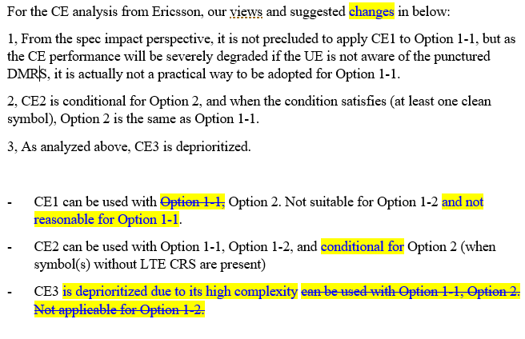  As indicated in our earlier comments (Ericcson1 in section 3.1.1), using both symbols (CE1) can be better than using only one symbol (CE2) at least for higher aggregation levels.  Below please find additional results with comparison between CE1 and CE2 (simulation assumptions same as 20MHz BW case given in our tdoc). Note: CE1 and CE2 description given in Ericsson3 comments in section 3.1.2.  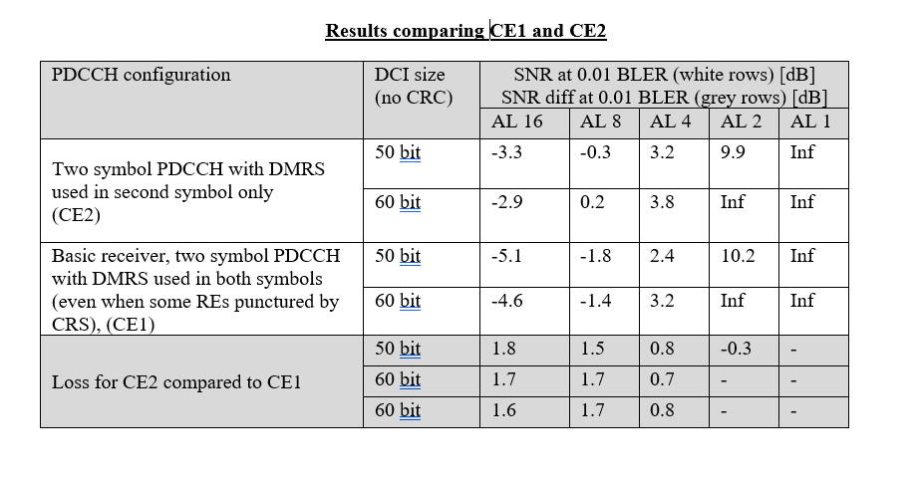  Also, we do not follow “- PDCCH DMRS REs overlapping with LTE CRS: Not expected” description. What is the motivation for such assumption?  Regarding Proposal#1-3  1 symbol CORESET overlapping with CRS (i.e., in sym#1) is more relevant than (Scenario#1: 2 symbols CORESET, all overlapped with CRS – Option 2 only). So. we suggest to include below scenario in place of Scenario#1.  Scenario#1_Alt: 1 symbol CORESET, overlapped with CRS – Option 2 only
Nokia, NSB | Wrt. Option 1-1, we tend to agree with Ericsson points  The “PDCCH DMRS REs overlapping with LTE CRS: Not expected” is unclear. In the figure it clearly is shown as punctured (by the receiver). Should we say here as well “Receiver punctures”?  In general there would be three different channel estimation implementations  - Use only the clean symbol  - Use both symbols, puncture the DMRS REs overlapping with CRS REs  - Use both symbols as in legacy, the CRS REs cause interference to the channel estimate. This alternative is perhaps not that attractive if the UE anyway knows that the DMRS REs are not going to be there, but understanding the performance of this option’s performance  From evaluation perspective it would be more interesting to look at least the first two. It is of course obvious that if only the first alternative is looked at, then by default option 1-2 will outperform option 1-1 and there is no need for any evaluation whatsoever as the comparison is uninteresting.  Wrt. Option 2: here also other implementation options than the plain legacy are of interest when evaluating performance. The full legacy implementation is obviously the most interesting to understand the minimum achievable performance when no CRS impact mitigating techniques are applied.
Huawei/Hisi | @Ericsson CE1 with polluted DMRS REs can achieve better performance than CE2 using only clean DMRS REs – this is beyond our expectation. Maybe we may add CE1 also for Option 1-1/1-2, but from the results of companies’ Tdocs, the results may be controversial, e.g., from R1-2203581, all AL<=8 will suffer an error floor under CE1.  ‘PDCCH DMRS REs overlapping with LTE CRS: Not expected’ - may be changed as ‘PDCCH DMRS REs overlapping with LTE CRS: All DMRS REs on overlapping symbol Not used for CE expected’  BTW, two comments as below:  - We may need to align the EVM for LTE CRS BPRE (or power ratio with NR PDCCH) for Option 2/CE1.  - We may need to evaluate the impact to LTE UEs if the CRS works in superposition mode.
MediaTek | We are generally fine with the proposal. However, as pointed out by Ericsson and Nokia, Scenario#1: 2 symbols CORESET, all overlapped with CRS – Option 2 only  might not be that significant compared to  Scenario#1_Alt: 1 symbol CORESET, overlapped with CRS – Option 2 only  Therefore, we suggest to remove  Scenario#1: 2 symbols CORESET, all overlapped with CRS – Option 2 only  and keep  Scenario#1_Alt: 1 symbol CORESET, overlapped with CRS – Option 2 only  We think one thing is missing in the proposal is the baseline for comparison in order to analyze the gain according to WID:  Investigate enabling LTE CRS to puncture NR PDCCH, including the impact to NR PDCCH DMRS if there is the performance gain from the additional PDCCH resources  Therefore, we suggest following update  Scenario#1: 1 symbols CORESET, all overlapped with CRS v.s. 1 symbol clean symbol – Option 2 only  Scenario#2: 2 symbols CORESET, including 1 overlapping symbol and 1 clean symbol v.s. 1 symbol clean symbol or 2 clean symbols– Option 1-1/1-2/2  Scenario#3: 3 symbols CORESET, including 1 overlapping symbol and 2 clean symbols v.s. 2 clean symbols – Option 1-1/1-2/2  We also have another general comment on how to simulate those scenarios for Option 2:  For the overlapped symbol(s), whether and how to simulate the superposistion?  Baseline: May puncture the PDCCH/PDCCH DMRS, or may superposition the two?
Samsung | We suggest to remove scenario 1. If there is overlapping with 2 CRS symbols, that means that the first and second symbols are used. PHICH/PCFICH on the first symbol also needs to be accounted for. That is not realistic.  OK with scenarios 2 and 3.
Xiaomi | We prefer removing scenario#1 too. Introducing a scenario only applied for Option 2 is meaningless.  According to our understanding, the advantage of CE#1 compared with CE#2 for scenario#2 is that, UE can perform channel estimation by the DMRS on two symbols. In this case, the temporal variation for CSI due to UE mobility can be captured. However, CE#1 also takes the polluted signal received on overlapped REs for channel estimation, which results in worse decoding performance. On the other hand, although the temporal variation for CSI cannot be captured by CE2, CE2 can provide more resources for PDCCH transmission, which is beneficial for decoding performance.  @ Ericsson, we observe that the UE speed offered in your Tdoc (R1-2204885) for LLS is 3km/h. In our expectation, the variation between two consecutive OFDM symbol is negligible. We cannot understand why the performance of CE#1 is much better than CE#2, can you explain that?
LG | OK with scenarios 2 and 3.  Regarding scenario 1, as Samsung commented in above, it seems to be unrealistic if the two CRS symbols are symbol index 0 and 1 (rather than symbol index 7 and 8).
Ericsson5 | Additional comments that we provided already on the reflector copied below.  - Spec impact: It would be good further discuss/converge on potential spec impact for different options (e.g. if time available this week). For next meeting, hopefully companies can consider providing example TPs. Our (Ericsson) understanding of spec impact is given in section 2.3 (+ any similar changes to 38.211) of R1-2204885. If companies see other/additional changes (e.g. for Options 1-1,1-2,2), having detailed proposal explaining them would help the discussion.  - Baseline used for comparison in the evaluations: The Rel17 baseline should be comparable to the corresponding evaluated Rel18 case. e.g., same #OFDM symbols for NR PDSCH. Assumption for #symbols used for LTE/NR PDCCH can of course be different between Rel17 baseline and corresponding evaluated Rel18 case.  We suggest to further consider below Proposal xyz and additional modification to Proposal#3  Proposal xyz (to capture as observation): Companies are encouraged to provide example TPs reflecting expected spec impact for the evaluated/proposed option(s)  Proposal#3 additional modifications compared to R1-2205356:  LTE support KPI ratio of LTE UEs Companies to report (e.g. total PDCCH capacity, fraction of LTE UEs, fraction of Rel-18 NR UEs, fraction of Rel-15/16 NR UEs, etc.). Companies to report considered baseline(s). Baseline(s) should be comparable to the evaluated option(s) (e.g. same #symbols used for NR PDSCH).  @Xiaomi: In sym#1 only every third PDCCH-DMRS RE is punctured by CRS and other DMRS REs are still ‘good’. So, comparing sym#1 only vs. sym#1+sym#2. using more DMRSs for CE (in spite of some affected by puncturing), i.e., as in CE2 appears to be beneficial at least at higher ALs. It would be good to check this through more evaluation

Update-4

Proposal#1-3:
For evaluations consider the following list of scenarios:
Scenario#1A: 1 symbol CORESET, overlapped with CRS – Option 2 only
Scenario#2: 2 symbols CORESET, including 1 overlapping symbol and 1 clean symbol – Option 1-1/1-2/2
Scenario#3: 3 symbols CORESET, including 1 overlapping symbol and 2 clean symbols – Option 1-1/1-2/2

Evaluation assumptions

LLS assumptions

Proposal #2: LLS simulations assumptions:

Parameters | Values
Carrier frequency | 2 GHz
SCS | 15 kHz
Bandwidth | 10 MHz
Channel model | TDL-C 300-100
Correlation | Low
Number of BS antennas | 4 Tx (Two cross-polarized antenna pairs)
Number of UE antennas | 2 Rx (One cross-polarized antenna pair)
DCI payload (excluding CRC) | 60 bits
Interleaving | Non-Interleaved
Precoding | Precoder cycling per REG bundle
REG bundle size | 6 PRBs
CRS | 4 port CRS
Channel estimation | practical – companies to report details
CORESET configuration | companies to report

Company | Comment
OPPO | We think the typical BW for NR is 20MHz (to align with SLS in Proposal 3), and the BW for LTE could be smaller than that of NR. In addition, the number of LTE CRS ports in case of LTE-NR coexistence can be 2.
Vivo | Same view as OPPO BW should be 20MHz.  For number of BS antennas, we suggest adding 2TX, companies can select one between 2TX and 4TX.
Nokia, NSB | The proposal is in principle agreeable. We would also suggest 20 MHz carrier BW to be added.
MediaTek | For channel bandwidth, we would like to add 5 MHz as a candidate.  For CRS, 4 port CRS should be the only candidate for the study, which is the motivation of this object. Moreover, more than 1 CRS pattern should be considered in the evaluation.  For channel estimation, we suggest to list some candidates to facilitate the discussion. Otherwise, it might be difficult to align the results from different companies. Also, this aspect might also have impact on the demodulation requirement in RAN4 and we prefer to align companies’ views on how to handle punctured DMRS in RAN1 discusison.  For CORESET configuration, it is not clear to us the meaning of this field. Is it for the CORESET symbol duration (2 symbols, 3 symbols)? Or the locations of PDCCH monitoring symbols (first 3 symbols, first 4 symbols in a slot)?
Apple | Number of symbols for PDCCH need to be specified, i.e., 1 or 2.
NTT DOCOMO | We are fine with the proposal.
Ericsson1 | Providing input for both link and system simulation assumptions here in one place.  Suggest aligning carrier frequency and BW (i.e., use 2GHz and 20MHz) for both link and system level simulation assumptions.  4Tx-2Rx (gNB-UE) antennas is OK. Perhaps good to clarify antenna configuration as below if not already common understanding  gNB: (M,N,P,Mg,Ng;Mp,Np)= (1,2,2,1,1;1,1)  UE: (M,N,P,Mg,Ng;Mp,Np)= (1,1,2,1,1;1,1)  On DCI payload, we think 60bits is on higher side considering the scheduling is for a 20MHz FDD carrier with above antenna configuration (i.e., no need for TCI indication etc.) and considering UL grants (DCI 0_1 based which are expected to be smaller) are sent along with DL assignments. We propose to include both 50bits and 60 bits in the evaluation.  Prefer to keep Uma as proposed by Moderator.  Finally, on Nokia comment on relevance of SLS, we somewhat agree. In our understanding the SLS assumptions (if used) are just to arrive at static SINR -> CCE aggregation level distributions and not for dynamic system level simulations.
Huawei/Hisi | We have following changing suggestions:  1, Bandwidth 20MHz. In addition, 5MHz/10MHz can also be optionally considered, as it is typical combination of narrow band 5MHz/10MHz LTE + wideband 20MHz NR for the re-farming scenarios. To ease the simulation, the simulation of NR runs on 5MHz/10MHz, while the capacity can be calculated by considering 20MHz (only 5MHz/10MHz part contributes capacity gain).  2, UE Speed should be added with 30km/h to be aligned with SLS EVM outdoor; in addition, a high speed case is also beneficial, e.g., 120km/h, 350km/h.
ZTE | We also agree that BW of 20MHz is more typical.  Regarding the channel model, we suggest to also add TDL-A as a candidate.  For interleaving, we think it more typical to use ‘Interleaved’ for PDCCH.
Xiaomi | Same view that the simulation BW should be 20MHz to align with SLS in Proposal 3.
Spreadtrum | Agree with HW. We think high-speed scenarios should be evaluated.
LG | We have similar view with other companies.  The BW of 20MHz can be added, and “Interleaved” may also be considered.  Regarding CORESET configuration, at least the location and the number of symbols need to be provided.
Samsung | OK to consider 20 MHz for the BW.  The UE speed is not expected to make much difference as the symbols are few (1 or 2) and next to each other. Suggest to pick one value as reference, e.g. 30 Kmph, and have other values optional.

Update-1
Dear all, I have changed to 20 MHz BW based on all the comments, separated out UE speed from channel model and added optional cases in []:

Proposal #2: LLS simulations assumptions, [] are optional:

Parameters | Values
Carrier frequency | 2 GHz
SCS | 15 kHz
Bandwidth | 20 MHz [5, 10 MHz]
Channel model | TDL-C 300, [TDL-A 300]
Correlation | Low
Number of BS antennas | 4 Tx, (M,N,P,Mg,Ng;Mp,Np)= (1,2,2,1,1;1,1)
Number of UE antennas | 2 Rx (M,N,P,Mg,Ng;Mp,Np)= (1,1,2,1,1;1,1)
DCI payload (excluding CRC) | 60 bits
Interleaving | Non-Interleaved, [Interleaved]
Precoding | Precoder cycling per REG bundle
REG bundle size | 6 PRBs
CRS | 4 port CRS
Channel estimation | practical – companies to report details
CORESET/PDCCH configuration | companies to report duration and starting symbol of PDCCH monitoring
UE speed | 30 kmph [120 kmph, 350 kmph]

Company | Comment
Ericsson2 | Thank you for the updates. We propose to use 50bits and 60bits as DCI payload for the evaluation as commented earlier (On DCI payload, we think 60bits is on higher side considering the scheduling is for a 20MHz FDD carrier with above antenna configuration (i.e., no need for TCI indication etc.) and considering UL grants (DCI 0_1 based which are expected to be smaller) are sent along with DL assignments. We propose to include both 50bits and 60 bits in the evaluation.)

Update-2
Can we take this as an offline agreement ?

Proposal #2: LLS simulations assumptions, [] are optional:

Parameters | Values
Carrier frequency | 2 GHz
SCS | 15 kHz
Bandwidth | 20 MHz [5, 10 MHz]
Channel model | TDL-C 300, [TDL-A 300]
Correlation | Low
Number of BS antennas | 4 Tx, (M,N,P,Mg,Ng;Mp,Np)= (1,2,2,1,1;1,1),  [2 Tx, (M,N,P,Mg,Ng;Mp,Np)= (1,1,2,1,1;1,1).]
Number of UE antennas | 2 Rx (M,N,P,Mg,Ng;Mp,Np)= (1,1,2,1,1;1,1)
DCI payload (excluding CRC) | 60 bits [50bits]
Interleaving | Non-Interleaved, [Interleaved]
Precoding | Precoder cycling per REG bundle
REG bundle size | 6 PRBs
CRS | 4 port CRS
Channel estimation | practical – companies to report details
CORESET/PDCCH configuration | companies to report duration and starting symbol of PDCCH monitoring
UE speed | 30 kmph [120 kmph, 350 kmph]

Company | Comment
MediaTek | For channel bandwidth, our original preference is to evaluate 5MHz/10MHz/20MHz. However, if only one values is selected, we suggest using 10MHz and consider 5 and 20MHz as optional. Note that this channel bandwidth is the overlapped channel bandwidth between NR and LTE and we are not sure assuming 20MHz is a practical scenarios but we are open to it.  For DCI sizes, we are ok to add 50 bits as optional if 70bits can also be added as optional.  For CRS ports, we support 4 ports CRS. However, should we also consider more than one CRS pattern? At least, 2 CRS patterns should be considered in our view.
Vivo | Thanks to FL to include 2TX, we support 2TX.  Metric for LLS evaluation should be included: for LLS, the metric is PDCCH capacity.  In addition, as we commented to proposal 1-1, assumptions of CORESET configuration (i.e., 1 CORESET or 1 R18 CORESET+1 R17 CORESET) should be specified.  For CRS ports, we support 4 ports CRS.
Xiaomi | We are generally fine with above assumptions. We suggest that UE speed of 3kmph is also included. In this way, more LLS performance curves of different scenarios can be obtained.
Ericsson3 | Prefer to include 3kmph as optional UE speed.  On MTK comment to add 70bit DCI, we are not OK. Could proponent clarify what DCI fields are needed for such payload size.
Huawei/Hisi | Generally OK with it. Basically we think the evaluation should consider the typical and worst cases, so 30km/h is the most typical case while 350km/h is one of the worst cases. But as other companies want to add 3km/h, we can accept to make it optional.  @Moderator to clarify: companies are encouraged to evaluate at least the baseline parameters, right (to align the performances over companies under exactly the same assumptions)?  30 kmph [3kmph, 120 kmph, 350 kmph]
LG | We are OK with the Proposal #2 from FL.

Update-3

Proposal #2: LLS simulations assumptions, [] are optional:

Parameters | Values
Carrier frequency | 2 GHz
SCS | 15 kHz
Bandwidth | 20 MHz [5, 10 MHz]
Channel model | TDL-C 300, [TDL-A 300]
Correlation | Low
Number of BS antennas | 4 Tx, (M,N,P,Mg,Ng;Mp,Np)= (1,2,2,1,1;1,1),  [2 Tx, (M,N,P,Mg,Ng;Mp,Np)= (1,1,2,1,1;1,1).]
Number of UE antennas | 2 Rx (M,N,P,Mg,Ng;Mp,Np)= (1,1,2,1,1;1,1)
DCI payload (excluding CRC) | 60 bits [50bits]
Interleaving | Non-Interleaved, [Interleaved]
Precoding | Precoder cycling per REG bundle
REG bundle size | 6 PRBs
CRS | 4 port CRS
Channel estimation | practical – companies to report details
CORESET/PDCCH configuration | companies to report duration and starting symbol of PDCCH monitoring
UE speed | 30 kmph [3kmph, 120 kmph, 350 kmph]

Company | Comment
vivo | As we commented in the last round, metric for LLS evaluation should be included: for LLS, the metric is PDCCH capacity.  Regarding the CORESET configuration, I think the duration of PDCCH is already specified in the agreed options and scenarios listed in Proposal#1-3, so it seems that duration can be removed. Or if I misunderstood anything?  Furthermore, regarding the BW of CORESET, is it assumed to be the same as carrier BW or is it up to each company to report? Hope FL could clarify.
Mod | @vivo, yes CORESET config. is from Proposal#1-3, my understanding is CORESET BW is same as carrier BW, for PDCCH capacity see SLS table below. Let me propose this  CORESET/PDCCH configuration companies to report duration and starting symbol of PDCCH monitoring
MediaTek | We share the same view with vivo and Huawei that the metrics are missing and the CORESET/PDCCH configuration should follow Proposal 1-3, as mentioned by Moderator. In addition to the PDCCH capacity gain and LTE UE coexistence, we would like to add: coexistence with Rel-15/16/17 UEs.
Mod2 | @MTK, thanks – let us have the coexistance discussion with Proposal#3:  One more comment I missed from Huawei, so my proposal is this;  CORESET/PDCCH configuration companies to report duration and starting symbol of PDCCH monitoring  Power ratio of LTE-CRS RE/NR RE Companies to report (if applicable)
Samsung | OK with the proposal.  Although we agree with E/// that 50 bits (+24 CRC) is more typical, fine with 60 bits in order to have a basic common evaluation scenario.  The speed can be 30 Kmph – other higher/lower speeds at 2 GHz will not make a difference in the conclusions as PDCCH is over few adjacent symbols.
Xiaomi | Support the proposal.  After obtaining the simulation curves, the difference in performance at different UE speeds can be observed.
LG | OK with the proposal.  Regarding CORESET/PDCCH configuration, as others commented in above, we also think it may be able to follow Proposal 1-3.

Update-4

Proposal #2: LLS simulations assumptions, [] are optional:

Parameters | Values
Carrier frequency | 2 GHz
SCS | 15 kHz
Bandwidth | 20 MHz [5, 10 MHz]
Channel model | TDL-C 300, [TDL-A 300]
Correlation | Low
Number of BS antennas | 4 Tx, (M,N,P,Mg,Ng;Mp,Np)= (1,2,2,1,1;1,1),  [2 Tx, (M,N,P,Mg,Ng;Mp,Np)= (1,1,2,1,1;1,1).]
Number of UE antennas | 2 Rx (M,N,P,Mg,Ng;Mp,Np)= (1,1,2,1,1;1,1)
DCI payload (excluding CRC) | 60 bits [50bits]
Interleaving | Non-Interleaved, [Interleaved]
Precoding | Precoder cycling per REG bundle
REG bundle size | 6 PRBs
CRS | 4 port CRS
Channel estimation | practical – companies to report details
UE speed | 30 kmph [3kmph, 120 kmph, 350 kmph]
Power ratio of LTE-CRS RE/NR RE | Companies to report (if applicable)

SLS assumptions

Proposal #3: SLS simulations assumptions:

Parameters | Values
Carrier frequency | 2.1 GHz
SCS | 15 kHz
Simulation bandwidth | 20 MHz
BS antenna height | 25 m
UE height | 1.5m
TRP transmit power | 49 dBm 20 MHz
Scenario | Urban Macro
ISD | 500m
Device deployment | 80% indoor, 20% outdoor
UE speeds | Indoor users: 3km/h
 | Outdoor users (in-car): 30 km/h
BS noise figure | 5 dB
BS antenna element gain | 8 dBi
UE noise figure | 9 dB
Thermal noise level | -174 dBm/Hz
Traffic | Full Buffer
Macro sites | 19
Downtilt | 102°
Minimum BS to UE distance | 35m

Company | Comment
OPPO | The above evaluation assumptions do not seem to account for the challenging condition in which some of the PDCCH DMRS REs are missing, for example,  - In time domain, for Tx option-1, PDCCH DMRS may occur only on one symbol (if the number of CRS ports is 4), then a low UE speed (up to 30km/h, which is roughly a school-zone limit in some area) could be in favor of the sparse DMRS density in time domain.  - In frequency domain, the puncturing of PDCCH DMRS effectively makes the frequency domain channel selectivity to be less trackable by DMRS. For this issue, our understanding is that the RMa channel model may suffer more than Uma.
Nokia, NSB | Mix of indoor/outdoor is not recommended. In general we would aim to avoid a SLS sim campaign in a 2-meeting WI.
Huawei/Hisi | We are fine with the SLS table, with one suggestion that Rma can be considered also, since 2.1GHz is used for wide area coverage by many operators. Considering the SLS CDF of geometry is easy to be obtained, it will not add big efforts on simulation.
Xiaomi | Fine with the proposal.
Samsung | We don’t see a need for SLS simulations and it is unlikely to have calibrated and easily comparable results. Also, all insight for the present case can be obtained from LLS.

Update-1

Dear all, thanks for the comments, for PDCCH capacity some SLS scenario is useful guidance perhaps, but if we cannot agree its also fine, I expect most of the GTW time for proposal-1
Proposal #3: SLS simulations assumptions, [] are optional:

Parameters | Values
Carrier frequency | 2.1 GHz
SCS | 15 kHz
Simulation bandwidth | 20 MHz
BS antenna height | 25 m
UE height | 1.5m
TRP transmit power | 49 dBm 20 MHz
Scenario | Urban Macro, [Rma]
ISD | 500m
Device deployment | 80% indoor, 20% outdoor
UE speeds | Indoor users: 3km/h
 | Outdoor users (in-car): 30 km/h
BS noise figure | 5 dB
BS antenna element gain | 8 dBi
UE noise figure | 9 dB
Thermal noise level | -174 dBm/Hz
Traffic | Full Buffer
Macro sites | 19
Downtilt | 102°
Minimum BS to UE distance | 35m

Company | Comment

Update-2

Pls. comment if any concerns on taking this as an offline agreement:

Proposal #3: SLS simulations assumptions, [] are optional:

Parameters | Values
Carrier frequency | 2.1 GHz
SCS | 15 kHz
Simulation bandwidth | 20 MHz
BS antenna height | 25 m
UE height | 1.5m
TRP transmit power | 49 dBm 20 MHz
Scenario | Urban Macro (500m ISD), [Rma (1732m ISD)]
Device deployment | 80% indoor, 20% outdoor (Uma) [50% indoor,50% in-car (Rma)]
UE speeds | Indoor users: 3km/h
 | Outdoor users (in-car): 30 km/h
BS noise figure | 5 dB
BS antenna element gain | 8 dBi
UE noise figure | 9 dB
Thermal noise level | -174 dBm/Hz
Traffic | Full Buffer
Macro sites | 19
Downtilt | 102° or according to Scenario
Minimum BS to UE distance | 35m

Company | Comment
MediaTek | We only have comment on the channel bandwidth and we suggest to be 10MHz to reflect the overlapped channel bandwidth between NR and LTE.
Qualcomm | We would suggest to include a row for companies to report ratio of UEs supporting PDCCH reception with LTE CRS REs.
Xiaomi | Support
Huawei/Hisi | Support in principle, with minor change of aligning the BW with LLS: 20 MHz [5, 10 MHz]

Update-3

Proposal #3: SLS simulations assumptions, [] are optional:

Parameters | Values
Carrier frequency | 2.1 GHz
SCS | 15 kHz
Simulation bandwidth | 20 MHz [5, 10 MHz]
BS antenna height | 25 m
UE height | 1.5m
TRP transmit power | 49 dBm 20 MHz
Scenario | Urban Macro (500m ISD), [Rma (1732m ISD)]
Device deployment | 80% indoor, 20% outdoor (Uma) [50% indoor,50% in-car (Rma)]
UE speeds | Indoor users: 3km/h
 | Outdoor users (in-car): 30 km/h
BS noise figure | 5 dB
BS antenna element gain | 8 dBi
UE noise figure | 9 dB
Thermal noise level | -174 dBm/Hz
Traffic | Full Buffer
Macro sites | 19
Downtilt | 102° or according to Scenario
Minimum BS to UE distance | 35m
LTE support | ratio of LTE UEs

Company | Comment
Qualcomm | We suggested to have a row for each company to indicate “ratio of Rel-18 UEs supporting NR-PDCCH reception with LTE CRS REs”.
vivo | If it is up to the company to report the ratio, it does not seem necessary to add a row to the table.
Mod | Given the comments above, let me propose this:  LTE support KPI ratio of LTE UEs Companies to report (e.g. total PDCCH capacity, fraction of LTE UEs, fraction of Rel-18 NR UEs)
Xiaomi | Support the proposal.

Update-4

Proposal #3: SLS simulations assumptions, [] are optional:

Parameters | Values
Carrier frequency | 2.1 GHz
SCS | 15 kHz
Simulation bandwidth | 20 MHz [5, 10 MHz]
BS antenna height | 25 m
UE height | 1.5m
TRP transmit power | 49 dBm 20 MHz
Scenario | Urban Macro (500m ISD), [Rma (1732m ISD)]
Device deployment | 80% indoor, 20% outdoor (Uma) [50% indoor,50% in-car (Rma)]
UE speeds | Indoor users: 3km/h
 | Outdoor users (in-car): 30 km/h
BS noise figure | 5 dB
BS antenna element gain | 8 dBi
UE noise figure | 9 dB
Thermal noise level | -174 dBm/Hz
Traffic | Full Buffer
Macro sites | 19
Downtilt | 102° or according to Scenario
Minimum BS to UE distance | 35m
LTE support KPI | Companies to report (e.g. total PDCCH capacity, PDCCH coverage/outage, Potential degradation of LTE, fraction of LTE UEs, fraction of Rel-18 DSS NR UEs, whether and how to achieve coexistence with legacy Rel-15/16 UEs, etc.). Companies to report considered baseline(s). Baseline(s) should be comparable to the evaluated option(s)

Further clarifications

Issues | Comment
option 1-1, spec. impact | Company 1:  Company 2:
option 1-2, spec. impact | Company 1:  Company 2:
option 2, spec. impact | Company 1:  Company 2:
Spec. impact from applicability restrictions (e.g. Case 1-4 of Proposal#1-1) | Company 1:  Company 2:
Other specification impact (UE capability etc.) | Company 1:  Company 2:
KPI Clarifications (e.g. how to determine PDCCH capacity, how to evaluate legacy NR UEs etc.) | Company 1:  Company 2:

References

[1] RP-213575, New WI: Enhancement of NR Dynamic spectrum sharing (DSS), Ericsson, 3GPP TSG RAN Meeting #94e, Electronic Meeting, Dec. 6 - 17, 2021.
[2] R1-2203137, Discussion on NR PDCCH reception in symbols with LTE CRS REs Huawei, HiSilicon
[3] R1-2203210 Discussion on NR PDCCH reception for DSS ZTE
[4] R1-2203344 Discussion on NR PDCCH reception in symbols with LTE CRS Res Spreadtrum Communications
[5] R1-2203581 Discussion on PDCCH reception on CRS symbol vivo
[6] R1-2203648 Evaluation of NR PDCCH overlapping with LTE CRS InterDigital, Inc.
[7] R1-2203834 Discussion on NR PDCCH reception in symbols with LTE CRS REs xiaomi
[8] R1-2203923 Considerations on PDCCH receptions in symbols with LTE CRS Samsung
[9] R1-2204024 Discussion on NR PDCCH reception in symbols with LTE CRS REs OPPO
[10] R1-2204260 Discussion on NR PDCCH reception in symbols with LTE CRS REs Apple
[11] R1-2204323 Discussion on NR PDCCH reception in symbols with LTE CRS REs CMCC
[12] R1-2204395 Discussion on NR PDCCH reception in symbols with LTE CRS REs NTT DOCOMO, INC.
[13] R1-2204630 Discussion on NR PDCCH reception in symbols with LTE CRS REs LG Electronics
[14] R1-2204709 Discussion on NR PDCCH reception in symbols with LTE CRS REs MediaTek Inc.
[15] R1-2204815 Discussion on NR PDCCH reception in DSS Intel Corporation
[16] R1-2204823 NR PDCCH overlapping with LTE CRS Nokia, Nokia Shanghai Bell
[17] R1-2204885 NR PDCCH reception in symbols with LTE CRS REs Ericsson
[18] R1-2205049 NR PDCCH reception in symbols with LTE CRS REs Qualcomm Incorporated

Appendix (Summary of the agreements)
The agreements made in RAN1#TBD meetings are provided below.

