3GPP TSG RAN WG1 Meeting #109-e R1-22xxxxx
9th May – 20th May 2022
Agenda Item: 8.10
Source: Moderator (Qualcomm Incorporated)
Title: Summary #1 of [109-e-R17-eIAB-03]
Document for: Discussion and decision

Introduction
This contribution provides a summary of the following email discussion:
[109-e-R17-eIAB-03] Issues #6, #7, #9, #10, #13, #14, #16 by May 20 – Luca (Qualcomm)
- This email discussion is to start on May 16

The referenced issues #6, #7, #9, #10, #13, #14, and #16 were identified in the preparation phase [109-e-Prep-AI8.10-eIAB] based on the contributions [1] – [13] and were prioritized as priority 3.
Discussion topics are purple background highlighted.
FL agreements or conclusions from email discussion and/or online sessions are green background highlighted.
Active discussion items for which companies’ input is sought are yellow background highlighted.
Inactive discussion topics are grey highlighted.
New text from the moderator in each round of discussion after the initial revision is highlighted in green.

Summary
This discussion covers 7 issues identified based on the contributions [1] – [13] submitted for agenda item 8.10.
Issue #6. Handling of multiple DCI format 2_5 indications with overlapping durations
- References: [3], [10], [11]
- No upper layer signaling impact – priority 3
Issue #7. Brackets in definition of H/S/NA for RB set
- References: [6], [7], [10], [13].
- No upper layer signaling impact – priority 3
Issue #9. Extension of exception for cell-specific/semi-static signals to soft or not available RB sets
- References: [7], [9], [13]
- No upper layer signaling impact – priority 3
Issue #10. Update to determination of availability in DC scenario
- References: [13]
- No upper layer signaling impact – priority 3
Issue #13. DL Tx power adjustment MAC-CE
- References: [13]
- No upper layer signaling impact – priority 3
Issue #14. Descriptions of MT’s UL MAC-CEs
- References: [13]
- No upper layer signaling impact – priority 3
Issue #16. Alignment of parameters names
- References: [13]
- No upper layer signaling impact – priority 3

Discussion

Issue #6. Handling of multiple DCI format 2_5 indications with overlapping durations
This issue relates to a potential limitation in the current specification for the scenario in which there is a desire to release of Soft resources via DCI Format 2_5 following different periodicities amongst different DU cells associated with the MT cell
Related input from contributions:
ZTE  [3] | Proposal 5: For multiple DCI Format 2_5 indications with overlapping durations, Rel-16 mechanism is reused.
Ericsson  ]10] | Proposal 11 One availabilityCombination of the availabilityCombinations table is reserved to signal to the IAB-DU that “No new Availability Indication is provided” in DCI format 2_5 for slots which receive multiple Availability Indicators.
ETRI  [11] | Proposal 3. RAN1 to clarify that with proper configurations there are no potential issues from multiple DCI Format 2_5 indications with overlapping durations.

Conclusion (RAN1-108e)
Defer discussion (contribution driven) of potential issues/solutions for multiple DCI Format 2_5 indications with overlapping durations until RAN1#109-e.

Summary of views:
- [3] proposed to reuse Rel-16 mechanism
- [10] proposed to reserve an entry in the availabilityCombinations table to signal to the IAB-DU that “No new Availability Indication is provided” in DCI format 2_5 for slots which receive multiple Availability Indicators.
- [11] proposed to clarify that there is no issue, with proper configuration.

Based on the input on this issue the FL recommends getting additional input from more companies.

FL Proposal 3.1a
RAN1 to downselect in RAN1#109-e one of the following alternatives:
- Alt1: in Rel17 there is no additional specification for handling of multiple DCI Format 2_5 indications with overlapping durations.
- Alt2: One availabilityCombination of the availabilityCombinations table is reserved to signal to the IAB-DU that “No new Availability Indication is provided” in DCI format 2_5 for slots which receive multiple Availability Indicators.

Company | Do you agree with FL Proposal 3.1a?  Views on Alt1 vs. Alt2? | Comments
Ericsson | Support the proposal, prefer Alt2 | Considering the limited amount of availabilityCombination(s), i.e., resourceAvailability(s), in the RRC DCI format 2_5 configuration, we think the existing resolution of overlapping DCIs in Rel-16 is not applicable. Alt. 2 has no signaling impact and would circumvent the otherwise required coordination on consecutive and overlapping DCI format 2_5.
Nokia | Preference for Alt.1 | Our understanding is that this is still an optimization related to Rel-16 IAB behavior in recovering DCI format 2_5. For this reason, we do not see this as a proposal that should be considered as a part of Rel-17 maintenance.
ZTE, Sanechips | Alt 1 | No additional enhancement is needed.
vivo | Alt1
NTT Docomo | Alt.1
Samsung | Alt.1 | We think Rel-16 mechanism still works in Rel-17.
Huawei, HiSi | Alt.1 | As another alternative, if two DCI format 2_5 indications have overlapping durations, the IAB-MT ignores the indication for duration of the later DCI format 2_5 that are overlapped with the previous DCI format 2_5.
Intel | Alt.1

Issue #7. Brackets in definition of H/S/NA for RB set
This issue relates to…
Related input from contributions:
Samsung  [6] | Proposal 2: In the definition for FDM Hard, remove “[provided it does not impact the IAB-MT’s ability to transmit and receive in any other RB set that is configured as Not Available or configured as Soft and not indicated available]”.
NTT DOCOMO  [7] | Proposal 2: Adopt the following TP for TS 38.213 section 14.  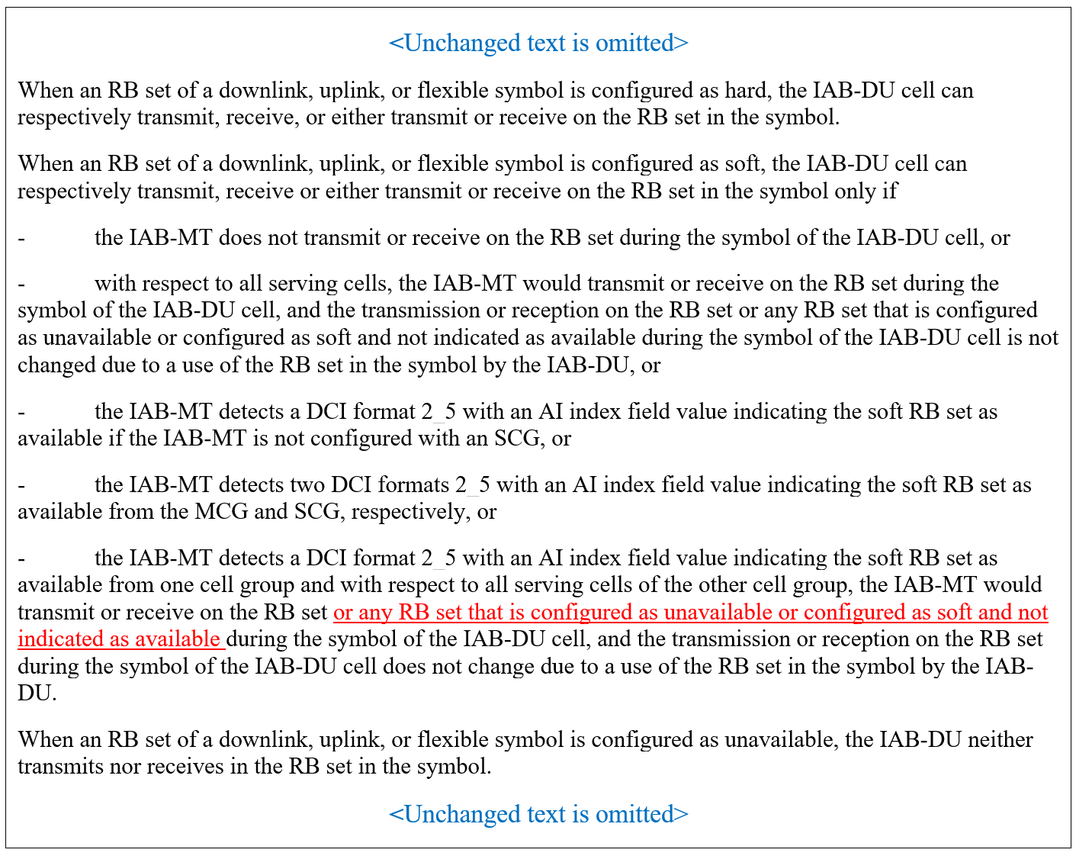
Ericsson  ]10] | Proposal 6 Remove the brackets in the definition of frequency domain H/S/NA from the agreement of the RAN1#108-e meeting and agree on the following text proposal.  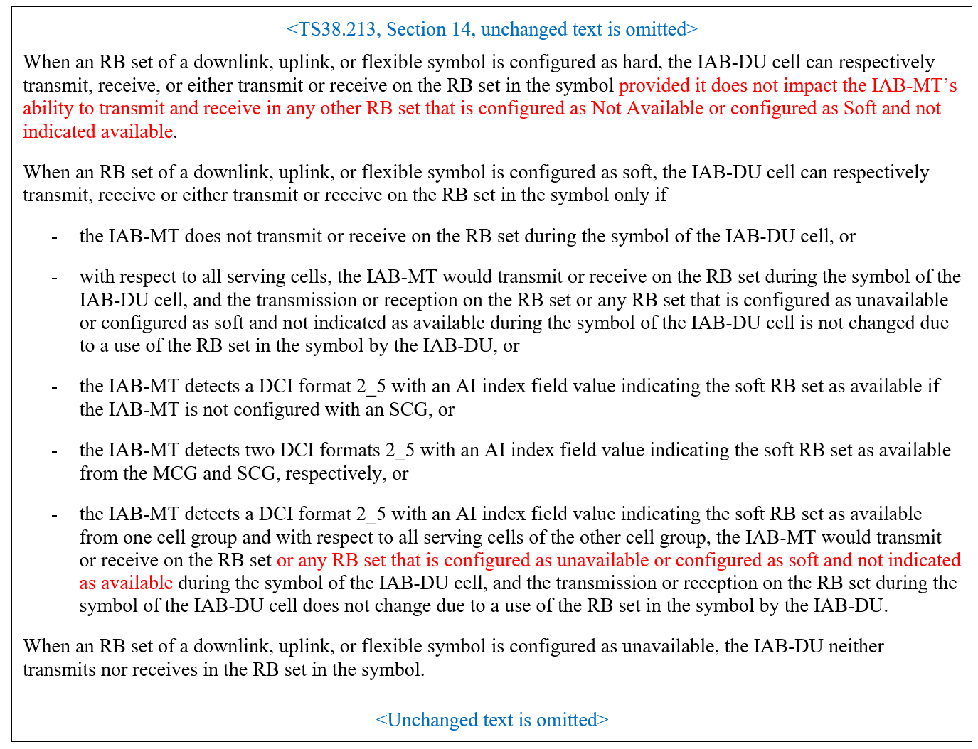
Qualcomm  [13] | Proposal 3.2  Adopt to the following text proposal for soft RB sets in 38.213:  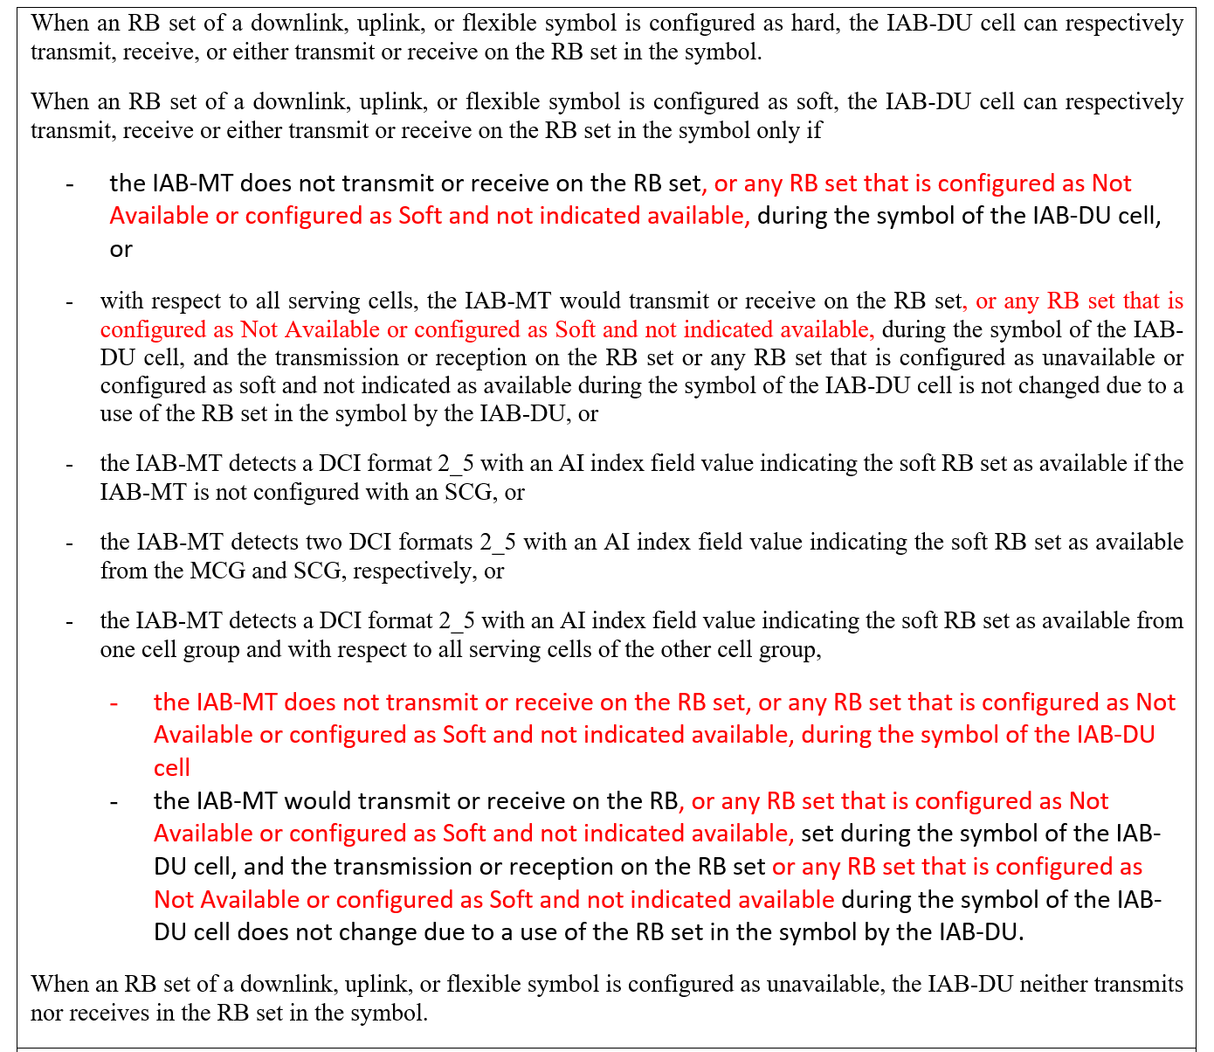

RAN1#108-e achieved the following agreement, in which there are some clauses in the brackets that may need further discussions and clarifications.
Agreement (RAN1#108-e)
Adopt the following definition for H/S/NA configured in an RB set of a symbol:
- FDM Hard: When an RB set of a downlink, uplink, or flexible symbol is configured as hard, the IAB-DU cell can respectively transmit, receive, or either transmit or receive on the RB set in the symbol [provided it does not impact the IAB-MT’s ability to transmit and receive in any other RB set that is configured as Not Available or configured as Soft and not indicated available].
- FDM Soft: When an RB set of a downlink, uplink, or flexible symbol is configured as soft, the IAB-DU cell can respectively transmit, receive or either transmit or receive on the RB set in the symbol only if
  - the IAB-MT does not transmit or receive on the RB set during the symbol of the IAB-DU cell, or
  - with respect to all serving cells,
    - the IAB-MT would transmit or receive on the RB set during the symbol of the IAB-DU cell, and the transmission or reception on the RB set [or any adjacent RB set that is configured as Not Available or configured as Soft and not indicated available] during the symbol of the IAB-DU cell is not changed due to a use of the RB set in the symbol by the IAB-DU, or
  - if the IAB-MT is not configured with SCG
    - if the IAB-MT detects a DCI format 2_5 with an AI index field value indicating the soft RB set as available
  - if the IAB-MT is configured with SCG
    - the IAB-MT detects two DCI formats 2_5 with an AI index field value indicating the soft RB set as available from MCG and SCG respectively, or
    - the IAB-MT detects a DCI format 2_5 with an AI index field value indicating the soft symbol RB set as available from one cell group (either MCG or SCG), and, with respect to all serving cells of the other cell group:
      - the IAB-MT would transmit or receive on the RB set during the symbol of the IAB-DU cell, and the transmission or reception on the RB set during the symbol of the IAB-DU cell is not changed due to a use of the RB set in the symbol by the IAB-DU.
- FDM NA: When an RB set of a downlink, uplink, or flexible symbol is configured as unavailable, the IAB-DU neither transmits nor receives at the RB set in the symbol.

38.213(V17.1.0) currently has the following related clause.
When an RB set of a downlink, uplink, or flexible symbol is configured as hard, the IAB-DU cell can respectively transmit, receive, or either transmit or receive on the RB set in the symbol.
When an RB set of a downlink, uplink, or flexible symbol is configured as soft, the IAB-DU cell can respectively transmit, receive or either transmit or receive on the RB set in the symbol only if
- the IAB-MT does not transmit or receive on the RB set during the symbol of the IAB-DU cell, or
- with respect to all serving cells, the IAB-MT would transmit or receive on the RB set during the symbol of the IAB-DU cell, and the transmission or reception on the RB set or any RB set that is configured as unavailable or configured as soft and not indicated as available during the symbol of the IAB-DU cell is not changed due to a use of the RB set in the symbol by the IAB-DU, or
- the IAB-MT detects a DCI format 2_5 with an AI index field value indicating the soft RB set as available if the IAB-MT is not configured with an SCG, or
- the IAB-MT detects two DCI formats 2_5 with an AI index field value indicating the soft RB set as available from the MCG and SCG, respectively, or
- the IAB-MT detects a DCI format 2_5 with an AI index field value indicating the soft RB set as available from one cell group and with respect to all serving cells of the other cell group, the IAB-MT would transmit or receive on the RB set during the symbol of the IAB-DU cell, and the transmission or reception on the RB set during the symbol of the IAB-DU cell does not change due to a use of the RB set in the symbol by the IAB-DU.
When an RB set of a downlink, uplink, or flexible symbol is configured as unavailable, the IAB-DU neither transmits nor receives in the RB set in the symbol.

Summary of views:
- Regarding FDM Hard:
  - Remove “[provided it does not impact the IAB-MT’s ability to transmit and receive in any other RB set that is configured as Not Available or configured as Soft and not indicated available]”
    - Supported by [6], [7], [13]
  - Include “provided it does not impact the IAB-MT’s ability to transmit and receive in any other RB set that is configured as Not Available or configured as Soft and not indicated available”
    - Supported by [10]
- Regarding FDM Soft:
  - Include “or any RB set that is configured as Not Available or configured as Soft and not indicated available”
    - Supported by [6], [7], [10], [13]
- [7], [10], and [13] provided related TPs.
There is consensus amongst the companies that provided input on this issue about removing the square brackets around “or any RB set that is configured as Not Available or configured as Soft and not indicated available” for the FDM Soft definition in the aforementioned RAN1#108-e agreement.
There is a majority amongst the companies that provided input on this issue about removing the text “provided it does not impact the IAB-MT’s ability to transmit and receive in any other RB set that is configured as Not Available or configured as Soft and not indicated available” within square brackets around for the FDM Hard definition in the aforementioned RAN1#108-e agreement. The FL assessment of this aspect is aligned with the majority view because:
a) it keeps the definition of a Hard resource consistent with the Rel16 definition whereby a Hard resource can be used unconditionally by the IAB-DU, and
b) there will ne no guarantee that the cell-specific/semi-static signals for which a protection is desired to be in place as for Rel16 (see issue #9) without further changes to the specification (being equivalent to a Hard resource provides no guarantee of ability to use).
Moreover the FL notes that the potentially impacted specification text is also potentially subject to additional unrelated modifications based on the discussion of other issues, hence it is proposed to agree on an amendment of the related RAN1#108-e agreement and then a TP can be defined later once all issues are (hopefully) closed.

FL Proposal 3.2a
The following RAN1#108-e agreement is amended as:
Agreement (RAN1#108-e)
Adopt the following definition for H/S/NA configured in an RB set of a symbol:
- FDM Hard: When an RB set of a downlink, uplink, or flexible symbol is configured as hard, the IAB-DU cell can respectively transmit, receive, or either transmit or receive on the RB set in the symbol [provided it does not impact the IAB-MT’s ability to transmit and receive in any other RB set that is configured as Not Available or configured as Soft and not indicated available].
- FDM Soft: When an RB set of a downlink, uplink, or flexible symbol is configured as soft, the IAB-DU cell can respectively transmit, receive or either transmit or receive on the RB set in the symbol only if
  - the IAB-MT does not transmit or receive on the RB set during the symbol of the IAB-DU cell, or
  - with respect to all serving cells,
    - the IAB-MT would transmit or receive on the RB set during the symbol of the IAB-DU cell, and the transmission or reception on the RB set [or any adjacent RB set that is configured as Not Available or configured as Soft and not indicated available] during the symbol of the IAB-DU cell is not changed due to a use of the RB set in the symbol by the IAB-DU, or
  - if the IAB-MT is not configured with SCG
    - if the IAB-MT detects a DCI format 2_5 with an AI index field value indicating the soft RB set as available
  - if the IAB-MT is configured with SCG
    - the IAB-MT detects two DCI formats 2_5 with an AI index field value indicating the soft RB set as available from MCG and SCG respectively, or
    - the IAB-MT detects a DCI format 2_5 with an AI index field value indicating the soft symbol RB set as available from one cell group (either MCG or SCG), and, with respect to all serving cells of the other cell group:
      - the IAB-MT would transmit or receive on the RB set during the symbol of the IAB-DU cell, and the transmission or reception on the RB set during the symbol of the IAB-DU cell is not changed due to a use of the RB set in the symbol by the IAB-DU.
- FDM NA: When an RB set of a downlink, uplink, or flexible symbol is configured as unavailable, the IAB-DU neither transmits nor receives at the RB set in the symbol.

Company | Do you agree with FL Proposal 3.2a? | Comments
Ericsson | Yes and no | We agree the removal of the brackets in the specification on the use of FDM Soft resources.  We disagree on the removal of the bracketed text for the FDM Hard resources. While we agree with the FL assessment to keep the definition of a Hard resource consistent with the Rel16 definition, in Rel-16 there was no possibility that TDM Hard resources would affect any adjacent frequency resources. The intention of H/S/NA in Rel-16 and Rel-17 is to coordinate MT and collocated DU resources. In other words, resources that are indicated to the parent node as available for the parent link (such as DU NA resources) should actually be usable. Since in FDM there is potentially interference between frequency resources within the same band, and since there is no agreement about guard band or signaling thereof that would allow the parent DU to adjust the use of NA or Soft-INA resources for the IAB-MT, only the IAB-DU can take responsibility of the interference and thereby guarantee that the parent node can used DU NA resources. Hence, the IAB-DU cannot unconditionally use Hard resources.
Nokia | Agree
ZTE, Sanechips | Agree
Vivo | Agree
NTT Docomo | Agree
Samsung | Yes | Agree with the FL assessment. In addition, our view is that guard band is either up to IAB or parent IAB and then, hard resource can be unconditionally used by IAB DU as in Rel-16.
Huawei, HiSi | Agree | We tend to agree the TP.
Intel | Agree

Issue #9. Extension of exception for cell-specific/semi-static signals to soft or not available RB sets
This issue relates to the TP for the RAN1#104-e agreement on the Extension of exception for cell-specific/semi-static signals to soft or not available RB sets.
Related input from contributions:
NTT DOCOMO  [7] | Proposal 1: Adopt the following TP for TS 38.213 section 14.  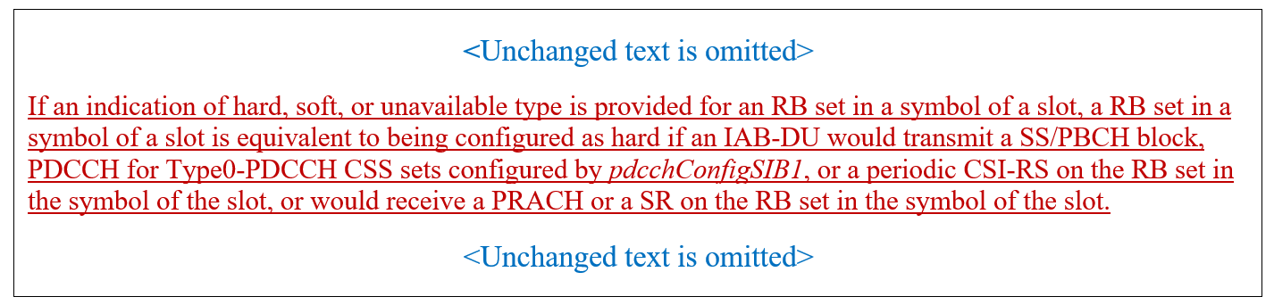
LG Electronics  [9] | Proposal 1: Capture the following TP for TS 38.213 on frequency resource for cell-specific/semi-static signals and channels.  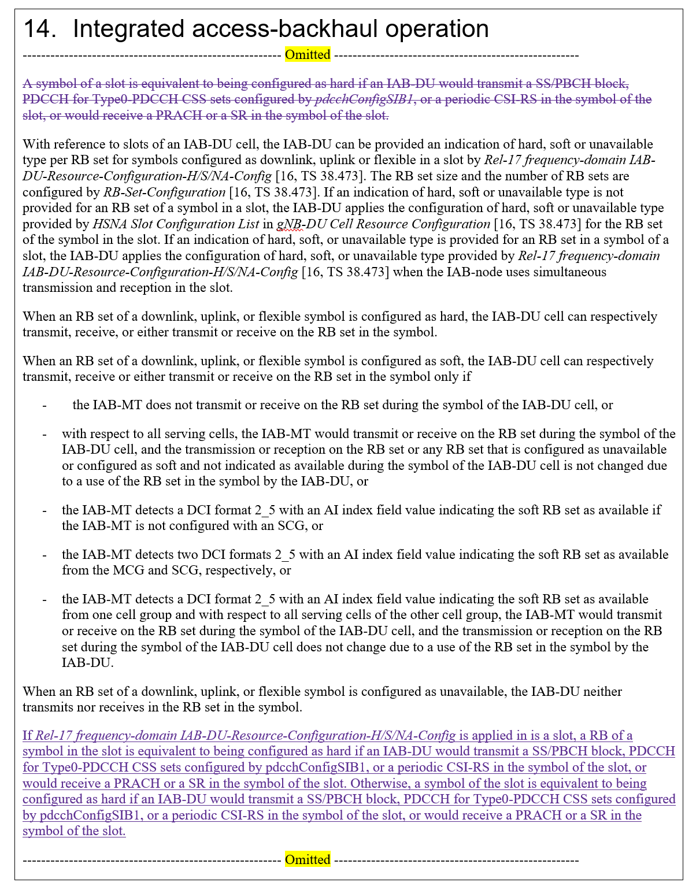
Qualcomm  [13] | Proposal 4.2  Adopt the following text proposal for cell-specific/semi-static signals in the frequency domain in 38.213:  An RB set of a symbol is equivalent to being configured as hard if an IAB-DU would transmit a SS/PBCH block, PDCCH for Type0-PDCCH CSS sets configured by pdcchConfigSIB1, or a periodic CSI-RS in the RB set of the symbol, or would receive a PRACH or a SR in the RB set of the symbol.

RAN1#104-e agreed to the following.
Agreement (RAN1-104e)
Regardless of simultaneous operation, the same cell-specific/semi-static signals and channels of the IAB-DU considered as hard time/frequency resources in Rel-16 are also considered as hard time/frequency resources in Rel-17.
FFS: IAB-MT behavior in case of conflicts between cell-specific signals/channels and other resource configurations of the IAB-MT (e.g., dedicated slot configurations)

38.213 has the following clause (from Rel-16)
A symbol of a slot is equivalent to being configured as hard if an IAB-DU would transmit a SS/PBCH block, PDCCH for Type0-PDCCH CSS sets configured by pdcchConfigSIB1, or a periodic CSI-RS in the symbol of the slot, or would receive a PRACH or a SR in the symbol of the slot.

Summary of views:
- [7], [9] and [13] have TPs to extend the above 38.213 clause to the RB sets.
The FL has a slight preference for keeping the Rel-16 version of the clause unchanged and adding the same clause in which ‘symbol’ is replaced with ‘RB set of a symbol’.

FL Proposal 3.3a
Adopt the following TP in clause 14 of TS38.213:
An RB set of a symbol is equivalent to being configured as hard if an IAB-DU would transmit a SS/PBCH block, PDCCH for Type0-PDCCH CSS sets configured by pdcchConfigSIB1, or a periodic CSI-RS in the RB set of the symbol, or would receive a PRACH or a SR in the RB set of the symbol.

Company | Do you agree with FL Proposal 3.3a? | Comments
Ericsson | Support | With proper resource configuration we do not think there should be a collision between cell-specific signals and channels and DU FDM guard band resources as discussed in Proposal 3.2a.
Nokia | Agree
ZTE, Sanechips | Agree
Vivo | Agree
NTT Docomo | Agree
Samsung | Yes
Huawei, HiSi | Agree
Intel | Agree

Issue #10. Update to determination of availability in DC scenario
This issue relates to a correction in the description of the implicit determination of availability of a Soft resource for the DC scenario.
Related input from contributions:
Qualcomm  [13] | Proposal 4.1  Adopt to the following text proposal for soft symbols in 38.213:  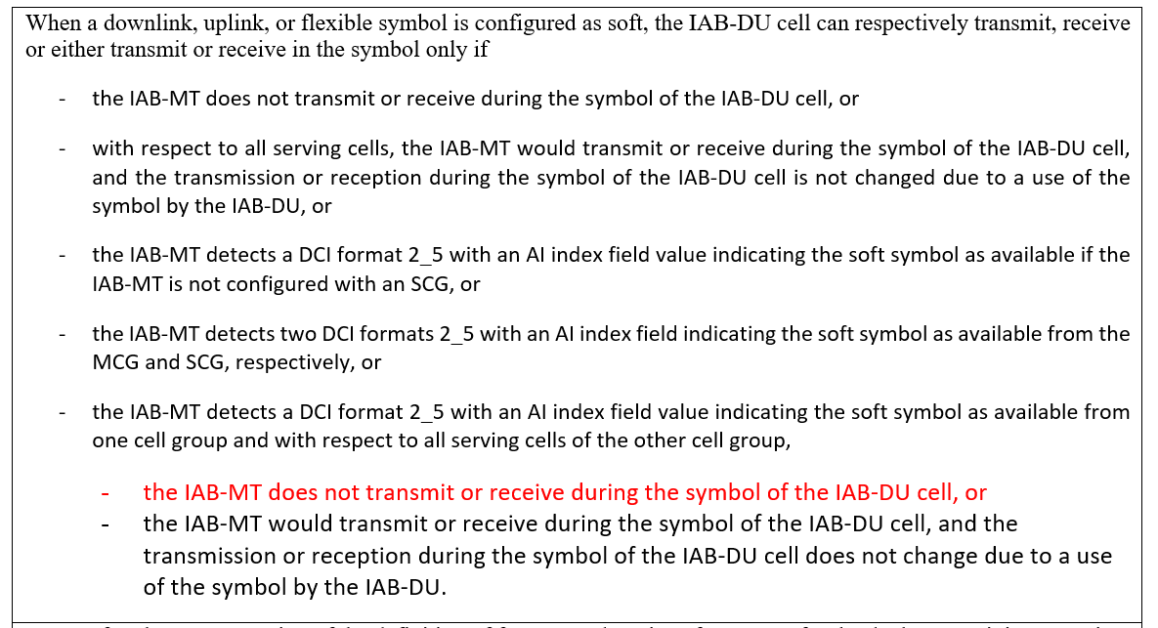

38.213(V17.1.0) currently has the following related clauses:
When a downlink, uplink, or flexible symbol is configured as soft, the IAB-DU cell can respectively transmit, receive or either transmit or receive in the symbol only if
- the IAB-MT does not transmit or receive during the symbol of the IAB-DU cell, or
- with respect to all serving cells, the IAB-MT would transmit or receive during the symbol of the IAB-DU cell, and the transmission or reception during the symbol of the IAB-DU cell is not changed due to a use of the symbol by the IAB-DU, or
- the IAB-MT detects a DCI format 2_5 with an AI index field value indicating the soft symbol as available if the IAB-MT is not configured with an SCG, or
- the IAB-MT detects two DCI formats 2_5 with an AI index field indicating the soft symbol as available from the MCG and SCG, respectively, or
- the IAB-MT detects a DCI format 2_5 with an AI index field value indicating the soft symbol as available from one cell group and with respect to all serving cells of the other cell group, the IAB-MT would transmit or receive during the symbol of the IAB-DU cell, and the transmission or reception during the symbol of the IAB-DU cell does not change due to a use of the symbol by the IAB-DU.

Summary of views:
- [13] has a TP to correct the case where the availability indication is received from one cell group and not from the other one, and hence the conditions for implicit determination of availability need to be specified for the SCG.
The FL assessment is that this is a required specification correction to reflect RAN1’s intent of the following RAN1#105-e agreement:
RAN1#105-e Agreement
For an IAB-MT with multiple serving cells (including the case with two parent nodes), a per-cell IAB-DU soft resource is considered as available if the resource is either explicitly indicated (via DCI 2_5), or implicitly determined as available with respect to all serving cells.
- If the IAB-DU per-cell soft resource neither explicitly indicated as Available, nor implicitly determined as Available by the IAB-DU with respect to at least one serving cell
  - Alt 1. The IAB-DU per-cell resource is assumed to be not available
- This agreement does not necessarily mean the Rel-16 spec does not support what is described in the main bullet

FL Proposal 3.4a
Adopt the following TP in clause 14 of TS38.213:
When a downlink, uplink, or flexible symbol is configured as soft, the IAB-DU cell can respectively transmit, receive or either transmit or receive in the symbol only if
- the IAB-MT does not transmit or receive during the symbol of the IAB-DU cell, or
- with respect to all serving cells, the IAB-MT would transmit or receive during the symbol of the IAB-DU cell, and the transmission or reception during the symbol of the IAB-DU cell is not changed due to a use of the symbol by the IAB-DU, or
- the IAB-MT detects a DCI format 2_5 with an AI index field value indicating the soft symbol as available if the IAB-MT is not configured with an SCG, or
- the IAB-MT detects two DCI formats 2_5 with an AI index field indicating the soft symbol as available from the MCG and SCG, respectively, or
- the IAB-MT detects a DCI format 2_5 with an AI index field value indicating the soft symbol as available from one cell group and with respect to all serving cells of the other cell group,
- the IAB-MT does not transmit or receive during the symbol of the IAB-DU cell, or
- the IAB-MT would transmit or receive during the symbol of the IAB-DU cell, and the transmission or reception during the symbol of the IAB-DU cell does not change due to a use of the symbol by the IAB-DU.

Company | Do you agree with FL Proposal 3.4a? | Comments
Ericsson | Agree
Nokia | Agree
ZTE, Sanechips | Agree
Vivo | Agree
NTT Docomo | Agree
Samsung | Yes
Huawei, HiSi | Agree
Intel | Agree

Issue #13. DL Tx power adjustment MAC-CE
This issue relates to some potential inaccuracies in the current TS38.213 specification in regard to the DL Tx power adjustment MAC-CE.
Related input from contributions:
Qualcomm  [13] | Proposal 4.3  Adopt the following text proposal for DL TX Power Adjustment MAC-CE in 38.213:  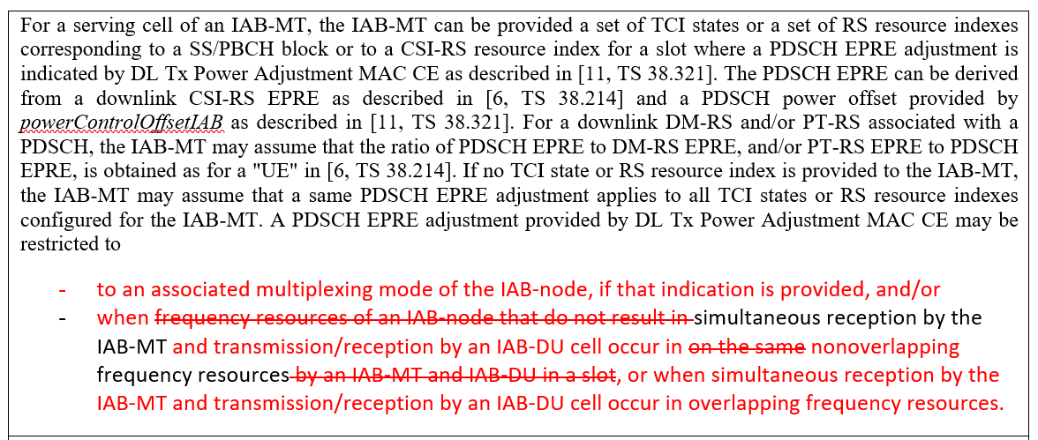

38.213(V17.1.0) has the following description for the DL Tx Power Adjustment MAC CE:
For a serving cell of an IAB-MT, the IAB-MT can be provided a set of TCI states or a set of RS resource indexes corresponding to a SS/PBCH block or to a CSI-RS resource index for a slot where a PDSCH EPRE adjustment is indicated by DL Tx Power Adjustment MAC CE as described in [11, TS 38.321]. The PDSCH EPRE can be derived from a downlink CSI-RS EPRE as described in [6, TS 38.214] and a PDSCH power offset provided by powerControlOffsetIAB as described in [11, TS 38.321]. For a downlink DM-RS and/or PT-RS associated with a PDSCH, the IAB-MT may assume that the ratio of PDSCH EPRE to DM-RS EPRE, and/or PT-RS EPRE to PDSCH EPRE, is obtained as for a "UE" in [6, TS 38.214]. If no TCI state or RS resource index is provided to the IAB-MT, the IAB-MT may assume that a same PDSCH EPRE adjustment applies to all TCI states or RS resource indexes configured for the IAB-MT. A PDSCH EPRE adjustment provided by DL Tx Power Adjustment MAC CE may be restricted to frequency resources of an IAB-node that do not result in simultaneous reception on the same frequency resources by an IAB-MT and IAB-DU in a slot.

There are two concerns about the above clause:
- it does not capture the fact that the indicated DL TX power adjustment may be associated with a specific multiplexing mode, and
- it does not correctly capture the following RAN1#107-e agreement about the overlapping and non-overlapping frequency resources.

RAN1#107-e Agreement
The indication of the desired/provided DL TX power adjustment and desired UL PSD range can further include:
- An indication of whether a desired/provided power configuration or adjustment is applied on FDM resources where the simultaneous MT’s and DU’s signals are non-overlapping in the frequency-domain and/or on non-FDM resources where the simultaneous MT’s and DU’s signals may overlap in the frequency-domain, for a given (MT CC, DU cell).

Summary of views:
- [13] has a TP to capture the indication of the associated configurations.

FL Proposal 3.5a
Adopt the following TP in clause 14 of TS38.213:
For a serving cell of an IAB-MT, the IAB-MT can be provided a set of TCI states or a set of RS resource indexes corresponding to a SS/PBCH block or to a CSI-RS resource index for a slot where a PDSCH EPRE adjustment is indicated by DL Tx Power Adjustment MAC CE as described in [11, TS 38.321]. The PDSCH EPRE can be derived from a downlink CSI-RS EPRE as described in [6, TS 38.214] and a PDSCH power offset provided by powerControlOffsetIAB as described in [11, TS 38.321]. For a downlink DM-RS and/or PT-RS associated with a PDSCH, the IAB-MT may assume that the ratio of PDSCH EPRE to DM-RS EPRE, and/or PT-RS EPRE to PDSCH EPRE, is obtained as for a "UE" in [6, TS 38.214]. If no TCI state or RS resource index is provided to the IAB-MT, the IAB-MT may assume that a same PDSCH EPRE adjustment applies to all TCI states or RS resource indexes configured for the IAB-MT. A PDSCH EPRE adjustment provided by DL Tx Power Adjustment MAC CE may be restricted to
- to an associated multiplexing mode of the IAB-node, if that indication is provided, and/or
- when frequency resources of an IAB-node that do not result in
  - simultaneous reception by the IAB-MT and transmission/reception by an IAB-DU cell occur in on the same nonoverlapping frequency resources by an IAB-MT and IAB-DU in a slot, or when
  - simultaneous reception by the IAB-MT and transmission/reception by an IAB-DU cell occur in overlapping frequency resources.

Company | Do you agree with FL Proposal 3.5a? | Comments
Ericsson | Disagree | In our understanding, the above TP is addressing scenarios for DL power control due to self-interference and this has been agreed to be handled by implementation.
Nokia | Agree | In our understanding this updates 38.213 to reflect that power adjustment can be associated with a multiplexing mode. The application of associated multiplexing mode should be reflected in 38.213.  RAN1#106bis-e  Agreement  The following alternative is selected for the association between the indicated parent-node’s DL TX power adjustment, provided by an IAB-MT to its parent-node, and IAB-node’s resources and/or configurations:  - Alt 2. The desired DL TX power adjustment is indicated to be associated with some combination (one or multiple) of the following IAB-node’s configurations:  - Multiplexing mode  - MT’s DL beam (e.g. TCI state id)  - (MT CC, DU cell) pair  - DU resource configuration  - FFS: Slot index  - FFS: timing mode (e.g., Case-7 timing)
ZTE, Sanechips | Agree with comments | For the second sub-bullet, we think it also wants to reflect the following agreement at R1#107-e:  Agreement  The indication of the desired/provided DL TX power adjustment and desired UL PSD range can further include:  - An indication of whether a desired/provided power configuration or adjustment is applied on FDM resources where the simultaneous MT’s and DU’s signals are non-overlapping in the frequency-domain and/or on non-FDM resources where the simultaneous MT’s and DU’s signals may overlap in the frequency-domain, for a given (MT CC, DU cell).  And we prefer to update the TP as:  - to an associated multiplexing mode of the IAB-node, if that indication is provided, and/or  - when frequency resources of an IAB-node that do not result in  - simultaneous reception by the IAB-MT and transmission/reception by an IAB-DU cell occur in on the same nonoverlapping frequency resources by an IAB-MT and IAB-DU in a slot, if an indication of applying DL Tx Power Adjustment to nonoverlapping frequency resources is provided, or when  - simultaneous reception by the IAB-MT and transmission/reception by an IAB-DU cell occur in overlapping frequency resources, if an indication of applying DL Tx Power Adjustment to overlapping frequency resources is provided.
Vivo | Agree | We prefer ZTE’s version, which is more clear to reflect the complete agreements.
NTT DOCOMO | Agree | We agree the TP to capture the agreement.
Samsung |  | Further update can be made based on the discussion regarding spec. impact on DL Tx Power Adjustment. That is, as well as associated multiplexing mode and frequency resource, time domain resource can be clarified for example, “- slot(s) by slot index in the provided DL TX power adjustment indication if indicated”
Huawei, HiSi |  | For a serving cell of an IAB-MT, the IAB-MT can be provided a set of TCI states or a set of RS resource indexes corresponding to a SS/PBCH block or to a CSI-RS resource index for a slot where a PDSCH EPRE adjustment is indicated by DL Tx Power Adjustment MAC CE as described in [11, TS 38.321]. The PDSCH EPRE can be derived from a downlink CSI-RS EPRE as described in [6, TS 38.214] and a PDSCH power offset provided by powerControlOffsetIAB as described in [11, TS 38.321]. For a downlink DM-RS and/or PT-RS associated with a PDSCH, the IAB-MT may assume that the ratio of PDSCH EPRE to DM-RS EPRE, and/or PT-RS EPRE to PDSCH EPRE, is obtained as for a "UE" in [6, TS 38.214]. If no TCI state or RS resource index is provided to the IAB-MT, the IAB-MT may assume that a same PDSCH EPRE adjustment applies to all TCI states or RS resource indexes configured for the IAB-MT. A PDSCH EPRE adjustment provided by DL Tx Power Adjustment MAC CE may be restricted to  - to an associated with multiplexing mode of the IAB-node, if that indication is provided, and/or  - when frequency resources of an IAB-node that do not result in  - simultaneous reception by the IAB-MT and transmission/reception by an IAB-DU cell occur in on the same nonoverlapping frequency resources by an IAB-MT and IAB-DU in a slot, or when  - simultaneous reception by the IAB-MT and transmission/reception by an IAB-DU cell occur in overlapping frequency resources.

Issue #14. Descriptions of MT’s UL MAC-CEs
This issue relates to missing descriptions of MT’s UL MAC-CEs in TS38.213.
Related input from contributions:
Qualcomm  [13] | Proposal 4.4  38.213 to capture the descriptions of the following MAC-CE messages:  - IAB-MT Recommended Beam Indication  - Desired DL Tx Power Adjustment  - Desired IAB-MT PSD Range

38.213(V17.1.0) has the descriptions of the Child IAB-DU Restricted Beam Indication MAC CE and DL Tx Power Adjustment MAC-CE but does not have any description for IAB-MT Recommended Beam Indication, Desired DL Tx Power Adjustment, and Desired IAB-MT PSD Range.
While 38.321 will have the detailed design and content of these MAC-CE, it will not likely have an informative description of the intention and applicability of these messages. Hence, it seems appropriate to introduce these MAC-CEs in 38.213.
Summary of views:
- [13] proposed to capture the descriptions of the following MC-CE messages in 38.213
  - IAB-MT Recommended Beam Indication
  - Desired DL Tx Power Adjustment
  - Desired IAB-MT PSD Range

FL Proposal 3.6a
TS38.213 to capture the descriptions of the following MAC-CE messages:
- IAB-MT Recommended Beam Indication
- Desired DL Tx Power Adjustment
- Desired IAB-MT PSD Range

Company | Do you agree with FL Proposal 3.6a? | Comments
Ericsson | Needs further discussion | In our understanding, the MT’s recommended, or desired parameters have no impact on the actual operation. This is in line with the skipped description of Desired Guard Symbols (which only appears in TS 38.321).  If we add, e.g., Desired DL Tx Power Adjustment, we should also add a description about Desired Guard Symbols and P27 (Case-6 Timing Required signaling from MT to parent) to be consistent.
Nokia | Not necessary | Our view is that optional MAC-CEs which provide recommended or preferred configurations do not need to be specified in 38.213 because they do not have specific RAN1 impact on IAB behavior.
ZTE, Sanechips | Seems not necessary | It’s similar as the situation of Desired Guard Symbols MAC CE in Rel-16, it is not necessary to add these descriptions in 38.213.
NTT Docomo | Not necessary | We share similar view with ZTE.
Samsung | Yes | Our preference is to capture them in RAN1 specification because it is for IAB MT operation (corresponding to UE) to parent IAB.
Huawei, HiSi |  | This can be captured in 321.

Issue #16. Alignment of parameters names
This issue relates to alignment of parameters names in TS38.213 with upper-layer parameters defined naming.
Related input from contributions:
Qualcomm  [13] | Proposal 4.5  Adopt the following text proposals for 38.213:  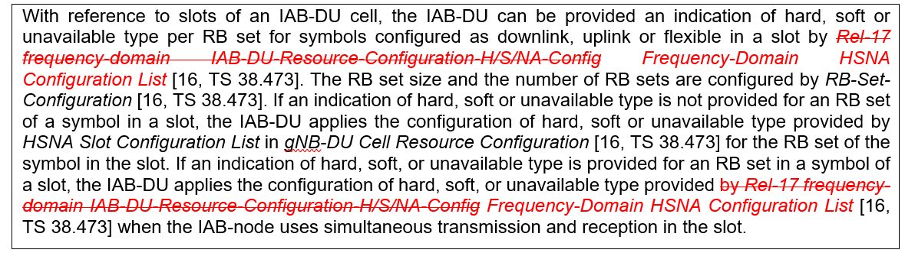  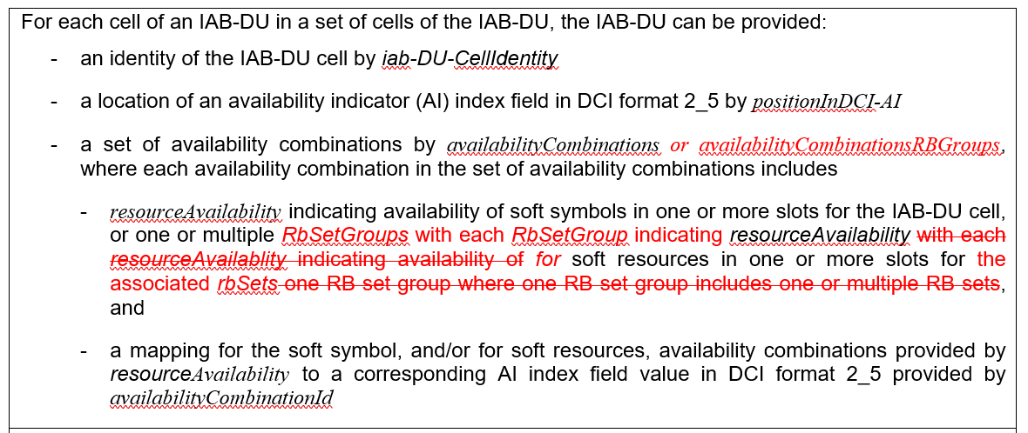

Given the name of some of the related upper-layer messages and parameters are getting finalized, 38.213 should be updated to correctly reflect them.

Summary of views:
- [13] has TPs for the following
  - Use “Frequency-Domain HSNA Configuration List” instead of “Rel-17 frequency-domain IAB-DU-Resource-Configuration-H/S/NA-Config”
  - Reflect the RRC parameters (such as “availabilityCombinationsRBGroups”, “RbSetGroups”) related to the availability indication.

FL Proposal 3.7.1a
Adopt the following TP in clause 14 of TS38.213:
With reference to slots of an IAB-DU cell, the IAB-DU can be provided an indication of hard, soft or unavailable type per RB set for symbols configured as downlink, uplink or flexible in a slot by Rel-17 frequency-domain IAB-DU-Resource-Configuration-H/S/NA-Config Frequency-Domain HSNA Configuration List [16, TS 38.473]. The RB set size and the number of RB sets are configured by RB-Set-Configuration [16, TS 38.473]. If an indication of hard, soft or unavailable type is not provided for an RB set of a symbol in a slot, the IAB-DU applies the configuration of hard, soft or unavailable type provided by HSNA Slot Configuration List in gNB-DU Cell Resource Configuration [16, TS 38.473] for the RB set of the symbol in the slot. If an indication of hard, soft, or unavailable type is provided for an RB set in a symbol of a slot, the IAB-DU applies the configuration of hard, soft, or unavailable type provided by Rel-17 frequency-domain IAB-DU-Resource-Configuration-H/S/NA-Config Frequency-Domain HSNA Configuration List [16, TS 38.473] when the IAB-node uses simultaneous transmission and reception in the slot.

Company | Do you agree with FL Proposal 3.7.1a? | Comments
Ericsson | Agree
Nokia | Agree
ZTE, Sanechips | Agree
Vivo | Agree
NTT Docomo | Agree
Samsung | Yes
Huawei, HiSi | Agree
Intel | Agree

FL Proposal 3.7.2a
Adopt the following TP in clause 14 of TS38.213:
For each cell of an IAB-DU in a set of cells of the IAB-DU, the IAB-DU can be provided:
- an identity of the IAB-DU cell by iab-DU-CellIdentity
- a location of an availability indicator (AI) index field in DCI format 2_5 by positionInDCI-AI
- a set of availability combinations by availabilityCombinations or availabilityCombinationsRBGroups, where each availability combination in the set of availability combinations includes
- resourceAvailability indicating availability of soft symbols in one or more slots for the IAB-DU cell, or one or multiple RbSetGroups with each RbSetGroup indicating resourceAvailability with each resourceAvailablity indicating availability of for soft resources in one or more slots for the associated rbSets one RB set group where one RB set group includes one or multiple RB sets, and
- a mapping for the soft symbol, and/or for soft resources, availability combinations provided by resourceAvailability to a corresponding AI index field value in DCI format 2_5 provided by availabilityCombinationId

Company | Do you agree with FL Proposal 3.7.2a? | Comments
Ericsson | Partially agree | There is very little risk of confusion, here. In ASN.1, rbSetGroup is the parameter name for the concept of RB set group. In any case, and to remain consistent with the Rel-16 way of description, we prefer the following TP as it has a minimum change:  “- resourceAvailability indicating availability of soft symbols in one or more slots for the IAB-DU cell, or one or multiple resourceAvailability with each resourceAvailablity indicating availability of soft resources in one or more slots for one RB set group rbSetGroup where one RB set group rbSetGroup includes one or multiple RB sets rbSet, and”
Nokia | Agree
ZTE, Sanechips | Agree
Vivo | Agree
NTT Docomo | Agree | AvailabilityCombination-r17 ::= SEQUENCE {  availabilityCombinationId-r16 AvailabilityCombinationId-r16,  rbSetGroups-r17 SEQUENCE (SIZE (1..maxNrofRbSetGroups-r17)) OF RbSetGroup-r17 OPTIONAL, -- Need M  resourceAvailability-r16 SEQUENCE (SIZE (1..maxNrofResourceAvailabilityPerCombination-r16)) OF INTEGER (0..7) OPTIONAL -- Need M  }  RbSetGroup-r17 ::= SEQUENCE {  resourceAvailability-r16 SEQUENCE (SIZE (1..maxNrofResourceAvailabilityPerCombination-r16)) OF INTEGER (0..7) OPTIONAL, -- Need M  rbSets-r17 SEQUENCE (SIZE (1..maxNrofRbSets-r17)) OF INTEGER (0..7) OPTIONAL -- Need M  }  We copied the RRC parameter as above. An availabilityCombination-17 include multiple RbSetGroup-r17; each RbSetGroup-r17 include resourceAvailability-r16 indicating resource availability for the RB set group, and rbSets-r17 indicate RB sets associated with the RB set group.  However, we got confused on how to understand the parameter rbSets-r17? (may not be very related to this proposal) We feel it is not clear how rbSets-r17 indicates RB sets associated with an RB set group? Some reply on this issue will be appreciated!
Samsung |  | OK with the change from Ericsson.
Huawei, HiSi | Agree
Intel | Agree | This may not be very related to this proposal but we have similar concern as Docomo regarding current RRC parameter.  In our understanding, the purpose to construct an RB set group is to make all RB sets within an RB set group to be available at once, i.e., only one indication for one RB set group.  Then, compared with time-domain 512x256 AI table in Rel-16 RRC signaling (listed in the first table below), the frequency-domain 512x256 AI table in Rel-17 RRC signaling(with 8 RB set groups in one slot) is shown in the second table below.  Table 1: 512x256 AI table in Rel-16 time-domain  availabilityCombinationId (from AI index) Slot index  0 1 … 255  0 A resourceAvailability (3 bits per slot)  1 A 2nd resourceAvailability  … …  511 A 3rd resourceAvailability  Table 2: 512x256 AI table in Rel-17 frequency-domain (with 8 RB set groups in one slot)  availabilityCombinationId (from AI index) Slot index  0 1 … 255  0 A resourceAvailability (8 bits per slot)  1 A 2nd resourceAvailability  … …  511 A 3rd resourceAvailability  Hence, the RRC signaling we propose is as below:  AvailabilityCombination ::= SEQUENCE {  availabilityIndicationCombinationId AICombinationId,  resourceAvailability-r16 SEQUENCE (SIZE (1..maxNrofAIPerCombination)) OF INTEGER (0..7)  resourceAvailability-r17 SEQUENCE (SIZE (1..maxNrofAIPerCombination)) OF INTEGER (0..255)  }

References
[1] R1-2203078 Remaining issues on R17 IAB enhancements, Huawei, HiSilicon
[2] R1-2203353 Maintenance on Enhancements to Integrated Access and Backhaul, Nokia, Nokia Shanghai Bell
[3] R1-2203359 Maintenance on enhancements to IAB, ZTE, Sanechips
[4] R1-2203523 Maintenance on Enhancements to Integrated Access and Backhaul, vivo
[5] R1-2203763 Discussions on enhancements to resource multiplexing between child and parent links of an IAB node, CEWiT
[6] R1-2203871 Maintenance on Enhancements to NR IAB, Samsung
[7] R1-2204351 Maintenance on Enhancements to Integrated Access and Backhaul, NTT DOCOMO, INC.
[8] R1-2204413 Resource multiplexing in enhanced IAB systems, Lenovo
[9] R1-2204528 Remaining details on enhancements to IAB, LG Electronics
[10] R1-2204640 Maintenance on enhanced IAB, Ericsson
[11] R1-2204648 Discussions on eIAB maintenance, ETRI
[12] R1-2204777 Remaining details on Frequency-domain Resource Multiplexing for IAB, Intel Corporation
[13] R1-2204992 Remaining issues on eIAB, Qualcomm Incorporated
[14] RP-220519, 3GPP TSG RAN Meeting #95e, Electronic Meeting, March, 2022
[15] R2-224093, 3GPP RAN TSG WG2 Meeting #117-e, Electronic Meeting, February-March, 2022

