3GPP TSG-RAN WG1 Meeting #106bis-e R1-21xxxxx
e-Meeting, 11th – 19th October 2021

Agenda Item: 8.17.6
Title: FL summary on incoming LS on capability related RAN2 agreements for RedCap
Source: Moderator (Ericsson)
Document for: Discussion, Decision

1 Introduction
This feature lead (FL) summary (FLS) concerns the following email discussion for the Rel-17 work item (WI) for support of reduced capability (RedCap) NR devices [1]. The RAN1 agreements made so far for this WI are summarized in [2].
[106bis-e-R17-UE-features-REDCAP-02] Discuss incoming LS on capability related RAN2 agreements for REDCAP for a possible reply LS by October 18 – Johan (Ericsson)
This email discussion concerns the questions raised by RAN2 in the LS in [3]. This FLS considers the input provided on this topic in contributions [7] – [19]. The issues in focus in this round of the discussion in this meeting are tagged FL2.
Follow the naming convention in this example:
- RedCapCapabilityLsFLS-v000.docx
- RedCapCapabilityLsFLS-v001-CompanyA.docx
- RedCapCapabilityLsFLS-v002-CompanyA-CompanyB.docx
- RedCapCapabilityLsFLS-v003-CompanyB-CompanyC.docx
If needed, you may “lock” a spreadsheet file for 30 minutes by creating a checkout file, as in this example:
- Assume CompanyC wants to update RedCapCapabilityLsFLS-v002-CompanyA-CompanyB.docx.
- CompanyC uploads an empty file named RedCapCapabilityLsFLS-v003-CompanyB-CompanyC.checkout
- CompanyC checks that no one else has created a checkout file simultaneously, and if there is a collision, CompanyC tries to coordinate with the company who made the other checkout (see, e.g., contact list below).
- CompanyC then has 30 minutes to upload RedCapCapabilityLsFLS-v003-CompanyB-CompanyC.docx
- If no update is uploaded in 30 minutes, other companies can ignore the checkout file.
- Note that the file timestamps on the server are in UTC time.
In file names, please use the hyphen character (not the underline character) and include ‘v’ in front of the version number, as in the examples above and in line with the general recommendation (see slide 10 in R1-2108693), otherwise the sorting of the files will be messed up (which can only be fixed by the RAN1 secretary).
To avoid excessive email load on the RAN1 email reflector, please note that there is NO need to send an info email to the reflector just to inform that you have uploaded a new version of this document. Companies are invited to enter the contact info in the table below.
FL2 Question 1-1: Please consider entering contact info below for the points of contact for this email discussion.
Company | Point of contact | Email address
vivo | Xueming Pan | panxueming@vivo.com
ZTE | Youjun Hu | hu.youjun1@zte.com.cn
MediaTek | Mohammed Al-Imari | Mohammed.Al-Imari@mediatek.com
Intel Corporation | Debdeep Chatterjee | debdeep.chatterjee@intel.com
Ericsson | Sandeep Narayanan Kadan Veedu | sandeep.narayanan.kadan.veedu@ericsson.com
FUTUREWEI | Vip Desai | vipul.desai@futurewei.com
Qualcomm | Jing Lei | leijing@qti.qualcomm.com
Nokia, NSB | Cassio Ribeiro | cassio.ribeiro@nokia.com
Samsung | Feifei Sun | Feifei.sun@samsung.com

2 Feedback on RAN2 agreements
The LS from RAN2 [3] informs about the following RAN2 agreements and asks RAN1 and RAN4 to provide feedback, if any, on the agreements.
RAN2#114-e:
Agreements online:
1. RAN2 Working Assumption: by default, all non-RedCap UE capabilities are applicable for RedCap UE, and therefore only for non-RedCap capabilities that are not appliable for RedCap UE, we clarify in the definitions for parameters in TS38.306, the value or feature is not applicable for RedCap UE

RAN2#115-e:
Agreements:
1. The number of DRBs supported by RedCap UEs is less than legacy value (which is 16). There will be a single mandatory value (FFS if 4 or 8). FFS if it will be possible to have an optional capability
2. “RRC processing delay” is not relaxed for RedCap UE
3. PDCP/RLC AM 12 bits SN is mandatory for RedCap UE, and PDCP/RLC AM 18bits SN is optional supported by RedCap UE; FFS on how to capture this in specification
4. NE-DC, and (NG)EN-DC are not supported by RedCap UE; FFS on how to capture it in the specification
5. DAPS and CAPC related capabilities are not applicable for RedCap UE; [8/20] FFS on CHO. FFS on how to capture this in the specification

Agreements via email - from offline 109:
1. Maximum 8 DRBs is mandatory supported by RedCap UEs.
2. From RAN2 perspective, inter RAT mobility related capabilities are applicable for RedCap UE
3. From RAN2 perspective, measurement related capabilities are applicable for RedCap UE
4. From RAN2 perspective, URLLC related capabilities are applicable for RedCap UE except those affected by CA/DC
5. From RAN2 perspective, IAB related capabilities are not applicable for RedCap UE, i.e., the RedCap UE is not expected to act as IAB node
6. Do not introduce capability signalling on the supported Rx number for RedCap UE since the number of Rx branches for RedCap is implicitly indicated by the corresponding capability parameter maxNumberMIMO-LayersPDSCH in the existing UE capability framework;

FL1 High Priority Question 2-1: Is there a need for RAN1 to provide feedback on the above RAN2 agreements? If yes, please elaborate in the Comments field.
Company | Y/N | Comments
ZTE, Sanechips | Y | From RAN1 perspective, measurement related capabilities are applicable for RedCap UE except those affected by CA/DC, e.g., FG 1-11.
FUTUREWEI | N
Nokia, NSB | N | RAN2 agreements are clear.
LGE | N | No need.
FL2 | High Priority Question 2-1a: Should RAN1 provide the feedback that from RAN1 perspective, measurement related capabilities are applicable for RedCap UE except those affected by CA/DC (e.g., FG 1-11)?
FUTUREWEI2 | N | Not necessary because item #3 is clear.
Intel | N | Not necessary.
ZTE, Sanechips |  | We can accept we do not need the separate feedback to RAN2. At least this FG 1-11 also should be discussed in section 3.
Samsung | N

3 Rel-15/16 features not applicable for RedCap UEs
The LS from RAN2 [3] asks RAN1 and RAN4 whether there are any Rel-15/16 UE features or capabilities which should not be applicable for RedCap UEs.
The WID [1] indicates that the following capabilities are not applicable for RedCap UEs:
- Carrier aggregation
- Dual connectivity
- UE bandwidths wider than 20 MHz in FR1 or wider than 100 MHz in FR2
- More than 2 UE Rx branches or more than 2 DL MIMO layers
Furthermore, RAN#93-e has made the following agreements [4] which may be relevant for the RAN1 response to RAN2:
- In Rel-17, there will be no work on any RedCap specific specification update for any of the following:
  - RedCap UEs also supporting V2X/PC5 on n47
  - RedCap UEs operating in unlicensed bands
  - RedCap UEs supporting SUL
- The specification will not contain any explicit restriction to prevent implementation of RedCap UEs with these features.
- Note: The consequence of this agreement would be:
  - If any spec change/addition is found necessary in order to enable one of the options above then it will not happen in Rel-17.
The RAN2 agreements listed in the LS [3] indicate that the following capabilities are not applicable for RedCap UEs:
- More than [4 or 8] DRBs
- NE-DC and (NG)EN-DC
- DAPS and CAPC related capabilities
- IAB related capabilities
The FL’s understanding is that CAPC in the above list may have been intended to say CPAC, not CAPC, which could be clarified by a new agreement in the next RAN2 meeting in that case.
The FL questions below use the following categorization (according to Alternative 1 in clause 10.1 in RedCap SI TR [6]) of RedCap UE capability requirements that are different from those for non-RedCap UEs:
- Mandatory features for non-RedCap UEs that are not applicable for RedCap UEs
- Mandatory features for non-RedCap UEs that are optional for RedCap UEs
- Mandatory features for non-RedCap UEs that are supported for RedCap UEs but with different value
- Optional features for non-RedCap UE that are not applicable for RedCap UE
- Optional features for non-RedCap UE that are mandatorily supported for RedCap UE
In the next rounds of this email discussion, the FL intention is to discuss what FGs from the Rel-16 UE feature list [5] that might not be applicable to RedCap UEs in the light of the above agreements and potential additional agreements made in this meeting. If deemed necessary, the relevant FG lists can be provided for information in the reply LS to RAN2.
However, in the following FL questions, the intention is to capture views on whether there (from RAN1 perspective) should be any other differences between the RedCap and non-RedCap UE capability requirements than what follows from the already agreed differences listed above in this section of this document. That is, in responses to the questions below, please do not enter, e.g., any capabilities related to CA or DC, since they are already listed above.
FL1 High Priority Question 3-1: Are there any mandatory features for non-RedCap UEs that should not be applicable for RedCap UEs, beyond the capabilities related to the features already listed in this section of this document? If yes, please elaborate in the Comments field.
Company | Y/N | Comments
vivo | Y | We identified following two existing FGs (mandatory with capability signaling), which are not applicable to RedCap UEs, as they are related to >1 ports in UL and >4 layers in DL, respectively.
ZTE, Sanechips | Y | FG 4-12 is applicable to UE supporting more than 4 layers, which exceeds the RedCap UE capability.
MediaTek | Y | FG2-16b is not applicable to RedCap UEs.
Intel | Y | Aside from those related to CA/DC, FG 2-16b and FG #4-12 should not be applicable for RedCap UEs.
Ericsson |  | It is not clear to us why features that require support for more than > 1 UL port should be forbidden for RedCap UEs. This issue should be further discussed. In our view, these features may be optional for RedCap UEs.
FUTUREWEI | Y | For FG4-12, we think it may not be applicable to RedCap UEs.  In our understanding, the WID does not preclude RedCap UEs from supporting more than one uplink antenna port.
Qualcomm | Y | Agree with the comments of Vivo, ZTE and MediaTek.
Nokia, NSB | Y | The following Rel-15 UE feature groups are related to carrier aggregation and dual connectivity, and hence should not be supported by the RedCap UE.  1-10 Support of SCell without SS/PBCH block  6-13 Case 1 Single Tx UL LTE-NR DC  8-1 Dynamic power sharing for LTE-NR DC  8-2 Operation A with single UL Tx case 1
LGE | Y | Layer-1 UE features 4-12 (HARQ-ACK spatial bundling for PUCCH or PUSCH per PUCCH group)  We also prefer the FG2-16b (Support 1+2 DMRS (uplink)) to be not applicable to RedCap as commented by many companies.
FL2 | High Priority Question 3-1a: Which ones (if any) of the following are mandatory features for non-RedCap UEs that should not be applicable for RedCap UEs?  - 1-10  - 2-16b  - 4-12  - 6-13  - 8-1  - 8-2
FUTUREWEI2 | Not applicable to RedCap UEs  - FG 4-12 (see our reasons)  - Falls under CA/DC category (we can identify but RAN2’s decisions should automatically exclude them).  - FG 1-10  - FG 6-13  - FG 8-1 (along with dependency 6-24)  - FG 8-2  Our views on the remaining features in the FL list: Applicable to RedCap UEs  - 2-16b: no restriction for supporting more than 1 UL port in WID
Intel | The following should not be applicable for RedCap UEs:  - 2-16b  - 4-12  The following should already be precluded by RAN2 based on the relation to CA/DC:  - 1-10  - 6-13  - 8-1  - 8-28-1a
ZTE, Sanechips | At least 4-14 should not be supported. As for 2-16b, it is suggested to firstly discuss whether more than one uplink antenna port can be applied for RedCap UE and then decide related UE capabilities.  From our understanding, uplink antenna port for RedCap UE is no more than one and 2-16b should not be supported for RedCap UE, since more uplink antenna ports brings more cost and complexity for RedCap.  As for the other FGs, they are not supported since they are CA/DC related. It is suggested to include them in the LS for RAN2 reference.
Samsung | For the FGs related to CA/DC, since it is clear in the WID, those should not be supported by RedCap.  For UL antenna port, we’d like to FFS.  4-12, we wonder whether spec change is needed or not with the note.

FL1 High Priority Question 3-2: Are there any mandatory features for non-RedCap UEs that should be optional for RedCap UEs, beyond the capabilities related to the features already listed in this section of this document? If yes, please elaborate in the Comments field.
Company | Y/N | Comments
vivo | Y | We have identified following existing FGs (mandatory with capability signaling), which can be made optional for RedCap UEs, with the reasons provided below.  For RedCap, UE can always perform radio link monitoring procedure based on measurement of SSB if it is agreed in AI 8.6.1.1 that SSB is always available in the RRC configured BWP. If so, the necessity of RedCap UE mandatorily support the CSI-RS based RLM is unclear.  For RedCap, it can be considered that the control and data channel can always use the same TCI state/spatial relation for complexity reduction.
ZTE, Sanechips |  | DL 256QAM is optional for RedCap UE.
MediaTek | Y | In our view, FG 1-7 should be optional for RedCap UEs.
Intel |  | Decision on FG 1-7 can follow after progress on related discussions in AI 8.6.1.1.
Ericsson |  | Same view as Intel
FUTUREWEI |  | Per the agreement WID objective “The existing UE capability framework is used; changes to capability signalling are specified only if necessary”, we have not identified any necessary changes
Qualcomm | Y | 256QAM for PDSCH, FG 1-7. FFS 2-61, FG 2-55 and FG 2-4a
Nokia, NSB | Y | 2-3 PDSCH MIMO layers  (RF) 1-4 256QAM for PDSCH
LGE |  | RF and RRM features 1-4 (256QAM for PDSCH).  Others including the Layer-1 UE features 1-7 (CSI-RS based RRM measurement with associated SS-block) can be added depending on the progress in RedCap WI.
FL2 | High Priority Question 3-2a: Which ones (if any) of the following are mandatory features for non-RedCap UEs that should be optional for RedCap UEs?  - 1-4  - 1-7  - 2-4a  - 2-55  - 2-61
FUTUREWEI2 | mandatory features for non-RedCap UEs that should be optional for RedCap UEs  - RF/RRM FG 1-4: this is being discussed in feature discussions  Our views on the remaining features in the FL list:  FFS with the default no change  - FG 1-7  - FG 2-4a (Additional active TCI state for PDCCH)  - FG 2-61 (Additional active spatial relation for PUCCH)  No change  - FG 2-55: the number of allowable candidates may change for component 1, components 2 and 3 do not apply for band combination reasons. It is assumed RAN2 will make the appropriate changes
ZTE, Sanechips | It is better to tag the 1-4 as RF/RRM FG 1-4.  For 2-55, we are OK to discuss it in RAN2. For the other FGs, we are positive to keep them optional.
Samsung | Some of them are overlapped with the discussion in the other email thread, e.g., 1-4,  FG 1-7 may depends on the outcome of AI 8.6.1.1  FG 2-4a/FG 2-61 may not need spec change/  FG 2-55, to discuss in RAN 2.

FL1 High Priority Question 3-3: Are there any mandatory features for non-RedCap UEs that should be supported for RedCap UEs but with different value, beyond the capabilities related to the features already listed in this section of this document? If yes, please elaborate in the Comments field.
Company | Y/N | Comments
vivo | Y | We identified the following FGs. The highlighted components are related to CA thus are not applicable to RedCap UEs, and the components related to per CC limit are still valid and can be reported by RedCap UEs.  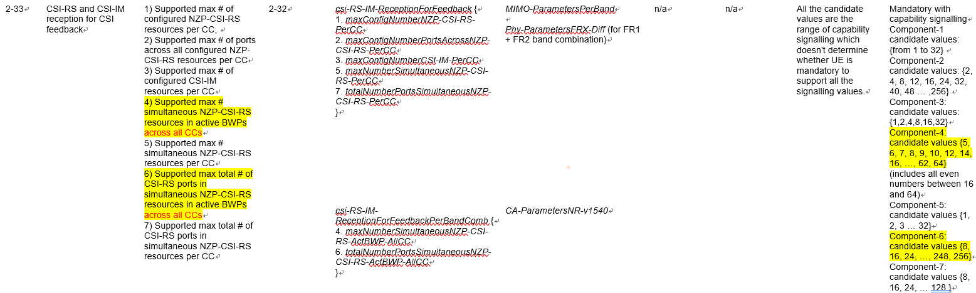  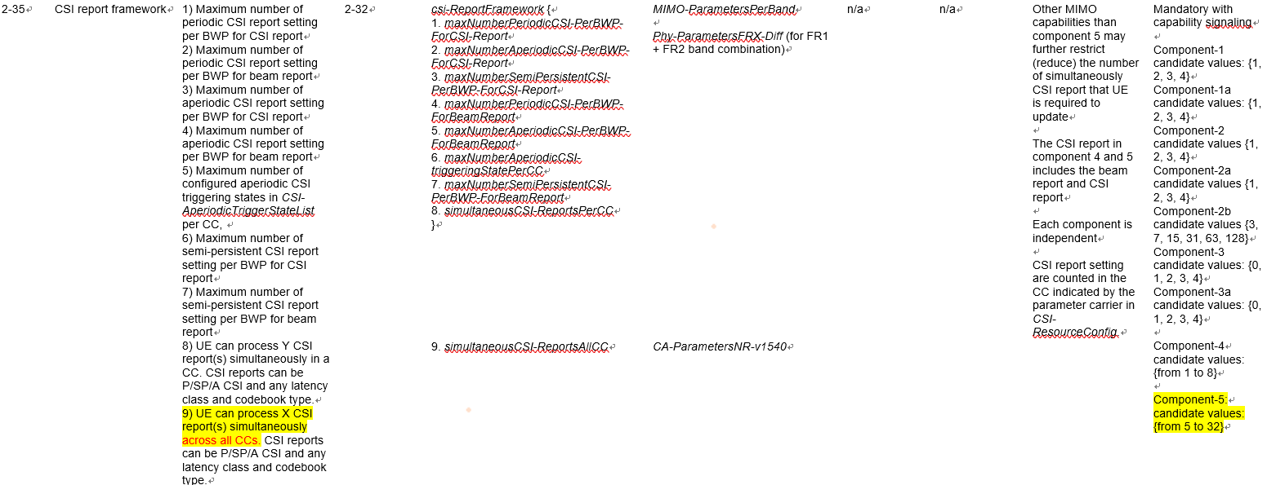  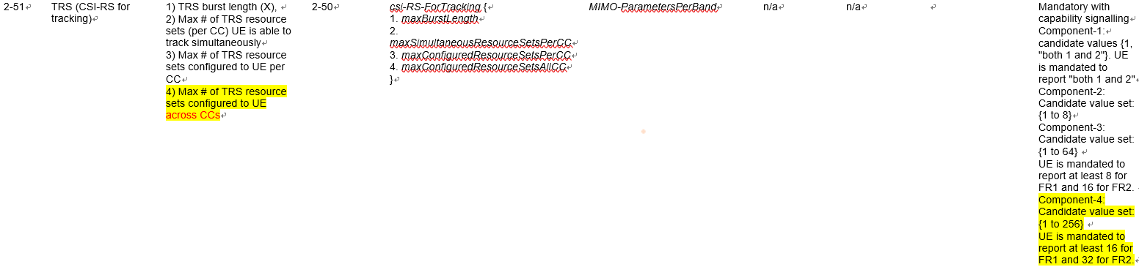
FUTUREWEI | Y | It is not so clear what RAN2 intends to do for FGs which are applicable to RedCap UEs and there is at least one value that a RedCap UE could legitimately report. In this case our view is we probably do not need any clarification. We suggest to focus on cases where the value range to be reported or the description needs a modification for RedCap.  One example is FG 5-5b (UE PDSCH processing capability #2 with scheduling limitation for 30kHz-SCS) where the maximum PDSCH BW of 136 RBs exceeds 20 MHz. The values within FG can be modified to use fewer RBs for RedCap UEs.
FL2 | High Priority Question 3-3a: Which ones (if any) of the following are mandatory features for non-RedCap UEs that should be supported for RedCap UEs but with different value?  - 2-33  - 2-35  - 2-51  - 5-5b
FUTUREWEI2 | mandatory features for non-RedCap UEs that should be supported for RedCap UEs but with different value  - FG 5-5b  Open to consider changes in listed values due to not supporting CA. As we commented, it is not so clear what RAN2 intends to do for FGs which are applicable to RedCap UEs and there is at least one value that a RedCap UE could legitimately report.  - FG 2-33, FG 2-35, FG 2-51
Intel | None.  The adaptations to FG 2-33/2-35/2-51 w.r.t. CA configurations can be implemented by RAN2 following from the lack of CA/DC support.  FG 5-5b is not a mandatory feature for non-RedCap UEs, and no adaptations are necessary for Cap 2 for RedCap.
ZTE, Sanechips | 5-5b is not supposed to be discussed here, since it is an optional capability. As for the other FGs, they are CA/DC related and can be dealt together in RAN2.
Samsung | CA related, we think some modification might be needed.  No need to change on FG5-5b

FL1 High Priority Question 3-4: Are there any optional features for non-RedCap UE that should not be applicable for RedCap UEs, beyond the capabilities related to the features already listed in this section of this document? If yes, please elaborate in the Comments field.
Company |  | Y/N | Comments
vivo |  |  | Not identified.
ZTE, Sanechips |  | Y | • FG 10-20, FG 10-20a, and FG 10-29 are not needed due to the RedCap UE bandwidth limitation.  • FGs exceeding RX and 1 Tx are not supported, including 2-13, 2-14,15-18, 15-19, 16-3a-3, 16-3b-2
Ericsson |  |  | Same comment as for Q3-1. It is not clear to us why features that require support for more than > 1 UL port should be forbidden for RedCap UEs. This issue should be further discussed. In our view, these features may be optional for RedCap UEs.
FUTUREWEI |  | Y | - For FG 10-x, several NR-U FGs have text related to the scenarios as listed in Appendix B.3 of 38.300. Based on the RAN2 LS, it appears that Scenario A (NR licensed / NR shared), Scenario B (LTE licensed / NR shared), and Scenario E (NR licensed / NR shared)] can be excluded. We should let RAN2 decide whether to update 38.300 or capture the scenarios in some other way  - In our understanding, the WID does not preclude RedCap UEs from supporting more than one uplink antenna port. We should be careful about removing features with more than one Tx port
Qualcomm |  |  | UE features related to DAPS and IAB should not be supported by RedCap UE  FG 2-56, FG 4-25/26/27  SFI should not be supported by HD-FDD and FD-FDD RedCap UE
Nokia, NSB |  |  | Many optional features have features that are not supported for RedCap as pre-requisites, and we understand those features would not be supported for RedCap UE either, but perhaps it is not needed to list every single one.
FL2 | High Priority Question 3-4a: Which ones (if any) of the following are optional features for non-RedCap UE that should not be applicable for RedCap UEs?  - 2-13  - 2-14  - 2-56  - 4-25  - 4-26  - 4-27  - 10-20  - 10-20a  - 10-29  - 10-x  - 15-18  - 15-19  - 16-3a-3  - 16-3b-2
FUTUREWEI2 | optional features for non-RedCap UE that should not be applicable for RedCap  - FG4-25 and 4-26 and 2-56 (Falls under CA/DC category (we can identify but RAN2’s decisions should automatically exclude them).  Informative statement to RAN2  - FG 10-x – as we commented, some scenario descriptions for some NR-U features may need to change for RedCap UEs. We just suggest informing RAN2 of this potential modifications for NR-U scenarios.  Our views on the remaining features in the FL list:  No change  - FGs 2-13, 2-14, 15-18, 16-3a-3, 16-3b-2: no restriction for supporting more than 1 UL port in WID  - FG 15-19 (Support of rank 2 reception): If a SL UE has two Rx branches, it may support this feature  FFS  - FG 4-27 (More than one group of overlapping channels for control multiplexing)  - FG 10-20, 10-20a, 10-29: if the number of 20 MHz NR-U carriers is 1, then the FGs are applicable
ZTE, Sanechips | We are supportive to remove these optional FGs listed by the FL.  Additionally, FG 1-11 should be included if no feedback is provided in Question 2-1.
Samsung | We don’t think optional supported features should be excluded for RedCap by default. Following the guidance from RAN, we don’t need to do optimization of optional features, on the other hand, we don’t declare they cannot be supported as well.

FL1 High Priority Question 3-5: Are there any optional features for non-RedCap UE that should be mandatorily supported for RedCap UEs, beyond the capabilities related to the features already listed in this section of this document? If yes, please elaborate in the Comments field.
Company | Y/N | Comments
vivo |  | Suggest to discuss whether some or all the Rel-16 UE power saving features are mandatory for RedCap UEs, i.e.  RAN1 features  19-1 DRX Adaptation  19-2 Cross Slot Scheduling  19-3 Maximum MIMO Layer Adaptation  19-4a UE assistance information  RAN2 features  19-1 UE assistance information for power saving – DRX preference  19-2 UE assistance information for power saving – Maximum aggregated bandwidth preference  19-3 UE assistance information for power saving – Maximum number of secondary component carrier preference  19-4 UE assistance information for power saving – Maximum number of MIMO layers preference  19-5 UE assistance information for power saving – preference to transition out of RRC_CONNECTED  19-6 Relaxed measurement  It can also be discussed if some or all Rel-17 UE power saving features are mandatory for RedCap UEs, but this can be discussed later until the Rel-17 UE power saving FGs becomes stable.
ZTE, Sanechips |  | Not identified.
MediaTek | No | We don’t see a need to mandate RedCap UEs to support optional features.
Ericsson |  | This would depend on the outcome of the discussion in AI 8.6.1.1, e.g., related to whether FG 6-1a should be mandatory or not.
FUTUREWEI |  | We are open to discuss making some Rel-16 PS features mandatory (e.g., FG 19-2 cross slot scheduling)  Suggest to discuss FG 5-17a (PDSCH repetitions over multiple slots). In order to fit within the bandwidth limits of RedCap UEs, a code rate higher than the target code rate may be used. The low target code rate may result from having fewer Rx branches. While HARQ can achieve a low code rate, there is an increase in delay and overhead. With repetitions over multiple slots, there is less delay. In addition, there is an improvement in power savings and flexibility in scheduling.
Qualcomm |  | R17 RA-SDT and CG-SDT
Nokia, NSB | Y | 6-1a, BWP operation without restriction on BW of BWP(s)
LGE | Y | Same view with Ericsson. No other feature that shall be mandatory has been identified.
FL2 | High Priority Question 3-5a: Which ones (if any) of the following are optional features for non-RedCap UE that should be mandatorily supported for RedCap UEs?  - 5-17a  - 6-1a  - 19-1  - 19-2  - 19-3  - 19-4  - 19-4a  - 19-5  - 19-6
FUTUREWEI2 | Optional features for non-RedCap UE that should be mandatorily supported for RedCap UEs  - 5-17a  Our views on the remaining features in the FL list:  Pending outcome of discussions  - 6-1a  Open for discussion  - 19-1, 19-2, 19-3, 19-4, 19-4a, 19-5, 19-6
Intel | - Open to mandating the following for RedCap UEs considering lower capabilities in terms of DL coverage/reliability for RedCap UEs:  - 5-17a  - FG 6-1a should be resolved as part of discussions in 8.6.1.1.  - Rel-16 UE PS features or R17 SDT features should be available for optional support by RedCap UEs. We do not see a justification to mandate RedCap UEs to implement these features – if they are relevant to certain use-cases and implementations, such UEs may support these features.
ZTE, Sanechips | FG 6-1a can be revisited after the outcome of 8.6.1.1 discussion.  For FG 5-17a, since DL coverage enhancement is not identified, also this FG does not need to be mandated.  As for the power saving related FGs in RAN1, there is no need to mandate them.
Samsung | We don’ see optional features have to be mandatory. If so, we should discuss them in AI 8.6 instead.

4 Rel-17 features not applicable for RedCap UEs
Some contributions [7][12][14][17] discuss RedCap UE support for features developed in other Rel-17 work items. The FL recommendation is to postpone that discussion until the Rel-17 work items and Rel-17 UE feature list discussions have progressed a bit further.

References
- RP-211574, “Revised WID on support of reduced capability NR devices”, Ericsson
- R1-2108271, “RAN1 agreements for Rel-17 NR RedCap”, Rapporteur (Ericsson)
- R1-2108714, “LS on capability related RAN2 agreements for RedCap”, RAN2
- RP-212634, “Moderator's summary for discussion [93e-16-RedCap-WI]”, Intel
- TR 38.822 V16.1.0, “NR; User Equipment (UE) feature list (Release 16)”
- TR 38.875 V17.0.0, “Study on support of reduced capability NR devices (Release 17)”
- R1-2108803, “Discussion on the Capabilities of RedCap UEs”, FUTUREWEI
- R1-2108823, “RAN1 aspects for RAN2-led features for RedCap”, Ericsson
- R1-2108984, “Discussion on L1 reduced capability signaling”, Vivo, Guangdong Genius
- R1-2109313, “Discussion on RedCap UE capabilities”, Nokia, Nokia Shanghai Bell
- R1-2109331, “Discussion on RAN2 reply LS on UE capabilities for RedCap”, ZTE, Sanechips
- R1-2109339, “Discussion on RedCap UE features”, ZTE, Sanechips
- R1-2109420, “Discussion on the remaining issues of higher layer related topics for RedCap”, Xiaomi
- R1-2109499, “RAN1 aspects for RAN2-led features for RedCap”, Samsung
- R1-2109647, “On UE features for RedCap”, Intel Corporation
- R1-2109687, “Discussion on RAN1 aspects for RAN2-led features for RedCap”, NTT DOCOMO, INC.
- R1-2109740, “[Draft] Reply LS on capability related RAN2 agreements for RedCap”, MediaTek Inc.
- R1-2109998, “RAN1 aspects for RAN2-led features for RedCap”, Sharp
- R1-2110282, “On RAN1 aspects of RAN2-led RedCap features”, Nordic Semiconductor ASA

