3GPP TSG RAN WG1 Meeting #106bis-e R1-2109173

e-Meeting, Oct 11th – Oct 19th, 2021

Agenda Item: 8.15.1

Source: Moderator (MediaTek)

Title: Summary #7 of AI 8.15.1 Enhancements to time and frequency

synchronization

Document for: Discussion and Decision

# Introduction

At the RAN#92 meeting, a new Work Item was approved for IoT Non Terrestrial Network (NTN) [1]. In this meeting, company views on UL synchronization for IoT NTN are summarized and observations/proposals on identified issues are made. Observations and proposals in Company’s TDoc contributions are listed in the Appendix.

# GNSS Measurements

## Backround

In RAN1#106-e, the following agreement was made:

Agreement:

For sporadic short transmission, UE in RRC\_CONNECTED should go back to idle mode and re-acquire a GNSS position fix if GNSS becomes outdated.

There was no further agreement during RAN1#106-e on this issue. Moderator made recommendation as follows (the moderator revised the wording to remove “shall” fromrecommendation as it is too early to discuss specification)

***RAN1#106-e Moderator Recommendation: In order to make progress, companies could focus on what is required to be specified for the following:***

* ***UE behaviour to ensure that it has a valid GNSS position fix for UL transmission***
* ***UE behaviour to ensure it autonomously determines how long a GNSS position fix is valid.***
* ***The UE to autonomously determine how long a GNSS fix is valid*** 
  + ***Option 1: an internal timer in the device is used by UE to set autonomously the GNSS validity duration***
  + ***Option 2: a specified timer is used by UE to set autonomously the GNSS validity duration***
* ***The UE to signal to the network the length of time that GNSS position fix is valid for to ensure common understanding on validity of GNSS position fix between the UE and eNB. This allows eNB to schedule UL transmission that starts while the UE has a valid GNSS position fix and ends before the GNSS position fix becomes outdated.***

***In the worst case, the UE always knows how long the scheduled UL transmission is and also knows the duration of validity of the GNSS position fix. The simplest UE behavior is that UE does not starts transmission if it cannot complete it before the GNSS position fix becomes outdated.***

## Company views

### In RRC\_IDLE:

CMCC proposed two approaches for idle UE to acquire GNSS position fix for sporadic short transmission::

* Approach 1: UE performs GNSS Measurement each time it is wake up from IDLE mode even if the GNSS position fix keeps valid.
  + Option 1: an internal timer in the device is used by UE to set autonomously the GNSS validity duration
  + Option 2: a specified timer is used by UE to set autonomously the GNSS validity duration
* Approach 2: When UE is wake up from IDLE mode, if the GNSS position fix is outdated, or if the GNSS validity duration is valid but the remaining GNSS validity duration is less than a threshold, it performs GNSS Measurements.
  + Option 2: a specified timer is used by UE to set autonomously the GNSS validity duration

For sporadic DL traffic, UE may perform GNSS measurements after a paging occasion and only if it has been paged to reduce battery consumption. GNSS measurement duration can be up to 10 seconds. After MME requests the lower layer to start paging, it may receive paging response after a long time (e.g.10 seconds). In specification TS 24.301, to initiate high level paging procedure initiated by the MME, the EMM (EPS Mobility Managed) entity in the network requests the lower layer to start paging and shall start the supervision timer T3413/T3415:

* T3415 for this paging procedure, if the network accepted to use eDRX for the UE and the UE does not have a PDN connection for emergency bearer services.
* Otherwise, T3413 for this paging procedure.

The MME can re-attempt the paging procedure if T3413/T3415 expires before a response is received. The expiry time of T3413/T3415 is implementation dependent and is not specified in 3GPP, network operator may configure expiry time of T3413/T3415 large enough to ensure a sufficient gap considering GNSS measurement duration (e.g., 10 seconds) after decoding the paging message and before initiating UL transmission.in NTN.



**Figure 1: Paging procedure using S-TMSI. (CMCC R1-2109308)**

CATT proposed the UE triggers the GNSS measurement when it is waken up due to T3412 timer expiration, and then enter IoT active state after GNSS measurement.



Figure 2 GNSS signal reception and IoT UE wakeup (CATT R1-2109201)

Nokia proposed UE shall report GNSS measurement gap at prior occasion such that network can allocate sufficient time between sending a paging message and when to expect random access procedure initialization from UE. Network shall not repeat the paging message for a UE during the UE’s GNSS measurement gap.

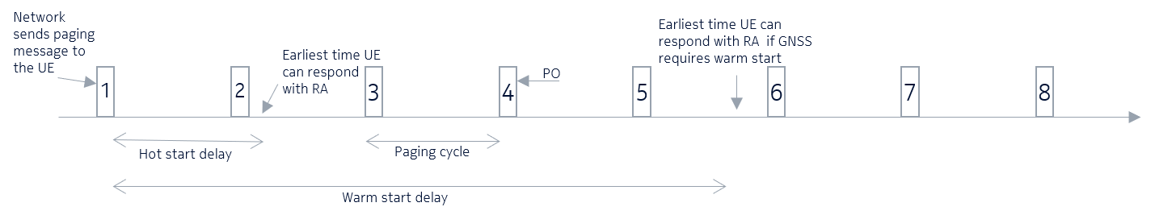

Figure 1 Illustration of GNSS start delay in a paging scenario. (Nokia R1-2109265)

|  |  |  |
| --- | --- | --- |
| **Assumption for GNSS TTFF** | | **GNSS TTFF** |
| Cold start | No valid ephemeris, almanac | < 30 seconds (first TTFF of GNSS module) |
| Warm start | Valid almanac if used at least once within 180 days of last TTFF | < 5 seconds (at least a few TTFF within 180 days for optimised prediction algorithms)  Up to 30 seconds (un-optimized algorithms) |
| Hot start | Valid ephemeris if used within 4 hours of last TTFF | < 1 second |

***Table 1****: Assumption for GNSS TTFF (MediaTek R1-2107067)*

***Moderator view:*** *Commenting companies have indicated timer-based mechanisms for UE to acquire GNSS measurements during paging procedure. GNSS measurement duration can be up to 10 seconds. After MME requests the lower layer to start paging, it may receive paging response after a long time (e.g., 10 seconds). The MME can re-attempt the paging procedure if T3413/T3415 expires before a response is received. Several approachs were proposed with UE performs GNSS Measurement each time it is wake up from IDLE mode, when UE is wake up from IDLE mode, if the GNSS position fix is outdated based on threshold, or UE shall report GNSS measurement gap at prior occasion. More discussions in RAN1 needed to align companies understanding and oreference on these approaches.*

***Initial proposal – Section 2.2.1:***

***Companies are encouraged to further discuss and align their understanding on the following for UE in RRC\_IDLE***

***Q1: Is is companies understanding that the network can configure existing supervision timers T3413/T3415 large enough to ensure a sufficient gap to accommodate GNSS acquisition after decoding the paging message and before initiating UL transmission (i.e. 10 seconds or longer)?***

***Q2: Companies views and preference for the considered approaches:***

1. ***UE performs GNSS Measurement each time it wakes up from IDLE mode even if the GNSS position fix keeps valid***
2. ***When UE wakes up from IDLE mode, if the GNSS position fix is outdated, or if the GNSS validity duration is valid but the remaining GNSS validity duration is less than a threshold, it performs GNSS Measurements***
3. ***UE shall report GNSS measurement gap at prior occasion such that network can allocate sufficient time between sending a paging messages.***

|  |  |
| --- | --- |
| Companies | Comments |
|  |  |
|  |  |
|  |  |
|  |  |
|  |  |
|  |  |
|  |  |
|  |  |
|  |  |
|  |  |
|  |  |
|  |  |
|  |  |
|  |  |
|  |  |
|  |  |

### In RRC\_CONNECTED:

Ericsson observed that the short connection can be defined by considering the validity durations of GNSS position fix, common TA (if indicated) and satellite ephemeris, and proposed to send an LS to RAN4 on time and frequency error requirements for IoT NTN before discussing the details of validity duration for GNSS position. For connections which do not qualify as short sporadic, further discussions on acquiring GNSS position fix during RRC Connected mode are needed. These discussions can be deferred until the start of Release 18.

Huawei, ZTE,Qualcomm, Nokia, NEC, SONY proposed UE can report the validity duration of GNSS position fix. This helps eNB scheduling. when UE needs to refresh its GNSS position fix if it becomes outdated. ZTE, Huawei, NEC further propose eNB schedule gaps for GNSS measurements;

Intel, MediaTek proposed to rely on UE implementation for GNSS validity. Before commencing an UL transmission, the UE shall ensure it has a GNSS position fix that is valid for the duration of that UL transmission

Apple proposed UE autonomously determines the validity of GNSS position fix, based on UE’s mobility patterns (e.g., UE speed).

Huawei observed that when GNSS position becomes outdated at the UE, the UL synchronization may still be maintained given that closed-loop TA adjustment can also compensate the error of UE self-calculated TA. There is no need to specify the UE behavior when GNSS becomes out-of-dated

ZTE discussed UE stays in RRC\_CONNECTED mode but suspends the UL transmission when validity duration of GNSS is over.

Qualcomm proposed RAN2 specify mechanism that declares RLF when the UE’s GNSS-based geolocation validity expires. Intel proposed UE declares RLF if UE GNSS measurements are not valid.

Nokia proposed UE goes back to IDLE to acquire a new GNSS and initiate CFRA to move back to RRC\_CONNECETED. GNSS measurement window for both initial access phase and in CONNECTED mode should be specified.

OPPO observed if the eNB does not know the UE GNSS validity duration, whether UE autonomously go back to idle mode should be discussed and confirmed by RAN2.

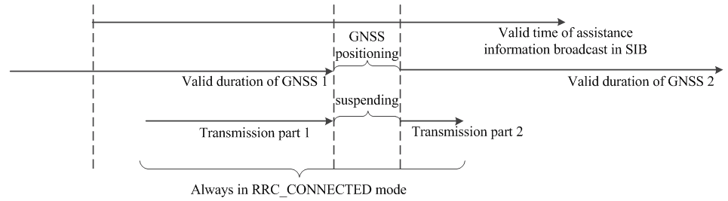

Figure 8 Illustration of GNSS update in RRC\_CONNECTED mode (ZTE R1-2109847)

MediaTek provided some analysis showing that the validity of the GNSS position fix duration can be in the order of 60 seconds for high-velocity UEs depending on assumptions for UE algorithms (i.e. dead reckoning). Apple also provided some analysis showing worst-case could be in the order of 5 seconds.

MediaTek proposed two ways for UE to move to RRC\_IDLE to re-acquire GNSS Position fix if GNSS Position fix needs refresh:

Rel-15 NB-IoT specified UE differentiation feature in TS 36.413. The stationary indication is provided by the NB-IoT module vendor in Subscription Based UE Differentiation Information and is stored in UE context.

* This information is included in INITIAL CONTEXT SETUP REQUEST message , CONNECTION ESTABLISHMENT INDICATION message , UE INFORMATION TRANSFER message , HANDOVER REQUEST message, RETRIEVE UE CONTEXT RESPONSE message, …
* There is no impact on UE since these messages are not exchanged over the Uu interface – i.e. no dedicated signalling. These are S1/X2 messages specified in TS 36.413. This implies the network knows the UE is stationary, but the UE does not know it is stationary.

RAI(Release Assistant Indication) feature**:** In RAI, when the UE is aware of there is no more data to be received or transmitted, then UE can notify the network(by NAS signaling, MAC CE BSR) which can then release the connection faster for the purpose of power saving.

* For Rel-14, If RAI is configured in MAC-MainConfig Information Element (TS 36.331 Section 6.3.2), a BSR with a buffer size of zero indicates implicit “Release Assistance Indication” and the network can release the connection right away (TS 36.321 Section 5.4.5).
* For Rel-16, a new mac CE for RAI is specified for explicit Release Assistance Indication (TS 36.321 Section 6.1.3.19).

TS 36.321 V16.3.0 Table 6.1.3.19-1: Values for AS RAI

|  |  |
| --- | --- |
| Codepoint/Index | Value |
| 00 | No RAI information |
| 01 | No subsequent DL and UL data transmission is expected |
| 10 | A single subsequent DL transmission is expected |
| 11 | Reserved |

***Moderator view:*** *Commenting companies have indicated a preference to move to idle, stay in connect, or trigger RLF. It was discussed whether UE waits for GNSS position fix to become outdated or provides some assistance signalling before GNSS position fix becomes outdated to stay in RRC\_CONNECTED with a scheduling gap to allow GNSS measurements or request network to release connection. For sporadic short transmission, it was proposed RAN1 send an LS to RAN4 on time and frequency error requirements for IoT NTN before discussing the details of validity duration for GNSS position. For connections which do not qualify as short sporadic, further discussions on acquiring GNSS position fix during RRC Connected mode are deferred until the start of Release 18.*

***Revised Initial proposal – Section 2.2.2-1/2:***

***If GNSS position fix becomes outdated in RRC\_CONNECTED, UE triggers RLF.***

* ***RAN2 specify mechanism to declare RLF***

***Before GNSS position fix becomes outdated in RRC\_CONNECTED, UE may send UE assistance signalling to request eNB to do one of the following:***

* ***Release connection – e.g. Release/resume RRC messages***
* ***FFS Configures scheduling gap window to re-acquire GNSS position fix without releasing connection***

***FFS Re-use spare bit of Rel-16 MAC CE Release Assistance Indication for IoT NTN (TS 36.321 Section 5.4.5) or specifiy new MAC CE***

***FFS UE can report GNSS position fix validity duration***

***Initial proposal – Section 2.2.2-3:***

***Companies are encouraged to further discuss and align their understanding on the following for UE in RRC\_CONNECTED***

***Q1: UE behaviour when GNSS position fix for UL transmission become outdated in RRC\_CONNECTED***

* ***No need to specifiy UE behaviour***
* ***Suspends the UL transmission***
* ***Others? Please say what and why***

***Q2: For sporadic short transmission, RAN1 send an LS to RAN4 on time and frequency error requirements for IoT NTN before discussing the details of validity duration for GNSS position***

***Q3: For connections which do not qualify as short sporadic, further discussions on acquiring GNSS position fix during RRC Connected mode are deferred until the start of Release 18.***

|  |  |
| --- | --- |
| Companies | Comments |
|  |  |
|  |  |
|  |  |
|  |  |
|  |  |
|  |  |
|  |  |
|  |  |
|  |  |
|  |  |
|  |  |
|  |  |
|  |  |
|  |  |
|  |  |
|  |  |

## FIRST ROUND- GNSS Measurements

TBA

# Validity timer for UL synchronization

## Background

The following agreements were made in RAN1#106e.

Agreement:

* Satellite ephemeris read on SIB are valid for the duration of sporadic short transmission in RRC\_CONNECTED.
* Common TA parameters if indicated and read on SIB are valid for the duration of sporadic short transmission in RRC\_CONNECTED.
* Note: The duration of the short transmission is not longer than the “validity timer for UL synchronization” referred to in the WID objective (but which still needs further discussion for specifying further details)

Agreement:

The validity timer of UL synchronization is configured by the network

* FFS: Whether a single validity timer or separate validity timers are used for satellite ephemeris and common TA parameters

Agreement:

UE in RRC\_IDLE reads the satellite ephemeris on SIB and the common TA parameters if indicated on SIB and (re-)start the validity timer(s) for UL synchronization before moving to RRC\_CONNECTED.

* FFS: Details of the precise (re-)start time for the validity timer for UL synchronization to ensure a common understanding between gNB and UE.
* Other signaling details for validity timer are up to RAN2

## Company views

Indication of of start time / validity durationof ephemeris / common TA parameters on SIB, re-acquisition of SIB:

SONY discussed that SIB signals (1) the start time of transmission of the ephemeris information and (2) the ephemeris validity duration. Before starting a transmission, the UE should estimate:

* TULTX: The time it will take to transmit the short transmission. It can be estimated based on the UE’s understanding of its coverage derived from measurements and estimates of the number of repetitions required for transmission
* Tvalid: The remaining time for which the satellite ephemeris and common TA parameters will be valid. It can be calculated from the validity duration of the ephemeris information of Tvalid = TD – (T1 – T0), where T0 and T1 are the times at which that ephemeris information was first transmitted and when the UE reads it respectively

In order to be confident of completing the transmission, the UE should only start the UL transmission if Tvalid > TULTX.

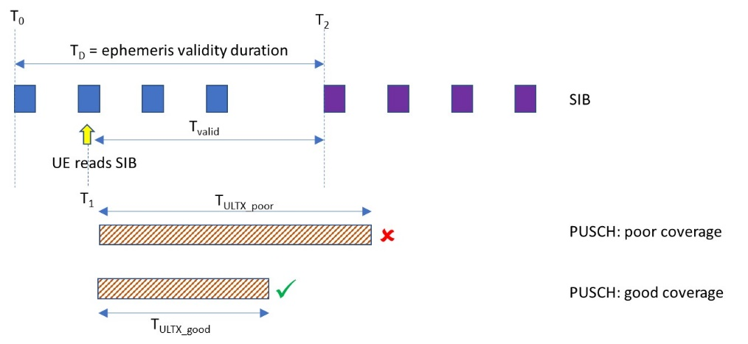

Figure 1 – Determination of whether PUSCH can be transmitted based on ephemeris validity (SONY R1-2109804)

ZTE proposed similarly to SONY that the activation time instant of validity duration for assistance information broadcast by SIB can be implicitly known as a reference time linked to DL subframe where initial SIB carrying the assistance information is broadcast. If the residual duration of validity timer is shorter than the time duration of following UL transmission, UE will postpone the access to network until new assistance information is activated.

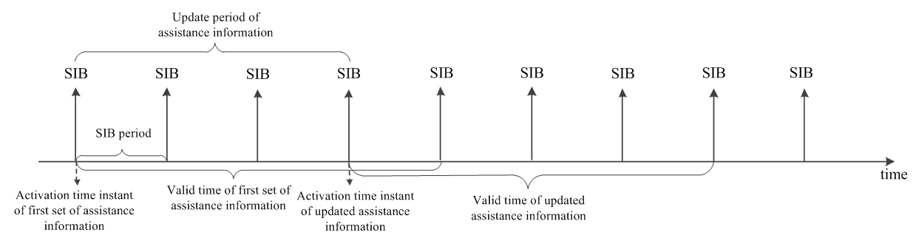

Figure 4 Illustration of indication of assistance information (ZTE R1-2109847)

Nokia proposed UE can report the validity duration of satellite ephemeris. This helps eNB scheduling, which can schedule a gap to allow UE to re-acquire the satellite ephemeris on SIB if it becomes outdated. The UE can keep in RRC\_CONNECTED and perform a new synchronization via CFRA.

Intel proposed there is no need for eNB to be aware of the state of the validity timer (i.e. particular time instances where timer starts/restarts/ends).

OPPO observed that in legacy IoT system the UE is not required to acquire any system information updates. For IoT NTN, the eNB should be aware of when the UE updates the satellite ephemeris, and updates the UL sync validity timer accordingly. eNB may inform the UE that an acquisition is needed and then the UE starts to read the new SIB.

Mavenir proposed if validity timer(s) for UL synchronization expires, UE stays in RRC\_CONNECTED state and reads SIB to refresh ephemeris / common TA parameters.

CATT proposed the duration of short transmission should be defined by the number of RU scheduled and repetition further.

CMCC proposed that for sporadic short transmission, UE read the satellite ephemeris and common TA parameters once before accessing the network and doesn’t re-read SIBs in RRC\_CONNECTED. A single validity timer for both satellite ephemeris and common TA parameters is set to minimum validity duration of the both parameters.

Ericsson proposed IoT NTN UE can use the ephemeris Epoch time as a reference for starting the validity timer. It was agreed in RAN1#106-e that the serving satellite ephemeris Epoch time is implicitly known as a reference time defined by the starting time of a DL slot and/or frame.

The moderator further summarize companies views on the following:

What does UE do if validity timer expires / before validity timer expires?

* UE goes to RRC\_IDLE: NEC, MediaTek (via Rel1-6 MAC CE Release Assistance Indication), OPPO (autonomously), FGI, APT, III, ITRI
* UE stays in RRC\_CONNECTED: ZTE (activation time, validity duration with shceduling gaps to re-read SIB), Xiaomi (re-read SIB)
* UE in RRC\_CONNECTED may trigger RLF: Huawei, Qualcomm, Intel

Network controlled SIB acquisition mechanism for UE updates of the satellite ephemeris data: OPPO

* eNB indicates to the UE that an acquisition is needed

(re-)start time for the validity timer for UL synchronization

* upon reading ephemeris / common TA information on the SIB:
  + Immediately: Huawei, FGI, APT, III, ITRI, Apple, Nordic semiconductor ASA
  + counting starting from first repetition: Qualcomm, NEC
  + Activation time: ZTE
  + Based on ephemeris Epoch time implicitly known as a reference time: Ericsson

Single / Separate validity timers:

Ericsson proposed separate validity timers are preferred if ephemeris and common TA are transmitted in different SIBs, otherwise a single validity timer can be used for both ephemeris and common TA.

CMCC proposed that if long connection or multiple (sporadic) short transmissions is to be further supported, separate validity timers for satellite ephemeris and common TA parameters can be considered for indication flexibility, since satellite ephemeris and common TA parameters may have different validity duration.

CMCC indicated preference to indicate both satellite ephemeris and common TA parameters in the same SIB or in the SI same window.

SONY observed that since the common TA parameters can change more quickly than the ephemeris information, the frequency / periodicity of ephemeris information and common TA parameter signalling can be different.

Apple discussed that common TA mainly indicate the RTT between satellite and timing reference point. If the timing reference point is configured to be at satellite, then the common TA is always equal to 0 and it has infinite validity duration. This is different from the validity duration for satellite ephemeris.

Single/separate timers for satellite ephemeris and common TA parameters

* Single validity timer: Huawei, ZTE, Spreadtrum, MediaTek, CMCC (for shor sporadic connection), Samsung, Intel, Ericsson (if transmitted on same SIB)
* Separate validity timers: CATT, Lenovo, CMCC (for long or multiple sporadic short transmissions), SONY, FGI, APT, III, ITRI, Ericsson (if transmitted on different SIB), Apple, Nordic semiconductor ASA
* Up to RAN2: Xiaomi

***Moderator view:*** *Commenting companies have indicated a preference for UE stay in connected and read SIB to refresh ephemeris / common TA parameters, while other companies preference is to trigger RLF. Both satellite ephemeris and common TA parameters may be indicated in the same SIB or in the SI same window. It was discussed whether UE waits for validity timer to expire or provides assistance signalling before validity timer expires to stay in RRC\_CONNECTED with a scheduling gap to allow re-acquisition of SIB or request network to release connection. There is not enough consensus on single timer or separate timers. To help with this issue more understanding on what is needed for a signle timer would be helpful.*

***Revised Initial proposal – Section 3.2-1/2:***

***If validity timer expires in RRC\_CONNECTED, UE triggers RLF.***

* ***RAN2 specify mechanism to declare RLF***

***Before validity timer expires in RRC\_CONNECTED, UE may send UE assistance signalling to request eNB to do one of the following:***

* ***Release connection – e.g. Release/resume RRC messages***
* ***FFS Configures UL scheduling gap window to re-acquire ephemeris on SIB without releasing connection***

***FFS Re-use spare bit of Rel-16 MAC CE Release Assistance Indication for IoT NTN (TS 36.321 Section 5.4.5) or specify new MAC CE***

***FFS UE can report GNSS position fix validity duration***

***Initial proposal – Section 3.2-3:***

***(re-)start time for the validity timer for UL synchronization upon reading ephemeris information on the SIB – FFS options***

* ***Immediately***
* ***Counting starting from first repetition***
* ***Activation time instant***

***Initial proposal – Section 3.2-4:***

***Companies are encouraged to further discuss and align their understanding on the following***

* ***Q1: What would be ways to only use a single validity timer for ephemeris and common TA parameters?***
  + ***Similar validity time assumption for prediction error for ephemeris and common TA parameters based on analysis provided by companies in AI 8.4.2 in NR NTN?***
  + ***Satellite ephemeris and common TA parameters in the same SIB or in the SI same window?***
  + ***Need some discussions in RAN2***
* ***Q2: Network controlled SIB acquisition mechanism where eNB indicate to UE to re-acquire the satellite ephemeris data based on UE location.***

|  |  |
| --- | --- |
| Companies | Comments |
|  |  |
|  |  |
|  |  |
|  |  |
|  |  |
|  |  |
|  |  |
|  |  |
|  |  |
|  |  |
|  |  |
|  |  |
|  |  |
|  |  |
|  |  |
|  |  |

## FIRST ROUND - Validity timer for UL synchronization

TBA

# Long UL transmission on PUSCH and PRACH

## Background

The following issues are for discussions based on agreements were made during RAN1#106e.

* Configuration of UL transmission segment via SIB or dedicated RRC signalling
* Downscoping of values for NPRACH/RACH UL transmission segment duration
* Downscoping of values NPUSCH/PUCH UL transmission segment duration
* New UL gaps for long UL transmissions
* Phase discontinuity in segmented pre-compensation

During Rel-17 IoT NTN SI, it was clarified that there is impact on specification of applying TA adjustments during long UL transmission:

In the specifications UE is not allowed to adjust timing advance in the duration of repetitions as specified in TS 36.133 V16.8.0, Clause 7.20.2.

[***3GPP TS 36.133 V16.8.0, Section 7.20.2] When a repetition period is configured on the uplink for which R>1, the UE shall not adjust the uplink transmission timing autonomously during an ongoing repetition period other than at initial transmission as defined above.***

## Company views

### Configuration of UL transmission segment

The following agreements were made during RAN1#106e on configuration of UL transmission segment.

Agreement:

The UL transmission segment duration is configured by the network

* FFS: Details of the configuration signalling.

Agreement:

* The UL transmission segment duration is provided by UE-specific RRC signalling or by signalling in SIB.
* NOTE: the values of UL transmission segment duration for NB-IoT can be different to those for eMTC

The maximum total TA drift over service link and feeder link in 256 ms can be in the order of 24 µs for LEO-600 km as can be derived from TR 36.763 Section 6.1 Table 6.1-1: IoT NTN reference scenario parameters. At higher elevation angles it can be lower and even 0 µs.



Figure 2. Evaluation of TA change during a transmission period of 256 ms. (Nokia R1-2109265)

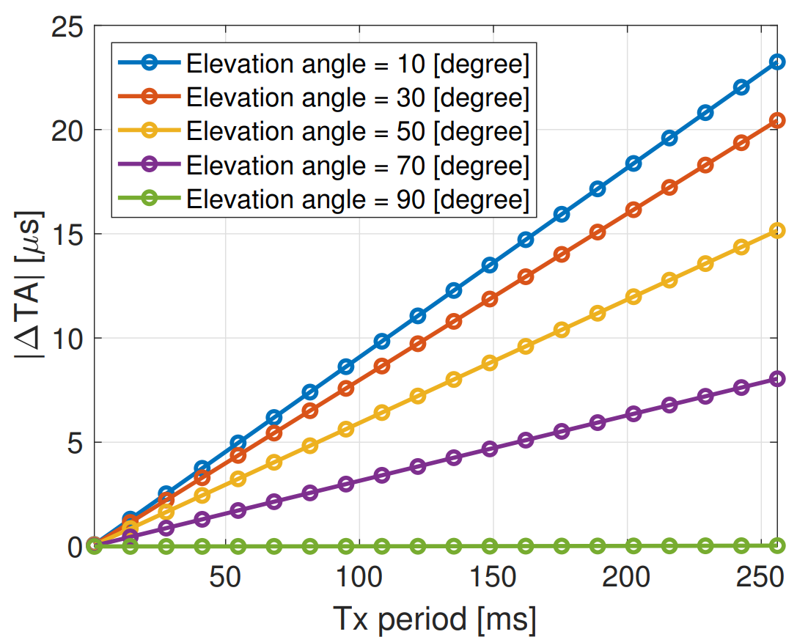

Figure 3. TA changes during a 256 ms transmission period at different elevation angles from 10 degree to 90 degrees (Nokia R1-2109265)

Configuration mechanisms:

Huawei discussed it is more efficient to signal the maximum allowed time-continuous transmission and UL gaps in the system information according to the relative speed and elevation between satellite and its serving cell or beam. The number of time-continuous repetitions for preamble and time-continuous duration for UL data transmission for NB-IoT over NTN can be indicated by system information. The UL segment duration *X* should be a number of *N* PUSCH repetition units which does not exceed the maximum allowed continuous transmission time *Tseg\_max* based on the elevation angle and the timing error Te, as in $X \left(ms\right)=N×T_{rep_unit} ,$ where $N=\left\lfloor \frac{T_{seg_max}}{T_{rep_unit}}\right\rfloor .$ Huwaei proposed indicating common TA drift rate in addition to common TA for UL TA adjustment for long UL transmission.

Nokia discussed the the network is aware of TA adjustments made by the UE in advance using the UE reports its location. Network should be in control of the timing advance updates applied at the UE. If TAC is generated to fix a temporary deviation in the UE transmission timing, when UE updates their autonomous components on the timing advance formula, there may be an overcompensation of the timing advance, generating a similar deviation on the opposite direction. The TAC should operate in two different states to allow both differential and absolute indication of the TAC updates. Nokia proposed an indexed table is usedto indicate the applicable segment durations for different elevation angles. : The segment duration for TA should be selected based on the elevation angle.

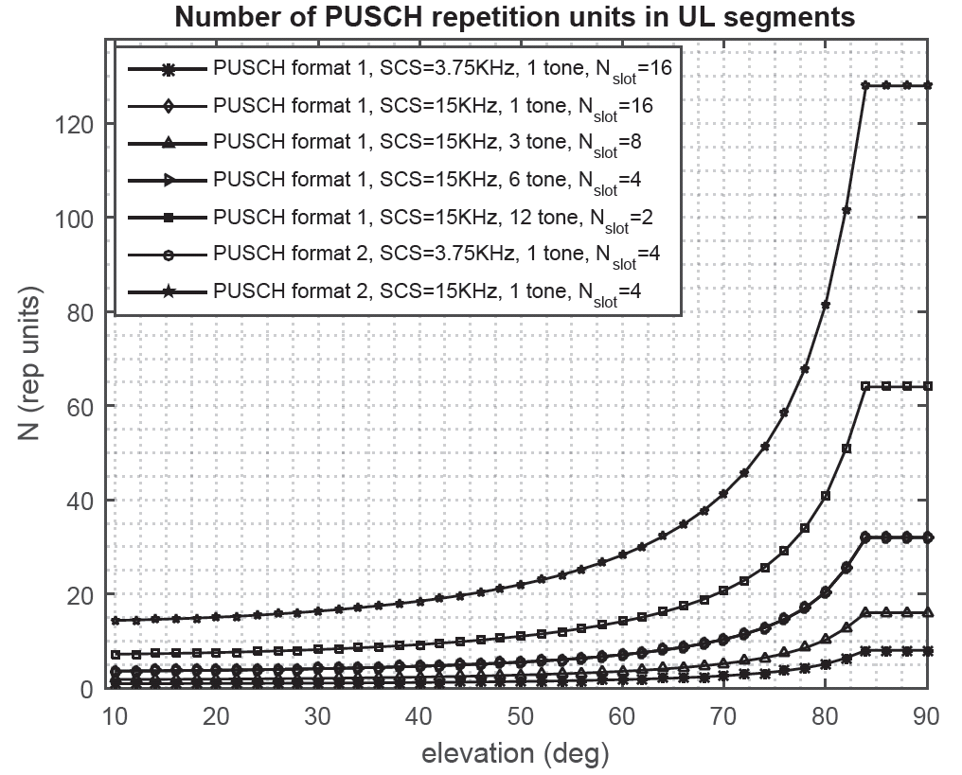

**Figure 2. Number of PUSCH repetition units in a UL segment for LEO-600. (Huawei R1-2108750)**

|  |  |  |  |  |  |  |  |  |  |  |  |
| --- | --- | --- | --- | --- | --- | --- | --- | --- | --- | --- | --- |
| **Elevation angle** | | | **10o** | **20 o** | **30 o** | **40 o** | **50 o** | **60 o** | **70 o** | **80 o** | **83 o~90o** |
| Max-continuous transmission time based on *Te* (ms) | | | 28.7 | 30.08 | 32.63 | 36.89 | 43.97 | 56.52 | 82.63 | 162.8 | 256 |
| **Case 1** | ***X*** (ms) | Mrep |  |  | 32 | 32 | 32 | 32 | 64 | 160 | 256 |
| Mrep | ~ | ~ | ~ | ~ | ~ | ~ | ~ | ~ | ~ |
| Mrep | ~ | ~ | ~ | ~ | ~ | ~ | ~ | ~ | ~ |
| **Case 2** | ***X*** (ms) | Mrep | 24 | 24 | 32 | 32 | 40 | 56 | 80 | 160 | 256 |
| Mrep | ~ | ~ | ~ | ~ | ~ | ~ | ~ | ~ | ~ |
| Mrep | ~ | ~ | ~ | ~ | ~ | ~ | ~ | ~ | ~ |
| **Case 3** | ***X*** (ms) | Mrep | 16 | 16 | 32 | 32 | 32 | 48 | 80 | 160 | 256 |
| Mrep | 24 | 24 | 32 | 32 | 40 | 56 | 80 | 160 | 256 |
| Mrep | 28 | 28 | 32 | 36 | 40 | 56 | 80 | 160 | 256 |
| **Case 4** | ***X*** (ms) | Mrep | 24 | 24 | 32 | 32 | 40 | 56 | 80 | 160 | 256 |
| Mrep | 28 | 28 | 32 | 36 | 40 | 56 | 80 | 160 | 256 |
| Mrep | 28 | 30 | 32 | 36 | 42 | 56 | 82 | 162 | 256 |
| **Case 5** | ***X*** (ms) | Mrep | 28 | 28 | 32 | 36 | 40 | 56 | 80 | 160 | 256 |
| Mrep | 28 | 30 | 32 | 36 | 42 | 56 | 82 | 162 | 256 |
| Mrep | 28 | 30 | 32 | 36 | 43 | 56 | 82 | 162 | 256 |
| **Case 6** | ***X*** (ms) | Mrep | 24 | 24 | 32 | 32 | 40 | 56 | 80 | 160 | 256 |
| Mrep | ~ | ~ | ~ | ~ | ~ | ~ | ~ | ~ | ~ |
| Mrep | ~ | ~ | ~ | ~ | ~ | ~ | ~ | ~ | ~ |
| **Case 7** | ***X***(ms) | Mrep | 28 | 30 | 32 | 36 | 42 | 56 | 82 | 162 | 256 |
| Mrep | ~ | ~ | ~ | ~ | ~ | ~ | ~ | ~ | ~ |
| Mrep | ~ | ~ | ~ | ~ | ~ | ~ | ~ | ~ | ~ |

**Table 2. UL segment duration for long UL transmission for NPUSCH for NB-IoT NTN (Huawei R1-2108750)**

|  |  |  |  |
| --- | --- | --- | --- |
| Index | Minimum elevation angle (deg) | Segment  duration (ms) | Number of segments in X |
| 0 | 10 | 2 | 128 |
| 1 | 10 | 4 | 64 |
| 2 | 10 | 8 | 32 |
| 3 | 10 | 16 | 16 |
| 4 | 38 | 32 | 8 |
| 5 | 67 | 64 | 4 |
| 6 | 79 | 128 | 2 |
| 7 | 85 | 256 | 1 |

Table 1. Indexed table for the segment lengths depending on the UE elevation angle. (Nokia R1-2109265)

Samsung proposed for segmented UE pre-compensation per N time units, the value of N can be separately configured for UL timing pre-compensation and UL frequency pre-compensation

FGI, APT proposed to deprioritize FFS: RAN1 to further discuss valid and invalid subframes. Valid and invalid subframes are used to reserve UL resources for coexistence between NR and NB-IoT via a bitmap. In TR 36,763, the co-existence between NTN NR and NTN IoT is beyond the scope of the Rel-17 IoT NTN study.

The moderator further summarize companies views on the following:

Configuration of UL transmission segment:

* Via signalling on SIB: Huawei
* Via UE-specific RRC signalling:
* Based on UE elevation angle: Nokia, Huawei

UL TA adjustment for long UL transmission:

* Based on common TA and common TA drift: Huawei
* Based on UE location: Nokia

Deprioritize FFS: RAN1 to further discuss valid and invalid subframes

***Moderator view:*** *Companies commented on mechanisms for configuration of UL transmission segment based on satellite secenarios, elevation angle; UL TA adjustments using common TA parameters, UE location report; and ways for configuration via SIB or dedicated RRC signalling; de-prioritize invalid subframes.*

*On UL TA adjustments, the moderator understanding is that the NR-NTN agreements on* NTA update for IoT NTN *as working assumption with some adaptation for the granularity and size of fields for TAC in msg2 and in MAC CE as is further discussed in Section 6.2. Whether the common TA drift or UE location can be used for UL TA adjustments is a separate discussion. The potential issue of timing overcompensation by the UE, when TAC and UE correction are both applied together is under discussion in NR NTN.*

***Initial Proposal – Section 4.2.1:***

***Companies are encouraged to further discuss and align their understanding on the following***

***Q1: Configuration of UL transmission segment:***

* ***Via signalling on SIB***
* ***Via UE-specific RRC signalling***

***Q2: Should UL transmission segment configured be based on satellite scenarios and UE elevation angle? If answer is YES, please say what should be specified or whether this can be up to the network to configure UL transmission segment.***

***Q3: Indication of common TA drift for UL TA adjustment for long UL transmission:***

|  |  |
| --- | --- |
| Companies | Comments |
|  |  |
|  |  |
|  |  |
|  |  |
|  |  |
|  |  |
|  |  |
|  |  |
|  |  |
|  |  |
|  |  |
|  |  |
|  |  |
|  |  |
|  |  |
|  |  |

### NPUSCH/PUSCH UL transmission segment

In RAN1#106-e, the following agreements on NPUSCH/PUSCH UL transmission segment were made

Agreement:

Duration of UL transmission segment for UE pre-compensation for PUSCH transmission is a number of PUSCH repetition units configured by the network

* For NB-IoT, repetition unit is $M_{identical}^{NPUSCH}×N_{slot}^{UL}×T_{slot}$
* For eMTC, repetition unit is $N_{slot}^{UL}×T_{slot}$ for sub-PRB allocation, where Tslot = 0.5 ms. For full-PRB allocation, repetition unit is one subframe.
* NOTE1: $M_{identical}^{NPUSCH}, N_{slot}^{UL}, T_{slot}$ are defined in TS 36.211 10.1.2.3 and 10.1.3.6 for NB-IoT
* NOTE2: $M_{symb}^{UL}, M_{slot}^{UL}$ M\_^UL\_slot is defined in TS 36.211, 5.2.3A for eMTC
* FFS: RAN1 to further discuss valid and invalid subframes
* FFS: Configuration details

Agreement:

* For NB-IoT/eMTC NTN, the network configures one of K candidate values for the UL transmission segment duration of NPUSCH/PUSCH in a k-bit field.
  + For NB-IoT, maximum 3-bit field with a maximum number of K=8 candidate values 2 ms, 4 ms, 8 ms, 16 ms, 32 ms, 64 ms, 128 ms, 256 ms
* FFS: Down scoping of K candidate values, size of k-bit field

***NOTE: the values of UL transmission segment duration for NB-IoT can be different to those for eMTC***

Agreement:

For NB-IoT, if a mapping to Nslots slots or a repetition of the mapping in an UL transmission segment for UE pre-compensation for NPUSCH transmission contains a resource element which overlaps with any configured NPRACH resource, the NPUSCH transmission in overlapped Nslots slots is postponed until the next Nslots slots not overlapping with any configured NPRACH resource.

* NOTE: Nslots is defined in TS 36.211, 10.1.3.6

Down-scoping of UL transmission segment duration values for NPUSCH in NB-IoT:

Huawei discussed the the time-duration of NPUSCH repetition unit, i.e. $M_{identical}^{NPUSCH}×N_{slot}^{UL}×T_{slot}$, only consists of a few values {2ms, 4ms, 8ms, 16ms, 32ms} for frame structure type 1. The values of *X* for all numerology cases can be determined for different elevation angles. K=5 max UL transmission segment duration values {16 ms, 32 ms, 64 ms, 128 ms, 256 ms) can be configured in a 3-bit field.

Qualcomm proposed the segment duration value(s) depend on the satellite orbit type, with GEO satellites supporting longer durations of time than LEO satellites. -For GEO, the smaller values of segment durations may not be required

Vivo assumes maximum UL transmission segment duration should not exceed 32 ms for LEO and 256 ms for GEO, and propose minimum candidate values are 4 ms for NB-IoT and 2 ms for eMTC.

Qualcomm proposed for For PUSCH, the segment duration for uplink pre-compensation may be indicated/negotiated between the network and the UE via dedicated unicast signalling, including UE sending assistance information to the network, e.g., indicating its mobility pattern and speed.

Qualcomm proposed for eMTC when frequency hopping is configured:

* When the hopping interval is less than the configured segment duration for uplink synchronization, the UE shall use the hopping interval as the segment duration for uplink synchronization
* When the hopping interval is greater than or equal to the configured segment duration for uplink synchronization, the UE shall use HI×⌊N\_configured/HI⌋ as the segment duration for uplink synchronization, where HI denotes the hopping interval, and N\_configured is the configured segment duration.

Downscoping K values for NPUSCH for NB-IoT/eMTC:

* {16 ms, 32 ms, 64 ms, 128 ms, 256 ms} : Huawei
* Max 32 ms for LEO: Vivo, CATT
* Smaller candidate values not needed for GEO: Qualcomm
* Candidate value 256 ms not needed since UL Compensation gap 40 ms specified: FGI, APT, III, ITRI
* No downscoping: ZTE, MediaTek

***Moderator view:*** *Companies have discussed need to downscope lower candidate values, higher candidate values, no downscoping for candidate values of UL transmission segment NPUSCH/PUSCH. More discussions needed to align company understanding.*

***Initial Proposal – Section 4.2.2:***

***Companies are encouraged to further discuss and align their understanding for candidate values of UL transmission segment NPUSCH/PUSCH on the following***

1. ***{16 ms, 32 ms, 64 ms, 128 ms, 256 ms}***
2. ***Max 32 ms for LEO***
3. ***Candidate value 256 ms not needed***
4. ***Smaller candidate values not needed for GEO***
5. ***Different candidate values for LEO and GEO***
6. ***No downscoping***

|  |  |
| --- | --- |
| Companies | Comments |
|  |  |
|  |  |
|  |  |
|  |  |
|  |  |
|  |  |
|  |  |
|  |  |
|  |  |
|  |  |
|  |  |
|  |  |
|  |  |
|  |  |
|  |  |
|  |  |

### NPRACH/PRACH duration of UL transmission segment Duration

In RAN1#106-e, the following agreements on NPRACH/PRACH UL transmission segment were made

Agreement:

Duration of UL transmission segment for UE pre-compensation for PRACH transmission is a number of RACH repetition units configured by the network

* For NB-IoT, repetition unit is P symbol groups.
* For eMTC, repetition unit is one preamble including guard period.
* FFS: Configuration details

Agreement:

* For NB-IoT NTN, the network configures one of K values for the UL transmission segment duration of each PRACH preamble format in a k-bit field, where the size of the k-bit field and the number of K candidate values depend on the preamble format.
* Format 0 and format 1: 3-bit field, K=6 candidate values 2.4.(TCP+TSEQ), 4.4.(TCP+TSEQ), 8.4.(TCP+TSEQ), 16.4.(TCP+TSEQ), 32.4.(TCP+TSEQ), 64.4.(TCP+TSEQ)
* Format 2:  2-bit field, K=4 candidate values 2.6.(TCP+TSEQ), 4.6.(TCP+TSEQ), 8.6.(TCP+TSEQ), 16.6.(TCP+TSEQ)
* FFS: Down scoping of K candidate values, size of k-bit field
* FFS: Whether the same segment duration can be used for all preambles within a preamble format

Agreement:

For eMTC, the network configures one of K values for the UL transmission segment duration of PRACH in a k-bit field.

* FFS: K candidate values, size of k-bit field

Huawei discussed the UL segment duration should be a number of *N*PRACH repetition units which does not exceed the maximum allowed continuous transmission time *Tseg\_max* based on the elevation angle and the timing error Te. The values of number of NPRACH repetition units for format 0, 1, and 2 can be determined for different elevation angles with a 4-bit indication in the system information for the pre-compensation of all preamble formats.

CATT, SONY proposed the same segment duration should be used for all preambles within a preamble format.

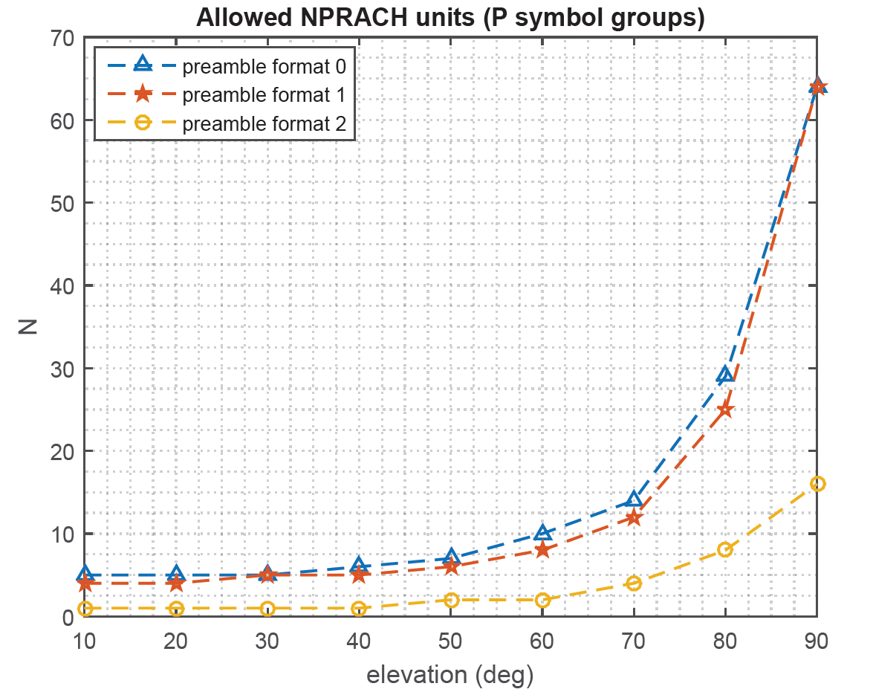

**Figure 3 Maximum allowed time-continuous transmission and TA drift rate for LEO-600km (Huawei R1-2108750)**

**Table 3. Number of NPRACH repetition units at different elevation angles. (Huawei R1-2108750)**

|  |  |  |  |  |  |  |  |  |  |
| --- | --- | --- | --- | --- | --- | --- | --- | --- | --- |
| Elevation | 10o | 20o | 30o | 40o | 50o | 60o | 70o | 80o | 90o |
| Format 0 | 5 | 5 | 5 | 6 | 7 | 10 | 14 | 29 | 64 |
| Format 1 | 4 | 4 | 5 | 5 | 6 | 8 | 12 | 25 | 64 |
| Format 2 | 1 | 1 | 1 | 1 | 2 | 2 | 4 | 8 | 16 |

The moderator further summarize companies views on the following:

Downscoping K values for NPRACH for NB-IoT:

* Up-scoping Format 0 and 1 with K=7 candidate values to add *4\*(TCP+TSEQ)*: ZTE
* Up-scoping Format 2 with K=5 candidate values to add 6\*(TCP+TSEQ): Huawei, ZTE
* Downscoping with maximum values for LEO for Format 0,1, and 2: Vivo (first 2 values format#1,1 a,d first value format #2), CATT (first 4 values format #0,#1, and new candidate values 1.6.(TCP+TSEQ) and 3.6.(TCP+TSEQ) for format #2 up to 4.6.(TCP+TSEQ) **)**

K candidate values for PRACH for eMTC:

* ZTE, Vivo (LEO only): 3-bit field, with K=8 values (TCP+TSEQ+TGP), 2\*(TCP+TSEQ+TGP), 4\*(TCP+TSEQ+TGP), 8\*(TCP+TSEQ+TGP), 16\*(TCP+TSEQ+TGP), 32\*(TCP+TSEQ+TGP), 64\*(TCP+TSEQ+TGP), 128\*(TCP+TSEQ+TGP)
* SONY: 3-bit field with a maximum number of K=8 candidate values 2 ms, 4 ms, 8 ms, 16 ms, 32 ms, 64 ms, 128 ms, 256 ms
* CATT: Formats #0,#1,#2: 3-bit field, with K=5 values 2 ms, 4 ms, 8 ms, 16 ms, 32 ms; Formats #3: 3-bit field, with K=5 values 3 ms, 6 ms, 12 ms, 24ms ,30ms;
* Vivo (GEO): 2-bit field with 3 candidate values {2\*(TCP + TSEQ), 4\*(TCP + TSEQ), 8\*(TCP + TSEQ)}.

|  |  |  |  |  |  |  |
| --- | --- | --- | --- | --- | --- | --- |
| Preamble format | P | TCP | TSEQ | TCP + TSEQ | Repetition unit duration $P×\left(T_{CP}+T_{SEQ}\right)$ | Maximum continuous transmission time |
| 0 | 4 | $$2048 T_{s}$$ ($66.7 μs$) | $$5×8192 T_{s}$$ | 1.4 ms | 5.6 ms | $64×5.6=358.4$ ms |
| 1 | 4 | $8192 T_{s}$ ($266.7 μs$) | $$5×8192 T_{s}$$ | 1.6 ms | 6.4 ms | $64×6.4=$ 409.6 ms |
| 2 | 6 | $24576 T_{s}$ ($800 μs$) | $$3×24576 T_{s}$$ | 3.2 ms | 19.2 ms | $16×19.2=307.2$ ms |

NB-IoT preamble formats

|  |  |  |  |  |
| --- | --- | --- | --- | --- |
| **Preamble format** |  |  | **Guard Time(ms)** | **Time Duration(ms)** |
| 0 |  |  | 0.097 | 1 |
| 1 |  |  | 0.516 | 2 |
| 2 |  |  | 0.197 | 2 |
| 3 |  |  | 0.716 | 3 |
| 4 (see Note) |  |  |  |  |
| NOTE: Frame structure type 2 and special subframe configurations with UpPTS lengths and only assuming that the number of additional SC-FDMA symbols in UpPTS X in Table 4.2-1 of TS36.211 is 0. | | | | |

Preamble formats for eMTC

***Moderator view:*** *To our understanding, there is link between UL transmission segment and elevation angle. Companies have questioned whether all values are needed or just keep legacy transmission segment, or add new values to list agreed for discussions in RAN1#106e.*

***Initial Proposal – Section 4.2.3:***

***Companies are encouraged to further discuss and align their understanding for candidate values of UL transmission segment NPRACH/PRACH on the following***

***Q1: Downscoping of K values for NPRACH***

1. ***No need to introduce new transmission segments (i.e. only use legacy transmission segments 64.4.(TCP+TSEQ) for format 0 and 1, and 16.6.(TCP+TSEQ)  for format #2***
2. ***Same transmission segment duration for all preamble***
3. ***New transmission segments added – i.e.. 4\*(TCP+TSEQ) for format 0 and 1, and 6\*(TCP+TSEQ) for format 2.***

***Q2: K values for PRACH for eMTC***

1. ***3-bit field, with K=8 values (TCP+TSEQ+TGP), 2\*(TCP+TSEQ+TGP), 4\*(TCP+TSEQ+TGP), 8\*(TCP+TSEQ+TGP), 16\*(TCP+TSEQ+TGP), 32\*(TCP+TSEQ+TGP), 64\*(TCP+TSEQ+TGP), 128\*(TCP+TSEQ+TGP)***
2. ***3-bit field with K=8 candidate values 2 ms, 4 ms, 8 ms, 16 ms, 32 ms, 64 ms, 128 ms, 256 ms***
3. ***Formats #0,#1,#2: 3-bit field, with K=5 values 2 ms, 4 ms, 8 ms, 16 ms, 32 ms; Formats #3: 3-bit field, with K=5 values 3 ms, 6 ms, 12 ms, 24ms ,30ms;***
4. ***2-bit field with K=3 candidate values {2\*(TCP + TSEQ), 4\*(TCP + TSEQ), 8\*(TCP + TSEQ)}.***

***Q3: Same value used for segment durations for all preambles***

|  |  |
| --- | --- |
| Companies | Comments |
|  |  |
|  |  |
|  |  |
|  |  |
|  |  |
|  |  |
|  |  |
|  |  |
|  |  |
|  |  |
|  |  |
|  |  |
|  |  |
|  |  |
|  |  |
|  |  |

### New UL gaps for long UL transmission

New gaps for long transmission of NPRACH:

The total 2-way delay dift can be up to ~100 µs/s over service link and feeder link (UE-SAT-eNB) at lowest elevation angle of 10 degree on service link and feeder link. For long transmission of RACH, there will be a large timing drift in case of large number of repetitions for preamble transmission. For NB-IoT, the maximum time-continuous transmission can be 409.6 ms, which gives a total 2-way delay drift of about 41 µs/s or 1258.Ts. This exceeds the max transmit timing error of 2.6 µs =80.Ts in NB-IoT.

Huawei proposed UE autonomous TA adjustment should be applied during the long preamble transmission duration to compensate the large timing drift.

Qualcomm observed that the UE can handle the (small) changes/adjustments across chunks/segments in time and frequency by dropping/inserting samples as and when required. This prevents any potential throughput loss and scheduling complications that additional gaps may precipitate.

Company views on new gaps for NPRACH in NB-IoT (based on their proposals in TDoc submissions):

* New gaps: Spreadtrum, FGI, APT
* No New gaps: Huawei, Qualcomm, Nordic Semiconductor ASA

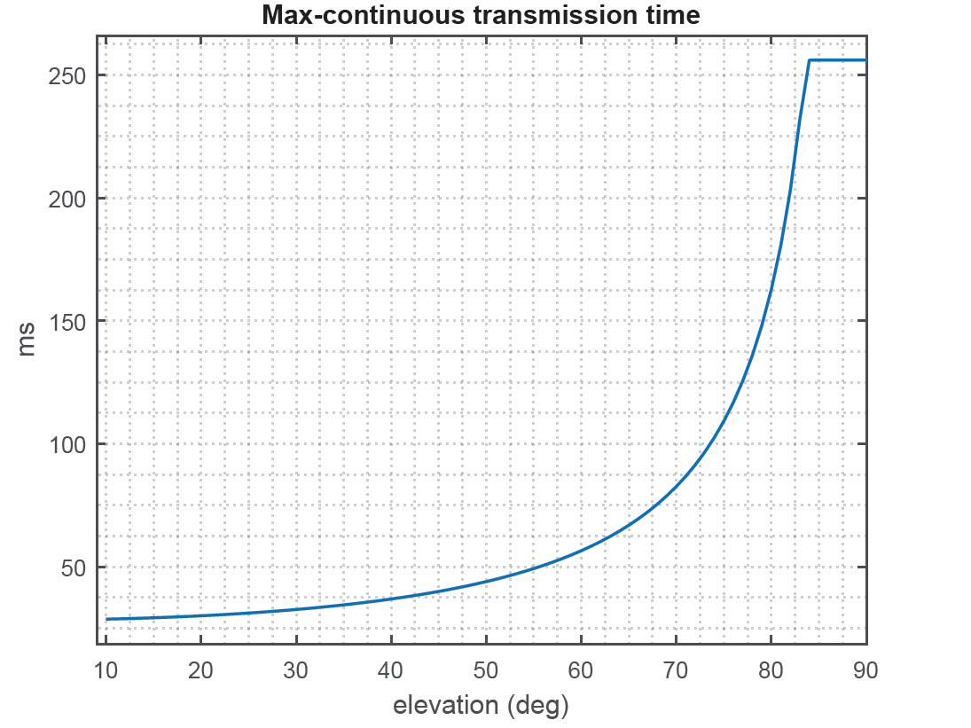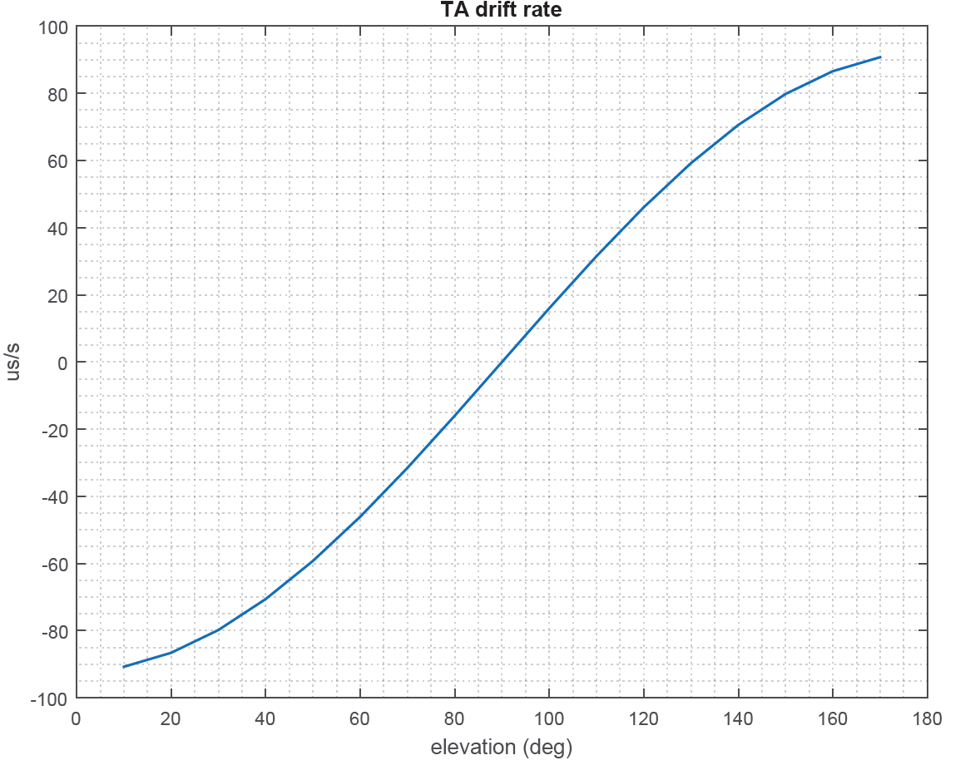

**Figure 1. Maximum allowed time-continuous transmission and TA drift rate for LEO-600km (Huawei R1-2108750)**

New gaps for long transmission of NPUSCH :

The total 2-way delay dift can be up to ~100 µs/s over service link and feeder link (UE-SAT-eNB) at lowest elevation angle of 10 degree on service link and feeder link. For long transmission of NPUSCH/PUSCH, there will be a large timing drift in case of large number of repetitions at low elevation angles. For NB-IoT and eMTC, the legacy maximum time-continuous transmission can be 256 ms, which gives a total 2-way delay drift of about 25 µs/s or 769.Ts, which exceeds the max transmit timing error of 2.6 µs =80.Ts in NB-IoT and 0.78 µs = 24.Ts in eMTC respectively.

FGI, APT discussed cases for overlapping. If decreasing (case 1), UE shall add gaps due to TA adjustment to postpone the repetition units to ensure eNB receives the long UL transmission without gaps among the repetitions. If increasing (case 2), UE could 1) complete transmission of repetition unit n and not transmit the overlapped part of repetition unit n+1; or 2) drop the overlapped part of repetition unit n; 3) drop the whole repetition unit n; or 4) postpone repetition unit n+1 until the next slot not overlapping (including TA impact) with any configured NPRACH or NPUSCH resource.

Figure 1: Long UL transmission enhancement in IoT over NTN (FGI, APT R1-2109869)

Huawei proposed to introduce extra gaps for TA adjustment based on different elevation angles. More UL gaps should be inserted according to the maximum allowed time-continuous transmission for IoT over NTN, which is based on the common TA drift rate and the worst case of UE-specific TA drift rate in a cell.

Nokia proposed one SC-FDMA symbol can be punctured between two segments for TA adjustment.

Samsung proposed if transmission signal is overlapped between two adjacent segments, overlapped samples of the last segment can be dropped.

Lenovo proposed last Y time duration or first Y time duration NPUSCH transmission every X ms time interval for TA adjustment is dropped/punctured.

CATT proposed for small TA variation, TA adjustment is implemented by dropping tail samples of a segment or delaying a few samples for UL transmission. For large TA variation, the gap can be configured with Original GP reused for (N)PRACH’s new gap.

Nokia observed that TA drift induced timing error during the maximum continuous transmission time of NPRACH is smaller than the preamble’s cyclic prefix. No need to introduce new transmission segments to NPRACH.

MediaTek observed new gap of 1 ms may not be difficult for eNB to to schedule UEs with UL transmission duration of 1 ms since repetitions may most likely be needed. Re-using gap of 40 ms has lower imact on specifications and eNB scheduler implementation, and no impact on peak data rates for normal SNR conditons where use of many repetitions is not required.

Spreadtrum, ZTE, Vivo mentioned new gaps can avoid issues of UL transmission segments overlapping.

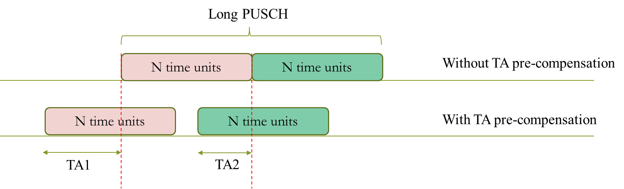

Figure 1: the UE's TA pre-compensation value changes from large to small (Spreadtrum R1-2108931)

**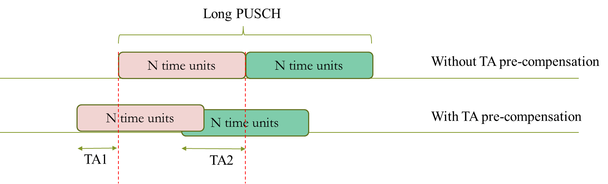**

Figure 2: the UE's TA pre-compensation value changes from small to large (Spreadtrum R1-2108931)

The moderator further summarize companies views on the following:

* New gaps: Huawei, ZTE, Spreadtrum, Vivo, NEC, Samsung, FGI, APT, CATT, MediaTek
  + 1 ms: ZTE
  + 40 ms (legacy UL gap) ZTE
  + Smaller than 1 ms: Huawei, FGI, APT, III, ITRI
  + Indicated by system Information: Huawei
* No new gaps: Nordic Semiconductor ASA, Nokia

***Moderator view:*** *Companies have discussed need for new gaps for NPUSCH/PUSCH and NPRACH. To the moderator understanding there can be different values for new gaps – 1 ms, 40 ms, smaller than 1 ms. In case no gap, there can be several ways TAadjustments can be implementated or it can be done within the preamble’s cyclic prefix or the guard band. Other ways up to UE implementation can also be considered based on the RAN4 timing requirements. More discussions needed to align company understanding.*

***Initial Proposal – Section 4.2.4:***

***Companies are encouraged to comment on options for new gaps between UL transmission segments:***

* ***Option 1: New gaps for NPUSCH/PUSCH:*** 
  1. ***1 ms:***
  2. ***40 ms (legacy UL gap)***
  3. ***Smaller than 1 ms***
     1. ***one punctured SC-FDMA symbol in NPUSCH/PUSCH***
     2. ***one dropped/punctured time duration in NPUSCH/PUSCH***
  4. ***Indicated by system Information***
* ***Option 2: No new gaps between UL transmission segments: (Please, say if this has impact on the specifications or can be up to UE implementation based on RAN4 timing requirements).***
  1. ***Small TA adjustment is implemented by dropping tail samples of a segment for NPUSCH/PUSCH***
  2. ***Small TA adjustment is implemented by delaying a few samples for UL transmission for NPUSCH/PUSCH***
  3. ***Large TA adjustment is done within the NPRACH/RACH preamble’s cyclic prefix or the guard band***
  4. ***Other ways up to UE implementation***

|  |  |
| --- | --- |
| Companies | Comments |
|  |  |
|  |  |
|  |  |
|  |  |
|  |  |
|  |  |
|  |  |
|  |  |
|  |  |
|  |  |
|  |  |
|  |  |
|  |  |
|  |  |
|  |  |
|  |  |

### Postponement of long NPUSCH due to overlap with NPRACH :

ZTE proposed the postponement of NPUSCH due to overlap with NPRACH is counted in segment duration. The portion of postponement which coincides with a UL gap is counted as part of the gap.

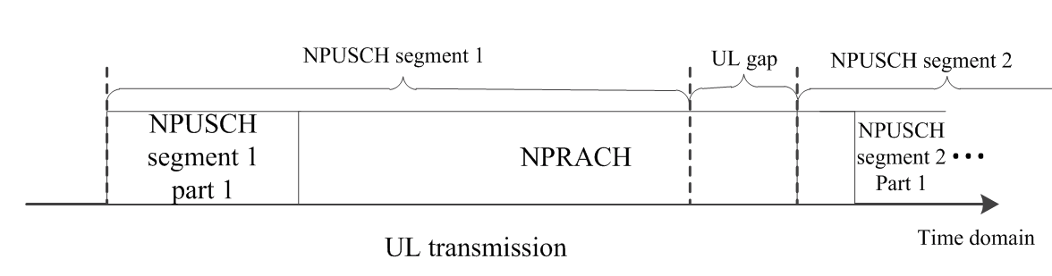

Figure 3 Illustration of overlap between NPUSCH and NPRACH. (ZTE R1-2109847)

***Moderator view:*** *postponement of long NPUSCH due to overlap with NPRACH. RAN1#106-e made agreement “For NB-IoT, if a mapping to Nslots slots or a repetition of the mapping in an UL transmission segment for UE pre-compensation for NPUSCH transmission contains a resource element which overlaps with any configured NPRACH resource, the NPUSCH transmission in overlapped Nslots slots is postponed until the next Nslots slots not overlapping with any configured NPRACH resource.”.*

***Initial Proposal – Section 4.2.5:***

***Companies are encouraged to further discuss and align their understanding on the following for postponement of long NPUSCH due to overlap with NPRACH***

1. ***Counted in segment duration.***
2. ***Portion of postponement which coincides with a UL gap is counted as part of the gap***
3. ***Others (please, say what and why)***

|  |  |
| --- | --- |
| Companies | Comments |
|  |  |
|  |  |
|  |  |
|  |  |
|  |  |
|  |  |
|  |  |
|  |  |
|  |  |
|  |  |
|  |  |
|  |  |
|  |  |
|  |  |
|  |  |
|  |  |

### Phase discontinuity in segmented pre-compensation

Huawei discussed that for long repetitions, that the phase discontinuity at the subframe boundary when applying new pre-compensation is predictable based on the UE GNSS acquired position, satellite ephemeris and common TA drift rate and can be compensated at the UE side.

ZTE observed that the PAPR increment due to phase discontinuity in segmented pre-compensation is acceptable even if no further enhancement is introduced. Further improvement on the PAPR with proper configuration of segment length can be achieved. If segment overlap and phase discontinuity are expected to be mitigated, more frequent new UL gaps can be inserted between segments to avoid overlap between segments when TA is adjusted. The phase discontinuity due to UL signal puncturing, which is performed at segment boundary to advance the transmission timing, can also be avoided. The additional UL gap does not need to be as large as traditional 40 ms UL gap since it is mainly to handle the overlap between segments instead of recovering DL synchronization. The maximum TA variation between adjacent segments is restricted by , which is much shorter than 1 slot.

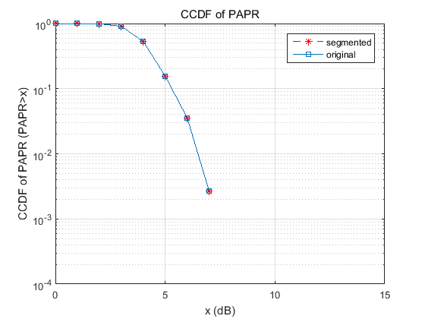

Figure 1 PAPR of segmented signal with 12 subcarriers (ZTE R1-2109847)

|  |  |
| --- | --- |
| papr_1sccomp | papr_1sccomp_edge |
| 1. pi/2-BPSK, center subcarrier | 1. pi/2-BPSK, edge subcarrier |
| papr_1sccomp_pidiv4qpsk | papr_1sccomp_pidiv4qpsk_edge |
| 1. pi/4-QPSK, center subcarrier | 1. pi/4-QPSK, edge subcarrier |

Figure 2 PAPR of segmented signal with 1 subcarrier with 100 us/s TA drift rate (ZTE R1-2109847)

Nokia observed that Timing-drift-induced phase error can exceed the maximum demodulation tolerance at the receiver. Analysis in Nokia R1-2109625 is copied below to allow understanding of the issue:

On UL, baseband signal with SC-FDMA (Section 10.1.5 of TS36.211) with a resource unit containing only one subcarrier ($N_{sc}^{RU}=1$), time-continuous signal *sk* ,*l* (*t* ) for sub-carrier index *k* in SC-FDMA symbol *l* in an uplink slot is



$ϕ_{k,j}=ρ\left(\tilde{l} mod 2\right)+φ_{k}\left(\tilde{l}\right)$, where $ρ=\left\{\begin{aligned}\frac{π}{2} for BPSK \\ \frac{π}{4} for QPSK \end{aligned}\right.$

$φ_{k}\left(\tilde{l}\right)=\left\{\begin{aligned}0 \tilde{l}=0 \\ φ_{k}\left(\tilde{l}-1\right)+2πΔf\left(k+1/2\right)\left(N+N_{CP,l}\right)T_{s} \tilde{l}>0\end{aligned}\right.$ $\tilde{l}=0,1,…,N_{TB}M_{rep}^{NPUSCH}N_{RU}N_{slots}^{UL}N_{symb}^{UL}-1$

$l= \tilde{l} mod N_{symb}^{UL}$

The phase of current symbol $φ\left(\tilde{l}\right)$ is an increment of $2πΔf\left(k+\frac{1}{2}\right)\left(N+N_{CP,l}\right)T_{s}$ from the phase of previous symbol $φ\left(\tilde{l}-1\right)$. In NTN, the required timing advance is time-varying due to the motion of satellite. During a transmission period, the TA change amount is roughly the product of the TA drift rate and the transmission time. For IoT devices that rely on a large number of repetitions in data transmission, the long transmission time will incur a non-negligible timing drift for the UL signal. When the signal’s propagation distance changes with the movement of a satellite, a phase error will be encountered at the receiver. When the phase of the transmitted signal is $Φ\left(T_{s}\right)$ at time $T_{s}$, the transmitted signal arrives at the receiver with an additional delay known as timing drift. As the received signal is sampled at $T_{s}$, the receiver observes the phase of a delayed signal waveform, resulting in a phase error on the received signal. Note that the symbol phase of the received signal increases at a lower rate $k/\left(1+r/2\right)$ as opposed to the original rate $k$.

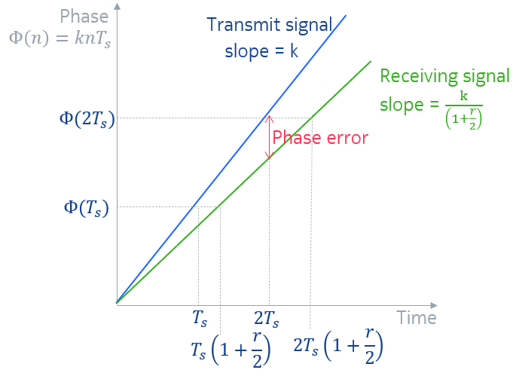

Figure 7 Receiver can observe a lower phase than the transmitted signal’s phase due to TA drift. (R1-2109265)

As the TA change becomes large, there may be a serious impact on the signal’s phase continuity, causing the data symbols not to be demodulated successfully. In particular, a TA change of $\left|ΔTA\right|$ corresponds to a timing drift of $\frac{\left|ΔTA\right|}{2}$ for the UL signal waveform. The accumulated timing drift in the UL signal during the transmission period. This timing drift produces an increasing phase error along the time. Additionally, a UE with smaller elevation angle may have a faster phase error accumulation. Due to the TA drift, the symbol phase slope at the receiver will change by a factor (1+r⁄2)^(-1).

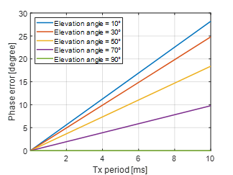

Figure 8 The amount of phase error in UL transmission period increase with the transmission period.(Nokia R1-2109625)

Nokia proposed two ways to resolve the issue of phase error due to TA change between UL transmission segment:

* At the UE transmitter, UE scales up the phase difference across symbols based on TA drift rate: the phase error can be pre-compensated by scaling up the phase difference across symbols by a factor χ. The symbol phase for the l ̃-th symbol becomes φ(l ̃ )=φ(l ̃-1)+2πΔf(k+1/2)(N+N\_(CP,l) ) T\_s χ (1) , where χ is a function of TA drift rate r, χ(r)=1+r/2. With the phase pre-compensation, the phase of the l ̃-th symbol of the received signal will be φ(l ̃ )=φ(l ̃-1)+2πΔf(k+1/2)(N+N\_(CP,l) ) T\_s after propagation while the TA drifts.
* At eNB transmitter, the network estimate the UE-specific TA drift and pre-compensate the phase difference across symbols based on UE location: he phase error can be corrected by the eNB receiver instead of the UE pre-compensating the phase error. In the demodulation process, the eNB will use the time drifted symbol phase for the $\tilde{l}$-th symbol as in (1), but with the timing correction factor $χ\left(r\right)={\left(1+r/2\right)}^{-1}$. With this phase correction, the reference phase of the demodulator will be the same as the phase of the received signal.

***Moderator view:*** *Companies have provided some analsysis for this issue of phase error due to TA change between UL transmission segment. The moderator understanding is that the impact on the PAPR is not significant. The impact on demodulation performance of UL signals at the eNB is significant.*

***Initial Proposal – Section 4.2.6:***

***Companies are encouraged to further discuss and align their understanding on this issue of phase error due to TA change between UL transmission segment:***

***Q1: Impact of phase error due to TA change between UL transmission segment on PAPR is not significant. Please, say why if there is different understanding.***

***Q2: Impact of phase error due to TA change between UL transmission segment on UL signals demodulation performance can be pre-compensated:***

1. ***At UE transmitter: UE scales up the phase difference across symbols based on UE GNSS acquired position, satellite ephemeris and common TA drift.***
2. ***At eNB transmitter: Network estimate the UE-specific TA drift and pre-compensate the phase difference across symbols based on UE location.***

***Q3: In case answer to Q2, a) is Yes, are new gaps between UL transmission segments needed?***

|  |  |
| --- | --- |
| Companies | Comments |
|  |  |
|  |  |
|  |  |
|  |  |
|  |  |
|  |  |
|  |  |
|  |  |
|  |  |
|  |  |
|  |  |
|  |  |
|  |  |
|  |  |
|  |  |
|  |  |

## FIRST ROUND - Long UL transmission on PUSCH and PRACH

Configuration of UL transmission segment:

TBA

Duration of UL transmission segment:

TBA

New UL gaps for long UL transmission:

TBA

Phase discontinuity in segmented pre-compensation:

TBA

# DL Synchronization

## Background

In RAN#92e, the following objective was agreed in the Rel-17 IoT NTN WID [1]

*Specify the following time and frequency synchronization enhancements that are not covered by NR\_NTN\_Solutions WI agreements, according to Section 8 in TR 36.763:*

* *DL synchronization enhancements: A single solution will be selected between: new channel raster, (part of) ARFCN-indication-in-MIB.*

The differential Doppler frequency can be up to +/-39.9 kHz with set-4 LEO-600. The max Doppler shift cann be +/-48 kHz. Wth 20 ppm oscillator error at UE, there can be additional frequency error term of +/-40 KHz. The total uncertainty on DL raster exceeds half of 100 kHz channel raster of terrestrial NB-IoT/eMTC. Synchronizing on the wrong raster could cause error in (N)Cell frequency selection.

## Company views

Ericsson observed that RAN4 input is needed before increasing the channel raster size and multiple hypotheses testing may be needed if ARFCN-indication-in-MIB is used. RAN1 can compare the pros and cons of increasing the channel raster step size and introducing ARFCN-indication-in-MIB

Huawei observed introducing the new channel raster with larger step size (100 kHz) has no extra signalling overhead. Indication of (part of)ARFCN will increase the MIB payload size and overhead and also causes potential compatibility issue for terminals operating in both terrestrial IoT network and the NTN IoT network.

Lenovo considered the standard effort and potential available bit in MIB indicating the ARFCN, we prefer solution A to investigate the possible increasing channel raster step size by RAN4, e.g., channel raster with step size of 300kHz.

Intel observed both solutions are able to solve the issue of ARFCN ambiguity. Increased channel raster step size may lead to reduced number of NB-IoT carriers if bandwidth is a limiting factor for NTN NB-IoT deployments. Number of carriers shall be selected to have sufficient number of NB-IoT carriers considering UE complexity for DL synchronization. It is simpler from the implementation perspective and requires less standardization efforts. Support Common Doppler pre-compensation for DL, with indication of Common Doppler pre-compensation should follow design agreed for NR NTN

Qualcomm observed that increasing the channel raster step size limits possible Ncell deployments for operators. For example, if the raster step size is doubled, the number of Ncells that an operator can deploy within their allocated spectrum reduces by half. The current MIB in NB-IoT alreadyt indicates the “raster offset” between +/- 2.5 KHz and +/- 7.5 kHz to solve an analogous ambiguity that may arise in terrestrial, depending on where the Ncells can be in frequency. Indicating a portion of the ARFCN in NB-MIB for IoT NTN would need two LSBs to lock on an odd or even ARFCN, while also determining the direction of the Doppler frequency shift There are 9 spare bits in the NB-MIB, so 2 spare bits can be used for the two LSBs of the ARFCN.

New channel raster with step size greater than 100 kHz for DL synchronization in IoT NTN

* Support: Huawei, CATT, ZTE, MediaTek, Xiaomi (200 kHz), Lenovo (300 kHz), Intel, Apple

(part-)ARFCN-indication-in-MIB

* Support: Qualcomm (2 LSBs)

DL frequency pre-compensation:

* Support: Huawei

***Moderator view:*** *To moderator understanding, the differential Doppler frequency can be up to +/-39.9 kHz with set-4 LEO-600 km. This is close to maximum Doppler shift +/-48 kHz without DL frequency pre-compensation. Discussions on DL frequency pre-compensation by the network on service link is also discussed in NR NTN and can be postponed until NR NTN WI concludes on this topic to avoid duplication of discussion.*

***Initial Proposal – Section 5.2:***

***Companies are encouraged to further discuss on the pros and cons of DL synchronization solutions: (please, also indicate preference if any and why)***

***Q1: Is it company understanding that the differential Doppler frequency can be up to +/-39.9 kHz with set-4 LEO-600 km. This is close to maximum Doppler shift +/-48 kHz without DL frequency pre-compensation?***

***Q2: new channel raster with larger step size (>100 kHz)***

* ***RAN4 input is needed before increasing the channel raster size***
* ***Has no extra signalling overhead***
* ***Limits possible Ncell deployments for operators***

***Q3: (part of)ARFCN indication in MIB***

* ***Need two spare LSBs to lock on an odd or even ARFCN without ambiguity on direction***
* ***Need multiple hypotheses testing.***

|  |  |
| --- | --- |
| Companies | Comments |
|  |  |
|  |  |
|  |  |
|  |  |
|  |  |
|  |  |
|  |  |
|  |  |
|  |  |
|  |  |
|  |  |
|  |  |
|  |  |
|  |  |
|  |  |
|  |  |

## FIRST ROUND – DL Synchronization

TBA

.

# Synchronization aspects common to IoT NTN and NR NTN

## Background

In RAN#92e, the following objective was agreed in the Rel-17 IoT NTN WID [1]

*Specify the following time and frequency synchronization enhancements, using NR\_NTN\_solutions WI agreements as baseline, according to Section 8 in TR 36.763:*

*- UE pre-compensation including ephemeris format (orbital / Position -Velocity)*

*- UE pre-compensation for UL synchronization in RRC\_IDLE and RRC\_CONNECTED states based at least on its GNSS-acquired position and the serving satellite ephemeris*

*- Timing advance formula (granularity of the timing advance may be different)*

*- Combination of Open (i.e. UE autonomous TA estimation, and common TA estimation) and Closed TA (i.e., received TA commands) control loops in RRC\_CONNECTED state*

*Agreements on the above are up to the decision in NR\_NTN\_Solutions WI and will be used for IoT NTN with minimum changes, if any.*

In RAN1#106-e, the following agreements were made

Agreement:

The following agreements from NR NTN are re-used for IoT NTN as working assumption.

1. The Doppler shift over the feeder link and any transponder frequency error for both Downlink and Uplink is compensated by the GW and satellite-payload without any specification impacts in Release 17.
2. The orbital propagator model to be used at UE side can be left to implementation
3. Timing Advance formula can be transposed to IoT-NTN with Ts used instead of Tc

The Timing Advance applied by an NR NTN UE in RRC\_IDLE/INACTIVE and RRC\_CONNECTED is given by:

$$T_{TA}=\left(N_{TA}+N_{TA,UE-specific}{+N}_{TA,common}{+N}_{TA,offset}\right)×T_{s}$$

Where:

* $N_{TA}$ is defined as 0 for PRACH and updated based on TA Command field in msg2/msgB and MAC CE TA command.
  + FFS: details of NTA update/accumulation.
* $N_{TA,UE-specific}$ is UE self-estimated TA to pre-compensate for the service link delay.
* $N_{TA,common}$ is network-controlled common TA, and may include any timing offset considered necessary by the network.
* $N_{TA,common}$ with value of 0 is supported.
  + FFS:  details of signaling including granularity.
* $N_{TA,offset}$ is a fixed offset used to calculate the timing advance.

Note-1: Definition of $N_{TA}$  is different from that in RAN1#103-e agreement in NR NTN WI.

Note-2: UE might not assume that the RTT between UE and gNB is equal to the calculated TA for Msg1/Msg A.

Note-3: $N_{TA,common}$  is the common timing offset X as agreed in RAN1 #103-e in NR NTN WI.

1. Support the delivery of ephemeris information using both ephemeris formats, i.e., state vectors and orbital elements

* Set 1: Satellite position and velocity state vectors (position/velocity)
  + Position X,Y,Z in ECEF (m)
  + Velocity VX,VY,VZ in ECEF (m/s)
* Set 2: Parameters in orbital parameter ephemeris format
  + Semi-major axis α [m]
  + Eccentricity e
  + Argument of periapsis ω [rad]
  + Longitude of ascending node Ω [rad]
  + Inclination i [rad]
  + Mean anomaly M [rad] at epoch time to
  + FFS: Whether pre-provisioned ephemeris based on orbital elements can be used as reference. Thereby, only delta corrections can be broadcast in order to reduce the overhead

1. For TA update in RRC\_CONNECTED state, combination of both open (i.e. UE autonomous TA estimation, and common TA estimation) and closed (i.e., received TA commands) control loops shall be supported for IoT-NTN

Agreement:

The following agreement from NR NTN are re-used for IoT NTN as working assumption

1. In Rel-17 IoT-NTN, at least support UE which can compute timing advance and frequency adjustment for serving link based on its GNSS position and serving satellite ephemeris signalled by the network and apply corresponding timing advance and frequency adjustment in RRC\_IDLE and RRC\_CONNECTED modes
2. Serving satellite ephemeris Epoch time is implicitly known as a reference time defined by the starting time of a DL slot and/or frame.

FFS: Whether this starting time is given by predefined rule or it is indicated by the Network

## Company views

RAN1#106-e made agreement NTA update based on TA Command field in msg2 and MAC CE TA command:

*In NR NTN, NTA update based on TA Command  field in msg2/msgB and MAC CE TA command is used for UL timing alignment correction as follows:*

* *When TAC ( $T_{A})$ in msg2/msgB is received,  UE receives the first adjustment and $N_{TA}$ is updated as follows:*

$N_{TA}=N_{TA_old}+T_{A}. 16.\frac{64}{2^{μ}}$*, FFS: the value of $N_{TA_old}$,*

$$where, T_{A} is the TAC field in msg2/msgB$$

* *When TACs ( $T_{A})$ provided within the MAC CE is received, $N_{TA}$ is updated as follows:*

$N_{TA_new}=N_{TA_old}+\left(T_{A}-31\right).\frac{16.64}{2^{μ}}$*,*

$$Where, T_{A} is the TAC field receivd in MAC CE command$$

MediaTek proposed for NB-IoT NTN, NTA update based on TA Command field in msg2 and MAC CE TA command is used for UL timing alignment correction as follows:

* No extension on TAC 11-bit field in Random Access Response (TS 36.213 Section 16.1.2)
* When TAC (TA) in Msg2 is received, UE first adjustment and NTA is adjusted as follows: NTA,new = NTA,old + TA ×16, FFS: the value of NTA\_old, where TA is the timing advance command in msg2.
* In other cases, a 6-bit timing advance command, TA, indicates adjustment of the current NTA value, NTA,old, to the new NTA value, NTA,new, by index values of TA = 0, 1, 2,..., 63, where NTA,new = NTA,old + (TA −31)×16. Here, adjustment of NTA value by a positive or a negative amount indicates advancing or delaying the uplink transmission timing by a given amount respectively.

Nordic Semiconductor ASA proposed Increase the maximum step size for MAC-CE TA adjustment by factor being multiple of ratio between maximum terrestrial and non-terrestrial RTT.

**Moderator view**: *On UL TA adjustments, the moderator understanding is that the NR-NTN agreements on* NTA update for IoT NTN *as working assumption with some adaptation for the granularity and size of fields for TAC in msg2 and in MAC CE.*

***Initial Proposal – Section 6.2:***

***In NB-IoT NTN, NTA update based on TA Command field in msg2 and MAC CE TA command is used for UL timing alignment correction as follows:***

* ***No extension on TAC 11-bit field in Random Access Response***
* ***When TAC (TA) in Msg2 is received, UE first adjustment and NTA is adjusted as follows: NTA,new = NTA,old + TA ×16, FFS: the value of NTA\_old, where TA is the timing advance command in msg2.***
* ***In other cases, a 6-bit timing advance command, TA, indicates adjustment of the current NTA value, NTA,old, to the new NTA value, NTA,new, by index values of TA = 0, 1, 2,..., 63, where NTA,new = NTA,old + (TA −31)×16. Here, adjustment of NTA value by a positive or a negative amount indicates advancing or delaying the uplink transmission timing by a given amount respectively.***

|  |  |
| --- | --- |
| Companies | Comments |
|  |  |
|  |  |
|  |  |
|  |  |
|  |  |
|  |  |
|  |  |
|  |  |
|  |  |
|  |  |
|  |  |
|  |  |
|  |  |
|  |  |
|  |  |
|  |  |

## FIRST ROUND - Synchronization aspects common to IoT NTN and NR NTN

TBA

# Conclusions

TBA

# References

1. RP-211601, “NB-IoT/eTMC support for NTN WI”, MediaTek, RAN#92-e, May 2021
2. R1-2108750, Huawei, Discussion on time and frequency synchronization enhancement for IoT in NTN, RAN1#106-e, August 2021
3. R1-2108931, Spreadtrum, Discussions on enhancements to time and frequency synchronization, RAN1#106-e, August 2021
4. R1-2109011, VIVO, Discussion on time and frequency synchronization enhancements for NB-IoT/eMTC over NTN, RAN1#106-e, August 2021
5. R1-2109080, OPPO, Discussion on enhancements to time and frequency synchronization, RAN1#106-e, August 2021
6. R1-2109115, Mavenir, Enhancements to time and frequency synchronization, RAN1#106-e, August 2021
7. R1-2109171, MediaTek, Enhancements to time and frequency synchronization for IoT NTN, RAN1#106-e, August 2021
8. R1-2109176, Qualcomm, Enhancements to time and frequency synchronization, RAN1#106-e, August 2021
9. R1-2109201, CATT, Time and frequency synchronization enhancement for IoT over NTN, RAN1#106-e, August 2021
10. R1-2109265, Nokia, Nokia Shanghai Bell, Enhancement to time and frequency synchronization for NB-IoT/eMTC over NTN, RAN1#106-e, August 2021
11. R1-2109308, CMCC, Enhancements on time and frequency synchronization for IoT NTN, RAN1#106-e, August 2021
12. R1-2109308, Lenovo, Motorola Mobility, Time and frequency synchronization for IoT NTN, RAN1#106-e, August 2021
13. R1-2109362, NEC, Enhancements to time and frequency synchronization, RAN1#106-e, August 2021
14. R1-2109396, Xiaomi, Discussion on time and frequency synchronization for IoT NTN, RAN1#106-e, August 2021
15. R1-2109522, Samsung, On enhancements to time and frequency synchronization, RAN1#106-e, August 2021
16. R1-2109640, Intel, On synchronization for NB-IoT and eMTC NTN, RAN1#106-e, August 2021
17. R1-2109804, Sony, Enhancement to time synchronisation for IoT-NTN, RAN1#106-e, August 2021
18. R1-2109829, FGI, Asia Pacific Telecom, III, ITRI, Enhancements to time and frequency synchronization to NB-IoT NTN, RAN1#106-e, August 2021
19. R1-2109847, ZTE, Discussion on synchronization for IoT-NTN, RAN1#106-e, August 2021
20. R1-2109956, Ericsson, On time and frequency synchronization enhancements for IoT NTN, RAN1#106-e, August 2021
21. R1-2110063, Apple, Discussion on Time and Frequency Synchronization in IoT NTN, RAN1#106-e, August 2021
22. R1-2110260, Nordic Semiconductor ASA, Enhancements to time and frequency synchronization, RAN1#106-e, August 2021

# Appendix

|  |  |
| --- | --- |
| Contribution | Observation/Proposals |
| Huawei (R1-2108750) | ***Observation 1:*** *There is no need to specify the UE behavior when GNSS becomes out-of-dated.*  ***Observation 2:*** *There will be a large timing drift in case of large number of repetitions for preamble transmission.*  ***Observation 3:*** *There will be**a large timing drift in case of 256ms time-contiguous transmission for NPUSCH.*  ***Observation 4***: *The phase discontinuity is predictable and can be compensated at the UE side.*  ***Observation 5***: *TA pre-compensation by sampling frequency adjustment at UE side will introduce extra complexity and power consumption at UE side.*  ***Observation 6:*** *The variation of sampling frequency adjustment for TA compensation may not be able to be handled by UE due to the hardware limitations.*  ***Proposal 1:*** *A UE can report**the validity duration of GNSS position fix to assist with eNB scheduling.*  ***Proposal 2:*** *UE autonomous TA adjustment should be applied during the long preamble transmission duration to compensate the large timing drift.*  ***Proposal 3****: Introduce extra gaps for TA adjustment based on different elevation angles.*  ***Proposal 4:*** *More UL gaps should be inserted according to the maximum allowed time-continuous transmission for IoT over NTN.*  ***Proposal******5****: The maximum allowed time-continuous transmission is based on the common TA drift rate and the worst case of UE-specific TA drift rate in a cell.*  ***Proposal 6:*** *Indicate* *time-continuous repetition number for preamble and time-continuous duration for UL data transmission in the system information for NB-IoT over NTN.*  ***Proposal 7:*** *Support indicating common TA drift rate in addition to common TA for UL TA adjustment in case of UL transmission with long duration.*  ***Proposal 8:*** *Sampling frequency adjustment at UE side with no UL gaps is not supported due to complexity and UE hardware limitations.*  ***Proposal 9***: *Network configures one of 5 candidate values for the UL transmission segmentation duration of NPUSCH in a 3-bit field, where the 8 candidate values are*   * *{16 ms, 32 ms, 64 ms, 128 ms, 256 ms}*   ***Proposal 10****: Network configures one of K values for the UL transmission segment duration of each PRACH preamble format in a k-bit field in the system information where the size of k and K values are:*   * *Format 0 and format 1: 3-bit field, K=6 candidate values 2\*4\*(TCP+TSEQ), 4\*4\*(TCP+TSEQ), 8\*4\*(TCP+TSEQ), 16\*4\*(TCP+TSEQ), 32\*4\*(TCP+TSEQ), 64\*4\*(TCP+TSEQ)* * *Format 2: 3-bit field, K=5 candidate values 2\*6\*(TCP+TSEQ), 2\*6\*(TCP+TSEQ), 4\*6\*(TCP+TSEQ), 8\*6\*(TCP+TSEQ), 16\*6\*(TCP+TSEQ)*   ***Proposal 11****: A single validity timer is used for satellite ephemeris and common TA parameters if they are put in the same SIB.*  ***Proposal 12****: The validity timer of UL synchronization (re)starts upon reading the corresponding SIB and UE in RRC\_CONNECTED may trigger RLF if validity timer for UL synchronization expires.*  ***Proposal 13***: *Support introducing the new channel raster with step size greater than 100 kHz for DL synchronization in IoT NTN.*  ***Proposal 14:*** *DL frequency pre-compensation is needed for reducing the complexity and power consumption of IoT devices.*  ***Proposal 15:*** *The indication of DL frequency pre-compensation is normalized to the subcarrier spacing.* |
| Spreadtrum (R1-2108931) | ***Proposal 1****: Inserting a gap between adjacent segments (N time units) to avoid the overlap of segments for long PUSCH should be supported.*  ***Proposal 2****: Inserting a gap between adjacent segments (N time units) to avoid the overlap of segments for long PRACH should be supported.*  ***Proposal 3****: For short sporadic connection, a single validity timer of UL synchronization for both common TA and satellite ephemeris should be supported.* |
| VIVO (R1-2109011) | ***Proposal 1****: For PUSCH transmission segment duration in LEO scenario, use*   * *2-bit field with 4 candidate values {4ms, 8ms, 16ms, 32ms} for NB-IoT,* * *2-bit field with 3 candidate values {2ms, 4ms, 8ms} for eMTC.*   ***Proposal 2****: For PUSCH transmission segment duration in GEO scenario, use*   * *3-bit field with 7 candidate values {4ms, 8ms, 16ms, 32ms, 64ms, 128ms, 256ms} for NB-IoT,* * *3-bit field with 8 candidate values {2ms, 4ms, 8ms, 16ms, 32ms, 64ms, 128ms, 256ms} for eMTC.* * *Proposal 3: For PRACH transmission segment duration in LEO scenario, use* * *1-bit field with 2 candidate values {2\*4\*(TCP + TSEQ), 4\*4\*(TCP + TSEQ)} for format 0,1 of NB-IoT,* * *1-bit field with 1 candidate values {1\*6\*(TCP + TSEQ)} for format 2 of NB-IoT,* * *2-bit field with 3 candidate values {2\*(TCP + TSEQ), 4\*(TCP + TSEQ), 8\*(TCP + TSEQ)} for eMTC.*   ***Proposal 4****: For PRACH transmission segment duration in GEO scenario, use*   * *3-bit field with 5 candidate values {2\*4\*(TCP + TSEQ), 4\*4\*(TCP + TSEQ), 8\*4\*(TCP + TSEQ), 16\*4\*(TCP + TSEQ), 32\*4\*(TCP + TSEQ)} for format 0 and 1 of NB-IoT,* * *2-bit field with 3 candidate values {2\*6\*(TCP + TSEQ), 4\*6\*(TCP + TSEQ), 8\*6\*(TCP + TSEQ)} for format 2 of NB-IoT,* * *3-bit field with 8 candidate values {2\*(TCP + TSEQ), 4\*(TCP + TSEQ), 8\*(TCP + TSEQ), 16\*(TCP + TSEQ), 32\*(TCP + TSEQ), 64\*(TCP + TSEQ), 128\*(TCP + TSEQ), 256\*(TCP + TSEQ)} for eMTC.*   ***Proposal 5****: Support the enhanced UL gaps mechanism for time and frequency segmented pre-compensation during UL transmission.* |
| OPPO (R1-2109080) | ***Observation 1****: if the eNB does not know the UE GNSS validity duration, and RAN1 agreement seems to allow UE autonomously going back to idle mode. This should be confirmed by RAN2 whether there is potential issue.*  ***Proposal 1****: send an LS to RAN2 to ask if it is possible to allow UE autonomously going back to idle mode.*  ***Proposal 2****: consider to adopt network controlled SIB acquisition mechanism for UE updates the satellite ephemeris data.* |
| Mavenit (R1-2109115) | ***Proposal 1:****The duration of each sporadic short transmission in RRC\_CONNECTED state is assumed to be less than the validity duration of GNSS position fix.*  ***Proposal 2:*** *If validity timer(s) for UL synchronization expires, UE stays in RRC\_CONNECTED state and reads SIB to refresh ephemeris / common TA parameters.* |
| MediaTek (R1-2109171) | GNSS measurements for sporadic short transmissions:  ***Observation 1:*** *The validity of the GNSS position fix duration can be in the order of 60 seconds for high-velocity UEs.*  ***Observation 2****: Suspend/resume of the connection with UE context stored in UE and network is User Plane optimization.*  ***Proposal 1****: For NB-IoT NTN, re-use Rel-14/16 Release Assistant Indication for fast release of RRC connection:*  ***Proposal 2****: For NB-IoT NTN, Rel-15 UE differentiation for stationary / low-mobility devices can be used to share same understanding in UE and eNB that GNSS measurements are not needed during RRC\_CONNECTED.*  ***Proposal 3:*** *RAN1 deprioritize discussions on the needs to support long connection.*  Validity timer for UL synchronization:  ***Proposal 4****: A single validity timer or separate validity timers are used for satellite ephemeris and common TA parameters.*  ***Observation 3****: Details of satellite ephemeris broadcast on NTN SIB before UE initiates RACH procedure can be further discussed in RAN2.*  ***Proposal 5****: UE (re-)start time for the validity timer for UL synchronization after reading satellite ephemeris on NTN SIB immediately before initiating RACH procedure.*  ***Proposal 6:*** *When validity timer for UL synchronization expires, the network sends UE to Idle using RRCConnectionRelease-NB message and RRCConnectionResume-NB message with rrc-suspend release cause set.*  Long UL Transmission on PUSCH:  ***Observation 4****: At high elevation angles, UL transmission segment duration of up to 256 ms can be configured for NPUSCH / PUSCH.*  ***Observation 5****: At low elevation angles, UL transmission segment duration smaller than 26 ms for NB-IoT and 0.78 us for eMTC can be configured for NPUSCH / PUSCH to be consistent with specified transmit timing error Te = 80\*Ts= 2.6us and Te=24\*Ts =0.78 us respectively in TS 36.133 Table 7.20.2-1.*  For NPUSCH/PUSCH:  ***Observation 6****: for NB-IoT / eMTC, the need to down-scope the K candidate values for NPUSCH / PUSCH should be clarified.*  For NPRACH:  ***Observation 7****: for NB-IoT, the need to down-scope the K candidate values for NPRACH should be clarified.*  New UL gaps for Long UL Transmission:  ***Observation 8****: Assuming a UL transmission segment of several ms or 10 ms, the phase discontinuity could be in the order of several 10s of degrees, which would likely have significant impact on demodulation performance.*  ***Proposal 7****: For NB-IoT / eMTC, consider the following options for gaps between UL transmission segments for NPUSCH/PUSCH:*   * *Re-use legacy UL compensation gap of 40 ms.* * *New gap of 1 ms.*   ***Proposal 8****: For NB-IoT / eMTC, consider the following options for gaps between UL transmission segments for NPRACH:*   * *Re-use legacy UL compensation gap of 40 ms.* * *New gap of 1 ms.*   DL Synchronization:  ***Proposal 9****: New channel raster of 200 kHz is supported.*  Synchronization aspects common to IoT NTN and NR NTN:  ***Proposal 10:*** *For NB-IoT NTN, NTA update based on TA Command field in msg2 and MAC CE TA command is used for UL timing alignment correction as follows:*   * *No extension on TAC 11-bit field in Random Access Response (TS 36.213 Section 16.1.2)* * *When TAC (TA) in Msg2 is received, UE first adjustment and NTA is adjusted as follows: NTA,new = NTA,old + TA ×16, FFS: the value of NTA\_old, where TA is the timing advance command in msg2.* * *In other cases, a 6-bit timing advance command, TA, indicates adjustment of the current NTA value, NTA,old, to the new NTA value, NTA,new, by index values of TA = 0, 1, 2,..., 63, where NTA,new = NTA,old + (TA −31)×16. Here, adjustment of NTA value by a positive or a negative amount indicates advancing or delaying the uplink transmission timing by a given amount respectively.* |
| Qualcomm (R1-2109176) | ***Proposal 1****: A UE starts the ephemeris validity timer upon reading the SIB carrying satellite ephemeris. The duration of valid ephemeris is counted starting from the first repetition of this SIB.*  ***Proposal 2****: Introduce a mechanism to initiate/declare RLF when the ephemeris validity timer expires while in RRC\_CONNECTED mode.*   * *Details to be specified by RAN2, including specification of any RLF timers for ephemeris recovery*   ***Proposal 3****: A UE initiates a GNSS validity period when it acquires a fresh GNSS position fix to obtain its geolocation.*   * *The duration of this validity period is autonomously determined by the UE.* * *The start of validity period and validity duration is reported to the network by the UE.*   ***Proposal 4****: Introduce a mechanism that declares RLF when the UE’s GNSS-based geolocation validity expires.*   * *Details to be specified by RAN2.*   ***Proposal 5****: No gaps are specified between successive segments with different (constant within a segment) uplink pre-compensation values.*  ***Proposal 6****: The segment duration value(s) for uplink pre-compensation of time and frequency depend on the satellite orbit type, with GEO satellites supporting longer durations of time than LEO satellites.*   * *For GEO, the smaller values of segment durations may not be required, leading to a smaller bit-field size in the SIB/RRC configuration for GEO.*   ***Proposal 7****: For eMTC when frequency hopping is configured:*   * *When the hopping interval is less than the configured segment duration for uplink synchronization, the UE shall use the hopping interval as the segment duration for uplink synchronization* * *When the hopping interval is greater than or equal to the configured segment duration for uplink synchronization, the UE shall use $HI×\left\lfloor \frac{N_{configured}}{HI}\right\rfloor$ as the segment duration for uplink synchronization, where $HI$ denotes the hopping interval, and $N_{configured}$ is the configured segment duration.*   ***Proposal 8****: For PUSCH, the segment duration for uplink pre-compensation may be indicated/negotiated between the network and the UE via dedicated unicast signalling.*   * *This may involve the UE sending assistance information to the network, e.g., indicating its mobility pattern and speed.*   ***Observation 1****: Increasing the channel raster step size limits possible Ncell deployments for operators. For example, if the raster step size is doubled, the number of Ncells that an operator can deploy within their allocated spectrum reduces by half.*  ***Observation 2****: The MIB in NB-IoT already indicates a channel raster offset to aid the UE accurately determining the frequency of the Ncell.*  ***Proposal 9****: Indicate two LSBs of the ARFCN in the MIB for NB-IoT over NTN.*   * *The NB-MIB currently has 9 spare bits, facilitating this indication seamlessly.* |
| CATT (R1-2109201) | ***Observation 1****: The new UL gap for long UL transmission will cause slot misalignment for (N)PUSCH, if the length of new UL gap is not the integer of a slot.*  ***Observation 2****: UE may have the maximum initial frequency error more than 50KHz contributed by oscillator, Doppler shift and anchor carrier offset in S band.*  ***Proposal 1****: For NB-IoT/eMTC, network configures segment duration candidates for the UL transmission segment duration of NPUSCH/PUSCH in a 3-bit field with a maximum number of K=5 candidate values 2 ms, 4 ms, 8 ms, 16 ms, 32 ms.*  ***Proposal 2****: For NPRACH preamble format in a k-bit field in NB-IoT, where the size of the k-bit field and the number of K candidate values depend on the preamble format:*  *• Format 0 and Format 1: 2-bit field, K=4 candidate values are 2.4.(TCP+TSEQ), 4.4.(TCP+TSEQ), 8.4.(TCP+TSEQ), 16.4.(TCP+TSEQ)*  *• Format 2: 2-bit field, K=4 candidate values are 1.6.(TCP+TSEQ), 2.6.(TCP+TSEQ), 3.6.(TCP+TSEQ), 4.6.(TCP+TSEQ)*  ***Proposal 3****: For eMTC, the network configures one of 5 K values for the UL transmission segment duration of PRACH in 3 k-bit field:*  *• Format0&1&2: 3-bit field, K=5 candidate values are 2 ms, 4 ms, 8 ms, 16 ms, 32 ms,*  *• Format3: 3-bit field, K=5 candidate values 3 ms, 6 ms, 12 ms, 24ms ,30ms*  ***Proposal 4****: The same segment duration should be used for all preambles within a preamble format.*  ***Proposal 5****: For small TA variation, TA adjustment is implemented by dropping tail samples of a segment or delaying a few samples for UL transmission.*  *Proposal 6: For large TA variation, the gap can be configured with*   * *Last symbol of a slot can be reserved for (N)PUSCH’s gap* * *Original GP is reused for (N)PRACH’s gap.*   ***Proposal 7****: The duration of short transmission should be defined by the number of RU scheduled and repetition further.*  ***Proposal 8****: Separate validity timer can be configured for satellite ephemeris and TA parameters.*  ***Proposal 9****: Increasing channel raster in IoT NTN is supported.*  ***Proposal 10****: The UE triggers the GNSS measurement when it is waken up due to T3412 timer expiration, and then enter IoT active state after GNSS measurement.* |
| Nokia, Nokia Shanghai Bell (R1-2109265) | ***Observation 1****: The acquired GNSS/ephemeris will be out-of-date after some time because of e.g. UE movement or satellite perturbation. UE need to keep valid GNSS/ephemeris before any UL transmission.*  ***Observation 2****: there would be unexpected/uncontrolled operation of UE for eNB scheduling if there is no common understanding on validity timer of GNSS and ephemeris, causing that network can not schedule as no information on when UE can/will transmit or receive.*  ***Observation 3****: If the network is not aware that a UE requires time to obtain valid GNSS information the network may trigger additional paging before the UE has a chance to initiate the pre-compensated random access procedure.*  ***Observation 4****: If UE validates GNSS before every paging occasion it will waste energy due to low paging probability.*  ***Observation 5****: GNSS measurement may be needed in CONNECTED mode, when GNSS information may get out of date.*  ***Observation 6****: Multiple IoT UE with different capability and channel status may request different GNSS measurement window.*  ***Observation 7****: The TA error during the 256 ms UL transmission period exceeds the maximum tolerance when the subcarrier spacing is 15 kHz.*  ***Observation 8****: The TA error in a transmission segment duaration is related to the elevation angle.*  ***Observation 9****: Long segment duration can be used by the UE at a high elevation angle.*  ***Observation 10****: TA drift induced timing error during the maximum continuous transmission time of NPRACH is smaller than the preamble’s cyclic prefix.*  ***Observation 11****: If TAC is generated to fix a temporary deviation in the UE transmission timing, when UE updates their autonomous components on the timing advance formula, there may be an overcompensation of the timing advance, generating a similar deviation on the opposite direction (Figure 5).*  ***Observation 12****: If TAC is generated to introduce an offset in UE timing due to eNB internal optimizations, the TAC should be applied regardless of UE accuracy for timing estimation.*  ***Observation 13****: In order to guarantee TA update loop stability, two operation modes for TAC update are needed.*  ***Observation 14****: Timing-drift-induced phase error can exceed the maximum demodulation tolerance at the receiver.*  ***Observation 15****: The phase error increases as the elevation angle decreases since the TA drift rate is higher at a lower elevation angle.*  ***Observation 16****: Accumulating phase error of SC-FDMA symbols occurs due to the TA drift in the IoT NTN scenarios.*  ***Proposal 1****: there should be common understanding on validity timer for GNSS and validity timer for ephemeris between UE and network, which should be specified in IoT NTN.*  ***Proposal 2****: TAT like validity timer could be used as a baseline, where UE should report to network so that both UE and network reset the validity timer and keep common understanding.*  ***Proposal 3****: to reduce overhead, UE reporting should be reduced, where e.g. only first report valid information and failure report.*  ***Proposal 4****: to save power consumption and latency, one possible way is only to perform a new UL synchronization by CFRA instead of CBRA or going back to IDLE mode.*  ***Proposal 5****: UE shall report GNSS measurement gap such that network can allocate sufficient time between sending a paging message and when to expect random access procedure initialization from UE.*  ***Proposal 6****: Network shall not repeat the paging message for a UE during the UE’s GNSS measurement gap.*  ***Proposal 7****: A GNSS measurement gap, corresponding to the time the UE requires to validate GNSS, shall be configured in the paging procedure. The position and duration of the gap can be decided and supported in Rel 17.*  ***Proposal 8****: GNSS measurement window for both initial access phase and in CONNECTED mode should be specified.*  ***Proposal*** *9: Overhead reduction should be considered for selection of GNSS measurement window and coordination between UE and eNB.*  ***Proposal 10****: Within the segment duration, the accumulated timing error due to TA drift should not exceed the tolerance provided by the cyclic prefix.*  ***Proposal 11****: For TA value changing during the repetitions of PUSCH, a simple configuration of a bundle of TA and corresponding time to utilize from Node B to UE, should be considered as one option.*  ***Proposal 12****: An indexed table is used to indicate the applicable segment durations for different elevation angles.*  ***Proposal 13****: The segment duration for TA should be selected based on the elevation angle.*  ***Proposal 14****: One SC-FDMA symbol can be punctured between two segments for TA adjustment.*  ***Proposal 15****: No need to introduce new transmission segments to NPRACH.*  ***Proposal 16****: Network should be in control of the timing advance updates applied at the UE.*  ***Proposal 17****: If UE is performing autonomous update of timing advance during RRC\_CONNECTED mode, the network should know the details of such adjustments in advance.*  ***Proposal 18****: The eNB should be able to use the closed-loop solution (Timing Advance Commands over DL MAC-CE) at any time.*  ***Proposal 19****: the TAC should operate in two different states to allow both differential and absolute indication of the TAC updates.*  ***Proposal 20****: Phase error in SC-FDMA should be compensated in the IoT NTN scenarios.*  ***Proposal 21****: UE should reduce the phase error by compensating the timing-drift-induced phase error in its modulation process based on the TA drift rate.*  ***Proposal 22****: alternatively, eNB receiver can modify the reference phase for demodulation to match the received symbol phase.* |
| CMCC (R1-2109308) | ***Observation 1****: For sporadic short transmission:*   * *The idle UE wakes up from idle DRX / PSM, access the network, perform uplink and/or downlink communications for a short duration of time and go back to idle.* * *Before accessing the network, the UE acquires GNSS position fix and does not need to re-acquire a GNSS position fix for the transmission of the packets.*   ***Observation 2****: For GNSS Measurements in IDLE mode, the following approaches are considered:*   * *Approach 1: UE performs GNSS Measurement each time it is wake up from IDLE mode even if the GNSS position fix keeps valid.* * *Approach 2: When UE is wake up from IDLE mode, if the GNSS position fix is outdated, or if the GNSS validity duration is valid but the remaining GNSS validity duration is less than a threshold, it performs GNSS Measurement.*   ***Observation 3****: For sporadic DL traffic, UE may perform GNSS measurements after a paging occasion and only if it has been paged to reduce battery consumption. The existing timers (e.g., T3413/T3415) can be configured large enough to ensure a sufficient gap to accommodate GNSS acquisition after decoding the paging message and before initiating UL transmission.*  ***Proposal 1****: If Approach 1 (i.e., UE performs GNSS Measurement each time it is wake up from IDLE mode even if the GNSS position fix keeps valid) is supported,*   * *For UE autonomously determine how long a GNSS fix is valid, one of the following options is considered:*   + *Option 1: an internal timer in the device is used by UE to set autonomously the GNSS validity duration*   + *Option 2: a specified timer is used by UE to set autonomously the GNSS validity duration* * *There is no needed for a UE to signal to the network the length of time that GNSS position fix is valid.*   ***Proposal 2****: If Approach 2 (i.e., When UE is wake up from IDLE mode, if the GNSS position fix is outdated, or if the GNSS validity duration is valid but the remaining GNSS validity duration is less than a threshold, it performs GNSS Measurement) is supported,*   * *For UE autonomously determine how long a GNSS fix is valid, support Option 2.*   + *Option 2: a specified timer is used by UE to set autonomously the GNSS validity duration* * *The UE shall signal to the network the length of time that GNSS position fix is valid.*   ***Proposal 3****: If an extreme long UL transmission is scheduled that UE cannot complete the UL transmission before the GNSS position fix becomes outdated, the UE does not start the UL transmission.*  ***Proposal 4****: If only sporadic short transmission is supported, support configuration of a single validity timer for both satellite ephemeris and common TA parameters.*  ***Proposal 5****: If only sporadic short transmission is supported, network indicates both satellite ephemeris and common TA parameters in the same SIB or in the same SI window.*  ***Proposal 6****: If long connection or multiple (sporadic) short transmissions is to be supported, configuration of separate validity timers for satellite ephemeris and common TA parameters can be considered.* |
| Lenovo, Motorola Mobility (R1-2109308) | ***Proposal 1****: UE pre-compensation done per N time units with inserting transmission gap or puncturing uplink transmission should be considered in UL transmission in IoT on NTN.*  ***Proposal 2****: Two individual timers are introduced to determine the validity of uplink synchronization.*  ***Proposal 3****: For DL synchronization enhancement, new channel raster with a step size greater than 100 kHz (e.g., 300kHz) is introduced.*  ***Proposal 4****: IoT NTN DL common frequency pre-compensation and corresponding indication can follow NR NTN solution, and wait until DL common frequency pre-compensation discussions have concluded in NR NTN WI if any.* |
| NEC (R1-2109362) | ***Proposal 1****: An internal timer in the device is used by UE to set autonomously the GNSS validity duration.*  ***Proposal 2****: The UE shall signal to the network the length of time that GNSS position fix is valid for to ensure common understanding on validity of GNSS position fix between the UE and eNB.*  ***Proposal 3:*** *Validity timer duration is counted from the first SIB repetition.*  ***Proposal 4:*** *Upon expiry of the validity timer in RRC\_CONNECTED state, the UE goes to idle state to read the SIB with updated ephemeris information.*  ***Proposal 5:*** *Support UL gaps during long transmission to avoid phase discontinuity between segments.*  ***Proposal 6:*** *Support increased channel raster size in IoT NTN.* |
| Xiaomi (R1-2109396) | ***Observation 1****: 100 kHz channel raster may not be large enough to avoid ambiguity in DL synchronization of IoT over NTN when multiple cells from different satellites could cover same UE.*  ***Proposal 1****: New Channel raster with a step size increased to 200 kHz should be supported.*  ***Proposal 2****: It is up to RAN2 to decide whether a single or separate validity timers are needed for satellite ephemeris and common TA parameters*  ***Proposal 3****: UE stay in connected and read SIB to refresh ephemeris / common TA parameters at the expiry of the validation timer.* |
| Samsung (R1-2109522) | ***Proposal 1****: Frequent new gap is supported during long UL transmission, and the details of the new gap can be further discussed.*  ***Proposal 2****: For sporadic short transmission, UE specific TA is reported only once, e.g., reporting UE specific TA in Msg3 or Msg5 via MAC CE.*  ***Proposal 3****: A single validity timer is used for both satellite ephemeris and common TA parameters. And, the agreements on validity timer for NR NTN can be reused for IOT NTN.*  ***Proposal 4****: For segmented UE pre-compensation per N time units, the value of N can be separately configured for UL timing pre-compensation and UL frequency pre-compensation.*  ***Proposal 5****: For segmented UE timing pre-compensation, if transmission signal is overlapped between two adjacent segments, overlapped samples of the last segment can be dropped.* |
| Intel (R1-2109640) | ***Proposal 1****: Common TA may include parameter(s) indicating timing drift*   * *In addition, indication of Common TA 2nd order derivative can be considered* * *Alternately, indication of reference point location can be used to calculate Common TA*   ***Proposal 2:*** *Solution based on channel raster with a step size increased to be greater than 100 kHz for NB-IoT NTN should be supported if there are no issues with the number of NB-IoT carriers*  ***Proposal 3****: Support Common Doppler pre-compensation for DL*   * *Indication of Common Doppler pre-compensation should follow design agreed for NR NTN*   ***Proposal 4****: Rely on UE implementation for GNSS validity*   * *Before commencing an UL transmission, the UE shall ensure it has a GNSS position fix that is valid for the duration of that UL transmission* * *If UE GNSS measurements are not valid UE declares RLF*   ***Proposal 5****: The following is supported for validity timer*   * *Validity timer for satellite ephemeris and Common TA are the same* * *If UE doesn’t read the satellite ephemeris/Common TA within the validity timer duration it declares RLF* * *There is no need for eNB to be aware of state of the validity timer at the UE* |
| Sony (R1-2109804) | ***Proposal 1****: SIB signals (1) the start time of transmission of the ephemeris information and (2) the ephemeris validity duration.*  ***Proposal 2****: SIB signals (1) the start time of transmission of the common TA parameters and (2) the validity duration of the common TA parameters.*  ***Proposal 3****: The validity information for ephemeris information and common TA parameter signalling can be transmitted with different frequency / periodicity.*  ***Observation 1****: The UE can estimate the length of time required for an UL transmission based on the amount of data to transmit and the coverage conditions at the UE.*  ***Observation 2****: The UE does not know when it will be scheduled by the eNB.*  *Observation 3: The UE does not know whether its UL transmission will complete before its GNSS position fix becomes invalid.*  ***Proposal 4****: The UE can signal the length of time that its GNSS position fix will remain valid to the eNB. The eNB may take this information into account when scheduling UEs.*  ***Proposal 5****: There is no down-scoping of the UL transmission segment durations that were agreed in RAN1#106e. This applies for both eMTC and NB-IoT. It applies for both PRACH and PUSCH.*  ***Proposal 6****: The same segment duration can be used for all preambles within a preamble format.*  ***Proposal 7****: For eMTC NTN, the network configures one of K candidate values for the UL transmission segment duration of PRACH in a k-bit field.*   * *For NB-IoT, maximum 3-bit field with a maximum number of K=8* **candidate values 2 ms, 4 ms, 8 ms, 16 ms, 32 ms, 64 ms, 128 ms, 256 ms** |
| FGI, Asia Pacific Telecom, III, ITRI (R1-2109829) | ***Observation 1****: RAN1 shall discuss overlapping between repetition units of the same UL transmission due to applying different TA adjustments.*  ***Proposal 1****: Signaling for common TA shall wait for NR NTN’s agreements in RAN1#106-bis-e.*  ***Proposal 2****: Starting time of Epoch shall wait for NR NTN’s agreements in RAN1#106-bis-e.*  ***Proposal 3****: If UE-eNB RTT decreases during long UL transmission, UE shall add additional transmission gaps due to applying different TA adjustments. (No additional enhancements based on RAN1#106-e)*  ***Proposal 4****: If UE-eNB RTT increases during long UL transmission, UE could 1) complete transmission of unit n and not transmit the overlapped part of unit n+1; 2) truncates transmission of unit n; 3) drop the whole transmission of unit n, and 3) add additional transmission gaps to postpone unit n+1 unit a next slot not overlapping (including TA impact) with its repetitions or UL resources. (Enhancement is needed)*  ***Proposal 5****: Deprioritize FFS: RAN1 to further discuss valid and invalid subframes*  ***Proposal 6****: Support both UE-specific RRC signaling and SIB broadcasting for the UL transmission segment duration.*  ***Proposal 7****: For NB-IoT, consider a 3-bit field with a maximum number of K=8 candidate values 2 ms, 4 ms, 8 ms, 16 ms, 32 ms, 64 ms, 128 ms, and a reserved bit.*  ***Proposal 8****: Separated validity timers for satellite ephemeris and common TA parameters shall be supported.*  ***Proposal 9****: When the validity timer is not running, UE in RRC\_CONNECTED should go back to idle mode.*  ***Proposal 10****: The precise (re-)start time for ephemeris shall be the time when ephemeris is received.*  ***Proposal 11****: The precise (re-)start time for common TA shall be the time when common TA parameters are received.* |
| ZTE (R1-2109847) | ***Observation 1:*** *The PAPR increment due to phase discontinuity in segmented pre-compensation is acceptable even if no further enhancement is introduced.*  ***Observation 2:*** *Further improvement on the PAPR with proper configuration of segment length can be achieved.*  ***Proposal 1:*** *Increasing the channel raster is preferred for DL synchronization.*  ***Proposal 2:*** *For NB-IoT/eMTC NTN, the network configures one of 8 candidate values for the UL transmission segment duration of NPUSCH/PUSCH in a 3-bit field. The candidate values are:*   * *2ms, 4ms, 8ms, 16ms, 32ms, 64ms, 128ms, 256ms*   ***Proposal 3:*** *For NB-IoT NTN, the network configures one of K candidate values for the UL transmission segment duration of NPUSCH/PUSCH in a 3-bit field. The candidate values are:*   * *Format 0 and format 1: K=7 candidate values 4\*(TCP+TSEQ), 2\*4\*(TCP+TSEQ), 4\*4\*(TCP+TSEQ), 8\*4\*(TCP+TSEQ), 16\*4\*(TCP+TSEQ), 32\*4\*(TCP+TSEQ), 64\*4\*(TCP+TSEQ)* * *Format 2: K=5 candidate values 6\*(TCP+TSEQ), 2\*6\*(TCP+TSEQ), 4\*6\*(TCP+TSEQ), 8\*6\*(TCP+TSEQ), 16\*6\*(TCP+TSEQ)*   ***Proposal 4:*** *For eMTC NTN, the network configures one of 8 candidate values for the UL transmission segment duration of NPUSCH/PUSCH in a 3-bit field. The candidate values are:*   * *(TCP+TSEQ+TGP), 2\*(TCP+TSEQ+TGP), 4\*(TCP+TSEQ+TGP), 8\*(TCP+TSEQ+TGP), 16\*(TCP+TSEQ+TGP), 32\*(TCP+TSEQ+TGP), 64\*(TCP+TSEQ+TGP), 128\*(TCP+TSEQ+TGP)*   ***Proposal 5:*** *If the phase discontinuity is needed to be handled, introduction of new UL gap is preferred. The length of new UL gap can be set as 1ms or 40 ms as legacy UL gap.*  ***Proposal 6:*** *The postponement of NPUSCH due to overlap with NPRACH is counted in segment duration. The portion of postponement which coincides with a UL gap is counted as part of the gap.*  ***Proposal 7:*** *The activation time instant of validity duration for assistance information broadcast by SIB can be implicitly known as a reference time linked to DL subframe where initial SIB carrying the assistance information is broadcast.*  ***Proposal 8:*** *The validity duration length can be indicated along with assistance information broadcast by SIB. A coarse signaling granularity can be applied, e.g., a second.*  ***Proposal 9:*** *A update period of assistance information broadcast by SIB can be configured to UE and should be equal to or shorter than the validity duration.*  ***Proposal 10:*** *A single validity timer should be supported for assistance information broadcast by SIB, and the followings are applied at UE side*   * *The timer should be started/restarted when the updated assistance information is activated based on configured validity duration.*   ***Proposal 11:*** *If the residual duration of validity timer is shorter than the time duration of following UL transmission, UE will postpone the access to network until new assistance information is activated.*  ***Proposal 12:*** *The UE’s behavior for GNSS information acquisition should be explicitly specified at least before initiating UL transmission after the eDRX/PSM.*  ***Proposal 13:*** *A validity timer should be specified for GNSS position fix*   * *The timer should be started/restarted when a GNSS position fix is performed.*   ***Proposal 14:*** *Report of GNSS validity duration should be supported to ensure common understanding between BS and UE.*  ***Proposal 15:*** *Report of time length for GNSS positioning should be supported to ensure common understanding between BS and UE when GNSS update in RRC\_CONNECTED mode is supported.*  ***Proposal 16:*** *Report of happening of GNSS positioning should be supported to ensure common understanding between BS and UE.* |
| Ericsson (R1-2109956) | ***Observation 1****: For NB-IoT NPRACH format 2, the TA error after 1 preamble repetition unit spanning 19.2 ms is 1.92 μs assuming a 100 μs/s TA drift. This TA error is 3.84 μs for 2 preamble repetition units.*  ***Observation 2****: For NB-IoT NPRACH format 2, the network should be able to configure a transmission segment duration spanning 1 preamble repetition unit.*  ***Observation 3****: For eMTC PRACH, it is sufficient to use a 3-bit field to indicate the configured value of transmission segment duration for long uplink transmission.*  ***Observation 4****: For eMTC PRACH, it is sufficient to adopt a single value range for transmission segment duration for all PRACH formats.*  ***Observation 5****: For eMTC PUSCH, different sets of values can be specified for the transmission segment duration for sub-PRB and full-PRB allocations.*  ***Observation 6****: Before addressing the issue of phase discontinuity due to large timing drift, the severity of its adverse impacts such as high PAPR first needs to be determined.*  ***Observation 7****: The need and purpose of a new UL compensation gap for long UL transmission should first be justified. For example, it is not clear if it is needed for avoiding phase discontinuity, re-acquiring satellite ephemeris, getting a GNSS position fix, calculating pre-compensation values, or adjusting transmit timing and frequency.*  ***Observation 8****: An ephemeris validity timer can be defined for each individual satellite or for a group of satellites.*  ***Observation 9****: Further discussions are needed for the case where ephemeris validity timer expires during an ongoing connection.*  ***Observation 10****: RAN4 input is needed before increasing the channel raster size.*  ***Observation 11****: Multiple hypotheses testing may be needed if ARFCN-indication-in-MIB is used.*  ***Observation 12****: The short connection can be defined by considering the validity durations of GNSS position fix, common TA (if indicated) and satellite ephemeris.*  *Based on the discussion in the previous sections we propose the following:*  ***Proposal 1****: As a baseline, the time and frequency synchronization for eMTC and NB-IoT should follow the same principles as outlined in the NR NTN WI.*  ***Proposal 2****: For NB-IoT PRACH, the network configures one of the K values for the uplink transmission segment duration of each PRACH preamble format using a k-bit field, where the number of K candidate values depend on the preamble format. We propose using a 3-bit field to indicate the following set of values for the uplink transmission segment duration:*   * *Format 0 and format 1: 3-bit field, K=6 candidate values 2.4.(TCP+TSEQ), 4.4.(TCP+TSEQ), 8.4.(TCP+TSEQ), 16.4.(TCP+TSEQ), 32.4.(TCP+TSEQ), 64.4.(TCP+TSEQ)* * *Format 2: 3-bit field, K=5 candidate values 1.6.(TCP+TSEQ), 2.6.(TCP+TSEQ), 4.6.(TCP+TSEQ), 8.6.(TCP+TSEQ), 16.6.(TCP+TSEQ)*   ***Proposal 3****: For eMTC PRACH, the network configures one of the K values for the uplink transmission segment duration of each PRACH preamble format using a k-bit field. We propose using a 3-bit field to indicate the following set of values for the uplink transmission segment duration (units: number of PRACH repetitions): 1 2 4 8 16 32 64 128.*  ***Proposal 4****: For eMTC PUSCH, we propose using a 3-bit field to indicate the following set of values for the uplink transmission segment duration: Full-PRB allocation (unit: subframes): 2 4 8 16 32 64 128 256 Sub-PRB allocation (unit: resource units): 1 2 4 8 16 32 64 128*  ***Proposal 5****: UE may pre-calculate the timing and frequency pre-compensation values for each anticipated pre-compensation occasion prior to the start of the UL transmission.*  ***Proposal 6****: Separate validity timers are preferred if ephemeris and common TA are transmitted in different SIBs, otherwise a single validity timer can be used for both ephemeris and common TA.*  ***Proposal 7****: IoT NTN UE can use the ephemeris Epoch time as a reference for starting the validity timer.*  ***Proposal 8****: RAN1 to compare the pros and cons of increasing the channel raster step size and introducing ARFCN-indication-in-MIB.*  ***Proposal 9****: Send an LS to RAN4 on time and frequency error requirements for IoT NTN before discussing the details of validity duration for GNSS position.* |
| Apple (R1-2110063) | ***Proposal 1****: UE autonomously determines the validity of GNSS position fix, based on UE’s mobility patterns (e.g., UE speed).*  ***Proposal 2****: UE does not report the validity of GNSS position fix to network. UE simply does not start uplink transmission if its duration is longer than the validity of UE’s GNSS position fix.*  ***Proposal 3:*** *Separate validity timers are configured for satellite ephemeris and common TA parameters.*  ***Proposal 4****: Validity timer for uplink synchronization (i.e., satellite ephemeris or common TA parameters) (re)starts at the starting time of the downlink subframe when the corresponding uplink synchronization parameters are received.*  ***Proposal 5****: Consider increasing the channel raster step size in IoT NTN.* |
| Nordic Semiconductor ASA (R1-2110260) | ***Proposal-1****: No new gaps are introduced for long UL transmissions.*  ***Proposal-2****: Increase the maximum step size for MAC-CE TA adjustment by factor being multiple of ratio between maximum terrestrial and non-terrestrial RTT.*  ***Proposal-3****: A separate validity timer for SIB ephemeris and timer for common TA is configured by eNB with initial timer values X and Y. Validity timer for SIB ephemeris is reset at least upon UE reading SIB with ephemeris and validity timer for common TA is reset at least upon UE receiving SIB with common TA or receiving a TA command.* |