3GPP TSG RAN WG1 #101 R1-2004713
e-Meeting, May 25th – June 5th, 2020

Agenda item: 7.2.6.1
Source: Moderator (Samsung)
Title: Feature lead summary for MU-MIMO CSI thread #2
Document for: Discussion and Decision

- Introduction

Based on the discussion during the preparation phase summarized in [1] and the Phase-2 instruction from the MIMO chairman, the following issue is to be discussed in thread #2 for MU CSI:

Discuss the following issue:
- Examine when the UE reports useless information (bitmap and reference amplitude are reported even if LCC is absent) for 3 out of 8 supported parameter combinations and whether this optimization is significantly beneficial and should be addressed by specification
- If so, modify the definition of $K_{0}=\max\left\{x,\left\lceil β2LM_{1}\right\rceil \right\}$ to ensure that a UE can report one NZC per polarization for rank $ν≤4$. Two alternatives to be discussed are:
  - Alt 1:$x=\max\left\{2,ν\right\}$
  - Alt 2: $x=4$
- Possible conclusion
  - There is no consensus in supporting the proposals in N.1, N.2, N.3, N.4-1a/2a/2b, N.5, N.6, and N.7 as summarized in Table 2 [of [1]]

Issue 3 (“possible conclusion”) has been discussed at length in Phase-1 and the content has been agreeable to the group. Therefore, the group is to focus on issues 1 and 2 which are pertinent to N.4-1b.

It is quite apparent that issue 1 and 2 are inter-dependent. Whether issue 2 needs to be discussed depends on whether the problem raised in issue 1 requires spec-based solution(s). Conversely, the need for spec-based solution(s) in issue 1 should be based on the assessment of the two alternatives given in issue 2 (Alt1 and Alt2 for the value of x) since only such alternatives are to be considered if a spec-based solution is to be adopted. Therefore, issue 1 and 2 cannot be decoupled and should be decided jointly.

In addition, given that proposal N.4-1b is non-essential and an optimization, more stringent assessment based on a properly identified core issue should be made. In this case, the core issue is precisely the absence of LCC with the presence of bitmap and reference amplitude in an instant of eType-II CSI reporting. To assess the seriousness of this core issue, each interested company is encouraged to:
- state the scenarios in which the core issue occurs,
- assess the importance of each of those scenarios,
- assess the benefit of the two alternatives, and
- state whether a spec-based solution is justified and, if so, which one

- Summary
Interested companies are to provide their abridged views in the following table.
Table 1 Abridged views
Company | Position
 | Spec-based solution not needed | Spec-based solution needed: Alt 1 | Spec-based solution needed: Alt 2
Samsung | Yes
Apple | Slightly prefer not to change

In the table below, interested companies are to provide more detailed views based on the four points in section 1.
Table 2 More detailed views
Company | Comment
Samsung | - The issue exists with small #SBs (e.g. 3,4), which however is not a target use case of eT2.  - The main use case of eT2 is MU-MIMO with frequency-selective MU scheduling – which requires sufficiently large number of SBs.  - Optimization of a corner case  - Optimization since the current spec is not broken, and the proposal (Alt 1 and Alt 2) targets performance improvement (when compared with Type I CSI)  - Corner case (cf. point 1. above) since the probability of being configured with small #SBs for MU-MIMO is extremely small.  - The issue is only with certain value(s) of ParamCombination-r16 (e.g. 1). The gNB however is free to configure other ParamCombination-r16 values (e.g. 2). Hence, there is already spec-support to avoid this.  - Note: a larger ParamCombination-r16 value implies a larger K0 value. And Alt 1 and Alt 2 essentially propose to increase K0 value. But, the same (a large K0 value) can be achieve by configuring a large ParamCombination-r16 value.  - If the concern is performance loss when compared with Type I, then gNB is free to configure Type I codebook (or R15 T2 CB). Note that a small K0 value (e.g. K0=1) implies lower-resolution, hence such a codebook is any way closer to Type I. If K0 is too small (e.g. 1), the gNB might as well configure Type I.  - Regarding higher rank (e.g. rank 3-4), if gNB allows (expects) higher rank CSI, then it should configure reasonable/appropriate value for codebook parameters (such as ParamCombination-r16 and number of SBs). It is strange to configure ParamCombination-r16=1 and small #SBs, and expect a UE to report high rank CSI. In our view, there is no technical motivation behind such weird configurations.
Apple | Based on our check, for any CSI subband configuration, we don’t see an issue for parameter combination 4/5/6 (and 7/8). The issue seems to exist only in parameter combination 1/2/, as shown below. There are many cases that NW can configure something that UE cannot do, such as measuring a non-active BWP or deactivated SP-CSI-RS. The handling of the specification is either to explicitly or to implicitly clarify that UE is not expected to perform the corresponding action, which we think is real missing part.  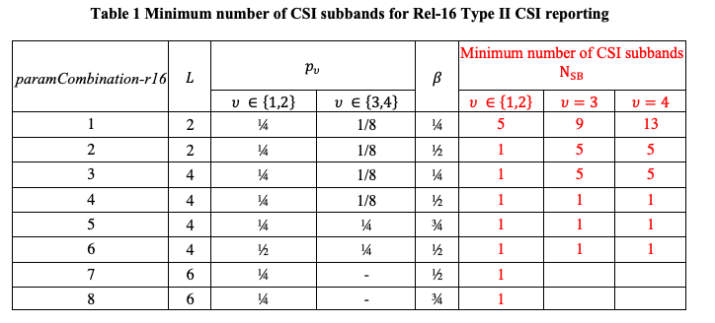

...

- Conclusion

Based on the above inputs and discussion, the following FL proposals are made:
- The following is to be captured as a conclusion:
  - There is no consensus in supporting the proposals in N.1, N.2, N.3, N.4-1a/2a/2b, N.5, N.6, and N.7 as summarized in Table 2 of [1] (R1-2003880)
- …

References
- R1-2003880 Feature lead summary for MU-MIMO CSI Moderator (Samsung)

