**3GPP TSG RAN WG1 #101e R1-** **20xxxxx**

**May 25th – June 5th, 2020**

**Agenda item:** 7.2.5.4

**Source:** Moderator (Qualcomm)

**Title:** Summary of [101-e-NR-L1enh-URLLC-HARQ&Scheduling-01]

**Document for:** Discussion and Decision

# 1 Introduction

This document summarizes the companies’ views and captures the agreements related to the following email discussion:

**Email Discussion #1 by 5/29 and corresponding TP (if any) by 6/5 – Kianoush (Qualcomm):**

* *Issue #1: Cancellation timeline for the case the high priority channel is dynamically scheduled*
  + *Potential modification for the previous agreement on when the UE can cancel the ongoing transmission*
  + *Determination of SCS and N2 for the case of non-CA UL and CA UL*
* *Issue #2: Intra-UE cancellation and multiplexing order*
* *Issue #3: Revision of existing RAN1 agreement*

|  |
| --- |
| The agreement in RAN1#100bis-e is updated as follows:   * If a UE is scheduled with a first PDSCH and a second PDSCH which is starting later than the first PDSCH on a given serving cell, the corresponding PUCCHs carrying HARQ-ACK with different priorities can overlap in time.   + ~~FFS: For supporting this feature, a new FG, separate from FG 12-1, will be introduced.~~   + ~~FFS: The PUCCH associated with the second PDSCH cannot be scheduled for transmission at or earlier than PUCCH associated with the first PDSCH.~~ |

**Companies are encouraged to share their initial feedback by 05/26.**

The summary of the companies’ proposals is available in [1]

# 2 Issue#1: Intra-UE Cancellation Timeline Determination and Behaviour

### 2.1 Revisiting the Agreement on Intra-UE Cancellation Timeline

One of the issues brought up during RAN1 #100e-b was to clarify/modify the cancellation time according to the following agreement:

**Agreement:**

*When a high-priority UL transmission overlaps with a low-priority UL transmission in a slot,*

* *The UE is expected to cancel the low-priority UL transmission starting from Tproc,2 +d1 after the end of PDCCH scheduling the high-priority transmission, where*
  + *Tproc,2 is corresponding to UE processing time capability for the carrier.*
  + *Value d1 is the time duration corresponding to 0,1,2 symbols reported by UE capability*
  + *Note: d_2,1=0 is for cancellation*
* *The minimum processing time of the high priority channel is extended by d2 symbols*
  + *Value d2 is the time duration corresponding to 0,1,2 symbols reported by UE capability*

*The overlapping condition is per repetition of the uplink transmission*

The main reason for clarifying/modifying the above agreement is that enforcing an exact cancellation time incurs additional UE implementation complexity.

The following options were discussed:

* **Option#1:** Tproc,2+d1 is the exact time for cancellation, i.e., the UE is not allowed to cancel the low priority channel earlier or later than the time pointed by Tproc,2+d1.
* **Option#2:** Tproc,2+d1 is the latest time for cancellation, i.e., the UE is allowed to cancel the low priority channel earlier than the time indicated by Tproc,2+d1, however, the deadline for cancellation is at the time indicated by Tproc,2+d1.
* **Option#3:** Tproc,2+d1 is the earliest time for cancellation, i.e., the UE could cancel the low priority channel at or after the time indicated by Tproc,2+d1, but not earlier. The deadline for cancellation is the start of the first symbol of the high priority channel.
* **Option#4:** A UE is expected to cancel the overlapping low priority channel by the first overlapping symbol at the latest. Further, the UE is expected the gap between the end of PDCCH carrying the grant for the high priority channel and the starting symbol of the high priority channel to be no smaller than Tproc,2+d1.

**Question #1: Which of the abovementioned options should be adopted? Please share your preferred option and additional comments in the table below.**

|  |  |  |
| --- | --- | --- |
| **Company** | **Preferred Option** | **Comment** |
|  |  |  |
|  |  |  |
|  |  |  |
|  |  |  |
|  |  |  |
|  |  |  |
|  |  |  |

### 2.2 Minimum Processing Timeline Extension for a High Priority Channel

As agreed previously, in case of collision, the minimum processing timeline for a dynamically scheduled high priority channel should be extended by d2 symbols; d2 is reported as a UE capability. However, this agreement has not yet been captured in the specification.

The feature lead recommendation is to capture the agreement by adopting the following TP:

**Proposal#1: Adopt the following TP to capture the minimum processing timeline extension for scheduling a high priority channel in case of collision:**

|  |
| --- |
| **Modified clause (Section 5.3 of TS 38.214)** |

If the first uplink symbol of the PUCCH which carries the HARQ-ACK information, as defined by the assigned HARQ-ACK timing *K1* and the PUCCH resource to be used and including the effect of the timing advance, starts no earlier than at symbol *L1*, where *L1* is defined as the next uplink symbol with its CP starting after after the end of the last symbol of the PDSCH carrying the TB being acknowledged, then the UE shall provide a valid HARQ-ACK message.

*- N1* is based on *µ* of table 5.3-1 and table 5.3-2 for UE processing capability 1 and 2 respectively, where *µ* corresponds to the one of (*µPDCCH*, *µPDSCH*, *µUL*) resulting with the largest *Tproc,1*, where the *µPDCCH* corresponds to the subcarrier spacing of the PDCCH scheduling the PDSCH, the *µPDSCH* corresponds to the subcarrier spacing of the scheduled PDSCH, and *µUL* corresponds to the subcarrier spacing of the uplink channel with which the HARQ-ACK is to be transmitted, and κ is defined in clause 4.1 of [4, TS 38.211].

*-* If the PDSCH DM-RS position $l_{1}$ for the additional DM-RS in Table 7.4.1.1.2-3 in clause 7.4.1.1.2 of [4, TS 38.211] is $l_{1}=12$ then *N1,0=14* inTable 5.3-1*,* otherwise *N1,0=13.*

- If the UE is configured with multiple active component carriers, the first uplink symbol which carries the HARQ-ACK information further includes the effect of timing difference between the component carriers as given in [11, TS 38.133].

- For the PDSCH mapping type A as given in clause 7.4.1.1 of [4, TS 38.211]: if the last symbol of PDSCH is on the *i-*th symbol of the slot where *i* < 7, then *d1,1 = 7 - i*, otherwise *d1,1 = 0.*

* If the UE reports the capability of [intra-UE prioritization], and if a PUCCH of a larger priority index is overlapping with PUCCH/PUSCH of a smaller priority index, is determined by the reported UE capability [XXXXX].

|  |
| --- |
| **End** |

|  |
| --- |
| **Modified clause (Section 6.4 of TS 38.214)** |

If the first uplink symbol in the PUSCH allocation for a transport block, including the DM-RS, as defined by the slot offset *K2* and the start and length indicator *SLIV* of the scheduling DCI and including the effect of the timing advance, is no earlier than at symbol *L2*, where *L2* is defined as the next uplink symbol with its CP starting after the end of the reception of the last symbol of the PDCCH carrying the DCI scheduling the PUSCH, then the UE shall transmit the transport block.

*- N2* is based on *µ* of Table 6.4-1 and Table 6.4-2 for UE processing capability 1 and 2 respectively, where *µ* corresponds to the one of (*µDL*, *µUL*) resulting with the largest *Tproc,2*, where the *µDL* corresponds to the subcarrier spacing of the downlink with which the PDCCH carrying the DCI scheduling the PUSCH was transmitted and *µUL* corresponds to the subcarrier spacing of the uplink channel with which the PUSCH is to be transmitted, and *κ* is defined in clause 4.1 of [4, TS 38.211].

- If the first symbol of the PUSCH allocation consists of DM-RS only, then *d2,1* = 0*,* otherwise *d2,1* = 1.

- If the UE is configured with multiple active component carriers, the first uplink symbol in the PUSCH allocation further includes the effect of timing difference between component carriers as given in [11, TS 38.133].

- If the scheduling DCI triggered a switch of BWP, *d2,2* equals to the switching time as defined in [11, TS 38.133], otherwise *d2,2*=0.

* If the UE reports the capability of [intra-UE prioritization], and if a PUSCH of a larger priority index is overlapping with a PUCCH of a smaller priority index, $d_{2}$ is determined by the reported UE capability [XXXXX].

- For a UE that supports capability 2 on a given cell, the processing time according to UE processing capability 2 is applied if the high layer parameter *processingType2Enabled* in *PUSCH-ServingCellConfig* is configured for the cell and set to *enable*,

- If the PUSCH indicated by the DCI is overlapping with one or more PUCCH channels, then the transport block is multiplexed following the procedure in clause 9.2.5 of [6, TS 38.213], otherwise the transport block is transmitted on the PUSCH indicated by the DCI.

|  |
| --- |
| **End** |

|  |  |
| --- | --- |
| **Company** | **Comment** |
|  |  |
|  |  |
|  |  |
|  |  |
|  |  |
|  |  |
|  |  |

### 2.3 SCS and N2 Determination for UL non-CA

In this section, the main assumption is that a UE is configured with a single UL carrier; however, multiple serving cells may have been configured for a UE. Hence, all collisions happen on a single serving cell even though the uplink channels, if dynamically scheduled, can be scheduled using PDCCHs received on different serving cells. In order to calculate Tproc,2, two inputs are needed: (1) SCS, and (2) N2.

To determine the input SCS, the following proposal can be considered (Note that the SCS of the low and high priority channels is identical since the UE is configured with a single UL serving cell; however, the proposal is written in a more generic manner.)

**Proposal#2: If a UE is configured with a single UL carrier and in case a dynamically scheduled high priority channel overlaps with a low priority channel, the SCS for Tproc,2 calculation is determined as the smallest SCS configuration of the PDCCH providing the DCI for the low priority channel (if any), the SCS configuration for the PDCCH providing the DCI for the high priority channel, the SCS configuration of the low priority channels to be cancelled and the SCS configuration of the high priority channel.**

|  |  |
| --- | --- |
| **Company** | **Comment** |
|  |  |
|  |  |
|  |  |
|  |  |
|  |  |
|  |  |
|  |  |

To determine N2, the following proposal can be considered (Note that timing capability #2 is only supported in case of self-carrier scheduling):

**Proposal #3:** **If a UE is configured with a single UL carrier and in case a dynamically scheduled high priority channel overlaps with a low priority channel, N2 for Tproc,2 calculation is determined as:**

* **If the overlapping group consists of a high priority PUCCH carrying HARQ-ACK and low priority PUCCHs and/or PUSCHs and if *processingType2Enabled* of *PDSCH-ServingCellConfig* is set to *enable* for the serving cell with the high priority DCI format and for all serving cells corresponding to the low priority HARQ-ACK information transmission in the overlapping group and if *processingType2Enabled* of *PUSCH-ServingCellConfig* is set to *enable* for the serving cell with the corresponding low priority PUSCHs in the overlapping group, $N_{2}$ is 5 for $μ=0,$ 5.5 for $μ=1$ and 11 for $μ=2;$ otherwise, $N_{2}$ is 10 for $μ=0,$ 12 for $μ=1$, 23 for $μ=2$ and 36 for $μ=3.$**
* **If the overlapping group consists of a high priority PUSCH and low priority PUCCHs and/or PUSCHs and if *processingType2Enabled* of *PUSCH-ServingCellConfig* is set to *enable* for the serving cell with the high priority DCI format and for the serving cell with the corresponding low priority PUSCHs in the overlapping group and if *processingType2Enabled* of *PDSCH-ServingCellConfig* is set to *enable* for all serving cells corresponding to the low priority HARQ-ACK information transmission in the overlapping group, $N_{2}$ is 5 for $μ=0,$ 5.5 for $μ=1$ and 11 for $μ=2;$ otherwise, $N_{2}$ is 10 for $μ=0,$ 12 for $μ=1$, 23 for $μ=2$ and 36 for $μ=3.$**

|  |  |
| --- | --- |
| **Company** | **Comment** |
|  |  |
|  |  |
|  |  |
|  |  |
|  |  |
|  |  |
|  |  |

### 2.4 SCS and N2 Determination for CA UL

**Feature lead comment: Based on the discussions amongst the feature leads, the SCS and N2 determination for UL CA will be discussed after the discussion in Section 2.3 is stable.**

# 3 Multiplexing versus Intra-UE Prioritization Order

During RAN1 #99, RAN1 reached the following two agreements:

During the last RAN 1 meeting, the following agreement was reached:

**Agreement:**

* *To resolve collision between UL transmissions, a UE performs the following:* 
  + *Step 1: Resolve collision between UL transmissions with same priority.*
  + *Step 2: Resolve collision between UL transmissions with different priorities.*

**Agreement:**

*When a high-priority UL transmission overlaps with a low-priority UL transmission in a slot,*

* *The UE is expected to cancel the low-priority UL transmission starting from Tproc,2 +d1 after the end of PDCCH scheduling the high-priority transmission, where*
  + *Tproc,2 is corresponding to UE processing time capability for the carrier.*
  + *Value d1 is the time duration corresponding to 0,1,2 symbols reported by UE capability*
  + *Note: d_2,1=0 is for cancellation*
* *The minimum processing time of the high priority channel is extended by d2 symbols*
  + *Value d2 is the time duration corresponding to 0,1,2 symbols reported by UE capability*

*The overlapping condition is per repetition of the uplink transmission*

According to the first agreement, in an event of collision, before prioritization, the channels of the same priority should be multiplexed. However, based on the second agreement, the cancellation is triggered upon detection of “a” high priority grant. Hence, as shown in [2], in some cases (e.g., as illustrated in Figure (a)), multiplexing before cancellation is possible. However, in some other scenarios (e.g., as illustrated in Figure (b)), multiplexing before cancellation is not feasible. In particular, under (b), if the UE is enforced to wait and see if another high priority grant might be scheduled, its time for cancellation will be shorter than Tproc,2+d1.

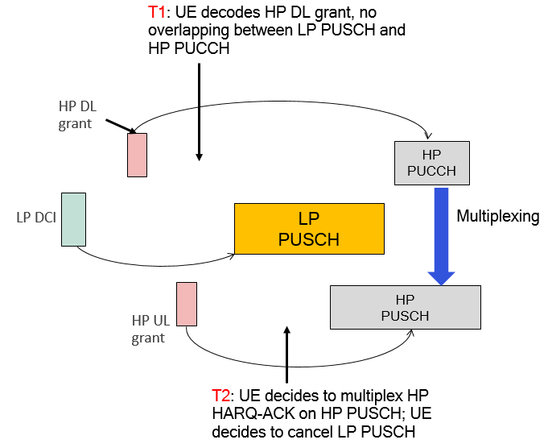

(a)

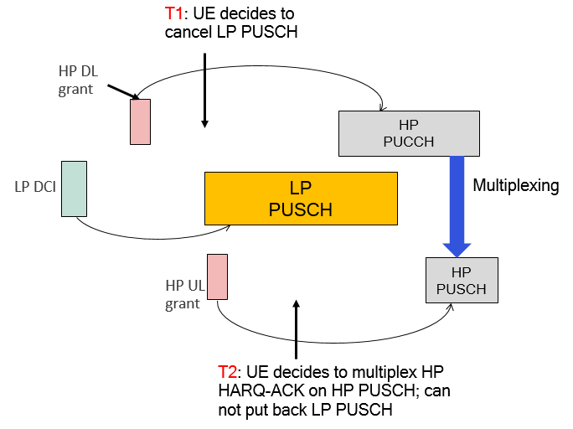

(b)

To address the abovementioned issue, the following options are proposed:

* **Option#1:** No specification change is needed [3]
  + **FL comment: Some elaboration on how the issue should be avoided would be helpful.**
* **Option#2:** If the first symbol of the LP UL transmission is later than Tproc,2+d1 after the end of the second PDCCH scheduling the HP PUSCH, the UE transmits the LP PUCCH/PUSCH; otherwise, the LP PUCCH/PUSCH is cancelled [4].
* **Option#3:** When resolving collision between a high priority uplink transmission and one or more low priority uplink transmissions, the cancellation of the low priority channel(s) is triggered upon reception of the first PDCCH scheduling an overlapping high priority channel, i.e., no look-ahead for intra-UE cancellation determination is assumed [2].

**Question #2: Which of the abovementioned options should be adopted? Please share your preferred option and additional comments in the table below.**

|  |  |  |
| --- | --- | --- |
| **Company** | **Preferred Option** | **Comments** |
|  |  |  |
|  |  |  |

# 4 Issue #3: PUCCH/PUCCH Collision Handling

In RAN1 #100e-b, the following agreement was reached:

**Agreement:**

* If a UE is scheduled with a first PDSCH and a second PDSCH which is starting later than the first PDSCH on a given serving cell, the corresponding PUCCHs carrying HARQ-ACK with different priorities can overlap in time.
  + FFS: For supporting this feature, a new FG, separate from FG 12-1, will be introduced.
  + FFS: The PUCCH associated with the second PDSCH cannot be scheduled for transmission at or earlier than PUCCH associated with the first PDSCH.

For RAN1 #101e, it is proposed to revise the agreement as follows:

**Proposal #4: Revise the RAN1 agreement as follows:**

|  |
| --- |
| The agreement in RAN1#100bis-e is updated as follows:   * If a UE is scheduled with a first PDSCH and a second PDSCH which is starting later than the first PDSCH on a given serving cell, the corresponding PUCCHs carrying HARQ-ACK with different priorities can overlap in time.   + ~~FFS: For supporting this feature, a new FG, separate from FG 12-1, will be introduced.~~   + ~~FFS: The PUCCH associated with the second PDSCH cannot be scheduled for transmission at or earlier than PUCCH associated with the first PDSCH.~~ |

If there is an objection, please provide your comments in the table below:

|  |  |
| --- | --- |
| **Company** | **Comments** |
|  |  |
|  |  |

# 5 References

**[1] R1-2004674, “Summary#1 on UCI enhancements for R16 URLLC,” Moderator (OPPO)**

**[2] R1-2004458, “Remaining issues on UCI enhancements for URLLC,” Qualcomm**

**[3] R1-2003578, “Maintenance of Rel-16 URLLC UCI enhancements,” Nokia, NSB**

**[4] R1-2003528, “Corrections on UCI enhancements,” Huawei/HiSi**