3GPP TSG-RAN WG1 Meeting #101-e R1-2003842

e-Meeting, 25th May – 5th June, 2020

Agenda Item: 7.2.2.1.3

Source: Moderator (Ericsson)

Title: Feature lead summary for Maintenance of UL Signals and Channels

Document for: Discussion, Decision

# 1 Introduction

This document contains a high level summary of the contributions made under the “UL Signals and Channels” sub-agenda item for 7.2.2 Rel-16 Maintenance of NR-based Access to Unlicensed Spectrum. According to the Chairman’s guidance, 2 email threads have been assigned to this agenda item.

The first phase of discussion until 5/22 will be used to select topic(s) for the 2 email threads.

Regarding Issue #1 which is essential in order to have a working specification, please see Appendix A in this summary regarding the two configuration alternatives in 38.331 for the initial DL/UL BWP. The intention of including Appendix A now is not to discuss this week; rather, it is included so that companies can review it and keep in mind for the discussion of Issue #1 next week.

# 2 Identified Issues

|  |  |  |  |
| --- | --- | --- | --- |
| **Issue**  **#** | **Description** | **Tdoc**  **References** | **Priority** |
| 1 | RB set allocation when interlaced transmission configured for PUSCH scheduled by RAR UL grant, PUSCH scheduled by DCI 0_0 addressed to TC_RNTI, and cell-specific PUCCH   * Requires discussion on supporting the two configuration alternatives for initial DL/UL BWP specified in 38.331 – Please see Appendix A of this summary.   TPs needed to 38.213 §8.3, 9.2.1 and 38.214 §6.1.2.2.3 | R1-2003841: P1,P3,P5,TP1,TP3,TP5  R1-2004041: P2-P4, TP2-TP4  R1-2003511: TP#2  R1-2003727: P2  R1-2004012: P1,P2  R1-2004084: P1,P2  R1-2004442: P2  R1-2003859: P2  R1-2004323: P3-P6, TP1-3  R1-2004003: P1  R1-2003449: P1, TP  R1-2003369: P1 | High |
| 2 | PUSCH allocation rule for PUSCH scheduled by DCI 0_0 in a CSS to accomodate CORESET bandwidth spanning more than one UL RB set, e.g., for carrier configured without intra-cell guardbands  TPs needed to 38.214 §6.1.2.2.3 | R1-2004041: P1, TP1  R1-2003511: TP#1  R1-2003727: P1  R1-2004012: P3  R1-2003822: P2,P3  R1-2004274: P2,P3  R1-2004084: P3  R1-2004442: P1  R1-2003859: P1  R1-2004323: P7 | High |
| 3 | Clarify DCI size matching rules for DCI 0_0 when interlaced transmission is configured | R1-2004012: P4,P5  R1-2004323: P1,P2 |  |
| 4 | Whether or not UL resource allocation Type 2 (interlacing) for DCI Format 0_2 | R1-2004323: P8  R1-2003449: P2 |  |
| 5 | PUSCH transmission in intra-cell guards between contiguous RB-sets based on UE capability  TP needed to 38.214 §6.1.2.2.3 | R1-2004041: P5 | Better suited to Wideband AI? |
| 6 | Editorial correction to UL resource allocation Type 2 when transform precoding is enabled regarding lowest-indexed PRBs  TP needed to 38.214 §6.1.2.2.3 | R1-2003859 | Editorial |
| 7 | Editorial corrections to PUCCH format description – interlace1 only applies to interlaced PF2/3  TP needed to 38.213 §9.2.1 | R1-2003655: P1, TP1 | Editorial |
| 8 | Clarifications on UCI multiplexing in PUSCH accounting for LBT outcome | R1-2003859: P3-P4 | Better suited to Channel Access AI? |
| 9 | Support CP extension for SRS (in addition to PUCCH/PUSCH, at least for aperiodic SRS triggered by DCI 0_1/1_1) | R1-2004274: P1 | Better suited to Channel Access AI? |
| 10 | Bundling of aperiodic SRS/PUCCH/PUSCH in same slot | R1-2004084: P7 |  |

The recommendation of the moderator is to consider at least the following two topics which are deemed essential

* Email thread A: At least Issue #1
* Email thread B: At least Issue #2

Please share your views on the priority of the topics (1-10) in the first table below. If you have additional comments, please provide them in the additional table.

* H: High priority
* L: Low priority
* N: Not needed/disagree that this is an issue

|  |  |  |  |  |  |  |  |  |  |  |
| --- | --- | --- | --- | --- | --- | --- | --- | --- | --- | --- |
| **Company** | **Issue #** | | | | | | | | | |
| 1 | 2 | 3 | 4 | 5 | 6 | 7 | 8 | 9 | 10 |
| Ericsson | H | H | N | N | N | L | L | N | N | N |
| LG Electronics | H | H | H | N | N | L | L | N | N | N |
| Sharp | H | H | L | L | H | L | L | L | L | N |
| Samsung | H | H | L | N | N | L | L | H | N | N |
| OPPO | H | H | L | N | N | L | L | L | L | L |
| ZTE | H | H | L | N | N | L | L | N | N | N |
| Lenovo, Motorola Mobility | H | H | L | N | N | L | L | N | N | N |

Please provide additional comments (if any) in the following table:

|  |  |
| --- | --- |
| **Company** | **View/Position** |
| Ericsson | Issues #5 is better suited to the Wideband AI  Issues #8,9 are better suited to the Channel Access AI |
| LG Electronics | Issue #5 is better to be handled under Wideband AI or UE feature.  Issue #9 is better to be handled under Channel access AI (agree with FL) |
| Sharp | We are fine for Issue#5 to be discussed in wideband AI or UL AI. |
| Samsung | We think issue #8 is a critical issue. In LTE eLAA, the clarification description is added in TS 36.213 for PHR which is based on scheduled PUSCH irrespective of whether the UE can access the LAA SCell for the PUSCH transmission, because UE may not have sufficient time to generate real/virtual PHR according to LBT result. In NR-U, similarly, UE may not have sufficient time to perform UCI multiplexing according to LBT result. Similar clarification description is needed in NR spec. Because UCI transmission on PUSCH is UL procedure, we captured this issue in UL tdoc, but we’re fine with FL’s suggestion to discuss it in channel access AI considering its relevance of LBT. |

# References

1. R1-2003369 Remaining issues on physical UL channel design in unlicensed spectrum vivo
2. R1-2003449 Remaining issues on the UL channels for NR-U ZTE, Sanechips
3. R1-2003511 Maintenance on uplink signals and channels Huawei, HiSilicon
4. R1-2003655 Remaining issues on UL signals and channels for NR-U MediaTek Inc.
5. R1-2003727 UL signals and channels for NR-unlicensed Intel Corporation
6. R1-2003822 Text proposals for UL signals and channels for NR-U Lenovo, Motorola Mobility
7. R1-2003841 UL signals and channels Ericsson
8. R1-2003859 UL signals and channels for NR-U Samsung
9. R1-2004003 Remaining issues in UL signals and channels for NR-U Spreadtrum Communications
10. R1-2004012 Remaining issues of UL signals and channels for NR-U LG Electronics
11. R1-2004041 Remaining issues on UL signals and channels for NR-U Fujitsu
12. R1-2004084 Discussion on the remaining issues of UL signals and channels OPPO
13. R1-2004274 Remaining Issues on UL Signals and Channels for NR-U Nokia, Nokia Shanghai Bell
14. R1-2004323 Remaining issues on UL signals/channels for NR-U Sharp
15. R1-2004442 TP for UL signals and channels for NR-U Qualcomm Incorporated
16. 3GPP TR 38.889, “Study on NR-based access to unlicensed spectrum,” v.16.0.0, December 2018.
17. 3GPP TS 38.331, “Radio Resource Control (RRC) protocol specification,” v.16.0.0, March 2020.

# Appendix A Configuration Options for Initial DL/UL BWP

In Section 7.2.1 of the TR from the NR-U study item, it is stated that the initial DL/UL BWP is ~20 MHz (see Section 7.2.1 of [16]):

This originated from an NR-U agreement during RAN1#93, which was the same meeting in which RAN1 discussed an LS from RAN2 on two possible configuration options for the initial DL/UL BWP. RAN1 ended up agreeing to support the two configuration options (Option 1 and Option 2) listed in Appendix B.2 of 38.331. This is copied into Appendix B below for convenience.

Initial active DL/UL BWP is approximately 20MHz for 5GHz band, though the final value will be quantized to number of PRBs. Initial active DL/UL BWP is approximately 20MHz for 6GHz band if similar channelization as 5GHz band is used for 6GHz band.

For the case of UL resource allocation Type 2 (interlace transmission), these configuration options are relevant for the discussion on RB set allocation for the following cases which make use of the initial UL BWP:

* RB set allocation rule for PUSCH scheduled by RAR UL Grant, i.e., Msg3 of the RACH procedure
* RB set allocation rule for PUSCH scheduled by DCI 0_0 addressed to TC-RNTI, i.e., for Msg3 re-transmissions
* RB set allocation rule for PUCCH transmissions prior to dedicated configuration, e.g., for HARQ ACK of Msg4

Since Rel-15 supports both Option 1 and Option 2, it should be further discussed how to capture the NR-U agreement on 20 MHz initial DL/UL BWP in consideration of both of these options. As it turns out, this is fairly straight forward to do, as will be discussed here. In fact, the Rel-15 spec already supports that the DL transmissions prior to the UE entering RRC_CONNECTED mode (e.g., Msg2 and Msg4) are confined to the same bandwidth as CORESET0 (~20 MHz for NR-U), regardless of whether Option 1 or Option 2 is used, i.e., regardless of the size of the initial DL BWP:

* 38.212 specifies that DCI 1_0 addressed to SI-RNTI / RA-RNTI / TC-RNTI restricts the FDRA to the size of CORESET0
* 38.214 Section 5.1.2.2 specifies that the PDSCH scheduled by DCI 1_0 in CSS is restricted to the bandwidth of CORESET0.

Hence, what is left to discuss is UL transmissions prior to the UE entering RRC_CONNECTED mode (see above 3 bullets). To help with the discussion, consider the basic UE BWP capability, i.e., support of single “RRC configured” UL/DL BWP. This basic capability is described in FG 6-1 in 3GPP TR 38.822. Whether or not the UE supports additional BWPs (up to 2 or up to 4) doesn’t affect the discussion. Figure 1 below illustrates Option 1 and Option 2 adapted to the NR-U scenario, i.e., CORESET0 confined to a single RB set (~20 MHz). It shows the case for UEs that support a single “RRC configured” DL/UL BWP of bandwidth 80 MHz (spanning 4 RB sets) which the UE will uses once in CONNECTED mode for PxSCH/PxCCH transmission/reception.

The diagram shows time on the x-axis and frequency on the y-axis to illustrate the sequence in moving from IDLE to CONNECTED mode and the size of the various BWPs along the way. The main difference between Option 1 and Option 2 is that two BWPs are configured in Option 1, i.e., DL/UL BWP #0 (1 RB set) and #1 (4 RB sets), whereas only a single BWP is configured in Option 2, i.e., DL/UL BWP #0 (4 RB sets). As per 38.331, in Option 1, BWP#0 is not configured with dedicated parameters – i.e., only *BWP-DownlinkCommon* and *BWP-UplinkCommon* are configured in this BWP. This can be viewed as a “temporary BWP,” that is typically not used again after initial access since it has quite limited functionality. Despite the fact that Option 1 has two BWPs, it is still counted (in terms of UE capability) as a single “RRC configured BWP” (see extract from 38.331 in Appendix B below).

As discussed previously, despite the fact that the DL BWP #0 is >20 MHz for Option 2, according to the Rel-15 specifications, the DL transmission prior to the UE entering RRC_CONNECTED mode (e.g., Msg2, Msg4) are already restricted to be within the bandwidth of CORESET0. Hence, the agreement in TR is already captured by virtue of the fact that in NR-U it was agreed (and specified) that the CORESET0 bandwidth is 48 PRBs (~20 MHz). Note that Rel-15 specifies that the initial DL BWP must completely overlap CORESET0 (see parameter *initialDownlinkBWP* in *DownlinkConfigCommonSIB*).

Discussion Points:

What is left to discuss further is how to implement the agreement for the UL for both Option 1 and Option 2. A straightforward approach would be for NR-U to make a similar restriction that PUSCH/PUCCH transmissions prior to the UE entering connected mode (e.g., Msg3, HARQ ACK of Msg4) are restricted to an RB set that is contained within the bandwidth of CORESET0. This would then ensure that the agreement from the TR works for both Option 1 and Option 2.

1. For PUSCH transmission prior to dedicated configuration (e.g., Msg3 PUSCH and potential Msg3 re-transmissions), we are already discussing RB set allocation rules for PUSCH scheduled by RAR UL grant and DCI 0_0 addressed to TC-RNTI (Issue #1 in the table in Section 2), and it should be straight forward to ensure that the rules apply to both Option 1 and Option 2.
   * Both Alt-2 or Alt-3 discussed in the last meeting can be easily be modified to apply to both Option 1 and Option 2 such that the PUSCH is transmitted within the initial UL BWP within the bandwidth of CORESET0 (if the active UL BWP overlaps the initial UL BWP or the active UL BWP is the initial UL BWP)
2. For PUCCH transmissions prior to dedicated configuration (PF0/1 configured via SIB1), a simple rule that would work for both Option 1 and Option 2 and is consistent to the already PUCCH resource configuration after dedicated configuration, could be the following (this text would go into 38.213 Section 9.2.1)
   * The UE determines the PRB allocation for the PUCCH resource from the intersection of the RBs corresponding to interlace $m$ and the RBs of a single UL RB set within the initial UL BWP. The UE expects that the intersection results in either 10 or 11 RBs. The UL RB set is the one that intersects with the CORESET in which the DCI format is detected. [If there is no intersection, the UL RB set is RB set 0 in the initial UL BWP]

Note that the UE is aware of RB sets prior to dedicated configuration, since when the parameter *intraCellGuardBandUL-r16* is not configured, the UE assumes the default guard band configuration from RAN4 specifications (38.101-1) according to the carrier bandwidth, from which the UE determines RB sets.

1. For PRACH transmissions, the Rel-15 specifications already support that PRACH resources can be configured within an UL RB set that is contained within the bandwidth of CORESET0, so both Option 1 and Option 2 already work.

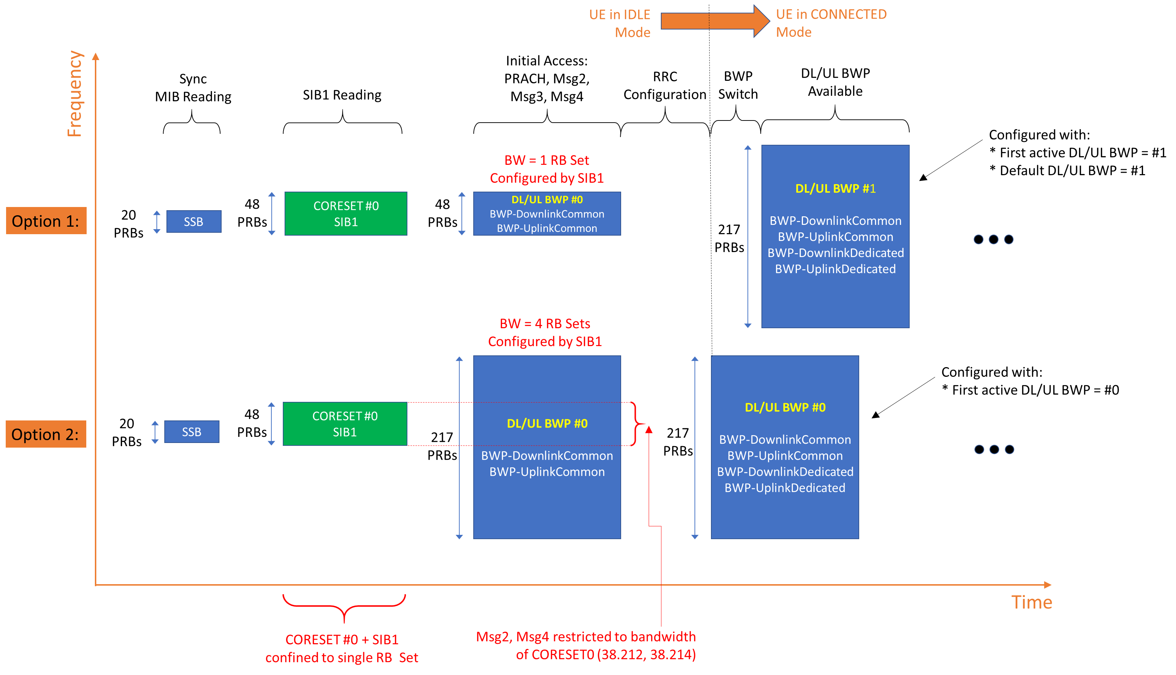

Figure 1: Configuration options for initial and first active BWP for UEs capable of a single "RRC configured" BWP (according to Basic FG 6-1). Option 1 and Option 2 are according to Annex B.2 of 38.331 for the case of an 80 MHZ UL/DL BWP used in RRC_CONNECTED mode.

# Appendix B Extract of Appendix B.2 from 38.331

B.2 Description of BWP configuration options

There are two possible ways to configure BWP#0 (i.e. the initial BWP) for a UE:

1) Configure *BWP-DownlinkCommon* and *BWP-UplinkCommon* in *ServingCellConfigCommon*, but do not configure dedicated configurations in *BWP-DownlinkDedicated* or *BWP-UplinkDedicated* in *ServingCellConfig*.

2) Configure both *BWP-DownlinkCommon* and *BWP-UplinkCommon* in *ServingCellConfigCommon* and configure dedicated configurations in at least one of *BWP-DownlinkDedicated* or *BWP-UplinkDedicated* in *ServingCellConfig*.

The same way of configuration is used for UL BWP#0 and DL BWP#0 if both are configured.

With the first option (illustrated by figure B2-1 below), the BWP#0 is not considered to be an RRC-configured BWP, i.e. UE only supporting one BWP can still be configured with BWP#1 in addition to BWP#0 when using this configuration. The BWP#0 can still be used even if it does not have the dedicated configuration, albeit in a more limited manner since only the SIB1-defined configurations are available. For example, only DCI format 1_0 can be used with BWP#0 without dedicated configuration, so changing to another BWP requires RRCReconfiguration since DCI format 1_0 doesn't support DCI-based switching.



**Figure B2-1: BWP#0 configuration without dedicated configuration**

With the second option (illustrated by figure B2-2 below), the BWP#0 is considered to be an RRC-configured BWP, i.e. UE only supporting one BWP cannot be configured with BWP#1 in addition to BWP#0 when using this configuration. However, UE supporting more than one BWP can still switch to and from BWP#0 e.g. via DCI normally, and there are no explicit limitations to using the BWP#0 (compared to the first option).



**Figure B2-2: BWP#0 configuration with dedicated configuration**

For BWP#0, the *BWP-DownlinkCommon* and *BWP-UplinkCommon* in *ServingCellConfigCommon* should match the parameters configured by MIB and SIB1 (if provided) in the corresponding serving cell.