Title: Delay Spread, PDP, and Polarization Measurements

File: SCM-044-QCOM-PDPPolMeas

Source: Steven Howard
QUALCOMM Inc.
(781) 276-0904
showard@qualcomm.com

Date: August 20, 2002

Notice

©2002 Third Generation Partnership Project Two (3GPP2). All rights reserved. Permission is granted for copying, reproducing, or duplicating this document only for the legitimate purposes of 3GPP2 and its organizational partners. No other copying, reproduction, or distribution is permitted.

Copyright Notification
No part may be reproduced except as authorized by written permission.
The copyright and the foregoing restriction extend to reproduction in all media.

© 2002, 3GPP Organizational Partners (ARIB, CWTS, ETSI, T1, TTA, TTC).
All rights reserved.

Introduction
Statistics from a multiple-input-multiple-output (MIMO) wideband channel measurement system are presented. These results are applicable to the spatial channel modeling (SCM) effort in the areas of:
- RMS Delay Spread parameters
- Mapping of power to path delays
- Polarization parameters
The same measurements have been used to derive the correlation between antenna pairs for a detected path [1]. A wide range of correlation values (correlation matrices) was computed from the measurements at the different locations within a sector even for the transmitter correlation where the antennas were separated by 40λ. A similar result was reported in [2] also. These results could be used to verify the accuracy of the SCM.

Measurement System
The system measures the complex-valued impulse responses (CIRs) of the 16 antenna pairs from 4 transmit ports to 4 receive ports in the US PCS (1.9 GHz) band. The sounding waveform is a 1023 length 4.995 Mcps m-sequence that was filtered to a 3.5 MHz bandwidth. Each transmitter port uses a delayed version of the sounding waveform. The receiver takes 5 MHz complex-valued samples and performs correlation and coherent integration to produce complex-valued channel impulse responses. The receiver is coherent over all 4 ports with the oscillators and clocks locked to a common 10 MHz reference.
Two +/- 45 degree slant cross-polarized PCS base station antennas with 68 degree horizontal 3 dB beam width and 10 degree vertical beam width were used at the transmitter, and these were placed atop a building separated by 40λ for the measurements. The per transmitter EIRP was 63 W. Two +/- 45 degree slant cross-polarized PCS patch antennas with 65 degree horizontal 3 dB beam width and 60 degree vertical beam width were used at the receiver, and these were mounted 3 feet above the roof of a van about 10 feet above ground separated by 1λ for the measurements. The receiver antennas were oriented toward the transmitter before each measurement. The van was moving ~10 mph while the measurement was performed, and the antenna pointing was maintained. The measurement is performed over a distance of 35-45 meters. Although the antenna configuration is more typical of a wireless data network, the mobility assured adequate signal fading to compute local statistics on a Tx/Rx antenna pair basis.
Measurements were performed in two areas. In Lowell, MA, a light urban/suburban area with the transmit antennas on a 165 foot building, 103 locations were measured. The transmit antennas were far above the local clutter of this relatively flat measurement area. In Worcester, MA, a light urban area with the transmit antennas on a 50 foot building, 74 locations were measured. Worcester is a hilly area.

Path Definition
At each measurement location, 2000 CIRs per Tx/Rx pair are stored into a file. The CIR per Tx/Rx pair sample rate was 278 Hz for Worcester (7.2 second measurement) and 221 Hz for Lowell (9 second measurement). The complex values stored in the file are a_{mn}(r,s) where: m ∈ [1, 2, 3, 4] is the receiver port index, n ∈ [1, 2, 3, 4] is the transmitter port index, r ∈ [1, 2, …, 128] is the CIR delay window index, and s ∈ [1, 2, …, 2000] is the CIR sample index.
Each file was processed to identify the delay r = r₁ at which the main path arrived and the delays r = r_{l} of any significant multipath arrivals. The first step in this process involves thresholding the Power Delay Profile (PDP) of each Tx/Rx pair at 10 dB above the noise floor. The PDP of a Tx/Rx pair is defined as:

$${\text{PDP}}_{\text{mn}}\left(r\right)=\frac{1}{\text{2000}}\sum{{\left|a_{\text{mn}}\left(r,s\right)\right|}^{2}}$$

An example of the 4 PDPs corresponding to the 4 transmit antennas (Tx 1 through Tx 4) measured at receive antenna 1 (Rx 1) is shown in Figure 1. The samples of the PDP that exceed the threshold are used to compute the delay spread. The peaks of the PDP are used in computing the ordered path statistics.
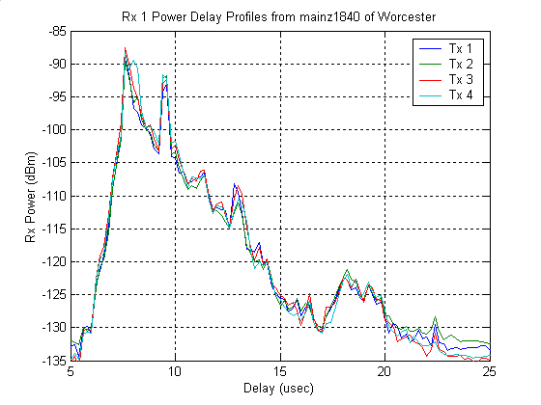
Figure 1 – Power Delay Profiles at Rx 1 from a Worcester measurement.

Clusters of energy were identified as a continuous sequence of delays where the threshold was exceeded in all 16 PDPs. The local maximums of the Combined PDP (CPDP) were used to identify the delay of a path from each cluster. The CPDP is defined as:

$$\text{CPDP}\left(r\right)=\frac{1}{\text{16}}\sum{\sum{{\text{PDP}}_{\text{mn}}\left(r\right)}}$$
Figure 2 shows the CPDP derived from the 16 PDPs from the same location as shown in Figure 1.

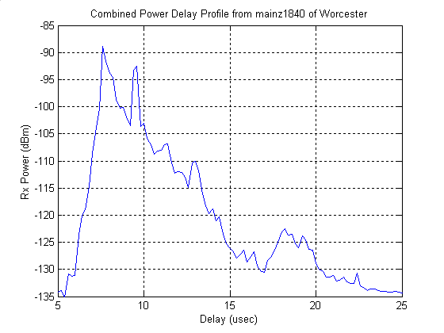
Figure 2 – Combined Power Delay Profile from a Worcester measurement.

The l^{th} path samples for the i^{th} Tx/Rx pair is then defined as:

$$α_{i}^{(l)}\left(s\right)=a_{\text{mn}}\left(r_{l},s\right), i=4(m−1)+n, i∈[1,2,\text{.}\text{.}\text{.},\text{16}]\text{.}$$

Measurements that clearly exhibited at least one other strong, separate cluster in addition to the main path existed in 41 out of 103 Lowell locations and 34 out of 74 Worcester locations. The minimum delay between the main path and the second path was 9 samples (1.8 usec). These path samples are used in the cross-polarization discrimination (XPD) analysis presented in this contribution.

Delay Spread
Using the thresholded PDP, the time dispersion of the channel is measured. The root mean square (RMS) delay spread is the square root of the second central moment of the normalized thresholded PDP. The excess delay spread is the delay between the earliest arriving and latest arriving detected signal energy of the thresholded PDP. There are 16 PDPs resulting from the 16 Tx/Rx antenna pairs at each location measured. 8 of the PDPs are associated with Tx/Rx antennas with the same polarization, and 8 of the PDPs are associated with Tx/Rx antennas with the opposite polarization. The complementary cumulative distribution function (CCDF) of the RMS delay spread for Lowell and Worcester is plotted in Figure 3 and Figure 4 respectively. Each figure has three CCDF curves: the CCDF of all locations and all 16 Tx/Rx antenna pairs (All), the CCDF of all locations and the 8 Tx/Rx antenna pairs with the same polarization (Same Slant), and the CCDF of all locations and the 8 Tx/Rx antenna pairs with the opposite polarization (Opposite Slant).
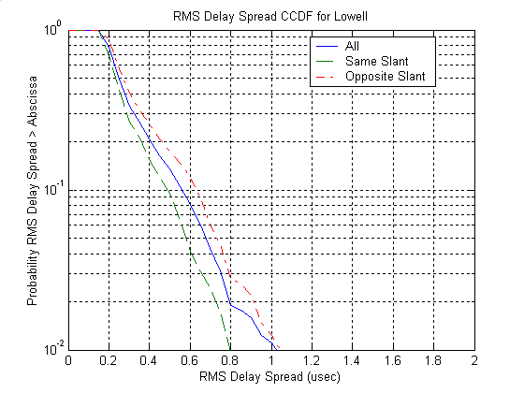
Figure 3 – Lowell CCDFs of RMS Delay Spread.
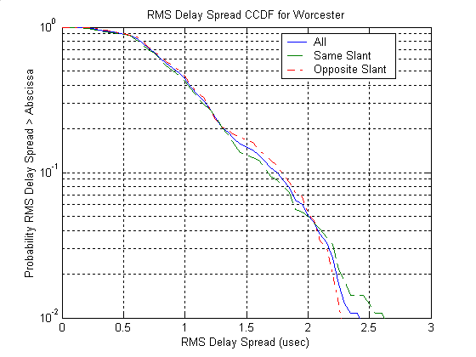
Figure 4 - Worcester CCDFs of RMS Delay Spread.
Table I gives the statistics of the RMS Delay Spread distributions.
Table I – RMS Delay Spread statistics
Area | Tx/Rx Slant | Mean (usec) | Std. Dev. (usec) | Median (usec)
Lowell | All | 0.35 | 0.20 | 0.27
Lowell | Same | 0.31 | 0.16 | 0.26
Lowell | Opposite | 0.38 | 0.23 | 0.29
Worcester | All | 1.04 | 0.48 | 0.95
Worcester | Same | 1.02 | 0.49 | 0.92
Worcester | Opposite | 1.05 | 0.48 | 0.98

Since directional antennas were used in the measurements, the delay spreads measured might be 30% less than what would be measured with omni-directional ones [3]. If this is the case, then the Lowell mean RMS delay spread compares quite well with the proposed suburban macro mean RMS delay spread of 0.5 usec (0.35/(1-0.3) = 0.5). Worcester’s mean RMS delay spread of 1 usec is high compared to the proposed urban macro mean RMS delay spread of 0.9 usec even before factoring in the directional antennas, but Worcester is a hilly area and one would expect a good deal of dispersion.
The RMS delay spread of the same slant pairs is in general less than the opposite slant pairs probably because the main path of the same slant PDPs is greater than the main path of the opposite slant PDPs. This is particularly true for Lowell and will be shown in the section on path polarization discrimination. The larger main path gives a more centralized PDP.
The complementary cumulative distribution function (CCDF) of the excess delay spread for Lowell and Worcester is plotted in Figure 5 and Figure 6 respectively.
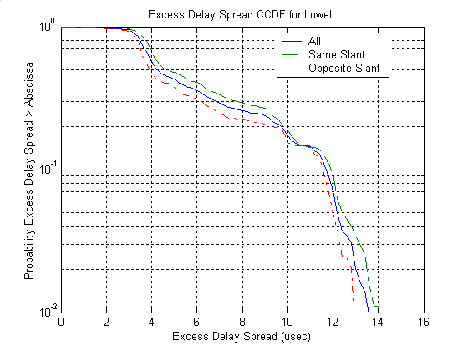
Figure 5 - Lowell CCDFs of Excess Delay Spread.
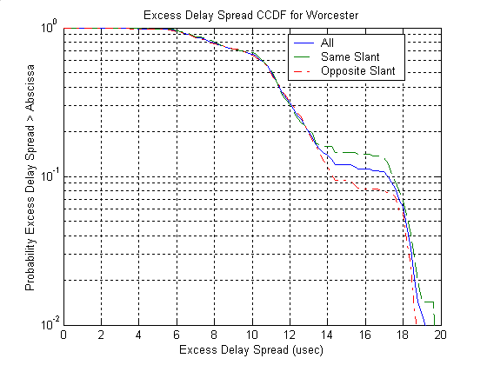
Figure 6 - Worcester CCDFs of Excess Delay Spread.
The excess delay spread in particular is very sensitive to the threshold used for the PDP. Another measure of the dispersion of the channel is the Profile Width [3]. A second threshold is applied to the PDP that is set at a level with respect the maximum of the PDP and then the excess delay is computed. The complementary cumulative distribution function (CCDF) of the excess delay spread and profile width for different threshold levels for Lowell and Worcester is plotted in Figure 7 and Figure 8 respectively.
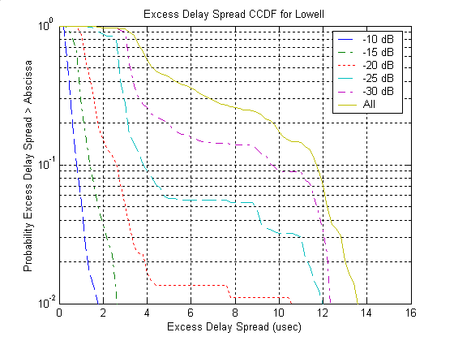
Figure 7 - Lowell CCDFs of Excess Delay Spread and Profile Width.
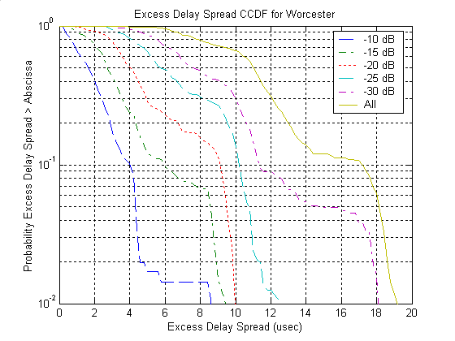
Figure 8 - Worcester CCDFs of Excess Delay Spread and Profile Width.

Mapping of Power to Path Delays
Different procedures have been proposed for assigning mean power to delays. It has been assumed that the mean power is exponentially decaying function of the path delay. Similar to what has been presented in [4], statistics of the measured PDPs are presented here. Figure 9 is generated by normalizing each PDP by its maximum value and histogramming all the PDPs for Lowell. Figure 10 repeats this for the Worcester PDPs. An exponential decay of power with delay is evident in both figures.
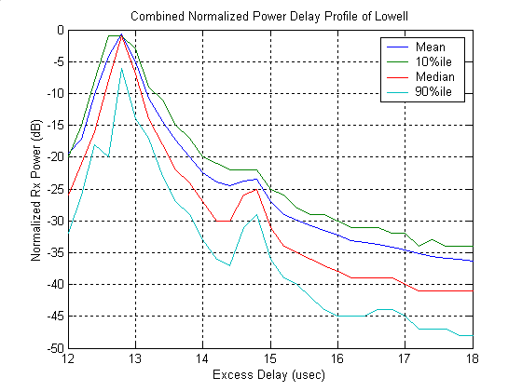
Figure 9 – Statistics for each delay from the normalized PDPs of Lowell .

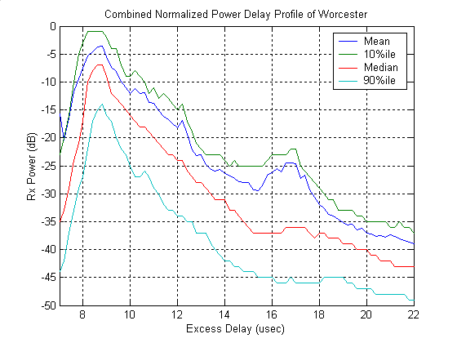
Figure 10 - Statistics for each delay from the normalized PDPs of Worcester.
The probability that the j^{th} largest peak of a PDP is found at the k^{th} delay is shown for Lowell in Figure 11 and Worcester in Figure 12. The distributions for the six largest peaks are shown with the six curves. These distributions are derived from the peaks of the thresholded PDPs of each area. A peak is a sample of the thresholded PDP that is greater than the PDP sample that precedes it and the PDP sample that succeeds it. With this definition, the minimum separation between peaks is two samples (0.4 usec). Although the j^{th} largest peak is very likely to coincide with the j^{th} delay, there is a reasonable probability of finding it at one of the adjacent delay positions.

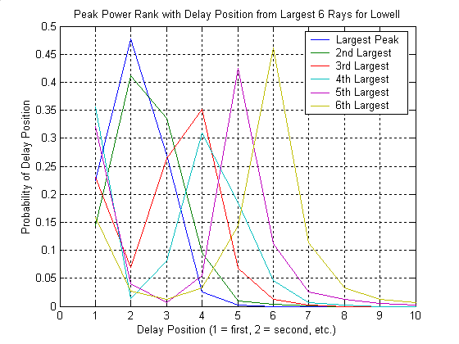
Figure 11 – Peak power versus delay position for Lowell.
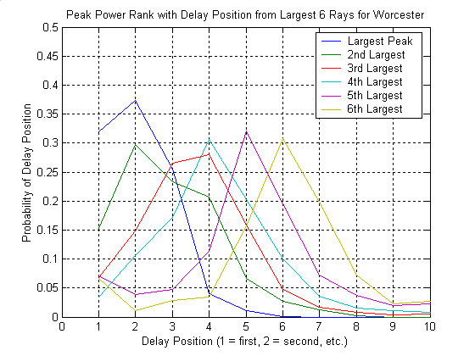
Figure 12 - Peak power versus delay position for Worcester.

Path Polarization
The cross-polarization discrimination (XPD) for a location is calculated as the ratio of the sum of the powers from the same slant Tx/Rx antenna pairs to sum of the powers from the opposite slant Tx/Rx antenna pairs. This can be done using the total power from each PDP or for a particular delay (path) common to all the PDPs. The main path is at the delay of the CPDP maximum power in the first cluster. The second path is at the delay of the CPDP maximum power in the second cluster. Not all locations have a second path. Figure 13 shows the XPD distributions for the Lowell data. Figure 14 is for the Worcester data.
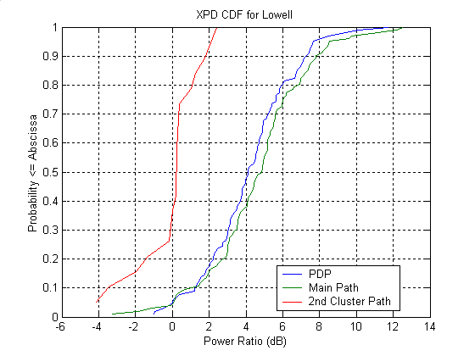
Figure 13 – Lowell XPD distributions.

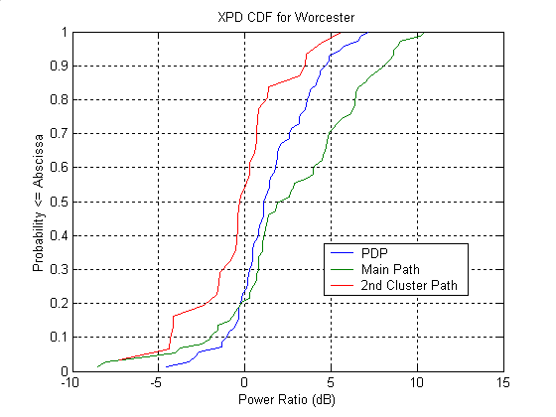
Figure 14 – Worcester XPD distributions.
Table II gives the statistics of the XPD distributions.
Table II – XPD Statistics
Area | Power | Mean (dB) | Std. Dev. (dB) | Median (dB)
Lowell | PDP | 4.2 | 2.4 | 4.1
Lowell | Main Path | 4.7 | 2.8 | 4.9
Lowell | 2nd Path | 0.0 | 1.7 | 0.2
Worcester | PDP | 1.6 | 2.4 | 1.2
Worcester | Main Path | 2.7 | 4.1 | 2.3
Worcester | 2nd Path | -0.2 | 2.8 | -0.2

Lowell, which had a high base site in a light urban/suburban area, has a main path and PDP mean XPD greater than hilly, light urban Worcester. Since the PDP total power is the sum of all the detected power at the different delays that includes the typically large main path, the PDP XPD value is heavily influenced by the main path XPD value. In [1], the correlation for the small-scale fading of the two different slants is shown.

Conclusion
In this contribution, the data from MIMO channel measurements has been analyzed to address some of the open issues in the SCM discussions.
The distribution of the RMS delay spread and its statistics were reported for two areas. Since directional antennas were used in the measurements, the delay spreads measured might be 30% less than what would be measured with omni-directional ones [3]. If this is the case, then the Lowell mean RMS delay spread compares quite well with the proposed suburban macro mean RMS delay spread of 0.5 usec (0.35/(1-0.3) = 0.5). Worcester’s mean RMS delay spread of 1 usec is high compared to the proposed urban macro mean RMS delay spread of 0.9 usec even before factoring in the directional antennas, but Worcester is a hilly area and one would expect a good deal of dispersion.
See section 3.2 for results and a discussion of the mapping of power to path delays. See section 3.3 for XPD statistics.

References

[1] S. Howard et. al., “Results from MIMO channel measurements,” in Proc. PIMRC2002, September 2002. Also see 3GPP2 contribution C50-SCM-20011127-001.
[2] G. Hess, “Resolvable multipath behavior”, 3GPP2 C50-SCM-20011031-002R.
[3] E. S. Sousa, V. M. Jovanovic, and C. Daigneault, “Delay spread measurements for the digital cellular channel in Toronto,” in IEEE Trans. Veh. Technol, Vol. 43, pp. 837-847, Nov. 1994.
[4] Motorola, “Path Characteristics for Spatial Channel Model”, SCM-041, August 1, 2002, Teleconference.

