**3GPP TSG-RAN WG4 Meeting #99-e R4-2108655   
Electronic Meeting, May 19-27, 2021**

**Agenda item: 10.1.6**

**Source: vivo, Keysight, Samsung**

**Title: TP to TR38.884 v0.3.0 on testing time reduction**

**Document for: Approval**

# 1 Introduction

In RAN4#98bis-e meeting, good progress on testing time reduction has been made [1][2]. RSRP(B) is feasible to find the RX beam peak search, and Single link polarization measurement is also applicable for EIRP test based on UE declaration.

This contribution provides the text proposals on testing time reduction methods to TR 38.884.

# 2 Discussion

In the last RAN4 meeting, the initial conclusions on enhanced approach has been agreed [1]:

* RSRP(B) based RX beam peak search
  + RAN4 confirm that RSRP is feasible to find the beam peak direction
  + Further discuss RSRP or RSRP&EIS based beam peak searching procedure
    - If RSRP is selected, further discuss whether an additional MU element is needed.
  + Whether the test procedure of Rx beam peak search based on RSRPB for demodulation and CSI testing can be applicable is FFS
* Single Pollink
  + For EIRP test, whether single Pollink is randomly selected (from either theta Pollink or phi Pollink) or test under 2 link directions, depends on UE declaration

Given the RSRP is feasible to find the beam peak direction, then select RSRP-based beam peak searching procedure would be a simple and direct way to go. Only issue is RAN4 may need further study whether the RSRP accuracy would have impact on the final beam peak direction.

In this contribution, we propose test procedure to adopt RSRP-based RX beam peak searching and Single link polarization measurement.

# 3 References

1. R4-2103952, “Email discussion summary for [98e][330] FR2_enhTestMethods,” Moderator (Apple), 3GPP RAN4#98-e, Feb 2021.
2. R4-2103920, “WF on ETC and test time reduction,” vivo, 3GPP RAN4#98-e, Feb 2021.
3. R4-2104520, Discussions on FR2 test time reduction, vivo, 3GPP RAN4#98-e, Feb 2021.
4. R4-2111004, Measurement Grids for Optional 4x2 PC3 Antenna Array Configuration, Keysight Technologies, 3GPP RAN4#99-e, May 2021.

# 4 Text Proposal to TR 38.884

**--------------Start of text proposal -------------**

## 8.2 New measurement grid

### 8.2.1 New measurement grids based on 4x2 antenna pattern assumption

For PC3 UEs, an 4x2 antenna array has been agreed for measurement grid analyses. The Table 8.2.1-1 and Table 8.2.1-2 outline the antenna patterns for simulation.

Table 8.2.1-1: Single Antenna Element Radiation Pattern

|  |  |
| --- | --- |
| Antenna element horizontal radiation pattern | $A_{E,H}\left(φ\right)=-\min\left[12{\left(\frac{φ}{φ_{3dB}}\right)}^{2},A_{m}\right]$, Am = 30 dB |
| Horizontal half-power beamwidth of single element | 260° |
| Antenna element vertical radiation pattern | $A_{E,V}\left(φ\right)=-\min\left[12{\left(\frac{θ-90}{θ_{3dB}}\right)}^{2},{SLA}_{V}\right]$, SLAV = 30 dB |
| Vertical half-power beamwidth of single array element | 130º |
| Array element radiation pattern | $A_{E}\left(φ,θ\right)=G_{E,\text{max}}-\min\left[\left(A_{E,H}\left(φ\right)+A_{E,V}\left(θ\right)\right),A_{m}\right],$ GE,max = 1.5 dBi |
| Element gain without antenna losses | GE,max = 1.5 dBi |

Table 8.2.1-2: Composite Antenna Array Radiation Pattern

|  |  |
| --- | --- |
| Composite array radiation pattern in dB | the super position vector is given by: $v_{n,m}=\text{exp}\left(i∙2π\left(\left(n-1\right)∙\frac{d_{V}}{λ}∙\cos\left(θ\right)+\left(m-1\right)∙\frac{d_{H}}{λ}∙\sin\left(θ\right)∙\sin\left(φ\right)\right)\right)$ , $n=1,2,…N_{V};m=1,2,…N_{H}$ ;  the weighting is given by: $w_{i,n,m}=\frac{1}{\sqrt{N_{HN_{V}}}}\text{exp}\left(i∙2π\left(\left(n-1\right)∙\frac{d_{V}}{λ}∙\sin\left(θ_{i,etilt}\right){-\left(m-1\right)∙\frac{d_{H}}{λ}∙\cos\left(θ_{i,etilt}\right){∙\sin\left(φ_{i,etilt}\right)}}\right)\right)$ |
| Antenna array configuration (Row×Column) | 4 × 2 |
| Horizontal radiating element spacing dh/λ | 0.5 |
| Vertical radiating element spacing dv/λ | 0.5 |

Based on 4x2 antenna array, the following three types of measurement grids need to be derived:

- Beam Peak Search Grid: using this grid, the TX and RX beam peak direction will be determined. 3D EIRP scans are used to determine the TX beam peak direction and 3D Throughput/RSRP/EIS scans for RX beam peak directions.

- Spherical Coverage Grid: using this grid, the CDF of the EIRP/EIS distribution in 3D is calculated to determine the spherical coverage performance.

- TRP Measurement Grid: using this grid, the total power radiated by the DUT in the TX beam peak direction is determined by integrating the EIRP measurements taken on the sampling grid.

#### 8.2.1.1 Beam Peak Search Measurement Grid

Follow the analysis approach in TR38.810 Annex G, similar analyses based on 50k simulations have been performed for the 4x2 antenna array assumption. The global beam peak of the 4x2 antenna array was determined first. Subsequently, the relative orientation of the simulated antenna array and the measurement grid was altered randomly.

Sample histograms and CDF distributions for the beam peak error for constant step-size measurement grids are shown in Figure 8.2.1.1-1 and for the constant density measurement grid (based on the charged particle implementation) in Figure 8.2.1.1-2. The histograms show a half-normal distribution.

Given the half-normal distribution, the MU term should be based on the determination of the offset from the beam peak that contains 95% of the distribution (alternatively, the value at which the CDF is 5%). This offset shall be considered a systematic error in the MU budget. The various statistical metrics are illustrated in Figure 8.2.1.1-3.

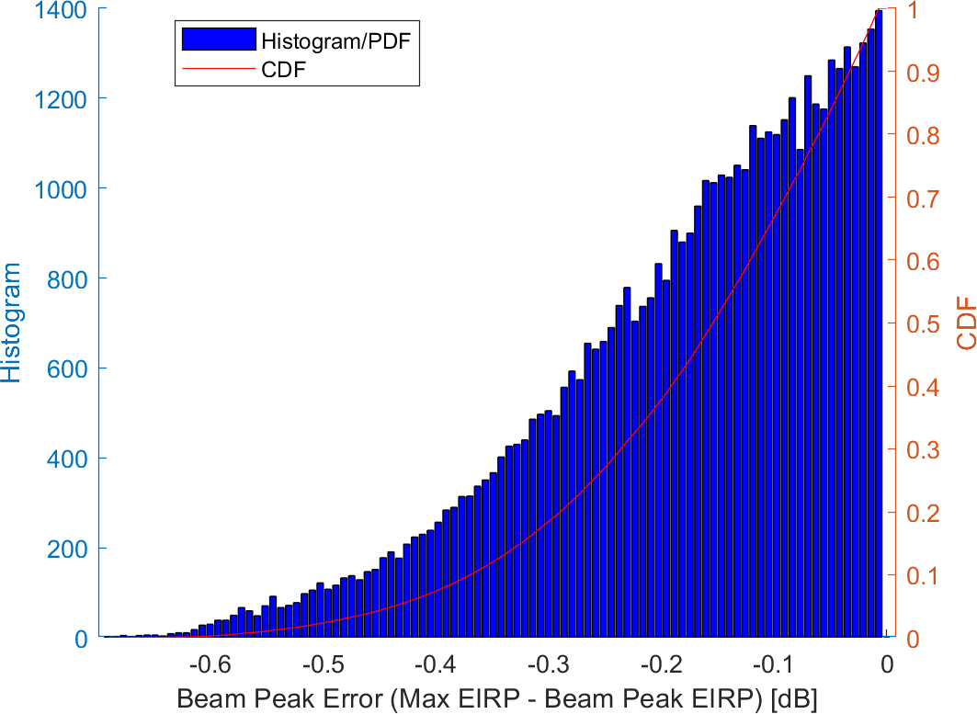 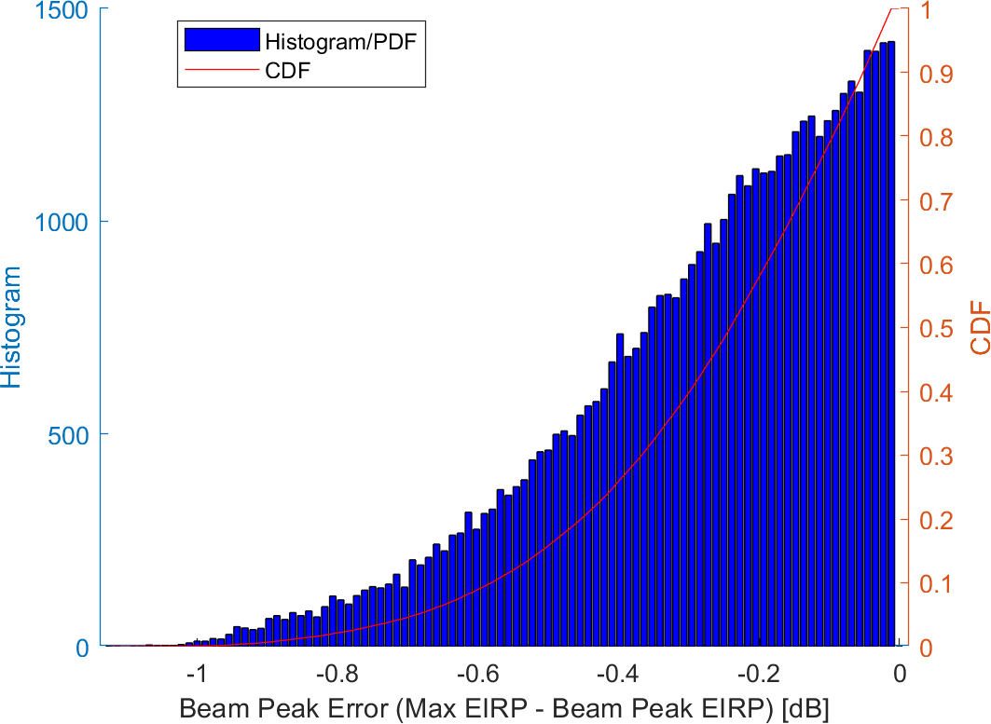

Figure 8.2.1.1-1: Histogram of maximum beam peak errors for sample constant-step size meausurement grids (left: 12o, right: 15o step size) for 260o/130o HPBW

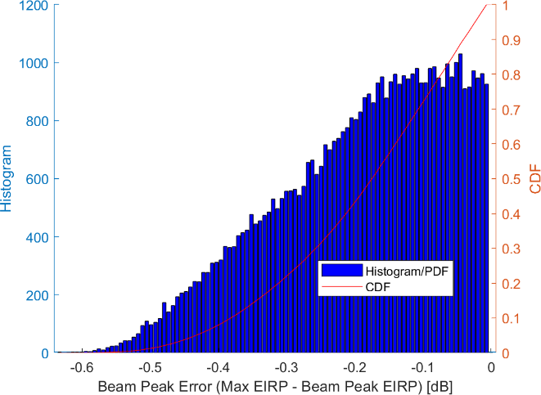 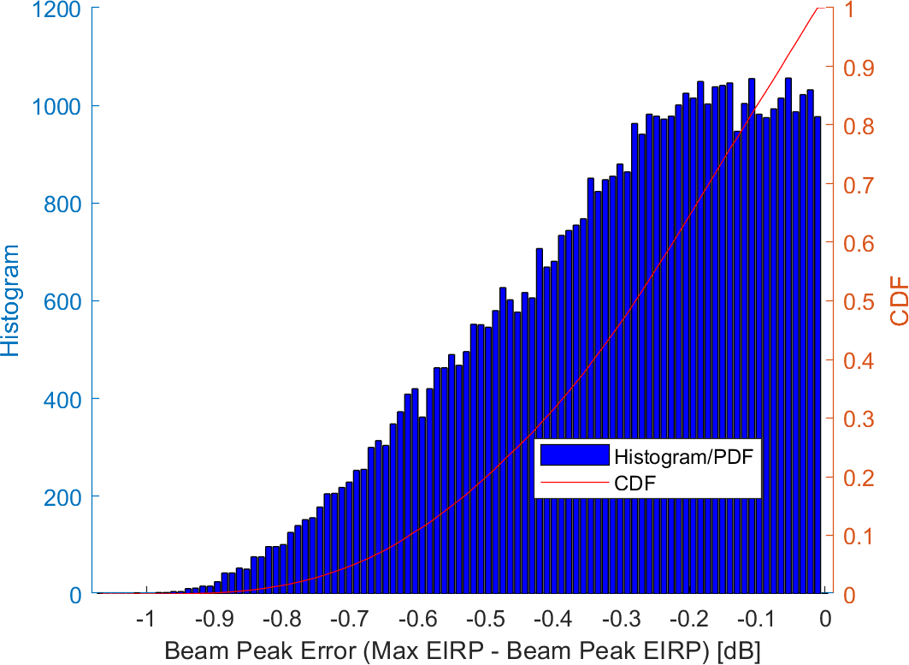

Figure 8.2.1.1-2: Histogram of maximum beam peak errors for sample constant density measurement grids (left: 320, right: 200 grid points) for 260o/130o HPBW

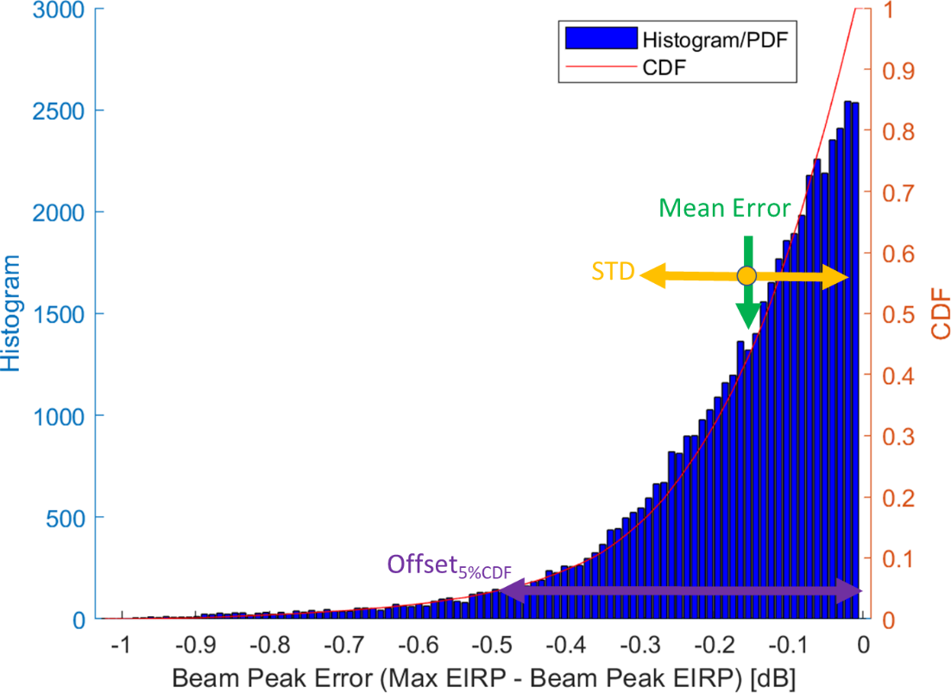

Figure 8.2.1.1-3: Statistical metrics for a sample half-normal distribution

The statistical results from simulations using 50k random orientations are then used for further analyses, summarized in Table 8.2.1.1-1 for constant-step size grids and in Table 8.2.1.1-2 for constant-density grids. The simulation assumptions of the rotations were the same as those outlined in Annex G.1.1 of [3]. it should be noted that these measurement grids are derived without consideration of UE beam steering effect (i.e. beam correspondence).

Table 8.2.1.1-1: Statistical Analyses of the 50k simulations for the constant-step size grids

|  |  |  |  |  |
| --- | --- | --- | --- | --- |
| Angular Step Size [o] | Number of unique grid points | Mean Error [dB] | STD [dB] | Offset5%CDF [dB] |
| 7.5 | 1106 | 0.07 | 0.05 | 0.17 |
| 9.0 | 762 | 0.10 | 0.07 | 0.25 |
| 10.0 | 614 | 0.12 | 0.09 | 0.31 |
| 11.25 | 482 | 0.15 | 0.11 | 0.38 |
| 12.0 | 422 | 0.17 | 0.13 | 0.44 |
| 12.86 | 366 | 0.20 | 0.15 | 0.50 |
| 13.8 | 314 | 0.23 | 0.17 | 0.58 |
| 15.0 | 266 | 0.27 | 0.21 | 0.69 |

Table 8.2.1.1-2: Statistical Analyses of the 50k simulations for the constant-density grids

|  |  |  |  |
| --- | --- | --- | --- |
| Number of unique grid points | Mean Error [dB] | STD [dB] | Offset5%CDF [dB] |
| 800 | 0.07 | 0.05 | 0.17 |
| 700 | 0.09 | 0.06 | 0.20 |
| 650 | 0.09 | 0.06 | 0.21 |
| 600 | 0.10 | 0.07 | 0.23 |
| 550 | 0.11 | 0.07 | 0.25 |
| 500 | 0.12 | 0.08 | 0.28 |
| 450 | 0.13 | 0.09 | 0.31 |
| 400 | 0.15 | 0.10 | 0.35 |
| 350 | 0.17 | 0.12 | 0.39 |
| 300 | 0.20 | 0.14 | 0.46 |
| 275 | 0.22 | 0.15 | 0.50 |
| 250 | 0.24 | 0.16 | 0.55 |

Based on the previously agreed limit of Offset5%CDF of 0.5dB (systematic error), the following minimum number of grid points would be required for Beam Peak Search Grid.

- Constant density grid with at least 275 grid points

- Constant step size grid with at least 366 grid points

Table 8.2.1.1-3: Min Number of Grid Points for TX/RX Beam Peak Search

|  |  |  |  |
| --- | --- | --- | --- |
| Antenna  Assumption   Grid Type | 8x2 | 4x2 | Factor of Improvement |
| Constant-Step Size | 1106 | 366 | 3.0 |
| Constant-Density | 800 | 275 | 2.9 |

The approximate test times for the 4x2 beam peak searches are as follows:

- Constant-Step Size: TX ~0.7hrs; RX ~4hrs

- Constant Density: TX ~0.5hrs; RX ~3hrs

#### 8.2.1.2 Spherical Coverage Measurement Grid

The simulation assumptions including the antenna patterns for the spherical coverage measurement grids are the same as Clause G.3 [3] except the 4x2 antenna array assumptions instead of 8x2.

At the 50%-tile CDF, i.e., the target CDF for Power Class 3, statistical analyses of all 10000 EIRPs, EIRP50%CDF, are performed.

The simulations in this contribution were only for the case where the beam peak is oriented in completely random orientations, i.e., the beam peak is not always aligned to a grid point. It is understood that the CDF curve cannot be used to accurately determine the TX beam peak (100%-tile CDF)

Unlike in [3], the simulations here were performed for EIRP only it was shown previously that the EIS simulations with infinitesimal DL power step sizes match the standard deviations of the EIRP results and that a finite DL power step size introduces a mean error that matches the DL power step size.

The results for various constant-step size measurement grids are tabulated in Table 8.2.1.2-1 and the grid with similar MUs as previously agreed for the 8x2 based PC3 configuration is highlighted.

Table 8.2.1.2-1: Statistical results of EIRP50%CDF for the 4x2 antenna array for constant step size measurement grids and the beam peak oriented in completely random orientations.

|  |  |  |  |
| --- | --- | --- | --- |
| **Step Size [o]** | **Number of unique grid points** | **Std. Dev [dB]** | **|Mean Error| [dB]** |
| 10.0 | 614 | 0.03 | 0.00 |
| 12.0 | 422 | 0.08 | 0.01 |
| 15.0 | 266 | 0.06 | 0.02 |
| 20.0 | 146 | 0.10 | 0.03 |
| 22.5 | 114 | 0.22 | 0.02 |
| 30.0 | 62 | 0.21 | 0.04 |
| 45.0 | 26 | 0.30 | 0.14 |

Similar results for the constant-density measurement grids are tabulated in Table 8.2.1.2-2 and the grid with similar MUs as previously agreed for the 8x2 based PC3 configuration is highlighted.

Table 8.2.1.2-2: Statistical results of EIRP50%CDF for the 4x2 antenna array for constant density measurement grids and the beam peak oriented in completely random orientations.

|  |  |  |
| --- | --- | --- |
| **Number of unique grid points** | **Std. Dev [dB]** | **|Mean Error| [dB]** |
| 50 | 0.19 | 0.05 |
| 60 | 0.25 | 0.03 |
| 70 | 0.21 | 0.04 |
| 80 | 0.22 | 0.03 |
| 90 | 0.14 | 0.03 |
| 100 | 0.12 | 0.03 |
| 110 | 0.10 | 0.03 |
| 120 | 0.09 | 0.03 |
| 130 | 0.07 | 0.02 |
| 140 | 0.07 | 0.02 |
| 150 | 0.07 | 0.02 |

At least 100 (constant density grid with charged particle implementation) or 146 (constant step size grid with 20deg step size) measurement grid points shall be used for EIRP spherical coverage procedure. Compared with 8x2 antenna array, the factor of improvement based on new measurement grid with 4x2 antenna is about 2, as summarized in the table 8.2.1.2-3.

Table 8.2.1.2-3: Min Number of Grid Points for Spherical Coverage

|  |  |  |  |
| --- | --- | --- | --- |
| Antenna  Assumption   Grid Type | 8x2 | 4x2 | Factor of Improvement |
| Constant-Step Size | 266 (15.0 deg) | 146 (20.0 deg) | 1.8 |
| Constant-Density | 200 | 100 | 2 |

#### 8.2.1.3 TRP Measurement Grid

The simulation assumptions including the antenna patterns for the TRP measurement grids are the same as Clause G.2 [3] except a 4x2 antenna array assumption instead of 8x2 for both single-element antenna patterns.

The results tabulated in this section outline the results of a statistical analyses with the positioning concept taken into account, i.e., the analyses were performed with and without the assumption that the beam peak direction is oriented away from the hemisphere towards the pole at  = 180o. Additionally, the standard deviations are presented when ranges of pattern values are disregarded (zeroed out). For the constant-step size measurement grids, three cases were investigated, i.e., no pattern values are disregarded, values only at one latitude at =180o, and the values at the bottom two latitudes are disregarded. The results with the re-positioning concept applied are summarized in Table 8.2.1.3-1 for the sin(theta) and the Clenshaw-Curtis quadratures while the results without the re-positioning concept applied are summarized in Table 8.2.1.3-2.

For the constant density measurement grids, a similar investigation was performed using the Charged Particle implementation. Two cases investigated were: no pattern values are disregarded and values between X≤  ≤ 180o are disregarded. The results with the re-positioning concept applied are summarized in Table 8.2.1.3-2 for the Charged Particle implementation while the results without the re-positioning concept applied are summarized in Table 8.2.1.3-4.

The previously agreed limit for the PC3 TRP grids is 0.25dB. Those measurement grids meeting that limit have been highlighted in green while the grids exceeding that limit are highlighted in red. It should be noted that some mean errors are relatively high for grids that meet the 0.25dB std. deviation limit and therefore should not be considered candidate measurement grids.

Table 8.2.1.3-1: Statistics of quadrature approaches for constant step size measurement grids for the 4x2 antenna array with the re-positioning concept applied.

|  |  |  |  |  |  |  |  |  |
| --- | --- | --- | --- | --- | --- | --- | --- | --- |
| **Number of** | | **Step Size =** | **Number of unique grid points** | **Number of Latitudes disregarded** | **Mean Error [dB]** | **Std. Dev [dB]** | **Quadrature** | **Re-Positioning Concept Applied** |
| **Latitudes** | **Longitudes** |
| 13 | 24 | 15 | 266 | 1 | -0.02 | 0.05 | Sin(theta) | yes |
| 13 | 24 | 15 | 266 | 1 | -0.01 | 0.01 | Clenshaw-Curtis | yes |
| 13 | 24 | 15 | 266 | 2 | -0.10 | 0.16 | Sin(theta) | yes |
| 13 | 24 | 15 | 266 | 2 | -0.08 | 0.12 | Clenshaw-Curtis | yes |
| 13 | 24 | 15 | 266 | 3 | -0.18 | 0.17 | Sin(theta) | yes |
| 13 | 24 | 15 | 266 | 3 | -0.16 | 0.14 | Clenshaw-Curtis | yes |
| 10 | 18 | 20 | 146 | 1 | -0.05 | 0.10 | Sin(theta) | yes |
| 10 | 18 | 20 | 146 | 1 | -0.01 | 0.03 | Clenshaw-Curtis | yes |
| 10 | 18 | 20 | 146 | 2 | -0.19 | 0.27 | Sin(theta) | yes |
| 10 | 18 | 20 | 146 | 2 | -0.15 | 0.18 | Clenshaw-Curtis | yes |
| 10 | 18 | 20 | 146 | 3 | -0.31 | 0.21 | Sin(theta) | yes |
| 10 | 18 | 20 | 146 | 3 | -0.28 | 0.17 | Clenshaw-Curtis | yes |
| 8 | 14 | 25.71 | 86 | 1 | -0.08 | 0.19 | Sin(theta) | yes |
| 8 | 14 | 25.71 | 86 | 1 | -0.02 | 0.05 | Clenshaw-Curtis | yes |
| 8 | 14 | 25.71 | 86 | 2 | -0.32 | 0.40 | Sin(theta) | yes |
| 8 | 14 | 25.71 | 86 | 2 | -0.25 | 0.26 | Clenshaw-Curtis | yes |
| 8 | 14 | 25.71 | 86 | 3 | -0.52 | 0.24 | Sin(theta) | yes |
| 8 | 14 | 25.71 | 86 | 3 | -0.46 | 0.17 | Clenshaw-Curtis | yes |
| 7 | 12 | 30 | 62 | 1 | -0.11 | 0.33 | Sin(theta) | yes |
| 7 | 12 | 30 | 62 | 1 | -0.03 | 0.13 | Clenshaw-Curtis | yes |
| 7 | 12 | 30 | 62 | 2 | -0.44 | 0.53 | Sin(theta) | yes |
| 7 | 12 | 30 | 62 | 2 | -0.34 | 0.32 | Clenshaw-Curtis | yes |
| 7 | 12 | 30 | 62 | 3 | -0.73 | 0.36 | Sin(theta) | yes |
| 7 | 12 | 30 | 62 | 3 | -0.66 | 0.26 | Clenshaw-Curtis | yes |

Table 8.2.1.3-2: Statistics of quadrature approaches for constant step size measurement grids for the 4x2 antenna array without the re-positioning concept applied.

|  |  |  |  |  |  |  |  |  |
| --- | --- | --- | --- | --- | --- | --- | --- | --- |
| **Number of** | | **Step Size =** | **Number of unique grid points** | **Number of Latitudes disregarded** | **Mean Error [dB]** | **Std. Dev [dB]** | **Quadrature** | **Re-Positioning Concept Applied** |
| **Latitudes** | **Longitudes** |
| 13 | 24 | 15 | 266 | 1 | -0.03 | 0.06 | Sin(theta) | no |
| 13 | 24 | 15 | 266 | 1 | -0.02 | 0.04 | Clenshaw-Curtis | no |
| 13 | 24 | 15 | 266 | 2 | -0.19 | 0.37 | Sin(theta) | no |
| 13 | 24 | 15 | 266 | 2 | -0.18 | 0.35 | Clenshaw-Curtis | no |
| 10 | 18 | 20 | 146 | 1 | -0.05 | 0.10 | Sin(theta) | no |
| 10 | 18 | 20 | 146 | 1 | -0.03 | 0.07 | Clenshaw-Curtis | no |
| 10 | 18 | 20 | 146 | 2 | -0.35 | 0.63 | Sin(theta) | no |
| 10 | 18 | 20 | 146 | 2 | -0.33 | 0.59 | Clenshaw-Curtis | no |
| 8 | 14 | 25.71 | 86 | 1 | -0.08 | 0.20 | Sin(theta) | no |
| 8 | 14 | 25.71 | 86 | 1 | -0.05 | 0.12 | Clenshaw-Curtis | no |
| 8 | 14 | 25.71 | 86 | 2 | -0.62 | 0.96 | Sin(theta) | no |
| 8 | 14 | 25.71 | 86 | 2 | -0.56 | 0.90 | Clenshaw-Curtis | no |
| 7 | 12 | 30 | 62 | 1 | -0.11 | 0.33 | Sin(theta) | no |
| 7 | 12 | 30 | 62 | 1 | -0.07 | 0.22 | Clenshaw-Curtis | no |
| 7 | 12 | 30 | 62 | 2 | -0.87 | 1.24 | Sin(theta) | no |
| 7 | 12 | 30 | 62 | 2 | -0.79 | 1.15 | Clenshaw-Curtis | no |

Table 8.2.1.3-3: Statistics for constant density measurement grid types for the 4x2 reference antenna array with the re-positioning concept applied (charged particle implementation only)

|  |  |  |  |  |
| --- | --- | --- | --- | --- |
| **Number of Grid Points** | **Range of Angles disregarded** | **Mean Error [dB]** | **Std. Dev [dB]** | **Re-Positioning Concept Applied** |
| 90 | none | 0.05 | 0.02 | yes |
| 80 | none | 0.05 | 0.03 | yes |
| 70 | none | 0.05 | 0.03 | yes |
| 60 | none | 0.05 | 0.05 | yes |
| 50 | none | 0.05 | 0.07 | yes |
| 40 | none | 0.04 | 0.17 | yes |
| 90 | 165o-180o | 0.00 | 0.08 | yes |
| 80 | 165o-180o | -0.01 | 0.09 | yes |
| 70 | 165o-180o | 0.02 | 0.07 | yes |
| 60 | 165o-180o | 0.01 | 0.09 | yes |
| 50 | 165o-180o | 0.00 | 0.11 | yes |
| 40 | 165o-180o | 0.04 | 0.17 | yes |
| 90 | 150o-180o | -0.10 | 0.18 | yes |
| 80 | 150o-180o | -0.09 | 0.18 | yes |
| 70 | 150o-180o | -0.11 | 0.20 | yes |
| 60 | 150o-180o | -0.10 | 0.20 | yes |
| 50 | 150o-180o | -0.14 | 0.21 | yes |
| 40 | 150o-180o | -0.13 | 0.28 | yes |

Table 8.2.1.3-4: Statistics for constant density measurement grid types for the 4x2 reference antenna array without the re-positioning concept applied (charged particle implementation only)

|  |  |  |  |  |
| --- | --- | --- | --- | --- |
| **Number of Grid Points** | **Range of Angles disregarded** | **Mean Error [dB]** | **Std. Dev [dB]** | **Re-Positioning Concept Applied** |
| 90 | none | 0.05 | 0.02 | no |
| 80 | none | 0.05 | 0.03 | no |
| 70 | none | 0.05 | 0.03 | no |
| 60 | none | 0.05 | 0.05 | no |
| 50 | none | 0.05 | 0.07 | no |
| 40 | none | 0.05 | 0.17 | no |
| 90 | 165o-180o | 0.00 | 0.13 | no |
| 80 | 165o-180o | -0.01 | 0.14 | no |
| 70 | 165o-180o | -0.02 | 0.17 | no |
| 60 | 165o-180o | -0.03 | 0.21 | no |
| 50 | 165o-180o | -0.04 | 0.26 | no |
| 40 | 165o-180o | -0.08 | 0.39 | no |
| 90 | 150o-180o | -0.28 | 0.58 | no |
| 80 | 150o-180o | -0.26 | 0.56 | no |
| 70 | 150o-180o | -0.32 | 0.64 | no |
| 60 | 150o-180o | -0.29 | 0.61 | no |
| 50 | 150o-180o | -0.36 | 0.70 | no |
| 40 | 150o-180o | -0.34 | 0.73 | no |

According to the above analysis, the following conclusions can be made:

- If the re-positioning concept is not applied to TRP test cases:

- 40 measurement grid points for constant density grid – Charged Particle implementation, with standard deviation of 0.17dB.

- 8 latitudes and 14 longitudes (84 grid points) for constant step size grid – sin (theta) weights integration approach, with standard deviation of 0.20dB with the allowance to skip and interpolate measurements at the pole at =180o.

- 7 latitudes and 12 longitudes (62 grid points) for constant step size grid – Clenshaw Curtis weights integration approach, with standard deviation of 0.22 dB with the allowance to skip and interpolate measurements at the pole at =180o

- If the re-positioning concept is applied to TRP test cases:

- 50 measurement grid points for constant density grid – Charged Particle implementation, with standard deviation of 0.21 dB with the allowance to skip and interpolate measurements beyond 150o in  

- 8 latitudes and 14 longitudes (86 grid points) for constant step size grid – sin (theta) weights integration approach, with standard deviation of 0.19dB with the allowance to skip and interpolate measurements the at pole at =180o

- 7 latitudes and 12 longitudes (62 grid points) for constant step size grid – Clenshaw Curtis weights integration approach, with standard deviation of 0.13 dB with the allowance to skip and interpolate measurements the at pole at =180o

### 8.2.2 Applicability of the 4x2 measurement grids

Since RAN5 has decided on maximum test system uncertainties and test tolerances already, it is not suggested to change the assumptions at this point as this will have significant impact in RAN5 and industry since changes in MU/MTSU could have impact on certifications and test platform validations. Keep the system-related assumptions unchanged in RAN5, i.e., based on the previously agreed worst case 8x2 assumptions.

It is therefore the 4x2-antenna-based measurement grids are agreed as an additional option for FR2 test cases, but not replace previous 8x2 based measurement grids. The selection of measurement grid based on 4x2 or 8x2 is based on optional vendor declaration. By default, 4x2-based measurement grids can be adopted for FR2 PC3 test cases.

The above new measurement grids based on 4x2 antenna array are applicable to both NTC and ETC test cases.

## 8.3 RSRP(B) based RX beam peak search

RSRP(B)-based RX beam peak search approach is applicable to find the beam peak, the beam peak searching time can be reduced significantly.

### 8.3.1 Test procedure

The RX beam peak direction is found with a 3D RSRP(B) scan (separately for each orthogonal downlink polarization). The RX beam peak direction is where the maximum total component of RSRP is found. The RX beam peak direction search grid points for this single grid approach are defined in Clause 8.2.

For RSRP(B) based Rx beam peak search, the measurement antenna and link antenna are the same one. The measurement procedure includes the following steps:

1) Select any of the three Alignment Options (1, 2, or 3) from Tables N.2-1 through N.2-3 [6] to mount the DUT inside the QZ.

2) Position the DUT in DUT Orientation 1 or 2 from Tables N.2-1 through N.2-3 [6].

3) Connect the SS (System Simulator) with the DUT through the measurement antenna with PolLink= polarization to form the RX beam towards the measurement antenna.

4) Set a proper high DL power supported by the test system, this value will be defined in RAN5 conformance test spec. Determine RSRP or RSRPBs (one per receiver branch) at PolMeas=PolLink= condition reported by UE.

5) Connect the SS (System Simulator) with the DUT through the measurement antenna with PolLink= polarization to form the RX beam towards the measurement antenna.

6) Set the same DL power as the one in step 4. Determine RSRP or RSRPBs (one per receiver branch) at PolMeas=PolLink= condition reported by UE.

7) Advance to the next grid point and repeat steps 3 through 6 until measurements within the full 3D scan have been completed.

8) Calculate total RSRP by linear sum two RSRPs, or total RSRPB by linear sum four RSRPBs. The RX beam peak direction is where the maximum total component of RSRP or RSRPB.

### 8.3.2 RSRP(B) accuracy

The RSRP(B) accuracy is FFS, assuming the SNR is higher than 17dB.

## 8.4 Single link polarization measurement

As an enhancement to the FR2 2Tx test cases, it has been proposed to adopt a Single link polarization measurement to reduce the test time. Single Pollink can be randomly selected from either theta Pollink or phi Pollink.

For EIRP test, whether single Pollink is adopted or test under 2 link directions, depends on UE declaration.

### 8.4.1 Test procedure

For single link polarization measurement, the link antenna can be randomly selected, in this clause the detailed Single Pollink measurement procedure for TX Beam Peak direction search and EIRP Spherical Coverage based on PolLink= is presented as an example:

1) Select any of the three Alignment Options (1, 2, or 3) from Tables N.2-1 through N.2-3 [6] to mount the DUT inside the QZ.

2) Position the DUT in DUT Orientation 1 from Tables N.2-1 through N.2-3 [6].

3) Connect the SS (System Simulator) with the DUT through the measurement antenna with PolLink= to form the TX beam towards the measurement antenna.

4) DUT refines its TX beam toward that direction depending on DUT’s beam correspondence capability which shall match OEM declaration:

a) if DUT’s beam correspondence capability is [bit-1], then DUT autonomously chooses the corresponding TX beam for PUSCH transmission using downlink reference signals to transmit in the direction of the incoming DL signal, which is based on beam correspondence without relying on UL beam sweeping

b) if DUT’s beam correspondence capability is [bit-0], then DUT chooses the TX beam for PUSCH transmission which is based on beam correspondence that relies on both DL measurements on downlink reference signals and network-assisted uplink beam sweeping.

5) Lock the beam and send continuously power control "up" commands in every uplink scheduling information to the UE

6) Measure the mean power Pmeas(PolMeas= PolLink=) of the modulated signal arriving at the power measurement equipment (such as a spectrum analyser, power meter, or gNB emulator).

7) Calculate EIRP (PolMeas=PolLink=) by adding the composite loss of the entire transmission path for utilized signal path, LEIRP,θ, and frequency to the measured power Pmeas(PolMeas=PolLink=)

8) Measure the mean power Pmeas (PolMeas=PolLink=) of the modulated signal arriving at the power measurement equipment.

9) Calculate EIRP (PolMeas=PolLink=) by adding the composite losses of the entire transmission path for utilized signal path, LEIRP,ϕ, and frequency to the measured power Pmeas (PolMeas=PolLink=)

10) Calculate total EIRP(PolLink=) = EIRP(PolMeas=PolLink=) + EIRP(PolMeas=PolLink=)

11) Advance to the next grid point and repeat steps 3 through 13 until measurements within zenith range 0o≤  ≤90o have been completed

15) After the measurements within zenith range 0o≤  ≤90o have been completed and

a) if the re-positioning concept is applied to the TX test cases, position the device in DUT Orientation 2 (either Options 1 or 2) from Tables N.2-1 through N.2-3 [6] for the Alignment Option selected in Step 1. For the TX beam peak search in the second hemisphere, perform steps 3 through 14 for the range of zenith angles 90o<  ≤0o.

b) if the re-positioning concept is not applied to the TX test cases, continue steps 3 through 13 for the range of zenith angles 90o<  ≤180o

The TX beam peak direction is where the maximum total component of EIRP(PolLink=) is found.

The EIRPtarget-CDF is then obtained from the Cumulative Distribution Function (CDF) computed using maximum EIRP(PolLink=) for all grid points.

### 8.4.2 Applicability of Single link polarization measurement

This test method is only applicable for the UEs support 2Tx transmission simultaneously. Whether single Pollink is adopted or test under 2 link directions, depends on UE declaration. Link antenna for Single Pollink measurement can be randomly selected, i.e., using either theta Pollink or phi Pollink.

**--------------End of text proposal -------------**