3GPP TSG-RAN WG4 Meeting # 99-e DRAFT R4-2108469

Electronic Meeting, May 19 - 27, 2021

Source: Huawei
Title: WF on maximum measurement uncertainty for Effective radiated RF power between 12.75 GHz and 26 GHz
Agenda Item: 4.1.3
Document for: Approval

Introduction
During the RAN4#99-e meeting, contribution treating on TBD removal for the maximum measurement uncertainty for measurements above 12.75GHz was submitted to topic [99-e][303] NR_EMC in [2]. Extract from CR in [2] below:
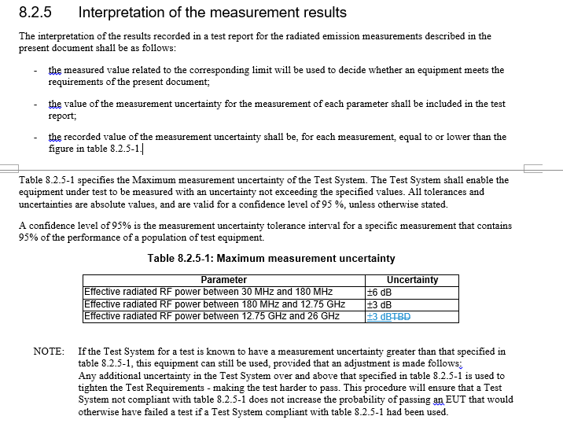

During the discussion, the following options were proposed for the maximum measurement uncertainty for effective radiated RF power measurements between 12.75 GHz and 26 GHz:
- Option 1: 3dB
- Option 2: at least 6 dB

Agreements
Based on the discussion, the following WF is proposed:
Interested companies are encouraged to provide further analysis and motivation for the maximum measurement uncertainty for effective radiated RF power measurements between 12.75 GHz and 26 GHz, considering the following options:
- Option 1: 3dB
- Option 2: at least 6 dB

Other options are not precluded. As this topic is related to Rel-15 specification, aim to conclude on this topic during RAN#100-e meeting.
Additionally, applicability analyses of the above MU value for EMC specifications is welcome (initial CR was related to NB BS only).

References
- R4-2108428 Email discussion summary for [99-e][303] NR_EMC
- R4-2111046 CR to 38.124: TBD removal for the maximum measurement uncertainty for measurements above 12.75GHz, Rel-15

