**3GPP TSG-RAN WG4 Meeting #98-bis-e R4-210xxxx   
Electronic Meeting, Apr. 12-20, 2021**

**Agenda item: 9.1.5**

**Source: vivo**

**Title: TP to TR38.884 v0.2.0 on ETC system**

**Document for: Approval**

# 1 Introduction

This contribution provides the text proposals related to FR2 ETC test system.

# 2 Discussion

In the last RAN4 meeting, some aspects related to ETC test system have been agreed [1]:

**ETC impact on test system**

* + **EIRP/EIS beam peak searching procedure under ETC:**
    - **Option 1: perform 3D scan**
    - **Option 2: beam peak search within a certain cone of directions around peak position under NTC (by declaration or NTC peak searching results)**
    - **-> By default, option 1 applied; if declaration present from UE vendor, then option 2 applied.**

**Note: option1 is needed for UE with best antenna panel switch based on temperature and/or UE without declaration present (Further work on the texts into TR if needed)**

* + **RAN4 agrees to define a temperature tolerance for FR2 ETC system. Several aspects need to consider:**
    - **an accuracy of temperature control by an air conditioner**
    - **accuracy of a thermocouple to measure a temperature in the ETC enclosure**
  + **The value of temperature tolerance is FFS.**
    - **[+/- 4] degrees Celsius tolerance is the starting point**
    - **Test only can be executed under target temperature within the tolerance**

The ETC test system, test procedure and temperature limit should be captured in the TR.

# 3 References

1. R4-2103920, “WF on ETC and test time reduction,” vivo, 3GPP RAN4#98-e, Feb 2021.

# 4 Text Proposal to TR 38.884

**--------------Start of text proposal -------------**

## 5.4 Extreme temperature conditions

### 5.4.1 ETC test system

Permitted test methods (i.e. DFF, IFF, NFTF) defined in Clause 5, TR 38.810 [3] can support extreme temperature condition tests with the update of additional temperature control system. An example of IFF-based ETC test system is shown in Figure 5.4.1-1 below.

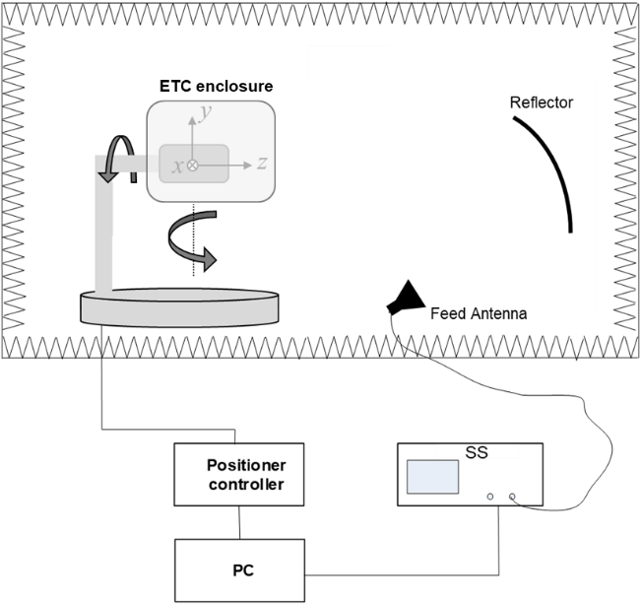

Figure 5.4.1-1: An example of an IFF-based ETC test system

The key aspects of the ETC setup are:

- The test system should support the temperature range for extreme conditions, i.e. -10°C to +55°C, defined in Annex E.2.1 in TS 38.101-2 [2].

- The criterion temperature tolerance is defined in 5.4.5

- A positioning system can support 3D scan.

~~- The enclosure would have impacts on Quality of Quite zone, the detailed MU value will be specified in RAN5.~~

### 5.4.2 Calibration procedure

The path loss calibration should be performed with ETC surrounding the calibration reference antenna, and the temperature condition should be maintained during calibration stage. The calibrated value should be compensated for ETC measurement.

### 5.4.3 Test procedure

For EIRP/EIS beam peak searching procedure under ETC, two test procedures are available:

* Option 1: perform 3D scan
* Option 2: beam peak search within a certain cone of directions around peak position under NTC (by declaration or NTC peak searching results)

By default, 3D scan is used for ETC tests. If a certain cone of directions around peak position under NTC can be declared by UE vendor or be got from NTC peak searching results, then option 2 can be used.

Note: 3D scan (option 1) is needed for UE with best antenna panel switched by temperature variation and/or UE without declaration present.

### 5.4.4 Temperature tolerance limit of ETC test system

The temperature tolerance for FR2 ETC system should be defined, and the test can only be executed under target temperature within the tolerance. At least two aspects need to consider:

* An accuracy of temperature control by an air conditioner
* Accuracy of a thermocouple to measure a temperature in the ETC enclosure

The recommended temperature tolerance limit of FR2 ETC system is ±[4]oC.

**--------------End of text proposal -------------**