**3GPP TSG-RAN WG4 Meeting #98bis-e** ***R4-210xxx***

**Electronic Meeting, 12 April – 20 April** **2021**

**Source:** Ericsson, Nokia, Nokia Shanghai Bell

**Title:** TP to the TR 38.844: Terminology

**Agenda Item:** 9.2.1

**Document for:** Agreement

# 1 Introduction

In this contribution we provide an update to the TP to the TR 38.844. This is a revision of R4-2106690 to make updates based upon Email Summary agreement.

# 2 References

1. R4-2103263, ”WF on Use of Larger CBW”, Skyworks Solutions Inc
2. R4-2103387, ”WF on Overlapping CBW method”, Nokia
3. R4-2106690, ”TP to the TR 38.844: Terminology”, Ericsson, Nokia, Nokia Shanghai Bell

##### [Start of changes]

# 3 Definitions of terms, symbols and abbreviations

## 3.1 Terms

For the purposes of the present document, the terms given in 3GPP TR 21.905 [1] and the following apply. A term defined in the present document takes precedence over the definition of the same term, if any, in 3GPP TR 21.905 [1].

**Existing immediately lower regular channel bandwidth:** the closest NR channel bandwidth defined in Rel-17 which is smaller/less than the irregular bandwidth

**Existing immediately wider regular channel bandwidth:** the closest NR channel bandwidth defined in Rel-17 which is larger/wider than the irregular bandwidth

**Irregular bandwidth**: an NR bandwidth that is not defined in Rel-17

**Overlapping UE channel BW from network perspective:** network supports the irregular bandwidth while each UE operates in an existing lowerregular NR channel bandwidth

**Overlapping UE channel BW from UE perspective:** network supports the irregular bandwidth while some new UEs support two overlapping (RF) carriers

**Overlapping CA:** the irregular bandwidth is handled by two overlapping component carriers (CCs) with NR channel bandwidth defined in Rel-17. One of them (PCell) or both CCs contain an SSB. It is network responsibility to prevent collisions between the different component carriers.

**Single BB carrier:** means that from baseband (RAN1) perspective, there is a single cell with a waveform according to a single carrier

## 3.2 Symbols

For the purposes of the present document, the following symbols apply:

<symbol> <Explanation>

## 3.3 Abbreviations

For the purposes of the present document, the abbreviations given in 3GPP TR 21.905 [1] and the following apply. An abbreviation defined in the present document takes precedence over the definition of the same abbreviation, if any, in 3GPP TR 21.905 [1].

ACLR Adjacent Channel Leakage Ratio

ACS Adjacent Channel Selectivity

BS Base Station

BW Bandwidth

CBW Channel Bandwidth

SCBW Smaller Channel Bandwidth (Existing immediate lower channel bandwidth)

FR1 Frequency Range 1

RF Radio Frequency

WCBW Wider Channel Bandwidth (Existing immediate wider channel bandwidth)

UE User Equipment

# 4 General

## 4.1 UE channel bandwidth

The following text is copied from TS38.101-1 for information:

The UE channel bandwidth supports a single NR RF carrier in the uplink or downlink at the UE. From a BS perspective, different UE channel bandwidths may be supported within the same spectrum for transmitting to and receiving from UEs connected to the BS. Transmission of multiple carriers to the same UE (CA) or multiple carriers to different UEs within the BS channel bandwidth can be supported.

From a UE perspective, the UE is configured with one or more BWP / carriers, each with its own UE channel bandwidth. The UE does not need to be aware of the BS channel bandwidth or how the BS allocates bandwidth to different UEs.

The placement of the UE channel bandwidth for each UE carrier is flexible but can only be completely within the BS channel bandwidth.

[Unchanged Sections]

Annex A (normative):   
Terminology Figures

# A.1 General

In this annex the associated figures are captured.

# A.2 Existing Immediately Wider Regular Channel Bandwidth

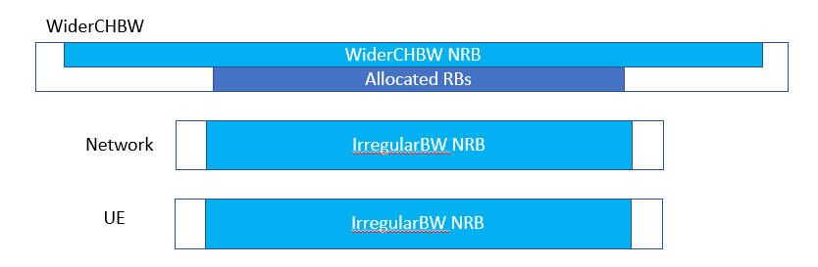

# A.3 Existing Immediately Lower Regular Channel Bandwidth

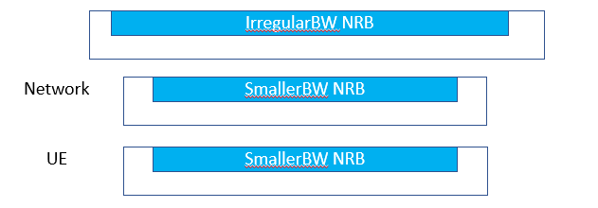

# A.4 Overlapping UE channel BW from network perspective

# A.5 Overlapping UE channel BW from UE perspective

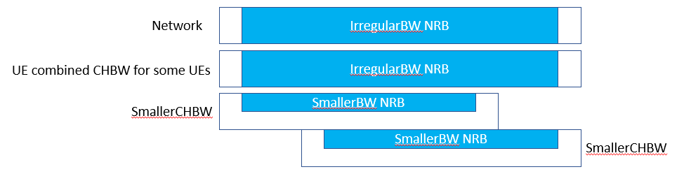

# A.6 Overlapping CA

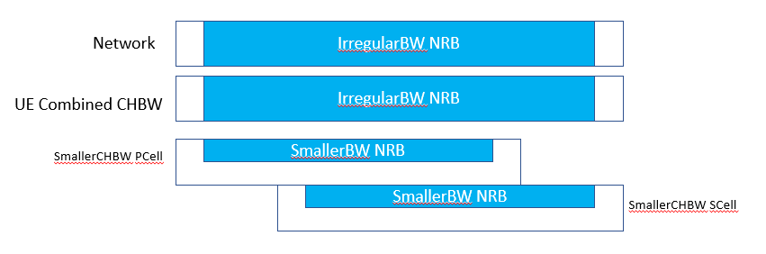

##### [End of changes]