**3GPP TSG-RAN4 Meeting #98-e *DRAFT* R4-2103267**

**Online, , 25th Jan 2020 – 5th Feb 2021**

**Source:** Huawei

**Title:** Regulatory aspects for the 600MHz range in APT region

**Agenda Item:** 12.4.2

**Document for:** Discussion and agreement

# Introduction

During RAN#90e meeting, LS from APT (Asia-Pacific Telecommunity) was received in RP-202143 and related new SID on 600MHz range for APT was approved in RP-202924.

In this contribution we provide the inputs on the regulatory overview of 600 MHz range. Related TP to TR is provided for approval.

# Discussion

The 470 - 694 MHz frequency range is allocated to the broadcasting service and mobile service on a co-primary basis in Region 3. The frequency band 470 - 698 MHz, or parts thereof, was identified by WRC-15 in 7 countries in Region 3 through footnote No. 5.296A for use by those administrations as listed wishing to implement terrestrial IMT systems. In addition, there was interest from other significant markets to do the same. Elsewhere, USA, Mexico and several other countries in Region 2 also identified this band for IMT through footnotes 5.295 and 5.308A. It is noted that *resolves 2* of Resolution 224 (Rev.WRC-15) encourages “administrations to take into account results of the existing relevant ITU-R studies, when implementing IMT applications/systems”.

The regulatory landscape overview for all regions in frequency range 470 – 694 MHz is provided in table below, based on ITU radio regulations.

Table: Frequency bands in the range 470 – 694 MHz in radio regulation

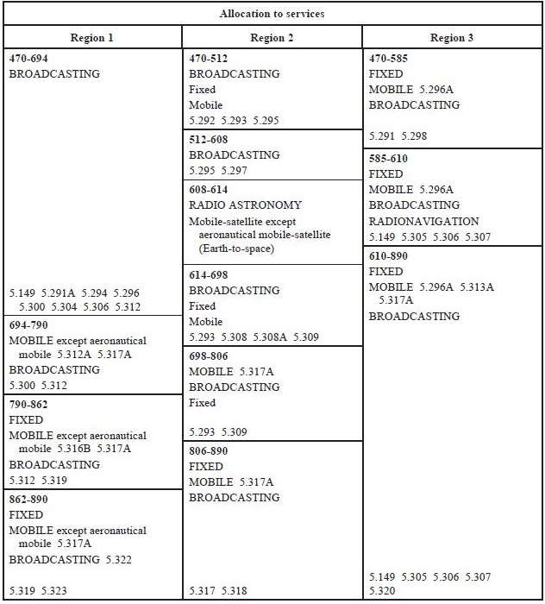

As captured in SID, since the regulatory study of frequency range around 600 MHz is for Region 3, the outcomes of this study item will not impact any requirements defined for US 600 MHz band, i.e. band n71.

It is proposed to capture the above information in the TR.

# Conclusions

Based on the discussion, it is proposed to agree in the following proposals:

**Proposal 1**: approve the attached TP to TR on regulatory aspects.

# References

[1] RP-202143 LS on Frequency arrangements for IMT in the band 470-703MHz, Asia-Pacific Telecommunity (APT), RAN#90e

[2] RP-202924 New SID: Study on extended 600MHz NR band, RAN#90e

# TP to TR 38.xxx (Regulatory aspects)

Based on the discussion above, the text proposal below is proposed for approval.

*------------------------------ Modified section ------------------------------*

# x Regulatory landscape

## x.1 General

The 470 - 694 MHz frequency range is allocated to the broadcasting service and mobile service on a co-primary basis in Region 3 [1]. The frequency band 470 - 698 MHz, or parts thereof, was identified by WRC-15 in 7 countries in Region 3 through footnote No. 5.296A for use by those administrations as listed wishing to implement terrestrial IMT systems. In addition, there was interest from other significant markets to do the same. Elsewhere, USA, Mexico and several other countries in Region 2 also identified this band for IMT through footnotes 5.295 and 5.308A. It is noted that resolves 2 of Resolution 224 (Rev.WRC-19) encourages the following:

*encourages administrations to take into account results of the existing relevant ITU Radiocommunication Sector studies, when implementing IMT applications/systems in the frequency bands*

* *694-862 MHz in Region 1,*
* *in the frequency band 470-806 MHz in Region 2,*
* *in the frequency band 790-862 MHz in Region 3,*
* *in the frequency band 470-698 MHz, or portions thereof, for those administrations mentioned in No. 5.296A, and*
* *in the frequency band 698-790 MHz, or portions thereof, for those administrations mentioned in No. 5.313A.*

The regulatory landscape overview for all regions in frequency range 470 – 694 MHz is provided in table x.1-1, based on ITU radio regulations [3].

Table x.1-1: ITU-R frequency allocation to services [3]

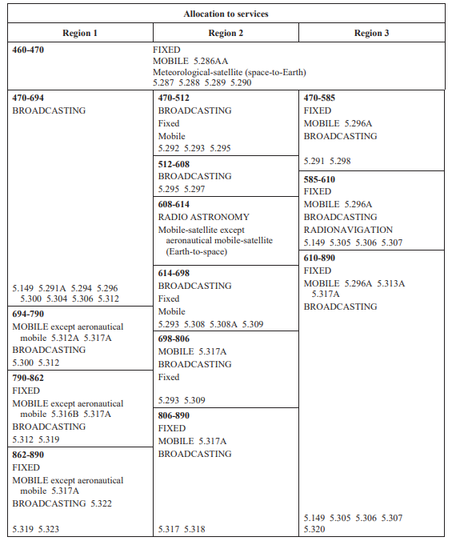

NOTE: Since regulatory study of frequency range around 600 MHz is for Region 3, the outcomes of this study item will not impact any requirements defined for US 600 MHz band, i.e. band n71.

Below, ITU RR footnotes referred in this clause are listed:

5.149 In making assignments to stations of other services to which the bands: 13 360-13 410 kHz, 25 550-25 670 kHz, 37.5-38.25 MHz, 73-74.6 MHz in Regions 1 and 3, 150.05-153 MHz in Region 1, 322-328.6 MHz, 406.1-410 MHz, 608-614 MHz in Regions 1 and 3, 1 330-1 400 MHz, 1 610.6-1 613.8 MHz, 1 660-1 670 MHz, 1 718.8-1 722.2 MHz, 2 655-2 690 MHz, 3 260-3 267 MHz, 3 332-3 339 MHz, 3 345.8-3 352.5 MHz, 4 825-4 835 MHz, 4 950-4 990 MHz, 4 990-5 000 MHz, 6 650-6 675.2 MHz, 10.6-10.68 GHz, 14.47-14.5 GHz, 22.01-22.21 GHz, 22.21-22.5 GHz, 22.81-22.86 GHz, 23.07-23.12 GHz, 31.2-31.3 GHz, 31.5-31.8 GHz in Regions 1 and 3, 36.43-36.5 GHz, 42.5-43.5 GHz, 48.94-49.04 GHz, 76-86 GHz, 92-94 GHz, 94.1-100 GHz, 102-109.5 GHz, 111.8-114.25 GHz, 128.33-128.59 GHz, 129.23-129.49 GHz, 130-134 GHz, 136-148.5 GHz, 151.5-158.5 GHz, 168.59-168.93 GHz, 171.11-171.45 GHz, 172.31-172.65 GHz, 173.52-173.85 GHz, 195.75-196.15 GHz, 209-226 GHz, 241-250 GHz, 252-275 GHz are allocated, administrations are urged to take all practicable steps to protect the radio astronomy service from harmful interference. Emissions from spaceborne or airborne stations can be particularly serious sources of interference to the radio astronomy service (see Nos. 4.5 and 4.6 and Article 29). (WRC-07)

5.295 In the Bahamas, Barbados, Canada, the United States and Mexico, the frequency band 470-608 MHz, or

portions thereof, is identified for International Mobile Telecommunications (IMT) – see Resolution 224 (Rev.WRC-19). This identification does not preclude the use of these frequency bands by any application of the services to which they are allocated and does not establish priority in the Radio Regulations. Mobile service stations of the IMT system within the frequency band are subject to agreement obtained under No. 9.21 and shall not cause harmful interference to, or claim protection from, the broadcasting service of neighbouring countries. Nos. 5.43 and 5.43A apply. (WRC-19)

5.296A In Micronesia, the Solomon Islands, Tuvalu and Vanuatu, the frequency band 470-698 MHz, or portions thereof, and in Bangladesh, Maldives and New Zealand, the frequency band 610-698 MHz, or portions thereof, are identified for use by these administrations wishing to implement International Mobile Telecommunications (IMT) – see Resolution 224 (Rev.WRC-19). This identification does not preclude the use of these frequency bands by any application of the services to which they are allocated and does not establish priority in the Radio Regulations. The mobile allocation in this frequency band shall not be used for IMT systems unless subject to agreement obtained under No. 9.21 and shall not cause harmful interference to, or claim protection from, the broadcasting service of neighbouring countries. Nos. 5.43 and 5.43A apply. (WRC-19)

5.305 *Additional allocation:* in China, the band 606-614 MHz is also allocated to the radio astronomy service on a primary basis.

5.306 *Additional allocation:* in Region 1, except in the African Broadcasting Area (see Nos. 5.10 to 5.13), and

in Region 3, the band 608-614 MHz is also allocated to the radio astronomy service on a secondary basis.

5.307 Additional allocation: in India, the band 608-614 MHz is also allocated to the radio astronomy service on

a primary basis.

5.308A In the Bahamas, Barbados, Belize, Canada, Colombia, the United States, Guatemala and Mexico, the

frequency band 614-698 MHz, or portions thereof, is identified for International Mobile Telecommunications (IMT) – see Resolution 224 (Rev.WRC-19). This identification does not preclude the use of these frequency bands by any application of the services to which they are allocated and does not establish priority in the Radio Regulations. Mobile service stations of the IMT system within the frequency band are subject to agreement obtained under No. 9.21 and shall not cause harmful interference to, or claim protection from, the broadcasting service of neighbouring countries. Nos. 5.43 and 5.43A apply. (WRC-19)

5.313A The frequency band, or portions of the frequency band 698-790 MHz, in Australia, Bangladesh, Brunei

Darussalam, Cambodia, China, Korea (Rep. of), Fiji, India, Indonesia, Japan, Kiribati, Lao P.D.R., Malaysia, Myanmar (Union of), New Zealand, Pakistan, Papua New Guinea, the Philippines, the Dem. People’s Rep. of Korea, Solomon Islands, Samoa, Singapore, Thailand, Tonga, Tuvalu, Vanuatu and Viet Nam, are identified for use by these administrations wishing to implement International Mobile Telecommunications (IMT). This identification does not preclude the use of these frequency bands by any application of the services to which they are allocated and does not establish priority in the Radio Regulations. (WRC-19)

## x.2 ITU Region 3

*Editor’s note: refer to the APT LS; any APT specific regulatory matters*

ITU Region 3 specific regulatory aspects for the frequency range 470 – 694 MHz are provided in this clause.

Referring to the APT LS, AWG-26 agreed to undertake the study to revise the APT/AWG/REP-79 [4] to develop frequency arrangements in the band 470-703 MHz for APT Members that wish to implement both the APT700 and a 600 MHz frequency arrangements that is optimal for APT Members.

According to Radio Regulations, in Region 3, the 610 – 890 MHz band is allocated to Fixed Service, Mobile Service and Broadcasting Service on a primary basis. Additionally, 606 – 614 MHz band is allocated for Radio Astronomy Service in China (i.e. footnote 5.305) and band 608 - 614 MHz is allocated for Radio Astronomy Service in India (i.e. footnote 5.307). Footnote 5.149 urges administrator to *protect the radio astronomy service from harmful interference.*

No specific regional regulatory requirements on unwanted emissions were identified for the IMT operation in frequency range 470 – 694 MHz in Region 3, so far.

*------------------------------ End of modified section ------------------------------*