3GPP TSG-RAN WG4 Meeting # 98-e R4-2101584
Electronic Meeting, 25th January– 5th Febuary, 2021

Source: Huawei, HiSilicon, Ericsson, US Cellular
Title: TP for TR 37.717-11-11: DC_12A_n71A
Agenda Item: 9.3.2
Document for: Approval

Introduction
The WID for NR DC was updated in RAN #90e meeting. This contribution provides a TP for TR 37.717-11-11 to finish the UE RF requirements for the band combination.

Discussion
The RF requirements for DC_12_n71 have discussed for several meetings. Based on the agreed WF [2], the Only single switched uplink can be used for DC_12_n71. Thus, the note shall be added in the configuration table. The remaining issue is whether to introduce a restriction on the specific implementation for DC_12_n71. In my opinion, it isn’t suitable to restrict the specific implementation, especially for band combinations. There are some reasons listed below.
1) It is well known that all of the band combinations are optional. If UE can’t support the specific band combination, no matter what the reason is, UE doesn’t have to report to support this band combination. Thus, it isn’t necessary to restrict the specific implementation when RAN4 specify the RF requirements.
2) If the restriction about the specific implementation is introduced, it isn’t helpful to further improve the responding technology and application scope of the UE for specific band combination. It is not conducive to further expanding related industries.
Anyway, there is no need to restrict the specific implementation for an optional band combination DC_12_n71 in the specification.
Proposal 1: It’s proposed not to restrict the specific implementation for DC_12_n71 in the specification.
However, we can clarify that the implementation with 4 antennas is targeted for FWA form factor for DC_12_n71 in the TR for easing companies’ concerns.

Analysis on RF requirements
The triplexer is assumed for DC_12_n71 and the possible UE architecture can be found as below in figure 1. The assumption of insertion loss is less than 3dB and the isolation (50 ~ 55dB) can be achieved. The Tx-Rx distance and the width of passband are enough to implement it. The corresponding frequency ranges of triplexer A and B are shown below:
Triplexer A: n71 DL 617~652MHz, n71 UL 663~698MHz, B12 DL 729~746MHz
Triplexer B: n71 DL 617~652MHz, B12 UL 699~716MHz, B12 DL 729~746MHz
1) Since RAN4 has agreed that the only single switched uplink can be used for DC_12_n71, spurious emission band UE co-existence requirement for band 12 and n71 respectively is applied.
2) When band n71 is transmitting, CIM5 may fall into B12 Rx band. Therefore, we need to analysis the MSD due to the cross band isolation with band n71 Tx.
3) When band 12 is transmitting with 5MHz/10MHz UL CBW and 20RB UL configurations, there is no MSD requirements for band n71 Rx (Tx-Rx distance is about 47MHz).
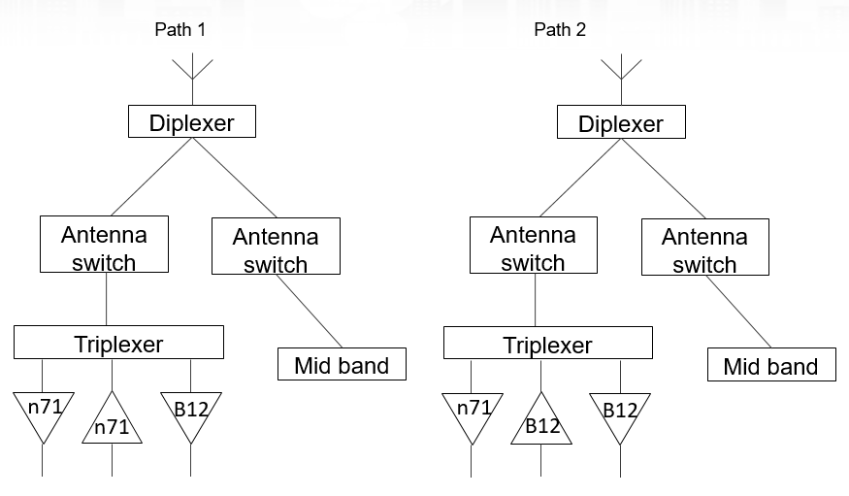
Figure 1 The UE architecture for DC_12_n71
The assumptions for the MSD analysis are shown below:
• Tx-Rx filter isolation = 50 dB
• I/Q-Image and LO-leakage = 28 dBc
• CIM3 = 60 dBc
• CIM5 = 70 dBc
• Diversity antenna isolation = 10 dB
• Noise Figure = 12 dB for both band n71 and B12
• RB allocation = 20
• RF frond-end loss = 4dB

The MSD analysis are shown below when band n71 Tx is aggressive band and band 12 Rx is victim.
Table 1 The MSD analysis for band n71 Tx -> band 12 Rx
 | parameter | main path | diversity path
Tx power(dBm) |  | 23
FE loss(dB) | 4
Tx power at Post PA(dBm) |  | 27
CIM5 rejection(dBc) | 70
CIM5 interference level at n71 Post PA(dBm) |  | -43
The isolation between band n71 Tx and B12 Rx | 50
antenna isolation(dB) | 10
CIM5 interference level at antenna port(dBm) |  | -89 | -107
TX_IM2 |  | -98.6 | -98.6
TX_Noise |  | -99.5 | -99.5
Themal noise |  | -95.5 | -95.4
Totle |  | -87.5 | -92.5
SNR requirement for QPSK | -1
REFSENSE (referred to antenna) |  | -88.5 | -93.5
combined REFSENS (B12 5MHz) |  | -94.7
REFSENS requirements (B12 5MHz) |  | -97
MSD |  | 2.3

References
[1] RP-202545, “Revised WID: Rel-17 Dual Connectivity (DC) of 1 band LTE (1DL/1UL) and 1 NR band (1DL/1UL)”, CHTTL
[2] R4-2008459, WF on single UL for DC-12-n71, Huawei

Text Proposal
<TP for TR 37.717-11-11>

6.1.x DC_12_n71

6.1.x.1 Configuration for DC
Table 6.1.x.1-1: Inter-band EN-DC configurations of 1 LTE band + 1 NR band
EN-DC  configuration | Uplink EN-DC  configuration  (NOTE 1) | Single UL allowed
DC_12A_n71A | DC_12A_n71A^{X,Y} | Yes
NOTE X: Only single switched UL is supported.
NOTE Y: The implementation with 4 antennas is targeted for FWA form factor for this band combination.

6.1.x.2 Maximum output power for DC
Table 6.1.x.2-1: Maximum output power for inter-band EN-DC of 1 LTE band + 1 NR band
DC configuration | Power class 3  (dBm) | Tolerance  (dB)
DC_12A_n71A^{X} | 23 | +2/-3
NOTE X: Only single switched UL is supported.

6.1.x.3 Spurious emission band UE co-existence for DC
Note that only Single Tx Switched UL mode is supported for this combination, spurious emission band UE co-existence requirement for band 12 and n71 respectively is applied.
Table 6.1.x.3-1: Requirements for band 12 spurious emissions for UE co-existence
E-UTRA Band | Spurious emission
 | Protected band | Frequency range (MHz) |  |  | Maximum Level (dBm) | MBW (MHz) | NOTE
12 | E-UTRA Band 2, 5, 13, 14, 17, 24, 25, 26, 27, 30, 41, 48, 53, 71, 74 | F_{DL_low} | - | F_{DL_high} | -50 | 1
 | E-UTRA Band 4, 10, 50, 51, 66, 70,  NR Band n77 | F_{DL_low} | - | F_{DL_high} | -50 | 1 | 2
 | E-UTRA Band 12, 85 | F_{DL_low} | - | F_{DL_high} | -50 | 1 | 15
NOTE 2: As exceptions, measurements with a level up to the applicable requirements defined in Table 6.6.3.1-2 are permitted for each assigned E-UTRA carrier used in the measurement due to 2nd, 3rd, 4th [or 5th] harmonic spurious emissions. Due to spreading of the harmonic emission the exception is also allowed for the first 1 MHz frequency range immediately outside the harmonic emission on both sides of the harmonic emission. This results in an overall exception interval centred at the harmonic emission of (2MHz + N x L_{CRB} x 180kHz), where N is 2, 3, 4, [5] for the 2nd, 3rd, 4th [or 5th] harmonic respectively. The exception is allowed if the measurement bandwidth (MBW) totally or partially overlaps the overall exception interval.

NOTE 15: These requirements also apply for the frequency ranges that are less than F_{OOB} (MHz) in Table 6.6.3.1-1 and Table 6.6.3.1A-1 from the edge of the channel bandwidth.
Table 6.1.x.3-2: Requirements for band n71 spurious emissions for UE co-existence
NR Band | Spurious emission for UE co-existence
 | Protected band | Frequency range (MHz) |  |  | Maximum Level (dBm) | MBW (MHz) | NOTE
n71 | E-UTRA Band 4, 5, 12, 13, 14, 17, 24, 26, 30, 48, 53, 66, 85 | F_{DL_low} | - | F_{DL_high} | -50 | 1
 | E-UTRA Band 2, 25, 41, 70,  NR Band n77 | F_{DL_low} | - | F_{DL_high} | -50 | 1 | 2
 | E-UTRA Band 29 | F_{DL_low} | - | F_{DL_high} | -38 | 1 | 15
 | E-UTRA Band 71 | F_{DL_low} | - | F_{DL_high} | -50 | 1 | 15
NOTE 2: As exceptions, measurements with a level up to the applicable requirements defined in Table 6.5.3.1-2 are permitted for each assigned NR carrier used in the measurement due to 2nd, 3rd, 4th or 5th harmonic spurious emissions. Due to spreading of the harmonic emission the exception is also allowed for the first 1 MHz frequency range immediately outside the harmonic emission on both sides of the harmonic emission. This results in an overall exception interval centred at the harmonic emission of (2 MHz + N x L_{CRB} x RB_{size} kHz), where N is 2, 3, 4, 5 for the 2nd, 3rd, 4th or 5th harmonic respectively. The exception is allowed if the measurement bandwidth (MBW) totally or partially overlaps the overall exception interval.

NOTE 15: These requirements also apply for the frequency ranges that are less than F_{OOB} (MHz) in Table 6.5.3.1-1 from the edge of the channel bandwidth.

6.1.x.4 MSD analysis for DC
Note that only Single Tx Switched UL mode is supported for this combination, so the MSD requirements due to cross band isolation need to be checked. Based on the analysis in the discussion part, the MSD requirements due to cross band isolation can be specified as below.
Table 6.1.x.4-1: Reference sensitivity exceptions (MSD) due to cross band isolation for PC3 EN-DC in NR FR1
E-UTRA or NR Band / Channel bandwidth of the affected DL band / MSD
UL band | DL band | 5 MHz  (dB) | 10 MHz  (dB) | 15 MHz  (dB) | 20 MHz  (dB) | 25 MHz  (dB) | 30 MHz  (dB) | 40 MHz  (dB) | 50 MHz  (dB) | 60 MHz  (dB) | 70 MHz  (dB) | 80 MHz  (dB) | 90 MHz  (dB) | 100 MHz  (dB)
n71 | 12 | 2.3 | 2.3
NOTE 1: Applicable only when harmonic mixing MSD for this combination is not applied.
NOTE 2: The B41 requirements are modified by -0.5dB when carrier frequency of the assigned E-UTRA channel bandwidth is within 2515 – 2690 MHz.
NOTE 3: These requirements apply when the uplink is active in Band n1, n84 and the separation between the lower edge of the uplink channel in Band n1, n84 and the upper edge of the downlink channel in Band 3 is < 60 MHz. For each channel bandwidth in Band 3, the requirement applies regardless of channel bandwidth in Band n1, n84.
NOTE 4: The DL victim band should be configured using the lowest SCS that is compatible with the highest CBW for which an MSD is specified.
NOTE 5: MSD test point can be chosen according to supported BW and lowest SCS supported by the UE.

Table 6.1.x.4-2: Uplink configuration for reference sensitivity exceptions due to cross band isolation for EN-DC in NR FR1
E-UTRA or NR Band / SCS / Channel bandwidth of the affected DL band / UL RB allocation of the agressor band
UL band | DL band | SCS of UL band (kHz) | 5 MHz  (L_{CRB}) | 10 MHz  (L_{CRB}) | 15 MHz  (L_{CRB}) | 20 MHz  (L_{CRB}) | 25 MHz  (L_{CRB}) | 30 MHz  (L_{CRB}) | 40 MHz  (L_{CRB}) | 50 MHz  (L_{CRB}) | 60 MHz  (L_{CRB}) | 70 MHz  (L_{CRB}) | 80 MHz  (L_{CRB}) | 90 MHz  (L_{CRB}) | 100 MHz  (L_{CRB})
n71 | 12 | 15 | 20 | 20
NOTE 1: The UL configuration applies regardless of the channel bandwidth of the UL band. UL resource blocks allocation in the table shall be further limited to that specified in Table 7.3.1-2 in TS 36.101 [4] or Table 7.3.2-3 in TS 38.101-1 [2].
NOTE 2: The UL resource blocks shall be located as close as possible to the downlink operating band but confined within the transmission bandwidth configuration for the channel bandwidth.
NOTE 3: When the maximum UL RB allocation “L_{CRB}” value is less than the maximum transmission bandwidth configuration “N_{RB}” defined in Table 5.3.2-1 in 38.101-1 [2] for the specified UL band SCS, the UL band should be configured using the lowest CBW that is compatible with the maximum specified L_{CRB} value.
NOTE 4: If the aggressor band is NR band, the test SCS and UL RB can be adjusted according to supported BW and lowest SCS supported by the UE.

6.1.x.5 ∆T_{IB} and ∆R_{IB} values
For DC_12_n71, the ΔT_{IB,c} and ΔR_{IB,c} values are given in the tables below.
Table 6.1.x.5-1: ΔTIB,c
Inter-band DC Configuration | E-UTRA and NR Band | ΔT_{IB,c} [dB]
DC_12_n71 | 12 | 1
 | n71 | 1
Table 6.1.x.5-2: ΔRIB,c
Inter-band DC Configuration | E-UTRA and NR Band | ΔR_{IB} [dB]
DC_12_n71 | 12 | 0.8
 | n71 | 0.8

<End of TP >

