**3GPP TSG-RAN WG4 Meeting # 97-e R4-200xxxx**

**Electronic Meeting, Nov. 2-13, 2020**

**Agenda item:** 4.7

**Source:** Moderator (Huawei, HiSilicon)

**Title:** Email discussion summary for [96e][201] NR_NewRAT_RRM_Core

**Document for:** Information

# Introduction

This contribution provides the summary of Rel-15 NR RRM core maintenance in Agenda 4.7. It will be used to capture the comments in the 1st round and 2nd round. The tentative agreements will be provided based on the proposals and comments.

The topics include the maintenance for the following topics:

* RRM measurements: CSSFoutside_gap, MO merging
* SCell activation: update the condition for TCI and multiple SSB configurations, SSB-less activation
* Beam management: CSI-RS bandwidth condition for BFD/CBD, sharing factor P for L1-RSRP measurement
* BWP switching: clarification of applicability of requirement related to PCell or SCell, or cross-carrier scheduling
* TCI switching: clarification of condition for case where NW configures both SSB and CSI-RS, TOk
* Others: frequency range for 8SSB configuration, E-CID, FSTD

# Topic #1: RRM measurement

## Companies’ contributions summary

|  |  |  |
| --- | --- | --- |
| **T-doc number** | **Company** | **Proposals / Observations** |
| [R4-2014273](https://www.3gpp.org/ftp/TSG_RAN/WG4_Radio/TSGR4_97_e/Docs/R4-2014273.zip) | Apple | **On CSSF for R15 EN-DC**  Proposal 1: the NR inter-RAT MO on NR serving CC configured by LTE MN shall be captured into CSSF outside MG:   * NR Inter-RAT measurement object configured by the E-UTRAN PCell   + NR inter-RAT MO configured by LTE MN is on the NR serving CC with no measurement gap, when none of the SMTC occasions of this NR inter-RAT measurement object are overlapped by the measurement gap   + NR inter-RAT MO configured by LTE MN is on the NR serving CC with no measurement gap, when part of the SMTC occasions of this NR inter-RAT measurement object are overlapped by the measurement gap   Proposal 2: RAN4 CSSF outside MG design uses option 3, i.e., in EN-DC the CSSF without MG is determined by the number of MOs without MG configured from both LTE MN and NR SN, and if any two MOs from LTE MN and NR SN meet MO merging rule, they shall be counted as one single MO in MO number counting.  Proposal 3: the CSSF outside MG shall be updated as in this contribution.  Proposal 4: the NR inter-RAT MO configured by LTE MN shall be further divided into following types for CSSF inside MG,   * NR inter-RAT MO configured by LTE MN is on the NR serving CC with no measurement gap, when all of the SMTC occasions of this inter-RAT MO are overlapped by the MG * NR inter-RAT MO configured by LTE MN is on the NR serving CC with measurement gap * NR inter-RAT MO configured by LTE MN is on the NR non-serving CC   Proposal 5: RAN4 CSSF inside MG design uses option 3, i.e., Mtot,i,j = Mintra,i,j + Minter,i,j : Total number of intra-frequency, inter-frequency and inter-RAT measurement objects which are candidates to be measured in gap j where the measurement object i is also a candidate. If any two MOs from LTE MN and NR SN meet MO merging rule, they shall be counted as one single MO in MO number counting. Otherwise Mtot,i,j equals 0. |
| [R4-2015445](https://www.3gpp.org/ftp/TSG_RAN/WG4_Radio/TSGR4_97_e/Docs/R4-2015445.zip) | Huawei, HiSilicon | **Correction to CSSF calculation R15**   1. Take inter-RAT measurement on serving carrier into account in the calculation of CSSFoutside_gap. 2. Clarify that in EN-DC inter-frequency measurement and inter-RAT measurement on the same frequencies are only count as one in CSSF_within_gap calculation if MO merging conditions are satisfied, as well as inter-frequency measurements configured by PCell and PSCell on the same frequency in NR-DC. |
| [R4-2015446](https://www.3gpp.org/ftp/TSG_RAN/WG4_Radio/TSGR4_97_e/Docs/R4-2015446.zip) | Huawei, HiSilicon | **Correction to CSSF calculation R16**  Cat A CR for R4-2015445 |
| [R4-2014274](https://www.3gpp.org/ftp/TSG_RAN/WG4_Radio/TSGR4_97_e/Docs/R4-2014274.zip) | Apple | **CR on CSSF for R15 EN-DC**  The CSSF requirement has been updated for EN-DC to consider the MOs configured from both LTE MN and NR SN in EN-DC. |
| [R4-2014765](https://www.3gpp.org/ftp/TSG_RAN/WG4_Radio/TSGR4_97_e/Docs/R4-2014765.zip) | MediaTek inc. | CR on MO merge |
| R4-2015210 | MediaTek inc. | CR on MO merge |

## Open issues summary

### Sub-topic 1-1 CSSF calcualtion for Inter-RAT measurement objective

In last RAN4 meeting, there was discussions on CSSF for EN-DC when the intra-frequency and inter-RAT measurements are configured on the same serving CC from both LTE MN and NR SN. Companies discussed this issue.

The related contributions include R4-2014273, R4-2014274, R4-2015445 and R4-2015446.

**Issue 1-1-1: How to capture inter-RAT MO on NR serving CC configured by LTE MN**

* Proposal: (Apple R4-2014273/R4-2014274, Huawei, HiSilicon R4-2015445/R4-2015446)
  + The NR inter-RAT MO on NR serving CC configured by LTE MN shall be calculated in CSSF outside MG
* Proposed changes:
  + Option 1 (Apple, R4-2014274)
* 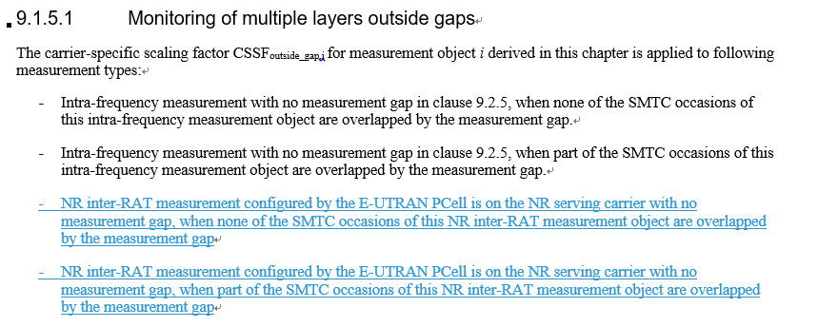
  + Option 2 (Huawei, HiSilicon, R4-2015446)

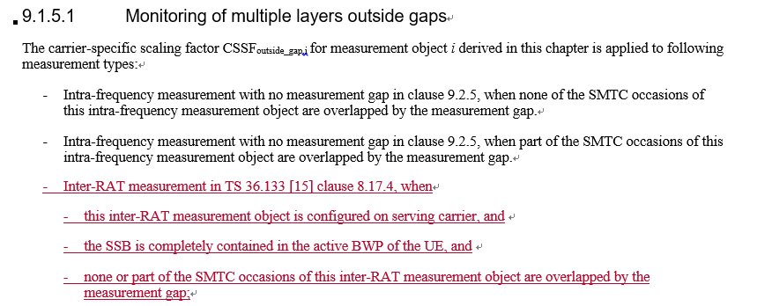

* Recommended WF
  + Can we agree that
    - The NR inter-RAT MO on NR serving CC configured by LTE MN shall be calculated in CSSF outside MG
  + Further discussion on how to capture the above tentative agreement in specification.

**Issue 1-1-2: How to count MO number configured from both LTE MN and NR SN**

* Proposal:
  + Option 1(Apple R4-2014273): RAN4 CSSF outside MG design uses option 3, i.e., in EN-DC the CSSF without MG is determined by the number of MOs without MG configured from both LTE MN and NR SN, and if any two MOs from LTE MN and NR SN meet MO merging rule, they shall be counted as one single MO in MO number counting.
  + Option 2(Mediatek R4-2014760): To simplify the CSSF definition, it shall always treat Inter-RAT measurement as SCC measurement in EN-DC.
* Proposed changes:
  + Option 1 (Apple, R4-2014274)
* 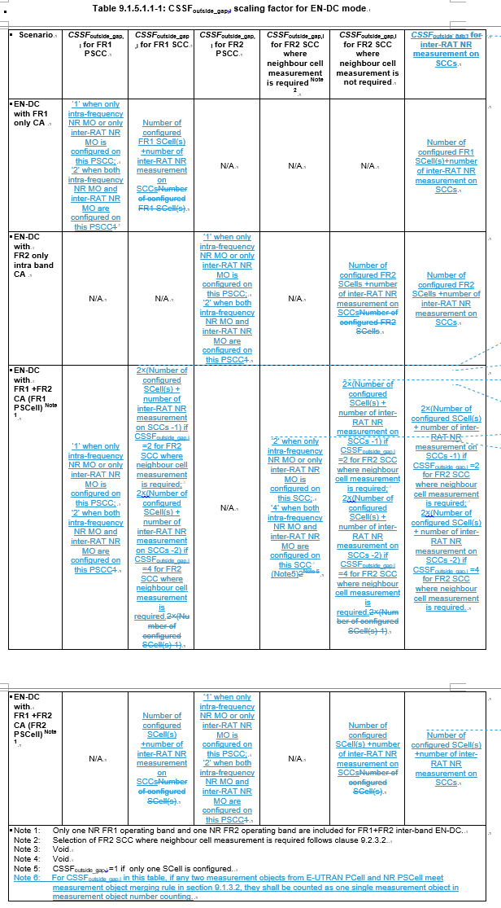
  + Option 2 (Huawei, HiSilicon, R4-2015446, Mediatek R4-2014760)
* 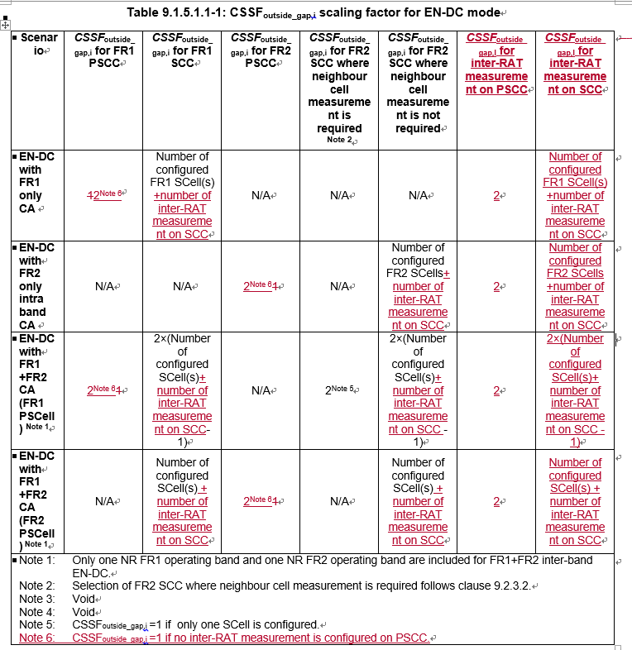
* Recommended WF
  + More discussion is needed

**Issue 1-1-3: Update requirement of monitoring of multiple layers within gaps**

* Proposal:
  + Option 1 (Huawei R4-2015445): Clarify that in EN-DC inter-frequency measurement and inter-RAT measurement on the same frequencies are only count as one in CSSF_within_gap calculation if MO merging conditions are satisfied, as well as inter-frequency measurements configured by PCell and PSCell on the same frequency in NR-DC.
  + Option 2 (Apple R4-2014274):
    - The NR inter-RAT MO configured by LTE MN shall be further divided into following types for CSSF inside MG,
      * NR inter-RAT MO configured by LTE MN is on the NR serving CC with no measurement gap, when all of the SMTC occasions of this inter-RAT MO are overlapped by the MG
      * NR inter-RAT MO configured by LTE MN is on the NR serving CC with measurement gap
      * NR inter-RAT MO configured by LTE MN is on the NR non-serving CC
    - RAN4 CSSF inside MG design uses option 3, i.e., Mtot,i,j = Mintra,i,j + Minter,i,j : Total number of intra-frequency, inter-frequency and inter-RAT measurement objects which are candidates to be measured in gap j where the measurement object i is also a candidate. If any two MOs from LTE MN and NR SN meet MO merging rule, they shall be counted as one single MO in MO number counting. Otherwise Mtot,i,j equals 0.
  + Option 3 (Mediatek R4-2014760): To simplify the CSSF definition, it shall always treat Inter-RAT measurement as SCC measurement in EN-DC.
* Proposed changes:
  + Option 1 (Apple, R4-2014274)
* 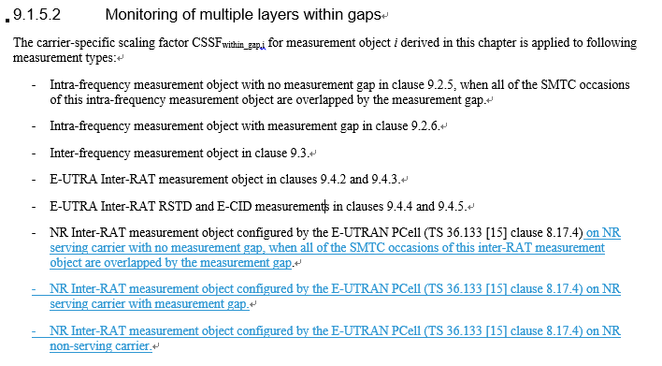
* 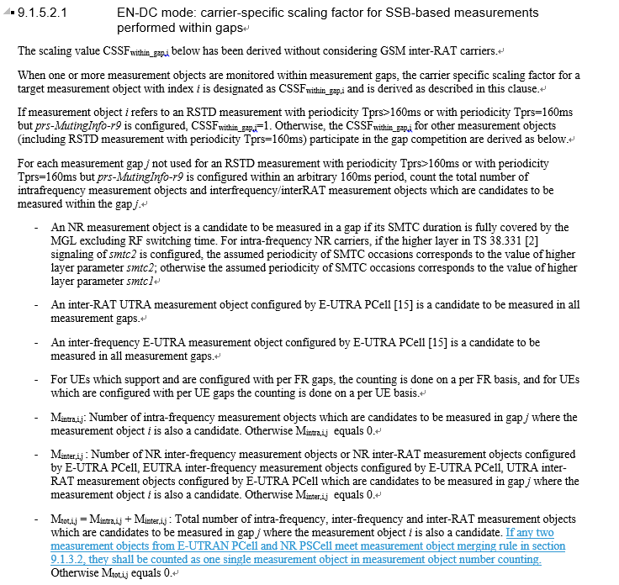
  + Option 2 (Huawei, HiSilicon, R4-2015446)
* 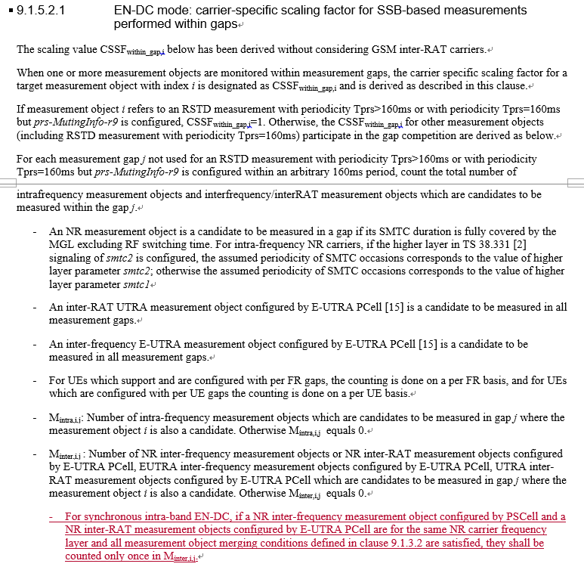
* Recommended WF
  + More discussion is needed

### Sub-topic 1-2 MO merging related to SSB-ToMeasure indications

**Issue 1-2: MO merging related to SSB-ToMeasure indications**

* Proposal: (Mediatek R4-2014765)
  + Clarify the layer shall be counted only once unless the configured NR frequency layers have different *SSB-ToMeasure* indications.

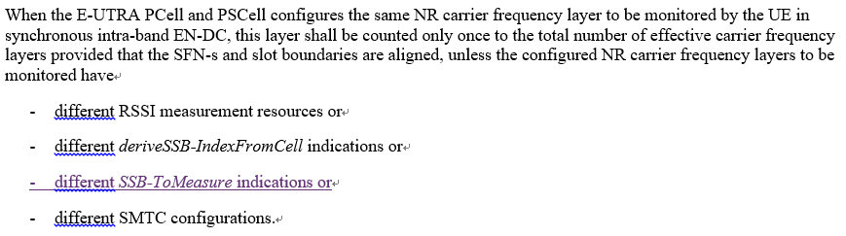

* Recommended WF
  + More discussion is needed

## Companies views’ collection for 1st round

### Comments for open issues

|  |  |
| --- | --- |
| **Company** | **Comments** |
|  |  |
|  |  |
|  |  |

## Summary for 1st round

### Summary of open issues

|  |  |
| --- | --- |
|  | **Status summary** |
| **Sub-topic#1-X-Y** | ***Tentative agreements:***  ***Candidate options:***  ***Recommendations for 2nd round:*** |

*Recommendations on WF/LS assignment*

|  |  |  |
| --- | --- | --- |
|  | **WF/LS t-doc Title** | **Assigned Company,**  **WF or LS lead** |
| #1 |  |  |

### CRs/TPs Status

|  |  |
| --- | --- |
| **CR/TP number** | **CRs/TPs Status update recommendation** |
| R4-2015445 |  |
| R4-2015446 |  |
| R4-2014274 |  |
| R4-2014765 |  |
| R4-2015210 |  |

## Discussion on 2nd round (if applicable)

[Comments and responses will be captured by moderator here]

|  |  |
| --- | --- |
| **Email** | **T-doc status summary** |
|  |  |

## Summary on 2nd round (if applicable)

*Moderator tries to summarize discussion status for 2nd round and provided recommendation on CRs/TPs/WFs/LSs Status update suggestion*

|  |  |
| --- | --- |
| **CR/TP/LS/WF number** | **T-doc Status update recommendation** |
|  |  |
|  |  |
|  |  |
|  |  |
|  |  |

# Topic #2: Scell activation

## Companies’ contributions summary

|  |  |  |
| --- | --- | --- |
| **T-doc number** | **Company** | **Proposals / Observations** |
| R4-2015735 | Huawei, HiSilicon | **Discussion on remaining issues in Rel-15 SCell activation requirements**  Proposal 1: The current FR1 SCell activation requirements apply provided that   * ‘*ssb-PositionInBurst*’ indicates only one SSB is being actually transmitted, or * ‘*ssb-PositionInBurst*’ indicates multiple SSBs and TCI indication is provided in same MAC PDU with SCell activation, or * the SCell is known and UE has reported the SCell with SSB index before the activation, or * the Es/Iot for at least one CSI-RS for CSI that UE is configured to measure is >= -2dB.   Proposal 2: The current SCell activation requirements apply provided that the SSB of the to-be-activated SCell is within the first active DL BWP of the SCell. |
| R4-2014760 | MediaTek inc. | **Remaining issues on RRM in R15**  Observation 1: For Scell, the only use case for RRC signalling *firstActiveDownlinkBWP-Id* is SCell addition.  Proposal 1: When ‘*ssb-PositionInBurst*’ indicates multiple SSBs but no TCI indication is provided in the same MAC PDU, there are two options:   * Option 1: Introducing $T_{uncertainty,MAC, FR1}$ in FR1 unknown SCell activation; * Option 2: RAN4 clarifies there is no requirement for this scenario.   Proposal 2: There is no such a procedure of RRC-based BWP switch for SCell. RAN4 to clarify that RRC-based BWP switch requirement is only applied to PCell/PSCell.  Proposal 3: Define L1-RSRP delay requirement as max(TL1-RSPR_Measurement_Period_SSB, TL1-RSRP_Measurement_Period_CSI-RS) when both SSB and CSI-RS are configured for L1-RSRP measurement.  Proposal 4: Delete TOk in active TCI list update requirement.  Proposal 5: Two MOs with different SSB-ToMeasure configuration shall be counted as two layers.  Proposal 6: To simplify the CSSF definition, it shall always treat Inter-RAT measurement as SCC measurement in EN-DC. |
| R4-2015736 | Huawei, HiSilicon | **CR on SCell activation requirements R15**  Clarify the applicability of the current SCell activation requirements. |
| R4-2015737 | Huawei, HiSilicon | **CR on SCell activation requirements R16**  Cat A CR for R4-2015736. |
| R4-2016580 | Qualcomm Incorporated | **CR to TCI activation in FR1**  Clarified the unknown FR1 SCell activation requirement is not applied when *ssb-PositionInBurst* indicates multiple SSBs but no TCI indication is provided in the same MAC PDU with SCell activation for the unknown cell. |
| R4-2015306 | NEC | **CR to TS 38.133 on clarification of applicability of SCell activation requirements for  unknown FR1 cell**  Since this is maintenance part, modifying requirements should be avoided. Hence added clarification for applicability of existing SCell activation requirements for FR1 unknown cell |
| [R4-2016581](https://www.3gpp.org/ftp/TSG_RAN/WG4_Radio/TSGR4_97_e/Docs/R4-2016581.zip) | Qualcomm Incorporated | **CR to SSB-less SCell activation delay requirement for deactivated FR1 SCell**  Added an SSB-less SCell activation delay requirement for deactivated FR1 SCell and included QCL relations between refernce signals across cells in the same FR1 band in accordance with allowed QCL relations specified by the current spec. |
| [R4-2015570](https://www.3gpp.org/ftp/TSG_RAN/WG4_Radio/TSGR4_97_e/Docs/R4-2015570.zip) | ZTE | **CR to 38.133 correction to SCell activation delay requirements**  Added requirements for SCell activation without SSB in FR1 intra-band CA . |
| R4-2015571 | ZTE | CR to 38.133 correction to SCell activation delay requirements  Cat A CR for [R4-2015570](https://www.3gpp.org/ftp/TSG_RAN/WG4_Radio/TSGR4_97_e/Docs/R4-2015570.zip) |

## Open issues summary

### Sub-topic 2-1 Requirement applicability for Scell activation

**Issue 2-1-1: Applicability related to ssb-PositionInBurst and TCI**

* Proposals:
  + Option 1 (Huawei R4-2015735): The current FR1 SCell activation requirements apply provided that
    - ‘*ssb-PositionInBurst*’ indicates only one SSB is being actually transmitted, or
    - ‘*ssb-PositionInBurst*’ indicates multiple SSBs and TCI indication is provided in same MAC PDU with SCell activation, or
    - the SCell is known and UE has reported the SCell with SSB index before the activation, or
    - the Es/Iot for at least one CSI-RS for CSI that UE is configured to measure is >= -2dB.
  + Option 2 (Mediatek R4-2014760): When ‘ssb-PositionInBurst’ indicates multiple SSBs but no TCI indication is provided in the same MAC PDU, Introducing T_(uncertainty,MAC,FR1) in FR1 unknown SCell activation;
  + Option 3 (Qualcomm R4-2016580, Mediatek R4-2014760, NEC R4-2015306):
    - Clarified the unknown FR1 SCell activation requirement is not applied when ssb-PositionInBurst indicates multiple SSBs but no TCI indication is provided in the same MAC PDU with SCell activation for the unknown cell.
* Proposed changes
  + Option 1 (Huawei R4-2015736/R4-2015737):

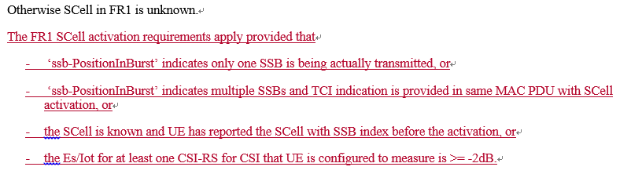

* + Option 2 (Mediatek R4-2014760): N/A
  + Option 3 (Qualcomm R4-2016580):

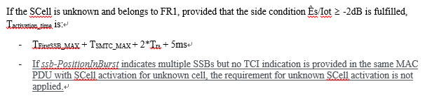

* + Option 4 (NEC R4-2015306)

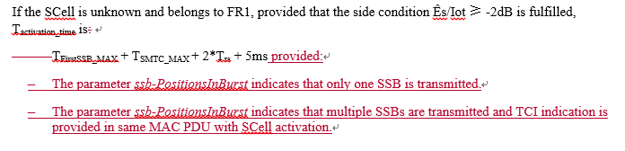

* Recommended WF
  + In principle, it seems that companies are OK to clarify that the requirement is applied on the condition that ‘*ssb-PositionInBurst*’ indicates multiple SSBs and TCI indication is provided in same MAC PDU with SCell activation, or to clarify that if *ssb-PositionInBurst* indicates multiple SSBs but no TCI indication is provided in the same MAC PDU with SCell activation for unknown cell, the requirement for unknown SCell activation is not applied.
  + More discussion on how to make changes

**Issue 2-1-2: Applicability related to first active BWP**

* Proposals (Huawei R4-2015735/R4-2015736):
  + The current SCell activation requirements apply provided that the SSB of the to-be-activated SCell is within the first active DL BWP of the SCell.
* Proposed changes (Huawei R4-2015736):



* Recommended WF
  + More discussion is needed.

### Sub-topic 2-2 SSB-less SCell activation delay requirement

**Issue 2-2: SSB-less SCell activation delay requirement**

* Proposal (Qualcomm R4-2016581, ZTE [R4-2015570](https://www.3gpp.org/ftp/TSG_RAN/WG4_Radio/TSGR4_97_e/Docs/R4-2015570.zip)/[R4-201557](https://www.3gpp.org/ftp/TSG_RAN/WG4_Radio/TSGR4_97_e/Docs/R4-2015570.zip)1)
  + Add an SSB-less SCell activation delay requirement for deactivated FR1 SCell and included QCL relations between refernce signals across cells in the same FR1 band in accordance with allowed QCL relations specified by the current spec.
* Proposed changes:
  + Option 1 (Qualcomm R4-2016581)

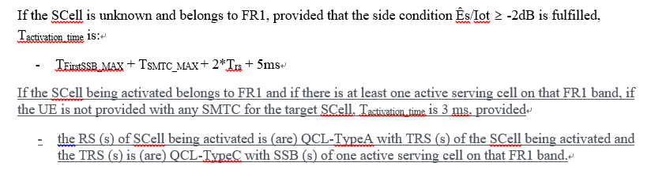

* + Option 2 (ZTE [R4-2015570](https://www.3gpp.org/ftp/TSG_RAN/WG4_Radio/TSGR4_97_e/Docs/R4-2015570.zip)/[R4-201557](https://www.3gpp.org/ftp/TSG_RAN/WG4_Radio/TSGR4_97_e/Docs/R4-2015570.zip)1)

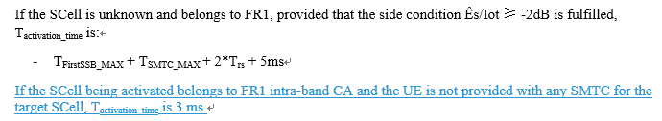

* Recommended WF
  + More discussion is needed

## Companies views’ collection for 1st round

### Comments for open issues

|  |  |
| --- | --- |
| **Company** | **Comments** |
|  |  |
|  |  |
|  |  |
|  |  |
|  |  |
|  |  |
|  |  |

## Summary for 1st round

### Summary of open issues

*Moderator tries to summarize discussion status for 1st round, list all the identified open issues and tentative agreements or candidate options and suggestion for 2nd round i.e. WF assignment.*

|  |  |
| --- | --- |
|  | **Status summary** |
| **Sub-topic#1-X-Y** | ***Tentative agreements:***  ***Candidate options:***  ***Recommendations for 2nd round:*** |

*Recommendations on WF/LS assignment*

|  |  |  |
| --- | --- | --- |
|  | **WF/LS t-doc Title** | **Assigned Company,**  **WF or LS lead** |
| #1 |  |  |

### CRs/TPs Status

*Moderator tries to summarize discussion status for 1st round and provides recommendation on CRs/TPs Status update*

|  |  |
| --- | --- |
| **CR/TP number** | **CRs/TPs Status update recommendation** |
| R4-2015736 |  |
| R4-2015737 |  |
| R4-2016580 |  |
| R4-2015306 |  |
| [R4-2016581](https://www.3gpp.org/ftp/TSG_RAN/WG4_Radio/TSGR4_97_e/Docs/R4-2016581.zip) |  |
| [R4-2015570](https://www.3gpp.org/ftp/TSG_RAN/WG4_Radio/TSGR4_97_e/Docs/R4-2015570.zip) |  |
| R4-2015571 |  |

## Discussion on 2nd round (if applicable)

[Comments and responses will be collected by moderator here]

|  |  |
| --- | --- |
| **Email** | **Status summary** |
|  |  |
|  |  |
|  |  |
|  |  |
|  |  |
|  |  |
|  |  |
|  |  |

## Summary on 2nd round (if applicable)

*Moderator tries to summarize discussion status for 2nd round and provided recommendation on CRs/TPs/WFs/LSs Status update suggestion*

|  |  |
| --- | --- |
| **CR/TP/LS/WF number** | **T-doc Status update recommendation** |
|  |  |
|  |  |
|  |  |
|  |  |
|  |  |

# Topic #3: Beam management

## Companies’ contributions summary

|  |  |  |
| --- | --- | --- |
| **T-doc number** | **Company** | **Proposals / Observations** |
| [R4-2014268](https://www.3gpp.org/ftp/TSG_RAN/WG4_Radio/TSGR4_97_e/Docs/R4-2014268.zip) | Apple | **CR on CSI-RS BW condition for BFD/CBD R15**  Add the side condition of CSI-RS BW for CBD/BFD, i.e., 24PRB. |
| R4-2014269 | Apple | **CR on CSI-RS BW condition for BFD/CBD R16**  Cat A CR for [R4-2014268](https://www.3gpp.org/ftp/TSG_RAN/WG4_Radio/TSGR4_97_e/Docs/R4-2014268.zip) |
| [R4-2015527](https://www.3gpp.org/ftp/TSG_RAN/WG4_Radio/TSGR4_97_e/Docs/R4-2015527.zip) | Huawei, HiSilicon | **CR on BFD and CBD requirements_R15**  Add the condition that the CSI-RS resource is over the bandwidth ≥ 24 PRBs within the active BWP. |
| R4-2015528 | Huawei, HiSilicon | **CR on BFD and CBD requirements_R16**  Cat A CR for [R4-2015527](https://www.3gpp.org/ftp/TSG_RAN/WG4_Radio/TSGR4_97_e/Docs/R4-2015527.zip) |
| [R4-2014270](https://www.3gpp.org/ftp/TSG_RAN/WG4_Radio/TSGR4_97_e/Docs/R4-2014270.zip) | Apple, Huawei, HiSilicon | **On AP-CSI-RS based L1-RSRP measurement**  Proposal 1:  AP CSI-RS based L1-RSRP measurement shall not be performed within MG duration. But outside MG, if this AP CSI-RS for L1-RSRP measurement is overlapped with L3 RRM measurement RS, the AP CSI-RS based L1-RSRP measurement shall be prioritized.  Proposal 2:   * in TS38.133, RAN4 clarifies that scaling factor P=1 for AP CSI-RS based L1-RSRP measurement outside MG regardless of whether this AP CSI-RS is overlapped with L3 measurement RS or not. * in TS38.133, RAN4 clarifies that longer SSB based L3 measurement period would be expected if SSB symbols for L3 measurement are colliding with AP CSI-RS for L1-RSRP. * in TS38.133, RAN4 clarifies that AP CSI-RS based L1-RSRP measurement requirement is not applied for the case that AP CSI-RS is overlapped with MG. |
| [R4-2014271](https://www.3gpp.org/ftp/TSG_RAN/WG4_Radio/TSGR4_97_e/Docs/R4-2014271.zip) | Apple, Huawei, HiSilicon | **CR on AP-CSI-RS based L1-RSRP measurement R15**  Revise the AP CSI-RS based L1-RSRP measurement requirement and add some clarification to L3 SSB based measurement. |
| R4-2014272 | Apple, Huawei, HiSilicon | **CR on AP-CSI-RS based L1-RSRP measurement R16**  Cat A CR for [R4-2014271](https://www.3gpp.org/ftp/TSG_RAN/WG4_Radio/TSGR4_97_e/Docs/R4-2014271.zip) |

## Open issues summary

### Sub-topic 3-1 CSI-RS bandwidth condition for beam management

**Issue 3-1: Applicability related to ssb-PositionInBurst and TCI**

* Proposed change:
  + Option 1 (Apple [R4-2014268](https://www.3gpp.org/ftp/TSG_RAN/WG4_Radio/TSGR4_97_e/Docs/R4-2014268.zip)/R4-2014269):

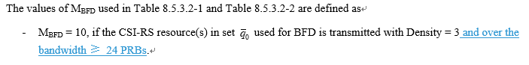

* + Option 2 (Huawei, HiSilicon [R4-2015527](https://www.3gpp.org/ftp/TSG_RAN/WG4_Radio/TSGR4_97_e/Docs/R4-2015527.zip)/R4-2015528)

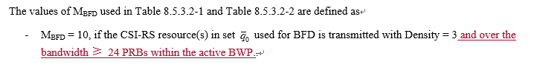

* Recommended WF
  + Which option is agreeable needs more discussion.

### Sub-topic 3-2 Aperiodic CSI-RS based L1-RSPR measurement

**Issue 3-2: Applicability related to ssb-PositionInBurst and TCI**

* Proposals (Apple, Huawei, HiSilicon [R4-2014270](https://www.3gpp.org/ftp/TSG_RAN/WG4_Radio/TSGR4_97_e/Docs/R4-2014270.zip)/[R4-2014271](https://www.3gpp.org/ftp/TSG_RAN/WG4_Radio/TSGR4_97_e/Docs/R4-2014271.zip)/R4-2014272)
  + Proposal 1: AP CSI-RS based L1-RSRP measurement shall not be performed within MG duration. But outside MG, if this AP CSI-RS for L1-RSRP measurement is overlapped with L3 RRM measurement RS, the AP CSI-RS based L1-RSRP measurement shall be prioritized.
  + Proposal 2:
    - In TS38.133, RAN4 clarifies that scaling factor P=1 for AP CSI-RS based L1-RSRP measurement outside MG regardless of whether this AP CSI-RS is overlapped with L3 measurement RS or not.
    - In TS38.133, RAN4 clarifies that longer SSB based L3 measurement period would be expected if SSB symbols for L3 measurement are colliding with AP CSI-RS for L1-RSRP.
    - In TS38.133, RAN4 clarifies that AP CSI-RS based L1-RSRP measurement requirement is not applied for the case that AP CSI-RS is overlapped with MG.
* Proposed changes (Apple, Huawei, HiSilicon [R4-2014270](https://www.3gpp.org/ftp/TSG_RAN/WG4_Radio/TSGR4_97_e/Docs/R4-2014270.zip)/[R4-2014271](https://www.3gpp.org/ftp/TSG_RAN/WG4_Radio/TSGR4_97_e/Docs/R4-2014271.zip)/R4-2014272)

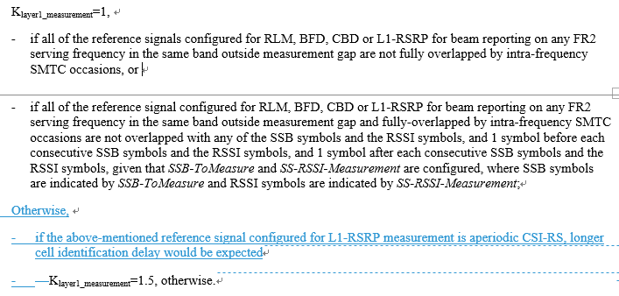

…

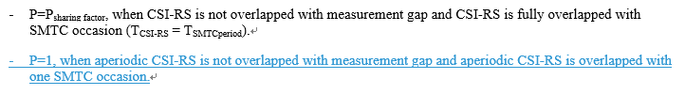

* Recommended WF
  + More discussion is needed

## Companies views’ collection for 1st round

### Comments for open issues

|  |  |
| --- | --- |
| **Company** | **Comments** |
|  |  |
|  |  |
|  |  |
|  |  |
|  |  |
|  |  |

## Summary for 1st round

### Summary of open issues

|  |  |
| --- | --- |
|  | **Status summary** |
| **Sub-topic#1-X-Y** | ***Tentative agreements:***  ***Candidate options:***  ***Recommendations for 2nd round:*** |

*Recommendations on WF/LS assignment*

|  |  |  |
| --- | --- | --- |
|  | **WF/LS t-doc Title** | **Assigned Company,**  **WF or LS lead** |
| #1 |  |  |

### CRs/TPs Status

*Moderator tries to summarize discussion status for 1st round and provides recommendation on CRs/TPs Status update*

|  |  |
| --- | --- |
| **CR/TP number** | **CRs/TPs Status update recommendation** |
| [R4-2014268](https://www.3gpp.org/ftp/TSG_RAN/WG4_Radio/TSGR4_97_e/Docs/R4-2014268.zip) |  |
| R4-2014269 |  |
| [R4-2015527](https://www.3gpp.org/ftp/TSG_RAN/WG4_Radio/TSGR4_97_e/Docs/R4-2015527.zip) |  |
| R4-2015528 |  |
| [R4-2014271](https://www.3gpp.org/ftp/TSG_RAN/WG4_Radio/TSGR4_97_e/Docs/R4-2014271.zip) |  |
| R4-2014272 |  |

## Discussion on 2nd round (if applicable)

In the second round the following email threads are needed:

|  |  |
| --- | --- |
| **Email** | **T-doc status summary** |
|  |  |
|  |  |
|  |  |

## Summary on 2nd round (if applicable)

*Moderator tries to summarize discussion status for 2nd round and provided recommendation on CRs/TPs/WFs/LSs Status update suggestion*

|  |  |
| --- | --- |
| **CR/TP/LS/WF number** | **T-doc Status update recommendation** |
|  |  |
|  |  |
|  |  |
|  |  |
|  |  |
|  |  |

# Topic #4: BWP switching

## Companies’ contributions summary

|  |  |  |
| --- | --- | --- |
| **T-doc number** | **Company** | **Proposals / Observations** |
| [R4-2016162](https://www.3gpp.org/ftp/TSG_RAN/WG4_Radio/TSGR4_97_e/Docs/R4-2016162.zip) | Ericsson | **HARQ delay during RRC based BWP, CBW and TCI switching procedures**   * Observation 1: RRC based BWP switching and UE specific CBW are serving cell procedure performed typically under higher SNR. Therefore, HARQ ACK may be delayed in rare circumstances. * Proposal 1: Clarify in the core requirement that if the ACK transmission for the received RRC takes longer than the RRC procedure delay for a procedure then the overall switching delay for that procedure may be extended. * Proposal 2: Proposal 1 is applicable for the following requirements:   + RRC based BWP switching delay   + UE specific CBW change delay and   + RRC based active TCI state switching delay. |
| [R4-2016373](https://www.3gpp.org/ftp/TSG_RAN/WG4_Radio/TSGR4_97_e/Docs/R4-2016373.zip) | Apple | **CR to 38.133 on Active BWP switch and Active TCI State Switching requirements - Rel15**  Add note that longer switching delay may be expected if THARQ > TRRCProcessing |
| R4-2016374 | Apple | **CR to 38.133 on Active BWP switch and Active TCI State Switching requirements - Rel16**  Cat A CR for [R4-2016373](https://www.3gpp.org/ftp/TSG_RAN/WG4_Radio/TSGR4_97_e/Docs/R4-2016373.zip) |
| [R4-2014237](https://www.3gpp.org/ftp/TSG_RAN/WG4_Radio/TSGR4_97_e/Docs/R4-2014237.zip) | Apple | **Discussion on RRC based BWP switch for Scell**  Observation #1: RRC based BWP switch by RRC re-configuration of firstActiveUplinkBWP-Id is not allowed for Scell.  Proposal #1: Update applicability of current RRC based BWP switch to only PCell or PScell.  Proposal #2: Discuss further on how to extend RRC based switching delay requirement to be applicable to SCell  Proposal#3: Send LS to RAN2 to clarify how RRC based BWP switch can be applicable to SCell. |
| [R4-2014565](https://www.3gpp.org/ftp/TSG_RAN/WG4_Radio/TSGR4_97_e/Docs/R4-2014565.zip) | Intel Corporation | **Discussion of RRC based BWP switching on single CC**  Proposal 1: Current single RRC based BWP switch delay requirement in Rel-15 is only applied for PCell or PScell.  Proposal 2: RRC based single BWP switch delay for SCell needs more discussion. |
| [R4-2014238](https://www.3gpp.org/ftp/TSG_RAN/WG4_Radio/TSGR4_97_e/Docs/R4-2014238.zip) | Apple | **CR on Applicability of RRC based BWP switch requirements - Rel15**   1. Delete Editor’s Note 2. Capture that RRC based BWP switch requirements for single CC are only applicable to PCell and PScell. |
| R4-2014239 | Apple | CR on Applicability of RRC based BWP switch requirements - Rel16  Cat A CR for [R4-2014238](https://www.3gpp.org/ftp/TSG_RAN/WG4_Radio/TSGR4_97_e/Docs/R4-2014238.zip). |
| [R4-2015529](https://www.3gpp.org/ftp/TSG_RAN/WG4_Radio/TSGR4_97_e/Docs/R4-2015529.zip) | Huawei, HiSilicon | **CR on RRC-based BWP switch requirements_R15**  Remove the notes: More than one BWP configurations for RRC-based BWP switch on SCell is FFS. |
| R4-2015530 | Huawei, HiSilicon | CR on RRC-based BWP switch requirements_R16  Cat A CR for [R4-2015529](https://www.3gpp.org/ftp/TSG_RAN/WG4_Radio/TSGR4_97_e/Docs/R4-2015529.zip). |
| [R4-2014761](https://www.3gpp.org/ftp/TSG_RAN/WG4_Radio/TSGR4_97_e/Docs/R4-2014761.zip) | MediaTek inc. | **CR on BWP switch**  Clarify RRC-based BWP switch only applies for PCell and PSCell. |
| R4-2015208 | MediaTek inc. | CR on BWP switch  Cat A CR for [R4-2014761](https://www.3gpp.org/ftp/TSG_RAN/WG4_Radio/TSGR4_97_e/Docs/R4-2014761.zip). |
| [R4-2015572](https://www.3gpp.org/ftp/TSG_RAN/WG4_Radio/TSGR4_97_e/Docs/R4-2015572.zip) | ZTE | **CR to 38.133 correction to RRC based BWP switch requirements**  RRC based BWP switch requirements is applicable for RRC configuration (including RRCsetup message and RRCresume message). |
| R4-2015573 | ZTE | CR to 38.133 correction to RRC based BWP switch requirements  Cat A CR for [R4-2015572](https://www.3gpp.org/ftp/TSG_RAN/WG4_Radio/TSGR4_97_e/Docs/R4-2015572.zip) |
| [R4-2015300](https://www.3gpp.org/ftp/TSG_RAN/WG4_Radio/TSGR4_97_e/Docs/R4-2015300.zip) | NEC | CR to TS 38.133 on DCI based BWP switch requirements applicability |

## Open issues summary

### Sub-topic 4-1 HARQ delay

**Issue 4-1: Clarification of requirement applicability when THARQ > TRRCprocessingDelay**

* Proposal (Ericsson [R4-2016162](https://www.3gpp.org/ftp/TSG_RAN/WG4_Radio/TSGR4_97_e/Docs/R4-2016162.zip), Apple [R4-2016373](https://www.3gpp.org/ftp/TSG_RAN/WG4_Radio/TSGR4_97_e/Docs/R4-2016373.zip)/R4-2016374)
  + Proposal 1: Clarify in the core requirement that if the ACK transmission for the received RRC takes longer than the RRC procedure delay for a procedure then the overall switching delay for that procedure may be extended.
  + Proposal 2: Proposal 1 is applicable for the following requirements:
    - RRC based BWP switching delay
    - UE specific CBW change delay and
    - RRC based active TCI state switching delay.
* Proposed change (Apple [R4-2016373](https://www.3gpp.org/ftp/TSG_RAN/WG4_Radio/TSGR4_97_e/Docs/R4-2016373.zip)/R4-2016374)

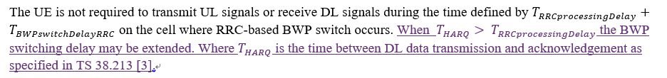

…



* Recommended WF
  + More discussion is needed.

### Sub-topic 4-2 Applicability condition for RRC based BWP switching

**Issue 4-2: Clarification on BWP configuration(s) for active BWP switch**

* Proposals:
  + Proposal 1 (Apple [R4-2014237](https://www.3gpp.org/ftp/TSG_RAN/WG4_Radio/TSGR4_97_e/Docs/R4-2014237.zip), Intel R4-2010032, Mediatek R4-2014760): Update applicability of current RRC based BWP switch to only PCell or PScell.
  + Proposal 2 (Apple [R4-2014237](https://www.3gpp.org/ftp/TSG_RAN/WG4_Radio/TSGR4_97_e/Docs/R4-2014237.zip), Intel R4-2010032): RRC based single BWP switch delay for SCell needs more discussion. Discuss further on how to extend RRC based switching delay requirement to be applicable to SCell.
  + Proposal 3 (Apple [R4-2014237](https://www.3gpp.org/ftp/TSG_RAN/WG4_Radio/TSGR4_97_e/Docs/R4-2014237.zip)): Send LS to RAN2 to clarify how RRC based BWP switch can be applicable to SCell.
  + Proposal 4 (ZTE [R4-2015572](https://www.3gpp.org/ftp/TSG_RAN/WG4_Radio/TSGR4_97_e/Docs/R4-2015572.zip)/[R4-201557](https://www.3gpp.org/ftp/TSG_RAN/WG4_Radio/TSGR4_97_e/Docs/R4-2015572.zip)3): RRC based BWP switch requirements is applicable for RRC configuration (including RRCsetup message and RRCresume message).
* Proposed changes:
  + Option 1 (Apple [R4-201423](https://www.3gpp.org/ftp/TSG_RAN/WG4_Radio/TSGR4_97_e/Docs/R4-2014237.zip)8):

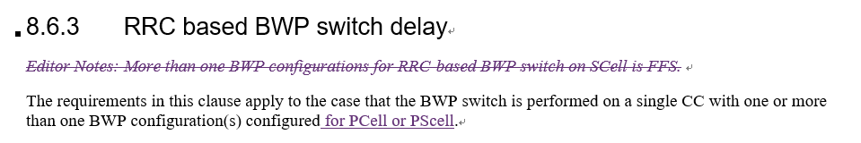

* + Option 2 (Huawei, HiSilicon [R4-2015529](https://www.3gpp.org/ftp/TSG_RAN/WG4_Radio/TSGR4_97_e/Docs/R4-2015529.zip))

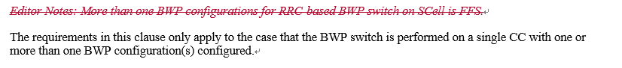

* + Option 3 (Mediatek [R4-2014761](https://www.3gpp.org/ftp/TSG_RAN/WG4_Radio/TSGR4_97_e/Docs/R4-2014761.zip)):

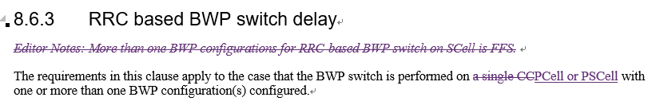

* + Option 4 (ZTE [R4-2015572](https://www.3gpp.org/ftp/TSG_RAN/WG4_Radio/TSGR4_97_e/Docs/R4-2015572.zip))

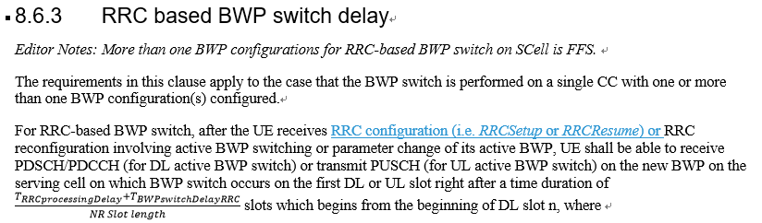

* Draft LS (Apple [R4-2014237](https://www.3gpp.org/ftp/TSG_RAN/WG4_Radio/TSGR4_97_e/Docs/R4-2014237.zip))

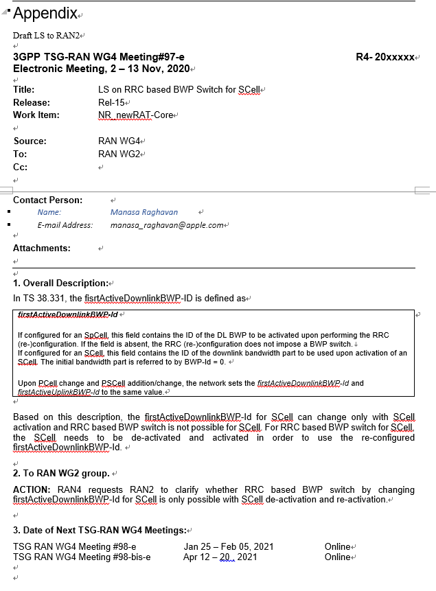

* Recommended WF
  + More discussion is needed.
  + Collect comments for Apple draft LS in [R4-2014237](https://www.3gpp.org/ftp/TSG_RAN/WG4_Radio/TSGR4_97_e/Docs/R4-2014237.zip)

### Sub-topic 4-3 Cross carrier scheduling

**Issue 4-3: Clarification on cross-carrier scheduling**

* Proposed change (NEC [R4-2015300](https://www.3gpp.org/ftp/TSG_RAN/WG4_Radio/TSGR4_97_e/Docs/R4-2015300.zip))

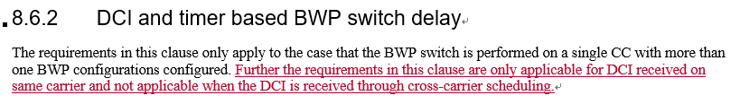

* Recommended WF
  + More discussion is needed

## Companies views’ collection for 1st round

### Comments for open issues

|  |  |
| --- | --- |
| **Company** | **Comments** |
|  |  |
|  |  |
|  |  |
|  |  |
|  |  |
|  |  |
|  |  |

## Summary for 1st round

### Summary of open issues

*Moderator tries to summarize discussion status for 1st round, list all the identified open issues and tentative agreements or candidate options and suggestion for 2nd round i.e. WF assignment.*

|  |  |
| --- | --- |
|  | **Status summary** |
| **Sub-topic#X-Y-Z** | ***Tentative agreements:***  ***Candidate options:***  ***Recommendations for 2nd round:*** |

*Recommendations on WF/LS assignment*

|  |  |  |
| --- | --- | --- |
|  | **WF/LS t-doc Title** | **Assigned Company,**  **WF or LS lead** |
| #1 |  |  |

### CRs/TPs Status

*Moderator tries to summarize discussion status for 1st round and provides recommendation on CRs/TPs Status update*

|  |  |
| --- | --- |
| **CR/TP number** | **CRs/TPs Status update recommendation** |
| [R4-2016373](https://www.3gpp.org/ftp/TSG_RAN/WG4_Radio/TSGR4_97_e/Docs/R4-2016373.zip) |  |
| R4-2016374 |  |
| [R4-2014238](https://www.3gpp.org/ftp/TSG_RAN/WG4_Radio/TSGR4_97_e/Docs/R4-2014238.zip) |  |
| R4-2014239 |  |
| [R4-2015529](https://www.3gpp.org/ftp/TSG_RAN/WG4_Radio/TSGR4_97_e/Docs/R4-2015529.zip) |  |
| R4-2015530 |  |
| [R4-2014761](https://www.3gpp.org/ftp/TSG_RAN/WG4_Radio/TSGR4_97_e/Docs/R4-2014761.zip) |  |
| R4-2015208 |  |
| [R4-2015572](https://www.3gpp.org/ftp/TSG_RAN/WG4_Radio/TSGR4_97_e/Docs/R4-2015572.zip) |  |
| R4-2015573 |  |
| [R4-2015300](https://www.3gpp.org/ftp/TSG_RAN/WG4_Radio/TSGR4_97_e/Docs/R4-2015300.zip) |  |

## Discussion on 2nd round (if applicable)

[Comments and responses will be collected by moderator here]

|  |  |
| --- | --- |
| **Email** | **Status summary** |
|  |  |
|  |  |
|  |  |
|  |  |
|  |  |
|  |  |
|  |  |
|  |  |

## Summary on 2nd round (if applicable)

*Moderator tries to summarize discussion status for 2nd round and provided recommendation on CRs/TPs/WFs/LSs Status update suggestion*

|  |  |
| --- | --- |
| **CR/TP/LS/WF number** | **T-doc Status update recommendation** |
|  |  |
|  |  |
|  |  |
|  |  |
|  |  |
|  |  |
|  |  |
|  |  |

# Topic #5: TCI switching

## Companies’ contributions summary

|  |  |  |
| --- | --- | --- |
| **T-doc number** | **Company** | **Proposals / Observations** |
| [R4-2014763](https://www.3gpp.org/ftp/TSG_RAN/WG4_Radio/TSGR4_97_e/Docs/R4-2014763.zip) | MediaTek inc. | **CR on TCI state**   * On 8.10.3,   Define the minimum requirement when both SSB and CSI-RS for L1-RSRP measurement are configured.   * On 8.10.6,   Replace TOk by 1. |
| R4-2015209 | MediaTek inc. | **CR on TCI state**  Cat A CR for [R4-2014763](https://www.3gpp.org/ftp/TSG_RAN/WG4_Radio/TSGR4_97_e/Docs/R4-2014763.zip) |
| [R4-2015672](https://www.3gpp.org/ftp/TSG_RAN/WG4_Radio/TSGR4_97_e/Docs/R4-2015672.zip) | ZTE Corporation | **[CR] Specify RRC processing delay in TCI state switching delay**  Specify that the definition of TRRC_processing is given in Clause 12 in TS 38.331. |
| R4-2015673 | ZTE Corporation | **[CR] Specify RRC processing delay in TCI state switching delay (Cat A)**  Cat A CR for [R4-2015672](https://www.3gpp.org/ftp/TSG_RAN/WG4_Radio/TSGR4_97_e/Docs/R4-2015672.zip) |
| [R4-2016373](https://www.3gpp.org/ftp/TSG_RAN/WG4_Radio/TSGR4_97_e/Docs/R4-2016373.zip) | Apple | **CR to 38.133 on Active BWP switch and Active TCI State Switching requirements - Rel15**  Add note that longer switching delay may be expected if THARQ > TRRCProcessing |
| R4-2016374 | Apple | **CR to 38.133 on Active BWP switch and Active TCI State Switching requirements - Rel16**  Cat A CR for [R4-2016373](https://www.3gpp.org/ftp/TSG_RAN/WG4_Radio/TSGR4_97_e/Docs/R4-2016373.zip) |

## Open issues summary

### Sub-topic 5-1 Condition for TCI switching related to SSB and CSI-RS configuration

**Issue 5-1: Condition for TCI switching related to SSB and CSI-RS configuration**

* Proposal (Mediatek [R4-2014763](https://www.3gpp.org/ftp/TSG_RAN/WG4_Radio/TSGR4_97_e/Docs/R4-2014763.zip)/R4-2015209)

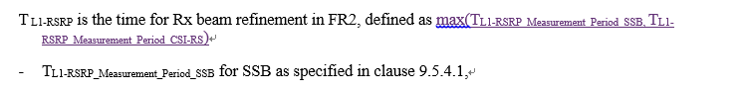

* Recommended WF
  + More discussion is needed.

### Sub-topic 5-2 Active TCI list update

**Issue 5-2: TOk in active TCI list update**

* Proposal (Mediatek [R4-2014763](https://www.3gpp.org/ftp/TSG_RAN/WG4_Radio/TSGR4_97_e/Docs/R4-2014763.zip)/R4-2015209) Delete TOk in active TCI list update requirement.

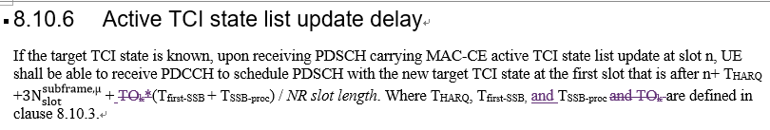

* Recommended WF
  + More discussion is needed.

### Sub-topic 5-3 Condition for TCI switching related to HARQ timing

**Issue 5-3: Condition for TCI switching related to HARQ timing**

* Proposal (Apple R4-2016373/R4-2016374) The other part of CR is discussed in Topic #4

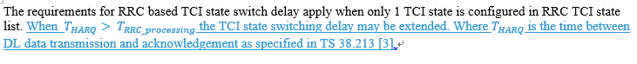

* Recommended WF
  + More discussion is needed.

### Sub-topic 5-4

Please provide the additional comments on the other CRs in Section 5.3.2

## Companies views’ collection for 1st round

### Open issues

|  |  |
| --- | --- |
| **Company** | **Comments** |
|  |  |
|  |  |
|  |  |
|  |  |
|  |  |
|  |  |
|  |  |

### CRs/TPs comments collection

Please provide comments in the table below.

|  |  |
| --- | --- |
| **CR/TP number** | **Comments collection** |
| [R4-2015672](https://www.3gpp.org/ftp/TSG_RAN/WG4_Radio/TSGR4_97_e/Docs/R4-2015672.zip)  R4-2015673 |  |
|  |
|  |
|  |
|  |
|  |

## Summary for 1st round

### Open issues

*Moderator tries to summarize discussion status for 1st round, list all the identified open issues and tentative agreements or candidate options and suggestion for 2nd round i.e. WF assignment.*

|  |  |
| --- | --- |
|  | **Status summary** |
| **Sub-topic#X-Y-Z** | ***Tentative agreements:***  ***Candidate options:***  ***Recommendations for 2nd round:*** |

*Recommendations on WF/LS assignment*

|  |  |  |
| --- | --- | --- |
|  | **WF/LS t-doc Title** | **Assigned Company,**  **WF or LS lead** |
| #1 |  |  |

### CRs/TPs Status

*Moderator tries to summarize discussion status for 1st round and provides recommendation on CRs/TPs Status update*

|  |  |
| --- | --- |
| **CR/TP number** | **CRs/TPs Status update recommendation** |
| [R4-2014763](https://www.3gpp.org/ftp/TSG_RAN/WG4_Radio/TSGR4_97_e/Docs/R4-2014763.zip) |  |
| R4-2015209 |  |
| [R4-2015672](https://www.3gpp.org/ftp/TSG_RAN/WG4_Radio/TSGR4_97_e/Docs/R4-2015672.zip) |  |
| R4-2015673 |  |

## Discussion on 2nd round (if applicable)

[Comments and responses will be collected by moderator here]

|  |  |
| --- | --- |
| **Email** | **Status summary** |
|  |  |
|  |  |
|  |  |
|  |  |
|  |  |

## Summary on 2nd round (if applicable)

*Moderator tries to summarize discussion status for 2nd round and provided recommendation on CRs/TPs/WFs/LSs Status update suggestion*

|  |  |
| --- | --- |
| **CR/TP/LS/WF number** | **T-doc Status update recommendation** |
|  |  |
|  |  |
|  |  |
|  |  |
|  |  |
|  |  |

# Topic #6: Others

## Companies’ contributions summary

|  |  |  |
| --- | --- | --- |
| **T-doc number** | **Company** | **Proposals / Observations** |
| [R4-2014693](https://www.3gpp.org/ftp/TSG_RAN/WG4_Radio/TSGR4_97_e/Docs/R4-2014693.zip) | CMCC | CR on carrier frequency range of PCell/PSCell for the maximum number of RLM-RS resources |
| R4-2014694 | CMCC | CR on carrier frequency range of PCell/PSCell for the maximum number of RLM-RS resources |
| [R4-2015876](https://www.3gpp.org/ftp/TSG_RAN/WG4_Radio/TSGR4_97_e/Docs/R4-2015876.zip) | Nokia, Nokia Shanghai Bell | Introducing reference to the source of the Lmax and NRLM. |
| R4-2015877 | Nokia, Nokia Shanghai Bell | Introducing reference to the source of the Lmax and NRLM. |
| [R4-2016022](https://www.3gpp.org/ftp/TSG_RAN/WG4_Radio/TSGR4_97_e/Docs/R4-2016022.zip) | Ericsson | CR 36.133 Removal of brackets for SFTD measurements (Rel-15) |
| R4-2016023 | Ericsson | CR 36.133 Removal of brackets for SFTD measurements (Rel-16) |
| [R4-2015731](https://www.3gpp.org/ftp/TSG_RAN/WG4_Radio/TSGR4_97_e/Docs/R4-2015731.zip) | Huawei, HiSilicon | CR to remove intra-frequency ECID requirements for NE-DC 36133 R15 |
| R4-2015732 | Huawei, HiSilicon | CR to remove intra-frequency ECID requirements for NE-DC 36133 R16 |
| [R4-2015733](https://www.3gpp.org/ftp/TSG_RAN/WG4_Radio/TSGR4_97_e/Docs/R4-2015733.zip) | Huawei, HiSilicon | CR to remove inter-RAT ECID requirements for NE-DC 38133 R15 |
| R4-2015734 | Huawei, HiSilicon | CR to remove inter-RAT ECID requirements for NE-DC 38133 R16 |
| [R4-2015159](https://www.3gpp.org/ftp/TSG_RAN/WG4_Radio/TSGR4_97_e/Docs/R4-2015159.zip) | Ericsson | Addition of symbol definitions |
| R4-2015160 | Ericsson | Addition of symbol definitions |

## Open issues summary

### Sub-topic 5-1

Please provide the additional comments on the CRs in Section 5.3.1.

## Companies views’ collection for 1st round

### CRs/TPs comments collection

Please provide the comments in the table below.

|  |  |
| --- | --- |
| **CR/TP number** | **Comments collection** |
| [R4-2014693](https://www.3gpp.org/ftp/TSG_RAN/WG4_Radio/TSGR4_97_e/Docs/R4-2014693.zip)  R4-2014694 |  |
|  |
|  |
|  |
| [R4-2015876](https://www.3gpp.org/ftp/TSG_RAN/WG4_Radio/TSGR4_97_e/Docs/R4-2015876.zip)  R4-2015877 |  |
|  |
|  |
|  |
| [R4-2016022](https://www.3gpp.org/ftp/TSG_RAN/WG4_Radio/TSGR4_97_e/Docs/R4-2016022.zip)  R4-2016023 |  |
|  |
|  |
| [R4-2015731](https://www.3gpp.org/ftp/TSG_RAN/WG4_Radio/TSGR4_97_e/Docs/R4-2015731.zip)  R4-2015732 |  |
|  |
|  |
| [R4-2015733](https://www.3gpp.org/ftp/TSG_RAN/WG4_Radio/TSGR4_97_e/Docs/R4-2015733.zip)  R4-2015734 |  |
|  |
|  |
| [R4-2015159](https://www.3gpp.org/ftp/TSG_RAN/WG4_Radio/TSGR4_97_e/Docs/R4-2015159.zip)  R4-2015160 |  |
|  |
|  |

## Summary for 1st round

### CRs/TPs Status

*Moderator tries to summarize discussion status for 1st round and provides recommendation on CRs/TPs Status update*

|  |  |
| --- | --- |
| **CR/TP number** | **CRs/TPs Status update recommendation** |
| [R4-2014693](https://www.3gpp.org/ftp/TSG_RAN/WG4_Radio/TSGR4_97_e/Docs/R4-2014693.zip) |  |
| R4-2014694 |  |
| [R4-2015876](https://www.3gpp.org/ftp/TSG_RAN/WG4_Radio/TSGR4_97_e/Docs/R4-2015876.zip) |  |
| R4-2015877 |  |
| [R4-2016022](https://www.3gpp.org/ftp/TSG_RAN/WG4_Radio/TSGR4_97_e/Docs/R4-2016022.zip) |  |
| R4-2016023 |  |
| [R4-2015731](https://www.3gpp.org/ftp/TSG_RAN/WG4_Radio/TSGR4_97_e/Docs/R4-2015731.zip) |  |
| R4-2015732 |  |
| [R4-2015733](https://www.3gpp.org/ftp/TSG_RAN/WG4_Radio/TSGR4_97_e/Docs/R4-2015733.zip) |  |
| R4-2015734 |  |
| [R4-2015159](https://www.3gpp.org/ftp/TSG_RAN/WG4_Radio/TSGR4_97_e/Docs/R4-2015159.zip) |  |
| R4-2015160 |  |

## Discussion on 2nd round (if applicable)

In the second round the following email threads are needed:

|  |  |
| --- | --- |
| **Email** | **T-doc status summary** |
|  |  |
|  |  |
|  |  |

## Summary on 2nd round (if applicable)

*Moderator tries to summarize discussion status for 2nd round and provided recommendation on CRs/TPs/WFs/LSs Status update suggestion*

|  |  |
| --- | --- |
| **CR/TP/LS/WF number** | **T-doc Status update recommendation** |
|  |  |
|  |  |
|  |  |
|  |  |
|  |  |
|  |  |