**3GPP TSG-RAN WG4 Meeting # 97-e R4-200xxxx**

**Electronic Meeting, Nov. 2-13, 2020**

**Agenda item:** 4.7

**Source:** Moderator (Huawei, HiSilicon)

**Title:** Email discussion summary for [96e][201] NR_NewRAT_RRM_Core

**Document for:** Information

# Introduction

This contribution provides the summary of Rel-15 NR RRM core maintenance in Agenda 4.7. It will be used to capture the comments in the 1st round and 2nd round. The tentative agreements will be provided based on the proposals and comments.

The topics include the maintenance for the following topics:

* RRM measurements: CSSFoutside_gap, MO merging
* SCell activation: update the condition for TCI and multiple SSB configurations, SSB-less activation
* Beam management: CSI-RS bandwidth condition for BFD/CBD, sharing factor P for L1-RSRP measurement
* BWP switching: clarification of applicability of requirement related to PCell or SCell, or cross-carrier scheduling
* TCI switching: clarification of condition for case where NW configures both SSB and CSI-RS, TOk
* Others: frequency range for 8SSB configuration, E-CID, FSTD

# Topic #1: RRM measurement

## Companies’ contributions summary

|  |  |  |
| --- | --- | --- |
| **T-doc number** | **Company** | **Proposals / Observations** |
| [R4-2014273](https://www.3gpp.org/ftp/TSG_RAN/WG4_Radio/TSGR4_97_e/Docs/R4-2014273.zip) | Apple | **On CSSF for R15 EN-DC**  Proposal 1: the NR inter-RAT MO on NR serving CC configured by LTE MN shall be captured into CSSF outside MG:   * NR Inter-RAT measurement object configured by the E-UTRAN PCell   + NR inter-RAT MO configured by LTE MN is on the NR serving CC with no measurement gap, when none of the SMTC occasions of this NR inter-RAT measurement object are overlapped by the measurement gap   + NR inter-RAT MO configured by LTE MN is on the NR serving CC with no measurement gap, when part of the SMTC occasions of this NR inter-RAT measurement object are overlapped by the measurement gap   Proposal 2: RAN4 CSSF outside MG design uses option 3, i.e., in EN-DC the CSSF without MG is determined by the number of MOs without MG configured from both LTE MN and NR SN, and if any two MOs from LTE MN and NR SN meet MO merging rule, they shall be counted as one single MO in MO number counting.  Proposal 3: the CSSF outside MG shall be updated as in this contribution.  Proposal 4: the NR inter-RAT MO configured by LTE MN shall be further divided into following types for CSSF inside MG,   * NR inter-RAT MO configured by LTE MN is on the NR serving CC with no measurement gap, when all of the SMTC occasions of this inter-RAT MO are overlapped by the MG * NR inter-RAT MO configured by LTE MN is on the NR serving CC with measurement gap * NR inter-RAT MO configured by LTE MN is on the NR non-serving CC   Proposal 5: RAN4 CSSF inside MG design uses option 3, i.e., Mtot,i,j = Mintra,i,j + Minter,i,j : Total number of intra-frequency, inter-frequency and inter-RAT measurement objects which are candidates to be measured in gap j where the measurement object i is also a candidate. If any two MOs from LTE MN and NR SN meet MO merging rule, they shall be counted as one single MO in MO number counting. Otherwise Mtot,i,j equals 0. |
| [R4-2015445](https://www.3gpp.org/ftp/TSG_RAN/WG4_Radio/TSGR4_97_e/Docs/R4-2015445.zip) | Huawei, HiSilicon | **Correction to CSSF calculation R15**   1. Take inter-RAT measurement on serving carrier into account in the calculation of CSSFoutside_gap. 2. Clarify that in EN-DC inter-frequency measurement and inter-RAT measurement on the same frequencies are only count as one in CSSF_within_gap calculation if MO merging conditions are satisfied, as well as inter-frequency measurements configured by PCell and PSCell on the same frequency in NR-DC. |
| [R4-2015446](https://www.3gpp.org/ftp/TSG_RAN/WG4_Radio/TSGR4_97_e/Docs/R4-2015446.zip) | Huawei, HiSilicon | **Correction to CSSF calculation R16**  Cat A CR for R4-2015445 |
| [R4-2014274](https://www.3gpp.org/ftp/TSG_RAN/WG4_Radio/TSGR4_97_e/Docs/R4-2014274.zip) | Apple | **CR on CSSF for R15 EN-DC**  The CSSF requirement has been updated for EN-DC to consider the MOs configured from both LTE MN and NR SN in EN-DC. |
| [R4-2014765](https://www.3gpp.org/ftp/TSG_RAN/WG4_Radio/TSGR4_97_e/Docs/R4-2014765.zip) | MediaTek inc. | CR on MO merge |
| R4-2015210 | MediaTek inc. | CR on MO merge |

## Open issues summary

### Sub-topic 1-1 CSSF calcualtion for Inter-RAT measurement objective

In last RAN4 meeting, there was discussions on CSSF for EN-DC when the intra-frequency and inter-RAT measurements are configured on the same serving CC from both LTE MN and NR SN. Companies discussed this issue.

The related contributions include R4-2014273, R4-2014274, R4-2015445 and R4-2015446.

**Issue 1-1-1: How to capture inter-RAT MO on NR serving CC configured by LTE MN**

* Proposal: (Apple R4-2014273/R4-2014274, Huawei, HiSilicon R4-2015445/R4-2015446)
  + The NR inter-RAT MO on NR serving CC configured by LTE MN shall be calculated in CSSF outside MG
* Proposed changes:
  + Option 1 (Apple, R4-2014274)

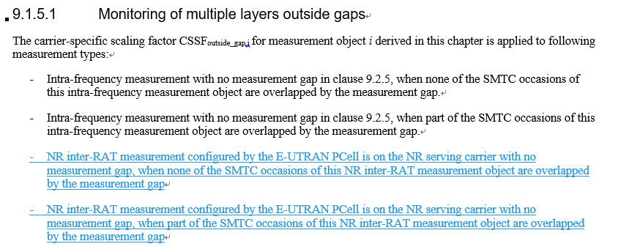

* + Option 2 (Huawei, HiSilicon, R4-2015446)

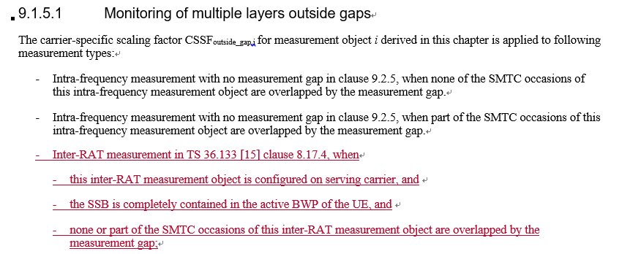

* Recommended WF
  + Can we agree that
    - The NR inter-RAT MO on NR serving CC configured by LTE MN shall be calculated in CSSF outside MG
  + Further discussion on how to capture the above tentative agreement in specification.

**Issue 1-1-2: How to count MO number configured from both LTE MN and NR SN**

* Proposal:
  + Option 1(Apple R4-2014273): RAN4 CSSF outside MG design uses option 3, i.e., in EN-DC the CSSF without MG is determined by the number of MOs without MG configured from both LTE MN and NR SN, and if any two MOs from LTE MN and NR SN meet MO merging rule, they shall be counted as one single MO in MO number counting.
  + Option 2(Mediatek R4-2014760): To simplify the CSSF definition, it shall always treat Inter-RAT measurement as SCC measurement in EN-DC.
* Proposed changes:
  + Option 1 (Apple, R4-2014274)

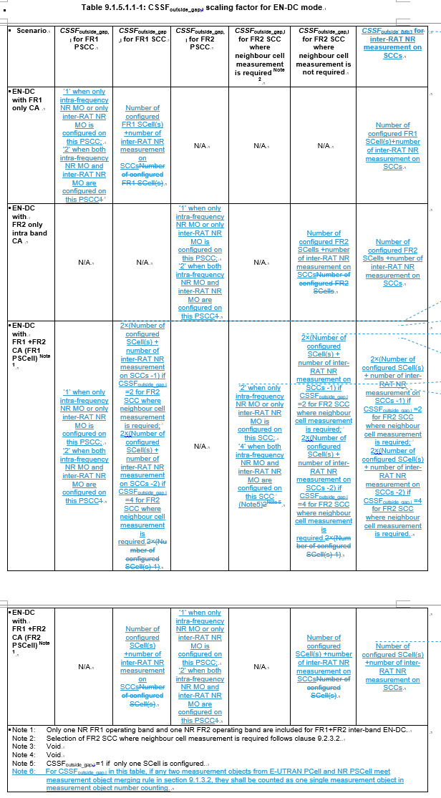

* + Option 2 (Huawei, HiSilicon, R4-2015446, Mediatek R4-2014760)

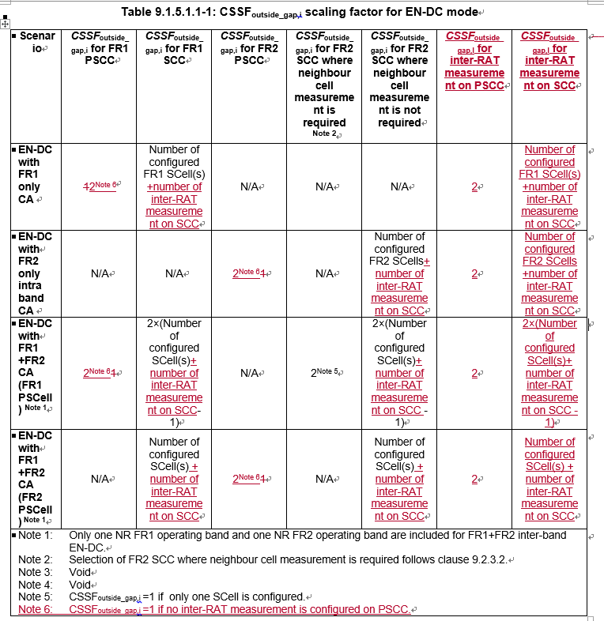

* Recommended WF
  + More discussion is needed

**Issue 1-1-3: Update requirement of monitoring of multiple layers within gaps**

* Proposal:
  + Option 1 (Huawei R4-2015445): Clarify that in EN-DC inter-frequency measurement and inter-RAT measurement on the same frequencies are only count as one in CSSF_within_gap calculation if MO merging conditions are satisfied, as well as inter-frequency measurements configured by PCell and PSCell on the same frequency in NR-DC.
  + Option 2 (Apple R4-2014274):
    - The NR inter-RAT MO configured by LTE MN shall be further divided into following types for CSSF inside MG,
      * NR inter-RAT MO configured by LTE MN is on the NR serving CC with no measurement gap, when all of the SMTC occasions of this inter-RAT MO are overlapped by the MG
      * NR inter-RAT MO configured by LTE MN is on the NR serving CC with measurement gap
      * NR inter-RAT MO configured by LTE MN is on the NR non-serving CC
    - RAN4 CSSF inside MG design uses option 3, i.e., Mtot,i,j = Mintra,i,j + Minter,i,j : Total number of intra-frequency, inter-frequency and inter-RAT measurement objects which are candidates to be measured in gap j where the measurement object i is also a candidate. If any two MOs from LTE MN and NR SN meet MO merging rule, they shall be counted as one single MO in MO number counting. Otherwise Mtot,i,j equals 0.
  + Option 3 (Mediatek R4-2014760): To simplify the CSSF definition, it shall always treat Inter-RAT measurement as SCC measurement in EN-DC.
* Proposed changes:
  + Option 1 (Apple, R4-2014274)

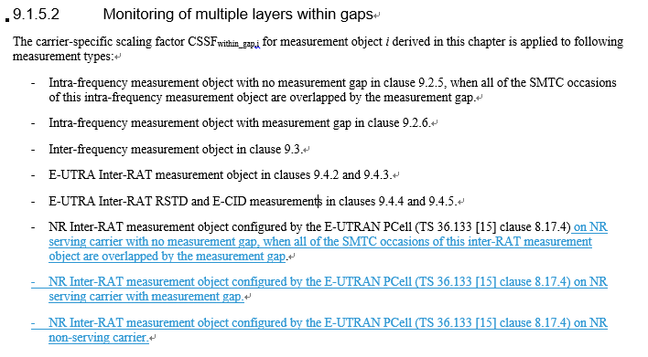

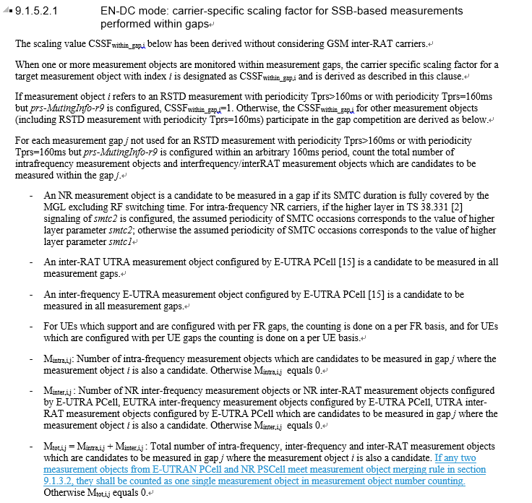

* + Option 2 (Huawei, HiSilicon, R4-2015446)

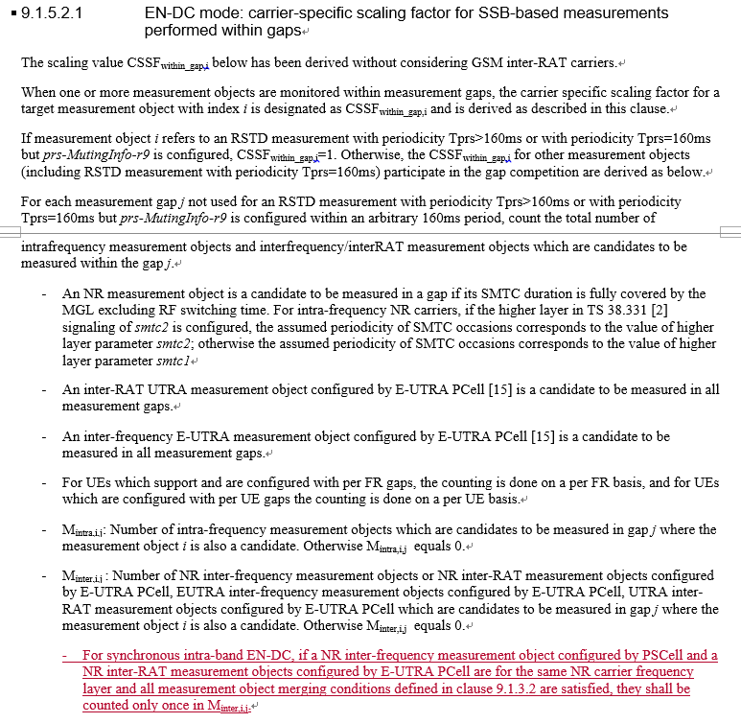

* Recommended WF
  + More discussion is needed

### Sub-topic 1-2 MO merging related to SSB-ToMeasure indications

**Issue 1-2: MO merging related to SSB-ToMeasure indications**

* Proposal: (Mediatek R4-2014765)
  + Clarify the layer shall be counted only once unless the configured NR frequency layers have different *SSB-ToMeasure* indications.

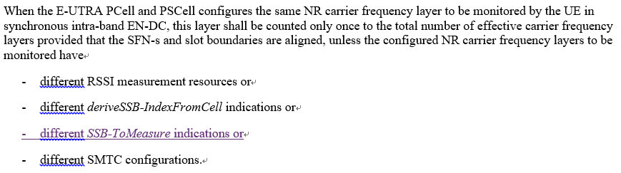

* Recommended WF
  + More discussion is needed

## Companies views’ collection for 1st round

### Comments for open issues

|  |  |
| --- | --- |
| **Company** | **Comments** |
| Apple | **Issue 1-1-1: How to capture inter-RAT MO on NR serving CC configured by LTE MN**  Agree with that “The NR inter-RAT MO on NR serving CC configured by LTE MN shall be calculated in CSSF outside MG” .  Regarding the proposed change, both option 1 and 2 is fine to us since they have the same physical meaning. We used option 1 because it’s in the same format as the context.  **Issue 1-1-2: How to capture inter-RAT MO on NR serving CC configured by LTE MN**  We propose to consider MO merging rule when counting the number of MOs in CSSF. Agree with Option 1.  Comment to option 2: (1) we prefer to consider MO merging rule, (2) the inter-RAT MO on FR2 SCCs that has neighbor cell measurement shall be counted as 4 if both LTE and NR configured MOs on this SCC; and then other CSSF in the other columns shall be revised accordingly  **Issue 1-1-3: Update requirement of monitoring of multiple layers within gaps**  We prefer option 1 since it clarifies the inter-RAT measurement types. Regarding the MO counting, option 1 and option 2 are same since both of they propose to use MO merging rule to decide the number of CSSF.  **Issue 1-2: MO merging related to SSB-ToMeasure indications**  Agree with MTK proposal |
| MTK | Issue 1-1-1:  We agree that the NR inter-RAT MO on NR serving CC configured by LTE MN shall be calculated in CSSF outside MG.  Issue 1-1-2:  As discussed in our tdoc, RAN2 had already agreed that if MCG MO has the same *ssbFrequency* with SCG MO, NW shall ensure that these two MOs have   * the same *ssbSubcarrierSpacing* * the same *SS-RSSI-Measurement* * the measurement window according to the *smtc* configured in TS 36.331 [10] includes the measurement window according to the *smtc1* configured in TS 38.331   It implies NW can have good coordination between MN and SN. In other words, if NW configures inter-RAT measurement from MCG in EN-DC, NW may want to measure the NR frequency layer from MN for different purposes with the MO in SN.  To simplify the CSSF definition, it shall always treat Inter-RAT measurement as SCC measurement in EN-DC.  Issue 1-1-3:  The same as issue 1-1-2. We prefer option 3: Don’t change current spec.  Issue 1-2:  As discussed in our tdoc, when SSB-ToMeasure is different in two CGs, Klayer1_measurement will be different due to collision with RLM-RS. Thus, two MOs can’t be merged together even other factors are the same.  At the same time, the P factor in RLM meas. shall be the largest P value deduced by two MOs. |
| Ericsson | **Issue 1-1-1: How to capture inter-RAT MO on NR serving CC configured by LTE MN**  Yes, we agree with the proposal; interRAT MO configured by LTE MN on NR serving frequencies and measured outside gap should be included in CSSF outside MG, this seems to be a bug in the current specification. However, we think they have not been excluded from CSSFwithin gap, and if this CR was agreed by itself they would be assumed to be measured both in gaps and outside gaps which is not correct.  **Issue 1-1-2: How to count MO number configured from both LTE MN and NR SN**  Our view is that the MO counting for CSSF purposes should be done consistently with the counting that is already agreed for measurement capabilities purposes. Which we understand to be option 1.  **Issue 1-1-3: Update requirement of monitoring of multiple layers within gaps**  Again we think the basic principle should be that if MO are merged as far as capabilities are concerned, they should be counted as 1 measurement for CSSF purposes as well (option 1 or option 2). So far we have not seen a big difference between option 1 or option 2, but as commented in issue 1-1-1 we have a concern that some MO might end up being double counted in both CSSFoutside_gap and CSSFwithin_gap, so CRs for issue 1-1-1 and 1-1-3 really need to be considered jointly.  **Issue 1-2: MO merging related to SSB-ToMeasure indications**  We do not see any reason that MO merging can’t be done even if SSB-toMeasure is different. From a physical layer point of view we know the UE can cope even if SSB-toMeasure isn’t signalled and the UE has to be willing to measure at possible single time index, so in case different SSB to measure are indicated, it should just be a case of a logical OR on the bitmasks to get the SSB that the physical layer needs to measure, then providing the results to the appropriate UE RRC entity for event evaluation. |
| Nokia | Sub-topic 1-1 CSSF calcualtion for Inter-RAT measurement objective  **Issue 1-1-1: How to capture inter-RAT MO on NR serving CC configured by LTE MN**  This needs further discussion. As discussed in last meeting and based on the detailed description in R4-2014273 it is our understanding is that the inter-RAT MO is already captured as the inter-RAT MO is ‘a serving cell’. It is therefore measured accordingly, and no additional measurements would be needed.  **Issue 1-1-2: How to count MO number configured from both LTE MN and NR SN**  This would need further discussion. Based on the description in R4-2014273 our understanding is that this may not be needed or at least not always. The copied text box relates to counting of carriers concerning the UE capability related to the number of carriers the UE at least shall be able to measure/monitor. CSSF is about how to share the measurement resources among configured carriers. Maybe this needs a bit more clarification.  For example, If the UE can measure the configured measurement resources within same SMTC why additional scaling is needed?  As for SMTC: This is good question but if e.g. the UE has already measured NR serving cell/carrier (which has SMTC = 20ms) why would the UE need additional measurement effort to measure same cell/carrier with e.g. SMTC = 80ms? This would just mean that the LTE requirements are relaxed compared to the NR requirements, but measurements performed once and would be the same – and UE can always perform better.  **Issue 1-1-3: Update requirement of monitoring of multiple layers within gaps**  It is needs to be clear which problem is addressed. Based on the listed cases in R4-2014273 it is not clear to us which scenarios they address and hence it is difficult to evaluate whether any clarifications are needed or not.  Based on above this would need more discussion to understand what problem actually needs to be addressed. |
| Huawei | **Issue 1-1-1: How to capture inter-RAT MO on NR serving CC configured by LTE MN**  Agree that “The NR inter-RAT MO on NR serving CC configured by LTE MN shall be calculated in CSSF outside MG”.  To Ericsson: for CSSF within gap, there seem to be different understandings of the current spec regarding whether MO merging is considered or not, so some clarification is needed.  To Nokia: At least for the case when MO configured by MN cannot be merged with MO configured by SN, UE needs to take separate measurement even they are for the same SSB frequency.  **Issue 1-1-2: How to capture inter-RAT MO on NR serving CC configured by LTE MN**  We are ok with either option but slightly prefer option 2 since it is a quite late change. Also MO merging referred by option 1 is designed for non-serving carrier, while here the discussion is about serving carrier.  **Issue 1-1-3: Update requirement of monitoring of multiple layers within gaps**  We are ok with option 1, which is technically same as option 2 but with more clarifications.  **Issue 1-2: MO merging related to SSB-ToMeasure indications**  No strong view on MO merging condition, but agree with MTK observation that there is ambiguity on Klayer1. |
| ZTE | **Issue 1-1-1: How to capture inter-RAT MO on NR serving CC configured by LTE MN**  Even for the intra-frequency measurement configured by NR PSCell, it may be conducted inside MG depending on the relationship of SSB and active BWP. It is not clear to us if it is feasible that the measurement can always be conducted outside MG.  **Issue 1-1-2: How to count MO number configured from both LTE MN and NR SN**  Option 1 seems straightforward. However the Note 6 should be clearer. In addition Note 6 should also consider the case that NR inter-RAT measurement on NR serving CC may be conducted inside MG.  **Issue 1-1-3: Update requirement of monitoring of multiple layers within gaps**  Option 1 is straightforward.  **Issue 1-2: MO merging related to SSB-ToMeasure indications**  We share similar view as Ericsson. It would be easy for UE to merge the MOs with different SSB-ToMeasure indication. |

## Summary for 1st round

### Summary of open issues

|  |  |
| --- | --- |
|  | **Status summary** |
| **Sub-topic#1-X-Y** | ***Tentative agreements:***  ***Candidate options:***  ***Recommendations for 2nd round:*** |

*Recommendations on WF/LS assignment*

|  |  |  |
| --- | --- | --- |
|  | **WF/LS t-doc Title** | **Assigned Company,**  **WF or LS lead** |
| #1 |  |  |

### CRs/TPs Status

|  |  |
| --- | --- |
| **CR/TP number** | **CRs/TPs Status update recommendation** |
| R4-2015445 |  |
| R4-2015446 |  |
| R4-2014274 |  |
| R4-2014765 |  |
| R4-2015210 |  |

## Discussion on 2nd round (if applicable)

[Comments and responses will be captured by moderator here]

|  |  |
| --- | --- |
| **Email** | **T-doc status summary** |
|  |  |

## Summary on 2nd round (if applicable)

*Moderator tries to summarize discussion status for 2nd round and provided recommendation on CRs/TPs/WFs/LSs Status update suggestion*

|  |  |
| --- | --- |
| **CR/TP/LS/WF number** | **T-doc Status update recommendation** |
|  |  |
|  |  |
|  |  |
|  |  |
|  |  |

# Topic #2: Scell activation

## Companies’ contributions summary

|  |  |  |
| --- | --- | --- |
| **T-doc number** | **Company** | **Proposals / Observations** |
| R4-2015735 | Huawei, HiSilicon | **Discussion on remaining issues in Rel-15 SCell activation requirements**  Proposal 1: The current FR1 SCell activation requirements apply provided that   * ‘*ssb-PositionInBurst*’ indicates only one SSB is being actually transmitted, or * ‘*ssb-PositionInBurst*’ indicates multiple SSBs and TCI indication is provided in same MAC PDU with SCell activation, or * the SCell is known and UE has reported the SCell with SSB index before the activation, or * the Es/Iot for at least one CSI-RS for CSI that UE is configured to measure is >= -2dB.   Proposal 2: The current SCell activation requirements apply provided that the SSB of the to-be-activated SCell is within the first active DL BWP of the SCell. |
| R4-2014760 | MediaTek inc. | **Remaining issues on RRM in R15**  Observation 1: For Scell, the only use case for RRC signalling *firstActiveDownlinkBWP-Id* is SCell addition.  Proposal 1: When ‘*ssb-PositionInBurst*’ indicates multiple SSBs but no TCI indication is provided in the same MAC PDU, there are two options:   * Option 1: Introducing $T_{uncertainty,MAC, FR1}$ in FR1 unknown SCell activation; * Option 2: RAN4 clarifies there is no requirement for this scenario.   Proposal 2: There is no such a procedure of RRC-based BWP switch for SCell. RAN4 to clarify that RRC-based BWP switch requirement is only applied to PCell/PSCell.  Proposal 3: Define L1-RSRP delay requirement as max(TL1-RSPR_Measurement_Period_SSB, TL1-RSRP_Measurement_Period_CSI-RS) when both SSB and CSI-RS are configured for L1-RSRP measurement.  Proposal 4: Delete TOk in active TCI list update requirement.  Proposal 5: Two MOs with different SSB-ToMeasure configuration shall be counted as two layers.  Proposal 6: To simplify the CSSF definition, it shall always treat Inter-RAT measurement as SCC measurement in EN-DC. |
| R4-2015736 | Huawei, HiSilicon | **CR on SCell activation requirements R15**  Clarify the applicability of the current SCell activation requirements. |
| R4-2015737 | Huawei, HiSilicon | **CR on SCell activation requirements R16**  Cat A CR for R4-2015736. |
| R4-2016580 | Qualcomm Incorporated | **CR to TCI activation in FR1**  Clarified the unknown FR1 SCell activation requirement is not applied when *ssb-PositionInBurst* indicates multiple SSBs but no TCI indication is provided in the same MAC PDU with SCell activation for the unknown cell. |
| R4-2015306 | NEC | **CR to TS 38.133 on clarification of applicability of SCell activation requirements for  unknown FR1 cell**  Since this is maintenance part, modifying requirements should be avoided. Hence added clarification for applicability of existing SCell activation requirements for FR1 unknown cell |
| [R4-2016581](https://www.3gpp.org/ftp/TSG_RAN/WG4_Radio/TSGR4_97_e/Docs/R4-2016581.zip) | Qualcomm Incorporated | **CR to SSB-less SCell activation delay requirement for deactivated FR1 SCell**  Added an SSB-less SCell activation delay requirement for deactivated FR1 SCell and included QCL relations between refernce signals across cells in the same FR1 band in accordance with allowed QCL relations specified by the current spec. |
| [R4-2015570](https://www.3gpp.org/ftp/TSG_RAN/WG4_Radio/TSGR4_97_e/Docs/R4-2015570.zip) | ZTE | **CR to 38.133 correction to SCell activation delay requirements**  Added requirements for SCell activation without SSB in FR1 intra-band CA . |
| R4-2015571 | ZTE | CR to 38.133 correction to SCell activation delay requirements  Cat A CR for [R4-2015570](https://www.3gpp.org/ftp/TSG_RAN/WG4_Radio/TSGR4_97_e/Docs/R4-2015570.zip) |

## Open issues summary

### Sub-topic 2-1 Requirement applicability for Scell activation

**Issue 2-1-1: Applicability related to ssb-PositionInBurst and TCI**

* Proposals:
  + Option 1 (Huawei R4-2015735): The current FR1 SCell activation requirements apply provided that
    - ‘*ssb-PositionInBurst*’ indicates only one SSB is being actually transmitted, or
    - ‘*ssb-PositionInBurst*’ indicates multiple SSBs and TCI indication is provided in same MAC PDU with SCell activation, or
    - the SCell is known and UE has reported the SCell with SSB index before the activation, or
    - the Es/Iot for at least one CSI-RS for CSI that UE is configured to measure is >= -2dB.
  + Option 2 (Mediatek R4-2014760): When ‘ssb-PositionInBurst’ indicates multiple SSBs but no TCI indication is provided in the same MAC PDU, Introducing T_(uncertainty,MAC,FR1) in FR1 unknown SCell activation;
  + Option 3 (Qualcomm R4-2016580, Mediatek R4-2014760, NEC R4-2015306):
    - Clarified the unknown FR1 SCell activation requirement is not applied when ssb-PositionInBurst indicates multiple SSBs but no TCI indication is provided in the same MAC PDU with SCell activation for the unknown cell.
* Proposed changes
  + Option 1 (Huawei R4-2015736/R4-2015737):

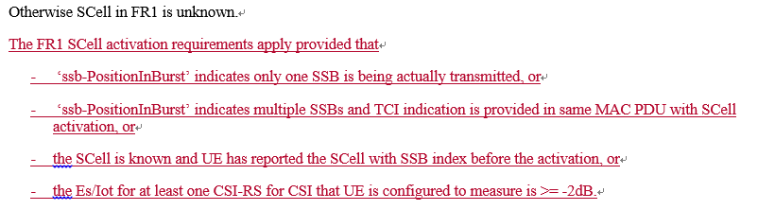

* + Option 2 (Mediatek R4-2014760): N/A
  + Option 3 (Qualcomm R4-2016580):

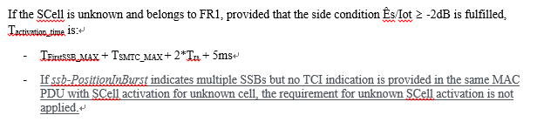

* + Option 4 (NEC R4-2015306)

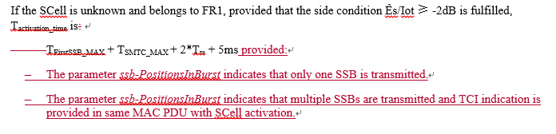

* Recommended WF
  + In principle, it seems that companies are OK to clarify that the requirement is applied on the condition that ‘*ssb-PositionInBurst*’ indicates multiple SSBs and TCI indication is provided in same MAC PDU with SCell activation, or to clarify that if *ssb-PositionInBurst* indicates multiple SSBs but no TCI indication is provided in the same MAC PDU with SCell activation for unknown cell, the requirement for unknown SCell activation is not applied.
  + More discussion on how to make changes

**Issue 2-1-2: Applicability related to first active BWP**

* Proposals (Huawei R4-2015735/R4-2015736):
  + The current SCell activation requirements apply provided that the SSB of the to-be-activated SCell is within the first active DL BWP of the SCell.
* Proposed changes (Huawei R4-2015736):



* Recommended WF
  + More discussion is needed.

### Sub-topic 2-2 SSB-less SCell activation delay requirement

**Issue 2-2: SSB-less SCell activation delay requirement**

* Proposal (Qualcomm R4-2016581, ZTE [R4-2015570](https://www.3gpp.org/ftp/TSG_RAN/WG4_Radio/TSGR4_97_e/Docs/R4-2015570.zip)/[R4-201557](https://www.3gpp.org/ftp/TSG_RAN/WG4_Radio/TSGR4_97_e/Docs/R4-2015570.zip)1)
  + Add an SSB-less SCell activation delay requirement for deactivated FR1 SCell and included QCL relations between refernce signals across cells in the same FR1 band in accordance with allowed QCL relations specified by the current spec.
* Proposed changes:
  + Option 1 (Qualcomm R4-2016581)

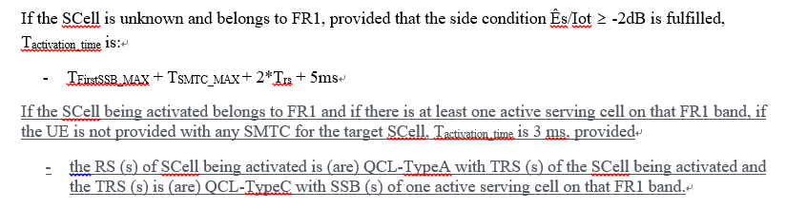

* + Option 2 (ZTE [R4-2015570](https://www.3gpp.org/ftp/TSG_RAN/WG4_Radio/TSGR4_97_e/Docs/R4-2015570.zip)/[R4-201557](https://www.3gpp.org/ftp/TSG_RAN/WG4_Radio/TSGR4_97_e/Docs/R4-2015570.zip)1)

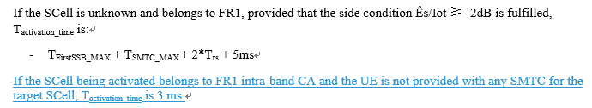

* Recommended WF
  + More discussion is needed

## Companies views’ collection for 1st round

### Comments for open issues

|  |  |
| --- | --- |
| **Company** | **Comments** |
| Apple | **Issue 2-1-1: Applicability related to ssb-PositionInBurst and TCI**  We agree with option 1 if companies would like to define requirement for all the possible scenarios, otherwise we are also fine with option 3 or 4 which mean we preclude those scenarios from requirement.  **Issue 2-1-2: Applicability related to first active BWP**  We support Huawei’s proposal.  **Issue 2-2: SSB-less SCell activation delay requirement**  We have concerns from both feature timeline perspective and technical perspective. Regarding the R15 timeline, we think it’s too late to introduce a new individual kind of requirement for Scell activation; the similar example is PUCCH SCell activation requirement is about to discussed in R17; so we think this SSB less SCell activation could be discussed from at least R16. Regarding the technical part, we have concern for intra-band non-contiguous case with 3us MRTD and the SCS of PCC/SCC is 30kHz, and after adding this SCell without SSB, UE may need to perform CSI-RS based SCell measurement up to its capability but the CSI-RS L3 RSRP/RSRQ measurement is introduced in R16 for RAN4, so we think it’s better to define this requirement after we have requirement for SCell CSI-RS L3 measurement. |
| MTK | 2-1-1:  We support Option 3 in R15. And Option 2 in R16.  When ‘ssb-PositionInBurst’ indicates multiple SSBs but no TCI indication is provided in the same MAC PDU, UE doesn’t know how to deduce timing information for this SCell.  An optional solution is to introduce the $T_{uncertainty,MAC, FR1}$ to wait the TCI info. as FR2 SCell, but considering it’s hard to update the spec. in current stage. We can claim no requirement for this scenario in R15.  At the same time, since this unknown FR1 Scell activation is a rarely case in current real field, we suggest that RAN4 doesn’t need to spend too much time on this paper issue.  2-1-2:  We support HW’s proposal.  In current stage, it’s too late for RAN4 to spend time to discuss this new scenario in R15. We can discuss this scenario in later release.  2-2:  We don’t support to introduce new scenario in R15.  In current stage, it’s too late for RAN4 to spend time to discuss this new scenario in R15. We can discuss this scenario in later release. |
| Ericsson | **Issue 2-1-1: Applicability related to ssb-PositionInBurst and TCI**  Given that this is FR1 where omni-directional antennas are assumed, we think it might be a bit too strict to assume that TCI state indication has to come with the same MAC PDU as the SCell activation command. In FR2 it is different, since UE has to know which spatial transmission filter to use already at the early stages of the activation procedure. For FR1, it should be enough to receive the TCI state indication before CSI-RS or PUCCH (depending on scenario).  **Issue 2-1-2: Applicability related to first active BWP**  The need for this is a little unclear. Why would UE receive over other subband than where the SSBs and/or CSI-RS are before it is ready to receive on PDCCH?  **Issue 2-2: SSB-less SCell activation delay requirement**  Our preference is Option 1 as it is consistent with how the same condition is described for SCell in FR2. |
| NEC | Issue 2-1-1: Applicability related to ssb-PositionInBurst and TCI  We are fine with Ericsson suggestion also. Which is option 5.  Option 5: If the SCell is unknown and belongs to FR1, Tactivation_time is TFirstSSB_MAX + TSMTC_MAX + 2*Trs + 5ms provided the TCI indication is received at UE before CSI-RS reception and the side condition Ês/Iot ≥ -2dB is fulfilled.  Issue 2-1-2: Applicability related to first active BWP  We are ok with proposal  Issue 2-2: SSB-less SCell activation delay requirement  We are prefer option 1 |
| Nokia | **Issue 2-1-1: Applicability related to ssb-PositionInBurst and TCI**  Recommended WF is acceptable but it need to clarified, which of the two options. We prefer to define when they requirements apply.  **Issue 2-2: SSB-less SCell activation delay requirement**  Need more discussion. Baseline proposals looks acceptable; however we would prefer clear definition. |
| CMCC | **Issue 2-2: SSB-less SCell activation delay requirement** |
|  | We support to specify the SSB-less SCell activation delay requirement for FR1. Currently, the requirements for SCell activation without SSB are only specified for FR2, we do not see the reason not to specify the corresponding requirements for FR1. |
| Huawei | **Issue 2-1-1: Applicability related to ssb-PositionInBurst and TCI**  Fine with the recommended WF. In addition, we think at least the last scenario in option 1 should be considered the scenario where the current requirements apply. There seems to be no technical issue raised by companies.  Regarding the new option suggested by Ericsson and NEC, is it correct understanding that UE is assumed to receive TCI within Tactivation_time?  **Issue 2-1-2: Applicability related to first active BWP**  We support the proposal.  To Ericsson, CSI-RS and SSB may not be transmitted on the same BWP, and in particular CSI-RS measurement is on per BWP basis. UE may try to receive CSI-RS on the first active BWP, and thus needs RF retuning to receive SSB if SSB is not contained the first active BWP. Similarly, if UE stays on the BWP with SSB, it will need to re-tune to the first active BWP to receive CSI-RS.  **Issue 2-2: SSB-less SCell activation delay requirement**  This may need to be further discussed. In our understanding, UE is assumed to use the timing of the active cell in the same band for receiving PDSCH or CSI-RS on the SCell. In this sense, the 3us MRTD for intra-band non-contiguous CA could be too large. |
| Qualcomm | **Issue 2-1-1: Applicability related to ssb-PositionInBurst and TCI**  We share the same view as MTK. For argument about “Omni beam for FR1”, it is not spec compliant and can potentially create more forward compatibility issues when beamforming becomes more prevalent than now. For an idea behind option 1 that network can configure UE with multiple CSI-RS resources and/or CSI-RS resource sets for CSI measurement/report, it is undesirable and also up to UE capability.  We believe Option 3 minimizes spec effort and properly addresses concerns about TCI activation missing in FR1 unknown SCell activation requirement. For Rel-16, we can further discuss Option 2 and Option 3.  **Issue 2-2: SSB-less SCell activation delay requirement**  We don’t believe this cause any significant spec effort. When cells are collocated and network is sure that actual reception time different between cells from UE perspective won’t be larger than CP, e.g. small cell deployments, network can activate SCell with very low latency by, e.g. not configuring SSB for the to-be-activated SCell. Note than this will also reduce possible interruption time window and thereby minimize Tput loss. Spec already supports everything for this such as feature list, QCL mapping, configuration, etc other than a simple RAN4 CORE requirement (Option 1). |
| ZTE | **Issue 2-1-1: Applicability related to ssb-PositionInBurst and TCI**  It is fine without requirements when TCI indication is not provided. Kind of agree with E/// that TCI indication isn’t necessary to be in the same MAC CE from specification perspective, though it may be the typical case.  **Issue 2-1-2: Applicability related to first active BWP**  We think this would be a very strong restriction to NW configuration. Instead we think requirements when SSB is outside of first active BWP could be specified if necessary.  **Issue 2-2: SSB-less SCell activation delay requirement**  Requirements for SCell without SSB are specified in Rel-15 for FR2, so there is no reason not to specify requirements for FR1. It cannot be assumed as a new feature or requirement.  Technically, after SCell activation, it is not necessary to perform CSI-RS based L3 measurement for the UE. Measurement can still be based on SSB on the target frequency. UE just needs to follow intra-band PCell/PSCell timing for the SCell without SSB.  For the CR, we have concern on 6581:  the RS (s) of SCell being activated is (are) QCL-TypeA with TRS (s) of the SCell being activated and the TRS (s) is (are) QCL-TypeC with SSB (s) of one active serving cell on that FR1 band.  The above restriction is not necessary for FR1. UE will follow PCell/PSCell timing for the SCell without SSB in FR1 and UE is doing Omni-directional receiving. |

## Summary for 1st round

### Summary of open issues

*Moderator tries to summarize discussion status for 1st round, list all the identified open issues and tentative agreements or candidate options and suggestion for 2nd round i.e. WF assignment.*

|  |  |
| --- | --- |
|  | **Status summary** |
| **Sub-topic#1-X-Y** | ***Tentative agreements:***  ***Candidate options:***  ***Recommendations for 2nd round:*** |

*Recommendations on WF/LS assignment*

|  |  |  |
| --- | --- | --- |
|  | **WF/LS t-doc Title** | **Assigned Company,**  **WF or LS lead** |
| #1 |  |  |

### CRs/TPs Status

*Moderator tries to summarize discussion status for 1st round and provides recommendation on CRs/TPs Status update*

|  |  |
| --- | --- |
| **CR/TP number** | **CRs/TPs Status update recommendation** |
| R4-2015736 |  |
| R4-2015737 |  |
| R4-2016580 |  |
| R4-2015306 |  |
| [R4-2016581](https://www.3gpp.org/ftp/TSG_RAN/WG4_Radio/TSGR4_97_e/Docs/R4-2016581.zip) |  |
| [R4-2015570](https://www.3gpp.org/ftp/TSG_RAN/WG4_Radio/TSGR4_97_e/Docs/R4-2015570.zip) |  |
| R4-2015571 |  |

## Discussion on 2nd round (if applicable)

[Comments and responses will be collected by moderator here]

|  |  |
| --- | --- |
| **Email** | **Status summary** |
|  |  |
|  |  |
|  |  |
|  |  |
|  |  |
|  |  |
|  |  |
|  |  |

## Summary on 2nd round (if applicable)

*Moderator tries to summarize discussion status for 2nd round and provided recommendation on CRs/TPs/WFs/LSs Status update suggestion*

|  |  |
| --- | --- |
| **CR/TP/LS/WF number** | **T-doc Status update recommendation** |
|  |  |
|  |  |
|  |  |
|  |  |
|  |  |

# Topic #3: Beam management

## Companies’ contributions summary

|  |  |  |
| --- | --- | --- |
| **T-doc number** | **Company** | **Proposals / Observations** |
| [R4-2014268](https://www.3gpp.org/ftp/TSG_RAN/WG4_Radio/TSGR4_97_e/Docs/R4-2014268.zip) | Apple | **CR on CSI-RS BW condition for BFD/CBD R15**  Add the side condition of CSI-RS BW for CBD/BFD, i.e., 24PRB. |
| R4-2014269 | Apple | **CR on CSI-RS BW condition for BFD/CBD R16**  Cat A CR for [R4-2014268](https://www.3gpp.org/ftp/TSG_RAN/WG4_Radio/TSGR4_97_e/Docs/R4-2014268.zip) |
| [R4-2015527](https://www.3gpp.org/ftp/TSG_RAN/WG4_Radio/TSGR4_97_e/Docs/R4-2015527.zip) | Huawei, HiSilicon | **CR on BFD and CBD requirements_R15**  Add the condition that the CSI-RS resource is over the bandwidth ≥ 24 PRBs within the active BWP. |
| R4-2015528 | Huawei, HiSilicon | **CR on BFD and CBD requirements_R16**  Cat A CR for [R4-2015527](https://www.3gpp.org/ftp/TSG_RAN/WG4_Radio/TSGR4_97_e/Docs/R4-2015527.zip) |
| [R4-2014270](https://www.3gpp.org/ftp/TSG_RAN/WG4_Radio/TSGR4_97_e/Docs/R4-2014270.zip) | Apple, Huawei, HiSilicon | **On AP-CSI-RS based L1-RSRP measurement**  Proposal 1:  AP CSI-RS based L1-RSRP measurement shall not be performed within MG duration. But outside MG, if this AP CSI-RS for L1-RSRP measurement is overlapped with L3 RRM measurement RS, the AP CSI-RS based L1-RSRP measurement shall be prioritized.  Proposal 2:   * in TS38.133, RAN4 clarifies that scaling factor P=1 for AP CSI-RS based L1-RSRP measurement outside MG regardless of whether this AP CSI-RS is overlapped with L3 measurement RS or not. * in TS38.133, RAN4 clarifies that longer SSB based L3 measurement period would be expected if SSB symbols for L3 measurement are colliding with AP CSI-RS for L1-RSRP. * in TS38.133, RAN4 clarifies that AP CSI-RS based L1-RSRP measurement requirement is not applied for the case that AP CSI-RS is overlapped with MG. |
| [R4-2014271](https://www.3gpp.org/ftp/TSG_RAN/WG4_Radio/TSGR4_97_e/Docs/R4-2014271.zip) | Apple, Huawei, HiSilicon | **CR on AP-CSI-RS based L1-RSRP measurement R15**  Revise the AP CSI-RS based L1-RSRP measurement requirement and add some clarification to L3 SSB based measurement. |
| R4-2014272 | Apple, Huawei, HiSilicon | **CR on AP-CSI-RS based L1-RSRP measurement R16**  Cat A CR for [R4-2014271](https://www.3gpp.org/ftp/TSG_RAN/WG4_Radio/TSGR4_97_e/Docs/R4-2014271.zip) |

## Open issues summary

### Sub-topic 3-1 CSI-RS bandwidth condition for beam management

**Issue 3-1: CSI-RS bandwidth condition for beam management**

* Proposed change:
  + Option 1 (Apple [R4-2014268](https://www.3gpp.org/ftp/TSG_RAN/WG4_Radio/TSGR4_97_e/Docs/R4-2014268.zip)/R4-2014269):

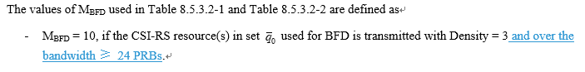

* + Option 2 (Huawei, HiSilicon [R4-2015527](https://www.3gpp.org/ftp/TSG_RAN/WG4_Radio/TSGR4_97_e/Docs/R4-2015527.zip)/R4-2015528)

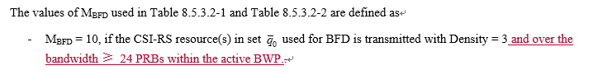

* Recommended WF
  + Which option is agreeable needs more discussion.

### Sub-topic 3-2 Aperiodic CSI-RS based L1-RSPR measurement

**Issue 3-2: Aperiodic CSI-RS based L1-RSRP measurement**

* Proposals (Apple, Huawei, HiSilicon [R4-2014270](https://www.3gpp.org/ftp/TSG_RAN/WG4_Radio/TSGR4_97_e/Docs/R4-2014270.zip)/[R4-2014271](https://www.3gpp.org/ftp/TSG_RAN/WG4_Radio/TSGR4_97_e/Docs/R4-2014271.zip)/R4-2014272)
  + Proposal 1: AP CSI-RS based L1-RSRP measurement shall not be performed within MG duration. But outside MG, if this AP CSI-RS for L1-RSRP measurement is overlapped with L3 RRM measurement RS, the AP CSI-RS based L1-RSRP measurement shall be prioritized.
  + Proposal 2:
    - In TS38.133, RAN4 clarifies that scaling factor P=1 for AP CSI-RS based L1-RSRP measurement outside MG regardless of whether this AP CSI-RS is overlapped with L3 measurement RS or not.
    - In TS38.133, RAN4 clarifies that longer SSB based L3 measurement period would be expected if SSB symbols for L3 measurement are colliding with AP CSI-RS for L1-RSRP.
    - In TS38.133, RAN4 clarifies that AP CSI-RS based L1-RSRP measurement requirement is not applied for the case that AP CSI-RS is overlapped with MG.
* Proposed changes (Apple, Huawei, HiSilicon [R4-2014270](https://www.3gpp.org/ftp/TSG_RAN/WG4_Radio/TSGR4_97_e/Docs/R4-2014270.zip)/[R4-2014271](https://www.3gpp.org/ftp/TSG_RAN/WG4_Radio/TSGR4_97_e/Docs/R4-2014271.zip)/R4-2014272)

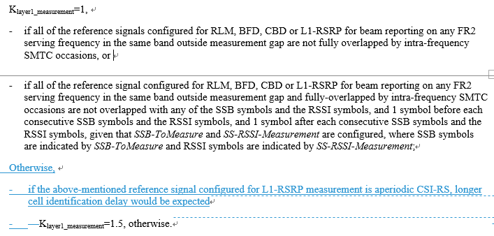

…

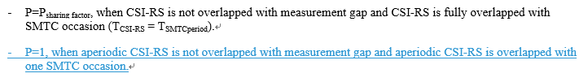

* Recommended WF
  + More discussion is needed

## Companies views’ collection for 1st round

### Comments for open issues

|  |  |
| --- | --- |
| **Company** | **Comments** |
| Apple | **Issue 3-1:**  Either option 1 or option 2 is fine to us.  **Issue 3-2:**  Support both proposal and changes. |
| MTK | Issue 3-1: Both option is fine.  Issue 3-2: Agree. |
| Intel | Issue 3-1:  Both option 1 and option 2 are fine.  Issue 3-2:  Agree about the proposed changes. |
| Ericsson | Issue 3-1 : Either clarification CR looks OK as a starting point. Since the introductory text in the section 8.5.3.1 already says “The requirements in this clause apply for each CSI-RS resource in the set  of resource configurations for a serving cell, provided that the CSI-RS resource(s) in set for beam failure detection are actually transmitted within the UE active DL BWP during the entire evaluation period specified in clause 8.5.3.2.” we don’t see it critical to make a special clarification for active BWP in this particular sub-bullet of 8.3.5.2. since it is generally true anyway.  Issue 3-2: Regarding the first part of the proposed changes, it starts with ‘Otherwise’, and ends with ‘Klayer1_measurement=1.5, otherwise’. We are fine with the intention of the changes, but it is good to improve the sentence.  We think it is better to say ‘aperiodic CSI-RS resources’ rather than ‘aperiodic CSI-RS’. |
| NEC | Issue 3-1: Both options are fine.  Issue 3-2: Support both the proposals in principle. Similar comment as Ericsson regarding the CR text. |
| Nokia | Issue 3-1: CSI-RS bandwidth condition for beam management  Both proposals are fine. UE is anyway only required to measure within the active BWP. However, we would prefer to capture this in the transmission parameter table as this is minimum requirement and have the assumption in the table:   |  |  | | --- | --- | | **Attribute** | **Value for BLER** | | DCI format | 1-0 | | Number of control OFDM symbols | 2 | | Aggregation level (CCE) | 8 | | Ratio of hypothetical PDCCH RE energy to average CSI-RS RE energy | 0dB | | Ratio of hypothetical PDCCH DMRS energy to average CSI-RS RE energy | 0dB | | Bandwidth (PRBs) | 48 | | Sub-carrier spacing (kHz) | SCS of the active DL BWP | | DMRS precoder granularity | REG bundle size | | REG bundle size | 6 | | CP length | Normal | | Mapping from REG to CCE | Distributed | | Bandwidth (CSI-RS) | 24 |   Issue 3-2: Aperiodic CSI-RS based L1-RSRP measurement  Network is aware of when measurement gaps are configured and hence in a good network configuration this should not happen. It is known that UE is not required to measure other than RRM measurements. E.g. ‘is not required to conduct reception/transmission from/to the corresponding NR serving cells for SA (with single carrier or CA configured) except the reception of signals used for RRM measurement(s) and the signals used for random access procedure according to TS38.321 [7].’ |
| Huawei | **Issue 3-1:**  Either option 1 or option 2 is fine to us.  **Issue 3-2:**  Support both proposal and changes.  To Nokia, we agree that UE behavior related to MG is clear, but here the scenario is collision between AP CSI-RS and SMTC outside MG. The current requirement is that P>1 which means AP CSI-RS is not always prioritized/measured. |

## Summary for 1st round

### Summary of open issues

|  |  |
| --- | --- |
|  | **Status summary** |
| **Sub-topic#1-X-Y** | ***Tentative agreements:***  ***Candidate options:***  ***Recommendations for 2nd round:*** |

*Recommendations on WF/LS assignment*

|  |  |  |
| --- | --- | --- |
|  | **WF/LS t-doc Title** | **Assigned Company,**  **WF or LS lead** |
| #1 |  |  |

### CRs/TPs Status

*Moderator tries to summarize discussion status for 1st round and provides recommendation on CRs/TPs Status update*

|  |  |
| --- | --- |
| **CR/TP number** | **CRs/TPs Status update recommendation** |
| [R4-2014268](https://www.3gpp.org/ftp/TSG_RAN/WG4_Radio/TSGR4_97_e/Docs/R4-2014268.zip) |  |
| R4-2014269 |  |
| [R4-2015527](https://www.3gpp.org/ftp/TSG_RAN/WG4_Radio/TSGR4_97_e/Docs/R4-2015527.zip) |  |
| R4-2015528 |  |
| [R4-2014271](https://www.3gpp.org/ftp/TSG_RAN/WG4_Radio/TSGR4_97_e/Docs/R4-2014271.zip) |  |
| R4-2014272 |  |

## Discussion on 2nd round (if applicable)

In the second round the following email threads are needed:

|  |  |
| --- | --- |
| **Email** | **T-doc status summary** |
|  |  |
|  |  |
|  |  |

## Summary on 2nd round (if applicable)

*Moderator tries to summarize discussion status for 2nd round and provided recommendation on CRs/TPs/WFs/LSs Status update suggestion*

|  |  |
| --- | --- |
| **CR/TP/LS/WF number** | **T-doc Status update recommendation** |
|  |  |
|  |  |
|  |  |
|  |  |
|  |  |
|  |  |

# Topic #4: BWP switching

## Companies’ contributions summary

|  |  |  |
| --- | --- | --- |
| **T-doc number** | **Company** | **Proposals / Observations** |
| [R4-2016162](https://www.3gpp.org/ftp/TSG_RAN/WG4_Radio/TSGR4_97_e/Docs/R4-2016162.zip) | Ericsson | **HARQ delay during RRC based BWP, CBW and TCI switching procedures**   * Observation 1: RRC based BWP switching and UE specific CBW are serving cell procedure performed typically under higher SNR. Therefore, HARQ ACK may be delayed in rare circumstances. * Proposal 1: Clarify in the core requirement that if the ACK transmission for the received RRC takes longer than the RRC procedure delay for a procedure then the overall switching delay for that procedure may be extended. * Proposal 2: Proposal 1 is applicable for the following requirements:   + RRC based BWP switching delay   + UE specific CBW change delay and   + RRC based active TCI state switching delay. |
| [R4-2016373](https://www.3gpp.org/ftp/TSG_RAN/WG4_Radio/TSGR4_97_e/Docs/R4-2016373.zip) | Apple | **CR to 38.133 on Active BWP switch and Active TCI State Switching requirements - Rel15**  Add note that longer switching delay may be expected if THARQ > TRRCProcessing |
| R4-2016374 | Apple | **CR to 38.133 on Active BWP switch and Active TCI State Switching requirements - Rel16**  Cat A CR for [R4-2016373](https://www.3gpp.org/ftp/TSG_RAN/WG4_Radio/TSGR4_97_e/Docs/R4-2016373.zip) |
| [R4-2014237](https://www.3gpp.org/ftp/TSG_RAN/WG4_Radio/TSGR4_97_e/Docs/R4-2014237.zip) | Apple | **Discussion on RRC based BWP switch for Scell**  Observation #1: RRC based BWP switch by RRC re-configuration of firstActiveUplinkBWP-Id is not allowed for Scell.  Proposal #1: Update applicability of current RRC based BWP switch to only PCell or PScell.  Proposal #2: Discuss further on how to extend RRC based switching delay requirement to be applicable to SCell  Proposal#3: Send LS to RAN2 to clarify how RRC based BWP switch can be applicable to SCell. |
| [R4-2014565](https://www.3gpp.org/ftp/TSG_RAN/WG4_Radio/TSGR4_97_e/Docs/R4-2014565.zip) | Intel Corporation | **Discussion of RRC based BWP switching on single CC**  Proposal 1: Current single RRC based BWP switch delay requirement in Rel-15 is only applied for PCell or PScell.  Proposal 2: RRC based single BWP switch delay for SCell needs more discussion. |
| [R4-2014238](https://www.3gpp.org/ftp/TSG_RAN/WG4_Radio/TSGR4_97_e/Docs/R4-2014238.zip) | Apple | **CR on Applicability of RRC based BWP switch requirements - Rel15**   1. Delete Editor’s Note 2. Capture that RRC based BWP switch requirements for single CC are only applicable to PCell and PScell. |
| R4-2014239 | Apple | CR on Applicability of RRC based BWP switch requirements - Rel16  Cat A CR for [R4-2014238](https://www.3gpp.org/ftp/TSG_RAN/WG4_Radio/TSGR4_97_e/Docs/R4-2014238.zip). |
| [R4-2015529](https://www.3gpp.org/ftp/TSG_RAN/WG4_Radio/TSGR4_97_e/Docs/R4-2015529.zip) | Huawei, HiSilicon | **CR on RRC-based BWP switch requirements_R15**  Remove the notes: More than one BWP configurations for RRC-based BWP switch on SCell is FFS. |
| R4-2015530 | Huawei, HiSilicon | CR on RRC-based BWP switch requirements_R16  Cat A CR for [R4-2015529](https://www.3gpp.org/ftp/TSG_RAN/WG4_Radio/TSGR4_97_e/Docs/R4-2015529.zip). |
| [R4-2014761](https://www.3gpp.org/ftp/TSG_RAN/WG4_Radio/TSGR4_97_e/Docs/R4-2014761.zip) | MediaTek inc. | **CR on BWP switch**  Clarify RRC-based BWP switch only applies for PCell and PSCell. |
| R4-2015208 | MediaTek inc. | CR on BWP switch  Cat A CR for [R4-2014761](https://www.3gpp.org/ftp/TSG_RAN/WG4_Radio/TSGR4_97_e/Docs/R4-2014761.zip). |
| [R4-2015572](https://www.3gpp.org/ftp/TSG_RAN/WG4_Radio/TSGR4_97_e/Docs/R4-2015572.zip) | ZTE | **CR to 38.133 correction to RRC based BWP switch requirements**  RRC based BWP switch requirements is applicable for RRC configuration (including RRCsetup message and RRCresume message). |
| R4-2015573 | ZTE | CR to 38.133 correction to RRC based BWP switch requirements  Cat A CR for [R4-2015572](https://www.3gpp.org/ftp/TSG_RAN/WG4_Radio/TSGR4_97_e/Docs/R4-2015572.zip) |
| [R4-2015300](https://www.3gpp.org/ftp/TSG_RAN/WG4_Radio/TSGR4_97_e/Docs/R4-2015300.zip) | NEC | CR to TS 38.133 on DCI based BWP switch requirements applicability |

## Open issues summary

### Sub-topic 4-1 HARQ delay

**Issue 4-1: Clarification of requirement applicability when THARQ > TRRCprocessingDelay**

* Proposal (Ericsson [R4-2016162](https://www.3gpp.org/ftp/TSG_RAN/WG4_Radio/TSGR4_97_e/Docs/R4-2016162.zip), Apple [R4-2016373](https://www.3gpp.org/ftp/TSG_RAN/WG4_Radio/TSGR4_97_e/Docs/R4-2016373.zip)/R4-2016374)
  + Proposal 1: Clarify in the core requirement that if the ACK transmission for the received RRC takes longer than the RRC procedure delay for a procedure then the overall switching delay for that procedure may be extended.
  + Proposal 2: Proposal 1 is applicable for the following requirements:
    - RRC based BWP switching delay
    - UE specific CBW change delay and
    - RRC based active TCI state switching delay.
* Proposed change (Apple [R4-2016373](https://www.3gpp.org/ftp/TSG_RAN/WG4_Radio/TSGR4_97_e/Docs/R4-2016373.zip)/R4-2016374)

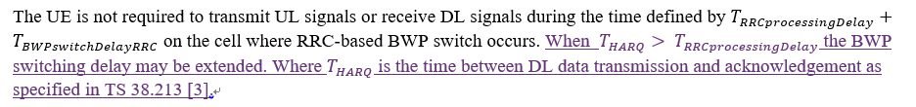

…



* Recommended WF
  + More discussion is needed.

### Sub-topic 4-2 Applicability condition for RRC based BWP switching

**Issue 4-2: Clarification on BWP configuration(s) for active BWP switch**

* Proposals:
  + Proposal 1 (Apple [R4-2014237](https://www.3gpp.org/ftp/TSG_RAN/WG4_Radio/TSGR4_97_e/Docs/R4-2014237.zip), Intel R4-2010032, Mediatek R4-2014760): Update applicability of current RRC based BWP switch to only PCell or PScell.
  + Proposal 2 (Apple [R4-2014237](https://www.3gpp.org/ftp/TSG_RAN/WG4_Radio/TSGR4_97_e/Docs/R4-2014237.zip), Intel R4-2010032): RRC based single BWP switch delay for SCell needs more discussion. Discuss further on how to extend RRC based switching delay requirement to be applicable to SCell.
  + Proposal 3 (Apple [R4-2014237](https://www.3gpp.org/ftp/TSG_RAN/WG4_Radio/TSGR4_97_e/Docs/R4-2014237.zip)): Send LS to RAN2 to clarify how RRC based BWP switch can be applicable to SCell.
  + Proposal 4 (ZTE [R4-2015572](https://www.3gpp.org/ftp/TSG_RAN/WG4_Radio/TSGR4_97_e/Docs/R4-2015572.zip)/[R4-201557](https://www.3gpp.org/ftp/TSG_RAN/WG4_Radio/TSGR4_97_e/Docs/R4-2015572.zip)3): RRC based BWP switch requirements is applicable for RRC configuration (including RRCsetup message and RRCresume message).
* Proposed changes:
  + Option 1 (Apple [R4-201423](https://www.3gpp.org/ftp/TSG_RAN/WG4_Radio/TSGR4_97_e/Docs/R4-2014237.zip)8):

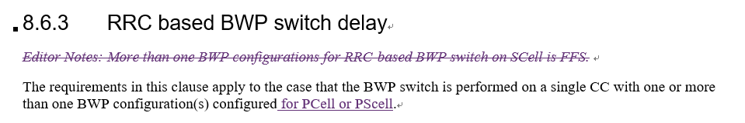

* + Option 2 (Huawei, HiSilicon [R4-2015529](https://www.3gpp.org/ftp/TSG_RAN/WG4_Radio/TSGR4_97_e/Docs/R4-2015529.zip))

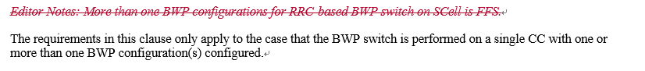

* + Option 3 (Mediatek [R4-2014761](https://www.3gpp.org/ftp/TSG_RAN/WG4_Radio/TSGR4_97_e/Docs/R4-2014761.zip)):

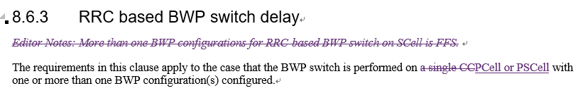

* + Option 4 (ZTE [R4-2015572](https://www.3gpp.org/ftp/TSG_RAN/WG4_Radio/TSGR4_97_e/Docs/R4-2015572.zip))

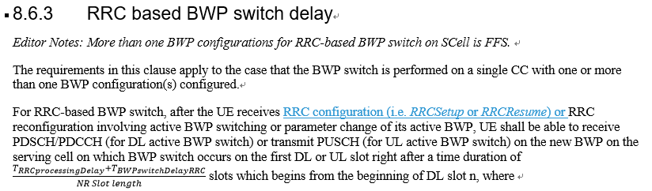

* Draft LS (Apple [R4-2014237](https://www.3gpp.org/ftp/TSG_RAN/WG4_Radio/TSGR4_97_e/Docs/R4-2014237.zip))

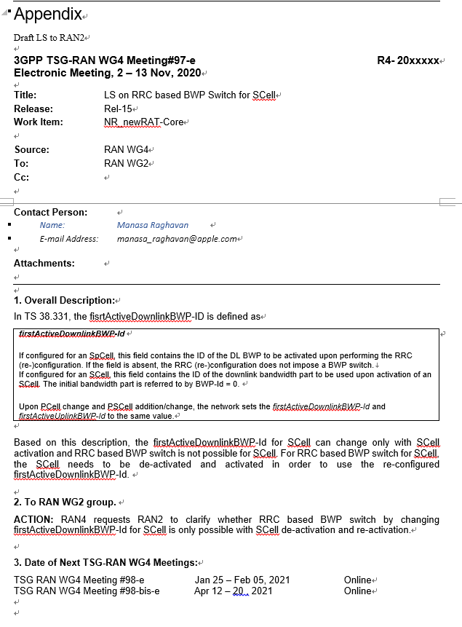

* Recommended WF
  + More discussion is needed.
  + Collect comments for Apple draft LS in [R4-2014237](https://www.3gpp.org/ftp/TSG_RAN/WG4_Radio/TSGR4_97_e/Docs/R4-2014237.zip)

### Sub-topic 4-3 Cross carrier scheduling

**Issue 4-3: Clarification on cross-carrier scheduling**

* Proposed change (NEC [R4-2015300](https://www.3gpp.org/ftp/TSG_RAN/WG4_Radio/TSGR4_97_e/Docs/R4-2015300.zip))

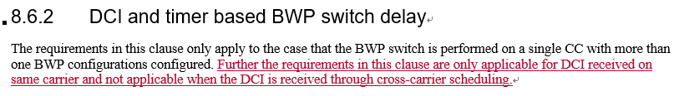

* Recommended WF
  + More discussion is needed

## Companies views’ collection for 1st round

### Comments for open issues

|  |  |
| --- | --- |
| **Company** | **Comments** |
| Apple | Sub-topic 4-1 HARQ delay  When THARQ > TRRCProcessingDelay the HARQ feedback from the UE might take longer due to BWP switch delay, hence the total BWP switching delay could also be longer as the UE is not required to transmit or received during the entire BWP switch delay period.  Sub-topic 4-2 Applicability condition for RRC based BWP switching  Option 1.  Also, we propose to send LS to RAN2 for clarification in case we need further clarification on applicability of existing RRC based BWP switch to SCell  Sub-topic 4-3 Cross carrier scheduling  We agree that requirements defined don’t apply to cross-carrier scheduling. However, we propose the following wording:  The requirements are only applicable to DCI based BWP switch on the same carrier. |
| MTK | Issue 4-1:  As we discussed in several meetings, this is a seldom scenario and only happens in SCS=15KHz.  We don’t agree to introduce this requirement in current stage for R15.  Issue 4-2:  Support proposal 1.  If no consensus in RAN4, we can support on proposal 3.  Issue 4-3:  Agree. |
| Intel | Issue 4-1:  Agree with proposal changes.  Issue 4-2:  Support option 1, option 2 and option 3.  From our understanding, RRC based BWP switch signalling for SCell is more like a configuration command rather than a switching command. LS can help to clarify whether and in what condition RRC based BWP switch can be applicable to SCell.  Issue 4-3:  Agree with proposed changes. |
| Ericsson | **Issue 4-1: Clarification of requirement applicability when THARQ > TRRCprocessingDelay**  Apple and Ericsson share the same proposals, and we are OK with the wording in the CRs (R4-2016373/R4-202016374)  **Issue 4-2 : Clarification on BWP configuration(s) for active BWP switch**  Our understanding is that RRC based BWP switch is possible on an Scell at activation. So RAN4 requirements should include RRC based Scell BWP switch even if might include activation delay. We support Apple proposals 2 and 3 and getting further clarification from RAN2 so that we can define the requirements.  **Issue 4-3: Clarification on cross-carrier scheduling**  Although DCI based BWP using cross carrier scheduling is functionally supported by RAN1 in R15 our understanding is that RAN4 has not defined the requirements because of ambiguities in cases where different SCS is used on the scheduling carrier and the BWP switch carrier which makes it ambiguous where the BWP switch would start from. So then we think that such clarification is OK. |
| NEC | **Issue 4-1: Clarification of requirement applicability when THARQ > TRRCprocessingDelay**  We still think this scenario may not occur. However the clarification may not have much impact on implementation. Hence, we are OK with the change.  **Issue 4-2 : Clarification on BWP configuration(s) for active BWP switch**  BWP change using RRC reconfiguration can happen for following scenarios  a) SCell addition  b) SCell modification  c) ReconfigurationWithSync.  Since the SCell is in deactivated state upon addition, the gNB configures the first activate BWP, to serve as active BWP upon SCell activation by MAC CE. This is applicable for scenario a) and c).  According to our understanding for case b) gNB can still modify BWP parameters through RRC reconfiguration. However changing number of BWP (if more than one BWP is configured) and BWP location/BW is not supported by RAN2 for the reason specified by MTK.  For scenario b) gNB may change BWP (when more than one BWP is configured) of SCell using SCell release and addition (in same RRC message). This actually takes one additional step of SCell activation.  Issue 4-3: Clarification on cross-carrier scheduling  If the changes are agreeable to all companies, we can revise wording if it is required. |
| Nokia | Issue 4-1: Clarification of requirement applicability when THARQ > TRRCprocessingDelay  If it is handling errors, then we don't think that is needed in RAN4 (we do not handle other ack/nack error cases). We had similar discussion in LTE when DRX configuration changed and at that time we left it for network implementation to handle. It would need to clear when conditions leading to the additional delay may happen as otherwise it seems to allow relaxation on UE side for any condition. Our understanding is that network is configuring the HARQ delay by ‘dl-DataToUL-ACK delay’ and this should be clarified. Hence, we can agree on clarifying, but wording would need some discussion.  Issue 4-2: Clarification on BWP configuration(s) for active BWP switch  For R15, according to RAN2 specification, RRC based BWP switch should be performed only for SpCell, proposal 1 is fine in R15. However, in R16 we have direct Scell activation by RRC in which case this parameter is valid, with this feature, RRC-based BWP switch should be performed for any cell.  Since the RAN2 specification is very clear on this, RAN4 does not need to send LS to RAN2 to clarify how RRC based BWP switch can be applicable to SCell.  Proposal 4 is fine.  Issue 4-3: Clarification on cross-carrier scheduling  We don’t think we should limit the DCI-based BWP switching on same carrier, we have cross-carrier scheduling with same SCS requirements in R15. |
| Huawei | Issue 4-2:  We agree that the BWP switch by changing the firstactivebwp-ID via RRC is only applicable for sPCell. But for a SCell, it is feasible to change the parameters of the active BWP ID without changing the active BWP ID via RRC. It is also a typical case considered in Rel-15 as it is stated in in 8.6.3 that “RRC reconfiguration involving active BWP switching or parameter change of its active BWP”. So we support the changes in option 2 that only remove the editor note without any other changes.  Issue 4-3:  The applicability clarification has already been added in the spec (R4-2012242 agreed in the last meeting), so the CR is no needed. |
| ZTE | Issue 4-1:  It seems a corner case. We don’t need to specify requirements for this.  Issue 4-2:  If we look at the current status, proposal 1 should be fine.  We also think it is worthy of further discussion if RAN4 can agree there is benefit if SCell BWP switch can be triggered by RRC directly, rather than via SCell activation. If agreements can be achieved then we can send an LS to RAN2.  ZTE’s CR [R4-2015572](https://www.3gpp.org/ftp/TSG_RAN/WG4_Radio/TSGR4_97_e/Docs/R4-2015572.zip)/[R4-201557](https://www.3gpp.org/ftp/TSG_RAN/WG4_Radio/TSGR4_97_e/Docs/R4-2015572.zip)3 address different issue. It only involves BWP switch on PCell rather than SCell. The main intention is adding the applicable scenario and we see the urgency to do this.  Issue 4-3:  We can further work on the wording. There is common understanding of this issue. |

## Summary for 1st round

### Summary of open issues

*Moderator tries to summarize discussion status for 1st round, list all the identified open issues and tentative agreements or candidate options and suggestion for 2nd round i.e. WF assignment.*

|  |  |
| --- | --- |
|  | **Status summary** |
| **Sub-topic#X-Y-Z** | ***Tentative agreements:***  ***Candidate options:***  ***Recommendations for 2nd round:*** |

*Recommendations on WF/LS assignment*

|  |  |  |
| --- | --- | --- |
|  | **WF/LS t-doc Title** | **Assigned Company,**  **WF or LS lead** |
| #1 |  |  |

### CRs/TPs Status

*Moderator tries to summarize discussion status for 1st round and provides recommendation on CRs/TPs Status update*

|  |  |
| --- | --- |
| **CR/TP number** | **CRs/TPs Status update recommendation** |
| [R4-2016373](https://www.3gpp.org/ftp/TSG_RAN/WG4_Radio/TSGR4_97_e/Docs/R4-2016373.zip) |  |
| R4-2016374 |  |
| [R4-2014238](https://www.3gpp.org/ftp/TSG_RAN/WG4_Radio/TSGR4_97_e/Docs/R4-2014238.zip) |  |
| R4-2014239 |  |
| [R4-2015529](https://www.3gpp.org/ftp/TSG_RAN/WG4_Radio/TSGR4_97_e/Docs/R4-2015529.zip) |  |
| R4-2015530 |  |
| [R4-2014761](https://www.3gpp.org/ftp/TSG_RAN/WG4_Radio/TSGR4_97_e/Docs/R4-2014761.zip) |  |
| R4-2015208 |  |
| [R4-2015572](https://www.3gpp.org/ftp/TSG_RAN/WG4_Radio/TSGR4_97_e/Docs/R4-2015572.zip) |  |
| R4-2015573 |  |
| [R4-2015300](https://www.3gpp.org/ftp/TSG_RAN/WG4_Radio/TSGR4_97_e/Docs/R4-2015300.zip) |  |

## Discussion on 2nd round (if applicable)

[Comments and responses will be collected by moderator here]

|  |  |
| --- | --- |
| **Email** | **Status summary** |
|  |  |
|  |  |
|  |  |
|  |  |
|  |  |
|  |  |
|  |  |
|  |  |

## Summary on 2nd round (if applicable)

*Moderator tries to summarize discussion status for 2nd round and provided recommendation on CRs/TPs/WFs/LSs Status update suggestion*

|  |  |
| --- | --- |
| **CR/TP/LS/WF number** | **T-doc Status update recommendation** |
|  |  |
|  |  |
|  |  |
|  |  |
|  |  |
|  |  |
|  |  |
|  |  |

# Topic #5: TCI switching

## Companies’ contributions summary

|  |  |  |
| --- | --- | --- |
| **T-doc number** | **Company** | **Proposals / Observations** |
| [R4-2014763](https://www.3gpp.org/ftp/TSG_RAN/WG4_Radio/TSGR4_97_e/Docs/R4-2014763.zip) | MediaTek inc. | **CR on TCI state**   * On 8.10.3,   Define the minimum requirement when both SSB and CSI-RS for L1-RSRP measurement are configured.   * On 8.10.6,   Replace TOk by 1. |
| R4-2015209 | MediaTek inc. | **CR on TCI state**  Cat A CR for [R4-2014763](https://www.3gpp.org/ftp/TSG_RAN/WG4_Radio/TSGR4_97_e/Docs/R4-2014763.zip) |
| [R4-2015672](https://www.3gpp.org/ftp/TSG_RAN/WG4_Radio/TSGR4_97_e/Docs/R4-2015672.zip) | ZTE Corporation | **[CR] Specify RRC processing delay in TCI state switching delay**  Specify that the definition of TRRC_processing is given in Clause 12 in TS 38.331. |
| R4-2015673 | ZTE Corporation | **[CR] Specify RRC processing delay in TCI state switching delay (Cat A)**  Cat A CR for [R4-2015672](https://www.3gpp.org/ftp/TSG_RAN/WG4_Radio/TSGR4_97_e/Docs/R4-2015672.zip) |
| [R4-2016373](https://www.3gpp.org/ftp/TSG_RAN/WG4_Radio/TSGR4_97_e/Docs/R4-2016373.zip) | Apple | **CR to 38.133 on Active BWP switch and Active TCI State Switching requirements - Rel15**  Add note that longer switching delay may be expected if THARQ > TRRCProcessing |
| R4-2016374 | Apple | **CR to 38.133 on Active BWP switch and Active TCI State Switching requirements - Rel16**  Cat A CR for [R4-2016373](https://www.3gpp.org/ftp/TSG_RAN/WG4_Radio/TSGR4_97_e/Docs/R4-2016373.zip) |

## Open issues summary

### Sub-topic 5-1 Condition for TCI switching related to SSB and CSI-RS configuration

**Issue 5-1: Condition for TCI switching related to SSB and CSI-RS configuration**

* Proposal (Mediatek [R4-2014763](https://www.3gpp.org/ftp/TSG_RAN/WG4_Radio/TSGR4_97_e/Docs/R4-2014763.zip)/R4-2015209)

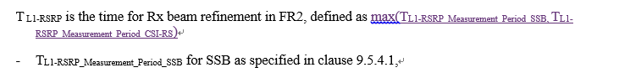

* Recommended WF
  + More discussion is needed.

### Sub-topic 5-2 Active TCI list update

**Issue 5-2: TOk in active TCI list update**

* Proposal (Mediatek [R4-2014763](https://www.3gpp.org/ftp/TSG_RAN/WG4_Radio/TSGR4_97_e/Docs/R4-2014763.zip)/R4-2015209) Delete TOk in active TCI list update requirement.

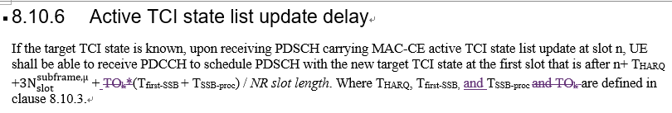

* Recommended WF
  + More discussion is needed.

### Sub-topic 5-3 Condition for TCI switching related to HARQ timing

**Issue 5-3: Condition for TCI switching related to HARQ timing**

* Proposal (Apple R4-2016373/R4-2016374) The other part of CR is discussed in Topic #4

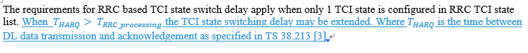

* Recommended WF
  + More discussion is needed.

### Sub-topic 5-4

Please provide the additional comments on the other CRs in Section 5.3.2

## Companies views’ collection for 1st round

### Open issues

|  |  |
| --- | --- |
| **Company** | **Comments** |
| Apple | Sub-topic 5-1 Condition for TCI switching related to SSB and CSI-RS configuration  We agree with the proposal that it’s up to UE implementation on which RS UE chooses to refine RX beam if both SSB and CSI-RS are configured for L1-RSRP measurement.  Sub-topic 5-2 Active TCI list update  We agree with the proposed change.  Sub-topic 5-3 Condition for TCI switching related to HARQ timing  Related to issue 4-1. |
| MTK | Issue 5-1: support the update.  UE doesn’t know follow which RS to execute the L1-RSRP measurement once NW configures both SSB and CSI-RS for measurement. Since RAN4 will only define the minimum requirement, a reasonable solution is the requirement shall follow the longest L1-RSRP delay duration.  Issue 5-2: support the update.  When NW asks UE to update the TCI state list, definitely the new added TCI state wasn’t included in original active TCI list. Otherwise, it’s not expected to update UE’s active TCI list. Thus, UE always needs the timing tracking bullet.  Issue 5-3: The same issue as 4-1. |
| Ericsson | **Issue 5-1: Condition for TCI switching related to SSB and CSI-RS configuration**  We are fine with the proposal.  **Issue 5-2: TOk in active TCI list update**  We are fine with the proposal. It only applies when there is a new TCI state. In case UE receives an identical UE-specific PDSCH TCI state activation bitmap to what it received last time, there is no new active TCI state. So the proposal makes sense.  **Issue 5-3: Condition for TCI switching related to HARQ timing**  We are fine with the proposal. |
| NEC | Issue 5-1:  Ok with the proposal  Issue 5-2:  Ok with the proposal  Issue 5-3:  Similar comments as BWP switching issue. We can agree to proposal as it may not have any implementation impact. |
| Nokia | Issue 5-1: Condition for TCI switching related to SSB and CSI-RS configuration  Is it corner case that network would do this?  This needs more discussion on how to capture this requirement is agreed. Can Mediatek clarify why it would be Max(…) and how the see the UE requirement?  Issue 5-2: TOk in active TCI list update  This needs more discussion. We have different understanding here and this change to us seems contradictive to 8.10.3. The reason for this change: ‘because the new target TCI state should not be in the old active TCI state list. Otherwise, this update is not necessary.’ is not clear to us and would need some clarification.  Issue 5-3: Condition for TCI switching related to HARQ timing  The reason for this change is still unclear. If Apple can clarify the reason for this change. Current change in the CR and reason is unclear. Our understanding is HARQ check and feedback is done on lower layer while the RRC processing higher layer aspect. It is not clear how the condition can be fulfilled. |
| MTK | To Nokia,  Issue 5-1,  From UE’s perspective, NW may configure both L1-RSRP for them. In this situation, UE doesn’t know how to handle it based on current spec.  The reason we using max{} is we suggest to define minimum requirement in RAN4. Otherwise, if we choose any RS as a reference, it will restrict UE’s implementation to follow the spec. But we think in current stage, it’s not a good choice. We can just believe this is a bug fix in R15.  Issue 5-2,  This section title is ‘active TCI state list update delay’. It implies the TCI state will be updated. This equals a new TCI state will be introduced. If no new TCI state will be added, also mentioned in Ericsson’s comments, the TCI list bitmap will be identical with the last one. Thus, no update is needed. |
|  |  |

### CRs/TPs comments collection

Please provide comments in the table below.

|  |  |
| --- | --- |
| **CR/TP number** | **Comments collection** |
| [R4-2015672](https://www.3gpp.org/ftp/TSG_RAN/WG4_Radio/TSGR4_97_e/Docs/R4-2015672.zip)  R4-2015673 | Ericsson : Don’t think the CR is needed even though it is technically correct |
| NEC: We also think CR may not be needed. But no strong view. |
| ZTE: Can Ericsson share with us some thoughts on why this CR seems not needed? In our view it is indeed needed or else the calculation cannot be done and the spec is broken in some sense. |
|  |
|  |
|  |

## Summary for 1st round

### Open issues

*Moderator tries to summarize discussion status for 1st round, list all the identified open issues and tentative agreements or candidate options and suggestion for 2nd round i.e. WF assignment.*

|  |  |
| --- | --- |
|  | **Status summary** |
| **Sub-topic#X-Y-Z** | ***Tentative agreements:***  ***Candidate options:***  ***Recommendations for 2nd round:*** |

*Recommendations on WF/LS assignment*

|  |  |  |
| --- | --- | --- |
|  | **WF/LS t-doc Title** | **Assigned Company,**  **WF or LS lead** |
| #1 |  |  |

### CRs/TPs Status

*Moderator tries to summarize discussion status for 1st round and provides recommendation on CRs/TPs Status update*

|  |  |
| --- | --- |
| **CR/TP number** | **CRs/TPs Status update recommendation** |
| [R4-2014763](https://www.3gpp.org/ftp/TSG_RAN/WG4_Radio/TSGR4_97_e/Docs/R4-2014763.zip) |  |
| R4-2015209 |  |
| [R4-2015672](https://www.3gpp.org/ftp/TSG_RAN/WG4_Radio/TSGR4_97_e/Docs/R4-2015672.zip) |  |
| R4-2015673 |  |

## Discussion on 2nd round (if applicable)

[Comments and responses will be collected by moderator here]

|  |  |
| --- | --- |
| **Email** | **Status summary** |
|  |  |
|  |  |
|  |  |
|  |  |
|  |  |

## Summary on 2nd round (if applicable)

*Moderator tries to summarize discussion status for 2nd round and provided recommendation on CRs/TPs/WFs/LSs Status update suggestion*

|  |  |
| --- | --- |
| **CR/TP/LS/WF number** | **T-doc Status update recommendation** |
|  |  |
|  |  |
|  |  |
|  |  |
|  |  |
|  |  |

# Topic #6: Others

## Companies’ contributions summary

|  |  |  |
| --- | --- | --- |
| **T-doc number** | **Company** | **Proposals / Observations** |
| [R4-2014693](https://www.3gpp.org/ftp/TSG_RAN/WG4_Radio/TSGR4_97_e/Docs/R4-2014693.zip) | CMCC | CR on carrier frequency range of PCell/PSCell for the maximum number of RLM-RS resources |
| R4-2014694 | CMCC | CR on carrier frequency range of PCell/PSCell for the maximum number of RLM-RS resources |
| [R4-2015876](https://www.3gpp.org/ftp/TSG_RAN/WG4_Radio/TSGR4_97_e/Docs/R4-2015876.zip) | Nokia, Nokia Shanghai Bell | Introducing reference to the source of the Lmax and NRLM. |
| R4-2015877 | Nokia, Nokia Shanghai Bell | Introducing reference to the source of the Lmax and NRLM. |
| [R4-2016022](https://www.3gpp.org/ftp/TSG_RAN/WG4_Radio/TSGR4_97_e/Docs/R4-2016022.zip) | Ericsson | CR 36.133 Removal of brackets for SFTD measurements (Rel-15) |
| R4-2016023 | Ericsson | CR 36.133 Removal of brackets for SFTD measurements (Rel-16) |
| [R4-2015731](https://www.3gpp.org/ftp/TSG_RAN/WG4_Radio/TSGR4_97_e/Docs/R4-2015731.zip) | Huawei, HiSilicon | CR to remove intra-frequency ECID requirements for NE-DC 36133 R15 |
| R4-2015732 | Huawei, HiSilicon | CR to remove intra-frequency ECID requirements for NE-DC 36133 R16 |
| [R4-2015733](https://www.3gpp.org/ftp/TSG_RAN/WG4_Radio/TSGR4_97_e/Docs/R4-2015733.zip) | Huawei, HiSilicon | CR to remove inter-RAT ECID requirements for NE-DC 38133 R15 |
| R4-2015734 | Huawei, HiSilicon | CR to remove inter-RAT ECID requirements for NE-DC 38133 R16 |
| [R4-2015159](https://www.3gpp.org/ftp/TSG_RAN/WG4_Radio/TSGR4_97_e/Docs/R4-2015159.zip) | Ericsson | Addition of symbol definitions |
| R4-2015160 | Ericsson | Addition of symbol definitions |

## Open issues summary

### Sub-topic 5-1

Please provide the additional comments on the CRs in Section 5.3.1.

## Companies views’ collection for 1st round

### CRs/TPs comments collection

Please provide the comments in the table below.

|  |  |
| --- | --- |
| **CR/TP number** | **Comments collection** |
| [R4-2014693](https://www.3gpp.org/ftp/TSG_RAN/WG4_Radio/TSGR4_97_e/Docs/R4-2014693.zip)  R4-2014694 | Apple: fine with this CR |
| MTK: Agree. |
| Ericsson : OK |
| NEC: agree |
| Huawei: OK |
| [R4-2015876](https://www.3gpp.org/ftp/TSG_RAN/WG4_Radio/TSGR4_97_e/Docs/R4-2015876.zip)  R4-2015877 | Apple: fine with this CR |
| MTK: Agree. |
| Ericsson : The CR is not needed. The table is not strictly duplicated. There is already the reference in the note of the table in 38.133. |
| NEC: OK |
| Huawei: similar as Ericsson, it seems current spec is correct and complete without the change. |
| [R4-2016022](https://www.3gpp.org/ftp/TSG_RAN/WG4_Radio/TSGR4_97_e/Docs/R4-2016022.zip)  R4-2016023 | Apple: fine with this CR |
| MTK: Agree. |
| Ericsson : OK |
| NEC: OK |
| Huawei: OK |
| [R4-2015731](https://www.3gpp.org/ftp/TSG_RAN/WG4_Radio/TSGR4_97_e/Docs/R4-2015731.zip)  R4-2015732 | Apple: agree with this CR |
| MTK: Agree. |
| Ericsson :  the CR is not needed. According to 38.305, LTE E-CID is supported also in Rel-15 for any serving node. [38.305]4.3.4           Enhanced Cell ID methods In the Cell ID (CID) positioning method, the position of an UE is estimated with the knowledge of its serving ng-eNB, gNB and cell. The information about the serving ng-eNB, gNB and cell may be obtained by paging, registration, or other methods.  Enhanced Cell ID (E‑CID) based on LTE signals positioning refers to techniques which use additional UE measurements and/or NG-RAN radio resource and other measurements to improve the UE location estimate.  Although E-CID based on LTE signals positioning may utilise some of the same measurements as the measurement control system in the RRC protocol, the UE generally is not expected to make additional measurements for the sole purpose of positioning; i.e., the positioning procedures do not supply a measurement configuration or measurement control message, and the UE reports the measurements that it has available rather than being required to take additional measurement actions.  In cases with a requirement for close time coupling between UE and ng-eNB measurements (e.g., TADV type 1 and UE E-UTRA Rx-Tx time difference), the ng-eNB configures the appropriate RRC measurements and is responsible for maintaining the required coupling between the measurements.  In the case of a serving gNB, E‑CID based on LTE signals positioning can be supported using E-UTRA measurements provided by a UE to the serving gNB.  The operation of the Enhanced Cell ID based on LTE signals method is described in clause 8.3. |
| Nokia: Removing the intra-frequency requirement for E-CID PSCC is OK for Rel-15. In NE-DC, SCC E-CID measurements while UE is served by NR PCell are inter-RAT measurements. So, deleting the SCC intra-frequency E-CID measurements is also OK. However, in Rel-16 E-CID measurements based on Rel-16 NR signals is possible. So, intra-frequency measurement requirements should be there for NE-DC case in Rel-16. |
| Huawei:  To Ericsson, we agree that LTE E-CID is supported in Rel-15, but it should be considered as an inter-RAT measurement instead of intra-frequency measurement, since LPP message is transmitted by the NR PCell not LTE PSCell.  To Nokia, we understand this CR is for 36.133 and the E-CID refers to E-CID based on LTE signals. Intra-frequency E-CID measurement based on NR signals are defined in clause 9.9.5 of 38.133, and we agree that it applies also for NE-DC. |
| [R4-2015733](https://www.3gpp.org/ftp/TSG_RAN/WG4_Radio/TSGR4_97_e/Docs/R4-2015733.zip)  R4-2015734 | Apple: agree with this CR |
| MTK: Agree. |
| Ericsson : not needed – see the comment above. intra-frequency LTE E-CID can be configured via Rel-16 LPP via NR PCell if these measurements are on the serving LTE carrier. |
| Nokia: Seems in generally fine. The term E-CID measurements is generic, and it is better to be specific about which measurement we are addressing in general (like it is done in the heading in 9.4.5.1). In 9.4.1, when we say “NR-E-UTRAN FDD or TDD measurement (RSRP, RSRQ, RS-SINR, RSTD, or E-CID)” it is unclear which E-CID measurement is referenced. E-CID in 9.4.1 is deleted but there is one more in the bullet list above the paragraph in which E-CID was deleted. |
| Huawei:  To Ericsson, same as comment above, LTE E-CID can be configured via Rel-16 LPP via NR PCell should be considered as inter-RAT measurement.  To Nokia, we can revise and replace “E-CID” in 9.4.1 to “E-CID RSRP and RSRQ”, if we understand the comments correctly. For the last comment, we understand the bullet is for SA or NR-DC, so the “E-CID” should be kept. |
| [R4-2015159](https://www.3gpp.org/ftp/TSG_RAN/WG4_Radio/TSGR4_97_e/Docs/R4-2015159.zip)  R4-2015160 | Apple: fine with this CR |
| MTK: Agree. |
| NEC: OK |
| Huawei: OK |

## Summary for 1st round

### CRs/TPs Status

*Moderator tries to summarize discussion status for 1st round and provides recommendation on CRs/TPs Status update*

|  |  |
| --- | --- |
| **CR/TP number** | **CRs/TPs Status update recommendation** |
| [R4-2014693](https://www.3gpp.org/ftp/TSG_RAN/WG4_Radio/TSGR4_97_e/Docs/R4-2014693.zip) |  |
| R4-2014694 |  |
| [R4-2015876](https://www.3gpp.org/ftp/TSG_RAN/WG4_Radio/TSGR4_97_e/Docs/R4-2015876.zip) |  |
| R4-2015877 |  |
| [R4-2016022](https://www.3gpp.org/ftp/TSG_RAN/WG4_Radio/TSGR4_97_e/Docs/R4-2016022.zip) |  |
| R4-2016023 |  |
| [R4-2015731](https://www.3gpp.org/ftp/TSG_RAN/WG4_Radio/TSGR4_97_e/Docs/R4-2015731.zip) |  |
| R4-2015732 |  |
| [R4-2015733](https://www.3gpp.org/ftp/TSG_RAN/WG4_Radio/TSGR4_97_e/Docs/R4-2015733.zip) |  |
| R4-2015734 |  |
| [R4-2015159](https://www.3gpp.org/ftp/TSG_RAN/WG4_Radio/TSGR4_97_e/Docs/R4-2015159.zip) |  |
| R4-2015160 |  |

## Discussion on 2nd round (if applicable)

In the second round the following email threads are needed:

|  |  |
| --- | --- |
| **Email** | **T-doc status summary** |
|  |  |
|  |  |
|  |  |

## Summary on 2nd round (if applicable)

*Moderator tries to summarize discussion status for 2nd round and provided recommendation on CRs/TPs/WFs/LSs Status update suggestion*

|  |  |
| --- | --- |
| **CR/TP/LS/WF number** | **T-doc Status update recommendation** |
|  |  |
|  |  |
|  |  |
|  |  |
|  |  |
|  |  |