**3GPP TSG-RAN WG4 Meeting # 97-e R4-2015680**

Electronic Meeting, 2-13 Nov., 2020

**Agenda item:** 11.1.5

**Source:** Huawei

**Title:** TP on spatial emission and interference mitigation

**Document for:** Approval

# Introduction

In RAN#87e the Study on IMT parameters for 6.425-7.025GHz, 7.025-7.125GHz and 10.0-10.5GHz was approved [1].

One of the objective is to prepare answering requests from ITU-R WP5D on relevant information for the sharing and compatibility studies.

* + Information on any other current or future feature of IMT systems that could be relevant for the sharing and compatibility studies w.r.t. other services, including e.g. deterministic calculations or Monte Carlo simulations

In last meeting spatial emission and interference mitigation has been discussed in [2]. The paper provide corresponding TP to TR 38.921.

# References

[1] RP-200513, New SI proposal: Study on IMT parameters for 6.425-7.025GHz, 7.025-7.125GHz and 10.0-10.5GHz Ericsson, Huawei, HiSilicon

[2] R4-2010489, Spatial emission and interference mitigation, Huawei, HiSilicon

[3] R4-20xxxxx, TR 38.921 V 0.2.0

# TP to TR 38.921

#### < START OF CHANGE>

# 9 Other Information relevant for the sharing and compatibility studies

## 9.1 Spatial emission

Traditionally, antenna data sheets provide information on not only the antenna peak gain in the intended direction but also the gain in unwanted directions. To describe characteristics in unintended directions the following metrics are used:

1. The antenna front-to-back ratio, which is the power ratio of radiative power in the main beam directions to the power radiated in the backward direction.
2. The antenna side lobe ratio, which is the power ratio between the main beam direction and the power of the strongest side lobe.

However, for an AAS base station it is clear that these traditional metrics of antenna characteristics are not directly relevant, since an AAS base station has the ability to adaptively shape the spatial characteristics to maintain optimum network throughput. Therefore, additional declarations were defined in TS 38.141-2, Annex G. The additional declarations include information on how much power is radiated outside the intended coverage region in relation to the power radiated with in the intended coverage region.

## 9.2 Interference management

Given an antenna array with *M* multiplied by *N* identical elements, the radiation pattern of the array antenna can be described according to the pattern multiplication theorem as:

(Eq. 9.2-1)

, where is *RE* is the radiation pattern for the array elements and *RA* is the radiation pattern associated to the array factor. The element patten, *RE(q,j)* is based on a parameterized Gaussian shaped element, with floors to model for side-lobe levels and front-to-back ratio. The element peak gain is directivity normalized, hence the peak element gain *GE,max*, element loss *LE* and half power beam widths *3dB* and *3dB* must be selected carefully to maintain correct antenna gain.

It can be noticed that both the element factor and the array factor can be used to shape the composite radiation pattern. The element pattern can be used to suppress side-lobe characteristics. For a limited steering range, a sub-array element can be used to suppress side-lobes better than a single element configuration. Typically for an AAS base station implementation the element radiation pattern and the array factor are customized to optimize the coverage within a specific coverage range for a given deployment scenario.

For a general array antenna, the array factor radiation pattern for transmitting array antenna with *MN* element per polarization can be expressed as:

(Eq. 9.2-2)

, where *wn* is the complex array excitation, **k** is the wave vector of the transmitted wave and **r** is the element location matrix.

9.2.1 Beam nulling

Beam nulling technology is used to suppress the unwanted spatial emission by inserting nulls in the radiation pattern for the direction of the interference. One typical applicable scenarios is multiple beams transmission. As shown in Figure 2 as one example, Beam 1 is the serving beam of UE 1 but the side lobe of beam 1 would interfere the UE2. The SINR for UE2 will be affected. In order to support high order modulation scheme such as DL 256 QAM, using beam nulling technology, a null can be placed at the direction to UE2 for beam 1. The weight of each antenna array of beam 1 can be obtained by specific algorithms so that SINR of beam1 is maximized in the direction to UE1 and the transmission power in the main lobe is maintained, and the side lobe are suppressed in the direction to UE2. Beam nulling can also be used in the inter-cell or inter system scenarios as long as the location or direction of the protected station is known.

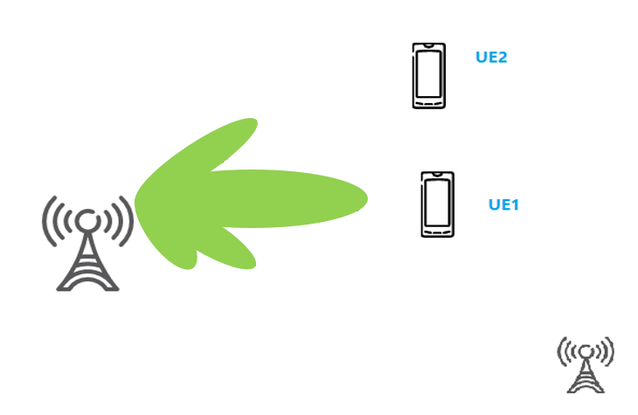

**X**

**X**

**Figure 9.2.1-1: Side lobe interference**

9.2.2 Amplitude weighting/tapering

AAS offer a wide range of opportunities on optimizing the directivity patterns through amplitude and phase control. High directivity antenna array also have side lobes which are often undesirable since they may cause intra-cell or inter-cell interference. Side lobe levels can be reduced via tailoring the amplitude across the antenna array which is often referred as amplitude weighting technology. Whilst amplitude weighting/tapering reduces the side lobes it also makes the main lobe wider and hence reduces gain. It needs tradeoff between antenna gain and side lobe suppression. For example:



Kaiser (a=3) Chebwin (R=35dB)

**Figure 9.2.2-1: Examples for amplitude weighting/tapering**

9.2.3 Asymmetric Side lobe shaping

In addition to beam tapering it is possible to manipulate the amplitude and the phase of the window (for example using modified Taylor series) to modify the side lobe levels asymmetrically. This technique is widely used with passive BS arrays to make the ground side lobes larger to fill in the angles between the main beam and the antenna. The same technique can be used to minimise radiation in specified unwanted directions. For example:



**Figure 9.2.3-1: Example for modified Taylor window**

#### < END OF CHANGE>