3GPP TSG-RAN WG4 Meeting #97-e R4-2014173
Electronic Meeting, Nov 2nd – 13th, 2020

Source: Qualcomm Incorporated
Title: 35MHz 45MHz AMPR, MPR, REFSENS
Agenda item: 10.22.3
Document for: Approval

Introduction
In this document, we discuss 35MHz and 45MHz AMPR MPR and REFSENS performance.

Discussion

Background
Last meeting, WF was generated to provide guidance on future work for 35MHz and 45MHz channel BWs [1].
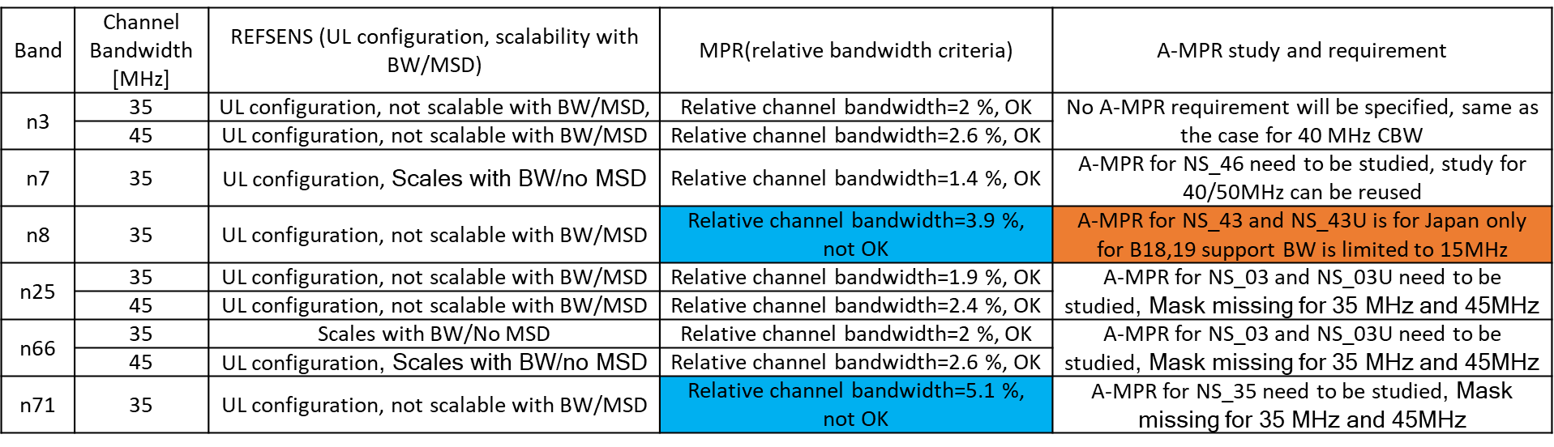

AMPR

n7 and B38 coexistence (NS_46)

Additional emission requirements:
The additional requirements for NS_46 are shown in Table 2.2.1-1.

Table 2.2.1-1: Additional requirements for “NS_46”
Protected band | Frequency range (MHz) |  |  | Maximum Level (dBm) | MBW (MHz) | NOTE
Frequency range | 2570 | - | 2575 | +1.6 | 5 | 1, 2
Frequency range | 2575 | - | 2595 | -15.5 | 5 | 1, 2
Frequency range | 2595 | - | 2620 | -40 | 1 | 1
NOTE 1: This requirement is applicable for carriers confined in 2500-2570 MHz.
NOTE 2: For these adjacent bands, the emission limit could imply risk of harmful interference to UE(s) operating in the protected operating band.

Analysis assumptions for AMPR

Current TS36.101 NS_07 B13 AMPR specification assumes no filter rejection in adjacent public safety band, and some current UE implementations may not have enough filter rejection to meet the strict requirement. Simulations are shown in section 4.1.

- No filter rejection from 2570-2620MHz
- CIM3 = -60dBc,
- Image and Carrier suppression at -28dBc
- PA calibration point of 1dB MPR to meet general requirements for full allocated DFT-s-OFDM QPSK waveform.

AMPR specifications for NS_46
As with the other channel BWs, the specification is written in such a way to align with the RB boundaries of LTE CA_NS_06 but adjusted for the NR spectral utilization. AMPR simulations are shown in section 4.
Table 2.2.1-2: A-MPR regions for NS_46
Channel Bandwidth, MHz | Carrier Center Frequency, Fc, MHz | Regions |  | A-MPR
Channel Bandwidth, MHz | Carrier Center Frequency, Fc, MHz | RB_{end}*12*SCS  MHz | L_{CRB}*12*SCS  MHz | A-MPR
25 MHz | 2534.5 ≤ F_{C} < 2557.5 |  | Note 1 | A3
30 MHz | 2515 ≤ F_{C} ≤ 2555 | ≥0, <1.44 | >0 | A4
30 MHz | 2515 ≤ F_{C} ≤ 2555 | ≥1.44, <13.5 | >max (0, 12*SCS*RB_{end} -1.8) | A5
30 MHz | 2515 ≤ F_{C} ≤ 2555 | ≥13.5, <19.8 | >11.52 | A6
30 MHz | 2515 ≤ F_{C} ≤ 2555 | ≥19.8, <25.92 | >6.3 | A7
30 MHz | 2515 ≤ F_{C} ≤ 2555 | ≥25.92 | >0 | A8
35 MHz | 2517.5 ≤ F_{C} ≤ 2552.5 | ≥0, <2.7 | >0 | A4
35 MHz | 2517.5 ≤ F_{C} ≤ 2552.5 | ≥2.7, <13.5 | >max (0, 12*SCS*RB_{end} –2.7) | A5
35 MHz | 2517.5 ≤ F_{C} ≤ 2552.5 | ≥13.5, <23.76 | >9.0 | A6
35 MHz | 2517.5 ≤ F_{C} ≤ 2552.5 | ≥23.76, <29.52 | >9.0 | A7
35 MHz | 2517.5 ≤ F_{C} ≤ 2552.5 | ≥29.52 | >0 | A8
40 MHz | 2520 ≤ F_{C} ≤ 2550 | ≥0, <4.14 | >0 | A4
40 MHz | 2520 ≤ F_{C} ≤ 2550 | ≥4.14, <18 | >max (0, 12*SCS*RB_{end} - 4.5) | A5
40 MHz | 2520 ≤ F_{C} ≤ 2550 | ≥18, <25.74 | >13.5 | A6
40 MHz | 2520 ≤ F_{C} ≤ 2550 | ≥25.74, <32.4 | >12.6 | A7
40 MHz | 2520 ≤ F_{C} ≤ 2550 | ≥32.4 | >0 | A8
50 MHz | 2525 ≤ F_{C} ≤ 2545 | ≥0, <9 | >0 | A4
50 MHz | 2525 ≤ F_{C} ≤ 2545 | ≥9, <21.6 | >max (0, 12*SCS*RB_{end} - 7.2) | A5
50 MHz | 2525 ≤ F_{C} ≤ 2545 | ≥21.6, <31.5 | >18 | A6
50 MHz | 2525 ≤ F_{C} ≤ 2545 | ≥31.5, <39.6 | >16.2 | A7
50 MHz | 2525 ≤ F_{C} ≤ 2545 | ≥39.6 | >0 | A8
Note 1: >9.72MHz for DFT-s-OFDM, >16.02MHz for CP-OFDM.

Table 2.2.1-3: A-MPR for NS_46
Modulation/Waveform |  | A3 | A4 | A5 | A6 | A7 | A8
 |  | Outer | Outer/Inner | Outer/Inner | Outer/Inner | Outer/Inner | Outer/Inner
DFT-s-OFDM | PI/2 BPSK | 4.5 | 5 | 2 | 3.5 | 6 | 10
DFT-s-OFDM | QPSK | 4.5 | 5 | 2 | 3.5 | 6 | 10
DFT-s-OFDM | 16 QAM | 4.5 | 5 | 2 | 3.5 | 6 | 10
DFT-s-OFDM | 64 QAM | 4.5 | 5 |  | 3.5 | 6 | 10
DFT-s-OFDM | 256 QAM |  |  |  |  | 6 | 10
CP-OFDM | QPSK | 6 | 5 | 3.5 | 5.5 | 7 | 11
CP-OFDM | 16 QAM | 6 | 5 | 3.5 | 5.5 | 7 | 11
CP-OFDM | 64 QAM | 6 | 5 | 3.5 | 5.5 | 7 | 11
CP-OFDM | 256 QAM | 6 |  |  |  | 7 | 11

Proposal 1: Use 35MHz NS_46 AMPR as highlighted in Section 2.2.1-2/3.

n25 and n66 (NS_03)
Updated NS_03 requirement below:
Δf_{OOB}  MHz | Channel bandwidth (MHz) / Spectrum emission limit (dBm) |  |  |  |  |  |  |  |  | Measurement bandwidth
Δf_{OOB}  MHz | 5 | 10 | 15 | 20 | 25 | 30 | 35 | 40 | 45 | Measurement bandwidth
± 0-1 | -13 | -13 | -13 | -13 | -13 | -13 | -13 | -13 | -13 | 1 % of channel BW
± 1-6 | -13 | -13 | -13 | -13 | -13 | -13 | -13 | -13 | -13 | 1 MHz
± 6-10 | -25 | -13 | -13 | -13 | -13 | -13 | -13 | -13 | -13 | 1 MHz
± 10-15 |  | -25 | -13 | -13 | -13 | -13 | -13 | -13 | -13 | 1 MHz
± 15-20 |  |  | -25 | -13 | -13 | -13 | -13 | -13 | -13 | 1 MHz
± 20-25 |  |  |  | -25 | -13 | -13 | -13 | -13 | -13 | 1 MHz
± 25-30 |  |  |  |  | -25 | -13 | -13 | -13 | -13 | 1 MHz
± 30-35 |  |  |  |  |  | -25 | -13 | -13 | -13 | 1 MHz
± 35-40 |  |  |  |  |  |  | -25 | -13 | -13 | 1 MHz
± 40-45 |  |  |  |  |  |  |  | -25 | -13 | 1 MHz
± 45-50 |  |  |  |  |  |  |  |  | -25 | 1 MHz

Proposal 2: Use same NS_03 AMPR 35MHz and 45MHz as specified in TS38.101-1.

n71 (NS_35)
Simulations were run and results are shown in section 4.3 using the SEM requirement below
Δf_{OOB}  (MHz) | Channel bandwidth (MHz) / Spectrum emission limit (dBm) |  |  |  |  |  | Measurement bandwidth
Δf_{OOB}  (MHz) | 5 |  | 10 | 15 | 20 | 35 | Measurement bandwidth
± 0-0.1 | -15 |  | -18 | -20 | -21 | -23.5 | 30 kHz
± 0.1-6 | -13 |  | -13 | -13 | -13 | -13 | 100 kHz
± 6-10 | -25¹ |  | -13 | -13 | -13 | -13 | 100 kHz
± 10-15 |  |  | -25¹ | -13 | -13 | -13 | 100 kHz
± 15-20 |  |  |  | -25¹ | -13 | -13 | 100 kHz
± 20-25 |  |  |  |  | -25¹ | -13 | 100 kHz
± 25-35 |  |  |  |  |  | -13 | 100 kHz
± 35-40 |  |  |  |  |  | -25 | 1 MHz
 |  | NOTE 1: The measurement bandwidth shall be 1 MHz

Simulation assumptions:
- CIM3 = -60dBc,
- Image and Carrier suppression at -28dBc
- PA calibration point of 1dB MPR to meet general requirements for full allocated DFT-s-OFDM QPSK waveform.

Simulations show no need for A-MPR; however, the measurements show a different picture due to linearity sensitivity to filter loading and associated memory effects with filling the entire RF band with 35MHz channel bandwidth. Therefore, further measurement study is required to determine AMPR impact.

Observation 1: Further measurement study is required to determine the 35MHz NS_35 AMPR impact.

REFSENS

n3 REFSENS
The analysis for NR band n3 is shown in Table 2.3.1-1. As the bandwidth increases, the amount of 5th order overlap in the RX bandwidth increases, so the sensitivity will degrade at a higher rate with respect to ideal REFSENS. The 5th order arises from the inter-modulation of CIM3 and the TX allocation along with the actual CIM5.

Table 2.3.1-1: REFSENS analysis and UL configuration.

Proposal 3: Use n3 35MHz and 45MHz REFSENS and UL configuration as highlighted in Table 2.3.1-1.

n25 REFSENS
The analysis for NR band n25 is shown in Table 2.3.2-1. As the bandwidth increases, the amount of 5th order overlap in the RX bandwidth increases, so the sensitivity will degrade at a higher rate with respect to ideal REFSENS. The 5th order arises from the inter-modulation of CIM3 and the TX allocation along with the actual CIM5. Also, at 45MHz, the IM3 of the TX image with the TX signal overlaps into the RX Victim BW.
Table 2.3.2-1: REFSENS analysis and UL configuration.

Proposal 4: Use n25 35MHz and 45MHz REFSENS and UL configuration as highlighted in Table 2.3.2-1.

n71 REFSENS
With the addition of 35MHz BW, the REFSENS degrades quite a bit keeping the same RB allocation position at RB start 0. The primary degradation is due to 3rd order intermodulation between TX image and the TX signal. When the RB position changes from 0 to 42, only the 5th order distortion comes into play like the partial overlap of 5th order distortion at 20MHz. Moving the RB position to 63, removes all effects of TX distortion.
Table 2.3.3-1: REFSENS analysis and UL configuration.

Proposal 5: Choose one of the three n71 35MHz REFSENS and UL configuration as highlighted in Table 2.3.3-1. Square brackets applied pending additional measurements.

n8 REFSENS
With the addition of 35MHz BW, the REFSENS degrades quite a bit keeping the same RB allocation position at RB end = NRB-1. The primary degradation is due to 3rd order intermodulation between TX image and the TX signal. When the RB end position changes from NRB-1 to NRB-44, only the 5th order distortion comes into play like the partial overlap of 5th order distortion at 20MHz. Moving the RB end position from NRB -1 to NRB-64, removes all effects of TX distortion.
Table 2.3.4-1: REFSENS analysis and UL configuration.

Proposal 6: Choose one of the three n8 35MHz REFSENS and UL configuration as highlighted in Table 2.3.4-1. Square brackets applied pending additional measurements.

MPR
For n71 and n8, the 35MHz channel BW exceeds the relative channel BW requirement of 3% as indicated in the WF.
Measurements show ACLR degradation using the full channel BW most likely due to PA filter loading sensitivity at both ends of the RF band. Linearity performance can be adversely affected. Memory effects can also be observed. The result can show ACLR imbalance. Correcting the imbalance would improve the margin to the general SEM requirement, but more time is required to investigate performance impact on the general ACLR requirement.

Observation 2: ∆MPR to meet general requirements may be applicable due to relative channel BW exceeding 3% threshold. The amount of ∆MPR needed requires further measurement study for n71 and n8 35MHz channel bandwidth.

Conclusion
Proposal 1: Use 35MHz NS_46 AMPR as highlighted in Section 2.2.1-2/3.

Proposal 2: Use same NS_03 AMPR 35MHz and 45MHz as specified in TS38.101-1.

Observation 1: Further measurement study is required to determine the 35MHz NS_35 AMPR impact.

Proposal 3: Use n3 35MHz and 45MHz REFSENS and UL configuration as highlighted in Table 2.3.1-1.
Proposal 4: Use n25 35MHz and 45MHz REFSENS and UL configuration as highlighted in Table 2.3.2-1.
Proposal 5: Choose one of the three n71 35MHz REFSENS and UL configuration as highlighted in Table 2.3.3-1. Square brackets applied pending additional measurements.
Proposal 6: Choose one of the three n8 35MHz REFSENS and UL configuration as highlighted in Table 2.3.4-1. Square brackets applied pending additional measurements.
Observation 2: ∆MPR to meet general requirements may be applicable due to relative channel BW exceeding 3% threshold. The amount of ∆MPR needed requires further measurement study for n71 and n8 35MHz channel bandwidth.

References:
- R4-2011793, “WF on UE RF requirement for 35 and 45MHz channel bandwidths “, Skyworks, Huawei, ZTE, [Qualcomm], 3GPP TSG-WG4 Meeting RAN4#96-e.

Simulations

Simulations for NR band n7

DFT-s-OFDM simulation plots 35 MHz with Fc =2552.5 MHz

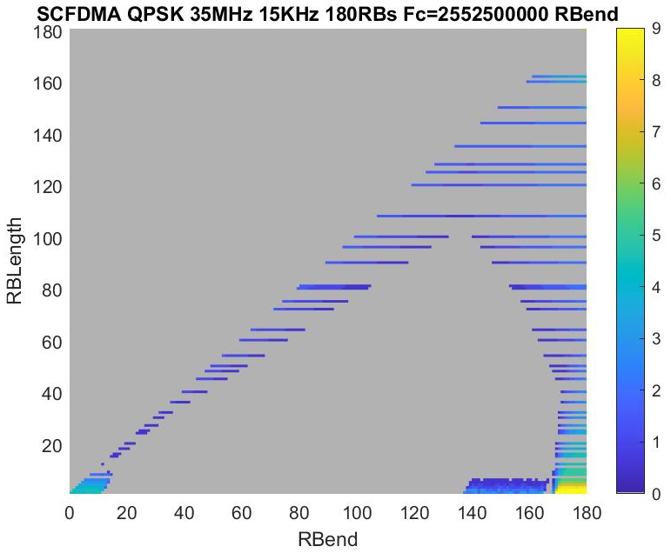

OFDM simulation plots 35 MHz with Fc =2552.5 MHz
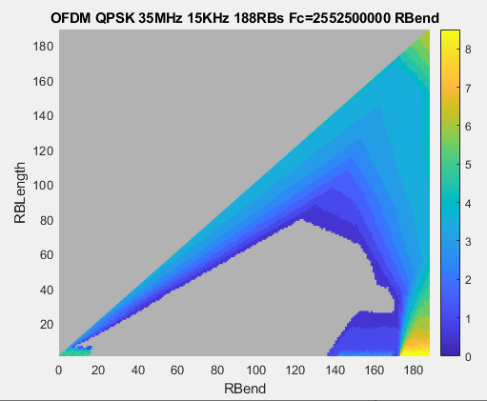
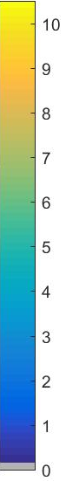

Simulations for NS_03

DFT-s-OFDM simulation plots 35 MHz in NR band n2

DFT-s-OFDM simulation plots 45 MHz in NR band n2

Simulations for NS_35

DFT-s-OFDM simulation plots 35 MHz in NR band n71
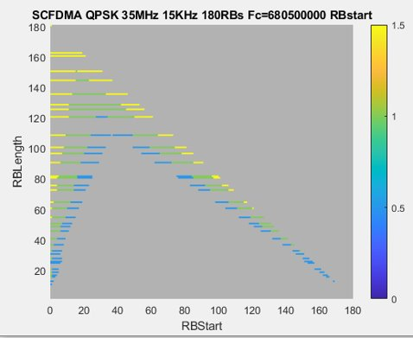

CP-OFDM simulation plots 35 MHz in NR band n71

