3GPP TSG-RAN WG4 Meeting # 97-e R4-20xxxxx
Electronic Meeting, Nov 2nd – 13th, 2020

Agenda item: 7.19.3
Source: Moderator (OPPO)
Title: Email discussion summary for [97e][116] NR_R16_Maintenance
Document for: Information

Introduction
This document summarizes the email discussions for agenda item 7.19.3 which is intended for R16 maintenance.
The discussions of this email thread are divided into the following four areas, i.e. papers for 38.101-1, for 38.101-2, for 38.101-3 and for other specs.

Topic #1: Papers for 38.101-1

Companies’ contributions summary
T-doc number | Company | Proposals / Observations
R4-2014167  Type: CR  CAT: F | Qualcomm | Title: CR CatF n7 NS_46 AMPR and coexistence  WIC: NR_n7_BW  Reason for change:  Missing the additional spurious requirement for NS_46 large channel BWs > 20MHz.  Summary of change:  - Add reference to the missing additional requirement sub-clause for channel BWs > 20MHz.  - Remove AMPR for 15MHz and 20MHz channel BWs for NS_46.  - Modify note 21 in coexistence table to refer to coexistence requirements only apply for channel BWs up to 20MHz with RB restriction for 15MHz and 20MHz channel BWs.  - Add the missing additional requirement sub-clause for all channel BWs for NS_46.
R4-2014517  Type: CR  CAT: F | Nokia | Title: n53 bracket removal  WIC: NR_n53-Core  Reason for change:  RAN5 is developping test cases for n53 but this band has A-MPR values and OOB table note 6 still in brackets which means that these requriements are untestable. Furthermore some references and numbering is corrected  Summary of change:  - Brackets removed and errors corrected
R4-2014520  Type: CR  CAT: B | Nokia, AT&T | Title: TS 38.101-3: Addition of missing lower order fallbacks  WIC: TEI16  Reason for change:  These configurations have relating higher order configurations already in REL16 specs. It is important to add these as a correction inorder to retain specification intergity.  DC_2A-30A_n2A  DC_2A-66A_n2A  DC_29A-30A_n2A  DC_29A-30A_n66A  DC_30A-66A_n66A  Summary of change:  Missing lower order configurations are added.  MSD for DC_2A-66A_n2A is reused from DC_2A-66A_n25A.  MSD for DC_29A-30A_n66A is reused from DC_1A-28A_n7A
R4-2014521 | Nokia, AT&T | Title: TR 37.716-21-11: Addition of missing lower order fallbacks
R4-2015033  Type: CR  CAT: F | ZTE | Title: CR to TS38.101-1: Correction on the general requirement and configured transmitted power requirement for inter-band DC  WIC: NR_newRAT-Core  Reason for change:  For the general requirement (subclause 4.3)  1. The sentence agreed in R4-2006997 was not implemented in the latest spec.  For Pcmax: (subclause 6.2B.4.1)  1. According to the configured transmitted power single carrier, the total power reduction is (MPR+ ∆MPR) dB.  2. The feature of PC2 inter-band NR-DC combination is not supported in Rel-16, therefore it is no need to consider ΔPPowerClass in the formulas.  3. The explanation for some inter-band DC specfied terms in the formulas are missing..  Summary of change:  - Add the sentence agreed in R4-2006997 in sub-clause 4.3  - Add ∆MPR in the term of MAX(MPRc A-MPRc), i.e. MAX(MPRc+∆MPRc, A-MPRc) and delete ΔPPowerClass in the PCMAX_L,f,c,MCG and PCMAX_L,f,c,SCG formulas  - Add the explanations for some inter-band DC specfied terms.
R4-2015299  Type: CR  CAT: F | Huawei | Title: Editorial correction on section 5.2C to 38.101-1 R16  WIC: TEI16  Reason for change:  This CR corrects title for 5.2C  Summary of change:  This CR corrects title for 5.2C
R4-2015339  Type: CR  CAT: F | OPPO | Title: CR on sum of power for multiple transmit connectors  WIC: TEI16  Reason for change:  In R4-2011768, below agreements have been reached in changing the description of how to sum powers from multiple connectors. The agreement is reproduced below. Even the agreements are made for UL MIMO/TxD, it is also applicable to other cases which require summing of powers from multiple connectors.  - RAN4 agree to define requirements for MOP and emission so that power is measured correctly for all implementations, including UE with transparent TxD:  - Use “requirements are defined as the sum of powers from both connectors”.  - This shall be interpreted as: Measure the power and emissions per connector and then sum them up afterwards.  - RAN4 will clean-up all requirements related to summing the powers and emissions, including UL MIMO, UL full power transmission requirement.  Summary of change:  Change the description from “measured as the sum of maximum output power at each UE antenna connector” to “defined as the sum of maximum output power from both UE antenna connectors”.
R4-2015553  Type: Discussion paper for approval | Huawei, HiSilicon, CMCC | Title: Discussion on spurious emission about UE co-existence between band n40 and n41  Proposal 1: To introduce -50dBm/MHz spurious emission requirements for band n41 frequency range when band n40 transmitting power.  Proposal 2: To introduce -40dBm/MHz spurious emission requirements for band n40 frequency range when band n41 transmitting power.
R4-2015554  Type: CR  CAT: F | Huawei, HiSilicon, CMCC | Title: CR on spurious emission about UE co-existence between band n40 and n41  WIC: NR_RF_FR1-Core  Reason for change:  1. The operators in China has a plan to use the asynchronized deployment between band n40 and n41. It’s necessary to specify the spurious emission about UE co-existence between band n40 and n41.  Summary of change:  - To add protected band n41 for band n40 spurious emissions for UE co-existence.  - To add protected band n40 for band n41 spurious emissions for UE co-existence.
R4-2015557  Type: CR  CAT: F | Huawei, HiSilicon | Title: CR for 38.101-1 to correct the notation of SUL band combinations in order to be aligned with 38.101-3  WIC: NR_SUL_combos_R16-Core  Reason for change:  1. Based on agreed CR R4-2006997, the sentence “5.2C Operating band combination for SUL” should be removed from subclause 5.2B. The headline of sub-clause 5.2C is missing.  2. Based on the agreed CR R4-2009948, the notation of DC_66A_n78(2A)_SUL_n78A-n86A is changed into DC_66A_ SUL_n78(2A)-n86A. The notation of SUL_n78(2A)-n86A can be aligned with 38.101-3. It’s helpfut to avoid the confusion.  3. Based on agreed CR R4-2009178, the sentence “6.3C Output power dynamics for SUL” should be removed from subclause 6.3B. The headline of sub-clause 6.3C is missing.  Summary of change:  1. To move the sentence “5.2C Operating band combination for SUL” as headline of sub-clause 5.2C.  2. To change the notation of CA_n78(2A)_SUL_n78A-n86A into SUL_n78(2A)-n86A.  3. To move the sentence “6.3C Output power dynamics for SUL” as headline of sub-clause 6.3C.
R4-2015699  Type: CR  CAT: F | Huawei, HiSilicon | Title: Reference measurement channels for 70 MHz CBW  WIC: TEI16  Reason for change:  70 MHz CBW is introduced in Rel-16 for band n77/n78, but the reference measurement channels for 70 MHz CBW are not defined.  Summary of change:  1. RMC for 70 MHz CBW is added
R4-2015914  Type: CR  CAT: F | Keysight | Title: Correction to supported channel bandwidths per SUL_n41A-n81A  WIC: NR_SUL_combos_R16-Core  Reason for change:  SUL_n41A-n81A ban combination includes 25 MHz and 30 MHz channel bandwiths for frequency band n81 but they are not supported according to table 5.3.5-1.  Summary of change:  Removing channel bandwidths 25 MHz and 30 MHz
R4-2016341  Type: CR  CAT: F | Ericsson | Title: CR for editorial corrections 38.101-1  WIC: NR_CA_R16_Intra  Reason for change:  Editorial corrections 38.101-1.  Summary of change:  Adding space between BW’s in the 2nd channel BW column for CA_n1B  Removing 35 MHz for CA_n7B in configuration table since 35 MHz is not yet defined.  Removing empty rows for CA_n48B and CA_n48C in Table 5.5A.1-1 (highlighted red)  Remove emply first row of CA_n48(2A) in Table 5.5A.2-1 (highlighted red)  Adding missing SCS for CA_n20A-n78A, CA_n41C-n79A, CA_n46B-n48A, CA_n46C-n48A, CA_n46D-n48A, CA_n46E-n48A  Correcting references from CA_7(2A) to CA_n7(2A) instead  Correcting references from CA_25(2A) to CA_n25(2A) instead  For the n41 row for CA_n41(2A)-n71A, the SCS column and the CA_n41(2A) BW column is merged (highlighted yellow)  For the n78 row for CA_n7A-n66A-n78(2A), the SCS column and the CA_n78(2A) BW column is merged (highlighted yellow)  Format the SCS values to the center for CA_n25A-n41A-n71A  Delete the emply rows between CA_n25A-n66A-n78A and CA_n28A-n40A-n78A (highlighted red)
R4-2016442  Type: CR  CAT: D | Qualcomm | Title: Replacement of void sub-clauses  WIC: NR_newRAT-Core  Reason for change:  Sub-clauses were incorrect marked as “Void” when the intention was to reserve them for future usage.  Summary of change:  Void sub-clauses are replaced with “Reserved”. Reserved sub-clauses are added to maintain clause numbering continuity. 7.3F is moved to 7.3B and 7.3G is moved to 7.3F.
R4-2016451  Type: CR  CAT: F | T-Mobile USA | Title: CR to for 38.101-1: CA uplink power clarification  WIC: TEI16  Reason for change:  Some of the wording on UE maximum output power for carrier aggregation is unclear  Summary of change:  Clarify the wording for UE maximum output power for carrier aggregation
R4-2016458  Type: CR  CAT: F | T-Mobile USA | Title: CR for 38.101-1: Editorial corrections  WIC: TEI16  Reason for change:  Many editorial errors exist in 38.101-1  Summary of change:  Corrects editorial errors
R4-2016483  Type: CR  CAT: F | Huawei, HiSilicon | Title: CR for TS 38.101-1 harmonic MSD for CA_n41-n79  WIC: TEI16  Reason for change:  For CA_n41-n79, the frequency range below 2506 MHz for Band n41 is not used, it is assumed before that there is no 2nd order harmonic issue due to the applicable frequency range. However, since n41 supports larger CBW, considering the spectrum regrowth for the harmonics, the interference would still cause REFSENS degradation for n79 especially for the DL channel close to 5000MHz.  Summary of change:  Add harmonic MSD for CA_n41-n79
R4-2016592  Type: CR  CAT: F | Qualcomm | Title: Editorial CR to change 'Void" section to reserved  Note: Paper did not submitted before meeting.
R4-2014327  Type: CR  CAT: F | Reliance Jio | Title: LTE/NR spectrum sharing in Band 40/n40  WIC: DSS_LTE_B40_NR_Bn40_Core  Reason for change:  To enable dynamic spectrum sharing between LTE and NR in B40/n40 band  Summary of change:  Section 5.4.2.1, Introduction of 7.5 KHz UL shift (FREF, shift) for TDD band n40

Open issues summary

Sub-topic 1-1 UE co-existence between n40 and n41
Moderator notes: UE co-existence requirements between n40 and n41 was removed from spec due to the assumption that the two bands will be synchronized and same UL/DL configuration. Now operator demands on the asynchronized NWs are shown, thus requirements are proposed in R4-2015553. The -50dBm/MHz for n40 Tx is same as removed requirement, and -40dBm/MHz is new for n41 Tx. CR is R4-2015554.
Issue 1-1-1: Whether following proposals from R4-2015553 is acceptable to define spurious emission requirements?
  - Proposal 1: To introduce -50dBm/MHz spurious emission requirements for band n41 frequency range when band n40 transmitting power.
  - Proposal 2: To introduce -40dBm/MHz spurious emission requirements for band n40 frequency range when band n41 transmitting power.
- Option 1: Yes
- Option 2: No
Company | Comments

Companies views’ collection for 1st round

CRs/TPs comments collection

CR/TP number | Comments collection
R4-2014167 | Title: CR CatF n7 NS_46 AMPR and coexistence
R4-2014517 | Title: n53 bracket removal
R4-2014520 | Title: TS 38.101-3: Addition of missing lower order fallbacks
R4-2014521 | Title: TR 37.716-21-11: Addition of missing lower order fallbacks  Moderator note: same changes as 4520.
R4-2015033 | CR to TS38.101-1: Correction on the general requirement and configured transmitted power requirement for inter-band DC
R4-2015299 | Editorial correction on section 5.2C to 38.101-1 R16
R4-2015339 | CR on sum of power for multiple transmit connectors
R4-2015554 | CR on spurious emission about UE co-existence between band n40 and n41  Moderator note: This CR depends on the conclusion in R4-2015553
R4-2015557 | CR for 38.101-1 to correct the notation of SUL band combinations in order to be aligned with 38.101-3
R4-2015699 | Reference measurement channels for 70 MHz CBW
R4-2015914 | Correction to supported channel bandwidths per SUL_n41A-n81A
R4-2016341 | Rel-16 CR editorial corrections 38.101-1
R4-2016442 | Replacement of void sub-clauses
R4-2016451 | CR to for 38.101-1: CA uplink power clarification
R4-2016458 | CR for 38.101-1: Editorial corrections
R4-2016483 | CR for TS 38.101-1: harmonic MSD for CA_n41-n79
R4-2016592 | Editorial CR to change 'Void" section to reserved
R4-2014327 | LTE/NR spectrum sharing in Band 40/n40

Summary for 1st round

Open issues
Moderator tries to summarize discussion status for 1st round, list all the identified open issues and tentative agreements or candidate options and suggestion for 2nd round i.e. WF assignment.
Status summary

Recommendations on WF/LS assignment
 | WF/LS t-doc Title | Assigned Company,  WF or LS lead

CRs/TPs
Moderator tries to summarize discussion status for 1st round and provides recommendation on CRs/TPs Status update
CR/TP number | CRs/TPs Status update recommendation

Discussion on 2nd round (if applicable)
The following WF and revised CR will be discussed in 2nd round to seek for approval and agreement.
Title:
Title:

Summary on 2nd round (if applicable)
Moderator tries to summarize discussion status for 2nd round and provided recommendation on CRs/TPs/WFs/LSs Status update suggestion
CR/TP/WF number | CRs/TPs/WFs Status update recommendation

Topic #2: Papers for 38.101-2

Companies’ contributions summary
T-doc number | Company | Proposals / Observations
R4-2014957  Type: CR  CAT: F | ZTE | Title: CR to TS 38.101-2 on fallback group for intra-band contiguous CA (Rel-16)  WIC: TEI16  Reason for change:  The fallback groups for intra-band contiguous CA classes CA_n259G and CA_n261D in the configuration table are incorrect groups.  Summary of change:  (1) Move CA_n259G and CA_n261D to the corresponding fallback groups.  (2) Remove the empty row for CA_n261H.
R4-2015980  Type: CR  CAT: F | ZTE | Title: Correction to modified MPR behaviour  WIC: TEI16  Reason for change:  Incorrect conditions for the bits in the field modifiedMPRbehavior (all defined in Rel-15).  Modified MPR behaviour introduced in an earlier release is mandatory in a later release.  Summary of change:  Annex H: “may set” is changed to “shall set” for the bits defined for n257, n258, n260 and n261.
R4-2016342  Type: CR  CAT: F | Ericsson | Title: Rel-16 CR editorial corrections 38.101-2  WIC: NR_CA_R16_Intra  Reason for change:  Editorial corrections 38.101-2  Summary of change:  Adding CA to n261I in the CA_n261(A-G-I) row of Table 5.5A.2-2  Removing references to Note 1 and Note 2 in Table 5.5A.2-2  Adding A to 1CC bands in Table 5.5A.2-2 to be consistent with notation in Table 5.5A.2-1  Removing not needed Note 1 in Table 5.5A.1-1 about maximum bandwidth band n261  Removing end comma not needed in the 2nd channel BW column for CA_n260Q and n261Q
R4-2016053  Type: CR  CAT: F | Ericsson | Title: Frequency separation class alignment  WIC: NR_newRAT-Core  Reason for change:  Alignment of Frequency Separation classes to TS38.331.  At RAN2#111-e (August 2020) two Rel-16 CRs to TS38.331 (R2-2008463) and TS38.306 (R2-2008462) where agreed.  Those CRs makes the needed uppdates to the specifications according to an RAN4 agreement stated in an LS to RAN2 in (R2-2006174 (R4-2009294)) Titled “LS on Frequency separation class for DL-only spectrum for FR2”  In TS38.331 previously stated:  -----------------------------  FreqSeparationClass ::= ENUMERATED {c1, c2, c3, ...}  Where the values c1, c2, c3 correspond to the values defined in TS38.101-2, Table 5.3A.4-2.  -----------------------------  After the change the I.E now indicates explicit values:  FreqSeparationClass ::= ENUMERATED { mhz800, mhz1200, mhz1400, ...}  And the new I.E for Frequency separation Class DL is added as:  FreqSeparationClassDL-Only-r16 ::= ENUMERATED {mhz200, mhz400, mhz600, mhz800, mhz1000, mhz1200}  ----------------------------  In this paper 38.101-2 is aligned with the updated signaling.  Summary of change:  The two tables; Table 5.3A.4-2 and Table 5.3A.4-3 are voided  The normative note in table 5.3A.4-2 is moved up to the requirement text.  The references to the voided tables are removed.
R4-2016593  Type: CR  CAT: F | Qualcomm | Title: Editorial CR to change 'Void" section to reserved  Note: Paper didn’t submitted before meeting.

Companies views’ collection for 1st round

CRs/TPs comments collection

CR/TP number | Comments collection
R4-2014957 | CR to TS 38.101-2 on fallback group for intra-band contiguous CA (Rel-16)
R4-2015980 | Correction to modified MPR behaviour
R4-2016342 | Rel-16 CR editorial corrections 38.101-2
R4-2016053 | Frequency separation class alignment

Summary for 1st round

Open issues
Moderator tries to summarize discussion status for 1st round, list all the identified open issues and tentative agreements or candidate options and suggestion for 2nd round i.e. WF assignment.
Status summary

Recommendations on WF/LS assignment
 | WF/LS t-doc Title | Assigned Company,  WF or LS lead

CRs/TPs
Moderator tries to summarize discussion status for 1st round and provides recommendation on CRs/TPs Status update
CR/TP number | CRs/TPs Status update recommendation

Discussion on 2nd round (if applicable)
The following WF and revised CR will be discussed in 2nd round to seek for approval and agreement.
Title:
Title:

Summary on 2nd round (if applicable)
Moderator tries to summarize discussion status for 2nd round and provided recommendation on CRs/TPs/WFs/LSs Status update suggestion
CR/TP/WF number | CRs/TPs/WFs Status update recommendation

Topic #3: Papers for 38.101-3

Companies’ contributions summary
T-doc number | Company | Proposals / Observations
R4-2014170  Type: Discussion paper for approval | Qualcomm | Title: Handling new channel bandwidths for ENDC and NRCA band combinations with MSD  Proposal 1: Modify the UL configuration table for larger UL channel BWs as shown in section 2.3
R4-2014169  Type: CR  CAT: F | Qualcomm | Title: CR CatF Cross Band Noise DC_3_n1_highBW  WIC: TEI16  Reason for change:  Missing cross band noise MSD for various interband ENDC band combinations with large NR UL BW  Summary of change:  - Modifed UL configuration by shifting the RB starting position for the 25, 30, 40, 50MHz channel bandwidths with the allocated UL resource blocks starting at RB positions 9, 19, 42, 63 respectively.
R4-2015552  Type: Discussion paper for approval | HW | Title: Consideration on Cross band isolation impact with larger BW  Observation 1: If the NR band is a DL band or victim band, the corresponding MSD value should be specified for the new channel bandwidth. If the NR band is a UL band or aggressive band, the UL configuration and MSD values need to be further considered.  Observation 2: It’s noted that UL configuration applies regardless of the channel bandwidth of the UL band and the UL resource blocks shall be located as close as possible to the downlink operating band in Table 7.3B.2.3.4-2 from TS 38.101-3.  Observation 3: Even if UL configuration applies regardless of the channel bandwidth of the UL band, UL allocation such as SCS and LCRB may still restrict the channel bandwidth.  Proposal 1: 15kHz SCS can be used for sub-3GHz FDD bands and sub-2.3GHz TDD/SUL bands except for n50 when RAN4 derive the UL configuration of the MSD due to cross band isolation.  Proposal 2: 30kHz SCS can be used for n41, n77, n78 and n79 when RAN4 derive the UL configuration of the MSD due to cross band isolation.  Proposal 3: UL SCS for n40 and n50 can be considered case by case. 15kHz or 30kHz or Both 15kHz and 30kHz can be used for n40 and n50 when RAN4 derive the UL configuration of the MSD due to cross band isolation.  Observation 4: MSD due to aggressive band PA spurious emission depends on RB allocation regardless of the channel bandwidth. The maximum RB allocation is the worst case for aggressive band PA spurious emission. However, the RB allocation can be limited when deriving the UL configuration of the MSD due to cross band isolation.  Observation 5: There is a difference between MSD due to spurious emission and CIM interference. The key factor for MSD due to CIM interference is whether the CIM interference falls into the DL channels. The minimum RB allocation is the worst case for CIM interference.  Proposal 4: It’s proposed that RAN4 create a new MSD exception due to CIM interference. The original MSD due to cross band isolation can focus on the aggressive band PA spurious emission.  Proposal 5: It’s proposed that Reference sensitivity exceptions (MSD) due to counter intermodulation interference for EN-DC in NR FR1 can be specified as table 1.
R4-2015795  Type: Discussion paper for approval | CHTTL | Title: Discussion on handling the cross band isolation requirement for larger channel BW in Rel.16  Proposal 1: for the Rel.16 combinations that face the issue on the cross band isolation with new added larger channel bandwidth, for example, DC_3_n1, limited UL BWs of the aggressor band for EN-DC combinations with the existing cross band noise MSD can be considered.
R4-2014317  Type: Discussion paper for approval | LGE | Title: Consideration on additional ILs and MSD levels for DC_20_n38 UE and/or V2X_20_n38 UE based on RF architecture  Observation1: For DC_20_n38 UE, RAN4 did not consider Harmonic trap filter based on the delta Tib/Rib levels for DC_20_n38 band combinations.  Observation2: Even though DC_20_n38 UE did not consider HTF, the required MSD levels by 3rd harmonic problems is specified as low MSD values compared in [2]  Proposal 1: RAN4 shall consider option2 or option3 to solve the RF architecture and MSD problems for DC_20A_n38A UE and V2X_20A_n38A UE.  Proposal 2: Based on RAN4 consensus, the proposed contents in section 3 according to candidate option2 or option3 will be applied for DC_20A_n38A and V2X_20A_n38A UE in TS38.101-3.
R4-2014318  Type: CR  CAT: F | LGE, HW | Title: Correction on additional ILs and MSD levels for DC_20_n38 UE  WIC: NR_newRAT-Core  Reason for change:  This CR is to update additional ILs and MSD levels by 3rd harmonic problem for DC_20_n38 UE 5G V2X UE in TS38.101-3.  Summary of change:  This CR is to revise MSD level for DC_20_n38 UE. The specified delta Tib/Rib for DC_20_n38 are derived without Harmonic trap filter even though 3rd harmonic from B20 fall into n38 reception frequency. However, the MSD level is quite lower values compare to the proposed MSD values in V2X_20_n38 UE.  So, RAN4 can update the additional ILs and MSD requirements based on RF architecture.
R4-2014582  Type: CR  CAT: F | Intel | Title: CR to 38.101-3 (Rel-16) error correntions to configurations for CA and DC  WIC: TEI16  Reason for change:  There are errors in CA and DC configurations in Clause 5.5A and 5.5B  Summary of change:  Correct errors
R4-2014883  Type: Discussion paper for approval | NTT DOCOMO INC. | Title: Clarification on RF assumption for B42_n77 and B42_n78  Proposal 1: Conform RF assumption in Rel-15 and Rel-16 that DC_42_n77 and DC_B42_n78 have intra-band architecture.  Proposal 2: Recommend that power imbalance requirements as UE demod requirements shall apply some inter-band EN-DC configuration where intra-band EN-DC requirements apply, e.g., DC_42_n77 and DC_42_n78.  Proposal 3: To avoid the delay of discussion in UE demod, agree Proposal 1 and Proposal 2 in 1st round discussion in RAN#97 and give feedback to UE demod session before 2nd round.
R4-2015042  Type: Discussion paper for approval | ZTE | Title: Discussion on the MSD of the new channel BW for EN-DC and NR CA band combinations  In this paper, we give some discussions on the MSD of the new channel BW for EN-DC and NR CA band combinations. Comparing with the currently three options included in the WF, option 2 is reasonable from specification aspect.
R4-2015264  Type: CR  CAT: F | Xiaomi | Title: CR for 38.101-3 Rel16 corrections on ACS requirements for intra-band contiguous EN-DC  WIC: NR_newRAT-Core  Reason for change:  In release 16, the transmitter is set to 4 dB below PCMAX_L,f,c for ACS case 2 which is not aligned with the requirement in release 15. The reason is that the agreed Cat A CR (R4-2000452) was not implemented accordingly when Cat F CR (R4-2000451) was implemented after RAN4 #94-e meeting.  Summary of change:  4dB is replaced by 24dB in the note 1 of table 7.5B.1-2.
R4-2015323  Type: CR  CAT: F | vivo | Title: Alignment of descritpion of the power class restriction for inter-band EN-DC  WIC: ENDC_UE_PC2_TDD_TDD  Reason for change:  The clarification for FDD-TDD ENDC HPUE has been agreed in Note 6 in Table 6.2B.1.3-1 with improved wording which is more clear. This can be also used for Note 5 to improve the consistency and better reflect the result for TDD-TDD ENDC HPUE.  Summary of change:  Change the Note 5 wording from:  ““NOTE 5: The UE is not required to support PC2 within each individual cell group. Power class support within each individual cell group is signaled separately by the UE.”  To:  “NOTE 5: The UE supports PC3 within both E-UTRA cell group and NR cell group. Power class support within each individual cell group is signaled separately by the UE.”
R4-2015324  Type: CR  CAT: F | vivo | Title: Correction of delta Powerclass for Inter-band EN-DC  WIC: ENDC_UE_PC2_TDD_TDD  Reason for change:  This is resubmission of CR R4-2010855 (CRNum: 0344). The original CR which was agreed in RAN4#96-e and also approved in RP-201504 in RAN#89, was mistakenly implemented into clause 6.2B.4.1.3a which is used for NE-DC in 38.101-3 v16.5.0. The correction for 6.2B.4.1.3 for EN-DC has to be done, and current revision to 6.2B.4.1.3a can also be kept.  -------------------  Power class 2 had been introduced for TDD-TDD ENDC and the fallback scheme had been defined in 6.2B.1.3. It has been clarified that under different conditions, the requirements for default or the supported power class would be applied and would “set the configured transmitted power as specified sub-clause 6.2B.4”  However, no revisions had been done for section 6.2B.4.1.3 which is for inter-band EN-DC for FR1. The ∆PPowerClass,EN-DC which is used to adjust this was not updated as for other cases, thus make the specification incomplete..  Summary of change:  The condition for “∆PPowerClass,EN-DC = 3 dB” in the cofigurated transmitted power has been clarified as “for a power class 2 capable EN-DC UE when requirements of default power class had been applied as specified in sub-clause 6.2B.1”, otherwise ∆PPowerClass,EN-DC = 0 dB;  This clarification aviods the duplicate condition description in this part, and effectively reduced the spec complexity.It is also general enough to applied to other inter-band EN-DC cases.
R4-2015331  Type: CR  CAT: F | OPPO | Title: CR on NR power class under EN-DC  WIC: TEI16  Reason for change:  The capability signaling for NR part under EN-DC has been defined in RAN2 38.331, thus RAN4 spec shall be aligned.  Summary of change:  Align the NR power class capability with 38.331.
R4-2015555  Type: Discussion paper for approval | Huawei, HiSilicon | Title: Discussion on asynchronous for DC_42_n79  Proposal 1: To introduce MSD values as below between band 42 and n79 if UE choose to support simultaneous Tx/Rx for DC_42_n79.
R4-2015729  Type: CR  CAT: F | Qualcomm | Title: CR to TS 38.101-3 corrections on inter-band EN-DC configurations including FR1 and FR2  WIC: DC_R16_xBLTE_2BNR_yDL2UL-Core  Reason for change:  Few configurations in the spec are not aligned with the agreed CR, R4-2006728, “Introducing CR on new EN-DC LTE(xDL/1UL)+ NR(2DL/1UL) DC in Rel-16”.  Summary of change:  Correct the specification to be aligned with the agreed CR, R4-2006728.  1. missing DC_3A-3A_n1A-n257A  2. wrong uplink DC configurations for DC_3A_n40A-n258A
R4-2015981  Type: CR  CAT: F | Ericsson | Title: Verification of the P-MPR method for EN-DC FDD-TDD power class 2  WIC: TEI16  Reason for change:  Introduce a test case for the P-MPR solution. The (UE-based) P-MPR solution is the default for EN-DC FDD-TDD PC2 in the absence of duty-cycle capabilities. Moreover, fallback to a lower EN-DC power class is not defined for the P-MPR solution.  The total EN-DC power P_Total^(EN-DC) is always 26 dBm for the P-MPR solution, there is not fallback behaviour (unclear if this is the case under all circumstances e.g. when the combined UL duty cycle exceeds 50% or for TDD U/D configurations up to 50% UL duty cycle ).  The P-MPR method is not verified. The solution is proprietary, but it should at least make sure that the maximum power of 26 dBm can be achieved for both non-simultaneos and simultaneous (overlapping) CG transmissions when the combined duty cycle is up to 50% resulting in a 23 dBm average total EN-DC power.  Summary of change:  Clause 6.2B.4.1.3: two test case are specified for EN-DC PC2:  1. For NR PC2, the UE shall meet the SA requirements when LTE and NR transmissions are not overlapping with a 60% UL duty cycle on FDD and 20% UL duty cycle on TDD.  2. For NR PC3, the UE shall meet the SA requirements when LTE and NR transmissions are overlapping with a 80% UL duty cycle on FDD and 20% UL duty cycle on TDD while the PUMAX requirement (simultaneous transmissions) is met.  The UL RMC for FDD with six (60%) and eight (80%) scheduled UL subframes per radio frame and the existing UL RMC for TDD (20%) are used for this purpose.  It is noted that for PC2, the test case for the PUMAX requirement only works when sub-frame p on the MCG and physical-channels q on the SCG are overlapping (this could also be the implication in general).
R4-2016343  Type: CR  CAT: F | Ericsson | Title: Rel-16 CR editorial corrections 38.101-3  WIC: DC_R16_1BLTE_1BNR_2DL2UL-Core  Reason for change:  Editorial corrections 38.101-3  Summary of change:  Adding missing bands in the ΔRIB,c table for DC_2-48_(n)5, DC_2-66_(n)5  Correcting band 66 DL frequency in MSD table for DC_66A_n7A-n78A  Adding DC_40C_n78A to Table 6.2B.1.3-1

Open issues summary

Sub-topic 3-1 Larger channel BW
Moderator notes: Paper R4-2014170, R4-2015042, R4-2015552, R4-2015795 are discussed in this sub topic which all about the handling of impact caused by new and larger CBW.
Issue 3-1-1: Regarding how to handle new and larger channel bandwidths introduced into NRCA and ENDC combinations which of the following options is acceptable?
  - Option 1: Modify the UL configuration table for larger UL channel BWs as shown below.
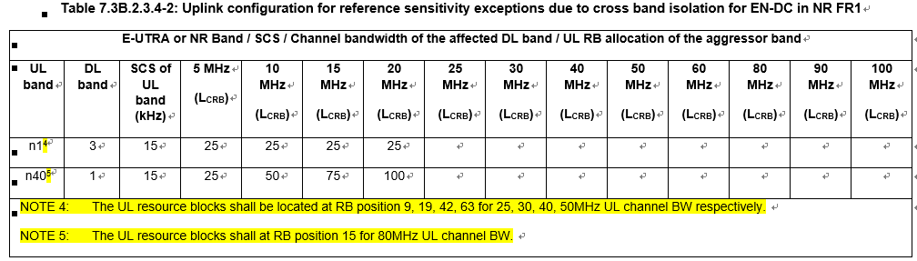
  - Option 2: RAN4 create a new MSD exception due to CIM interference as below. The original MSD due to cross band isolation can focus on the aggressive band PA spurious emission.
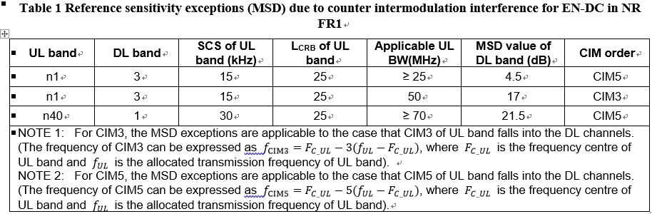
  - Option 3: For the Rel.16 combinations that face the issue on the cross band isolation with new added larger channel bandwidth, for example, DC_3_n1, limited UL BWs of the aggressor band for EN-DC combinations with the existing cross band noise MSD can be considered.
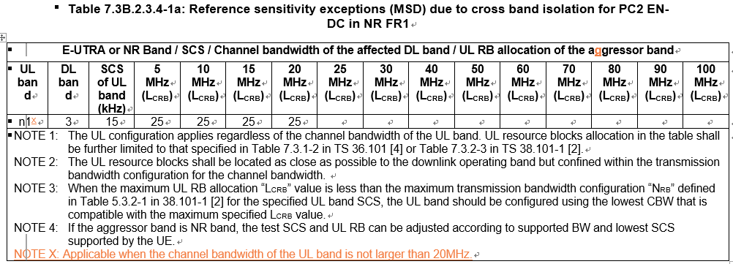
Moderator notes: Option1 is from paper R4-2014170, and the CR is R4-2014169. Option2 is from paper R4-2015552 with more proposals in issue 3-1-2. Option3 is from paper R4-2015795 and is open to other choices.

Company | Comments

Issue 3-1-2: Regarding SCS configurations to derive the MSD due to cross band isolation whether the proposals from R4-2015552 is acceptable?
  - Proposal 1: 15kHz SCS can be used for sub-3GHz FDD bands and sub-2.3GHz TDD/SUL bands except for n50 when RAN4 derive the UL configuration of the MSD due to cross band isolation.
  - Proposal 2: 30kHz SCS can be used for n41, n77, n78 and n79 when RAN4 derive the UL configuration of the MSD due to cross band isolation.
  - Proposal 3: UL SCS for n40 and n50 can be considered case by case. 15kHz or 30kHz or Both 15kHz and 30kHz can be used for n40 and n50 when RAN4 derive the UL configuration of the MSD due to cross band isolation.
- Option 1: Yes
- Option 2: No
Company | Comments

Sub-topic 3-2 UE architecture assumption and requirements
Moderator notes: Two main issues will be handled under this sub-topic, one is handling of different HTF assumptions in EN-DC requirements, the other is the architecture assumption for overlapping inter-band EN-DC.
Issue 3-2-1: Regarding HTF assumption in defining requirements which of the following options from R4-2014317 is acceptable to update the DC_20A_n38A delta Tib, delta Rib, and MSD requirements? If no options acceptable, please share the views.
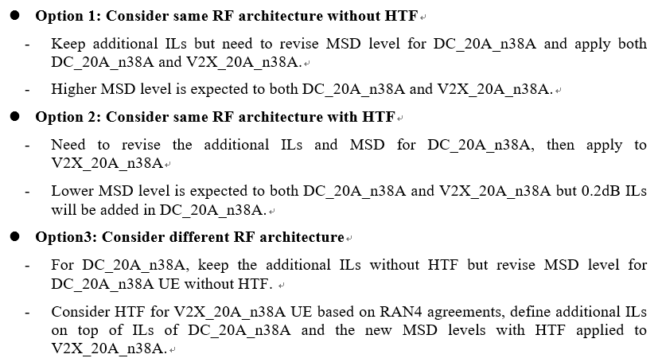
Moderator notes: The conclusion will impact CR R4-2014318.
- Option 1: Yes
- Option 2: No

Company | Comments

Issue 3-2-2: Regarding UE architecture for overlapping inter-band EN-DC whether the following proposals from R4-2014883 is acceptable or not?
  - Proposal 1: Conform RF assumption in Rel-15 and Rel-16 that DC_42_n77 and DC_B42_n78 have intra-band architecture.
  - Proposal 2: Recommend that power imbalance requirements as UE demod requirements shall apply some inter-band EN-DC configuration where intra-band EN-DC requirements apply, e.g., DC_42_n77 and DC_42_n78.
Moderator notes: There is special request from this paper, i.e. “To avoid the delay of discussion in UE demod, agree Proposal 1 and Proposal 2 in 1st round discussion in RAN#97 and give feedback to UE demod session before 2nd round”.
- Option 1: Yes
- Option 2: No

Company | Comments

Sub-topic 3-3 Simultaneous Tx/Rx

Issue 3-2-3: Regarding Simultaneous Tx/Rx DC_42_n79 whether the following proposals from R4-2015555 is acceptable or not?
  - Proposal 1: To introduce MSD values as below between band 42 and n79 if UE choose to support simultaneous Tx/Rx for DC_42_n79.
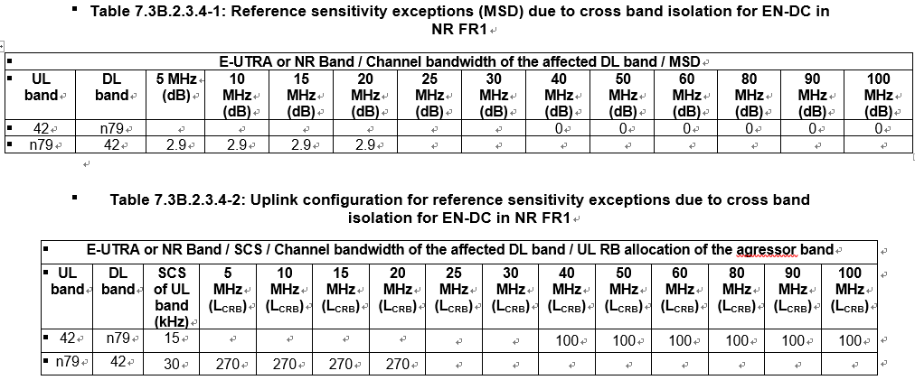
- Option 1: Yes
- Option 2: No

Company | Comments

Companies views’ collection for 1st round

CRs/TPs comments collection

CR/TP number | Comments collection
R4-2014169 | Title: CR CatF Cross Band Noise DC_3_n1_highBW  Moderator Note: This paper reply on whether discussion paper R4-2014170 is approved.
R4-2014318 | Title: Correction on additional ILs and MSD levels for DC_20_n38 UE  Moderator Note: This paper reply on the conclusion of discussion paper R4-2014317, i.e. which option is chosen. Now the changes are based on UEs with HTF.
R4-2014582 | Title: CR to TS 38.101-3 (Rel-16) Error corrections to configurations for CA and DC  Moderator Note: Editorial changes.
R4-2015264 | CR for 38.101-3 Rel16 corrections on ACS requirements for intra-band contiguous EN-DC
R4-2015323 | Alignment of descritpion of the power class restriction for inter-band EN-DC
R4-2015324 | Correction of delta Powerclass for Inter-band EN-DC  Moderator note: Content has been agreed before for EN-DC but implemented to a wrong section (NE-DC). This CR is reintroduce content for EN-DC.
R4-2015331 | CR on NR power class under EN-DC  Moderator note: Align the NR power class capability with 38.331.
R4-2015729 | CR to TS 38.101-3 corrections on inter-band EN-DC configurations including FR1 and FR2
R4-2015981 | Verification of the P-MPR method for EN-DC FDD-TDD power class 2  Moderator note: Introduce a test case for the P-MPR
R4-2016343 | Rel-16 CR editorial corrections 38.101-3

Summary for 1st round

Open issues
Moderator tries to summarize discussion status for 1st round, list all the identified open issues and tentative agreements or candidate options and suggestion for 2nd round i.e. WF assignment.
Status summary

Recommendations on WF/LS assignment
 | WF/LS t-doc Title | Assigned Company,  WF or LS lead

CRs/TPs
Moderator tries to summarize discussion status for 1st round and provides recommendation on CRs/TPs Status update
CR/TP number | CRs/TPs Status update recommendation

Discussion on 2nd round (if applicable)
The following WF and revised CR will be discussed in 2nd round to seek for approval and agreement.
Title:
Title:

Summary on 2nd round (if applicable)
Moderator tries to summarize discussion status for 2nd round and provided recommendation on CRs/TPs/WFs/LSs Status update suggestion
CR/TP/WF number | CRs/TPs/WFs Status update recommendation

Topic #3: Papers for other Specs

Companies’ contributions summary
T-doc number | Company | Proposals / Observations
R4-2014600  Type: CR  CAT: F | LGE | Title: CR for adding NR overlapping bands list in TS38.307  WIC: NR_newRAT-Core  Reason for change:  This CR is to update NR overlapping bands list in TS38.307  Summary of change:  This CR is to add NR overlapping bands list in annex A
R4-2014620  Type: CR  CAT: F | LGE | Title: CR for adding NR overlapping bands list in TS38.307 v16.4.0  WIC: NR_newRAT-Core  Reason for change:  This CR is to update NR overlapping bands list in TS38.307  Summary of change:  This CR is to add NR overlapping bands list in annex A
R4-2015856  Type: CR  CAT: B | CHTTL, ZTE Corporation, Dish, SGS Wireless | Title: CR to TS 38.307 on release independent update for the Rel.16 EN-DC and NR CA/DC  WIC: NR_CA_R16_intra-Core  NR_CADC_R16_2BDL_xBUL-Core  DC_R16_1BLTE_1BNR_2DL2UL-Core  DC_R16_2BLTE_1BNR_3DL2UL-Core  DC_R16_3BLTE_1BNR_4DL2UL-Core  DC_R16_4BLTE_1BNR_5DL2UL-Core  DC_R16_5BLTE_1BNR_6DL2UL-Core  DC_R16_xBLTE_2BNR_yDL2UL-Core  NR_SUL_combos_R16-Core  NR_CA_R16_3BDL_1BUL-Core  NR_CA_R16_4BDL_1BUL-Core  NR_CADC_R16_3BDL_2BUL-Core  DC_R16_LTE_NR_3DL3UL-Core  Reason for change:  More Rel.16 EN-DC and NR CA/DC configurations have been introduced in latest TS 38.101-1, 38.101-2, 38.101-3, an update is needed for the release independent specification.  Note that the draft CR with same content was endorsed in RAN#96-e, R4-2011781  Summary of change:  Update release-independent information for Rel.16 EN-DC and NR CA/DC configurations to be release independent from Rel.15.  Note that the NR-NR DC within FR1 is release independent from Rel.16.
R4-2014328  Type: CR  CAT: F | Reliance Jio | Title: LTE/NR spectrum sharing in Band 40/n40  WIC: DSS_LTE_B40_NR_Bn40_Core  Reason for change:  To enable dynamic spectrum sharing between LTE and NR in B40/n40 band  Summary of change:  Section 5.4.2.1, Introduction of 7.5 KHz UL shift (FREF, shift) in TDD band n40
R4-2014329  Type: CR  CAT: F | Reliance Jio | Title: LTE/NR spectrum sharing in Band 40/n40  WIC: DSS_LTE_B40_NR_Bn40_Core  Reason for change:  To enable dynamic spectrum sharing between LTE and NR in B40/n40 band  Summary of change:  Section 5.4 and B.4.7 added for UL 7.5KHz shift in n40 band

Companies views’ collection for 1st round

CRs/TPs comments collection
CR/TP number | Comments collection
R4-2014600 | Title: CR for adding NR overlapping bands list in TS38.307  Moderator note: This paper is for Rel-15
R4-2014620 | Title: CR for adding NR overlapping bands list in TS38.307 v16.4.0  Moderator note: This paper is same as 4600 for Rel-16.
R4-2015856 | CR to TS 38.307 on release independent update for the Rel.16 EN-DC and NR CA/DC
R4-2014328 | LTE/NR spectrum sharing in Band 40/n40  Moderator note: CR to 38.104
R4-2014329 | LTE/NR spectrum sharing in Band 40/n40  Moderator note: CR to 38.307

Summary for 1st round

Open issues
Moderator tries to summarize discussion status for 1st round, list all the identified open issues and tentative agreements or candidate options and suggestion for 2nd round i.e. WF assignment.
 | Status summary
Sub-topic#1 | Tentative agreements:  Candidate options:  Recommendations for 2nd round:

Suggestion on WF/LS assignment
 | WF/LS t-doc Title | Assigned Company,  WF or LS lead

CRs/TPs
Moderator tries to summarize discussion status for 1st round and provided recommendation on CRs/TPs Status update suggestion
CR/TP number | CRs/TPs Status update recommendation

Discussion on 2nd round (if applicable)

Summary on 2nd round (if applicable)
Moderator tries to summarize discussion status for 2nd round and provided recommendation on CRs/TPs/WFs/LSs Status update suggestion
CR/TP/WF number | CRs/TPs/WFs Status update recommendation

