**3GPP TSG-RAN4 WG4 Meeting # 97-e *R4-2016517***

**Electronic meeting, Nov. 2- 13, 2020**

|  |  |  |  |  |  |  |  |  |
| --- | --- | --- | --- | --- | --- | --- | --- | --- |
| *CR-Form-v12.0* | | | | | | | | |
| **CHANGE REQUEST** | | | | | | | | |
|  | | | | | | | | |
|  | **38.101-1** | **CR** | 0575 | **rev** | **-** | **Current version:** | **16.5.0** |  |
|  | | | | | | | | |
| *For* [***HE******LP***](http://www.3gpp.org/3G_Specs/CRs.htm#_blank)*on using this form: comprehensive instructions can be found at* [*http://www.3gpp.org/Change-Requests*](http://www.3gpp.org/Change-Requests)*.* | | | | | | | | |
|  | | | | | | | | |

|  |  |  |  |  |  |  |  |  |
| --- | --- | --- | --- | --- | --- | --- | --- | --- |
| ***Proposed change affects:*** | UICC apps |  | ME |  | Radio Access Network |  | Core Network |  |

|  |  |  |  |  |  |  |  |  |  |  |
| --- | --- | --- | --- | --- | --- | --- | --- | --- | --- | --- |
|  | | | | | | | | | | |
| ***Title:*** | CR on TS 38.101-1 time mask for shorter transient | | | | | | | | | |
|  |  | | | | | | | | | |
| ***Source to WG:*** | Huawei, HiSilicon | | | | | | | | | |
| ***Source to TSG:*** | R4 | | | | | | | | | |
|  |  | | | | | | | | | |
| ***Work item code:*** | NR_RF_FR1-Core | | | | |  | ***Date:*** | | | 2020-10-19 |
|  |  | | | |  | |  | | |  |
| ***Category:*** | **F** |  | | | | | ***Release:*** | | | Rel-16 |
|  | *Use one of the following categories:* ***F*** *(correction)* ***A*** *(mirror corresponding to a change in an earlier release)* ***B*** *(addition of feature),* ***C*** *(functional modification of feature)* ***D*** *(editorial modification)*  Detailed explanations of the above categories can be found in 3GPP [TR 21.900](http://www.3gpp.org/ftp/Specs/html-info/21900.htm). | | | | | | | | *Use one of the following releases: Rel-8 (Release 8) Rel-9 (Release 9) Rel-10 (Release 10) Rel-11 (Release 11) Rel-12 (Release 12)* *Rel-13 (Release 13) Rel-14 (Release 14) Rel-15 (Release 15) Rel-16 (Release 16)* | |
|  |  | | | | | | | | | |
| ***Reason for change:*** | | Introduce tpstart as the start line of shorter transient, the reason is provided in R4-2016516. | | | | | | | | |
|  | |  | | | | | | | | |
| ***Summary of change:*** | | Introduce tpstart as the start line of shorter transient. | | | | | | | | |
|  | |  | | | | | | | | |
| ***Consequences if not approved:*** | | The spec for inter-band CA is not clear. | | | | | | | | |
|  | |  | | | | | | | | |
| ***Clauses affected:*** | | 6.3.3 | | | | | | | | |
|  | |  | | | | | | | | |
|  | | **Y** | **N** |  | | | |  | | |
| ***Other specs*** | |  | **x** | Other core specifications | | | | TS/TR … CR … | | |
| ***affected:*** | | **x** |  | Test specifications | | | | TS 38.521-1 | | |
| ***(show related CRs)*** | |  | **x** | O&M Specifications | | | | TS/TR … CR … | | |
|  | |  | | | | | | | | |
| ***Other comments:*** | |  | | | | | | | | |

|  |  |
| --- | --- |
| ***This CR’s revision history:*** |  |

***<Start of change>***

## 3.2 Symbols

For the purposes of the present document, the following symbols apply:

ΔFGlobal Granularity of the global frequency raster

ΔFRaster Band dependent channel raster granularity

ΔfOOB Δ Frequency of Out Of Band emission

ΔFTX-RX Δ Frequency of default TX-RX separation of the FDD *operating band*

∆MPRc Allowed Maximum Power Reduction relaxation for serving cell *c*

ΔPPowerClass Adjustment to maximum output power for a given power class

RB The starting frequency offset between the allocated RB and the measured non-allocated RBΔRIB,c Allowed reference sensitivity relaxation due to support for inter-band CA operation, for serving cell *c*

ΔRIB,4R Reference sensitivity adjustment due to support for 4 antenna ports

ΔShift Channel raster offset

TC Allowed operating band edge transmission power relaxation

TC,*c*Allowed operating band edge transmission power relaxation for serving cell *c*

ΔTIB,c Allowed maximum configured output power relaxation due to support for inter-band CA operation, inter-band EN-DC operation and due to support for SUL operations, for serving cell *c*

BWChannel Channel bandwidth

BWChannel,block Sub-block bandwidth, expressed in MHz. BWChannel,block= Fedge,block,high- Fedge,block,low

BWChannel_CA Aggregated channel bandwidth, expressed in MHz

BWChannel,max Maximum channel bandwidth supported among all bands in a release

BWGB max( BWGB,Channel(*k*) )

BWGB,Channel(k) Minimum guard band defined in clause 5.3A.1 of carrier *k*

BWDL Channel bandwidth for DL

BWUL Channel bandwidth for UL

BWinterferer Bandwidth of the interferer

Ceil(x) Rounding upwards; ceil(x) is the smallest integer such that ceil(x) ≥ x

Floor(x) Rounding downwards; floor(x) is the greatest integer such that floor(x) ≤ x

FC *RF reference frequency* on the channel raster, given in table 5.4.2.2-1

FC,block, high Fc of the highest transmitted/received carrier in a *sub-block*

FC,block, low Fc of the lowest transmitted/received carrier in a *sub-block*

FC,low The Fc of the lowest carrier, expressed in MHz

FC,high The Fc of the highest carrier, expressed in MHz

FDL_low The lowest frequency of the downlink *operating band*

FDL_high The highest frequency of the downlink *operating band*

FUL_low The lowest frequency of the uplink *operating band*

FUL_high The highest frequency of the uplink *operating band*

Fedge,block,low The lower *sub-block* edge, where Fedge,block,low = FC,block,low - Foffset, low.

Fedge,block,high The upper *sub-block* edge, where Fedge,block,high = FC,block,high + Foffset, high.

Fedge , low The *lower edge* of *aggregated channel bandwidth*, expressed in MHz. Fedge,low = FC,low - Foffset,low.

Fedge, high The *higher edge* of *aggregated channel bandwidth*, expressed in MHz. Fedge,high = FC,high + Foffset,high.

FInterferer (offset) Frequency offset of the interferer (between the center frequency of the interferer and the carrier frequency of the carrier measured)

FInterferer Frequency of the interferer

FIoffset Frequency offset of the interferer (between the center frequency of the interferer and the closest edge of the carrier measured)

Foffset Frequency offset from FC_high to the *higher edge* or FC_low to the *lower edge.*

Foffset,high Frequency offset from FC,high to the upper *UE RF Bandwidth edge*, or from FC,block, high to the upper sub-block edge

Foffset,low Frequency offset from FC,low to the lower *UE RF Bandwidth edge*, or from FC,block, low to the lower sub-block edge

FOOB The boundary between the NR out of band emission and spurious emission domains

FREF RF reference frequency

FREF-Offs Offset used for calculating FREF

FREF,Shift RF reference frequency for Supplementary Uplink (SUL) bands and for the uplink for all FDD bands

Fuw (offset) The frequency separation of the center frequency of the carrier closest to the interferer and the center frequency of the interferer

GBChannel Minimum guard band defined in clause 5.3.3

LCRB Transmission bandwidth which represents the length of a contiguous resource block allocation

expressed in units of resources blocks

Max() The largest of given numbers

Min() The smallest of given numbers

 Physical resource block number

NRACLR NR ACLR

NRB Transmission bandwidth configuration, expressed in units of resource blocks

NRB_agg The number of the aggregated RBs within the fully allocated aggregated channel bandwidth

NRB,c The transmission bandwidth configuration of component carrier c, expressed in units of resource blocks

NRB,largest BW The largest transmission bandwidth configuration of the component carriers in the bandwidth combination, expressed in units of resource blocks

NRB,low The transmission bandwidth configurations according to Table 5.3.2-1 for the lowest assigned component carrier in clause 5.3A.1

NRB,high The transmission bandwidth configurations according to Table 5.3.2-1 for the highest assigned component carrier in clause 5.3A.1

NREF NR Absolute Radio Frequency Channel Number (NR-ARFCN)

NREF-Offs Offset used for calculating NREF

PCMAX The configured maximum UE output power

PCMAX, *c* The configured maximum UE output power for serving cell *c*

PCMAX, *f*, *c* The configured maximum UE output power for carrier *f* of serving cell *c* in each slot

PEMAX Maximum allowed UE output power signalled by higher layers

PEMAX, *c* Maximum allowed UE output power signalled by higher layers for serving cell *c*

PInterferer Modulated mean power of the interferer

Plargest BW Power of the largest transmission bandwidth configuration of the component carriers in the bandwidth combination

PPowerClass PPowerClass is the nominal UE power (i.e., no tolerance)

P-MPR*c* Maximum allowed UE output power reduction for serving cell *c*

PRB The transmitted power per allocated RB, measured in dBm

PUMAX The measured configured maximum UE output power

Puw Power of an unwanted DL signal

Pw Power of a wanted DL signal

RBstart Indicates the lowest RB index of transmitted resource blocks

SCSc SCS for the component carrier c

SCSlargest BW SCS for the largest transmission bandwidth configuration of the component carriers in the bandwidth combination

SCSlow SCS for the lowest assigned component carrier in clause 5.3A.1

SCShigh SCS for the highest assigned component carrier in clause 5.3A.1

*tp* Transient Period value signalled by the UE

*tpstart* Time starting line for transient period

T(PCMAX, *f*, *c*) Tolerance for applicable values of PCMAX, *f*, *c* for configured maximum UE output power for carrier *f* of serving cell *c*

TL,c Absolute value of the lower tolerance for the applicable *operating band* as specified in clause 6.2.1

SSREF SS block reference frequency position

UTRAACLR UTRA ACLR

<end of changes>

< start of changes >

### 6.3.3 Transmit ON/OFF time mask

#### 6.3.3.1 General

The transmit power time mask defines the transient period(s) allowed

- between transmit OFF power as defined in subclause 6.3.2 and transmit ON power symbols (transmit ON/OFF)

- between continuous ON-power transmissions with power change or RB hopping is applied. When a UE signals transient period capability, the transient period value (*tp)* can be 2, 4, or 7 usec. If no capability is signalled, the default transient period value of 10 usec applies. Values of tpstart for transient period starts before the transmission boundary for UE type 1 and UE type 2 as specified in table 6.3.3.1-1 respectively.

Table 6.3.3.1-1 value of tpstart

| tp  (μs) | Type 1 | Type 2 |
| --- | --- | --- |
| tpstart(μs) | tpstart (μs) |
| 2 | -0.5 | -1 |
| 4 | -1 | -2 |
| 7 | -2 | -3.5 |

In case of RB hopping, transition period is shared symmetrically.

Unless otherwise stated the requirements in clause 6.5 apply also in transient periods.

In the following subclauses, following definitions apply:

- A slot or long subslot transmission is a transmission with more than 2 symbols.

- A short subslot transmission is a transmission with 1 or 2 symbols.

< end of changes >

<start of changes>

#### 6.3.3.6 SRS time mask

……

When power change between consecutive SRS transmissions is required, then Figure 6.3.3.6-3 and Figure 6.3.3.6-4 apply.

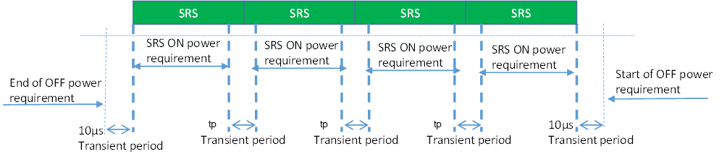

tpstart

tpstart

tpstart

Figure 6.3.3.6-3: Consecutive SRS time mask for the case when power change is required and when 15 kHz and 30 kHz SCS is used in FR1



Figure 6.3.3.6-4: Consecutive SRS time mask for the case when power change is required and when 60 kHz SCS is used in FR1, when the transient period is 10 µs

#### 6.3.3.7 PUSCH-PUCCH and PUSCH-SRS time masks

The PUCCH/PUSCH/SRS time mask defines the observation period between sounding reference symbol (SRS) and an adjacent PUSCH/PUCCH symbol and subsequent UL transmissions. The time masks apply for all types of frame structures and their allowed PUCCH/PUSCH/SRS transmissions unless otherwise stated.

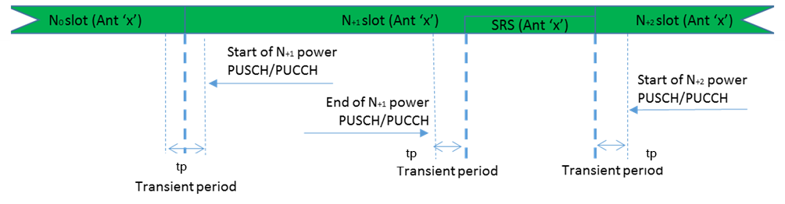

tpstart

Figure 6.3.3.7-1: PUCCH/PUSCH/SRS time mask when there is a transmission before or after or both before and after SRS, when sounded on the same antenna (Ant 'x')

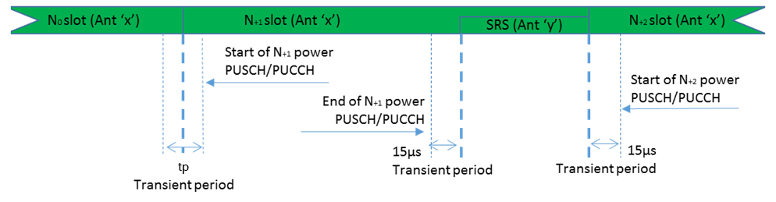

tpstart

Figure 6.3.3.7-2: PUCCH/PUSCH/SRS time mask when there is a transmission before or after or both before and after SRS, when sounded on a different antenna (Ant 'x' and Ant 'y' are different antenna ports)

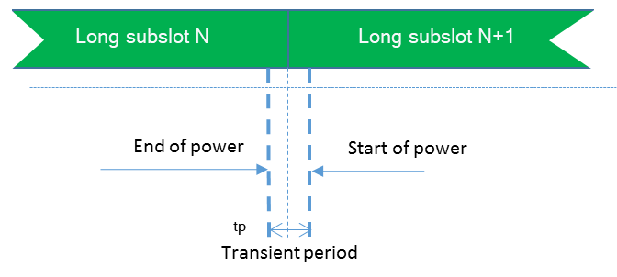

tpstart

Figure 6.3.3.7-3: Consecutive long subslot transmission and long subslot transmission time mask

#### 6.3.3.8 Transmit power time mask for consecutive slot or long subslot transmission and short subslot transmission boundaries

The transmit power time mask for consecutive slot or long subslot transmission and short slot transmission boundaries defines the transient periods allowed between such transmissions.

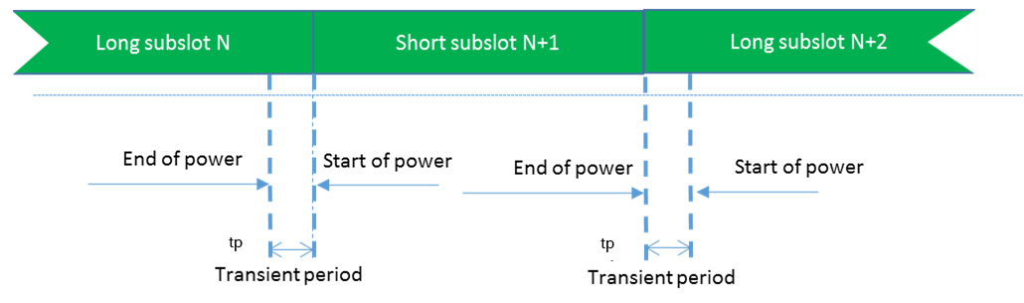

Figure 6.3.3.8-1: Consecutive slot or long subslot transmission and short subslot transmission time mask

#### 6.3.3.9 Transmit power time mask for consecutive short subslot transmissions boundaries

The transmit power time mask for consecutive short subslot transmission boundaries defines the transient periods allowed between short subslot transmissions.

The transient period shall be equally shared as shown on Figure 6.3.3.9-2.

Figure 6.3.3.9-1: Void

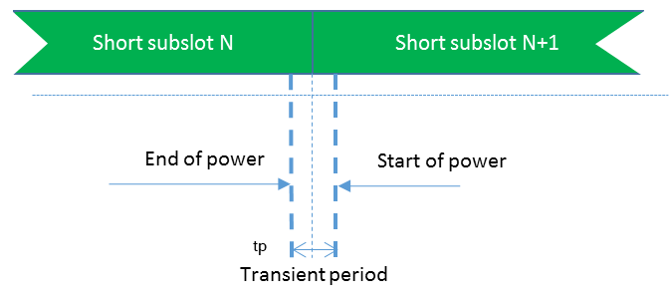

tpstart

Figure 6.3.3.9-2: Consecutive short subslot transmissions time mask

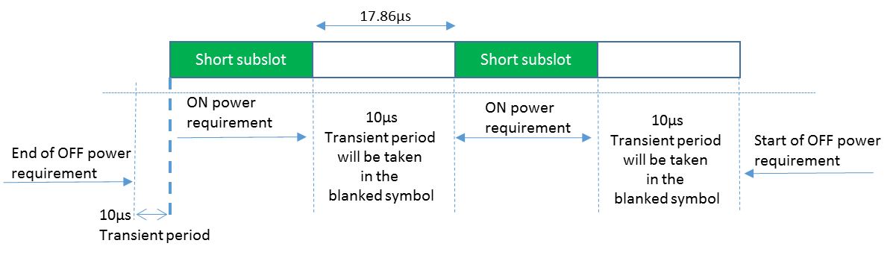

Figure 6.3.3.9-3: Consecutive short subslot (1 symbol gap) time mask for the case when transient period is required on both sides of the symbol and when 60 kHz SCS is used in FR1, when the transient period is 10 µs.

<end of changes>

***<End of change>***